**1. Abstract**

In this project, we examine the use of mobile web technology as a way to combat intimate partner violence by giving victims quick and easy access to relevant local information and resources. We have included a detailed analysis of the problem, as well as, the design of our solution. Though research may be scarce pertaining to the actual effect of the use of mobile technology as a safety tool for victims of violence, the second stage of our project (not covered in this paper) will entail contributing to the existing body of work by undertaking user/adoption studies to determine the efficacy of our mobile solution. It is our expectation that by availing themselves of this mobile platform, users will be better informed of their options, as well as, empowered to make decisions that will set them on the path to safety and freedom from domestic violence.

**2. Introduction**

Despite years of advancement in various aspects of human existence, from human rights to technology, our society remains plagued by a scourge, which has (arguably) been with us for as long as the human race has existed: domestic violence. Simply put, we are talking about violence that happens in the homes. However, more formally, we mean violent confrontations between family or household members involving physical harm, sexual assault, or fear of physical harm.[1]

As a societal blight, domestic violence transcends all races, genders, ages, socio-economic classes, religious affiliations, occupations and educational backgrounds. In the United States in particular (as of 2010), 1 in 3 women and 1 in 4 men had experienced violence/aggression from their intimate partners.[2] Being the blight that it is, domestic violence is passed on from one generation to the next, with children who witness domestic violence twice as likely to perpetrate this violence in their adult homes towards their spouses and/or children.[3],[4]

In the United States, a number of steps have been taken to combat domestic violence, and in particular, violence against women. These include the creation of information centers, associations, organisations and bills. To various degrees, these have been helpful. In particular, since the passage of the Violence Against Women Act in 1994, there has been a 67% decline in Intimate Partner Violence.[5] Although any and all decline is welcome, there is still a lot to be done; especially considering that, between 2001 and 2012, there had been over 2.5 times the number of women killed by their husbands or boyfriends in the US than the number of US troops killed in Afghanistan.[6]

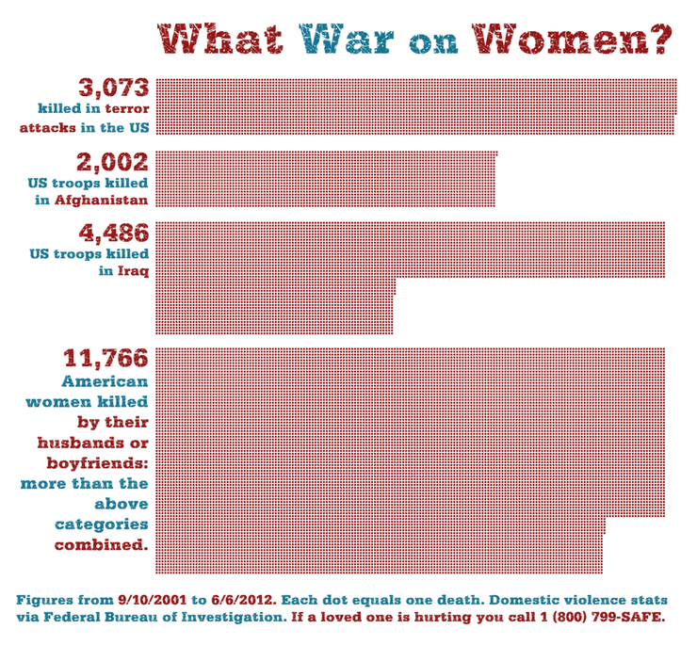

**Figure 1: Showing comparisons of deaths between 2001 and 2012.** [7]

These figures do not take into consideration the number of male victims; neither does it take into consideration the number of children, relatives, friends, responders etc. who would also have been killed as a result of domestic violence (a number which was set at above 20% of the domestic violence homicide victims between 2003 and 2009.)[8]

However, as with everything in life, there is a beginning. Domestic violence is no different. Violent acts rarely occur in isolation and are often experienced within the context of other acts of violence by the same perpetrator.[9] Nonetheless, despite the signs of violence or prevalence of physical abuse, the incident report rate is very low. Between 1999 and 2000, less than 17% of rape incidents and 27% of physical attacks with women ended up being reported.[10]Unfortunately, without any recourse to external aid, many of the victims do not have a fighting chance.

**New York**

In the city of New York, the situation is no different. Although, the true extent of Intimate Partner Violence (IPV) may be unknown, the data so far is rather alarming. For example, between 2003 and 2005, 44% of fatal violence against women was confirmed as the result of IPV.[11] Despite the number of steps taken by the state to stem the tide of violence (including the provision of 5 Family Justice Centers, FJCs, across the city), like the report statistics above show, the number of victims availing themselves of the provided resources is much less than the number of domestic violence victims. While the precise basis of this situation may encompass various reasons (for example fear of the perpetrator, desire to protect the abuser or children involved in the relationship etc), we believe that a lack of knowledge of the available resources is also partly responsible for the situation.

Thus, our project is premised on the idea that if we can:

* make information easily accessible to victims of domestic violence (with the option to access information anonymously/pseudonymously) as well as
* provide a way for survivors to remotely log incidents

Survivors will be encouraged to explore resources while deciding if they want to commit to an action plan or not. In the long run, they will be better equipped to deal with and escape from domestic violence.

**Technology and Domestic Violence**

Various attempts have been made to leverage internet based technology in solving the problems of educating victims of domestic violence. Some platforms centered around this idea include: the National Coalition Against Domestic Violence,[12] The IRIS Project,[13] and Safe Horizon[14] (all internet-based platforms), as well as, One Love Foundation's MyPlan[15] (a mobile-based platform).

In evaluating the effectiveness of internet based safety decision aid methods, Nancy Glass, the Associate Director of the Johns Hopkins Centre for Global Health in the U.S, conducted a 5-year randomized trial in which she observed the following positive outcomes:[16]

* Reduction in the victim's decisional conflict about safety
* Increase in the victim's safety seeking behaviours
* Reduction in the victim's exposure to IPV
* Improvement in the victim's mental health

**Our project**

With these outcomes in mind, our present project and prototype builds on the foundations laid by an earlier team of Cornell Tech students in answer to a challenge posed by the New York mayor’s office:

*How might we create a mobile application that provides comprehensive and multi-disciplinary information, tools and resources for domestic violence and sexual assault survivors while also protecting their safety and privacy?*

Like these students, our hypothesis is that more reports will be made if access to portals and incident logging facilities is put within easy reach of the victims.

Leveraging information provided by our partners at the NYC Office to Combat Domestic Violence (OCDV), the primary innovation in our project will be the creation of a new system that will be integrated into New York City’s infrastructure. This system will be aimed at providing survivors of IPV support and connections to the various services offered by the New York City mayor's office. Thus, we will be extending the previous design by providing a fully functional, production ready application, and a functionality that does not yet exist in New York City.

Following the final launch of the product, we will proceed to evaluate the adoption and use of our product by the victims of domestic violence in order to confirm or reject our hypothesis.

**4. System Design**

**Considerations**

Inline with any research involving violence against a specific group, and as put forth by the World Health Organisation (WHO), there are considerations that must be made when dealing with endangered populations.[17] Topmost of these considerations is the safety and security of the victims using our product.

In this regard, our approach to security is two-fold:

* Protection from discovery by the abuser
* Protection of the victim’s disclosed online data

The former security consideration informs our choice of a web-based application that can be accessed through a phone rather than a native mobile application. This platform will also be equipped with an emergency exit button to aid in covering the survivor's browsing history with the site.

Similar Applications

To the extent of our present knowledge, all existing models of web based domestic violence information sites also have implemented an emergency exit function to protect the victim from discoverability by the abuser. However, while they do well in navigating the user away from the site and redirecting the page to an innocuous page (for example, the Google home page, weather report or jokes site), all these have failed to get rid of data existing in the user’s history logs; most of which can be reached by sufficient clicks of the back button, or just simply inspecting the user’s browsing history. (A potential work-around would be browsing in a private/incognito mode and shutting down the window. However, such behaviour could seem suspicious to the abuser.)

**System Architecture**

Our application consists of two main components:

1) The information pages that provide various resources and information that users might need, including locations of Family Justice Centers, testimonials, technology tips for using the app safely, etc.

2) The OCDV portal that users can log in, upload and manage their records of incidences, evidences of being abused, and keep track of their court days, etc.

**Note**: Unlike existing platforms, we aim to design our emergency exit button such that it redirects away from the site without leaving any trace in the history logs.

**Key Features and Functions**

|  |  |
| --- | --- |
| **Feature** | **Description** |
| Services Offered | A list of all services offered at FJC |
| Testimonials | Experiences shared by survivors based on how their choice to visit an FJC transformed their respective lives. |
| FJC Virtual Tour | A portal to help users familiarize themselves with FJCs at different locations using pictures and videos. |
| Tech Safety Tips | Information on how to use the app safely. This includes using the exit function as well as securing personal information online |
| Prepare for visit | A guide on preparation that could be made before visiting a FJC. |
| FAQs | Frequently Asked Questions about the app and FJC |
| District Attorney Contact | Contact information of your district attorney |
| My FJC portal | A dashboard for users to upload and manage their records of incidences, evidences of being abused, and keep track of their court days, etc. |

**Interface Design**

**Emergency Information**

Our interface is designed to supply a user with immediate information (phone number and location) of the closest FJC as soon as the user arrives at the website. This design choice is based on the user potentially needing immediate help.

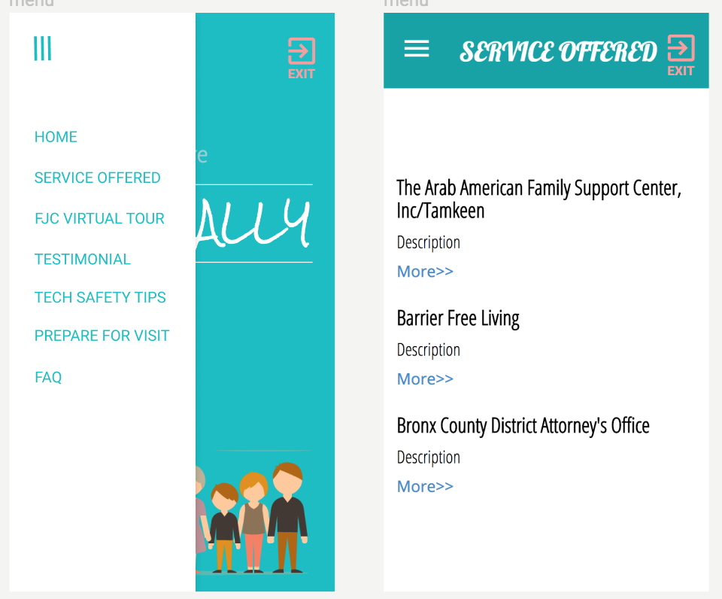

**Figure 3: Mobile Information Interface**

**Incident Logging/Reporting**

The user is also given quick access to online incident report tools in case the user is unable to call or visit the FJC. This can be done anonymously or by providing the user providing his/her contact information. In the case of the latter, the FJC will then be enabled to contact the user.

A user may also create an archive of incidence log reports by creating an account on the platform. New users will be prompted to choose this option by being nudged to create an account while old users will simply be matched to their accounts by their emails and asked to log in.

At every point, users will have the option of calling or communicating through the website forums, chats or emails.

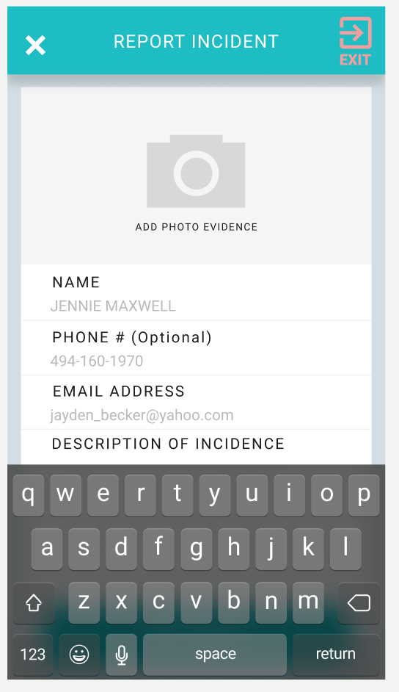

**Figure 3: Incident reporting interface**

**The Dashboard**

This gives the user access to various personalised functions such as a complete archive of incident reports logged by the user, evidence of abuse gathered by the user (notes, pictures etc), a scheduler to keep track of legal appointments or appointments with the FJC, as well as, a history log of interactions with the FJC.

**6. Implementation**

#### 

#### Based on communication with engineers of New York mayor’s office, our analyses of the specific requirements of the project and present technologies, we decided to implement our prototype using the “MEAN stack”.[18]

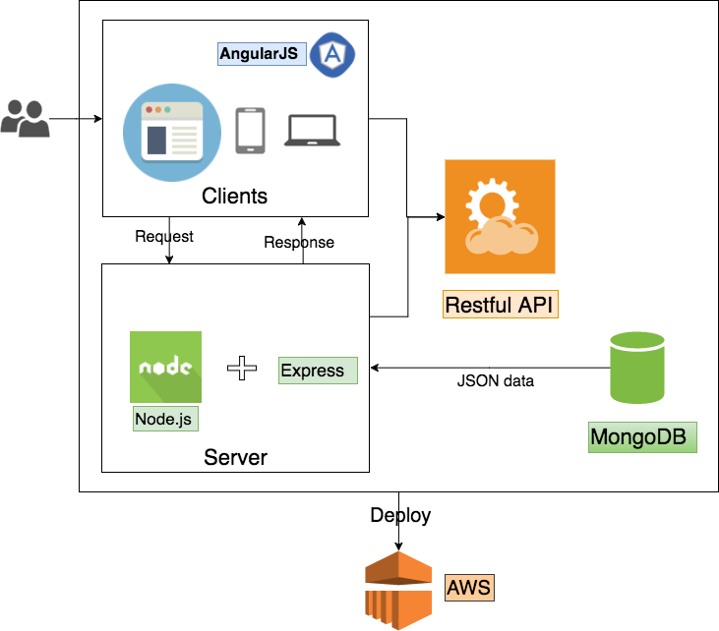

**Figure 6: Architecture Diagram**

**Present Achievements**

So far, we have built up the server and client end design. We would be including password encryption functions which will create passwords used to populate our identity authentication database.

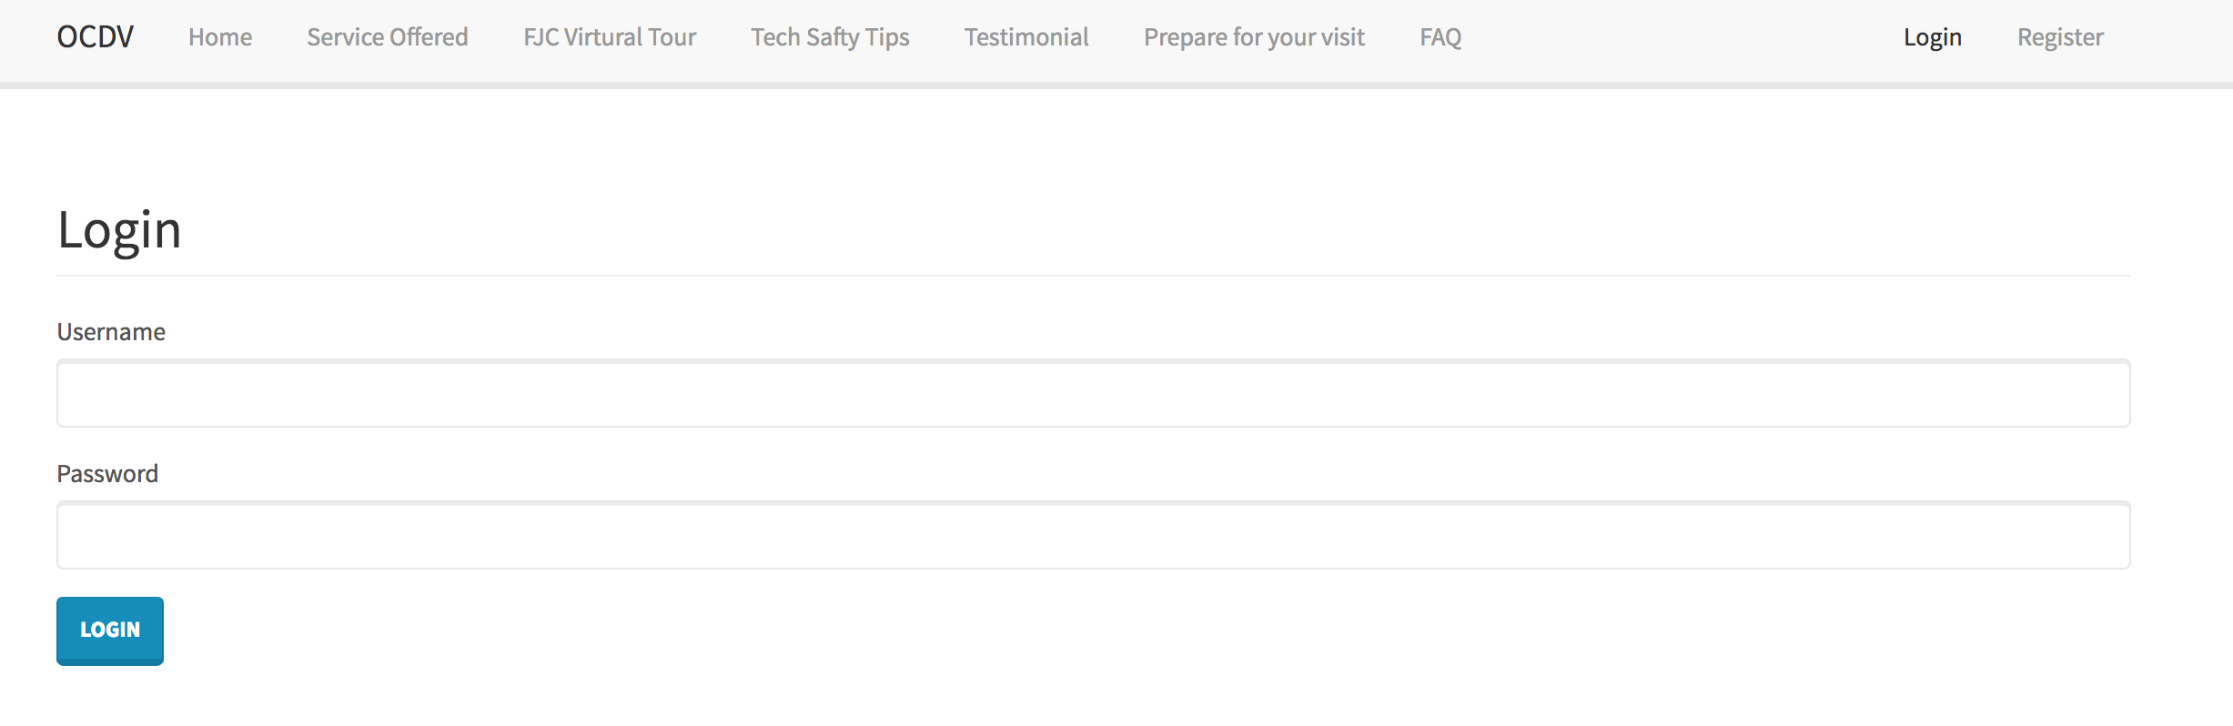

**Figure 7: User Authentication/Log in**

For frontend, we made several templates based on our research and user tests, one of which has already been connected to our backend but we are still making improvements on details.

**Evaluation**

In line with putting the safety of the survivors first, once we have completed the implementation of our model, we will conduct preliminary evaluations with the help of professionals and safety workers at the various Family Justice Centers. Following this, the next stage will be carrying out further tests with a closed group of real victims of domestic violence. The final, full-fledged testing will only be done when we are sure the model is as safe and error free as possible.

In order to help prove or disprove our hypothesis, we will focus on collecting usage data especially log in data, which will give us an idea of the frequency and duration of usage. Factors including the rate/volume of adoption and number of connections made with the FJCs (juxtaposed against what existed prior to the use of the application) will be also measured as well as the typical usage value of the application (that is, purposes for which users seem to use the application the most).

**Conclusion**

In line with various measures put in place by organisations and governments to stem the scourge of domestic violence, we believe that application of technology has a central role to play. By leveraging our present knowledge and skill base, we hope to contribute to further driving down the incidence of domestic violence and in essence, making the world a better place, not just for some but for all; because directly or indirectly, we all are affected by the scourge.

**References**

1. "Fast Facts on Domestic Violence, " *The Clark County Prosecuting Attorney*, Accessed: 13 May 2017, http://www.clarkprosecutor.org/html/domviol/facts.htm.
2. Michele C. Black, Kathleen C. Basile, Matthew J. Breiding, Sharon G. Smith Mikel L. Walters, Melissa T. Merrick Jieru Chen and Mark R. Stevens, "The National Intimate Partner and Sexual Violence Survey (NISVS): 2010 Summary Report," *National Center for Injury Prevention and Control, Centers for Disease Control and Prevention*, 2011,https://www.cdc.gov/violenceprevention/pdf/nisvs_report2010-a.pdf.
3. "16 Days of Activism Against Gender Violence, " *World Health Organization*, Accessed: 13 May 2017, <http://www.who.int/violence_injury_prevention/violence/global_campaign/16_days/en/index7.html>
4. Strauss, Gelles, and Smith, “Physical Violence in American Families: Risk Factors and Adaptations to Violence in 8,145 Families, " *Transaction Publishers*, 1990.
5. Truman, J. L. & Morgan, R. E. (2014). Nonfatal domestic violence, 2003-2012. Retrieved from <http://www.bjs.gov/content/pub/pdf/ndv0312.pdf>
6. Mansur Gidfar, "Don't Believe In The War On Women? Would A Body Count Change Your Mind?", *Upworthy*, Accessed: 13 May 2017, http://www.upworthy.com/dont-believe-in-the-war-on-women-would-a-body-count-change-your-mind.
7. M. Gidfar, "Don't Believe In The War On Women? " http://www.upworthy.com/dont-believe-in-the-war-on-women-would-a-body-count-change-your-mind.
8. Sharon G. Smith, Katherine A. Fowler and Phyllis H. Niolon, "Intimate Partner Homicide and Corollary Victims in 16 States: National Violent Death Reporting System, 2003–2009," *American Journal of Public Health* 104, no. 3, (2014), 461-466.

   https://www.cdc.gov/violenceprevention/pdf/nisvs_report2010-a.pdf.
9. "Facts About Domestic Violence and Stalking," *National Coalition Against Domestic Violence (NCADV)*, NCADV, 2015, <https://ncadv.org/files/Domestic%20Violence%20and%20Stalking%20NCADV.pdf> Retrieved from [www.ncadv.org](http://www.ncadv.org)
10. Patricia Tjaden, Nancy Thoennes, "Extent, Nature, and Consequences of Intimate Partner Violence: Findings From the National Violence Against Women Survey," *National Institute of Justice and the Centers for Disease Control and Prevention*, 2000, 49, https://www.ncjrs.gov/pdffiles1/nij/181867.pdf
11. Stayton C., Olson C., Thorpe L., Kerker B., Henning K., Wilt S., "Intimate Partner Violence Against Women in New York City, 2008 Report from the New York City Department of Health and Mental Hygiene," *New York City Department of Health and Mental Hygiene*, 2008, https://www1.nyc.gov/assets/doh/downloads/pdf/public/ipv-08.pdf.
12. http://ncadv.org/learn-more/what-is-domestic-violence
13. <http://www.stopdv.org/>
14. <https://www.safehorizon.org/>
15. <http://www.joinonelove.org/my_plan_app>
16. Nancy Glass, "Testing the Effectiveness of Internet/Smart Phone Based Interventions on Survivor Safety and Heath," https://www.wilsoncenter.org/sites/default/files/Nancy%20Glass_Testing%20the%20Effecitiveness%20of%20Internet%20Based%20Interventions%20on%20Survivor%20Safety%20and%20Health.pdf
17. "WHO multi-country study on women’s health and domestic violence against women: summary report of initial results on prevalence, health outcomes and women’s responses," *World Health Organization*, Geneva, 2005, http://www.who.int/gender/violence/who_multicountry_study/summary_report/summary_report_English2.pdf
18. MongoDB (NoSQL database), Express (a web framework for Node.js), “AngularJS (Client-end JavaScript)”, Node.JS(Server-end JavaScript)