EBU6304 Software Engineering Group Project

2025-26
Group number | 37
member 1 | QM no: 231222420 | Name: Yangfan Zhou
member 2 | QM no: 231222084 | Name: Congyu Guo
member 3 | QM no: 231221102 | Name: Mengnan Duan
member 4 | QM no: 231221984 | Name: Changyang Zhou
member 5 | QM no: 231222224 | Name: Congbo Li
member 6 | QM no: 231220035 | Name: Shirao Wang

First report

Requirements
1. Fact-Finding Techniques
To ensure the recruitment system accurately reflects the operational needs of BUPT International School, the team employed four complementary requirements elicitation techniques during the initial discovery phase. All findings from the four fact-finding techniques were systematically translated into user stories and acceptance criteria in the ProductBacklog_group37.xlsx and directly shaped the functional design of the low-fidelity prototype (Prototype_group37.pdf) for the first assessment.
1.1 Stakeholder Interviews
Semi-structured interviews were conducted with two Module Organisers (MOs) and one administrative staff member. The interviews focused on understanding the current recruitment workflow, pain points with the existing Excel-based process, and desired features for the new system. Key findings included: MOs reported spending an average of 3–4 hours per recruitment cycle manually sorting applications; the administrative team lacked a centralised view of TA workload distribution; and both groups expressed a strong desire for automated skill-matching capabilities.
1.2 Teaching Assistant Survey
An anonymous online questionnaire was distributed to 40 current and former Teaching Assistants. The survey gathered data on application experience, preferred communication channels, and feature priorities. Results indicated that 82% of respondents found the existing process cumbersome, 71% wanted real-time application status tracking, and 65% expressed interest in receiving personalised skill-gap feedback. These quantitative insights directly informed our MoSCoW prioritisation (Section 3).
1.3 Document Analysis
The team analyzed the existing recruitment artefacts, including the official TA application form (Excel template), previous semester’s recruitment records, and the school’s workload allocation spreadsheet. This analysis helped identify the core data entities (TA profiles, job postings, applications, workload records) and their relationships, which directly shaped the system’s data model and JSON/.txt/.csv file structure.
1.4 Observation and Contextual Inquiry
A team member observed one MO during an actual recruitment session, noting the sequence of actions performed: reviewing applications in Excel, cross-referencing skill requirements, emailing shortlisted candidates, and updating the workload tracker. This contextual inquiry revealed implicit requirements not captured in interviews, such as the need for batch status updates and the importance of deadline enforcement. These implicit requirements were added to the product backlog as low-priority user stories, ensuring the system design covers both explicit and implicit operational needs.
2. Iteration Planning
Sprint 1 is the core delivery phase for the EBU6304 first assessment, and all its core features are the key design content of the first assessment deliverables (Product Backlog, Prototype, Brief Report). This project is structured into four two-week iterations (Sprints), following the Scrum framework. Each iteration delivers a working software increment that builds incrementally upon the previous version. The rationale for feature allocation across iterations is driven by two principles: (1) establishing the core data flow (registration → job posting → application) first to create a usable end-to-end skeleton, and (2) deferring AI-powered and enhancement features to later iterations once the foundational CRUD operations are stable.
Iteration | Core Features | Rationale
Sprint 1 | User registration & login (TA, MO, Admin); TA profile creation; MO job posting; TA job browsing & application; basic data persistence (JSON/.txt/.csv) | Establishes the minimum viable product (MVP) data pipeline. Without these, no subsequent feature can function.
Sprint 2 | Application status tracking; MO candidate review & selection; CV upload; Admin workload overview; Job edit/close | Completes the core recruitment lifecycle and introduces administrative oversight.
Sprint 3 | AI skill-matching (TA–job); AI-ranked applicant list for MOs; Skill-gap identification for TAs | AI features add significant value but depend on stable profile and job data from Iterations 1–2.
Sprint 4 | AI workload balancing; In-app notifications; CSV report export; Invigilation management; UI polish | Enhancement and optimisation layer. These features improve UX and operational efficiency but are not critical to core functionality.

This incremental approach ensures that each Sprint Review delivers demonstrable value to the customer, while risk is managed by tackling the most architecturally significant features early.
3. Prioritisation Method
The team adopted the MoSCoW method (Must Have, Should Have, Could Have, Won’t Have) as the primary prioritisation framework. MoSCoW was selected over alternatives such as Kano analysis or weighted scoring for three reasons:
- Simplicity and Stakeholder Alignment: MoSCoW’s four-tier classification is intuitive for non-technical stakeholders (MOs and Admin staff), enabling meaningful participation in Sprint Planning sessions.
- Constraint-Driven Decisions: The technical constraint of text-file-only storage (no database) directly influenced which features are feasible within each iteration. MoSCoW allowed us to explicitly mark features that require database-like querying as “Could Have” until a suitable flat-file approach was designed.
- Agile Compatibility: MoSCoW integrates naturally with Scrum backlog refinement. “Must Have” items map to early Sprints, while “Could Have” items form the buffer that can be dropped if velocity is lower than expected.
The prioritisation process was collaborative. During Sprint Planning, each user story was discussed, and the team voted on its MoSCoW category using a simple majority rule. Disagreements were resolved by the Scrum Master facilitating discussion around customer impact and technical dependency analysis. For example, the AI skill-matching feature (US-012) was initially proposed as “Must Have” by one team member, but was reclassified to “Should Have” after dependency analysis revealed it requires stable profile and job data structures that would only be finalised in Sprint 2.
4. Estimation Method
Story Points were estimated using Planning Poker with a modified Fibonacci sequence (1, 2, 3, 5, 8, 13). The process followed these steps:
- Story Presentation: The Product Owner read each user story aloud, including its acceptance criteria, to ensure shared understanding.
- Independent Estimation: Each team member privately selected a Fibonacci card representing their assessment of the story’s relative complexity (considering effort, uncertainty, and technical risk).
- Simultaneous Reveal: All cards were revealed simultaneously to prevent anchoring bias.
- Discussion of Outliers: When estimates diverged by more than two Fibonacci positions (e.g., one member estimated 2 while another estimated 8), the highest and lowest estimators explained their reasoning. The team then re-voted until convergence was achieved.
- Consensus Recording: The agreed-upon estimate was recorded in the Product Backlog.
The reference story used for calibration was US-002 (MO Login), assigned 2 Story Points, representing a straightforward feature with minimal uncertainty. More complex stories, such as US-012 (AI Skill Matching, 8 points), were estimated relative to this baseline. The team’s initial velocity estimate for Sprint 1 was 25 Story Points, based on each member contributing approximately 10 hours per week to the project. This initial velocity estimate will be used as the baseline for Sprint 1 task allocation and will be continuously adjusted based on the actual development progress of the team in subsequent iterations.
The use of relative estimation (Story Points rather than hours) was deliberate: it accounts for the inherent uncertainty in software development and allows the team to refine velocity projections as actual data becomes available in subsequent Sprints. All story point estimates have been recorded in the ProductBacklog_group37.xlsx, with clear marking for each user story, which is the core deliverable of the first assessment.

Supporting material
Include supporting materials, such as interview questions, survey results, and customer feedback etc (if applicable).
Supporting Materials
(Not included in the 5-page report limit)
Appendix A: Fact-Finding Visualisations
Key quantitative findings from the fact-finding phase.
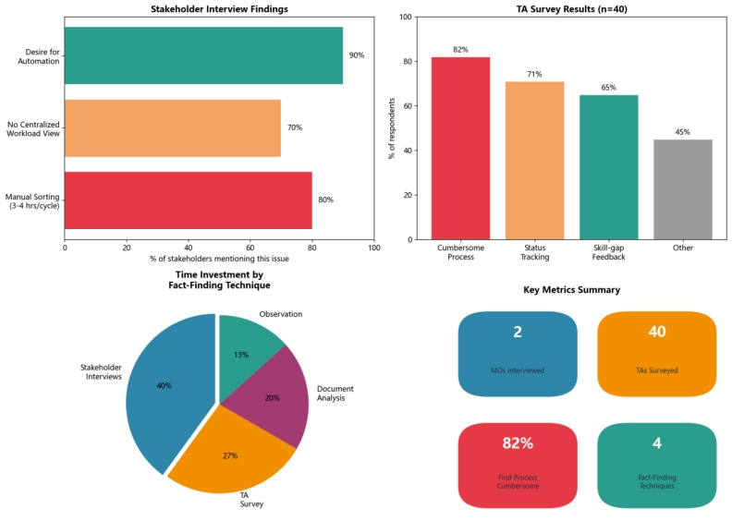
Figure A.1: Fact-Finding Summary Dashboard

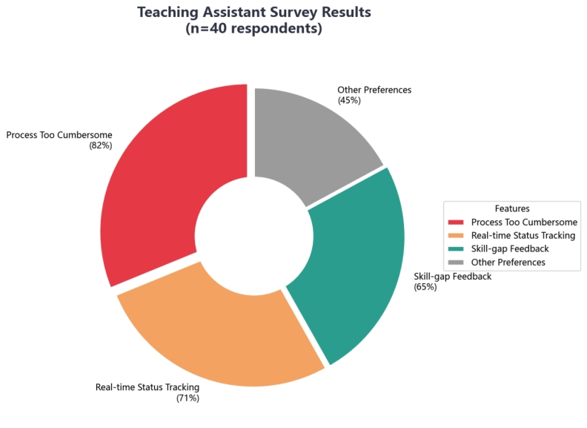
Figure A.2: TA Survey Results (n=40)

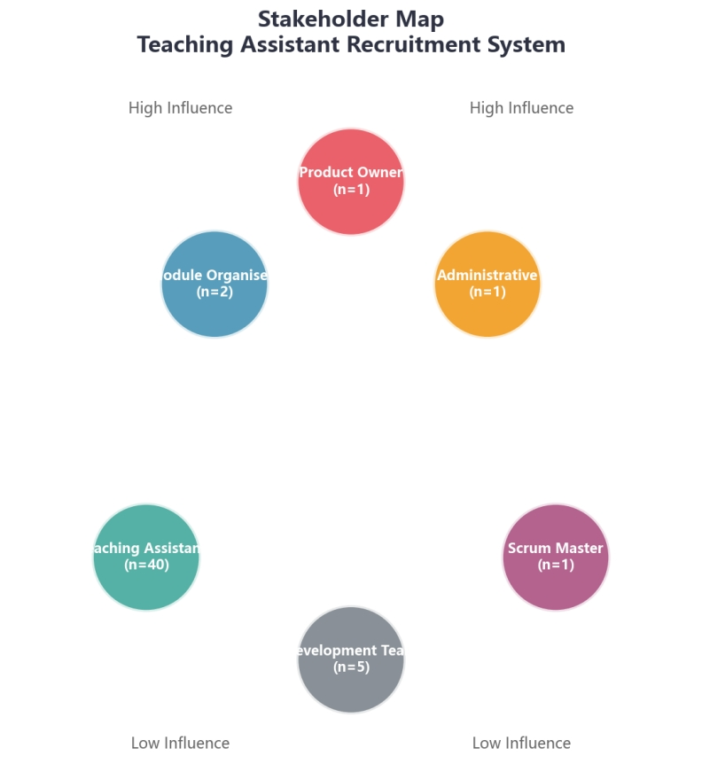
Figure A.3: Stakeholder Map

Appendix B: Process and Data Models
System architecture and data model documentation.
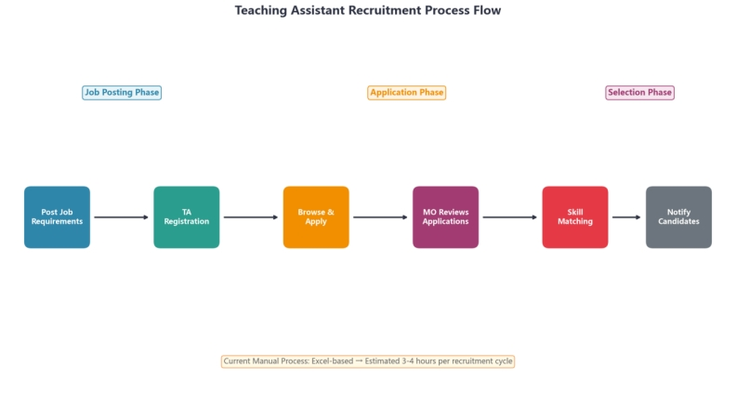
Figure B.1: TA Recruitment Process Flow

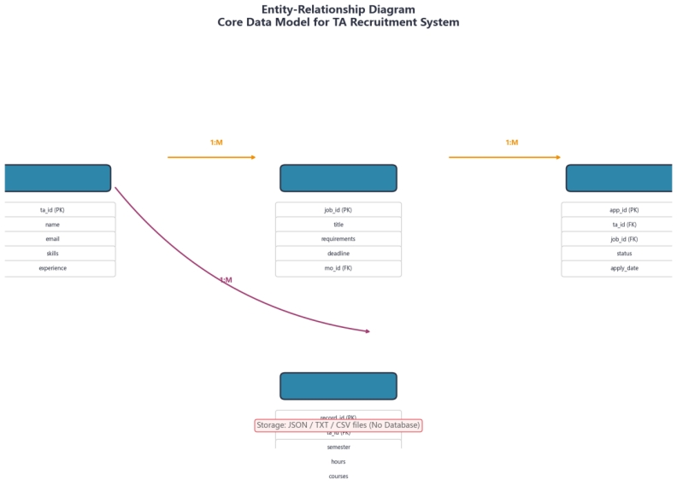
Figure B.2: Entity-Relationship Data Model

Appendix C: Sprint Planning Details
Visual representations of sprint planning and estimation.
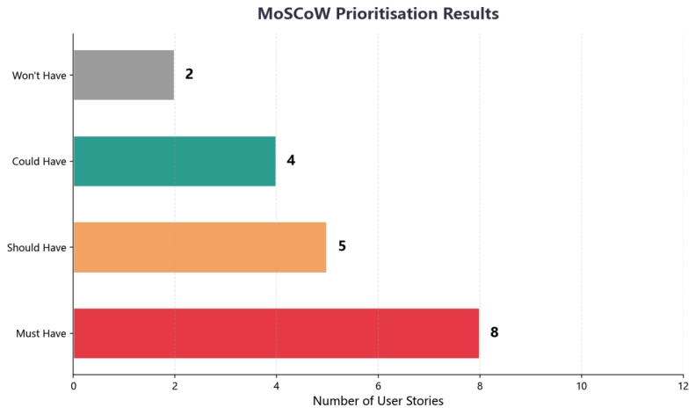
Figure C.1: MoSCoW Prioritisation Distribution

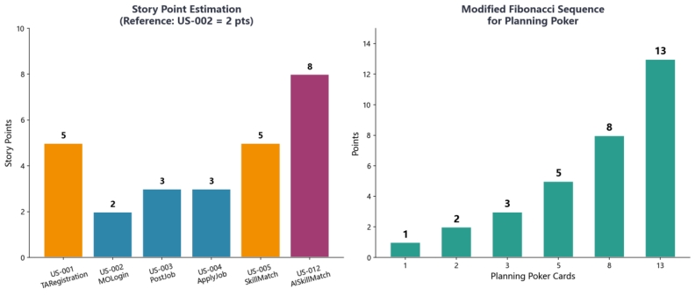
Figure C.2: Story Point Estimation (Planning Poker)

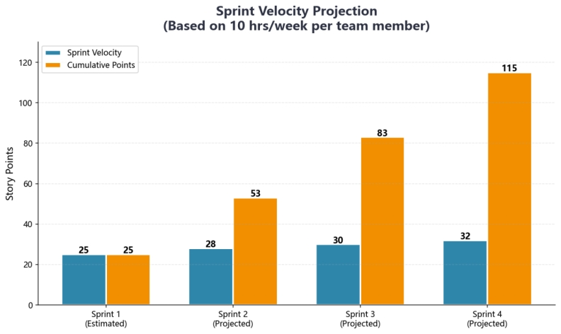
Figure C.3: Sprint Velocity Projection

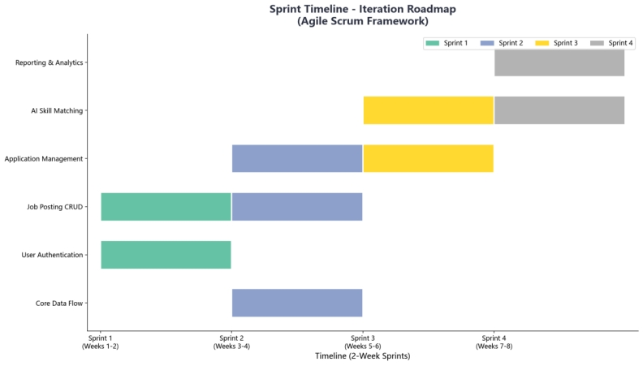
Figure C.4: Iteration Roadmap Timeline

