Assumptions of power flow model

Which components of power grids are considered?
- plants
- substations (buses)
- hypothetical transformers. OSM only include very few transformers, therefore, here we consider hypothetical transformers on the substations that carry multiple voltage level transmission lines.
- high-voltage transmission lines (110, 220, and 500 kV)

Substations
- Different consumers require different voltages. For example, industrial plants may require voltage to be delivered at 26, 69, or 138 kV, depending on the application of the plant (transmission/sub-transmission consumer). Large office buildings and hospitals will require lower voltages (13 or 4 kV, primary consumer). They are both business consumers. By the time we reach the general consumer living at home, they may require voltages of 380 to 40 volts (secondary consumer). This is residential consumer.

There are three overarching technical goals that engineers use to design and maintain the power grid:
- Power quality: the electrical devices and equipment are designed assuming that the power coming from grid that the voltage and frequency are correct and stable. Changes in the voltage can lead to brownouts or surges that damage connected equipment. All those generators connected provide momentum that smooths out the ripples and spikes that can occur from equipment faults or quickly changing electrical loads.
- Reliability: much of the grid’s complexity comes from how we manage faults and provide redundancy so that end-users are rarely faced with blackout conditions. Electricity can be rerouted when a piece of equipment is out of service.
- The supply meets the demand: Power production and consumption happens on a real-time basis. For the most part, electrical demand follows a consistent pattern, but factors like extreme weather can make it difficult to forecast. Grid operators balance demand by dispatching generation capacity in real time.
The second and third goal are exclusively considered, requiring the supply and demand statistics in normal days, then we make assumptions of electricity distribution in extreme weather days.

Electrical Busbar
The bus bar system consists of the isolator and the circuit breaker. On the occurrence of a fault, the circuit breaker is tripped off and the faulty section of the busbar is easily disconnected from the circuit.
Single Bus-Bar Arrangement (the simplest arrangement): The system has only one bus bar along with the switch. All the substation equipment like the transformer, generator, the feeder is connected to this bus bar only. The only disadvantage of such type of arrangement is that the complete supply is disturbed on the occurrence of the fault.

Resources:
https://www.youtube.com/watch?v=v1BMWczn7JM&ab_channel=PracticalEngineering
https://www.youtube.com/watch?v=fUWRyhsutL8&ab_channel=saVRee

Notes on Page 2 & 4 explains the reason that I choose Substations_KV and TransmissionLine_KV to create power network is they are more complete comparing to OSM and OpenInfraMap. They also include attributes of voltages. I created ‘power_grid.qgz’.

Illustrations of how hazards affect power network and business activities:

Elements in power flow model

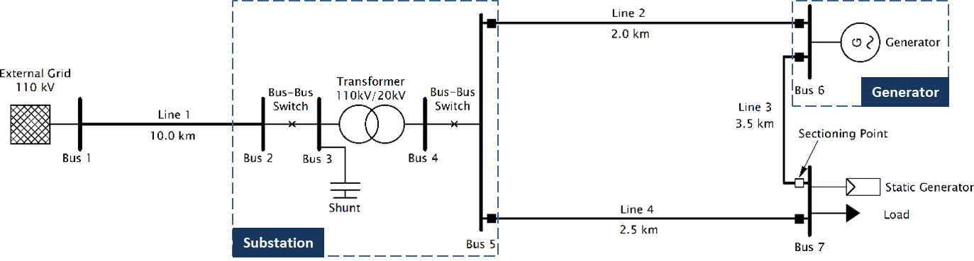
Figure 1 Example of power flow model

There are two types of bus construction. One type comprises generators and loads, with each element corresponding to one bus. As many buses are created as there are generators/loads. However, the problem lies in representing the connection (lines) between generators/loads and other parts of the grid (buses connecting other elements). The other type is substations. The number of buses required for a substation depends on whether it has switches and/or transformers.

Not all buses are connected by lines; for example, in Figure 1, Bus 2 and Bus 3 are connected by a switch, and Bus 3 and Bus 4 are connected by a transformer. They, along with lines, are all considered branches. If a substation includes switches and/or transformers, it will consist of more than two buses. In such cases, it's necessary to determine which two buses define the extent of the substation. Other elements connecting to this substation should be connected to these two buses. Generators, external grids, and loads are connected to the entire power grid by lines. The challenge remains in how to couple generators and loads into the network as mentioned in the section of Bus.

Lines represent physical connections; however, we lack information on which bus (substation) each generator/load connects to, nor do we possess geospatial data for those lines. Therefore, we integrate generators/loads into the network via switches (which still require buses to connect these elements). The geospatial information of the switch is unnecessary. Furthermore, controlling the switch's state enables us to regulate whether the element generates or consumes electricity.

Bus
- Busses are the nodes of the network that all other elements connect to.
- The substation busbar: typically, a set of three conductors, one for each phase of current. The substation is organized around the buses, and they are connected to incoming lines, transformers, protection equipment, switches, and the outgoing lines.
- Attributes:
  - vn_kv (voltage level, kilovolts). We use the actual voltage level indicated in the original OSM data or estimate it based on the number of cables and their respective voltage levels (summed).
  - geodata
  - type (Type of the bus. “n” - node, “b” – busbar (default), “m” – muff “b”).
  - zone (grid region). It can be used to group buses, for example network groups/regions.
  - in_service (True for in service or False for out of service).
  - max_vm_pu (Maximum bus voltage in p.u. - necessary for OPF)
  - min_vm_pu’ (Minimum bus voltage in p.u. - necessary for OPF)

Line
- Attributes:
  - from_bus, to_bus (BusID)
  - length_km (The line length in km)
  - std_type (Name of standard linetype). We use the pre-defined standard types provided by pandapower based on the voltage level of each line.
  - geodata
  - in_service
- Defining a line with length zero leads to a division by zero in the power flow and is therefore not allowed. Lines with a very low impedance might lead to convergence problems in the power flow. For the same reason, if you want to directly connect two buses, please use the switch element instead of a line with a small impedance!
- Pandapower assumes that the nominal voltage of ‘from’ bus and ‘to’ bus are equal, which means it does not support lines that connect different voltage levels. In the power grids we developed, we separate substations with different voltage levels into corresponding numbers of buses. For example, if a substation connects multiple lines with 110kV and 220kV, we separate it into two buses: one with 110kV and the other with 220kV, and add a transformer to it.

Switch
- necessary or optional???
- If a connection between a load and its power supply infrastructure is disrupted due to the influence of hazard/cascading failure, it can be considered as switching the switch position from closed=True to closed=False.
- Attributes:
  - et (element type: “b” = switch between two buses, “l” = switch between bus and line, “t” = switch between bus and transformer, “t3” = switch between bus and transformer3w).
  - closed (switch position: False = open, True = closed).
  - type (indicates the type of switch: “LS” = Load Switch, “CB” = Circuit Breaker, “LBS” = Load Break Switch or “DS” = Disconnecting Switch).

Load
- For a load, if the blackout is directly caused by a hazard, the attribute value of 'in_service' is changed from True to False; whereas indirect influence is controlled by a switch determining whether to cut off power.
- Attributes:
  - bus (the BusID to which the load is connected)
  - p_mw (the active power of the load): estimated by electricity demand.
  - q_mvar (the reactive power of the load): estimated by electricity demand.
  - in_service

Transformer
- Types
  - Two-winding transformer (net.trafo)
  - Three-winding transformer (net.trafo3w)
    - In the Substations_KV dataset, substations identified by asset_id 318, 594, and 397 could be configured as three-winding transformers.
    - Three-winding transformer loading cannot yet be constrained with the optimal power flow.
    - Note that three-winding transformers are modelled by three two-winding transformers connected in a Y-configuration, with an auxiliary bus in the center. Is this auxiliary bus automatically created????
- Where to add transformers?
  - Assuming a substation connecting lines with different voltage has only one transformer.
  - at the plant, transformers boost the voltage to minimize losses within lines.
Add transformers between plants and substations.
  - More energy customers are served from feeder lines that carry power from substations. From feeders, smaller transformers step down voltage to its final level for different users.
  - Add transformers surrounding consumers. how to define the service area of these transformers?
- Attributes:
  - hv_bus (The bus on the high-voltage side on which the transformer will be connected to).
  - lv_bus (The bus on the low-voltage side on which the transformer will be connected to).
  - mv_bus (The medium voltage bus on which the transformer will be connected to). This attribute is ONLY FOR THREE-WINDING TRANSFORMER.
We could use the get_element_index() function from the pandapower toolbox to find the bus indices of the buses with these names and create a transformer by directly specifying the parameters.
  - std_type (pre-defined in standard_linetype or customized std_type made using create_std_type())

Static generator
- PQ-bus
- Static generator element is modelled as constant generation without voltage control
- gen, sgen and ext_grid in the grid are modelled in the generator system! If you want to model the generation of power, you must assign a positive active power to the generator.
- Attributes:
  - bus
  - p_mv (the active power of the static generator, positive for generation): estimated by electricity generation data.
  - in_service
- A generator is modeled as a complex power injection at a specific bus (MATPOWER).

Generator
- modelled as voltage-controlled PV-bus.

External grid
- External grids represent the higher-level power grid connection and are modelled as the slack bus in the power flow calculation.
- The slack bus is a fictional concept in load flow studies and arises because the I²R losses of the system are not known accurately in advance for the load flow calculation. Therefore, the total injected power cannot be specified at every bus. The phase angle of the voltage at the slack bus is usually taken as reference or zero.
- How to choose slack bus to connect external grid?
  - From what above it results that the selection of the slack bus is not so important for most of the network contingencies. For extreme contingencies what mainly matters is the dynamic behavior of the system. The final state of the system (without cascading events) is hardly described by a simple load-flow with fixed power injections and a slack bus. However, this model will alert on possible severe contingencies without pretending to accurately simulate the consequences of the contingency.
  - Generally, the bus with largest generator is considered a slack bus.
  - The slack bus is a fictitious bus used to balance difference in total generation and total load to solve power flow problem. In general, any generation bus in the system can be selected as a slack bus, but normally the bus of the largest generator is used as a slack bus.
  - A slack bus can have load on it because in real systems it is actually the bus of a power plant, which can have its own load.
  - At slack bus, the per-unit (pu) value is defined as the nominal value divided by the base value. This is a commonly used numerical notation method in power system analysis and engineering calculations, representing the relative values of various physical quantities and parameters. System parameters (such as voltage, current, impedance, etc.) are converted into ratios relative to a base value. The main purpose of this conversion is to simplify power system calculations and analysis, especially in multi-voltage level systems.
  - distributed generators and slack nodes??????
  - where can either send excess power or receive supplemental power as needed??

Basic standard types
Lines and transformers
☐ Create custom types based on standard types/test cases for lines and transformers

Networks
- CIGRE Networks, MV Oberrhein (including geographical information)
- Test cases
  - Case 89pegase
  - Case 118
  - Case case_illinois200
  - Case 2869pegase and 9241pegase: represent a part of the European high voltage transmission network.
  - Case 3120sp: This case represents the Polish 400, 220 and 110 kV networks during summer 2008 morning peak conditions.
  - Case 1888rte, 2848rte, 6470rte, 6495rt, and 6515rte: French very high voltage and high voltage transmission network.
  - Case GB network: represents detailed model of electricity transmission network of Great Britian. It consists of 2224 nodes, 3207 branches and 394 generators.
  - Case Iceland: represents electricity transmission network of Iceland. It consists of 118 nodes, 206 branches and 35 generators.

Questions:
- How to determine which two substations a line connects?
GitHub repo ‘trails’, simplify.py (network representation)
- How are substations and loads interconnected?
  - We only have high-voltage transmission networks above 110kV, requiring a step-down process to supply electricity to loads.
  - There exists no direct physical linkage between substations and loads.
- How to define external grid?
Refs | Type | Description | Assumption/settings
Ouyang et al. (2009) | structural efficiency | Vulnerability can be described as the decrease of system efficiency after attack. To analyze structural vulnerability, infrastructure topologies are only considered, and the most important thing is to determine what are used to describe structural efficiency. | average reciprocal shortest path lengths (Crucitti et al., 2003)
 | DC power flow model | describe the transport of electrical flow in the network | - two types of nodes in the electrical network: generator nodes (produce power) and load nodes (offer power to other systems). Nodes are characterized by input power $P_{i}$, positive to generator nodes, negative to load nodes.  - Lines are characterized by the power flow through the lines $F_{ij}$, the reactance of the line $x_{ij}$.  - The redispatch is formulated in a conventional way as an optimization to minimize the change in generation or load shed subject to the system constraints.  - In this model, we assume all generators run at the same cost and all loads have the same priority to be served  -  - assume all power generators work in normal states and the power injections for all generators and all power load nodes are respectively 4 MPW and 8/13 MPW. The maximum generator power and maximum power flow through lines are assumed to be the products of a tolerant parameter (tp) and their normal values.
 | interdependencies | between power network and gas network | - If the power supply of one power load node is less than ps fraction of its normal power, the gas pipelines that are served by that power node will be closed.  - When the gas node for power production has none gas, the corresponding gas-fired generator will be removed and the power injections will be redispatched again so that some power nodes will be not able to dispatch sufficient power, further some gas nodes will be closed and then the efficiencies of both the two networks will decrease.  - “interdependent effect”:  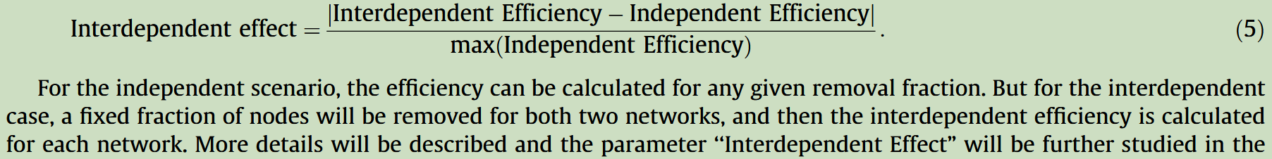  - power generators are independent  - if there is none of path from any power generators to a power load node, this power load node will be removed and the corresponding gas node will be also closed due to lack of power supply.
Brunner et al. (2024) | network analysis |  | - we look at the worst-case scenario of exposure and simply use a single step fragility curve function, where any exposure means the particular element has failed. With imminent coastal flooding, these systems would be expected to be turned off before they are exposed or at the moment they become exposed, and households will be evacuated if any flooding has occurred. Therefore, while it is possible to incorporate partial functionality, this is not entirely insightful for this case study.  - for this case study, it is assumed that if a node has any depth of flooding, it is at risk of failing. In practice, this could result from an operator safely shutting it off or from loss of service due to water exposure.  - based on adjacency matrix  - the system is represented by a directed acyclic graph.  - The vulnerability of the links are not considered in this study, primarily for the reason that for coastal flooding, the overhead power lines and the underground pipelines are not often the critical points of failure.  - This model uses a network topology-based approach, and thus does not consider the specific flows throughout the systems.  - The step of identifying connected vertices and setting the dependent vertices’ matrix values to 0 is repeated with the disconnected vertices to capture the successive indirect impacts until there are no more dependencies. The vertices that have lost connection are recorded, so that indirect impacts can be mapped.  - end degree: the total number of end users connected to a particular vertex in the network. This is a helpful metric to identify critical nodes from an end-user perspective.  - The connections among the utilities and end user nodes were primarily automated based on closest proximity by road network distance, since most urban utility infrastructure is underneath or alongside roads.

Business activities
The industry’s share is by far the largest, varying from 55% in 2020 to 63% in 2040 (EREA & DEA 2022).

Search strings for Places API

C3: Food, beverages, and tobacco
This sector refers to the processing of food, beverages and tobacco products (NACE Divisions 15 and 16). Importantly, it excludes the agricultural activities of growing, farming, rearing and hunting and fishing. Given that a number of products, such as wine, olive oil, eggs and cheese are also sold directly by agricultural holdings and recorded in part, therefore, as an agricultural activity when own-produced, this distinction is important to bear in mind.

C6: Wood and products of wood and cork
Except furniture.
The wood and wood products manufacturing sector includes the first processing stages of sawmilling and planning of wood and the downstream activity of the manufacture of products of wood, cork, straw and plaiting materials.

C8: Coke, refined petroleum, and nuclear fuel
The manufacture of petroleum products is characterized by the production of the following products:
- Fuels (automotive petrol and diesel fuel, aviation fuel, liquid petroleum gases – LPG
- Heating oils (heavy gas heating oils distinguished according to the content of sulfur).
- Lubricating oils (motor, transmission, industrial, and other oils).
- Asphalt and asphalt products (road, insulation, and construction asphalts, modified asphalts, cements, emulsions, suspensions, and other products).
- Petrochemical materials (LPG, primary petroleum intermediate fractions, hydro–crack, and others)
- Other raw materials, prefabricates, and low–tonnage petroleum products (process oils, paraffins, waxes, petroleum coke, solvents
- Intermediate products (of the petrol or gas oil character) for the manufacture of alternative automotive fuels (e.g. mixtures of biofuels with these products and heating oils)
- biofuels (mixture diesel fuel – diesel fuel with addition of methyl esters of rapeseed oils (MERO)
- other products (e.g. LPG for heating and others).

C9: Chemical and chemical products
Polymer Asia is a company developing masterbatch and compound products to supply the plastic industry with a variety of applications including packaging, electrical electronics, etc.
A masterbatch is a concentrated mixture of pigments and / or additives blended and extruded together in a carrier matrix, such as resin, wax, or a specific polymer, that is used to add these mixed additives to a final plastic product.

Chemical industry: it converts raw materials (oil, natural gas, air, water, metals, and minerals) into commodity chemicals for industrial and consumer products. It includes industries for petrochemicals such as polymers for plastics and synthetic fibers; inorganic chemicals such as acids and alkalis; agricultural chemicals such as fertilizers, pesticides and herbicides; and other categories such as industrial gases, speciality chemicals and pharmaceuticals.

C10: Rubber and plastics
The rubber sector (NACE Group 25.1) has three distinct parts: the manufacture of rubber tires and tubes; the retreading and rebuilding of rubber tires; and the manufacture of other rubber products.
The manufacture of plastic products (NACE Group 25.2) includes plastic sheets, pipes and tubes; plastic packaging goods (such as bags, containers and bottles); plastic products for the construction sector (such as doors, frames and baths); and other plastic products (such as insulating and lighting fittings). Note that the manufacture of plastic games, toys, footwear, furniture and linoleum are not considered.

C11: Other nonmetallic minerals
Non-metallic mineral products comprise of the production of cement, ceramics, glass, and lime.
Concrete factory, Ready mix concrete supplier, Building materials supplier? (Concrete uses cement as one of its components)

C12: Basic metals and fabricated metals
The metals and metal products manufacturing sector are energy intensive.
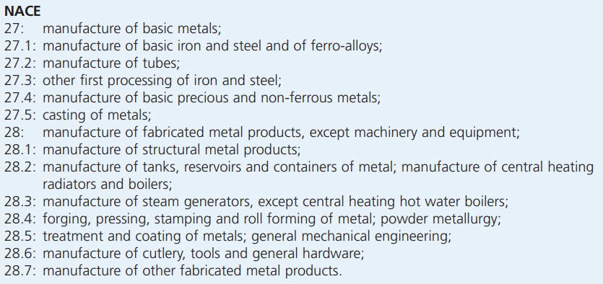

C13: Machinery, nec
This division includes the manufacture of machinery and equipment that act independently on materials either mechanically or thermally or perform operations on materials (such as handling, spraying, weighing or packing), including their mechanical components that produce and apply force, and any specially manufactured primary parts.

C14: Electrical and optical equipment
the manufacture of computers and office machinery (NACE Division 30); the manufacture of electrical machinery and equipment (NACE Division 31); the manufacture of radio, television and communication equipment (NACE Division 32); and instrument engineering (NACE Division 33), which includes the manufacture of medical, precision and optical equipment.
The electrical machinery and optical equipment sector are an important and strategic part of Europe’s manufacturing sector, producing a wide range of mostly high-technology products (for example, computers, switchgears or semi-conductors).

C15: Transport equipment
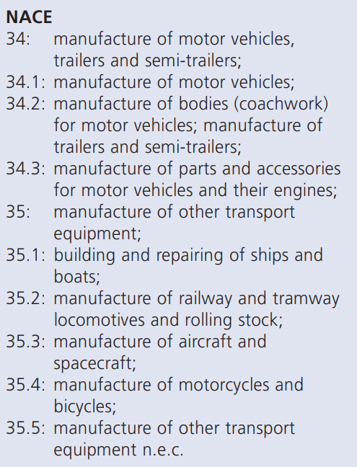

C16: Manufacturing, nec; recycling

Experiments
I roughly examined the extracted points and the distribution of industrial areas to determine: first, check whether the extracted points are correct; second, some large industrial areas have not been extracted any points, confirming whether such industrial areas indeed contain the search strings listed in the input. If they do not, then we need to identify which search strings we have missed.
I roughly examined the extracted points and the distribution of industrial areas to determine the following: first, to check whether the extracted points are correct; second, to identify large industrial areas that have not had any points extracted. For these areas, we need to confirm whether they indeed contain the search strings listed in the input. If they do not, we need to identify which search strings we have missed.

Coupling of power grid and business dependencies

Question: How do we couple business with its power supplier? In this case, how are the businesses are connected to the power grids?

The common approach is using Voronoi approach, where we fix a substation and find out which businesses lie within its service area. This approach is from the perspective of providers/suppliers. The second approach, on the contrary, is from the perspective of users. We fix the location of business and search the substations around it and connect the substation to this business based on distance rank.

We can even extend the second approach to a probabilistic-based method. We don’t know how substations and businesses are connected, but there are high chances that business will be connected to a closest substation, and similarly, it being connected to a farther substation is less likely.

In addition, we can also consider other dimensions, which are hard to be included in Voronoi approach. Capacity of substations are different; some are larger than others, so they are capable of providing more electricity power. We could consider capacity as a weight, then even though the second ranking closest substation is farther away, it may still be connected to the business because the first ranking small substation is already to full capacity.

There are certain conditions that more or less likely to be connected to one substation of the other, for example, geography. We could consider administrative boundaries/providers’ service areas. For example, we assume that there is a business lies on the border of service areas between two regional providers A and B, relying on provider A. Even if the business is closer to a substation within the provider B, it should still get connected to a farther substation within provider A. On an international level, national boundaries are the ones, but not sure provincial boundaries would be a limit. In some cases, like the US, Texas will not be connected to the rest of the country because they have their own grid.

Therefore, we propose a novel probability-based approach for coupling substations and businesses from the perspective of both suppliers and users. The likelihood of a business being connected to a certain substation is determined by both the distance and the capacity of the substations. (This relationship can be visualized as a multidimensional curve with distance on the x-axis, capacity on the y-axis, and probability on the z-axis, and represented as a surface in a graphical representation.)

- switch
- Reroute: If the providers indeed need to bump up capacity of the grid and start to use those redundancy lines in some cases. They must have those empty lines (or normal lines are being used, but not fully utilized) and hook it up to different substation.
- Probability distribution

Theoretically they both are doing a similar function that mapping the businesses and substations that are geometrically close to each other. But the second approach has more advantages:
- It will give us more flexibility if we want to model the redundant leaves in the power grid. For example, for a business, if its closest substation breaks down, it still can use reroute technique to get a supply from other substations.
- If there is an x percentage probability that you're connected to these and these things, like sort of a cumulative thing, you can say if they're all three flooded, is also a 80% or so that you're being affected by that.

Find nearest five substations for each business and function it as a spatial tree. The algorithm will look up to the nearest substation. If it fails, it looks up to the second one, and so on.

Question:
- Is it possible for a business to get electricity from more than one substations?
- If the nearest substation is fully utilized and the provider must connect a new building to another substation, is there any principle for how to choose the substation?

Discussion:
- There might be something we can think about for certain industries. A large industry could have its own substation.
- Further explore, add the order of substations in which they were built, like the urban planning or so? Because it doesn't seem that it's very orderly how they plan to the network. For instance, if we want to rebalance or reroute, only the substations built after this year or the latest one within this area can be connected.

Required data
- Locations of businesses and substations
- Capacity of substations
  - OSM: capacity of substations and voltage-level of transmission lines are incomplete.
- How to map energy use and substation capacity?
  - Measurement of energy use and substation capacity (gigawatts/kilowatts). Translate a substation’s kilo voltage level to its yearly capacity?
  - Some industries report on their operational hours.
  - We know the sector of the point, the initial go maybe just spread that sector across all points, evenly or based on the size of the industrial areas.
- Business needs
  - Energy use in different companies/sectors: Some big companies would have to report their energy use and CO2 annually.
  - Split up the businesses into high/low voltage users. For example, water utilities are always connected to high voltage. So even if a low-voltage substation is the nearest one to a water utility, this utility can’t get the energy from there anyway.
  - Share per sector.
  - How to split energy use per sector up across the businesses?

References
Brunner, L. G., R. A. M. Peer, C. Zorn, R. Paulik, and T. M. Logan. 2024. “Understanding Cascading Risks through Real-World Interdependent Urban Infrastructure.” Reliability Engineering & System Safety 241 (January):109653. https://doi.org/10.1016/j.ress.2023.109653.
EREA & DEA. 2022. “Viet Nam Energy Outlook Report 2021.”
Ouyang, Min, Liu Hong, Zi-Jun Mao, Ming-Hui Yu, and Fei Qi. 2009. “A Methodological Approach to Analyze Vulnerability of Interdependent Infrastructures.” Simulation Modelling Practice and Theory 17 (5): 817–28. https://doi.org/10.1016/j.simpat.2009.02.001.

