Programming&Org Team

Team Coordinator: Mengqi Zhao  
Team Members: Ryan Salter, Sadath Alam, Parsa Sarirafraz

developing soft and parallel programming skills using Project-based learning

Spring 2019

**Planning and Scheduling:**

|  |  |  |  |  |  |  |
| --- | --- | --- | --- | --- | --- | --- |
| Assignee Name | Email | Task | Duration (hours) | Dependency | Due Date | Notes |
| Mengqi Zhao | mzhao7@student.gsu.edu | Planning, Scheduling, and Raspberry Pi Setup |  | None |  |  |
| Ryan Salter | rsalter2@student.gsu.edu | Technical Writing (report) | 3 Hours | Slack, Github, Teamwork Basics, Raspberry Pi Installation, ARM Assembly Programming | 02/08/2019 |  |
| Sadath Alam | salam12@student.gsu.edu | Teamwork Basics and ARM Assembly Programming |  | Raspberry Pi Setup, Planning and Scheduling |  |  |
| Parsa Sarirafraz | psarirafraz1@student.gsu.edu | Collaboration Technology and Video Editing |  | None |  |  |

**Teamwork Basics:**

These are the answers for the questions from the Teamwork Basics document.

1. To get the task done, we should delegate jobs to individual students so we can complete all tasks in parallel.
2. Work norms
   1. How will work be distributed?
      1. Delegated tasks to individual team members (except Rasberry Pi since we’re doing that together)
   2. Who will set deadlines?
      1. The team coordinator, Mengqi Zhao.
   3. What happens if someone doesn’t follow through on his/her commitment (for example, misses a deadline)?
      1. If there is still time before submission, an in-person meeting is needed to ensure everything gets done on time. If the deadline is submission time, whatever credit the rest of the team thinks they deserve is what they get.
   4. How will work be reviewed?
      1. The report will be put together by me and sent to the Team Coordinator for review to ensure our submission quality is on point.
   5. What happens if people have different opinions about the quality of work?
      1. Help them understand that just because it works doesn’t mean you’re finished.
   6. What happens if people have different work habits?
      1. As long as everything gets in the report as needed before the submission deadline, it’ll be okay. Though of course it still has to be quality work.
3. Facilitator Norms
   1. Will you use a facilitator?
      1. No, all of us are responsible for making sure our teammates complete their assigned task.
   2. How will the facilitator be chosen?
      1. Whoever needs the data to complete the report is who I believe should be the facilitator.
   3. What are the responsibilities of the facilitator?
      1. To ensure that the project runs smoothly and efficiently.
4. Communication Norms
   1. When should communication take place and through what medium?
      1. Communication should take place through Slack whenever data needs to be transferred to another team member, or for any major problems that come up.
5. Handling difficult behavior:
   1. Too quiet
      1. Get the quiet person to express their ideas about the project and provide constructive criticism when their feedback toward the group leads to a positive result. Also get to know them!
   2. Argues
      1. Note whether or not the person’s criticism is constructive or destructive toward the ultimate goal of the group. As long as their criticism isn’t detrimental to the group, their feedback could be valuable to the group project and he/she could point out problems we haven’t thought of yet.
6. When making decisions, If the team is having trouble reaching a consensus, what should you do?
   1. Start narrowing down ideas one by one until we have the most optimal solution for our project. That means conceding if necessary.
7. What should you do if a person may reach a decision more quickly than others and pressure people to move on before it is a good idea to do so?
   1. Make an effort to “slow their roll” so to say and explain that decisions in a group require 4 unanimous, sound minds to make the decision, otherwise equilibrium is lost, and efficiency may drop.
8. What happens if most people on the team want to get an “A” on the assignment, but another person decides that a “B” will be acceptable?
   1. Explain to them the benefits of getting an “A” (i.e. safety net in case the next project doesn’t go well, 4.0 better than 3.0, etc.)

**Raspberry Pi Installation and ARM Assembly Programming:**

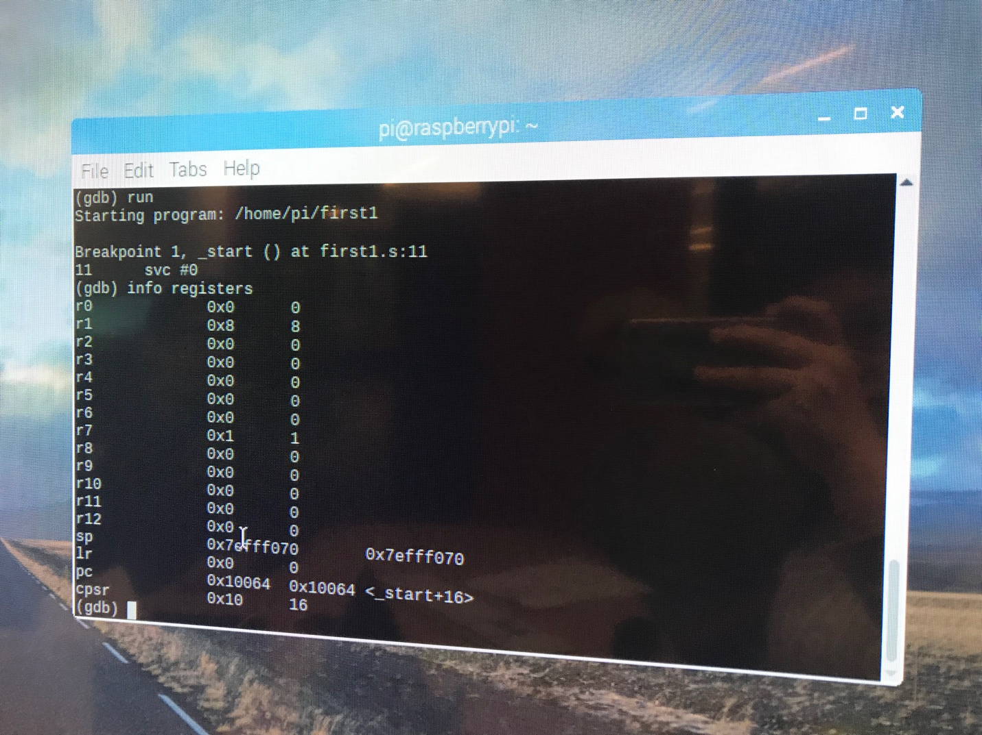Mengqi Zhao PLEASE INSERT CODE SNIPPETS AND EXPLANATIONS.

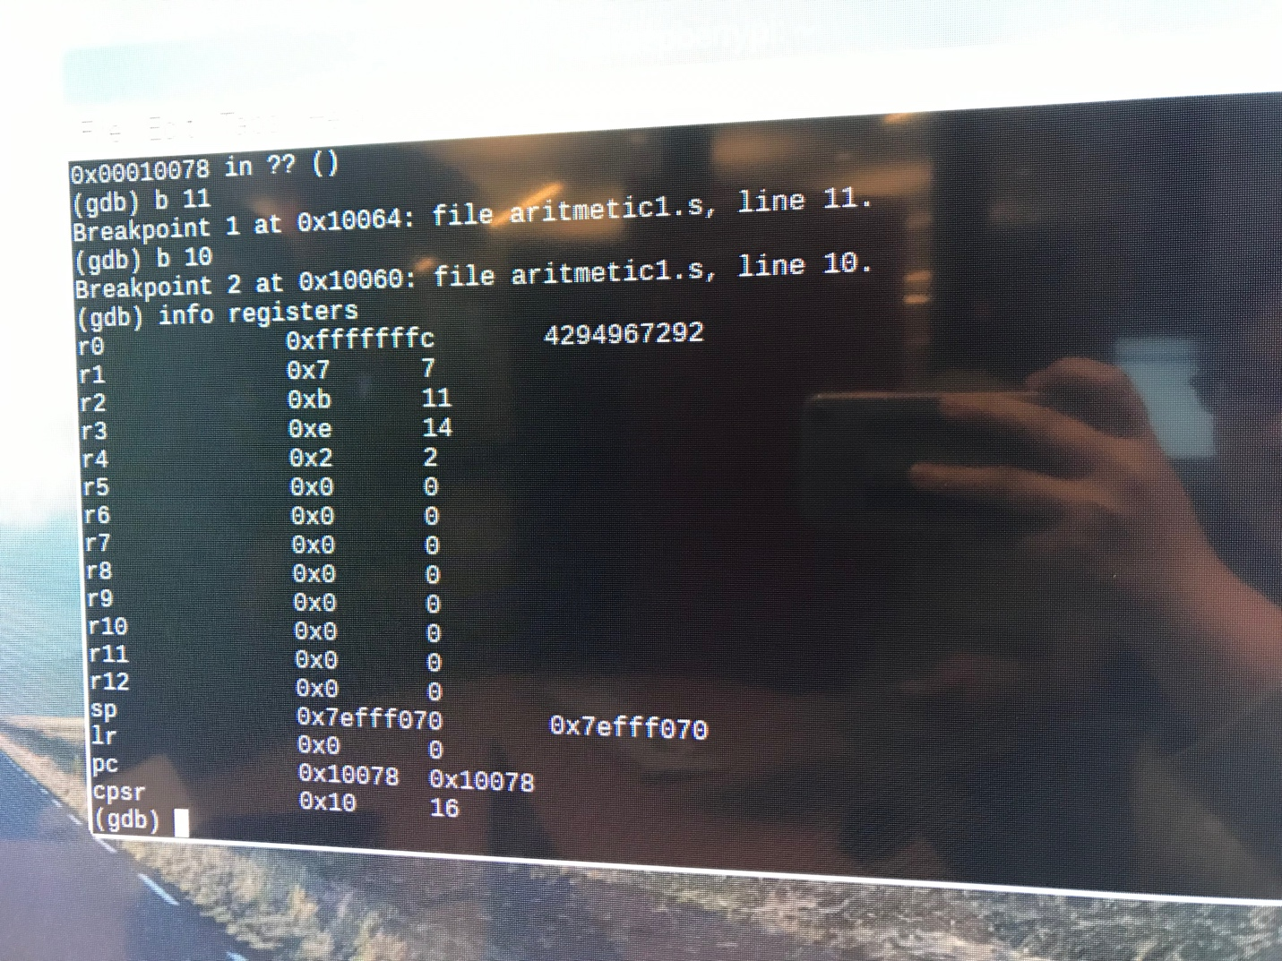

**Appendix:**

Slack: <https://programming-org-team.slack.com/messages/CFSGXRH1R/>

Github: <https://github.com/orgs/programming-orgteam/dashboard>

Youtube: <insert video link here>

Screenshots:

