Title: Lockdown or Fear, Which is the Major Force of Mobility Decline during Covid-19?

Author: Mengshan Zhao

Research Object

I want to dig into a recently concerned question: Which is the major force of citizen’s mobility decrease during the Covid-19? Is that due to the lockdown policy or the social awareness?

During the literature review, I find there are generally two directions for Covid-19 studies: The first one looks at how the disease or some policies (lockdown or CARES, for example) influence people's behaviors, while the second orientation suggests their direct economic impact. My research is closer to the first type.

There have been some papers discussing the impact of social awareness and lockdown policy: Austan Goolsbee and Chad Syverson (2020) argued that the lockdown policy can only explain a 7 percent decline in consumption flow, while the majority decrease should be due to the increasing social awareness. Goldfarb and Tucker (2020) applied retail activity data to evaluate citizen’s mobility. What’s more, studies on the social network also support that the social awareness is playing a big role in human behaviors. For example, Bailey, M, R Cao, T Kuchler and J Stroebel (2018a) found that the social network will influence people’s decisions on housing. In this research, I want to measure the real impact on citizen’s mobility by the sudden lockdown policy and the gradual awareness employing time-series datasets. Although the lockdown policy also generated a social awareness impact, the impact will show after its announce, which is normally earlier than its delivered.

Data Description

In this research, I combined two major datasets: The first one is the mobility data collected by Descartes Labs.[1] They collected anonymous locations data from mobile device using cloud computing strategy, then computed the daily mobility of citizens living in each county in the US. It is worthy noticing that the data in the county level is important as the detailed lockdown dates are varied between counties. Some counties began lockdown before the state government’s decision. The time range of the mobility dataset is from March first to the current, and they keep updating.

The citizen’s mobility is calculated in the following way: According to their explanation, the mobile device will automatically report a new position by its latitude, longitude and an estimate of accuracy with other identified information like time and its id. The researchers will collect the data once a day, which generally around 100GB, and use an algorithm to normalize the data. After the data clearing, they obtained the max-distance mobility per individual within the given county and select the median of the max-distance mobility-- m50 as the county’s mobility. What’s more, they use a normalization function to normalize m50. The normalization function is as followed:

$$m{50}_{index}=100\frac{m50}{m50_norm}$$

Where m50 stands for the median value of the max-distance mobility in a given region and m50_norm is the standard level of mobility in that region, defined as the median m50 from an earlier period of the region.

Fig. 1 and 2 are two sample graphs of the mobility dataset. Fig.1 is the change of mobility of six different states, and the Fig.2 shows the trend of mobility of different counties in Wisconsin state during March. We can see on the state level, the change pattern is very similar. Moreover, there is a decline at the beginning of April, when most of states begin the stay at home policy. However, we can still find the gap in the county level.

Fig 3 is a histogram of one state, Alabama, we can see that after the normalization process, the most frequent value of m50_index is around [80,90].

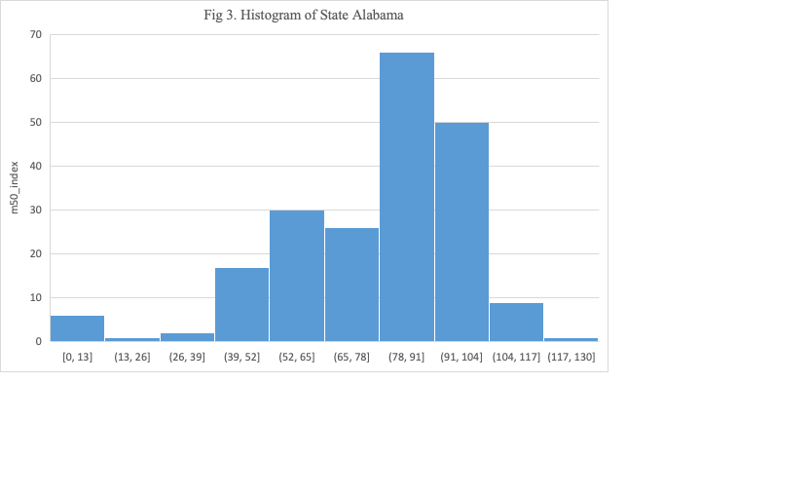

The second dataset is the Covid-19 twitter chatter dataset maintained by Georgia State University’s Panacea Lab.[2] This dataset tracked all the twitter and re-twitter that are relevant to Covid-19 from January, including all languages and nations. It included two versions of data, the first type is the whole dataset, and the second one is the “clean set” without all the retweeting. The second dataset is more helpful with the nature language processing (NLP) task. The researchers also collected the top 1000 words used each day from all twitters. Fig. 4 shows the trend of the number of twitters, and Fig.5 is the trend of the clean set.

Fig 6 shows a combination of the two datasets. The orange line is the mobility change of Wisconsin during March, and the blue line is the number of Twitter during that period. We can see there is a pattern that increasing in the number of Twitter leads to a decline in mobility.

There will be other county level datasets added as control variables. For instance, the specific date of county lockdown, detailed infected rate, mortality rate by county, GDP and other social figures of a region.

Reference:

Bailey, Michael, et al. "The economic effects of social networks: Evidence from the housing market." *Journal of Political Economy* 126.6 (2018): 2224-2276.

Baker, Scott R., et al. *Income, liquidity, and the consumption response to the 2020 economic stimulus payments*. No. w27097. National Bureau of Economic Research, 2020.

Goolsbee, Austan, and Chad Syverson. *Fear, lockdown, and diversion: Comparing drivers of pandemic economic decline 2020*. No. w27432. National Bureau of Economic Research, 2020.

Bartik, Alexander W., et al. *How are small businesses adjusting to covid-19? early evidence from a survey*. No. w26989. National Bureau of Economic Research, 2020.

Jordà, Òscar, Sanjay R. Singh, and Alan M. Taylor. *Longer-run economic consequences of pandemics*. No. w26934. National Bureau of Economic Research, 2020.

Kaplan, Greg, Benjamin Moll, and Giovanni L. Violante. *The Great Lockdown and the Big Stimulus: Tracing the Pandemic Possibility Frontier for the US*. No. w27794. National Bureau of Economic Research, 2020.

Baker, Scott R., et al. *How does household spending respond to an epidemic? consumption during the 2020 covid-19 pandemic*. No. w26949. National Bureau of Economic Research, 2020.

Hausman, Catherine, and David S. Rapson. "Regression discontinuity in time: Considerations for empirical applications." *Annual Review of Resource Economics* 10 (2018): 533-552.

Goldfarb, Avi, and Catherine Tucker. *Which Retail Outlets Generate the Most Physical Interactions?*. No. w27042. National Bureau of Economic Research, 2020.

1. Link of their project: <https://github.com/descarteslabs/DL-COVID-19>
2. Link to their project: <http://www.panacealab.org/covid19/>