The import points of neural network

1 optimizers

Upload the optimizer

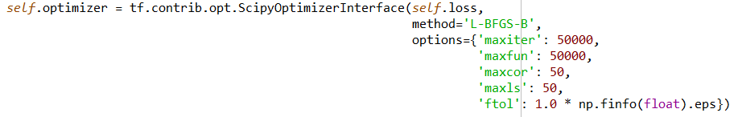



Use the optimizer

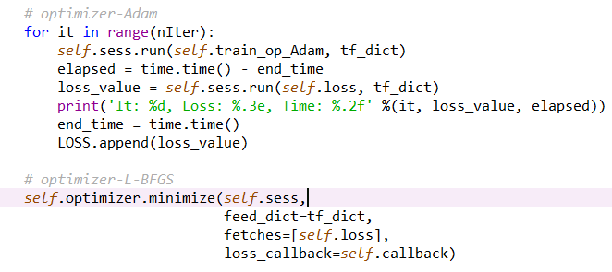

2 calculate the weights

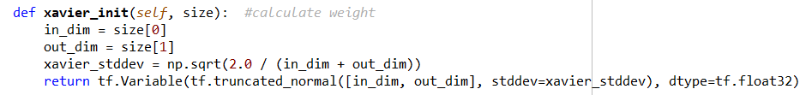

3 initial value

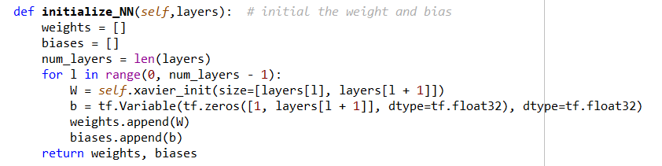

4 create network

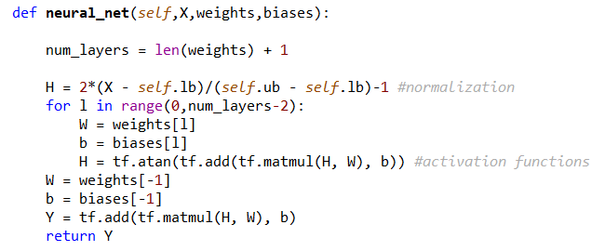

5 sampling method



6 create the loss function

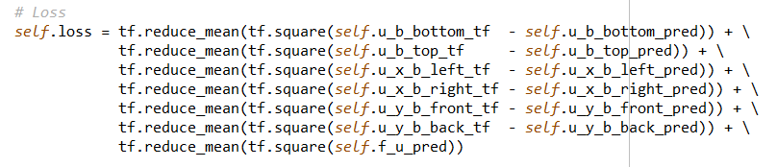

7 parameters of network

