

**Foshan University**

**课外实践任务报告**

**题 目：** **购物商城网站开发**

**学 院：**  **电子信息工程学院**

**班 级：** **16网络工程3**

**学 号：** **20160390332**

**学生姓名：** **蒙信亨**

**2018 年 7 月**

1. 设计任务

**1.1功能要求：**

1、用户登录以及退出功能

2、用户注册功能

3、根据物品类型查询商品

4、根据关键字查询商品

5、分页标签的使用

6、查看商品详情

7、加入商品到购物车

8、展示购物车以及删除购物车中的商品

9、下单功能

10、订单查询

可自行设计和完善功能。

**1.2 功能分类**

1）前台功能

|  |
| --- |
| 用户登录以及退出功能 |
| 用户注册功能 |
| 根据物品类型查询商品 |
| 根据关键字查询商品 |
| 分页标签的使用 |
| 查看商品详情 |
| 加入商品到购物车 |
| 展示购物车以及删除购物车中的商品 |
| 下单功能 |
| 订单查询 |

1. 后台功能

|  |
| --- |
| 商品管理（查看、编辑所有商品、商品资料搜索、添加商品） |
| 订单查询（包括查看、编辑所有订单） |
| 商品分类管理 |

|  |
| --- |
| 菜单导航 商品列表 |

1.3系统流程图

|  |
| --- |
| 商品详情 |

|  |
| --- |
| 进入主页面 |

|  |
| --- |
| 商品搜索 |

|  |
| --- |
| 加入购物车 |

|  |
| --- |
| 用户登录/注册登录 |

|  |
| --- |
| 生成订单 |

1. 主要程序设计

2.1 主页面展示

2.1.1 流程图

购物车

搜索框

Logo

登录、注册

Head

Main

商品列表

Banner

菜单导航

首页

版权块

Foot

2.1.2 调试及检测结果

（1）主页面展示：

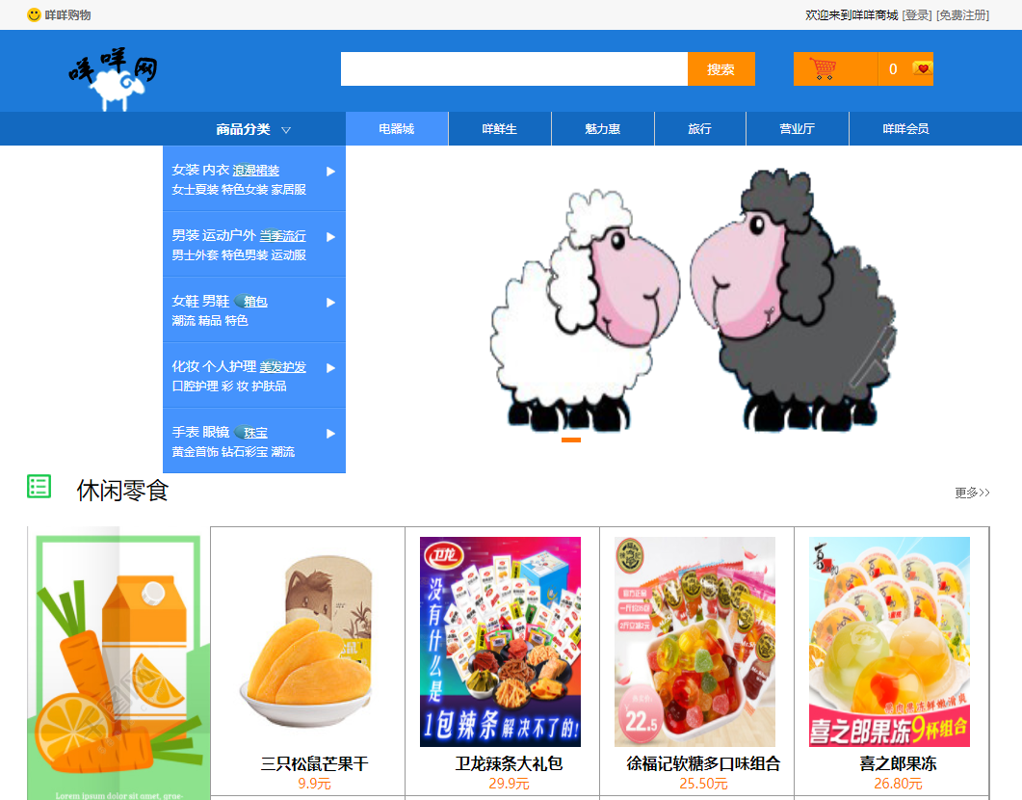

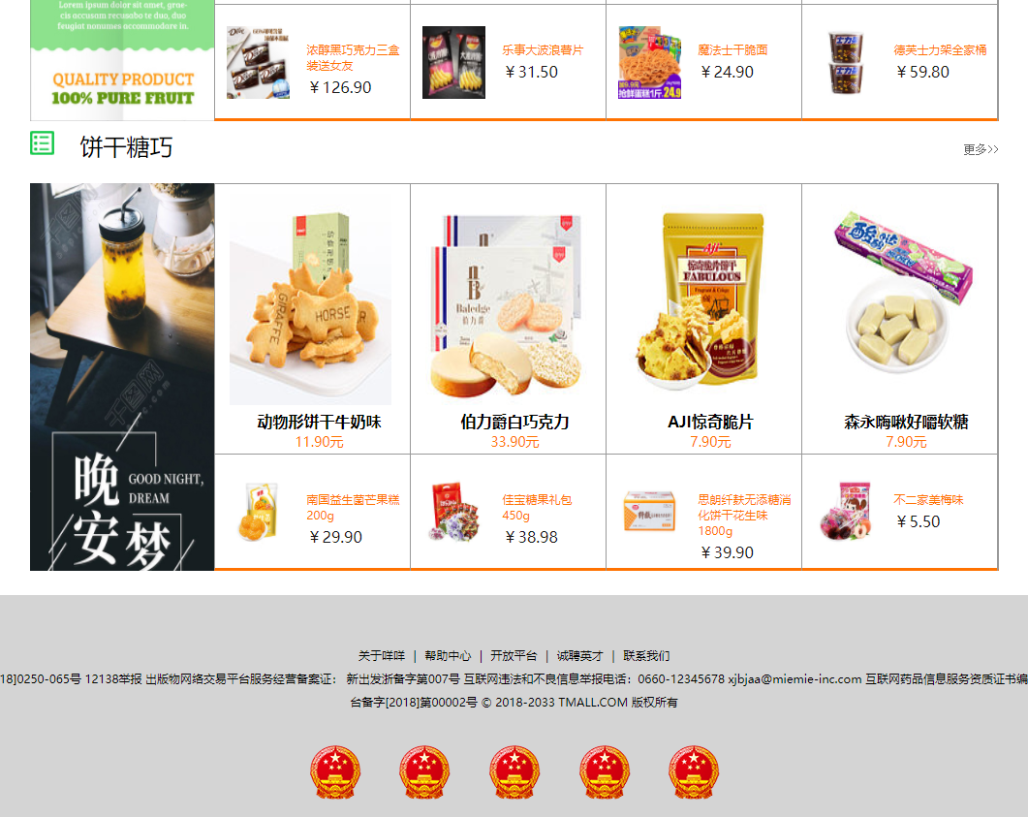

1. 菜单及导航功能：

1).鼠标指向上方导航列表，方框会变颜色



最左边方框为鼠标指向区域，颜色会变化。

2）.鼠标指向左边商品分类菜单，会弹出二级菜单列表。

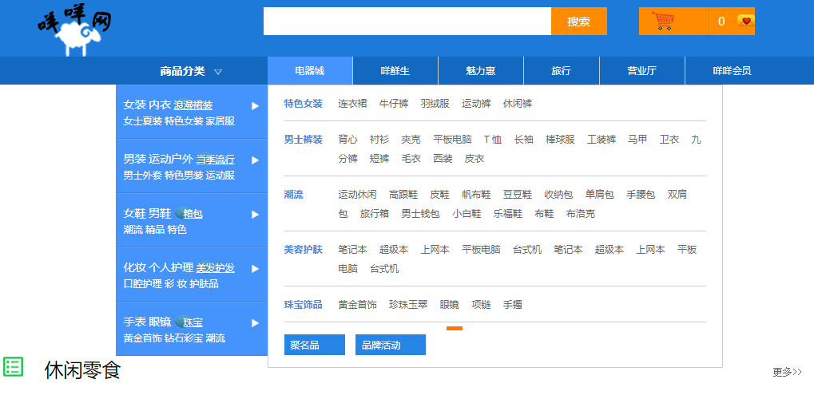

1. 点击商品分类栏目可进入商品分类选择界面。

（2）banger部分功能

点击banner图片下边的橙色条框，会从第一张图片变换到第二张图片。

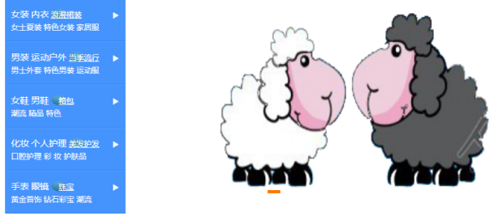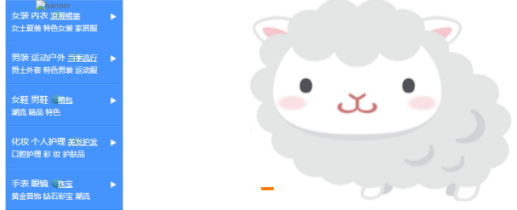

1. 购物车按钮

点击右上角的购物车图标可以进去购物车界面，查看购物车情况。

1. 商品列表

点击商品列表的商品会跳出商品详情页。

2.2 用户注册

2.2.1 流程图

账户名

设置密码

确认密码

邮箱

地址

提交

进入注册界面

2.2.2 调试及检测结果

（1）界面展示：

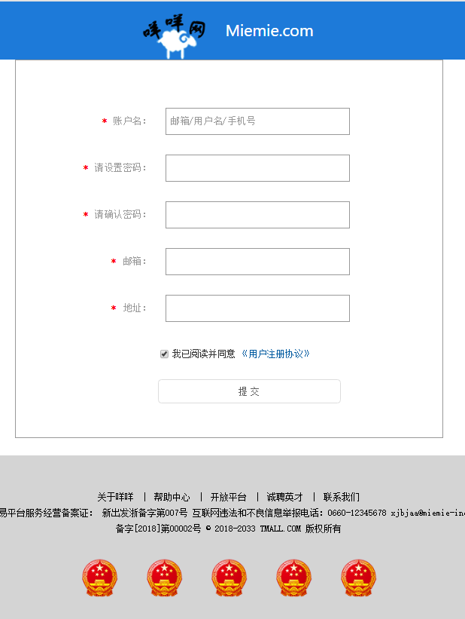

2.3 用户登录

2.3.1 流程图

账号

密码

可勾选：记住密码

自动登录

忘记密码？

（或选择其他登录方式）

登录

进入登陆界面

2.3.2 调试及检测结果

（1）界面展示：

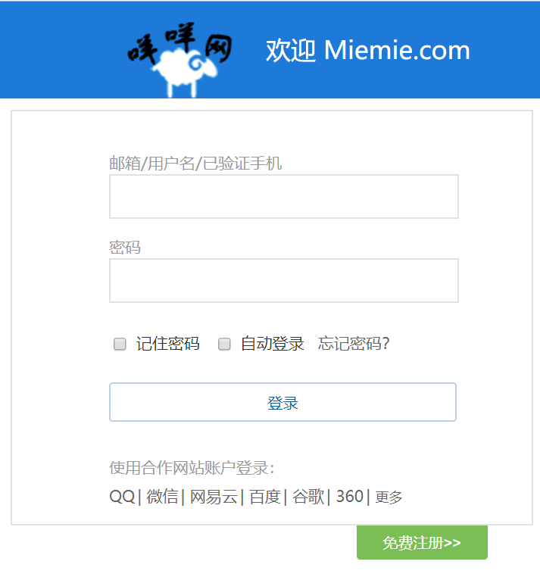

2.4 查看商品详情

2.4.1 流程图

商品分类标签

价格

选择商品规格

选择购买数量

送货地点

商品图片

商品详情

猜你喜欢

看了又看

商品评价

2.3.2 调试及检测结果

（1）界面展示：

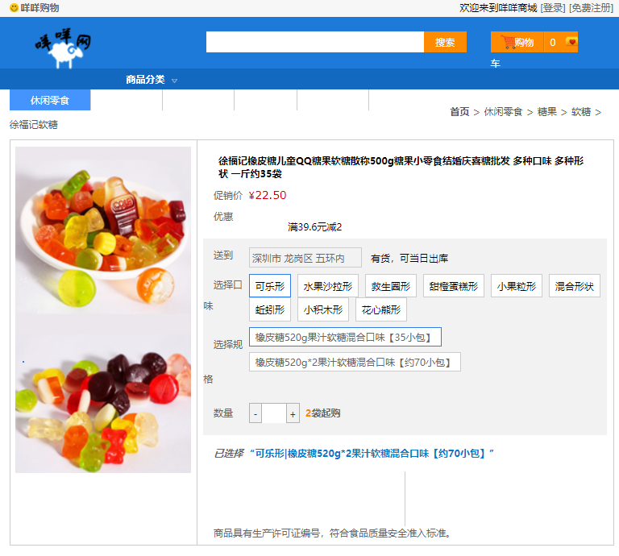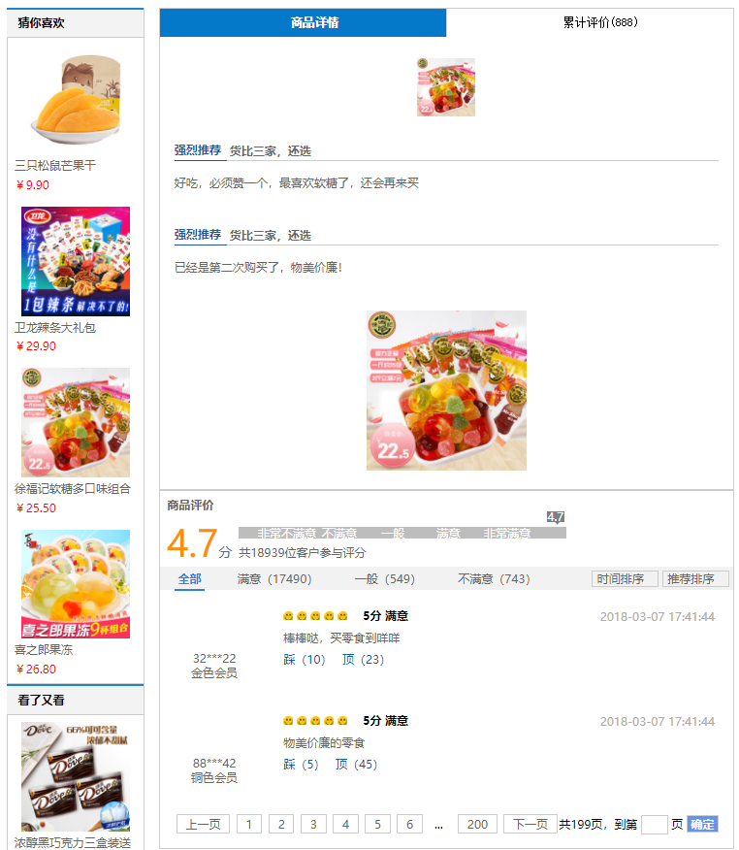

2.5 分页标签的使用

2.5.1 调试及检测结果：

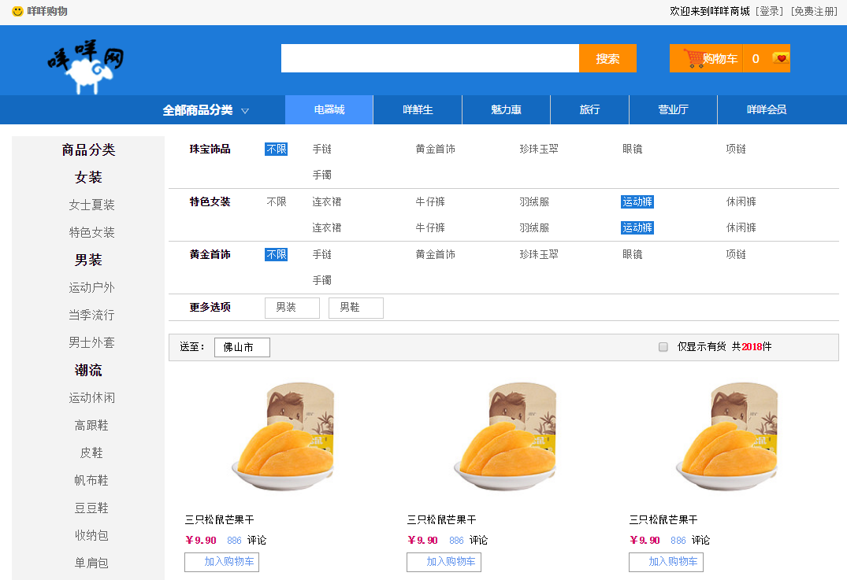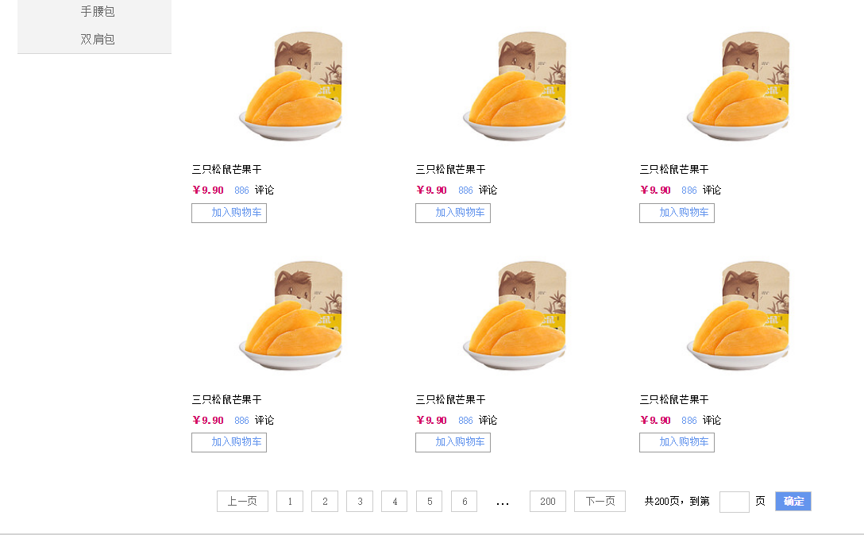

2.6 展示购物车及下单

2.6.1 流程图：

送货清单

发票信息

支付方式

收货信息

订单结算

2.6.2 调试及检测结果：

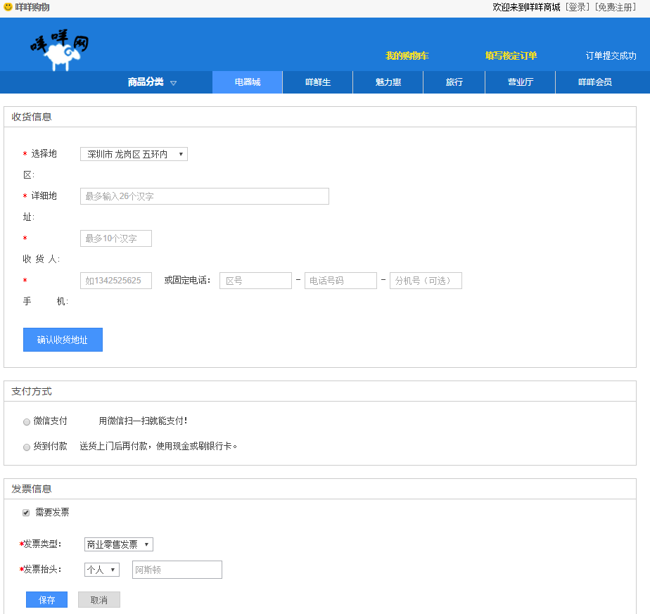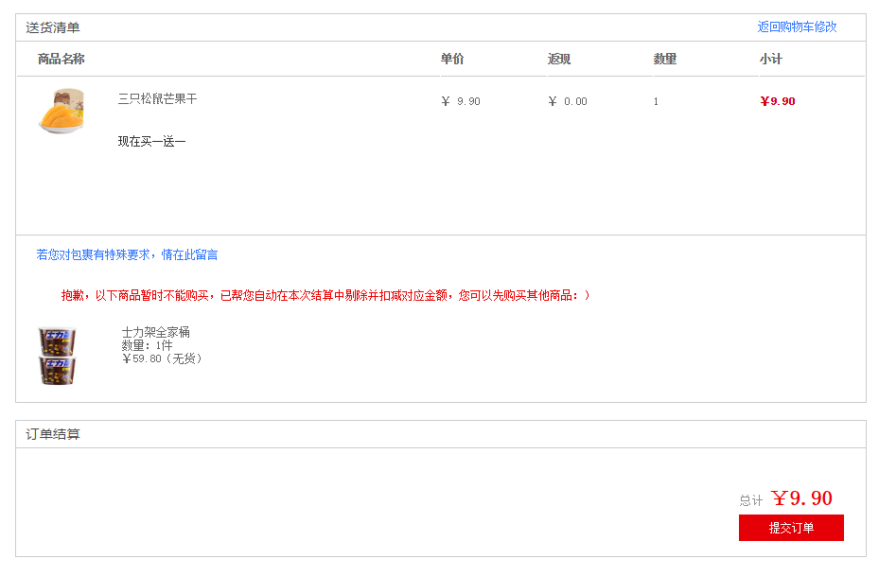

1. 总结

经过两个星期的努力终于完成了实践周的任务，制作一个购物商城网站。因为有了之前实践周的学习基础，这次做起来就比较容易上手。就是待在宿舍里耐心投入，专心敲代码，根据自己制定的计划，一步步地执行。觉得日子过得很充实，很有意义。

经过阅读题目要求，我把任务大致分为七大块，从主页面做起，然后是登录、注册、商品介绍、商品列表、购物车。过程也并不是一帆风顺，虽经常有bug，但通过自己查阅资料上网搜索，跟同学们探讨问题，很快就能得到解答，很庆幸自己有一些可靠的好同学，能互相帮忙。

想做一个鼠标经过能变换颜色的菜单列表，折腾了好久不知道问题出在哪，不会变换。通过自己上网学习了之后用CSS定义了一种active状态解决了问题。后面的广告banner图放映，菜单列表展开等相关的问题就迎刃而解了。购物车页面的送货地址下拉选择框也遇到问题，一直不能展开不知道原因，后面跟同学探讨后解决了问题。

在本次网站制作中，不仅学到了很多关于网页设计方面的知识，还初步了解掌握了一些后台管理方面的知识。这次任务让我认识到一个网站的制作不仅仅是编程，还包括设计，图片制作等知识，还必须掌握一定的软件应用方面的知识。

由于时间原因还不能做到很完善很满意，很多效果，很多想法想加进去却还暂时无法实现，今后的学习还要不断努力。总体上我对自己的成果还是比较满意，对于不足的地方还会继续改善。

附录

1.主页面代码

HTML代码

<!DOCTYPE html>

<html>

<head>

<meta charset="UTF-8">

<title>首页</title>

<link href="css/reset.css" rel="stylesheet" />

<link href="css/common.css" rel="stylesheet" />

<link href="css/main.css" rel="stylesheet" />

</head>

<body>

<div class="box">

<div class="headerBar">

<div class="topBar">

<div class="comWidth">

<div class="leftArea">

<a href="#" class="collection">咩咩购物</a>

</div>

<div class="rightArea">

<span>欢迎来到咩咩商城</span>

<a href="login.html">[登录]</a>

<a href="register.html">[免费注册]</a>

</div>

</div>

</div>

<div class="logoBar">

<div class="comWidth">

<div class="logo fl">

<a href="index.html"><img src="image/logo.png"alt="咩咩网"></a>

</div>

<div class="search_box fl">

<input type="text" class="search_text fl" />

<input type="button" class="search_btn fr" value="搜索" />

</div>

<div class="shopCar fr">

<a href="shopCart.html" class="shopText fl"></a>

<span class="shopNum fl">0</span>

</div>

</div>

</div>

<div class="navBox">

<div class="comWidth">

<div class="shopClass fl">

<h3>商品分类<i></i></h3>

<div class="shopClass_show">

<dl class="shopClass_item">

<dt>

<a href="product.html" class="b">女装</a>

<a href="product.html" class="b">内衣</a>

<a href="product.html" class="aLink">浪漫裙装</a>

</dt>

<dd>

<a href="product.html">女士夏装</a>

<a href="product.html">特色女装</a>

<a href="product.html">家居服</a>

</dd>

</dl>

<dl class="shopClass_item">

<dt>

<a href="product.html" class="b">男装</a>

<a href="product.html" class="b">运动户外</a>

<a href="product.html" class="aLink">当季流行</a>

</dt>

<dd>

<a href="product.html">男士外套</a>

<a href="product.html">特色男装</a>

<a href="product.html">运动服</a>

</dd>

</dl>

<dl class="shopClass_item">

<dt>

<a href="product.html" class="b">女鞋</a>

<a href="product.html" class="b">男鞋</a>

<a href="product.html" class="aLink">箱包</a>

</dt>

<dd>

<a href="product.html">潮流</a>

<a href="product.html">精品</a>

<a href="product.html">特色</a>

</dd>

</dl>

<dl class="shopClass_item">

<dt>

<a href="product.html" class="b">化妆</a>

<a href="product.html" class="b">个人护理</a>

<a href="product.html" class="aLink">美发护发</a>

</dt>

<dd>

<a href="product.html">口腔护理</a>

<a href="product.html">彩 妆</a>

<a href="product.html">护肤品</a>

</dd>

</dl>

<dl class="shopClass_item">

<dt>

<a href="product.html" class="b">手表</a>

<a href="product.html" class="b">眼镜</a>

<a href="product.html" class="aLink">珠宝</a>

</dt>

<dd>

<a href="product.html">黄金首饰</a>

<a href="product.html">钻石彩宝</a>

<a href="product.html">潮流</a>

</dd>

</dl>

</div>

<div class="shopClass_list hide">

<div class="shopClass_cont">

<dl class="shopList_item">

<dt>特色女装</dt>

<dd>

<a href="#">连衣裙</a>

<a href="#">牛仔裤</a>

<a href="#">羽绒服</a>

<a href="#">运动裤</a>

<a href="#">休闲裤</a>

</dd>

</dl>

<dl class="shopList_item">

<dt>男士裤装</dt>

<dd>

<a href="#">背心</a>

<a href="#">衬衫</a>

<a href="#">夹克</a>

<a href="#">平板电脑</a>

<a href="#">T 恤</a>

<a href="#">长袖</a>

<a href="#">棒球服</a>

<a href="#">工装裤</a>

<a href="#">马甲</a>

<a href="#">卫衣</a>

<a href="#">九分裤</a>

<a href="#">短裤</a>

<a href="#">毛衣</a>

<a href="#">西装</a>

<a href="#">皮衣</a>

</dd>

</dl>

<dl class="shopList_item">

<dt>潮流</dt>

<dd>

<a href="#">运动休闲</a>

<a href="#">高跟鞋</a>

<a href="#">皮鞋</a>

<a href="#">帆布鞋</a>

<a href="#">豆豆鞋</a>

<a href="#">收纳包</a>

<a href="#">单肩包</a>

<a href="#">手腰包</a>

<a href="#">双肩包</a>

<a href="#">旅行箱</a>

<a href="#">男士钱包</a>

<a href="#">小白鞋</a>

<a href="#">乐福鞋</a>

<a href="#">布鞋</a>

<a href="#">布洛克</a>

</dd>

</dl>

<dl class="shopList_item">

<dt>美容护肤</dt>

<dd>

<a href="#">笔记本</a>

<a href="#">超级本</a>

<a href="#">上网本</a>

<a href="#">平板电脑</a>

<a href="#">台式机</a>

<a href="#">笔记本</a>

<a href="#">超级本</a>

<a href="#">上网本</a>

<a href="#">平板电脑</a>

<a href="#">台式机</a>

</dd>

</dl>

<dl class="shopList_item">

<dt>珠宝饰品</dt>

<dd>

<a href="#">黄金首饰</a>

<a href="#">珍珠玉翠</a>

<a href="#">眼镜</a>

<a href="#">项链</a>

<a href="#">手镯</a>

</dd>

</dl>

<div class="shopList_links">

<a href="#">聚名品<span></span></a>

<a href="#">品牌活动<span></span></a>

</div>

</div>

</div>

</div>

<ul class="nav fl">

<li>

<a href="#" class="active">电器城</a>

</li>

<li>

<a href="#">咩鲜生</a>

</li>

<li>

<a href="#">魅力惠</a>

</li>

<li>

<a href="#">旅行</a>

</li>

<li>

<a href="#">营业厅</a>

</li>

<li>

<a href="#" class="nobor">咩咩会员</a>

</li>

</ul>

</div>

</div>

</div>

<!--Banner部分-->

<div class="banner comWidth clearfix">

<div class="banner_bar banner_big">

<ul class="imgBox">

<li>

<a href="proIntroduce.html"><img src="image/banner_02.png"alt="banner" ></a>

</li>

<li>

<a href="proIntroduce.html"><img src="image/banner_03.png" alt="banner"></a>

</li>

</ul>

<div class="imgNum">

<a href="#" class="active"></a>

<a href="#"></a>

<a href="#"></a>

</div>

</div>

</div>

<!--商品标题一-->

<div class="shopTit comWidth">

<span class="icon"></span>

<h3>休闲零食</h3>

<a href="product.html" class="more">更多&gt;&gt;</a>

</div>

<!--商品列表一-->

<div class="shopList comWidth clearfix">

<div class="leftArea">

<div class="banner_bar banner_sm">

<ul class="imgBox">

<li>

<a href="proIntroduce.html"><img src="image/banner_sm_01.jpg" alt="banner" /></a>

</li>

<li>

<a href="proIntroduce.html"><img src="image/banner_sm_02.jpg" alt="banner" /></a>

</li>

</ul>

</div>

</div>

<div class="rightArea">

<div class="shopList_top clearfix">

<div class="shop_item">

<div class="shop_img">

<a href="proIntroduce.html"><img src="image/shopImg.jpg" alt="shop" ></a>

</div>

<h3>三只松鼠芒果干</h3>

<p>9.9元</p>

</div>

<div class="shop_item">

<div class="shop_img">

<a href="proIntroduce.html"><img src="image/shopImg_02.jpg""alt="shop" /></a>

</div>

<h3>卫龙辣条大礼包</h3>

<p>29.9元</p>

</div>

<div class="shop_item">

<div class="shop_img">

<a href="proIntroduce.html"><img src="image/shopImg_03.jpg" alt="shop" /></a>

</div>

<h3>徐福记软糖多口味组合</h3>

<p>25.50元</p>

</div>

<div class="shop_item">

<div class="shop_img">

<a href="proIntroduce.html"><img src="image/shopImg_04.jpg"alt="shop" /></a>

</div>

<h3>喜之郎果冻</h3>

<p>26.80元</p>

</div>

</div>

<!--商品右侧底部-->

<div class="shopList_sm">

<div class="shopItem_sm">

<div class="shopItem_smImg">

<a href="proIntroduce.html"><img src="image/shopItem_smImg_01.jpg"alt="" /></a>

</div>

<div class="shopItem_text">

<p>浓醇黑巧克力三盒装送女友</p>

<h3>￥126.90</h3>

</div>

</div>

<div class="shopItem_sm">

<div class="shopItem_smImg">

<a href="proIntroduce.html"><img src="image/shopItem_smImg_02.jpg" alt="" /></a>

</div>

<div class="shopItem_text">

<p>乐事大波浪薯片</p>

<h3>￥31.50</h3>

</div>

</div>

<div class="shopItem_sm">

<div class="shopItem_smImg">

<a href="proIntroduce.html"><img src="image/shopItem_smImg_03.jpg" alt="" /></a>

</div>

<div class="shopItem_text">

<p>魔法士干脆面</p>

<h3>￥24.90</h3>

</div>

</div>

<div class="shopItem_sm">

<div class="shopItem_smImg">

<a href="proIntroduce.html"><img src="image/shopItem_smImg_04.jpg" alt="" /></a>

</div>

<div class="shopItem_text">

<p>德芙士力架全家桶</p>

<h3>￥59.80</h3>

</div>

</div>

</div>

</div>

</div>

<!--商品标题二-->

<div class="shopTit comWidth">

<span class="icon"></span>

<h3>饼干糖巧</h3>

<a href="product.html" class="more">更多&gt;&gt;</a>

</div>

<!--商品列表二-->

<div class="shopList comWidth clearfix">

<div class="leftArea">

<div class="banner_bar banner_sm">

<ul class="imgBox">

<li>

<a href="proIntroduce.html"><img src="image/banner_sm_03.jpg" alt="banner" /></a>

</li>

<li>

<a href="proIntroduce.html"><img src="image/banner_sm_04.jpg" alt="banner" /></a>

</li>

</ul>

</div>

</div>

<div class="rightArea">

<div class="shopList_top clearfix">

<div class="shop_item">

<div class="shop_img">

<a href="proIntroduce.html"><img src="image/shopImg_05.jpg" alt="shop" /></a>

</div>

<h3>动物形饼干牛奶味</h3>

<p>11.90元</p>

</div>

<div class="shop_item">

<div class="shop_img">

<a href="proIntroduce.html"><img src="image/shopImg_06.jpg" alt="shop" /></a>

</div>

<h3>伯力爵白巧克力</h3>

<p>33.90元</p>

</div>

<div class="shop_item">

<div class="shop_img">

<a href="proIntroduce.html"><img src="image/shopImg_07.jpg" alt="shop" /></a>

</div>

<h3>AJI惊奇脆片</h3>

<p>7.90元</p>

</div>

<div class="shop_item">

<div class="shop_img">

<a href="proIntroduce.html"><img src="image/shopImg_08.jpg" alt="shop" /></a>

</div>

<h3>森永嗨啾好嚼软糖</h3>

<p>7.90元</p>

</div>

</div>

<!--商品右侧底部-->

<div class="shopList_sm">

<div class="shopItem_sm">

<div class="shopItem_smImg">

<a href="proIntroduce.html"><img src="image/shopItem_smImg_05.jpg" alt="" /></a>

</div>

<div class="shopItem_text">

<p>南国益生菌芒果糕200g</p>

<h3>￥29.90</h3>

</div>

</div>

<div class="shopItem_sm">

<div class="shopItem_smImg">

<a href="proIntroduce.html"><img src="image/shopItem_smImg_06.jpg" alt="" /></a>

</div>

<div class="shopItem_text">

<p>佳宝糖果礼包450g</p>

<h3>￥38.98</h3>

</div>

</div>

<div class="shopItem_sm">

<div class="shopItem_smImg">

<a href="proIntroduce.html"><img src="image/shopItem_smImg_07.jpg" alt="" /></a>

</div>

<div class="shopItem_text">

<p>思朗纤麸无添糖消化饼干花生味1800g</p>

<h3>￥39.90</h3>

</div>

</div>

<div class="shopItem_sm">

<div class="shopItem_smImg">

<a href="proIntroduce.html"><img src="image/shopItem_smImg_08.jpg" alt="" /></a>

</div>

<div class="shopItem_text">

<p>不二家美梅味</p>

<h3>￥5.50</h3>

</div>

</div>

</div>

</div>

</div>

<div class="hr_25"></div>

<!--底部版权区-->

<div class="footer">

<p>

<a href="#">关于咩咩</a>

<i>|</i>

<a href="#">帮助中心</a>

<i>|</i>

<a href="#">开放平台</a>

<i>|</i>

<a href="#">诚聘英才</a>

<i>|</i>

<a href="#">联系我们</a>

</p>

<p>

增值电信业务经营许可证： 浙B2-20180708 网络文化经营许可证：浙网文[2018]0250-065号 12138举报 出版物网络交易平台服务经营备案证： 新出发浙备字第007号

互联网违法和不良信息举报电话：0660-12345678 xjbjaa@miemie-inc.com 互联网药品信息服务资质证书编号：浙-（经营性）-2018-0001 浙公网安备 4401002365478号

（浙）网械平台备字[2018]第00002号

© 2018-2033 TMALL.COM 版权所有

</p>

<p class="web">

<a href="#"><img src="image/webLogo_01.png" alt="logo"></a>

<a href="#"><img src="image/webLogo_01.png" alt="logo"></a>

<a href="#"><img src="image/webLogo_01.png" alt="logo"></a>

<a href="#"><img src="image/webLogo_01.png" alt="logo"></a>

<a href="#"><img src="image/webLogo_01.png" alt="logo"></a>

</p>

</div>

</div>

</body>

</html>

Css代码

@charset "utf-8";

/* CSS Document */

/*index首页模块*/

.box {

min-width: 1160px;

}

/*topBar*/

.leftArea {

float: left;

}

.rightArea {

float: right;

}

.topBar {

height: 31px;

background-color: #F7F7F7;

line-height: 31px;

}

.topBar a:hover {

color: red;

}

.collection {

background: url(../image/collection.png) left center no-repeat;

padding-left: 19px;

font-weight: bold;

}

/*logoBar*/

.logoBar {

height: 85px;

background-color: #1D7AD9;

}

.logo {

padding-left: 41px;

padding-top: 13px;

}

/*search*/

.search_box {

width: 430px;

padding-top: 23px;

padding-left: 185px;

}

.search_text {

width: 350px;

height: 35px;

padding: 0 5px;

}

.search_btn {

width: 70px;

height: 35px;

font-size: 14px;

font-family: "微软雅黑";

background-color: #FF8C00;

color: #fff;

cursor: pointer;

}

/*顶部右侧购物车*/

.shopCar {

width: 145px;

height: 35px;

background-color: #FF8C00;

margin-top: 23px;

font: 14px/35px "微软雅黑";

color: #fff;

margin-right: 59px;

display: inline;

}

.shopText {

height: 100%;

width: 87px;

border-right: #E27A00 solid 1px;

background: url(../image/shaoIcon.png) 10px center no-repeat;

text-indent: 40px;

}

.shopNum {

width: 19px;

height: 35px;

border-left: #FF9C01 solid 1px;

background: url(../image/sj.png) 33px center no-repeat;

text-align: right;

padding-right: 37px;

}

/*导航区*/

.navBox {

height: 35px;

background-color: #1369C0;

color: #fff;

font-family: "Microsoft YaHei";

}

.shopClass {

width: 190px;

position: relative;

}

.shopClass h3 {

line-height: 35px;

text-align: center;

}

.shopClass i {

width: 11px;

height: 7px;

overflow: hidden;

display: inline-block;

margin-left: 11px;

background: url(../image/down.png) left center no-repeat;

}

.nav, .shopClass h3 {

font-family: "微软雅黑";

}

.nav {

line-height: 35px;

}

.nav li {

float: left;

}

.nav li a:hover {

background-color: #4593FD;

}

.nav a {

height: 35px;

display: inline-block;

padding: 0 35px;

color: #fff;

border-right: #ccc solid 1px;

}

.nav .nobor {

border-right: none;

}

.nav .active {

background-color: #4593FD;

}

/*商品弹出列表*/

.shopClass_show {

background-color: #4593FD;

position: absolute;

left: 0;

top: 35px;

width: 100%;

}

.shopClass_item {

padding: 14px 10px;

border-bottom: #3487F2 solid 1px;

border-top: #5AA1FE solid 1px;

}

.shopClass_item dt {

height: 22px;

background: url(../image/show_sj.png)right center no-repeat;

}

.shopClass_item .b {

font: 14px/1 "微软雅黑";

}

.shopClass_item a {

color: #fff;

}

.shopClass_item a:hover {

text-decoration: underline;

}

.shopClass_item .aLink {

width: 48px;

height: 20px;

background: url(../image/aLink.png) left center no-repeat;

display: inline-block;

text-align: center;

line-height: 20px;

text-decoration: underline;

}

/*active状态*/

.shopClass_active {

background-color: #fff;

border-left: #4593FD solid 1px;

}

.shopClass_active dt {

background: none;

}

.shopClass_active a {

color: #000;

}

.shopClass_active .aLink {

color: #fff;

text-decoration: none;

}

/*弹出菜单区*/

.shopClass_list {

width: 568px;

border: #ccc solid 1px;

position: absolute;

left: 190px;

top: 35px;

}

.shopClass_cont {

padding: 0 20px;

}

.shopList_item {

padding: 10px 0;

border-bottom: #ccc solid 1px;

}

.shopList_item dt {

color: #4B87D9;

line-height: 24px;

font-weight: bold;

height: 24px;

}

.shopList_item dd {

padding-left: 68px;

line-height: 24px;

margin-top: -24px;

}

.shopList_item dd a {

margin-right: 12px;

}

.shopList_links {

padding: 15px 0;

}

.shopList_links a {

color: #fff;

background-color: #2785E6;

height: 26px;

line-height: 26px;

font-size: 12px;

display: inline-block;

padding: 0 14px 0 8px;

margin-right: 10px;

}

.shopList_links span {

width: 11px;

height: 7px;

background: url(../img/shop_sj.png) left center no-repeat;

display: inline-block;

margin-left: 7px;

}

/*banner部分*/

.banner {

margin-bottom: 15px;

}

.banner_bar {

float: right;

position: relative;

overflow: hidden;

}

.imgBox {

position: absolute;

left: 0;

top: 0;

}

.imgBox li {

float: left;

}

.imgBox img {

display: block;

}

.imgNum {

position: absolute;

left: 0;

bottom: 15px;

width: 100%;

text-align: center;

}

.imgNum a {

width: 20px;

height: 5px;

overflow: hidden;

background-color: #fff;

display: inline-block;

margin: 0 3px;

}

.imgNum .active {

background-color: #FF7700;

}

.banner_big,

.banner_big img {

width: 810px;

height: 326px;

}

.banner_big .imgBox {

width: 1620px;

height: 326px;

}

.banner_sm, .banner_sm img {

width: 190px;

height: 400px;

}

.banner_sm .imgBox {

width: 380px;

height: 400px;

}

/*商品标题*/

.shopTit {

height: 44px;

font-family: "微软雅黑";

margin-bottom: 10px;

margin-top: 10px;

}

.shopTit h3 {

font-size: 24px;

float: left;

font-weight: normal;

margin-left: 8px;

}

.shopTit .icon {

width: 44px;

height: 44px;

background: url(../image/showIcon.png) left top no-repeat;

float: left;

}

.shopTit .more {

float: right;

font-family: "宋体";

margin-top: 12px;

}

.shopTit .more:hover {

text-decoration: underline;

}

/*商品列表*/

.shopList .leftArea {

width: 190px;

}

.shopList .rightArea {

width: 808px;

border: #999 solid 1px;

border-bottom: #FF7201 solid 3px;

height: 396px;

}

/*商品列表右侧*/

.shopList_top, .shopList_sm {

margin-right: -4px;

}

.shop_item {

width: 202px;

border-right: #999 solid 1px;

border-bottom: #999 solid 1px;

height: 279px;

text-align: center;

font-family: "微软雅黑";

float: left;

padding-left: 15px;

padding-top: 10px;

box-sizing: border-box;

}

.shop_img {

height: 218px;

margin-bottom: 6px;

}

.shop_img img {

width: 90%;

height: 218px;

display: block;

}

.shop_item h3 {

font-size: 16px;

}

.shop_item p {

font-size: 14px;

color: #FF7300;

line-height: 21px;

}

/*商品右侧底部区*/

.shopItem_sm {

width: 201px;

border-right: #999 solid 1px;

height: 110px;

padding-top: 10px;

float: left;

}

.shopItem_smImg {

width: 95px;

height: 95px;

text-align: center;

float: left;

}

.shopItem_smImg img {

width: 65px;

height: 75px;

margin-right: 5px;

margin-top: 12px;

}

.shopItem_text {

padding-top: 28px;

width: 100px;

float: left;

}

.shopItem_text p {

color: #FF7300;

}

.shopItem_text h3 {

font-family: "微软雅黑";

font-size: 16px;

font-weight: normal;

color: #181818;

line-height: 30px;

}

/*底部样式*/

.footer {

background-color: #D4D4D4;

text-align: center;

line-height: 24px;

padding: 50px 0;

}

.footer i {

font-style: normal;

margin: 0 5px;

}

.footer a {

color: #000;

}

.footer a:hover {

color: #F60;

}

.web {

padding-top: 30px;

}

.web img {

margin: 0 12px;

}

.hr_25 {

height: 25px;

}

/*procuct产品列表模块*/

.hr_7 {

overflow: hidden;

height: 7px;

}

.products .leftArea {

width: 185px;

}

.products .rightArea {

width: 810px;

}

.products .banner_bar {

float: none;

}

/*产品分类导航*/

.leftNav {

background-color: #F3F3F3;

line-height: 34PX;

font-size: 14px;

border-bottom: #D7D7D7 solid 1px;

text-align: center;

}

.nav_cont {

padding: 0 18px 4px;

border-bottom: #D7D7D7 dotted 1px;

margin-bottom: -1px;

}

.nav_cont h3 {

font-size: 12px;

height: 30px;

line-height: 30px;

text-align: left;

}

.navCont_list {

line-height: 25px;

}

.navCont_list li a:hover {

text-decoration: underline;

}

.navCont_list li {

float: left;

width: 50%;

}

/*产品标题*/

.products_title {

height: 34px;

border-bottom: #ccc solid 2px;

}

.products_title h3 {

width: 180px;

border-bottom: #096DBA solid 2px;

height: 34px;

line-height: 34px;

text-indent: 9px;

}

/*产品列表*/

.products_list .item {

width: 25%;

float: left;

margin-bottom: 20px;

position: relative;

}

.products_list .item p {

padding-left: 15px;

}

.products_list .img_item {

height: 170px;

text-align: center;

padding-top: 12px;

}

.products_list .img_item img {

height: 160px;

width: 150px;

}

.products_list .item p {

line-height: 20px;

}

.products_list .item a {

color: #000;

}

.products_list .item a:hover {

text-decoration: underline;

}

.products_list .money {

color: #D4105A;

font-weight: bold;

padding-top: 10px;

}

.stars {

width: 13px;

height: 12px;

overflow: hidden;

background: url(../image/collection.png) left top no-repeat;

display: inline-block;

margin-right: 1px;

}

/*filter产品筛选*/

.hr_15 {

height: 15px;

}

.vertical li {

width: auto;

float: none;

padding-left: 8px;

}

.vertical .nav_title, .vertical .nav_cont h3 {

font-family: "微软雅黑";

font-size: 14px;

}

.screening {

border-bottom: #ccc solid 1px;

}

.screening dt {

line-height: 32px;

width: 74px;

text-align: right;

float: left;

margin-right: 42px;

font-weight: bold;

}

.limit {

width: 55px;

float: left;

line-height: 32px;

}

.screening .active {

background-color: #1D7AD9;

color: #fff;

}

.screening a {

padding: 2px;

}

.screening_list {

line-height: 32px;

width: 626px;

float: left;

}

.screening_list a:hover {

text-decoration: underline;

}

.screening_list li {

width: 20%;

float: left;

}

.screening_list .screen_more {

border: #ccc solid 1px;

height: 23px;

line-height: 23px;

margin-top: 4px;

float: left;

padding-right: 3px;

padding-left: 11px;

margin-right: 10px;

}

.screening_list .screen_more a {

background: url(../img/sj_grey.png) 92% center no-repeat;

padding-right: 25px;

}

.addInfo {

height: 31px;

border: #ccc solid 1px;

background-color: #F5F5F5;

}

.address {

float: left;

}

.add_text {

float: left;

line-height: 31px;

padding-right: 6px;

padding-left: 12px;

}

.addInfo .select {

margin-top: 4px;

}

.screen_text {

line-height: 31px;

padding-right: 80px;

}

.check {

position: relative;

top: -1px;

}

.check input, .check label {

vertical-align: middle;

}

.shop_number em {

color: #F00;

font-style: normal;

font-weight: bold;

}

.screening_list_more .item .addCar {

border: #999 solid 1px;

height: 22px;

display: inline-block;

padding: 0 6px 0 23px;

background: url(../img/car.png) 6px center no-repeat;

color: cornflowerblue;

}

.screening_list_more {

padding-left: 0.5%;

}

.screening_list_more .item {

width: 33.3%;

}

.screening_list_more .item .psecond {

margin-top: 5px;

margin-bottom: 5px;

}

.psecond .pcomment {

color: cornflowerblue;

margin-left: 8px;

}

/*page*/

.page {

text-align: center;

}

.page a {

height: 24px;

display: inline-block;

line-height: 24px;

border: #ccc solid 1px;

padding: 0 12px;

margin: 0 2px;

}

.page a:hover {

background-color: #181818;

color: #fff;

}

.page .hl {

display: inline-block;

padding: 0 12px;

margin: 0 2px;

}

.page .morePage {

padding-left: 14px;

display: inline-block;

height: 24px;

line-height: 24px;

}

.page input[type="text"] {

width: 29px;

padding: 0 3px;

border: #ccc solid 1px;

height: 24px;

line-height: 24px;

text-align: center;

}

.page input[type="button"] {

width: 44px;

padding: 0 3px;

border: #ccc solid 1px;

height: 24px;

line-height: 24px;

text-align: center;

background-color: cornflowerblue;

color: #fff;

font-weight: bold;

cursor: pointer;

}

.hot {

width: 52px;

height: 52px;

background: url(../img/hot.png) left top no-repeat;

position: absolute;

right: 0;

top: 0;

}

/*下拉框组件*/

.select {

border: #999 solid 1px;

height: 22px;

line-height: 22px;

float: left;

background-color: #fff;

padding-left: 10px;

position: relative;

padding-right: 20px;

z-index: 4;

}

.select h3 {

font-size: 12px;

font-weight: normal;

}

.select span {

position: absolute;

right: 0;

top: 0;

height: 100%;

width: 20px;

background: url(../img/sj_blue.png) center center no-repeat;

}

.show_select {

position: absolute;

left: 0;

top: 22px;

background-color: #fff;

width: 100%;

border: #999 solid 1px;

display: none;

}

.show_select li {

padding-left: 10px;

}

/*proIntroduce商品介绍*/

.hr-50 {

height: 50px;

}

.gray {

background-color: #f0f0f0;

}

.userPosition {

font-size: 0;

font-family: Verdana;

margin-top: 25px;

margin-bottom: 15px;

}

.userPosition em, .userPosition strong, .userPosition a, .userPosition span {

font-size: 12px;

color: #555;

}

.userPosition em {

font-style: normal;

}

.userPosition a:hover {

text-decoration: underline;

}

/*商品展示*/

.description-info {

background-color: #fff;

}

.description-info .leftArea {

width: 309px;

}

.description-info .rightArea {

width: 688px;

border-left: 1px solid #ccc;

}

.description {

border: 1px solid #ccc;

}

.description-imgs .big {

height: 340px;

text-align: center;

padding-top: 10px;

}

.description-imgs .small li {

float: left;

margin-left: -1px;

}

.description-imgs .small {

padding-left: 1px;

width: 265px;

margin: 0 auto;

}

.description-imgs .small li img {

border: 1px solid #ccc;

width: 50px;

}

.description-imgs .small .active {

border-color: #317ee7;

position: relative;

}

.des-content {

padding: 10px;

}

.des-content h3 {

font: bold 16px/22px "Microsoft YaHei";

padding: 13px 25px;

}

.des-content .dt {

width: 75px;

float: left;

color: #666;

text-indent: 17px;

line-height: 25px;

}

.des-content .dd {

padding-left: 75px;

}

.des-content .dl {

margin-bottom: 10px;

}

.des-money {

font-size: 18px;

color: #d70000;

font-family: Verdana;

}

.des-money em {

font-style: normal;

font-size: 12px;

}

/*换购*/

.hg-icon {

width: 55px;

height: 18px;

display: inline-block;

background: url(../img/jpg/hg-icon.jpg) left top no-repeat;

color: #fff;

font-style: normal;

text-indent: 16px;

line-height: 18px;

margin-right: 10px;

}

.hg {

padding-top: 4px;

display: inline-block;

}

/*送货*/

.des-position {

background-color: #f2f2f2;

padding-top: 15px;

padding-bottom: 10px;

}

#getwhere {

display: inline-block;

padding: 5px 27px 5px 5px;

border: 1px solid #ccc;

appearance: none;

-moz-appearance: none;

-webkit-appearance: none;

background: url(../img/jpg/getwhere.jpg) 92% center no-repeat;

color: #666;

font-size: 12px;

}

.theGoods {

margin-left: 10px;

}

.des-item .dd {

color: #000;

padding: 8px 10px;

background-color: #fff;

border: 1px solid #ccc;

float: left;

margin-right: 10px;

}

.des-item div:hover {

border-color: #317ee7;

cursor: pointer;

}

.des-item .dt {

line-height: 35px;

}

.des-item .des-item-active {

border-color: #317ee7;

}

.des-sm .dd {

padding: 4px 10px;

color: #666;

margin-bottom: 10px;

}

.des-sm .dt {

line-height: 58px;

}

/*数量*/

.des-content .des-number {

border: 1px solid #b2b2b2;

height: 32px;

width: 82px;

float: left;

padding-left: 0;

}

.des-number div {

height: 100%;

float: left;

}

.reduction, .plus {

width: 15px;

background: url(../img/jpg/add.jpg) left top no-repeat;

line-height: 32px;

text-align: center;

color: #333;

cursor: pointer;

}

.reduction {

border-right: 1px solid #b2b2b2;

text-align: center;

width: 20px;

}

.plus {

border-left: 1px solid #b2b2b2;

text-align: center;

width: 20px;

}

.des-input {

width: 40px;

background: url(../img/jpg/inputadd.jpg) left top no-repeat;

cursor: pointer;

}

.des-input input {

width: 100%;

height: 95%;

line-height: 32px;

text-align: center;

}

.xg {

float: left;

line-height: 32px;

padding-left: 10px;

color: #666;

font-weight: bold;

}

.xg em {

color: #f98700;

font-style: normal;

}

.des-content .dt-num {

line-height: 32px;

}

/*已选择*/

.des-select {

font-weight: bold;

color: #666;

text-indent: 17px;

height: 60px;

line-height: 60px

}

.des-select span {

color: #0479ca;

}

.shopping-btn, .buy-btn {

display: inline-block;

width: 180px;

height: 48px;

}

.shopping-btn {

background: url(../img/jpg/shopping-btn.jpg) left top no-repeat;

}

.buy-btn {

background: url(../img/jpg/buy-btn.jpg) left top no-repeat;

}

.line {

width: 1px;

height: 90px;

overflow: hidden;

background-color: #ccc;

display: inline-block;

margin: 0 40px;

}

.shopping-btn, .buy-btn, .line {

vertical-align: middle;

}

.shop-buy {

text-align: center;

}

.notes {

color: #666;

text-indent: 17px;

}

/*产品介绍*/

.des-info .leftArea {

width: 190px;

}

.des-info .rightArea {

width: 790px;

}

.recommend {

border: 1px solid #ccc;

background-color: #fff;

}

.recommend .tit {

height: 39px;

border-bottom: 1px solid #ccc;

border-top: 2px solid #1d86cf;

margin-top: -1px;

line-height: 39px;

text-indent: 15px;

font-size: 14px;

background-color: #f3f3f3;

}

.rec-item .rec-img-item {

text-align: center;

}

.rec-img-item img {

width: 150px;

}

.rec-item .money {

color: red;

margin-top: 5px;

}

.rec-item {

padding: 10px;

}

/*详细介绍*/

.des-infoContent {

border: 1px solid #ccc;

background-color: #fff;

}

.des-tit {

height: 39px;

background: url(../img/jpg/instro.jpg) left top repeat-x;

text-align: center;

}

.des-tit li {

float: left;

width: 50%;

font: 14px/39px SimSun;

margin-left: -1px;

border-left: 1px solid #ccc;

}

.des-tit .active {

background-color: #0479ca;

color: #fff;

font-weight: bold;

position: relative;

}

.des-tit .jieshao {

background: url(../img/project.png) left center no-repeat;

padding-left: 32px;

display: inline-block;

line-height: 39px;

}

.des-tit .pingjia {

background: url(../img/tall.png) left center no-repeat;

padding-left: 32px;

display: inline-block;

line-height: 39px;

}

.ad {

padding: 30px 0;

text-align: center;

}

.info-tit {

height: 26px;

border-bottom: 1px solid #ccc;

font-family: "Microsoft YaHei";

margin-bottom: 18px;

}

.info-tit h3 {

float: left;

font-size: 16px;

color: #2357a5;

border-bottom: 1px solid #2357a5;

height: 26px;

padding-right: 8px;

}

.info-tit h4 {

font-size: 12px;

line-height: 26px;

padding-left: 4px;

float: left;

color: #656565;

}

.info-text {

padding: 0 20px;

}

.info-text p {

line-height: 22px;

font-size: 14px;

color: #656565;

}

.center {

display: block;

margin: 0 auto;

}

/* 商品评价*/

.shopDes-tit {

line-height: 38px;

height: 38px;

font-size: 14px;

color: #666;

padding-left: 10px;

font-weight: bold;

}

.score-box {

padding-left: 10px;

}

.score {

font-family: "Microsoft YaHei";

float: left;

margin-right: 10px;

}

.score em {

font-size: 18px;

color: #65657d;

font-style: normal;

}

.score span {

font-size: 50px;

color: #ff8f00;

}

.score-speed {

float: left;

width: 450px;

line-height: 16px;

font-size: 12px;

margin-top: 12px;

position: relative;

}

.score-speed-text {

height: 16px;

overflow: hidden;

background-color: #bdbdbd;

color: #fff;

}

.score-speed-text li {

float: left;

}

.score-speed-text .speed-01 {

width: 114px;

text-indent: 26px;

}

.score-speed-text .speed-02 {

width: 82px;

}

.score-speed-text .speed-03 {

width: 76px;

}

.score-speed-text .speed-04 {

width: 65px;

}

.score-num {

position: absolute;

left: 94%;

top: -21px;

width: 25px;

height: 14px;

line-height: 14px;

background-color: #7f7f7f;

text-align: center;

color: #fff;

}

.score-num i {

border-width: 6px;

border-style: solid dashed dashed dashed;

border-color: #7f7f7f transparent transparent transparent;

width: 0;

height: 0;

display: block;

margin-left: 8px;

margin-top: -2px;

}

.score-speed p {

font-size: 12px;

color: #666;

margin-top: 10px;

}

/*满意度切换*/

.review-tab {

line-height: 32px;

background-color: #f2f2f2;

}

.review {

line-height: 32px;

height: 100%;

padding-left: 20px;

}

.review li {

float: left;

margin-right: 40px;

}

.review li a {

display: inline-block;

height: 30px;

padding: 0 5px;

line-height: 30px;

}

.review .active {

color: #317de6;

font-weight: bold;

border-bottom: 2px solid #317de6;

margin-bottom: -2px;

position: relative;

}

.review-sort a {

display: inline-block;

line-height: 20px;

height: 20px;

border: 1px solid #ccc;

padding: 0 20px 0 6px;

background: url(../img/sort.png) 58px center no-repeat;

}

.review-sort {

padding-right: 5px;

}

/*用户评价*/

.eva-userhead {

width: 150px;

text-align: center;

}

.evaHead img {

width: 60px;

height: 60px;

display: inline-block;

}

.eva {

padding: 20px 0;

position: relative;

}

.eva p {

color: #666;

line-height: 20px;

}

.eva-time {

color: #ababab;

position: absolute;

right: 25px;

top: 25px;

}

.eva-count {

font-weight: bold;

display: inline-block;

margin-left: 20px;

height: 30px;

line-height: 30px;

}

.starsBox {

height: 30px;

line-height: 30px;

}

.eva-cont p {

line-height: 30px;

}

.eva-cont {

padding-left: 20px;

padding-right: 20px;

width: 75%;

}

.ding, .cai {

color: #085c9b;

}

.pages {

text-align: right;

padding-right: 20px;

margin: 20px 0;

}

/*shopCart购物车*/

.hr-25 {

height: 25px;

}

.stepBox {

width: 396px;

padding-top: 26px;

}

.step {

width: 396px;

background: url(../img/jpg/carsum.jpg) left top no-repeat;

height: 20px;

}

.step-text {

color: #fff;

font-size: 12px;

line-height: 30px;

}

.step-text li {

float: left;

}

.s01, .s03 {

width: 30%;

}

.s02 {

width: 40%;

text-align: center;

}

.s03 {

text-align: right;

}

.step-text .active {

color: #f3e402;

font-weight: bold;

}

.shoppingCart {

padding-top: 20px;

}

.shopping-item {

border: 1px solid #ccc;

}

.shopping-tit {

height: 31px;

background: url(../img/jpg/grey.jpg) left top repeat-x;

color: #444;

font: 16px/31px "Microsoft YaHei";

text-indent: 12px;

border: 1px solid #ccc;

margin-bottom: -1px;

}

.padding-shop {

padding: 25px 30px;

}

#info {

font-size: 12px;

line-height: 34px;

color: #444;

}

#info input, #info select {

border: 1px solid #ccc;

height: 22px;

text-indent: 8px;

font-size: 12px;

color: #888;

}

#info .col444 {

color: #444;

}

#info select {

width: 170px;

font-size: 12px;

color: #444;

}

#info>div p:nth-of-type(1) {

width: 70px;

text-align: left;

float: left;

}

#info em {

color: #ff0000;

font-style: normal;

}

#info>div p:nth-of-type(2) {

float: left;

margin-left: 20px;

}

.personInfo input, .telInfo input {

width: 112px;

}

.addInfoo input {

width: 392px;

}

.comfirm {

padding-top: 25px;

}

.comfirmBtn {

padding: 10px 22px;

color: #fff;

background-color: #4493fc;

border: 1px solid #3784ed;

}

.givemoney {

font-size: 12px;

line-height: 40px;

border: 1px solid #ccc;

padding: 10px 25px;

color: #444;

}

.givemoney-1 input, .givemoney-2 input {

vertical-align: middle;

display: inline-block;

margin-right: 5px;

}

.payWei-2, .payCash-2 {

padding-left: 20px;

}

.weixin {

width: 30px;

height: 20px;

display: inline-block;

vertical-align: middle;

background: url(../img/jpg/chart.jpg) left top no-repeat;

}

/*发票信息*/

.padding25 {

padding: 0px 25px;

border: 1px solid #ccc;

}

.fapiao {

height: 40px;

line-height: 40px;

color: #444;

}

.fapiao input {

vertical-align: middle;

}

.bill, .bill select {

color: #444;

}

.bill select {

height: 22px;

padding-right: 5px;

margin-left: 22px;

}

.bill select, .bill input {

border: 1px solid #abadb3;

}

.bill {

line-height: 40px;

padding-top: 10px;

}

.bill b {

color: #ff0000;

}

.bill-head {

height: 24px;

width: 140px;

line-height: 24px;

margin-left: 20px;

text-indent: 5px;

}

.saveAndNo {

margin-top: 15px;

margin-bottom: 25px;

}

.saveAndNo input {

width: 66px;

height: 26px;

margin-left: 10px;

color: #666;

border: 1px solid #ccc;

}

.saveAndNo .active {

color: #fff;

background-color: #4391fc;

border-color: #3784ed;

}

/*送货清单*/

.backCar {

float: right;

font-size: 12px;

font-family: "SimSun";

margin-right: 33px;

color: #3377ff;

}

.backCar:hover {

text-decoration: underline;

}

/*送货清单*/

.songhuo {

border: 1px solid #ccc;

}

.table {

font-size: 12px;

color: #666;

width: 100%;

border-bottom: 1px solid #ccc;

}

.table th {

width: 12.5%;

text-align: left;

height: 38px;

border-bottom: 1px solid #ccc;

}

.table .th-left {

width: 50%;

text-indent: 25px;

}

.shopBuy-list {

padding-left: 25px;

}

.shopBuy-img {

width: 20%;

overflow: hidden;

padding: 10px 0;

}

.shopBuy-img img {

height: auto;

}

.shopBuy-info {

width: 80%;

}

.shopBuy-info p {

height: 50px;

line-height: 50px;

}

.tabtop {

vertical-align: top;

padding-top: 20px;

}

.shopBuyName-add {

color: #333;

}

.redmoney {

color: #d70000;

font-weight: bold;

}

.morerequest {

height: 45px;

line-height: 45px;

padding-left: 25px;

}

.morerequest a {

color: #37f;

}

.morerequest a:hover {

text-decoration: underline;

}

.sorry {

color: #e00;

padding-left: 25px;

height: 50px;

line-height: 50px;

}

.warn {

width: 12px;

height: 12px;

background: url(../img/jpg/warn.jpg) left top no-repeat;

display: inline-block;

padding-right: 10px;

}

.cantBuy {

padding: 10px 25px;

}

.cantBuy-img {

width: 80px;

height: 80px;

text-align: center;

}

.cantBuy-info p {

width: 200px;

padding-left: 20px;

color: #666;

}

.finalBox {

padding-top: 38px;

padding-bottom: 18px;

border: 1px solid #ccc;

}

.final {

float: right;

margin-right: 25px;

}

.all {

font-size: 14px;

color: #929292;

}

.all span {

font-size: 24px;

color: #f00000;

line-height: 40px;

font-weight: bold;

}

.allcom {

text-align: right;

}

.allcom input {

padding: 8px 35px;

color: #fff;

background: #e50007;

}

/*login登录页*/

.login-logo .comWidth {

width: 460px;

}

.login-logo .logo {

margin-left: 60px;

}

.welcome-title {

font: 22px/85px "Microsoft Yahei";

color: #fff;

float: left;

padding-left: 24px;

}

.loginBox {

width: 306px;

border: 1px solid #e1e1e1;

margin: 10px auto 0px;

padding: 36px 66px 10px 86px;

color: #999;

line-height: 20px;

font-size: 14px;

}

.login-list input[type="text"] {

border: 1px solid #e1e1e1;

height: 35px;

width: 261px;

padding-right: 40px;

padding-left: 5px;

}

.login-method {

background: url(../img/jpg/user.jpg) 95% center no-repeat;

}

.password {

background: url(../img/jpg/psw.jpg) 95% center no-repeat;

}

.space15 {

height: 15px;

}

.checklogin {

height: 70px;

line-height: 70px;

color: #333333;

}

.checklogin input {

vertical-align: middle;

}

.checklogin label {

margin-right: 8px;

}

.checklogin a:hover {

text-decoration: underline;

color: red;

}

.login-btn {

width: 306px;

height: 35px;

border: 1px solid #bbcfe5;

background: url(../img/jpg/button.jpg) left center repeat-x;

border-radius: 3px;

color: #085C9B;

}

.login-btn:hover {

font-weight: bold;

}

.space30 {

height: 30px;

}

.logina {

line-height: 30px;

color: #666;

}

.logina a:hover {

text-decoration: underline;

}

.login-more {

font-size: 12px;

color: #666;

appearance: none;

-moz-appearance: none;

-webkit-appearance: none;

padding-right: 10px;

background: url(../img/jpg/down.jpg) right center no-repeat;

}

.logina span {

width: 2px;

height: 12px;

display: inline-block;

margin-left: 2px;

margin-right: 2px;

}

.free-reg {

width: 460px;

margin: 0 auto;

}

.reg-btn {

width: 115px;

height: 30px;

float: right;

margin-right: 40px;

background-color: #7cbe56;

border: 1px solid #7cbe56;

border-bottom-left-radius: 3px;

border-bottom-right-radius: 3px;

}

.reg-btn a {

color: #fff;

}

.reg-btn a:hover {

text-decoration: underline;

}

/*reginster注册页*/

.logonBox {

width: 630px;

margin: 0 auto;

border: 1px solid #999;

font: 14px/36px NSimSun;

color: #999;

padding-top: 70px;

}

.logon-list input {

border: 1px solid#999;

height: 36px;

width: 230px;

text-indent: 5px;

padding-right: 40px;

}

.logonBox ::-webkit-input-placeholder {

color: #999;

font: 14px/36px NSimSun;

}

.logon-list li {

display: block;

height: 36px;

margin-bottom: 33px;

}

.logon-list li span {

display: inline-block;

width: 200px;

text-align: right;

margin-right: 15px;

}

.redtip {

display: inline-block;

width: 20px;

height: 36px;

line-height: 36px;

color: red;

padding-right: 10px;

}

.personN {

background: url(../img/jpg/user.jpg) 96% center no-repeat;

}

.personI {

background: url(../img/jpg/psw.jpg) 96% center no-repeat;

}

.readyAgree {

padding-left: 210px;

font-size: 12px;

color: #333;

}

.readyAgree .agreeA {

vertical-align: middle;

width: 14px;

height: 14px;

display: inline-block;

}

.readyAgree .agreeC {

display: block;

width: 270px;

height: 36px;

background: url(../img/jpg/button.jpg) left center repeat-x;

color: #606060;

margin-top: 20px;

margin-bottom: 50px;

border-radius: 5px;

border: 1px solid #dddddd;

cursor: pointer;

}

.userAgreement {

color: #005aa0;

}

.userAgreement:hover {

text-decoration: underline;

}

2.商品介绍页代码

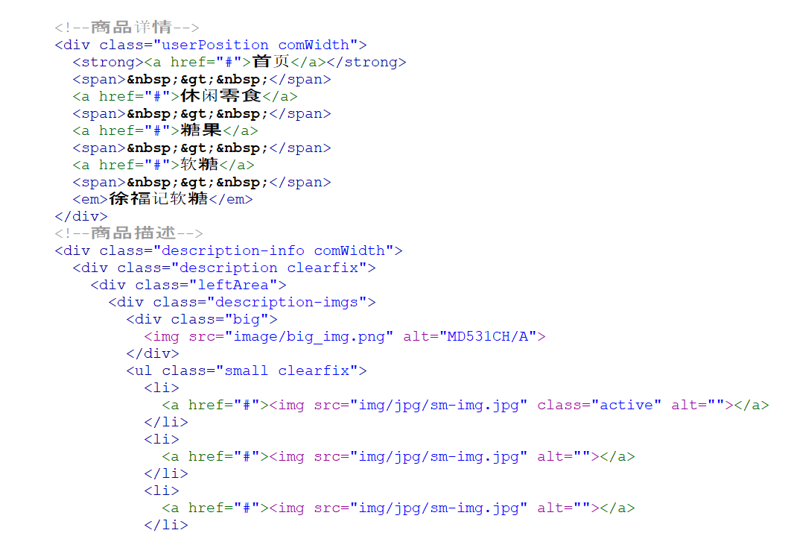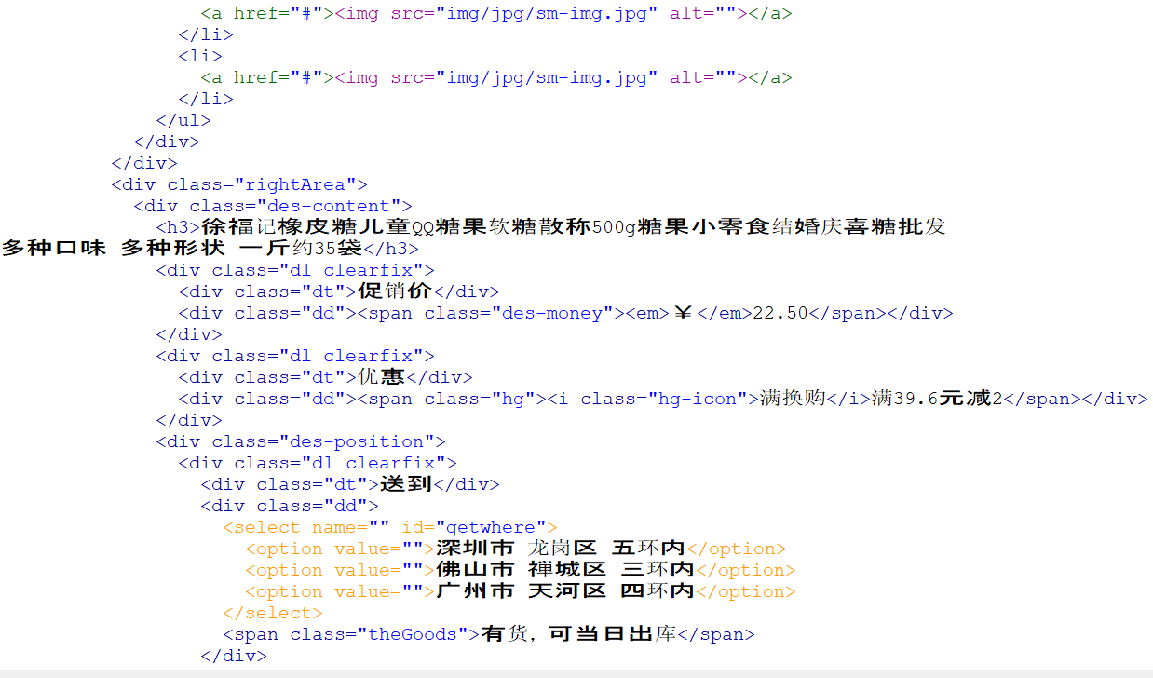

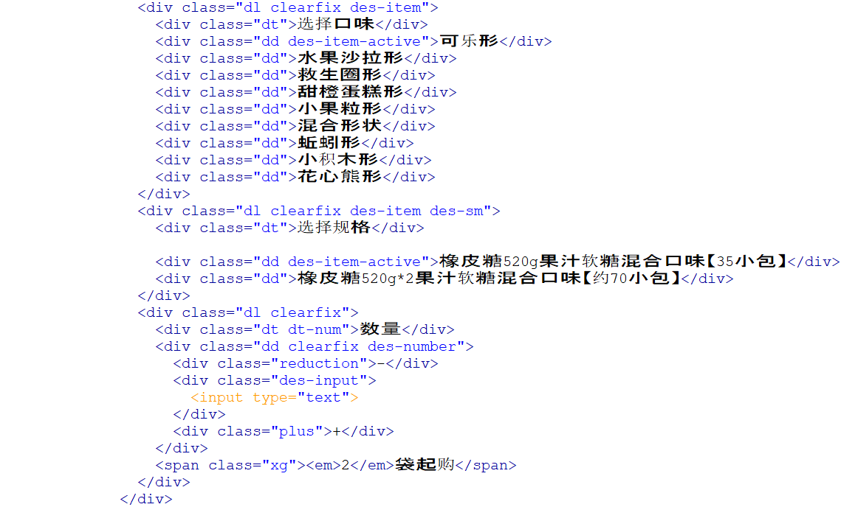

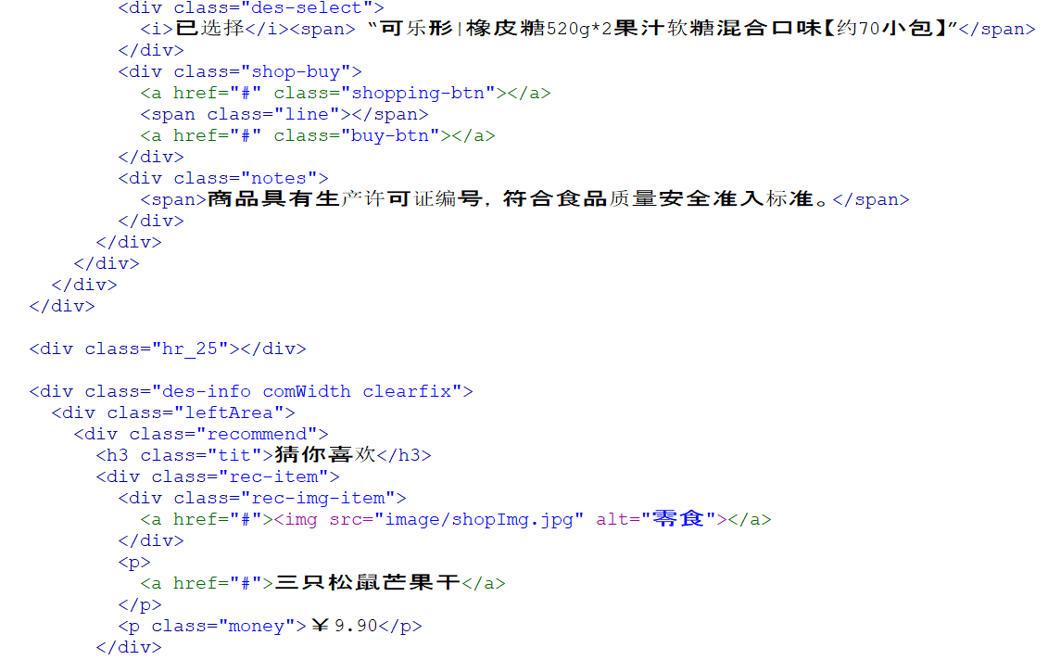

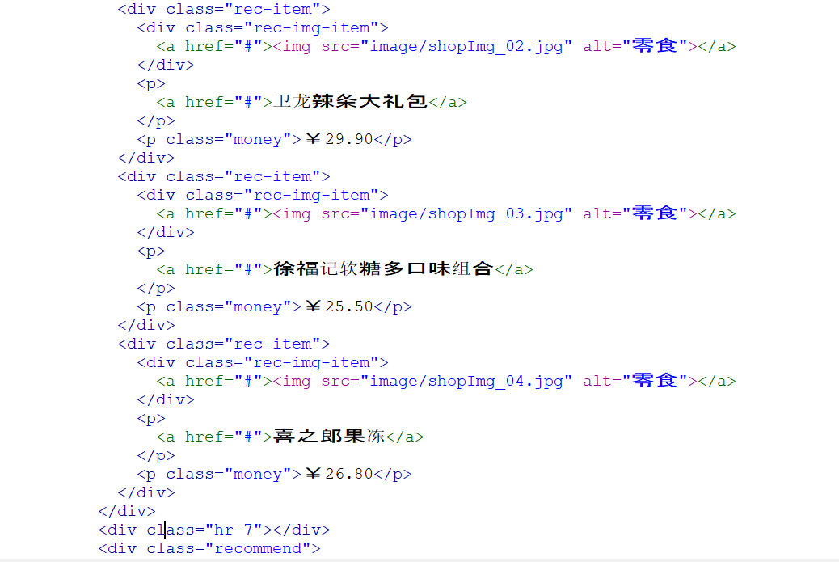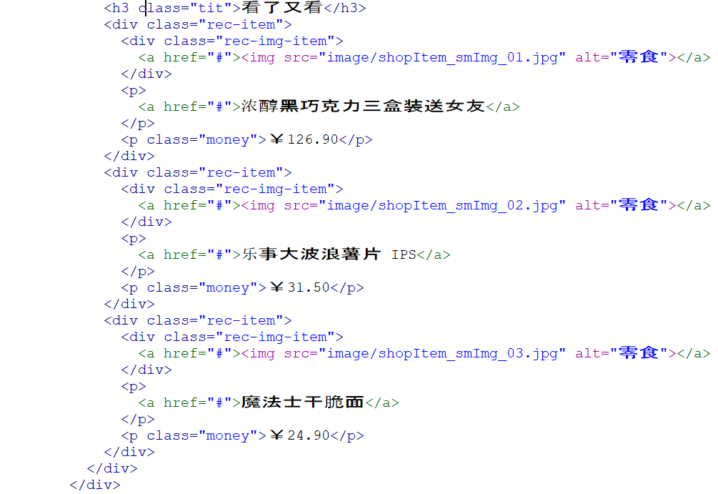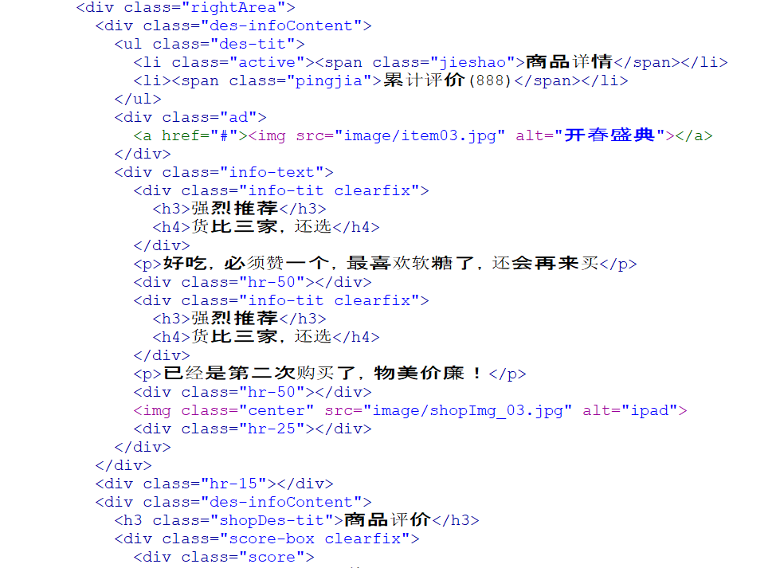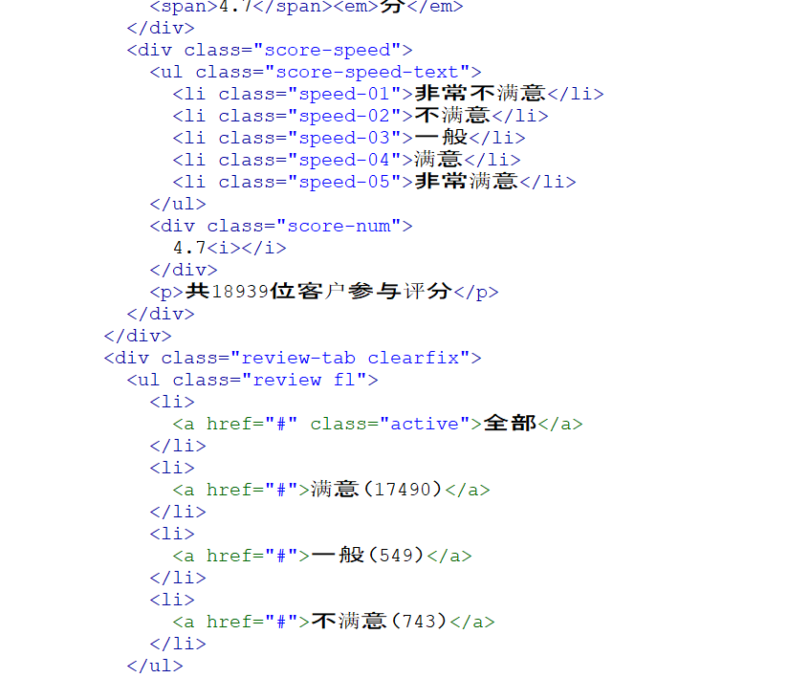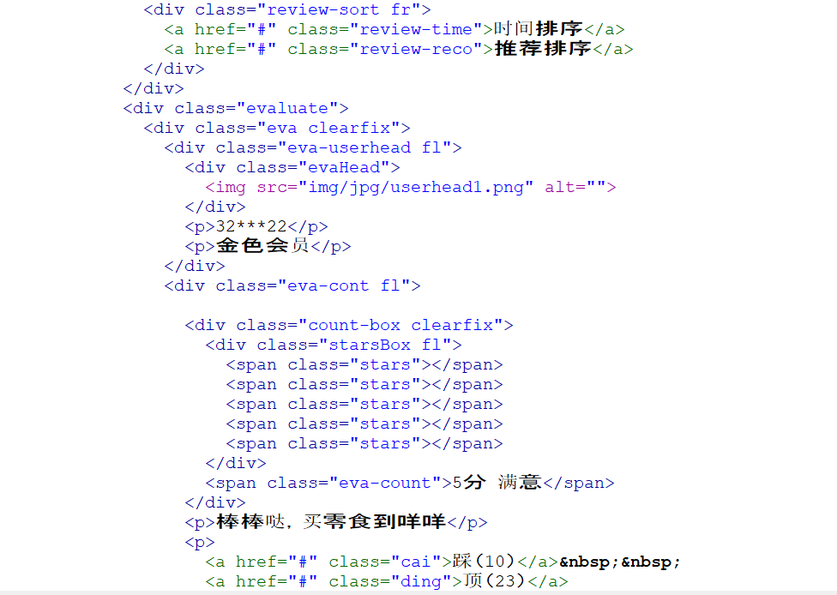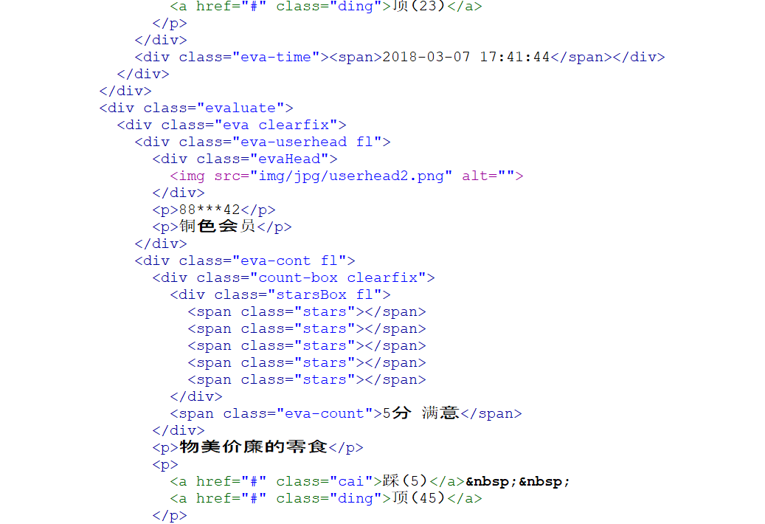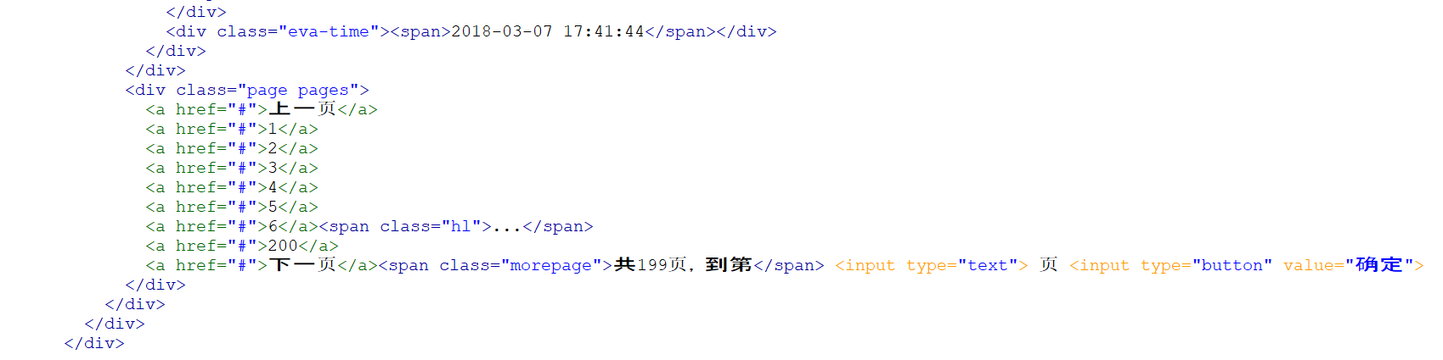

产品筛选页代码

<!--Banner部分-->

<div class="comWidth clearfix products">

<div class="leftArea">

<div class="leftNav vertical">

<h3 class="nav-title">商品分类</h3>

<div class="nav-cont">

<h3>女装</h3>

<ul class="navCont-list clearfix">

<li>

<a href="#">女士夏装</a>

</li>

<li>

<a href="#">特色女装</a>

</li>

</ul>

</div>

<div class="nav-cont">

<h3>男装</h3>

<ul class="navCont-list clearfix">

<li>

<a href="#">运动户外</a>

</li>

<li>

<a href="#">当季流行</a>

</li>

<li>

<a href="#">男士外套</a>

</li>

</ul>

</div>

<div class="nav-cont">

<h3>潮流</h3>

<ul class="navCont-list clearfix">

<li>

<a href="#">运动休闲</a>

</li>

<li>

<a href="#">高跟鞋</a>

</li>

<li>

<a href="#">皮鞋</a>

</li>

<li>

<a href="#">帆布鞋</a>

</li>

<li>

<a href="#">豆豆鞋</a>

</li>

<li>

<a href="#">收纳包</a>

</li>

<li>

<a href="#">单肩包</a>

</li>

<li>

<a href="#">手腰包</a>

</li>

<li>

<a href="#">双肩包</a>

</li>

</ul>

</div>

</div>

</div>

<!--右边商品-->

<div class="rightArea">

<div class="screening_box">

<dl class="screening clearfix">

<dt>珠宝饰品</dt>

<dd class="limit">

<a href="#" class="active">不限</a>

</dd>

<dd class="screening_list">

<ul class="clearfix">

<li>

<a href="#">手链</a>

</li>

<li>

<a href="#">黄金首饰</a>

</li>

<li>

<a href="#">珍珠玉翠</a>

</li>

<li>

<a href="#">眼镜</a>

</li>

<li>

<a href="#">项链</a>

</li>

<li>

<a href="#">手镯</a>

</li>

</ul>

</dd>

</dl>

<dl class="screening clearfix">

<dt>特色女装</dt>

<dd class="limit">

<a href="#">不限</a>

</dd>

<dd class="screening_list">

<ul class="clearfix">

<li>

<a href="#">连衣裙</a>

</li>

<li>

<a href="#">牛仔裤</a>

</li>

<li>

<a href="#">羽绒服</a>

</li>

<li>

<a href="#" class="active">运动裤</a>

</li>

<li>

<a href="#">休闲裤</a>

</li>

<li>

<a href="#">连衣裙</a>

</li>

<li>

<a href="#">牛仔裤</a>

</li>

<li>

<a href="#">羽绒服</a>

</li>

<li>

<a href="#" class="active">运动裤</a>

</li>

<li>

<a href="#">休闲裤</a>

</li>

</ul>

</dd>

</dl>

<dl class="screening clearfix">

<dt>黄金首饰</dt>

<dd class="limit">

<a href="#" class="active">不限</a>

</dd>

<dd class="screening_list">

<ul class="clearfix">

<li>

<a href="#">手链</a>

</li>

<li>

<a href="#">黄金首饰</a>

</li>

<li>

<a href="#">珍珠玉翠</a>

</li>

<li>

<a href="#">眼镜</a>

</li>

<li>

<a href="#">项链</a>

</li>

<li>

<a href="#">手镯</a>

</li>

</ul>

</dd>

</dl>

<dl class="screening clearfix">

<dt>更多选项</dt>

<dd class="screening_list">

<div class="screen_more">

<a href="#">男装</a>

</div>

<div class="screen_more">

<a href="#">男鞋</a>

</div>

</dd>

</dl>

</div>

<div class="hr_15"></div>

<div class="addInfo clearfix">

<div class="address">

<span class="add_text">送至：</span>

<div class="select">

<h3>佛山市</h3>

<span></span>

<ul class="show_select">

<li>禅城区</li>

<li>南海区</li>

<li>顺德区</li>

</ul>

</div>

</div>

<div class="fr screen_text">

<span class="check">

<input type="checkbox" id="check" />

<label for="check">仅显示有货</label>

</span>

<span class="shop_number">

共<em>2018</em>件

</span>

</div>

</div>

<div class="products_list screening_list_more clearfix">

<div class="item">

<div class="item_cont">

<div class="img_item">

<a href="#"><img src="image/shopImg.jpg" alt="" /></a>

</div>

<p>

<a href="#">三只松鼠芒果干</a>

</p>

<p class="psecond">

<span class="money">￥9.90</span>

<span class="pcomment">886</span>

<a href="#">评论</a>

</p>

<p>

<a href="#" class="addCar">加入购物车</a>

</p>

</div>

</div>

<div class="item">

<div class="item_cont">

<div class="img_item">

<a href="#"><img src="image/shopImg.jpg" alt="" /></a>

</div>

<p>

<a href="#">三只松鼠芒果干</a>

</p>

<p class="psecond">

<span class="money">￥9.90</span>

<span class="pcomment">886</span>

<a href="#">评论</a>

</p>

<p>

<a href="#" class="addCar">加入购物车</a>

</p>

</div>

</div>

<div class="item">

<div class="item_cont">

<div class="img_item">

<a href="#"><img src="image/shopImg.jpg" alt="" /></a>

</div>

<p>

<a href="#">三只松鼠芒果干</a>

</p>

<p class="psecond">

<span class="money">￥9.90</span>

<span class="pcomment">886</span>

<a href="#">评论</a>

</p>

<p>

<a href="#" class="addCar">加入购物车</a>

</p>

</div>

</div>

<div class="item">

<div class="item_cont">

<div class="img_item">

<a href="#"><img src="image/shopImg.jpg" alt="" /></a>

</div>

<p>

<a href="#">三只松鼠芒果干</a>

</p>

<p class="psecond">

<span class="money">￥9.90</span>

<span class="pcomment">886</span>

<a href="#">评论</a>

</p>

<p>

<a href="#" class="addCar">加入购物车</a>

</p>

</div>

</div>

<div class="item">

<div class="item_cont">

<div class="img_item">

<a href="#"><img src="image/shopImg.jpg" alt="" /></a>

</div>

<p>

<a href="#">三只松鼠芒果干</a>

</p>

<p class="psecond">

<span class="money">￥9.90</span>

<span class="pcomment">886</span>

<a href="#">评论</a>

</p>

<p>

<a href="#" class="addCar">加入购物车</a>

</p>

</div>

</div>

<div class="item">

<div class="item_cont">

<div class="img_item">

<a href="#"><img src="image/shopImg.jpg" alt="" /></a>

</div>

<p>

<a href="#">三只松鼠芒果干</a>

</p>

<p class="psecond">

<span class="money">￥9.90</span>

<span class="pcomment">886</span>

<a href="#">评论</a>

</p>

<p>

<a href="#" class="addCar">加入购物车</a>

</p>

</div>

</div>

<div class="item">

<div class="item_cont">

<div class="img_item">

<a href="#"><img src="image/shopImg.jpg" alt="" /></a>

</div>

<p>

<a href="#">三只松鼠芒果干</a>

</p>

<p class="psecond">

<span class="money">￥9.90</span>

<span class="pcomment">886</span>

<a href="#">评论</a>

</p>

<p>

<a href="#" class="addCar">加入购物车</a>

</p>

</div>

<div class="hot"></div>

</div>

<div class="item">

<div class="item_cont">

<div class="img_item">

<a href="#"><img src="image/shopImg.jpg" alt="" /></a>

</div>

<p>

<a href="#">三只松鼠芒果干</a>

</p>

<p class="psecond">

<span class="money">￥9.90</span>

<span class="pcomment">886</span>

<a href="#">评论</a>

</p>

<p>

<a href="#" class="addCar">加入购物车</a>

</p>

</div>

</div>

<div class="item">

<div class="item_cont">

<div class="img_item">

<a href="#"><img src="image/shopImg.jpg" alt="" /></a>

</div>

<p>

<a href="#">三只松鼠芒果干</a>

</p>

<p class="psecond">

<span class="money">￥9.90</span>

<span class="pcomment">886</span>

<a href="#">评论</a>

</p>

<p>

<a href="#" class="addCar">加入购物车</a>

</p>

</div>

</div>

</div>

<div class="hr_25"></div>

<div class="page">

<a href="#">上一页</a>

<a href="#">1</a>

<a href="#">2</a>

<a href="#">3</a>

<a href="#">4</a>

<a href="#">5</a>

<a href="#">6</a>

<span class="hl">...</span>

<a href="#">200</a>

<a href="#">下一页</a>

<span class="morePage">共200页，到第&nbsp;</span>

<input type="text" />&nbsp;页&nbsp;

<input type="button" value="确定" />

</div>

</div>

</div>

3.购物车页代码

<div class="stepBox fr">

<div class="step"></div>

<ul class="step-text">

<li class="s01 active">我的购物车</li>

<li class="s02 active">填写核定订单</li>

<li class="s03">订单提交成功</li>

</ul>

</div>

</div>

</div>

<div class="navBox">

<div class="comWidth">

<div class="shopClass fl">

<h3>商品分类<i></i></h3>

</div>

<ul class="nav fl">

<li>

<a href="#" class="active">电器城</a>

</li>

<li>

<a href="#">咩鲜生</a>

</li>

<li>

<a href="#">魅力惠</a>

</li>

<li>

<a href="#">旅行</a>

</li>

<li>

<a href="#">营业厅</a>

</li>

<li>

<a href="#" class="nobor">咩咩会员</a>

</li>

</ul>

</div>

</div>

</div>

<div class="shoppingCart comWidth">

<h3 class="shopping-tit">收货信息</h3>

<div class="shopping-item">

<div class="shopping-cont padding-shop">

<form action="" id="info">

<div class="areaInfo clearfix">

<p><em>*</em> 选择地区:</p>

<p>

<select name="" id="" class="col444">

<option value="">深圳市 龙岗区 五环内</option>

<option value="">佛山市 禅城区 三环内</option>

<option value="">广州市 天河区 四环内</option>

</select>

</p>

</div>

<div class="addInfoo clearfix">

<p><em>*</em> 详细地址:</p>

<p><input type="text" placeholder="最多输入26个汉字"></p>

</div>

<div class="personInfo clearfix">

<p><em>*</em> 收&nbsp;货&nbsp;人:</p>

<p><input type="text" placeholder="最多10个汉字"></p>

</div>

<div class="telInfo clearfix">

<p><em>*</em> 手&nbsp;&nbsp;&nbsp;&nbsp;&nbsp;&nbsp;机:</p>

<p>

<input type="text" placeholder="如13250360925">

<span>&nbsp;&nbsp;或固定电话：</span>

<input type="text" placeholder="区号" class="col444"> -

<input type="text" placeholder="电话号码" class="col444"> -

<input type="text" placeholder="分机号（可选）" class="col444">

</p>

</div>

</form>

<div class="comfirm">

<input type="button" value="确认收货地址" class="comfirmBtn">

</div>

</div>

</div>

</div>

<div class="shoppingCart comWidth">

<h3 class="shopping-tit">支付方式</h3>

<div class="givemoney">

<div class="givemoney-1 clearfix">

<div class="payWei-1 fl">

<input type="radio" name="pay" id="pay1"><label for="pay1">微信支付</label>

</div>

<div class="payWei-2 fl">

<span class="weixin"></span>用微信扫一扫就能支付！

</div>

</div>

<div class="givemoney-2 clearfix">

<div class="payCash-1 fl">

<input type="radio" name="pay" id="pay2"><label for="pay2">货到付款</label>

</div>

<div class="payCash-2 fl">

<span>送货上门后再付款，使用现金或刷银行卡。</span>

</div>

</div>

</div>

</div>

<div class="shoppingCart comWidth">

<h3 class="shopping-tit">发票信息</h3>

<div class="padding25">

<div class="fapiao">

<input type="checkbox" name="fapiao" id="fapiao" checked>

<label for="fapiao">需要发票</label>

</div>

<div class="bill">

<div>

<b>*</b>发票类型：

<select name="" id="">

<option value="">商业零售发票</option>

</select>

</div>

<div>

<b>*</b>发票抬头：

<select name="" id="">

<option value="">个人</option>

</select><input type="text" placeholder="阿斯顿" class="bill-head">

</div>

</div>

<div class="saveAndNo">

<input type="button" value="保存" class="active">

<input type="button" value="取消">

</div>

</div>

</div>

<div class="shoppingCart comWidth">

<h3 class="shopping-tit">送货清单<a href="#" class="backCar">返回购物车修改</a></h3>

<div class="songhuo">

<table class="table">

<tr>

<th class="th-left">商品名称</th>

<th>单价</th>

<th>返现</th>

<th>数量</th>

<th>小计</th>

</tr>

<tr>

<td>

<div class="shopBuy-list clearfix">

<div class="shopBuy-img fl">

<img src="image/shopImg_002.png" alt="">

</div>

<div class="shopBuy-info fr">

<p class="shopBuyName">三只松鼠芒果干</p>

<p class="shopBuyName-add">现在买一送一</p>

</div>

</div>

</td>

<td class="tabtop">￥ 9.90</td>

<td class="tabtop">￥ 0.00</td>

<td class="tabtop">1</td>

<td class="tabtop"><span class="redmoney">￥9.90</span></td>

</tr>

</table>

<div class="morerequest">

<a href="#">若您对包裹有特殊要求，情在此留言</a>

</div>

<div class="sorry">

<span class="warn"></span>

<span>抱歉，以下商品暂时不能购买，已帮您自动在本次结算中剔除并扣减对应金额，您可以先购买其他商品：）</span>

</div>

<div class="cantBuy clearfix">

<div class="cantBuy-img fl">

<img src="image/shopItem_smImg_04_2.png" alt="">

</div>

<div class="cantBuy-info fl">

<p class="pinfo">士力架全家桶</p>

<p>数量：1件</p>

<p>￥59.80<span class="nobuy-col">（无货）</span></4>

</p>

</div>

</div>

</div>

</div>

<div class="shoppingCart comWidth clearfix">

<h3 class="shopping-tit">订单结算</h3>

<div class="finalBox clearfix">

<div class="final">

<p class="all">总计 <span>￥9.90</span></p>

<p class="allcom"><input type="button" value="提交订单"></p>

</div>

</div>

</div>

<div class="hr-25"></div>

4.注册页代码

<!DOCTYPE html>

<html>

<head>

<meta charset="UTF-8">

<title>注册</title>

<link rel="stylesheet" href="css/reset.css">

<link rel="stylesheet" href="css/common.css">

<link rel="stylesheet" href="css/main.css">

</head>

<body>

<div class="box">

<div class="headerBar">

<div class="logoBar login-logo">

<div class="comWidth">

<div class="logo fl">

<a href="index.html"><img src="image/logo.png" alt="咩咩网"></a>

</div>

<h3 class="welcome-title">Miemie.com</h3>

</div>

</div>

</div>

<div class="hr-15"></div>

<div class="logonBox">

<ul class="logon-list">

<li>

<span><b class="redtip">*</b>账户名：</span>

<input type="text" placeholder="邮箱/用户名/手机号" class="personN">

</li>

<li>

<span><b class="redtip">*</b>请设置密码：</span>

<input type="text" class="personI">

</li>

<li>

<span><b class="redtip">*</b>请确认密码：</span>

<input type="text" class="personI">

</li>

<li>

<span><b class="redtip">*</b>邮箱：</span>

<input type="text" class="personI">

</li>

<li>

<span><b class="redtip">*</b>地址：</span>

<input type="text">

</li>

</ul>

<div class="readyAgree">

<div>

<input type="checkbox" checked class="agreeA">我已阅读并同意

<a href="#" class="userAgreement">《用户注册协议》</a>

</div>

<input type="button" class="agreeC" value="提 交">

</div>

</div>

<div class="hr-25"></div>

6.登录页代码

<!DOCTYPE html>

<html>

<head>

<meta charset="UTF-8">

<title>登录</title>

<link rel="stylesheet" href="css/reset.css">

<link rel="stylesheet" href="css/common.css">

<link rel="stylesheet" href="css/main.css">

</head>

<body>

<div class="box">

<div class="headerBar">

<div class="logoBar login-logo">

<div class="comWidth">

<div class="logo fl">

<a href="index.html"><img src="image/logo.png" alt="咩咩网"></a>

</div>

<h3 class="welcome-title">欢迎 Miemie.com</h3>

</div>

</div>

</div>

<div class="loginBox">

<ul class="login-list">

<li>邮箱/用户名/已验证手机</li>

<li><input type="text" class="login-method"></li>

<li class="space15"></li>

<li>密码</li>

<li><input type="text" class="password"></li>

<li class="checklogin">

<input type="checkbox" id="login">

<label for="login">记住密码</label>

<input type="checkbox" id="safelogin">

<label for="safelogin">自动登录</label>

<a href="#">忘记密码？</a>

</li>

<li>

<button class="login-btn">登录</button>

</li>

<li class="space30"></li>

<li>使用合作网站账户登录：</li>

<li class="logina">

<a href="#">QQ</a><span>|</span>

<a href="#">微信</a><span>|</span>

<a href="#">网易云</a><span>|</span>

<a href="#">百度</a><span>|</span>

<a href="#">谷歌</a><span>|</span>

<a href="#">360</a><span>|</span>

<select name="" class="login-more">

<option value="">更多</option>

</select>

</li>

</ul>

</div>

<div class="free-reg clearfix">

<button class="reg-btn">

<a href="register.html">免费注册&gt;&gt;</a>

</button>

</div>

<div class="hr-25"></div>