**Database Design Report**

**Specialist Clinic Reserving—ER-Diagram**

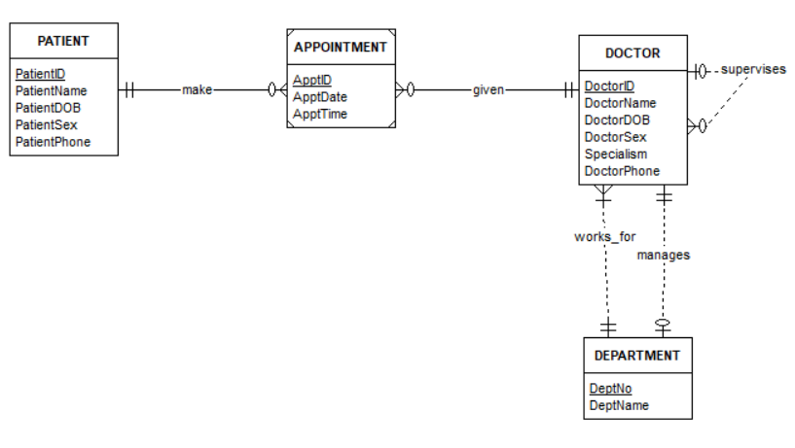

In this ER-Diagram includes 4 entities that are ‘DOCTOR’, ‘DEPARTMENT’, ‘PATIENT’ and ‘APPOINTMENT’. ‘APPOINTMENT’ is a weak entity because it depends if a patient makes it. A patient can make many appointments, but an appointment has only one patient. A doctor can have many appointments, but an appointment has only a doctor. A department has only a doctor in manager role, and a manager doctor only can manage a department. A department can have many doctors, but a doctor just can work for a department. Supervision relationships between doctor and doctor. One doctor in supervisor role can supervise many doctors, but a doctor just has a supervisor.

**Specialist Clinic Reserving—ER-to-Relational Mapping**

DOCTOR(DoctorID, DoctorName, DoctorDOB, DoctorSex, Specialism, DoctorPhone, DNo, SuperID)

PATIENT(PatientID, PatientName, PatientDOB, PatientSex, PatientPhone)

DEPARTMENT(DeptNo, DeptName, MgrID)

APPOINTMENT(ApptID, ApptDate, ApptTime, DoctorID, PatientID)

**Specialist Clinic Reserving—Convert the tables in to 3NF**

The tables are already in 3NF.:)