Table: Submissions

+---------------+----------+

| Column Name | Type |

+---------------+----------+

| sub_id | int |

| parent_id | int |

+---------------+----------+

There is no primary key for this table, it may have duplicate rows.

Each row can be a post or comment on the post.

parent_id is null for posts.

parent_id for comments is sub_id for another post in the table.

Write an SQL query to find number of comments per each post.

Result table should contain post_id and its corresponding number_of_comments, and must be sorted by post_id in ascending order.

Submissions may contain duplicate comments. You should count the number of **unique comments** per post.

Submissions may contain duplicate posts. You should treat them as one post.

The query result format is in the following example:

Submissions table:

+---------+------------+

| sub_id | parent_id |

+---------+------------+

| 1 | Null |

| 2 | Null |

| 1 | Null |

| 12 | Null |

| 3 | 1 |

| 5 | 2 |

| 3 | 1 |

| 4 | 1 |

| 9 | 1 |

| 10 | 2 |

| 6 | 7 |

+---------+------------+

Result table:

+---------+--------------------+

| post_id | number_of_comments |

+---------+--------------------+

| 1 | 3 |

| 2 | 2 |

| 12 | 0 |

+---------+--------------------+

The post with id 1 has three comments in the table with id 3, 4 and 9. The comment with id 3 is repeated in the table, we counted it **only once**.

The post with id 2 has two comments in the table with id 5 and 10.

The post with id 12 has no comments in the table.

The comment with id 6 is a comment on a deleted post with id 7 so we ignored it.

SELECT s1.sub_id as post_id, COUNT(distinct s2.sub_id) as number_of_comments

FROM submissions s1

LEFT JOIN submissions s2

ON s1.sub_id = s2.parent_id

WHERE s1.parent_id IS NULL

GROUP BY s1.sub_id

submissions s1 LEFT JOIN submissions s2 ON s1.sub_id = s2.parent_id

+---------+------------+

|s1.sub_id|s1.parent_id|s2.parent_id|s2.sub_id|

+---------+------------+------------+---------+

| 1 | Null | 1 | 3 |

| 1 | Null | 1 | 3 |

| 1 | Null | 1 | 4 |

| 1 | Null | 1 | 9 |

| 2 | Null | 2 | 5 |

| 2 | Null | 2 | 10 |

| 1 | Null | 1 | 3 |

| 1 | Null | 1 | 3 |

| 1 | Null | 1 | 4 |

| 1 | Null | 1 | 9 |

| 12 | Null | Null | Null |

| 3 | 1 | Null | Null |

| 5 | 2 | Null | Null |

| 3 | 1 | Null | Null |

| 4 | 1 | Null | Null |

| 9 | 1 | Null | Null |

| 10 | 2 | Null | Null |

| 6 | 7 | Null | Null |

+---------+------------+------------+---------+

WHERE s1.parent_id IS NULL

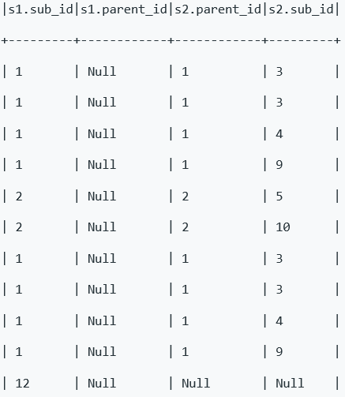

GROUP BY s1.sub_id

distinct s2.sub_id count(distinct s2.sub_id)

1 ----3, 4, 9 3

2-----5,10 2

12----NULL 0