CSC4350/6350

Spring 2017

A stock trading software. The price is real-time and the exchange is virtual.

Virtual Stock

BATMAN

2/28/2017

Mengyuan Zhu, Sungjae Kim, Sharon Kim, Jakub Pietrasik, Hyeun Kang

Virtual Stock

Contents

Requirements Traceability Matrix 2

Work Structure Document 3

Dictionary 3

Test Cases and Type Used Rational 4

Construction Cost Model 4

Gantt Chart 5

# Requirements Traceability Matrix

|  |  |  |  |  |
| --- | --- | --- | --- | --- |
| **Entry#** | **Para#** | **Requirements Traceability Matrix** | **Type** | **Use Case Name** |
| 1 | 1 | Batman shall develop a stock trading software with a user-friendly GUI. | SW, HW | Use Case 3 Show_Main_Window |
| 2 | 2 | The system shall provide a window for user to register an account in Batman. | SW | Use Case 2 User_Sign_Up |
| 3 | 2.1 | The system shall let user know and ask the user to refill the form for registration. | SW | n/a |
| 4 | 3 | The system shall have a window for user to log in. | SW | Use Case 1 User_Sign_In |
| 5 | 3.1 | The window shall provide a user name, password input, forgot password button, and sign in and sign up buttons. | SW | n/a |
| 6 | 3.2 | The system shall let user into the interface if the user type the right user information | SW | n/a |
| 7 | 3.3 | If the user failed to log in to the system, the system shall ask the user to refill the password. | SW | n/a |
| 8 | 3.4 | The system shall provide a pin number for quick log in | NTH | n/a |
| 9 | 4 | The system shall have a portfolio interface. | SW | Use Case 4Show_Portfolio |
| 10 | 4.1 | The system shall show a chart of user’s balance chart of today, total balance value, breaking news of today, stocks that a user keeps and his/her shares, and a watch list. | NTH | n/a |
| 11 | 4.2 | The search button shall also be shown in the corner for user to search a specific stock. | NTH | n/a |
| 12 | 4.3 | The color of the GUI shall be green if the user’s balance goes up and be red if the user’s balance goes down. | NTH | n/a |
| 13 | 5 | The system shall provide a window to show user’s account. | SW | Use Case 5 Show_Account |
| 14 | 5.1 | The account shall show the total balance, stocks balance, and cash balance. | NTH | n/a |
| 15 | 6 | The system shall give a function for user to transfer money to a bank or to the Batman app. | SW | Use Case 6 Show_Banking |
| 6 | 6.1 | The linked accounts shall be shown in the bottom. | NTH | n/a |
| 17 | 6.2 | The system shall provide a bank account for user to deposit money. | SW | n/a |
| 18 | 7 | The system shall provide a list of history of user’s trading log. | SW | Use Case 7 Show_History |
| 19 | 7.1 | The system shall also show the date. | NTH | n/a |
| 20 | 7.2 | The system shall allow the user to see the history from/to a specific date. | NTH | n/a |
| 21 | 8 | The system shall have a setting interface for user to reset pin number and update user information including name, password, email, phone number and address. | SW | Use Case 8 Show_Settings |
| 22 | 8.1 | The system shall also have a log out button for the user to log out. | SW | n/a |

# Work Structure Document

Group name: **Batman**

|  |  |
| --- | --- |
| **Name** | **Tasks** |
| Mengyuan Zhu | Team Coordinator  Documents handler  Java coder  Problem Statement  Requirements Traceability Matrix  Dictionary  A horizontal prototype of the software to be developed  Use cases and Interaction Diagrams - example as per given in class  Database to be used  Rational  Architecture |
| Sungjae Kim | Finalize code documentation  Java coder  Requirements Traceability Matrix  Gannt Chart  Category Interaction Diagram |
| Sharon Kim | User Guide  Function Point Cost Analysis.  Program tester  Rational |
| Jakub Pietrasik | Rational |
| Hyeun Kang | Object Design |

# Dictionary

**Portfolio:** In finance, a portfolio is a collection of investments held by an investment company, hedge fund, financial institution or individual.

**Broker:** A person who buys or sells an investment for you in exchange for a fee (a commission). Here is Tim’s favorite broker.

**Dividend:** this is a portion of a company’s earnings that is paid to shareholders, or people that own hat company’s stock, on a quarterly or annual basis. Not all company’s do this.

**Exchange:** An exchange is a place in which different investments are traded. The most well-known in the United States are the New York Stock Exchange and the Nasdaq.

**Quote:** Information on a stock’s latest trading price. This is sometimes delayed by 20 minutes unless you are using an actual broker trading platform.

**Volume:** The number of shares of stock traded during a particular time period, normally measured in average daily trading volume.

**Yield:** This usually refers to the measure of the return on an investment that is received from the payment of a dividend. This is determined by dividing the annual dividend amount by the price paid for the stock. If you bought stock XYZ for $40-a-share and it pays a $1.00-per-year dividend, you have a “yield” of 2.5%.

**JDK:** The Java Development Kit (JDK) is an implementation of either one of the Java Platform, Standard Edition; Java Platform, Enterprise Edition or Java Platform, Micro Edition platforms released by Oracle Corporation in the form of a binary product aimed at Java developers on Solaris, Linux, Mac OS X or Windows.

**GUI:** The graphical user interface is a type of user interface that allows users to interact with electronic devices through graphical icons and visual indicators such as secondary notation, instead of text-based user interfaces, typed command labels or text navigation.

**HTTP:** The Hypertext Transfer Protocol (HTTP) is an application protocol for distributed, collaborative, and hypermedia information systems. HTTP is the foundation of data communication for the World Wide Web.

**XML:** In computing, Extensible Markup Language (XML) is a markup language that defines a set of rules for encoding documents in a format that is both human-readable and machine-readable. The W3C's XML 1.0 Specification and several other related specifications-all of them free open standards—define XML.

# Test Cases and Type Used Rational

1.

2.

3.

4.

5.

# Construction Cost Model

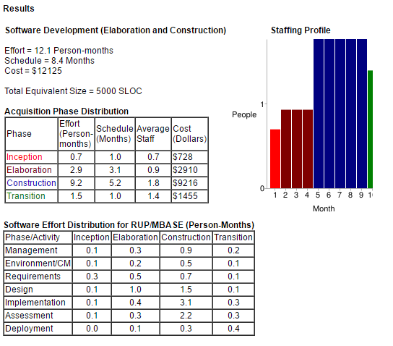

# Source Code

https://github.com/MengyuanZhu/SoftwareEngineering

# Gantt Chart