|  |  |  |  |  |  |
| --- | --- | --- | --- | --- | --- |
| **Measurement Parameter** | **Count** | **Simple** | **Average** | **Complex** |  |
|  | x | 3 | 4 | 6 | = |
|  | x | 4 | 5 | 7 | = |
|  | x | 3 | 4 | 6 | = |
|  | x | 7 | 10 | 15 | = |
|  | x | 5 | 7 | 10 | = |
| Count = Total   --------------------------------------------------------------------------------------- | | | | | |

*Note*. By clicking on the buttons above more information about the measurement parameters will be available.

Rate each factor (Fi, i=1 to14) on a scale of 0 to 5: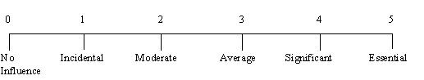

|  |  |
| --- | --- |
| F1.   Does the system require reliable backup and recovery? |  |
| F2.   Are data communications required? |  |
| F3.   Are there distributed processing functions? |  |
| F4.   Is performance critical? |  |
| F5.   Will the system run in a existing, heavily utilized operational environment? |  |
| F6.   Does the system require on-line data entry? |  |
| F7.   Does the on-line data entry require the input transaction to be built over multiple screens or operations? |  |
| F8.   Are the master files updated on-line? |  |
| F9.  Are the inputs, outputs, files or inquiries complex? |  |
| F10. Is the internal processing complex? |  |
| F11. Is the code designed to be reusable? |  |
| F12. Are conversion and installation included in the design? |  |
| F13. Is the system designed for multiple installations in different organizations? |  |
| F14. Is the application designed to facilitate change and ease of use by the user? |  |



***Result****.*  According to the input your project has:  