

|  |
| --- |
| Business Template  **Subject areas** |
| **Logo / Image** |

Contents

1 Business Description 3

1.1 Business background 3

1.2 Problems. Current Situation 3

1.3 The benefits of implementing a database. Project Vision 3

2 Model description 3

2.1 Definitions & Acronyms 3

2.2 Logical Scheme 3

2.3 Objects 3

# 

# Business Description

## Business background

The auction house operates as a marketplace where antiques, artwork, and valuable items are sold to the highest bidder. Sellers list their items for auction, and buyers place bids during scheduled auctions. The business ensures that each transaction is legally binding and maintains accurate records of all sales. This system helps facilitate trust between buyers and sellers while ensuring transparency in the auction process.

## Problems. Current Situation

The existing system for managing auction transactions relies heavily on manual record-keeping, which presents several challenges:

* **Inefficient tracking:** Paper-based records or spreadsheets make it difficult to track auction items, bids, and sales history.
* **Human errors:** Manual data entry increases the likelihood of mistakes in price listings, bid placements, and buyer/seller records.
* **Limited access:** Auction data is not easily accessible by authorized users, delaying decision-making processes.
* **Lack of security:** Without a centralized system, data integrity and security are at risk, making it difficult to verify transactions.

## the Benefits of implementing a database. Project Vision

To address these issues, an **Auction House Database** system will be implemented, providing the following benefits:

* **Improved Efficiency:** Automates auction item tracking, bid placement, and transaction records.
* **Data Accuracy:** Eliminates manual errors by enforcing data validation and constraints.
* **Accessibility:** Provides authorized employees with real-time access to auction data.
* **Security & Compliance:** Ensures that all transactions are securely stored and auditable.
* **Scalability:** Supports business growth by handling an increasing number of auctions, sellers, and buyers.

This database system will serve as the foundation for a robust and efficient auction house management platform.

# Model description

## Definitions & Acronyms

* **Auction:** A public sale in which goods or property are sold to the highest bidder.
* **Seller:** An individual or company that lists an item for auction.
* **Buyer:** An individual or company that places bids and purchases items from the auction.
* **Bid:** An offer made by a buyer to purchase an item at a specific price.
* **Lot Number:** A unique identifier assigned to an item for auction tracking.
* **Auction House:** The organization or platform that facilitates the auction process.
* **Transaction:** The finalization of a sale, where the highest bidder pays for an item.
* **Category:** A classification of auctioned items (e.g., antiques, paintings, collectibles).
* **Employee:** An individual responsible for managing auctions, processing transactions, or handling customer interactions.
* **Database:** A structured collection of data that organizes and stores auction-related information.

## Logical Scheme

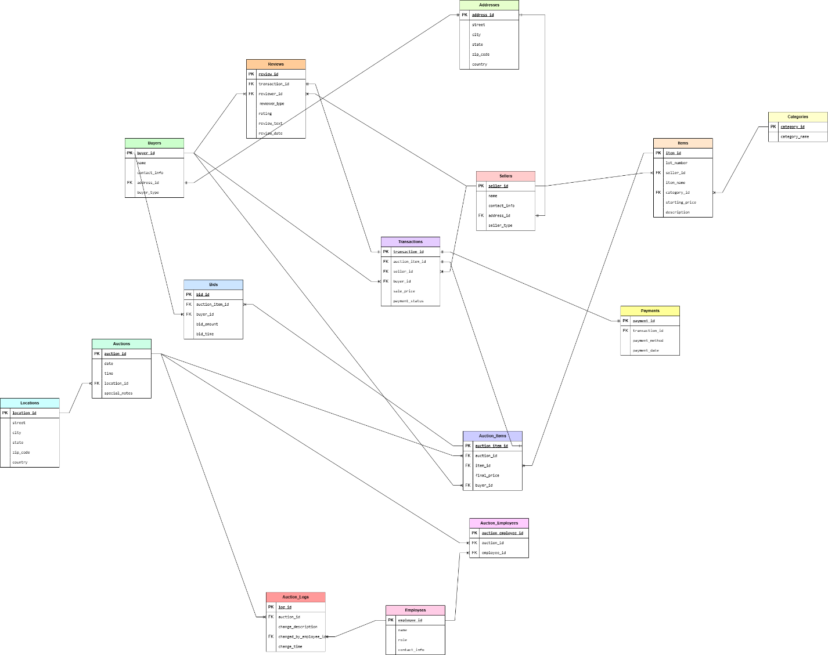

## Objects

**1. Table Description**

Stores information about sellers who list items for auction.

|  |  |  |  |
| --- | --- | --- | --- |
| Table Name | Field name | Field Description | Data Type |
| **Sellers** | seller_id | Unique ID for the seller, PK | INT (AUTO_INCREMENT) |
| name | Seller's name | VARCHAR(255), NOT NULL |
| contact_info | Seller's contact details | VARCHAR(255), NOT NULL |
| address_id | References Addresses table, FK | INT |
| seller_type | Indicates if seller is Individual/Company | ENUM('Individual', 'Company'), NOT NULL |

Sellers to Addresses, One-to-One Relationship (A seller has one address)

Example with data

|  |  |  |  |  |
| --- | --- | --- | --- | --- |
| seller_id | name | contact_info | address_id | seller_type |
| 1 | Charles Johnson | +7(701)-123-4567 | 5 | Individual |
| 2 | American Antiques | +7(771)-765-4321 | 8 | Company |

**2. Table Description**

Stores information about buyers who purchase auctioned items.

|  |  |  |  |
| --- | --- | --- | --- |
| Table Name | Field name | Field Description | Data Type |
| **Buyers** | buyer_id | Unique ID for the buyer, PK | INT (AUTO_INCREMENT) |
| name | Buyer's name | VARCHAR(255), NOT NULL |
| contact_info | Buyer's contact details | VARCHAR(255), NOT NULL |
| address_id | References Addresses table, FK | INT |
| buyer_type | Indicates if buyer is Individual/Company | ENUM('Individual', 'Company'), NOT NULL |

Buyers to Addresses, One-to-One Relationship (A buyer has one address)

Example with data

|  |  |  |  |  |
| --- | --- | --- | --- | --- |
| buyer_id | name | contact_info | address_id | buyer_type |
| 1 | Chloe Black | +7(701)-567-8910 | 3 | Individual |
| 2 | The History Savers | +7(771)-897-1065 | 11 | Company |

**3. Table Description**

Stores the addresses of buyers and sellers to avoid redundancy.

|  |  |  |  |
| --- | --- | --- | --- |
| Table Name | Field name | Field Description | Data Type |
| **Addresses** | address_id | Unique ID for the address, PK | INT (AUTO_INCREMENT) |
| street | Street name and number | VARCHAR(255), NOT NULL |
| city | City name | VARCHAR(100), NOT NULL |
| state | State or region | VARCHAR(100), NOT NULL |
| zip_code | ZIP or postal code | VARCHAR(20), NOT NULL |
| country | Country | VARCHAR(100), NOT NULL |

Addresses to Sellers & Buyers, an address can belong to one seller, an address can belong to one buyer

Example with data

|  |  |  |  |  |  |
| --- | --- | --- | --- | --- | --- |
| address_id | street | city | state | zip_code | country |
| 1 | 383 Kennedy | Springfield | Illinois | 62701 | USA |
| 2 | 543 Winter | Salt Lake City | Utah | 84101 | USA |

**4. Table Description**

Stores details of items that are auctioned.

|  |  |  |  |
| --- | --- | --- | --- |
| Table Name | Field name | Field Description | Data Type |
| **Items** | item_id | Unique ID for each item, PK | INT (AUTO_INCREMENT) |
| lot_number | Unique identifier for an item | VARCHAR(50), UNIQUE, NOT NULL |
| seller_id | References Sellers table, FK | INT |
| item_name | Name of the item | VARCHAR(255), NOT NULL |
| category_id | References Categories table, FK | INT |
| starting_price | Initial auction price | DECIMAL(10,2) CHECK(starting_price > 0), NOT NULL |
| description | Description of the item | TEXT |

Sellers to Items, one seller can have multiple items, but each item belongs to one seller

Example with data

|  |  |  |  |  |  |  |
| --- | --- | --- | --- | --- | --- | --- |
| item_id | lot_number | seller_id | item_name | category_id | starting_price | description |
| 1 | AJ200870 | 6 | Chanel Sac a Rabat Flap Bag | 5 | 1500.00 | Chanel 'Sac a Rabat' flap bag in marine fonce satin with canted squares of dark blue sequin quilted pattern. |
| 2 | LR489034 | 10 | US Coin Assortment | 3 | 1200.00 | NULL |

**5. Table Description**

Stores different item categories to prevent data duplication.

|  |  |  |  |
| --- | --- | --- | --- |
| Table Name | Field name | Field Description | Data Type |
| **Categories** | category_id | Unique ID for each category, PK | INT (AUTO_INCREMENT) |
| category_name | Name of the category | VARCHAR(255), UNIQUE |

Categories to Itmes, a category can have many items, an item belongs to one category

Example with data

|  |  |
| --- | --- |
| category_id | category_name |
| 3 | Jewelry |
| 5 | Coins |

**6. Table Description**

Stores details of auctions where items are sold.

|  |  |  |  |
| --- | --- | --- | --- |
| Table Name | Field name | Field Description | Data Type |
| **Auctions** | auction_id | Unique ID for each auction, PK | INT (AUTO_INCREMENT) |
| date | Date of the auction | DATE, NOT NULL |
| time | Time of the auction | TIME, NOT NULL |
| location_id | References Locations table, FK | INT |
| special_notes | Additional auction details | TEXT |

Auctions to Locations, each auction takes place at one location, but a location can host multiple auctions

Example with data

|  |  |  |  |  |
| --- | --- | --- | --- | --- |
| auction_id | date | time | location_id | special_notes |
| 1 | 2025-03-14 | 09:00:00 | 3 | Charity Auction |
| 2 | 2019-10-09 | 12:00:00 | 11 | NULL |

**7. Table Description**

Stores the locations where auctions take place.

|  |  |  |  |
| --- | --- | --- | --- |
| Table Name | Field name | Field Description | Data Type |
| **Locations** | location_id | Unique ID for each location, PK | INT (AUTO_INCREMENT) |
| street | Street address | VARCHAR(255), NOT NULL |
| city | City name | VARCHAR(100), NOT NULL |
| state | State or region | VARCHAR(100), NOT NULL |
| zip_code | Postal code | VARCHAR(20), NOT NULL |
| country | Country | VARCHAR(100), NOT NULL |

Auctions to Locations, each auction takes place at one location, but a location can host multiple auctions

Example with data

|  |  |  |  |  |  |
| --- | --- | --- | --- | --- | --- |
| location_id | street | city | state | zip_code | country |
| 3 | 780 Greg | Carson City | Nevada | 89701 | USA |
| 11 | 8827 152b | Edmonton | Alberta | T5A 0A1 | Canada |

**8. Table Description**

Links auctions and items, representing a Many-to-Many relationship.

|  |  |  |  |
| --- | --- | --- | --- |
| Table Name | Field name | Field Description | Data Type |
| **Auction_Items** | auction_item_id | Unique ID for the buyer, PK | INT (AUTO_INCREMENT) |
| auction_id | Buyer's name | INT |
| item_id | Buyer's contact details | INT |
| final_price | References Addresses table, FK | DECIMAL(10,2) CHECK(final_price > 0), NOT NULL |
| buyer_id | Indicates if buyer is Individual/Company | INT |

Buyers to Auction_Items, a buyer can purchase multiple auctioned items, and an item can be purchased by one buyer

Auction_Items to Auctions & Items, Many-to-Many relationship between auctions and items is handled via the Auction_Items table

Example with data

|  |  |  |  |  |
| --- | --- | --- | --- | --- |
| auction_item_id | auction_id | item_id | final_price | buyer_id |
| 1 | 5 | 51 | 3000.00 | 871 |
| 2 | 9 | 13 | 1500.00 | 47 |

**9. Table Description**

Stores financial records of completed sales for auctioned items.

|  |  |  |  |
| --- | --- | --- | --- |
| Table Name | Field name | Field Description | Data Type |
| **Transactions** | transaction_id | Unique ID for each transaction, PK | INT (AUTO_INCREMENT) |
| auction_item_id | References Auction_Items table, FK | INT |
| seller_id | References Sellers table, FK | INT |
| buyer_id | References Buyers table, FK | INT |
| sale_price | Final sale price of the item | DECIMAL(10,2) CHECK(sale_price > 0), NOT NULL |
| payment_status | Status of payment | ENUM ('Pending', 'Completed', 'Cancelled'), NOT NULL |

Transactions to Auction_Items, Sellers, Buyers, each transaction is linked to an auctioned item, a seller, and a buyer

Example with data

|  |  |  |  |  |  |
| --- | --- | --- | --- | --- | --- |
| transaction_id | auction_item_id | seller_id | buyer_id | sale_price | payment_status |
| 36 | 57 | 38 | 3 | 8999 | Completed |
| 95 | 360 | 78 | 11 | 1785 | Pending |

**10. Table Description**

Stores information about buyers who purchase auctioned items.

|  |  |  |  |
| --- | --- | --- | --- |
| Table Name | Field name | Field Description | Data Type |
| **Bids** | bid_id | Unique ID for each bid, PK | INT (AUTO_INCREMENT) |
| auction_item_id | References Auction_Items table, FK | INT |
| buyer_id | References Buyers table, FK | INT |
| bid_amount | Amount offered for the item | DECIMAL(10,2) CHECK(bid_amount > 0), NOT NULL |
| bid_time | Timestamp of the bid | TIMESTAMP DEFAULT CURRENT_TIMESTAMP |

Bids to Auction_Items & Buyers, Many-to-Many relationship between buyers and auction items is handled via the Bids table

Example with data

|  |  |  |  |  |
| --- | --- | --- | --- | --- |
| bid_id | auction_item_id | buyer_id | bid_amount | bid_time |
| 55 | 89 | 101 | 6500.00 | 2010-05-12 15:24:45 |
| 312 | 127 | 97 | 2200.00 | 2025-03-12 09:30:01 |

**11. Table Description**

Stores details of auction house employees.

|  |  |  |  |
| --- | --- | --- | --- |
| Table Name | Field name | Field Description | Data Type |
| **Employees** | employee_id | Unique ID for each employee, PK | INT (AUTO_INCREMENT) |
| name | Employee's name | VARCHAR(255), NOT NULL |
| role | Role in the auction house | VARCHAR(100), NOT NULL |
| contact_info | Employee's contact details | VARCHAR(255), NOT NULL |

Employees to Auction_Employees, Many-to-Many relationship between auctions and employees is handled via the Auction_Employees table

Example with data

|  |  |  |  |
| --- | --- | --- | --- |
| employee_id | name | role | contact_info |
| 3 | Daniel Smith | Manager | +7701-564-4578 |
| 7 | Noah Jackson | Manager | +771-951-7535 |

**12. Table Description**

Links employees to auctions they manage, representing a Many-to-Many relationship.

|  |  |  |  |
| --- | --- | --- | --- |
| Table Name | Field name | Field Description | Data Type |
| **Auction_Employees** | auction_employee_id | Unique ID, PK | INT (AUTO_INCREMENT) |
| auction_id | References Auctions table, FK | INT |
| employee_id | References Employees table, FK | INT |

Auction_Employees to Auctions & Employees, Many-to-Many relationship between auctions and employees is handled via the Auction_Employees table

Example with data

|  |  |  |
| --- | --- | --- |
| auction_employee_id | auction_id | employee_id |
| 1 | 2 | 5 |
| 2 | 4 | 6 |

**13. Description**

Stores details of payments for auction transactions.

|  |  |  |  |
| --- | --- | --- | --- |
| Table Name | Field name | Field Description | Data Type |
| **Payments** | payment_id | Unique ID for each payment, PK | INT (AUTO_INCREMENT) |
| transaction_id | References Transactions table, FK | INT |
| payment_method | Mode of payment | ENUM ('Credit Card', 'Bank Transfer', 'PayPal', 'Cash'), NOT NULL |
| payment_date | Date of payment | DATE, NOT NULL |

Payments to Transactions, each transaction has a corresponding payment

Example with data

|  |  |  |  |
| --- | --- | --- | --- |
| payment_id | transaction_id | payment_method | payment_date |
| 1 | 56 | Credit Card | 2024-08-07 |
| 2 | 15 | Cash | 2024-09-25 |

**14. Table Description**

Stores logs of changes made to auction records for tracking and security.

|  |  |  |  |
| --- | --- | --- | --- |
| Table Name | Field name | Field Description | Data Type |
| **Auction_Logs** | log_id | Unique ID for each log, PK | INT (AUTO_INCREMENT) |
| auction_id | References Auctions table, FK | INT |
| change_description | Description of changes made | TEXT, NOT NULL |
| changed_by_employee_id | References Employees table, FK | INT |
| change_time | Timestamp of change | TIMESTAMP DEFAULT CURRENT_TIMESTAMP |

Auction_Logs to Auctions & Employees, employees log changes made to auctions for tracking purposes.

Example with data

|  |  |  |  |  |
| --- | --- | --- | --- | --- |
| log_id | auction_id | change_description | changed_by_employee_id | change_time |
| 71 | 17 | Cancelled the Transaction | 3 | 2025-01-02 15:56:47 |
| 95 | 23 | 4th bid:4500 | 11 | 2025-02-05 17:45:36 |

**15. Table Description**

Stores buyer and seller reviews on transactions.

|  |  |  |  |
| --- | --- | --- | --- |
| Table Name | Field name | Field Description | Data Type |
| **Reviews** | review_id | Unique ID for each review, PK | INT (AUTO_INCREMENT) |
| transaction_id | References Transactions table, FK | VARCHAR(255), NOT NULL |
| reviewer_id | ID of the buyer or seller who submitted the review | VARCHAR(255), NOT NULL |
| reviewer_type | Specifies if reviewer is Buyer or Seller | ENUM ('Buyer', 'Seller') |
| rating | Rating given (1-5) | INT CHECK(rating BETWEEN 1 AND 5) |
| review_text | Text review content | TEXT |
| review_date | Date of review submission | DATE DEFAULT CURRENT_DATE |

Reviews to Transactions, each transaction can have one review from either a buyer or a seller.

Example with data

|  |  |  |  |  |  |  |
| --- | --- | --- | --- | --- | --- | --- |
| review_id | transaction_id | reviewer_id | reviewer_type | rating | review_text | review_date |
| 36 | 85 | 56 | Buyer | 5 | I’m glad that I’ve purchased that | 2017-07-30 |
| 52 | 75 | 85 | Seller | 3 | NULL | 2019-02-07 |