Regression linéaire

Lusmat Menjy Willy CHARLES

2022-12-08

#Importation des données

donnees=read.csv("CreditBancaire.csv")  
attach(donnees)

#Régression du nombre de jours de retard

lin=lm(Jours~Credit+Type, data = donnees)  
lin

##   
## Call:  
## lm(formula = Jours ~ Credit + Type, data = donnees)  
##   
## Coefficients:  
## (Intercept) Credit TypeConsommation TypeProduction   
## 8.519e+01 -5.484e-06 -1.486e+01 1.498e+01

#Affichage des résultats detaillés de la regression

sim=summary(lin)  
sim

##   
## Call:  
## lm(formula = Jours ~ Credit + Type, data = donnees)  
##   
## Residuals:  
## Min 1Q Median 3Q Max   
## -96.26 -69.22 -49.06 17.29 270.22   
##   
## Coefficients:  
## Estimate Std. Error t value Pr(>|t|)   
## (Intercept) 8.519e+01 1.275e+01 6.681 1.63e-10 ***  
## Credit -5.484e-06 1.182e-05 -0.464 0.643   
## TypeConsommation -1.486e+01 1.472e+01 -1.009 0.314   
## TypeProduction 1.498e+01 2.532e+01 0.591 0.555   
## ---  
## Signif. codes: 0 '***' 0.001 '**' 0.01 '*' 0.05 '.' 0.1 ' ' 1  
##   
## Residual standard error: 104 on 241 degrees of freedom  
## Multiple R-squared: 0.007512, Adjusted R-squared: -0.004842   
## F-statistic: 0.608 on 3 and 241 DF, p-value: 0.6104

#Affichage de t value et les probabilités

summary(lin)$coefficients[,3]

## (Intercept) Credit TypeConsommation TypeProduction   
## 6.6809256 -0.4637417 -1.0090929 0.5913659

summary(lin)$coefficients[,4]

## (Intercept) Credit TypeConsommation TypeProduction   
## 1.630050e-10 6.432514e-01 3.139421e-01 5.548295e-01

#Affichage des coefficients estimés et t value

summary(lin)$coefficients[,1]

## (Intercept) Credit TypeConsommation TypeProduction   
## 8.519082e+01 -5.483559e-06 -1.485726e+01 1.497503e+01

summary(lin)$coefficients[,3]

## (Intercept) Credit TypeConsommation TypeProduction   
## 6.6809256 -0.4637417 -1.0090929 0.5913659

#graphique en nuage de points

plot(Jours~Credit,pch=20)  
abline(lm(Jours~Credit,data = donnees),col='yellow',lwd=3)

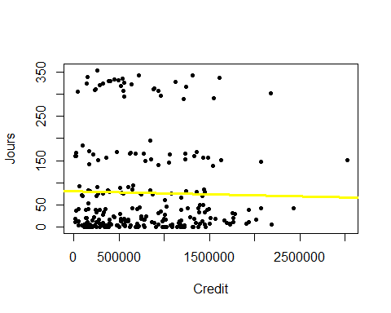

#Creation d’une fonction

freg=function(data){  
 regress<-summary(lm(y ~.,data=data))  
 estimate<-regress$coefficients[,1]  
 tvalue<-regress$coefficients[,3]  
 return(data.frame(estimate,tvalue))  
}

#Verifions la fonction

x=c(2,7,12,17,22,27,32,37,42,49)  
y=c(1,2,3,4,5,6,7,8,9,10)  
data=data.frame(x,y)  
freg(data)

## estimate tvalue  
## (Intercept) 0.6713511 9.694503  
## x 0.1954919 81.117713