Dear Diary Combined Implementation Report
  - Phase 4 Editor Architecture and Neon PostgreSQL Setup
Prepared 01/11/2026 · Asia/Kolkata · Owner review
The editor architecture is implemented locally, and the app has a verified server-side connection to Neon PostgreSQL. The final verification run passed 123 unit/integration tests and 60 production browser tests. The approved diary design and DD/MM/YYYY navigation are preserved.
Diary writing remains in memory. A successful database connectivity check does not save an entry. The interface continues to show Preview · not saved, and refresh or tab closure discards temporary writing.

Current implementation status
Area | Current status
Phases 1 through 3 | Approved and closed
Phase 4 editor architecture | Implemented and locally verified; awaiting owner review
Neon PostgreSQL setup | Separately authorized; initialization, deployment and live connectivity verified
Diary authentication | Unimplemented; Neon CLI sign-in authenticates the operator only
Diary entry persistence | Contracts defined; no production entry adapter, tables or mutations
Autosave and IndexedDB | Unimplemented; remain later-phase work
Git and remote CI | Changes remain uncommitted and unpushed; no new remote CI run
Frontend hosting | No frontend deployment performed

The workspace is /home/menma/Downloads/Diary, branch main. HEAD remains 2210ef2b59bf4cd1299f370407176aa5d9e74ed6, the approved Phase 3 commit. Its Foundation checks run 41289750313 succeeded. That historical result does not verify the current uncommitted changes.
The controlling baseline is v1.1 together with later owner instructions. The explicit Neon request replaces the originally planned Supabase database for this connection setup. It enabled PostgreSQL only; no Neon Auth service or alternative diary login was introduced. The original PRD and approved Word plans remain unchanged. Existing Phase 4 work was preserved during Neon setup.

Editor architecture and behavior
Phase 4 replaces direct mutation of textarea draft records with a small, React-independent model and controller. The existing persistent diary layout continues to own the workspace, so date navigation retains each date's document and editing position.
Component or module | Responsibility
Date page and DiaryPreview | Date context, diary composition, navigation and guarded focus intent
DiarySession | Retain the in-memory editor workspace and separate theme state
editor-model.ts | Immutable plain-text state, invariants and explicit transitions
editor-workspace.ts | Independent date records, subscriptions and editing-session tokens
useDiaryEditor.ts | Connect React to the selected date and capture selection/scroll
DiaryPaper and DiaryEditor | Present the existing paper and handle controlled native textarea input

The model reuses CalendarDate. A document contains only its date and text. Ready state includes an immutable baseline, local revision, selection range/direction, document scroll position, editable/read-only mode and idle/composing phase. Selection uses the textarea's UTF-16 offsets. The code preserves native text without trimming or introducing a rich-text format.
Lifecycle is not-loaded → ready → disposed. Initial load validates the document date. Loading a ready editor again is rejected, preventing an obsolete read from replacing current writing. Ordinary navigation disconnects its editing session and retains the document; it does not dispose of the draft.
Event | Implemented behavior
load | Initialize once from a document or known missing result
input | Record exact text/selection; advance revision for changed content
replace | Explicitly replace all content and model the caret at its end
clear | Retain a present empty document instead of deleting its record
position | Capture valid selection and scroll without dirtying content
mode | Change editability without resetting content or position
composition | Track intermediate native input; block programmatic replacement while composing
dispose | End the pure-model lifecycle; unavailable as an ordinary workspace edit

A missing document is null; an explicitly empty document contains content: "". Dirty state compares both presence and exact text with the local baseline. It never implies a server acknowledgement. Invalid transitions return typed failure reasons and leave the previous state intact.
Each mounted editor has a token tied to its date. A replacement connection invalidates its predecessor, so stale input, blur or cleanup cannot change the replacement's draft. Theme changes retain the textarea node, focus and selection. Date revisits restore the correct text, selection direction and scroll while respecting a newer deliberate focus choice. Long writing grows the document without nested editor scrolling.

Persistence and save contracts
The editor owns editing behavior; future adapters own persistence. The live Neon connection is not connected to the EntryPersistence interface and does not read or write diary entries.
EntryPersistence defines read(date) and write(date, request). A future implementation must be scoped to the verified diary owner. Client-supplied ownership is rejected by the request schema. Reads distinguish a successful missing entry from a failed request: missing means exists: false, empty text and version 0; an existing empty entry has exists: true and a positive version.
Writes contain exact content, a base version and UUID mutation ID. An immutable mutation snapshot also captures its date and local revision. Validators reject mismatched response dates, acknowledgements with the wrong date/ID/version, unsafe numeric versions and invalid IDs. Server content contracts enforce the planned 256 KiB UTF-8 limit and reject null characters without trimming text. Fake-adapter tests exercise the interface; no production entry adapter or server save engine is active.

Future server save states
State | Meaning
not-loaded | No authoritative entry result is available
loading | An authoritative read is pending
unchanged | A result is loaded without subsequent edits
unsaved | The current revision lacks server acknowledgement
saving | A particular immutable mutation remains unresolved
saved | A matching acknowledgement covers the latest local revision
save-failed | Preserve text and exact unresolved mutation metadata
conflict | Preserve local and remote versions for a later deliberate decision

These are contracts for future integration. An older acknowledgement must not mark newer text saved or replace editor content. A future device transaction may mean “Draft stored on this device”; it cannot produce the server Saved indicator.

Recovery boundary
The version 1 recovery record contains the owner/date/writer key, latest text and local revision, base server version, update timestamp and optional exact unresolved mutation. Newer text and an older pending snapshot are retained separately. Local drafts can retain text that server validation rejects, including oversized content, so validation cannot silently destroy writing.
RecoveryStorage defines owner-scoped enumeration, ordered transactional commits and conditional acknowledgement/cleanup. Older commits cannot regress revisions or resurrect an acknowledged mutation. Cleanup may remove a record only when the latest revision is acknowledged. Timestamps never select a winning draft. IndexedDB, reconciliation, actual transactional ordering and storage-failure handling remain unimplemented.
Future authentication must supply a verified owner before entry persistence is connected. The Neon operator login and pooled database credentials do not authenticate a diary user. The later schema, authorization and atomic-save design must account for Neon PostgreSQL rather than assuming Supabase-specific database authentication context.

Neon configuration and dependencies
The requested initialization and deployment targeted the existing project and production branch. No second project or development branch was created.
Configuration | Value or purpose
Organization | org-blue-night-62231221
Project | spring-bar-19934102 — Diary
Branch | production / br-holy-heart-b4yqhxus
Utilized service | PostgreSQL only
Policy | neon.ts; existing branch already matched it
App connection | Pooled DATABASE_URL
Future migration connection | DATABASE_URL_UNPOOLED; unused by the app
Branch metadata | NEON_BRANCH

Neon pulled the three variables into ignored .env.local, retaining the existing origin/timezone. Local environment permissions are 0600. .neon is ignored local project metadata. No connection strings, passwords or tokens are included in this report or browser responses.
The new postgres.server.ts module is protected with server-only and validates configuration through @neon/env. It creates a pool lazily, so builds do not contact the database. The pool has at most two connections, ten-second connection/query timeouts, certificate/hostname verification with sslmode=verify-full, and channel binding enabled. It caches only connections, never diary content or user identity. Vercel's lifecycle helper is attached when the Vercel runtime is detected; production Vercel hosting has not been tested.
GET /api/health/postgres runs only SELECT 1::integer AS connected and checks the returned value. It returns connected/unavailable status without database identity or raw driver errors, uses private/no-store responses, and returns HTTP 503 on failure. This is the only active database query added to the application.
Added dependency | Pinned version | Purpose
@neon/config | 1.10.0 | Neon policy
@neon/env | 1.6.8 | Injected environment validation
pg | 8.23.1 | Server PostgreSQL driver
@vercel/functions | 3.10.5 | Pool lifecycle on Vercel
@types/pg | 8.23.1 | Development-only TypeScript definitions

Runtime remains Node 24.22.1 and pnpm 12.8.1. Neon CLI is 8.16.0. Phase 4 itself added no dependencies; these additions belong to the subsequent Neon task. Existing direct Next.js, React, TypeScript, Vitest and Playwright versions remain pinned, and no npm lockfile was introduced. The CLI also installed global Neon agent tooling.

Verification results and command evidence
Check | Phase 4 result | Final result after Neon wiring
Unit/integration tests | 116 passed in 8 files | 123 passed in 9 files
Production browser tests | 60 passed | 60 passed
Lint and strict TypeScript | Passed | Passed
Production build | Passed | npm run build passed
Accessibility | Zero axe violations | Zero axe violations in the existing suite
Public output scan | 27 assets/payloads | 27; configured database credentials absent
Real database connection | Not part of Phase 4 | HTTP 200 after real PostgreSQL SELECT 1
Peer dependencies and whitespace | Passed | Passed

The final 123-test count includes the earlier 116 tests plus seven new PostgreSQL configuration/health-route cases; the counts must not be added together. The browser suite covers desktop, 320 px and 390 px Chromium, all four themes, calendar focus, navigation/history, isolated drafts, selection/scroll, native paste/undo, long writing, overflow and reflow. Its 24 axe scans cover the diary and open calendar in all four themes across three projects.
The deployment command completed successfully. PostgreSQL was already present:
No changes — branch production already matches the policy.
Utilized services: Postgres
Pulled 3 Neon variables into .env.local
Recorded npm run build output included:
> dear-diary@0.1.0 build
> next build
✓ Compiled successfully in 3.2s
Finished TypeScript in 3.4s ...
✓ Generating static pages using 7 workers (2/2) in 370ms
The production app was started with npm run start -- --port 3100. Actual npm run neon:check output:
GET /api/health/postgres: HTTP 200
{"status":"ok","services":{"postgres":"connected"}}
PASS: running Next.js route executed the read-only PostgreSQL SELECT 1 check.
PASS: diary HTTP 200; configured database credentials absent from rendered HTML.
This traversed the running HTTP server, Next.js handler and real pg driver. It proves the configured service is reachable; it does not prove diary entry persistence or owner authorization. Full setup commands and build output are retained in the Neon setup report.

Visual preservation and evidence
The Phase 4 production captures retained the approved paper, Sakura palette, typography, corners, controls and truthful status. Desktop, 390 px and 320 px Sakura PNGs were byte-identical to the approved Phase 3 captures. The desktop paper remained 1005 × 502 px at (24, 80), with 44 px rules; mobile retained 34 px rules. All six captures had no browser errors or horizontal overflow.
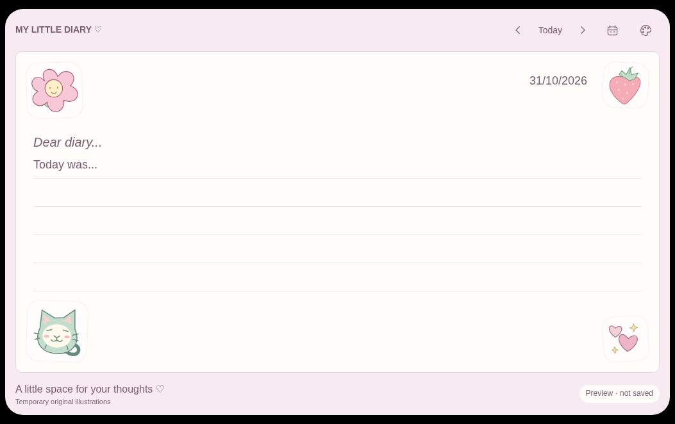
Desktop production capture at 1053 × 662 px.
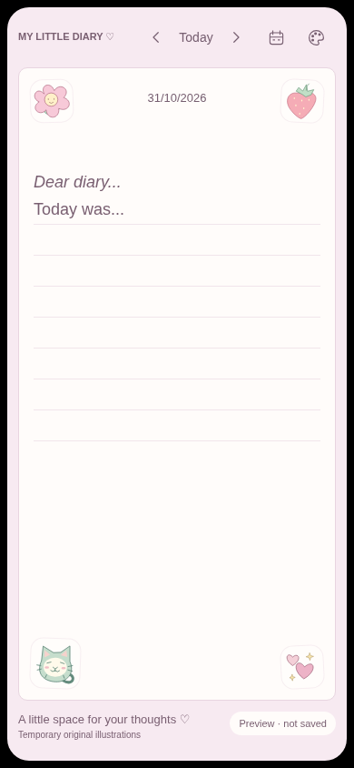
Mobile production capture at 390 × 844 px.
The Neon task changed no editor or visual implementation file. Twenty-one existing editor-related files were compared byte-for-byte with the pre-Neon private backup, with no differences. The final browser suite also passed after Neon wiring. The displayed captures are Phase 4 evidence; they were not recaptured for this combined report.
Additional evidence: 320 px mobile, Dreamy Sky, Lavender Dreams, Vintage Journal, and geometry and hashes.

Combined file inventory
The following inventory is relative to the approved Phase 3 commit. It includes earlier Phase 4 work and the subsequent Neon setup. It does not imply that all files changed during Neon wiring.

Modified files
- .env.example
- .gitignore
- README.md
- package.json
- pnpm-lock.yaml
- scripts/check-client-output.mjs
- src/components/diary/DiaryPaper.tsx
- src/components/diary/DiaryPreview.tsx
- src/components/diary/DiarySession.tsx

Created implementation and test files
- neon.ts
- src/lib/diary/editor-model.ts
- src/lib/diary/editor-workspace.ts
- src/lib/diary/persistence-contracts.ts
- src/lib/postgres-config.ts
- src/lib/postgres.server.ts
- src/components/diary/DiaryEditor.tsx
- src/components/diary/useDiaryEditor.ts
- src/app/api/health/postgres/route.ts
- tests/unit/editor.test.ts
- tests/unit/editor-component.test.tsx
- tests/unit/persistence-contracts.test.ts
- tests/unit/postgres.test.ts
- tests/e2e/editor.spec.ts
- scripts/capture-phase-4.mjs
- scripts/check-neon.mjs

Created reports and review evidence
- docs/phase-4-report.md
- docs/neon-setup-report.md
- docs/phase-4-neon-combined-report.md
- documents/Dear_Diary_Phase_4_and_Neon_Combined_Report.docx
- artifacts/phase-4/desktop.png
- artifacts/phase-4/mobile.png
- artifacts/phase-4/mobile-320.png
- artifacts/phase-4/dreamy-sky.png
- artifacts/phase-4/lavender-dreams.png
- artifacts/phase-4/vintage-journal.png
- artifacts/phase-4/layout-metrics.json
No files were deleted. Ignored .neon and .env.local were created/updated locally. Existing approved Word planning documents, Phase 2/3 evidence, CSS, illustrations and GitHub workflow were preserved. No app code changed while preparing this combined report.

Resolved setup failures and remaining limits
The initial Neon login failed with invalid_grant. The user's shell selected Neon 5.0.0, while an earlier installation had updated a different Node runtime. The relevant CLI installations were upgraded to 8.16.0, the user completed browser sign-in, and the DEFAULT OAuth session was verified before setup resumed.
An authenticated initialization then linked the project and pulled environment variables, but its skills installer failed under Node 20.20.2. Re-running the requested initialization using the app's Node 24.22.1 runtime succeeded and preserved the generated policy. The pre-existing ESLint deprecation notice did not fail verification. No unresolved setup, build or connectivity failure was reported by the completed runs.
Writing is still volatile. The workspace retains visited dates during its mounted tab/layout lifetime, without eviction, and memory can grow with usage. Refresh, tab closure or a full document reload discards drafts. There is no durable local buffer, cross-device synchronization or production save guarantee.
Composition was tested through DOM events, and browser tests used Chromium emulation. Real OS IME, iOS Safari/Android keyboard, screen-reader and production Vercel verification remain outstanding. Native undo across dates, remounts or reloads is not promised. The connection pool's Vercel path is prepared but was tested locally through the ordinary Node server.

Remaining inputs and implementation work
The owner email and account-recovery responsibility are needed before diary authentication provisioning. Verified-owner authorization must precede entry persistence. Later work must implement the Neon-compatible schema, permissions, version-checked atomic writes, exact mutation retries, save engine and mandatory IndexedDB reconciliation against the established contracts.
Final illustration rights/assets remain a later acceptance item. Hosting budget, regions, backup retention, acceptable data-loss window and restoration-time target remain production-provisioning decisions. Neither the CLI account nor a successful health probe resolves those requirements.

Owner review checklist
- ☐ Accept the Phase 4 model, transitions, editing behavior and contract boundaries.
- ☐ Confirm the unchanged diary presentation and navigation are accepted.
- ☐ Acknowledge that Neon connectivity is verified while diary writing remains unsaved.
- ☐ Authorize commit/push and exact-commit remote CI verification if desired.
- ☐ Separately authorize Phase 5 before authentication work begins.
The working tree contains the local implementation and reporting changes. Nothing has been committed or pushed. No frontend deployment was performed, and no Phase 5 authentication or Phase 6 diary persistence was implemented. The latest approved remote CI result remains the Phase 3 run linked at the beginning of this report.
The last verified local preview is http://127.0.0.1:3100/. Runtime commands and troubleshooting are in the README.

Source reports and technical references
Source handoffs: Phase 4 editor architecture, Neon setup and verification, and Phase 3 implementation.
Technical references: Neon connection methods, Neon Vercel guidance, node-postgres SSL, and node-postgres pooling.

