Dear Diary Consolidated Implementation Baseline
  - Approved decisions dependencies and final review checklist
Version 1.1 | 31 October 2026 | Baseline for final review
This version 1.1 baseline records the owner's approved product and architecture decisions and aligns the technical plan with the phase guide. It controls scope, recovery behavior, acceptance, and phase dependencies where version 1.0 wording differs. The detailed technical and phase documents retain their supporting specifications under the same version.
Architecture and implementation order are approved subject to these incorporated clarifications. Application development remains on hold. Beginning Phase 1 requires a separate explicit owner instruction.

1 Recorded owner decisions
Area | Baseline decision
Stack | Next.js App Router, strict TypeScript, Supabase PostgreSQL and Auth, Zod, CSS Modules, Vitest, and Playwright. Retain the existing runtime and tooling recommendations pending compatibility checks at setup.
Entry model | One entry per authenticated owner and calendar date; enforce composite uniqueness. Retain explicitly cleared entries.
Editor | Native textarea with freeform text and browser editing. No rich-text editor, mandatory title, metadata, or writing prompt.
Themes | Sakura Pink, Dreamy Sky, Lavender Dreams, and Vintage Journal. Sakura is the initial theme.
Decorations | Deterministic owner, date, theme, and manifest version selection; visually varied across dates, stable across refreshes and re-renders.
Timezone | Asia/Kolkata initially. Keep calendar dates independent of UTC timestamps.
FR-19 | IndexedDB recovery is approved and mandatory in the MVP and Phase 6. Local recovery never acknowledges a server save.
FR-18 and FR-20 | Shuffle and custom decorative uploads are excluded from the MVP. Bundled licensed illustrations remain required.
Safeguards | Retain version-checked writes, exact mutation retries, ownership checks, server validation, constraints, conflict resolution, private responses, and backup verification.
Interface | Diary dominates; compact navigation; no dashboard or sidebar; prioritize mobile writing and editing continuity.

Required release scope is FR-01 through FR-17 plus FR-19. This does not introduce full offline-first architecture or automatic conflict merging.

2 Inspected visual reference
The original screenshot was reattached and inspected on 31 October 2026. It is now available for Phase 2; there is no outstanding request to attach it. Its dimensions are 1053 by 662 pixels.
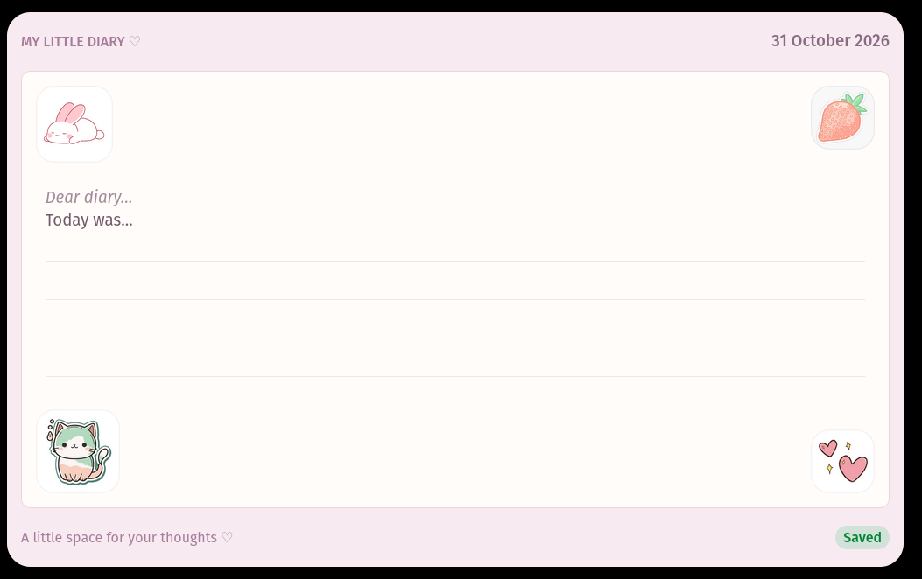
Original visual reference supplied by the owner on 31 October 2026
The image shows a pale pink rounded frame, a compact header, a large warm paper panel with a fine solid border, four small corner sticker tiles, muted mauve labels, light ruled lines, and a small footer save badge. The paper occupies most of the interface. These observed features replace the earlier provisional blue background, striped separator, illustrated header, and stitched border assumptions.
Sampled Sakura colors are frame #F7EAF1, paper #FFFCFA, border #E8D5E0, and ruled lines #F1E5EB. Other approved themes remain available. Calibrate desktop rules against approximately 44 px spacing and preserve comfortable mobile line height and text size.
The screenshot places the date in its outer header. Preserve the PRD requirement by placing the selected date in the paper's top-right region and keeping navigation compact. Record this functional adaptation during visual review. Sample text is illustrative, and the Saved badge must obey real server acknowledgement. Do not infer permission to reuse artwork from the screenshot alone.
Phase 2 completion requires direct comparison of an implemented page against this reference. Inspection of the reference during planning is not implementation acceptance.

3 Phase dependencies and completion conditions
Phase | Required outcome and dependency
1 Foundation | Explicit start authorization, fresh workspace inspection, pinned tooling, tokens, CI, and recovery contract boundaries.
2 Visual diary | Phase 1 complete; use the available screenshot; sign off implemented paper, frame, stickers, controls, mobile layout, and intentional adaptations.
3 Dates | Phase 2 complete; canonical date routes, today, picker, history, and tested calendar arithmetic.
4 Editor | Phase 3 complete; native editing, persistent draft ownership, per-date selection and scroll, and recovery adapter contracts.
5 Authentication | Phase 4 complete; provision the owner; verify login, cookies, expiry, privacy, and authorization before diary persistence.
6 Database autosave and recovery | Phase 5 complete and Phase 4 contracts ready; implement atomic server saves and mandatory IndexedDB recovery together.
7 Themes | Phase 6 complete; persist theme and timezone independently, preserving focus, drafts, and recovery.
8 Decorations | Phase 7 complete and artwork rights resolved; deterministic manifest and mobile-safe placement.
9 Mobile and accessibility | Phases 2 through 8 complete; verify keyboard, focus, selection, recovery, zoom, and touch behavior on real devices.
10 Release | All mandatory phases and screenshot acceptance complete; pass regression, environment isolation, backups, restoration, and production checks.

Responsive and accessibility work begins in Phase 2 and is refined throughout. Phase 9 is the completion review, not the first mobile implementation. No phase is complete merely because its dependency is documented as outstanding.

4 Editing and visual acceptance
During autosave, preserve the textarea node, focus, selection range and direction, and scroll position. Theme changes must not change content or remount the editor; restore previous writing focus after the control interaction unless the owner has made a newer deliberate focus choice.
Capture each date's selection and scroll before navigating. After loading the target, restore its remembered selection or use the end of the text for a new date. Restore focus only when navigation began from active editing and no later focus choice supersedes it. Keep calendar dialog focus accessible and avoid unexpected mobile keyboard activation. Do not promise one native undo history across different entries or reloads.
Visual acceptance must confirm the dominant paper surface, compact navigation, accurate reference proportions, subtle border and lines, quiet footer, and non-obstructing corner tiles. Test 320 px layouts, mobile keyboards, visible focus, touch targets, and 200 percent zoom. Never turn sample screenshot writing into mandatory prompts or prefilled saved content.

5 Required local recovery contract
Use a versioned IndexedDB record keyed by owner UUID, calendar date, and independent writer UUID. Store the latest draft, local revision, acknowledged base server version, schema version, update timestamp, and any unresolved mutation's exact snapshot, base version, and mutation ID. Separate records preserve competing drafts from multiple tabs. Never select a winning draft by timestamp.
Serialize local transactions after edits so older writes cannot replace newer revisions. Commit the outgoing draft before date navigation when storage is available and record immutable mutation metadata before network dispatch. If local storage fails, preserve memory, attempt protected server saving where possible, and show Recovery unavailable. Recovery remains required even though a browser can deny storage.
Authenticate the same owner and read fresh server state before recovered writes resume. Preserve unresolved records from every date, including dates other than the initially selected page. A compact recovery notice may expose affected dates without introducing a dashboard.
Comparison result | Reconciliation rule
Exact pending mutation acknowledged | Acknowledge that snapshot; keep any newer local edit pending.
Server still at the recorded base version | Resume the exact pending mutation, or issue a version-checked save for the recovered draft if no mutation was dispatched.
Server advanced through another mutation | Preserve both texts, pause automatic writes, and require deliberate conflict resolution.
Missing server entry with local base 0 | A version-checked initial save may create it.
Missing server entry with positive local base | Treat as a conflict, not permission to recreate old content.
Authentication or comparison unavailable | Preserve drafts and records; pause transmission and offer retry or reauthentication.

After a server acknowledgement, update the local base version and clear only its pending mutation transactionally. Remove a recovery record only when its latest revision is acknowledged and no newer edit exists. If cleanup fails after a server commit, retain the record and reconcile or retry safely later. A late acknowledgement must never erase a newer draft.
Reserve Saved for the server's acknowledgement of the latest text. Draft stored on this device refers only to a completed local transaction. Recovery unavailable is separate from network state. Do not present the two storage outcomes as equivalent.
Keep unresolved drafts during session expiry and require the same owner to reauthenticate. Normal logout flushes pending writing before clearing private memory and acknowledged records. If flushing fails, offer to remain signed in or deliberately retain the device draft and sign out. Discarding unresolved text requires an explicit action. Show quota, transaction, blocked-upgrade, and schema failures; never delete the local database to repair them.
Browser eviction and crashes before local commit remain possible. Conditional unload warnings and local recovery reduce risk without promising guaranteed delivery. The complete technical contract is section 9 of the technical plan; these rules are its controlling summary.

6 Acceptance and testing requirements
Test group | Required evidence
Server integrity | Composite uniqueness, calendar dates, exact mutation retries, version conflicts, retained empty entries, and no failed-read blank pages.
Local durability | Reload after a committed local transaction; recover all pending dates and writers; preserve the latest revision during acknowledgements and cleanup.
Reconciliation | Unchanged base, exact acknowledged mutation, another-device advance, missing entry mismatch, lost response, and deliberate conflict resolution.
Storage failures | Quota denial, failed transaction, blocked upgrade, interrupted migration, and cleanup failure; no destructive reset or false Saved state.
Session and privacy | Anonymous and non-owner denial, expiry and same-owner recovery, logout failure choices, private caches, and no content in logs.
Editing continuity | Assert active element, selection start/end/direction, and scroll through saves, theme changes, date revisits, and delayed responses.
Visual and mobile | Implemented-page comparison to the supplied image; keyboard and long-entry tests in iOS Safari and Android Chrome; stable themed stickers.
Release operations | Separate environments, redacted monitoring, and an isolated successful database restore before real diary use.

Use unit state-machine tests, real PostgreSQL integration tests, and Playwright tests with real browser IndexedDB. Controlled request barriers should reproduce concurrency rather than depend on timing alone. Optional recovery tests are no longer an acceptable description; FR-19 is a release condition.

7 Resolved document inconsistencies
Earlier wording | Version 1.1 resolution
Recovery optional or awaiting a decision | Approved mandatory FR-19 in scope, Phase 6, tests, risks, and release criteria.
Phase 2 could finish with reference acceptance outstanding | Direct implemented-page comparison and final visual acceptance are mandatory.
Screenshot unavailable | Reference now reattached, inspected, and incorporated; availability input closed.
Blue striped stitched visual assumptions | Replace with the inspected pink frame, fine paper border, corner tiles, and quiet footer.
Focus only implied | Explicit stable editor and guarded per-date selection and scroll restoration contract.
Locally recovered text might appear saved | Separate local durability from server acknowledgement and test every state.
Architecture approval could imply a start | Architecture and sequence approved; Phase 1 still requires explicit start authorization.

8 Remaining owner inputs
The architecture, themes, timezone, editor, entry model, decoration approach, FR-19, and excluded features are settled. Do not reopen these decisions.
- Before Phase 5, provide the owner email and confirm who controls account recovery.
- Before final artwork acceptance, supply licensed artwork or authorize original illustrations. The screenshot itself is already available.
- Before production provisioning, confirm hosting budget, region or residency requirements, backup retention, acceptable data-loss window, and restoration-time target.
Sakura Pink remains the initial theme. Existing content and request limits and engineering performance targets remain unchanged. No further product decision is needed to describe Phase 1; starting it is a separate authorization.

9 Final concise approval checklist
☐ Confirm version 1.1 as the implementation baseline and supersede conflicting version 1.0 wording.
☐ Confirm mandatory FR-19 reconciliation and truthful local versus server save states are captured correctly.
☐ Confirm the supplied screenshot controls Phase 2 visual comparison, with the documented date-placement adaptation.
☐ Confirm mobile editing continuity, focus, selection, and all existing integrity and authorization safeguards are retained.
☐ Explicitly authorize beginning Phase 1 when ready. Architecture approval and document updates alone do not authorize development.
No application development has begun. Wait for the owner's explicit Phase 1 start instruction.

