Prototype
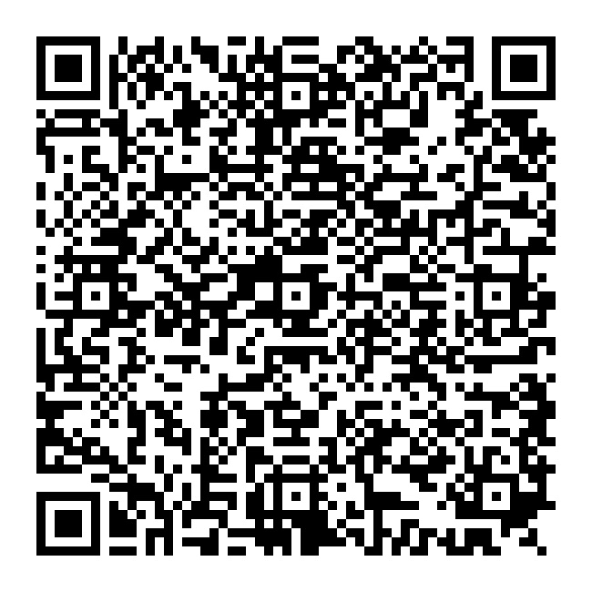
https://www.figma.com/proto/0vpfuZbywE90CQwOwAisCS/MooNet?node-id=192-1136&p=f&t=mM7LOV9SZLQt03rr-1&scaling=scale-down&content-scaling=fixed&page-id=0%3A1&starting-point-node-id=15%3A70

MooNet_App_Vid

https://drive.google.com/file/d/1Wr6GAIYx8mYTthdXIZpudGHC5dHCASsp/view?usp=drive_link

MooNet_Hardware_Vid


https://drive.google.com/file/d/1KyKgsSWx2J3-VqPtlXynx3P2U8ahcVqX/view?usp=sharing

