AL SALAM HOSPITALS
Digital Patient Concierge Avatar
Concept & Technical Approach Report
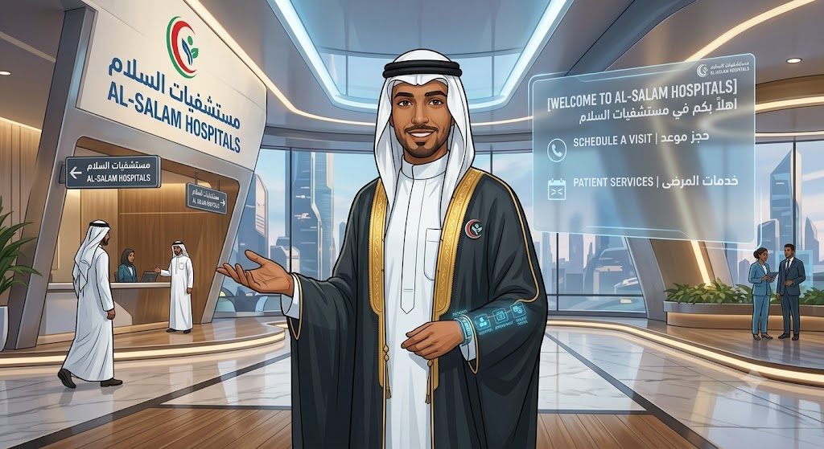
Companion to: Digital Patient Concierge MVP Development Pack, v1.0
Purpose: consolidate internal brainstorming — concept direction, reference products, and two candidate technical build paths — into the same decision format used in the MVP Development Pack.
A.1 Purpose and How to Read This Report
This report captures the team's brainstorming on the Digital Patient Concierge Avatar and restates it against the structure, scope, and guardrails already agreed in the MVP Development Pack (v1.0). It is meant to sit alongside that pack, not replace it: Sections A.2–A.9 confirm that the brainstorming is consistent with the approved scope, and Sections A.10–A.14 lay out the open technical build decision and the concrete next steps needed to close it.

A.2 Concept Direction
The working concept is a branded, bilingual digital human stationed at the lobby/reception desk, presented on a kiosk display and mirrored on the website. Early visual concepts (attached separately) show a culturally appropriate kuwaiti male persona in hospital-branded dress, positioned at the Al Salam Hospitals reception entrance, with an on-screen bilingual (Arabic/English) welcome panel offering “Schedule a Visit” and “Patient Services” as first actions.
This is consistent with the MVP Pack's Experience Layer (Section 3.1) and the “Welcome and language” capability (Section 2.1): language selection up front, no personal data collected at that stage, and a clear path into the core service journeys.

A.3 Reference Products Reviewed
The team reviewed existing digital-human products to benchmark look, feel, and interaction quality. Two demo videos were reviewed internally, and the product judged closest to our target experience is Humanizing (humanizing.com) — an existing avatar/agent platform used as the visual and interaction quality bar for our own build, not as a vendor recommendation at this stage.
Recommendation: treat Humanizing as a reference benchmark inside the Vendor/API Evaluation Matrix (Section 14 of the MVP Pack) rather than a default choice — it should be scored against the same weighted criteria (Arabic/English quality, security, integration, avatar experience, reliability, cost, governance) as any other avatar/speech vendor.

A.4 Confirmed MVP Service Scope
The brainstorming scope matches the MVP Pack's in-scope capabilities (Section 2.1) exactly. Restating it here with the intended delivery mechanism for each, since that mechanism is the open technical question this addendum exists to resolve:
Service | Delivery mechanism | MVP Pack reference
Doctor search, hospital directions, approved service/price inquiry | Internal REST APIs (Section 10.2) | Section 2.1, Section 10
Appointment request or booking | MCP (Model Context Protocol) tool calling into the scheduling workflow | Section 2.1, US-005
WhatsApp and live-agent handoff | APIs (Sections 10.2: /handoffs, /whatsapp/handoff) | Section 2.1, Flow D

Using MCP for the appointment workflow specifically (rather than a plain REST call) is the one addition versus the original pack, and it's the reason a multi-agent/orchestration layer is now part of the discussion in Section A.9–A.10 below.

A.5 Retrieval-Augmented Generation (RAG)
Confirmed: the solution must include a RAG layer over approved hospital content (doctor directory, department/location data, services and prices, FAQs, policies), exactly as specified in Section 9 of the MVP Pack. RAG answers non-transactional questions; live data (availability, bookings, patient-specific results) must continue to come from the deterministic workflow APIs, never from RAG.

A.6 Data and Integration Control
Reconfirmed as a hard requirement: all patient data and system integrations remain under Al Salam Hospitals' control, routed back through hospital-owned tools and APIs — consistent with the private/hybrid architecture in Section 3.1 and the deployment split in Section 3.3. Licensed components (avatar rendering, speech, and any orchestration/foundation-model service) sit behind governed interfaces and receive only the minimum data needed for a given turn.

A.7 Phased Rollout
Rollout sequencing matches Section 2/3 of the MVP Pack: pilot in one selected lobby or outpatient area first, then scale to additional channels and departments, and only later extend into AR wayfinding, VR patient education, and voice-agent services. No change from the approved plan — restated here for completeness.

A.8 New Capability Flagged: Wayfinding
Wayfinding (turn-by-turn or map-based guidance to a clinic, department, or service point) was flagged in brainstorming as new relative to the original pack's “directions” capability, which currently returns static location/route information (Section 2.1, /departments/{id}/directions). True wayfinding is the natural bridge toward the AR indoor-navigation phase described in Section 8 of the pack's appendix and should be scoped as a Should-later item (aligned with Epic E8) rather than pulled into the MVP, unless Operations wants a lightweight, non-AR version (e.g., step-by-step text/QR directions) added to the MVP backlog.

A.9 Agent Orchestration Approach
To coordinate multiple specialized tasks (doctor search, wayfinding, pricing, appointments, handoff) behind one conversational front end, the team proposes adopting an agent-orchestration pattern — a coordinating layer that routes a patient's request to the right specialized tool or sub-agent, rather than one monolithic prompt handling everything. This concept (referenced from IBM's overview of AI agent orchestration) maps directly onto the MVP Pack's existing “AI orchestration” layer (Section 3.1: intent routing, workflow engine, RAG, guardrails, conversation state, escalation logic) — it is a refinement of how that layer is built, not a new layer.
Action: the team should run a hands-on trial of an orchestration approach against 2–3 of the MVP's real journeys (doctor search, appointment request, handoff) before committing, per the two implementation paths in Section A.10.

A.10 Technical Implementation Paths Under Evaluation
Two candidate ways to build the orchestration/voice/avatar stack were identified. Neither is finalized; both should be validated against the same journeys (doctor search → appointment request → handoff) before a build decision is locked in at Milestone M1 (Section 5.1 of the MVP Pack).
Option 1 — Detailed Implementation Plan
Alexa+ ElevenLabs + HeyGen
Companion to: Concept & Technical Approach Addendum, Section A.10, Option 1. Purpose: turn Option 1 from a named stack into a concrete, buildable plan — architecture, integration steps, cost/latency, and a small proof-of-concept demo scope.
B.1 Objective of This Plan
Section A.10 of the addendum named Option 1 (Alexa + ElevenLabs + HeyGen) as the fastest path to a working demo, with one known gap: no native multi-agent coordination. This plan makes that option concrete enough to build: which component does what, how they connect, what a small proof-of-concept would cover, and what it would cost and feel like (latency) in the lobby. It intentionally does not try to solve the multi-agent gap — the point of the small demo is to confirm the gap is real and see exactly where it bites, before investing in Option 2 (LangGraph) or the hybrid path.

B.2 What Each Component Owns
Component | Role in the stack | Ownership
Alexa | Conversation/voice orchestration: channel handling (kiosk, web, WhatsApp), flow logic, intent routing, calling out to hospital APIs and to the speech/avatar services | Licensed platform, hospital-configured flows
ElevenLabs | Speech layer: Arabic/English speech-to-text (patient voice → text) and text-to-speech (response text → natural voice) | Licensed API
HeyGen LiveAvatar | Avatar rendering: turns the response voice into a lip-synced, gesturing video stream over WebRTC, shown on the kiosk/web screen | Licensed API
Hospital backend | RAG/knowledge base, Doctor/Directions/Price APIs, Appointment MCP tool, WhatsApp/handoff APIs, audit log | Hospital-owned (Sections 3.1, 10 of MVP Pack)

B.3 Architecture Diagram
The diagram below places Alexa as the single orchestration hub in the middle: it is the only component that talks to every other piece. ElevenLabs and HeyGen sit either side as licensed, swappable services; the hospital backend stays entirely on the hospital's side of the boundary, consistent with Section 3.1 of the MVP Pack. All five components write events into the shared Audit Log / Analytics / Monitoring layer (Section 3.2).
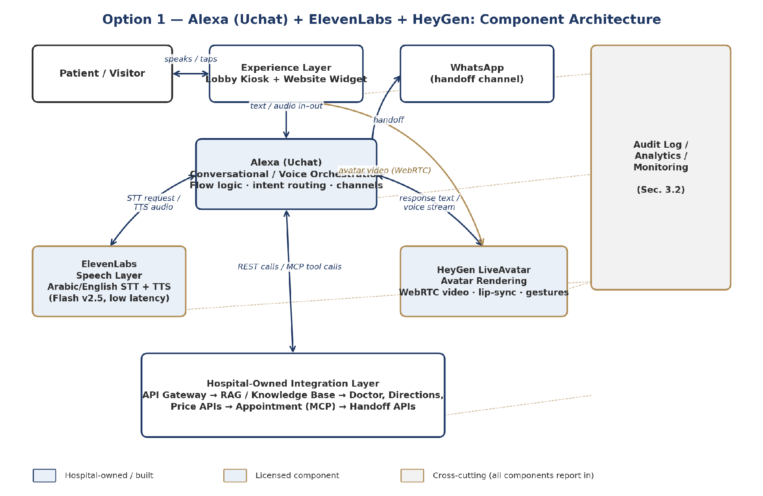
Figure B.1 — Option 1 component architecture: hospital-owned pieces (navy) vs. licensed components (gold).

B.4 What Happens on One Conversation Turn
To make the architecture concrete, here is a single patient turn end-to-end — asking for clinic directions — traced across every component. This is also the walkthrough the demo (Section B.6) needs to reproduce live.
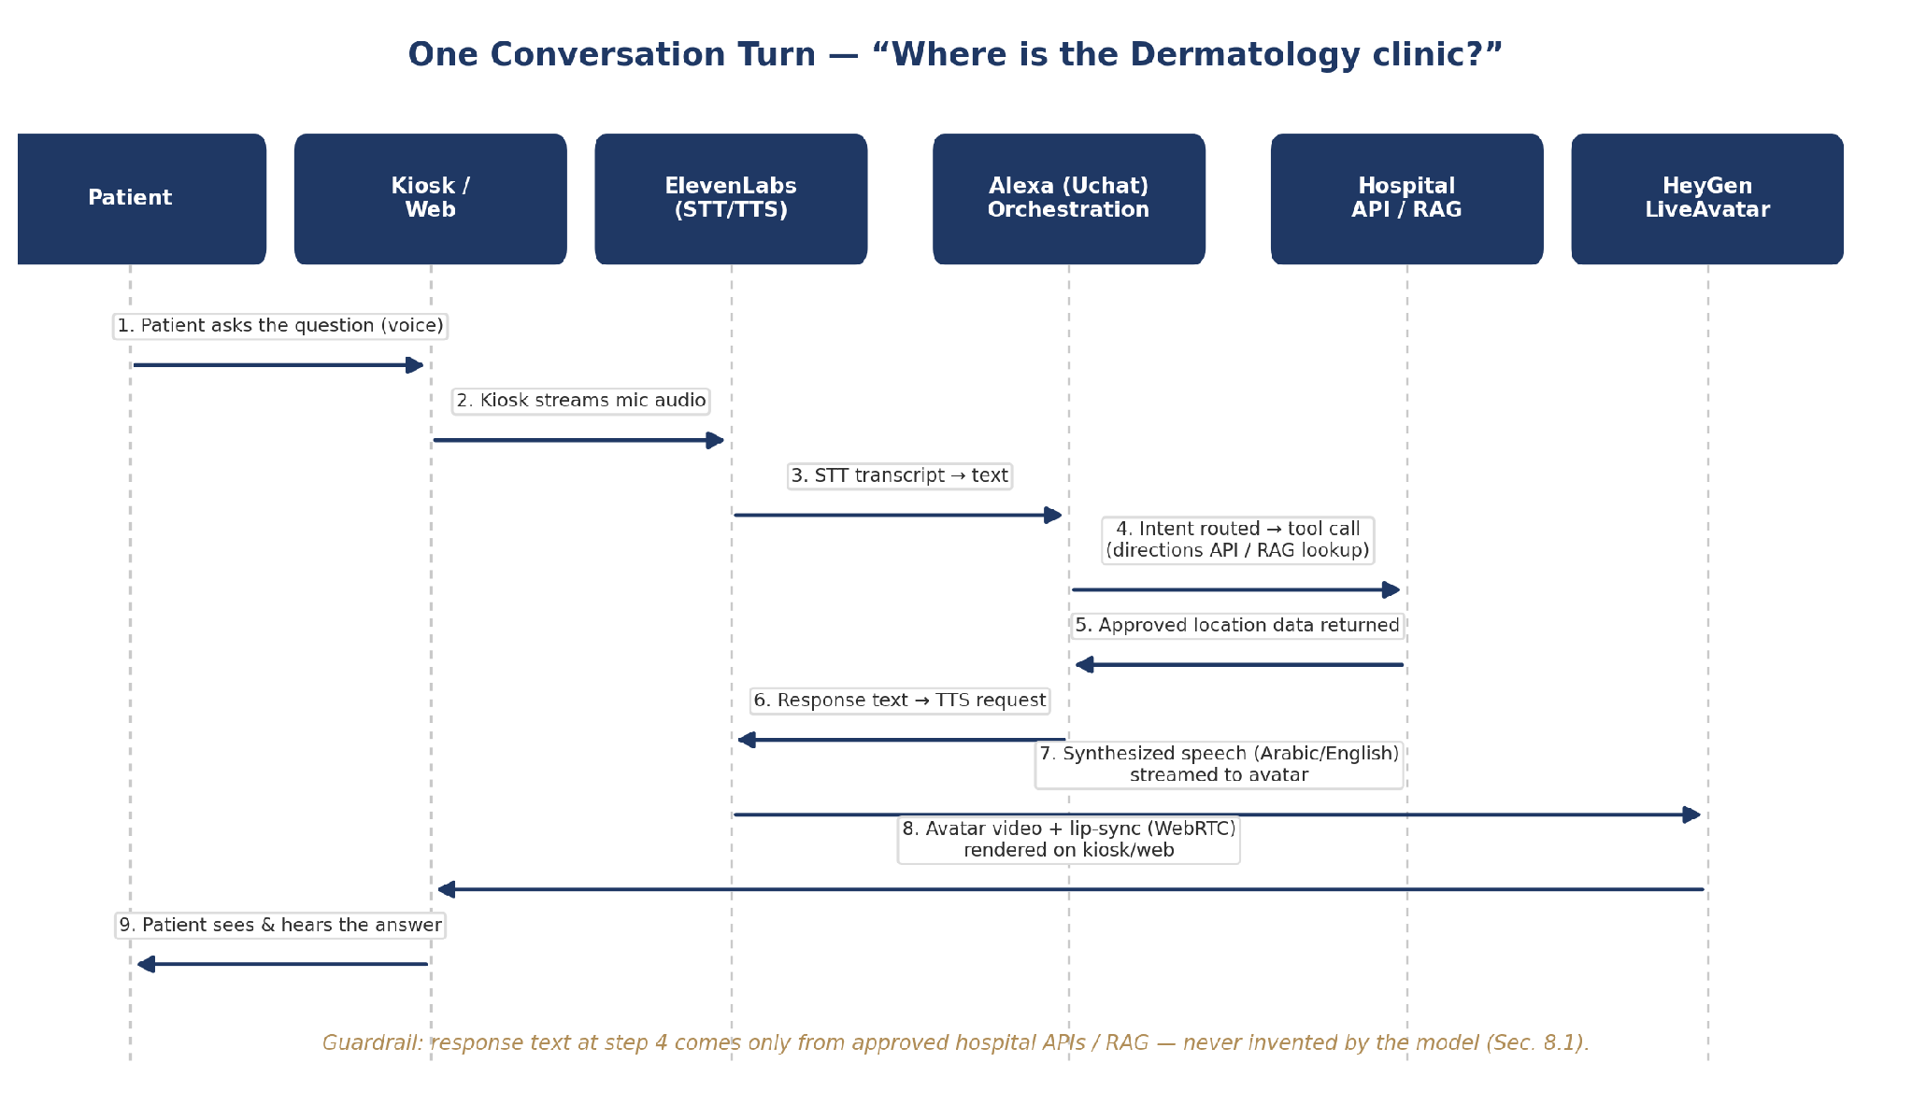
Figure B.2 — Turn-by-turn flow for a single patient question, Kiosk → answer.
Note where the guardrail sits: the orchestration layer (step 4) only ever passes back content retrieved from the hospital's RAG/API layer. Alexa, ElevenLabs, and HeyGen never originate facts — they route, voice, and render them.

B.5 Integration Steps

B.5.1 Alexa Setup
- Stand up an Alexa workspace; configure the kiosk/web channel and (later) WhatsApp as a second channel, so the same flow logic serves both.
- Build the core flow visually (no-code flow builder): welcome → language selection → intent menu → sub-flows for doctor search, directions, price inquiry, appointment request, handoff.
- Use Alexa’s external-request / webhook nodes to call the hospital's mock APIs first (Section 10.2 of the MVP Pack — /doctors, /departments/{id}/directions, /services/{id}), exactly matching the pack's “mock APIs from Day 1” principle.
- Use a JavaScript node (Alexa supports custom JS) to format API responses into clean, patient-facing sentences before they are sent to ElevenLabs for voicing.
- Log every turn (channel, language, intent, API called, outcome) out to the hospital's audit/analytics endpoint.

B.5.2 ElevenLabs Integration
- Use the Flash v2.5 model for both directions: patient speech → text (STT) and response text → speech (TTS). It is ElevenLabs' lowest-latency model (sub-500ms end-to-end), which matters for a lobby kiosk where silence feels broken quickly.
- Configure Arabic (Saudi Arabia / UAE) and English voices; keep the same two voice IDs consistently mapped to the avatar persona so the character sounds the same every session.
- Call the API over streaming/WebSocket rather than one-shot requests, so speech starts playing before the whole sentence is generated.
- Store the API key only on the hospital-side backend or Alexa's server-side node — never in kiosk-side/browser code (consistent with Section 11.1's secrets-vault requirement).

B.5.3 HeyGen LiveAvatar Integration
- Create/upload the branded Emirati-male persona as a HeyGen avatar; select LiveAvatar's real-time streaming mode (WebRTC, via LiveKit) rather than pre-rendered video.
- LiveAvatar can accept ElevenLabs-generated audio directly (it has native support for eleven_flash_v2_5 and eleven_multilingual_v2 voices) — this can simplify the pipeline by letting HeyGen call ElevenLabs internally for the response leg, instead of the hospital backend stitching audio and video itself.
- Pass approved hospital content in as LiveAvatar's “knowledge base” parameter only for tone/persona grounding — never as a substitute for the hospital's own RAG layer, per Section 9 of the MVP Pack.
- Budget for LiveAvatar's credit-based pricing: roughly 10 US cents per 30 seconds of streaming in Full mode, or per minute in the lighter-weight Lite mode — relevant for sizing a pilot-scale monthly cost estimate.

B.5.4 Hospital Backend Connection
- Stand up the mock Doctor / Directions / Service-Price / Appointment APIs exactly as scoped for Sprint 0 (Section 15.1 of the MVP Pack), so Alexa has something real to call from day one.
- Put an API gateway in front of these mocks now, even though they're mocks — it is the same gateway real HIS/scheduling integrations will sit behind later, so nothing has to be re-wired for the pilot.
- Wire appointment requests through as an MCP tool call rather than a plain REST call, per the addendum's Section A.4, so the appointment sub-task is already shaped the way a future multi-agent layer (Option 2 / LangGraph) would expect it.

B.6 Small Demo (Proof-of-Concept) Scope
A focused, two-to-three-journey demo is enough to validate the stack and surface the orchestration gap — no need to build the full MVP backlog first. Suggested scope:
Journey | What it proves | Data source
Welcome + language selection | Kiosk/web shell, avatar idle/greeting state, Arabic/English switch | Static config
Doctor search → directions (“Where is Dermatology?”) | Full turn shown in Figure B.2: STT → intent → mock API → TTS → avatar answer | Mock /departments API
Appointment request (single specialty, no real booking) | MCP tool call pattern end-to-end; where the demo will most likely expose the multi-agent gap if it also needs to check doctor availability and directions in the same turn | Mock /appointments API

Deliberately out of the demo: WhatsApp handoff, real patient verification, and any live HIS/scheduling data — these stay mocked or stubbed, matching the MVP Pack's own Day 16–30 “build foundation” scope.

B.7 Cost and Latency Notes
Component | Pricing model | Latency profile | Notes
Alexa | Platform subscription (free tier available; paid tiers for volume/channels) | Orchestration overhead only — not the bottleneck | No-code flow builder; JS/webhook nodes for custom logic
ElevenLabs | Billed per character (TTS) / per audio minute (STT); free tier ≈ 10k characters/month | Flash v2.5: well under 500ms end-to-end | Use Flash v2.5 for the live kiosk path; higher-quality models can be reserved for offline content
HeyGen LiveAvatar | Credit-based: ~10 US cents per 30 seconds (Full mode) or per minute (Lite mode) | Real-time WebRTC streaming | Separate credit pool from HeyGen's standard video-generation plans

These figures are enough to size a pilot-month estimate (kiosk operating hours × expected average session length × per-unit cost) once Operations confirms expected daily conversation volume — worth doing before Day 10 (M1) alongside the vendor scoring in Section A.14.

B.8 Known Gap — Reconfirmed, Not Solved
Reminder: This plan operationalizes Option 1 as-is; it does not add multi-agent coordination. The appointment-request demo journey (Section B.6) is specifically chosen because it is the most likely place the gap shows up — e.g., a request that needs doctor availability and directions resolved together in one coherent reply. Watching where the flow-builder logic gets awkward is the actual output of this demo, feeding directly into the Option 1 vs. Option 2 decision in Section A.14.

B.9 Next Steps
Action | Owner | Needed by
Provision Alexa workspace, ElevenLabs API key, HeyGen LiveAvatar credits | Backend/Integration + DevOps | Day 3–5 (Sprint 0)
Build the 3-journey demo flow against mock APIs (Section B.6) | AI/RAG Engineer + Dev Lead | Day 10 (M1)
Record where the appointment-request journey strains the flow builder | AI/RAG Engineer | Day 10 (M1), feeds A.14 decision
Draft pilot-month cost estimate using Section B.7 unit prices + Operations' expected volume | PM/Business Analyst + Operations | Before M1 (Day 10)

Option 2 — LangGraph
A graph-based multi-agent orchestration framework, currently under investigation by the team. It targets the coordination gap in Option 1 directly — structuring the doctor-search, wayfinding, pricing, appointment, and handoff logic as explicit, auditable agent/tool nodes with defined transitions, which aligns closely with the guardrail requirements in Section 8 (deterministic tool use, no invented facts, explicit escalation rules).
Not yet validated: avatar and speech integration approach, licensing/cost, and hosting model within the hospital's private/hybrid architecture (Section 3.1) still need to be worked out.

Dimension | Option 1: Alexa + ElevenLabs + HeyGen | Option 2: LangGraph
Multi-agent orchestration | Gap — needs a coordination layer built on top | Native strength — purpose-built for this
Speed to first demo | Faster — licensed, mature components | Slower — more custom build work
Avatar / speech readiness | Ready out of the box (HeyGen / ElevenLabs) | Not yet defined — to be paired with a rendering/speech vendor
Fit with guardrail model (Sec. 8) | Depends on the added coordination layer | Strong natural fit — explicit, auditable node logic
Status | Feasible now, gap identified | Under investigation

A pragmatic middle path exists and is worth testing: use Option 1's licensed avatar/speech components for the experience layer while adopting LangGraph (or an equivalent orchestration framework) purely for the AI-orchestration layer behind it — keeping the architecture split the MVP Pack already calls for (Section 3.1: licensed avatar/speech, hospital-built orchestration).

Option 3 — Open-Source Graph-Memory Real-Time Avatar
Built on Graphiti — an open-source temporal knowledge graph engine
Companion to: Concept & Technical Approach Addendum, Section A.10. Purpose: evaluate a third candidate — a fully open-source, self-hosted stack that replaces standard vector RAG with a temporal knowledge graph as the assistant's memory — with worked examples.

C.1 What This Option Is
This option was surfaced from a public engineering tutorial (Akshay Pachaar / “Daily Dose of Data Science”, ai-engineering-hub repository) demonstrating a real-time AI avatar with what the author calls “human-like memory.” The distinguishing idea is not the avatar rendering itself, but the memory layer underneath it: instead of a standard vector-similarity RAG, it uses Graphiti — an open-source (Apache 2.0), self-hostable temporal knowledge graph engine built by the Zep team.
Unlike Options 1 and 2, which are about how conversations are orchestrated, this option is about what the assistant remembers and how current that memory stays. It is best understood as a candidate upgrade to Section 9 (RAG) of the MVP Pack, not a replacement for Alexa or the avatar/speech layer — it can sit underneath either Option 1 or Option 2.

C.2 Why a Temporal Knowledge Graph Instead of Vector RAG
Standard vector RAG (as scoped in Section 9 of the MVP Pack) retrieves the most similar chunks of approved text to a patient's question. It works well for static content (FAQs, policies) but has a known weakness: when a fact changes — a doctor moves clinics, a price is updated — the old chunk and the new chunk can both look similar enough to the query to be retrieved, and the system has no built-in concept of which one is currently true.
A temporal knowledge graph stores facts as relationships between entities, each with a validity window (when a fact became true, and when it stopped being true). Updating a fact doesn't require deleting old data — it adds a new, currently-valid relationship and marks the old one as superseded. This matches a real hospital problem directly: doctor-to-clinic assignments, price and package changes, and department relocations are exactly the kind of facts that change on a schedule and must never be answered from stale data (Section 8.1's “never invent or use outdated content” rule).
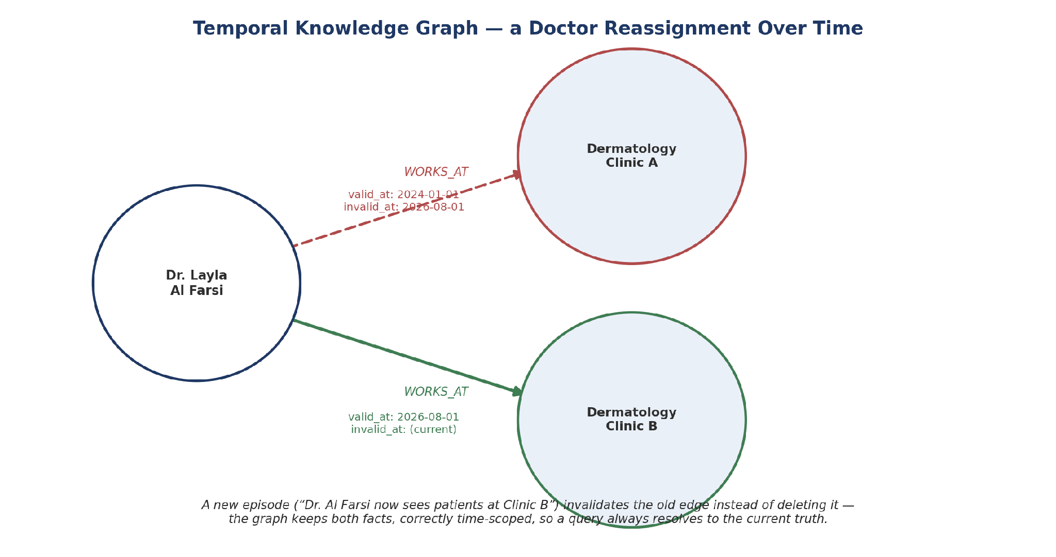
Figure C.1 — A doctor's clinic reassignment as a temporal graph: the old assignment is kept but marked superseded, not deleted.

C.3 Core Components
Layer | Role | This option
Orchestration | Channel handling, flow logic, calling out to memory and hospital APIs | Alexa (unchanged from Option 1/2)
Memory / knowledge layer | Stores and retrieves approved hospital facts | Graphiti — temporal knowledge graph, self-hosted
Graph database | Stores the entities/relationships Graphiti manages | Neo4j, FalkorDB, or Amazon Neptune (Graphiti supports all three)
Extraction LLM | Reads new content and proposes entities/relationships into the graph | Any OpenAI-, Anthropic-, Gemini-, or Groq-compatible model
Speech + avatar | Voice and rendered video, as in Option 1 | Reusable as-is — ElevenLabs / HeyGen, or open alternatives (Whisper, Kokoro, Simli)

C.4 Architecture
The overall shape stays the same as Option 1 — Alexa remains the single orchestration hub talking to speech, avatar, and hospital APIs. The only structural change is what sits behind the knowledge-lookup call: a self-hosted Graphiti/graph-database layer instead of (or in addition to) the vector RAG store.
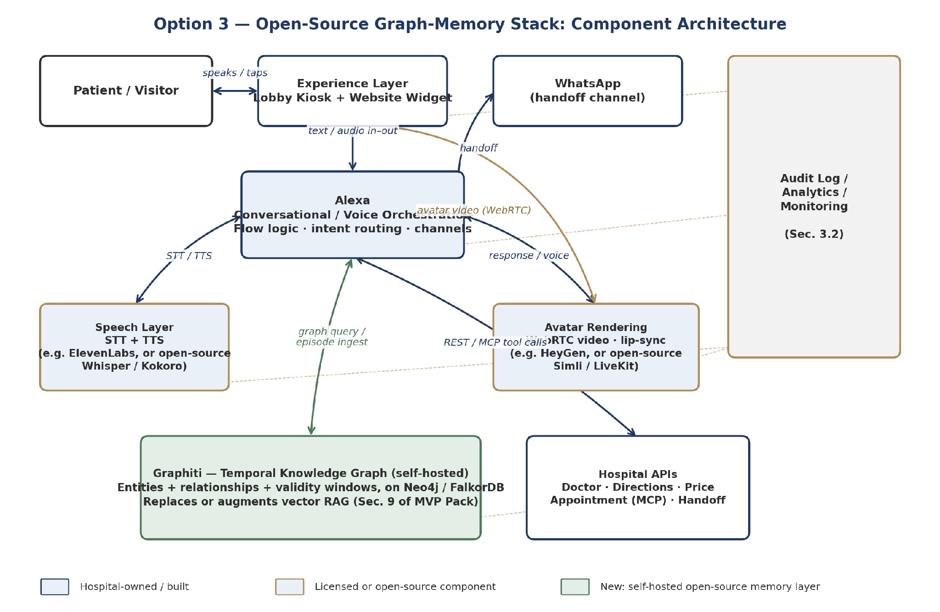
Figure C.2 — Option 3 architecture: the green box is the new self-hosted memory layer; everything else can be reused from Option 1.
Because Graphiti is self-hosted, this is the option that sits most comfortably inside the hard requirement in Section A.6 of the addendum — patient-relevant facts never have to leave hospital-controlled infrastructure to be stored or queried, unlike a third-party vector-RAG or managed knowledge-base service.

C.5 Code Walkthrough — Ingesting a Hospital Fact
Graphiti's core unit of information is an “episode” — a piece of text or structured data that gets automatically parsed into entities and relationships. Below is an illustrative example of how a doctor-directory change (Section 9.1 of the MVP Pack, doctor entity) would be ingested, following Graphiti's published quickstart pattern:
from datetime import datetime, timezone
from graphiti_core import Graphiti
from graphiti_core.nodes import EpisodeType

graphiti = Graphiti(
uri="bolt://localhost:7687", # hospital-hosted Neo4j / FalkorDB
user="neo4j",
password=os.environ["GRAPH_DB_PASSWORD"], # from hospital secrets vault
)
await graphiti.build_indices_and_constraints() # one-time setup

await graphiti.add_episode(
name="doctor_directory_update_2026_08_01",
episode_body=(
"Dr. Layla Al Farsi now sees patients at Dermatology "
"Clinic B, Level 3, Block C. She no longer holds "
"clinic hours at Clinic A."
),
source=EpisodeType.text,
source_description="Approved doctor-directory update, Medical Affairs",
reference_time=datetime(2026, 8, 1, tzinfo=timezone.utc),
)
Graphiti's extraction step reads that sentence, recognizes the doctor and clinic entities already in the graph, adds a new “works at Clinic B” relationship valid from 2026-08-01, and automatically marks the older “works at Clinic A” relationship as no longer current — without anyone writing that logic by hand.

C.6 Code Walkthrough — Answering a Patient Question
On the query side, Alexa would call a single search against the graph rather than a vector similarity lookup:
results = await graphiti.search(
"Where does Dr. Layla Al Farsi see patients?"
)

for r in results:
print(r.fact, r.valid_at, r.invalid_at)

# Example output:
# "Dr. Layla Al Farsi works at Dermatology Clinic B"
# valid_at=2026-08-01 invalid_at=None (current)
Graphiti's search combines semantic similarity with keyword matching and graph-distance reranking, and returns facts tagged with their validity window — so the response passed back through Alexa to ElevenLabs/HeyGen only ever contains the currently valid fact, satisfying the same “never answer from outdated content” guardrail as the existing vector-RAG design (Section 8.1).

C.7 Guardrail Fit
Reminder: Graphiti changes how facts are stored and retrieved — it does not relax any guardrail. The response text returned to Alexa must still come only from a graph query result, never from the extraction LLM's general knowledge; the extraction LLM's only job is building the graph from approved content, not answering patients directly.

C.8 Vector RAG vs. Graph RAG — Comparison
Dimension | Vector RAG (current MVP Pack, Sec. 9) | Graph RAG — Graphiti (Option 3)
How facts are found | Similarity between the question and text chunks | Relationships between named entities (doctors, clinics, services)
Handling changed facts | Old and new chunks can both look relevant; needs manual re-indexing/cleanup | New episode automatically supersedes the old relationship; both are kept, correctly time-scoped
Best suited to | Static content: FAQs, policies, service descriptions | Facts that change on a schedule: doctor assignments, prices, department moves
Hosting | Any vector DB, can be managed/external | Self-hosted graph DB (Neo4j / FalkorDB / Neptune) — stays inside hospital infrastructure
Maturity for this project | Already scoped and understood (Section 9) | New — needs a proof-of-concept before relying on it

These are not mutually exclusive: a pragmatic path is to keep vector RAG for static content (FAQs, policies) and add Graphiti specifically for the entities that change — doctor directory, price catalogue, department assignments — which is exactly the operational content Section 9.1 of the MVP Pack already flags as needing review/effective dates.

C.9 Where This Sits Relative to Options 1 and 2
This is not a competing orchestration path — it is a memory-layer upgrade that can sit underneath either Option 1 (Alexa + ElevenLabs + HeyGen) or Option 2 (LangGraph). It does not solve the multi-agent coordination gap identified in Section A.10; a graph memory still needs to be called by whatever orchestration layer wins that decision. Its main contribution is to the RAG requirement (Section A.5) and the data-control requirement (Section A.6), not to the orchestration debate.

C.10 Maturity and Risk
- Origin is a public tutorial/reference implementation, not a supported product — expect to invest real engineering time to harden it for a hospital pilot (error handling, access control, backup/restore of the graph database).
- Requires running and maintaining a graph database (Neo4j/FalkorDB) in the hospital's private/hybrid environment (Section 3.1) — an additional operational component versus a purely licensed vector-RAG service.
- Ingestion (add_episode) makes an LLM call per fact update to extract entities/relationships — worth costing out for the expected volume of doctor/price/department changes per month.
- The extraction quality (does it correctly recognize “Dr. Layla Al Farsi” as the same entity every time, in Arabic and English) needs its own test set, similar in spirit to the AI Quality Evaluation Set in Section 8.4 of the MVP Pack.

C.11 Next Steps
Action | Owner | Needed by
Stand up Graphiti + Neo4j (or FalkorDB) in a DEV environment; ingest the current doctor directory as a test set | AI/RAG Engineer | Day 10–15 (Sprint 0 / early build)
Run the doctor-reassignment scenario (Section C.5–C.6) end-to-end and confirm old facts are correctly superseded, not just added | AI/RAG Engineer | Before M2 (Day 30)
Compare answer quality and latency against the existing vector-RAG plan for the same 20 test questions (Section 8.4) | AI/RAG Engineer + Quality | Before M2 (Day 30)
Decide scope: full replacement of vector RAG, or hybrid (graph for changing facts, vector for static content) | Product Owner + AI/RAG Engineer | Before M2 (Day 30)

Option 4 — Avatar Rendering Alternatives
A swappable avatar-rendering layer evaluated against HeyGen LiveAvatar
Companion to: Concept & Technical Approach Addendum, Section A.10, and Option 1 Detailed Implementation Plan, Section B.5.3. Purpose: broaden the avatar-rendering choice beyond HeyGen — the orchestration (Alexa) and speech (ElevenLabs) layers stay as already decided; only the rendered face/video component is being re-evaluated.
Naming note: “Alexa” refers to the voice/orchestration platform used elsewhere in this project — a team working name only, not affiliated with Amazon Alexa.

D.1 Why Re-Open the Avatar Choice
Section A.10 named HeyGen LiveAvatar as the avatar-rendering component of Option 1, mainly because it was ready out of the box and integrates natively with ElevenLabs voices. Since then, the avatar-rendering market has broadened noticeably — LiveKit's plugin ecosystem alone now lists more than a dozen real-time avatar providers. This section treats avatar rendering as its own, swappable decision, separate from the orchestration (Alexa) and speech (ElevenLabs) choices, which do not need to change.

D.2 Three Categories of Avatar-Rendering Approach

Category A — Modular “face-only” APIs
You keep your own voice/orchestration stack (Alexa + ElevenLabs) and send audio or text to the provider, which returns a real-time, lip-synced video stream. This is the most natural fit for Al Salam's architecture, since orchestration is already decided. Candidates: Simli, D-ID (Agent API), Anam, Tavus (Conversational Video Interface), and HeyGen LiveAvatar itself, which also operates in this mode.

Category B — Fully-rendered 3D digital humans
Providers build a complete, often photoreal 3D character with full creative control over appearance — closer to the culturally specific Emirati persona in the original concept art. Candidates: Soul Machines, RAVATAR. These typically require more production investment and can carry higher latency than the video-based APIs in Category A.

Category C — Fully custom / self-hosted build
Build the avatar in-house using a 3D engine (Unreal Engine MetaHuman is the most common choice) and a real-time rendering/streaming pipeline (e.g. NVIDIA ACE / Omniverse Avatar Cloud Engine). No per-minute vendor billing once running, and the persona and all rendering stay on hospital-controlled infrastructure — consistent with the same data-control principle behind Option 3's self-hosted memory layer — but it carries real engineering and GPU-hosting cost.

D.3 Where It Plugs Into the Architecture
Whichever provider is chosen, it sits in exactly the same place Figure B.1 already reserved for HeyGen: Alexa sends response audio/text to the avatar layer and receives a WebRTC video stream back for the kiosk/web display. Nothing else in the architecture changes.
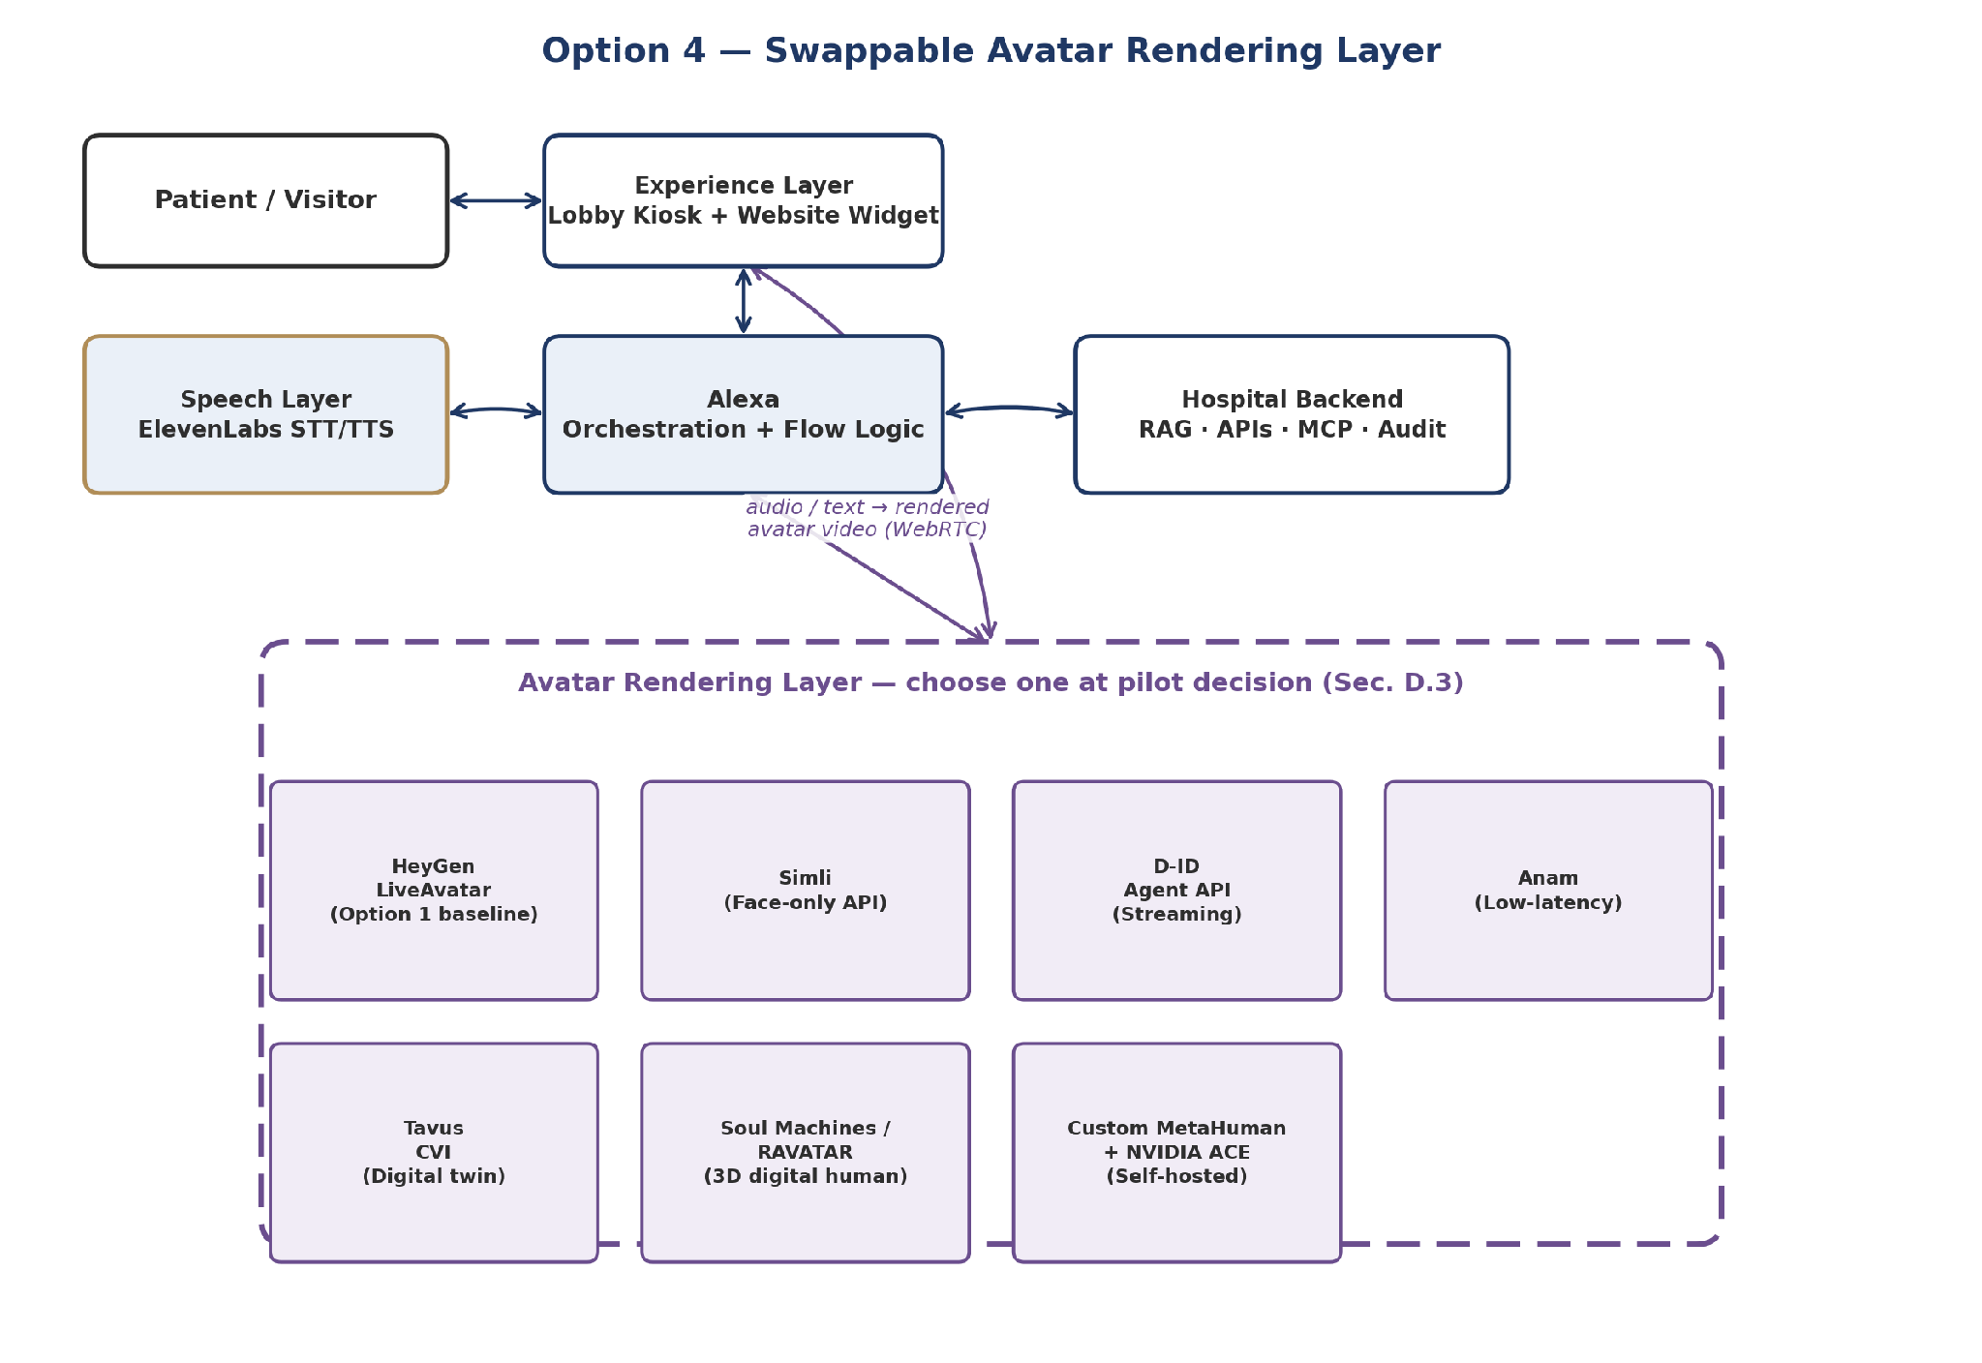
Figure D.1 — The avatar-rendering layer as a swappable component behind Alexa; every candidate plugs into the same interface.

D.4 Candidate Comparison
Provider | Category | Latency / streaming | Indicative cost | Custom persona from your own reference art/footage | Notes
HeyGen LiveAvatar | A — modular API | Real-time WebRTC | ~$0.10 per 30 sec (Full mode) | Yes — avatar creation from photo/video | Option 1 baseline; native ElevenLabs voice support
Simli | A — modular API | Real-time, speech-to-video | Usage-based (in line with managed-API range below) | Yes | Most “unbundled” option — pure face renderer, no bundled voice/LLM
D-ID (Agent API) | A — modular API | WebRTC streaming, sub-2s first frame | Usage-based | Yes — animates a supplied photo or generated persona | One of the more mature developer ecosystems in this space
Anam | A — modular API | ~180ms published benchmark (CARA-3) | Usage-based | Yes | Newer entrant; worth testing purely for responsiveness
Tavus (CVI) | A — modular API | Real-time conversational video | Usage-based | Yes — “digital twin” style personalization | Strong fit if a highly personalized/consistent persona matters
Soul Machines / RAVATAR | B — 3D digital human | Higher than Category A, real-time capable | Higher — production-project pricing, not simple per-minute | Full creative control — built to your art direction | Closest to the original concept art's photoreal/stylized look; real production investment
Custom: MetaHuman + NVIDIA ACE | C — self-hosted build | Depends on hospital GPU hosting | ~$0.06–$0.12/min raw compute once built (no vendor licence fee) | Full control — built entirely to spec | Largest upfront engineering + GPU-hosting effort; best long-run data control

As general market context: managed real-time avatar APIs (Category A) typically run in the $0.10–$0.37 per minute range depending on resolution and concurrency, while a self-hosted custom build (Category C) can bring raw compute cost down to roughly $0.06–$0.12 per minute — the gap being convenience, operations, and concurrency management rather than a difference in underlying rendering quality.

D.5 Evaluation Criteria Specific to Al Salam
Criterion | Why it matters here
Custom persona fidelity | The concept art already specifies a culturally appropriate Emirati-male persona in hospital-branded dress — the provider needs to reproduce that, not offer a generic stock character.
Arabic lip-sync quality | Same bar as the speech layer (Section B.5.2) — needs testing with real Arabic hospital terminology, not just English demo scripts.
Latency in a lobby setting | A kiosk conversation feels broken quickly if there's a visible delay between the voice and the avatar's mouth movement; this is the main practical differentiator between Category A providers.
Data control | Categories A and B send response content to an external rendering service for every turn; Category C keeps it entirely on hospital infrastructure — relevant to the addendum's Section A.6 requirement.
Integration effort vs. Sprint 0 timeline | Category A providers can plug into the existing Alexa/ElevenLabs pipeline within the 90-day window; Category B and C both carry meaningfully more production or engineering time.

D.6 Suggested Approach
Rather than treating this as a single up-front choice, it fits the addendum's existing pattern of validating options against real journeys before committing (Section A.10): trial two or three Category A providers (HeyGen LiveAvatar plus one or two of Simli / D-ID / Anam) against the same doctor-search and directions journey used in the Option 1 demo (Section B.6), scoring them on the criteria in Section D.5. Categories B and C are worth keeping on the roadmap as a post-pilot upgrade path — once patient volume and budget justify the higher production or engineering investment — rather than as MVP candidates.

D.7 Next Steps
Action | Owner | Needed by
Score HeyGen LiveAvatar, Simli, and D-ID against Section D.5 criteria using the same demo journey as Section B.6 | AI/RAG Engineer + Frontend/Kiosk Dev | Before M1 (Day 10), alongside Section A.14's vendor scoring
Request a custom-persona sample (matching the concept art) from each shortlisted Category A provider | IT / Procurement | Day 5–10 (Sprint 0)
Get a rough production quote from one Category B provider (Soul Machines or RAVATAR) for comparison purposes only | IT / Procurement | Day 10 (Sprint 0 close)
Flag Category C (custom MetaHuman build) as a post-pilot roadmap item, not an MVP candidate | Product Owner | M1 decision record

A.11 Analytics and Monitoring
Consistent with Section 3.2 of the MVP Pack, all conversation transactions should flow into a single Audit Log / Analytics / Monitoring layer — giving Operations and IT one dashboard view of volume, escalations, unanswered questions, and system health, rather than separate views per component (avatar, speech, orchestration, integrations).

A.12 Team Model Alignment
The brainstorming confirms the Section 4 team model from the MVP Pack as the right structure to execute this — having Backend/Integration, Frontend/Kiosk, AI/RAG, DevOps, Security, and Arabic content roles in place from day one is what makes either technical path in Section A.10 executable within the 90-day window.

A.13 Non-Negotiable Guardrails
Reconfirmed without change from Sections 2.2 and 8.1 of the MVP Pack:
Never in this MVP: Diagnosis, medication advice, autonomous clinical triage, full EMR access, AR/VR production rollout, facial recognition.

A.14 Open Decisions and Next Steps
Decision | Owner | Needed by
Validate Option 1 vs. Option 2 (or the hybrid path) against 2–3 real MVP journeys | AI/RAG Engineer + Dev Lead | Before M1 (Day 10)
Score Humanizing and any other avatar/speech vendors in the Section 14 evaluation matrix | IT / Procurement | Day 5–10 (Sprint 0)
Decide whether lightweight (non-AR) wayfinding is added to MVP backlog or deferred to Epic E8 | Product Owner / Operations | Day 10 (Sprint 0 close)
Confirm hosting/licensing plan for the chosen orchestration framework within the private/hybrid architecture | IT Architecture / Security | Before M2 (Day 30)

