AL SALAM HOSPITALS
Digital Patient Concierge Avatar
Option 1 — Detailed Implementation Plan
Alexa (Uchat) + ElevenLabs + HeyGen
Companion to: Concept & Technical Approach Addendum, Section A.10, Option 1. Purpose: turn Option 1 from a named stack into a concrete, buildable plan — architecture, integration steps, cost/latency, and a small proof-of-concept demo scope.
Naming note: “Alexa” refers to “Uchat,” the voice/orchestration platform under internal evaluation — a team working name only, not affiliated with Amazon Alexa.

B.1 Objective of This Plan
Section A.10 of the addendum named Option 1 (Alexa/Uchat + ElevenLabs + HeyGen) as the fastest path to a working demo, with one known gap: no native multi-agent coordination. This plan makes that option concrete enough to build: which component does what, how they connect, what a small proof-of-concept would cover, and what it would cost and feel like (latency) in the lobby. It intentionally does not try to solve the multi-agent gap — the point of the small demo is to confirm the gap is real and see exactly where it bites, before investing in Option 2 (LangGraph) or the hybrid path.

B.2 What Each Component Owns
Component | Role in the stack | Ownership
Alexa (Uchat) | Conversation/voice orchestration: channel handling (kiosk, web, WhatsApp), flow logic, intent routing, calling out to hospital APIs and to the speech/avatar services | Licensed platform, hospital-configured flows
ElevenLabs | Speech layer: Arabic/English speech-to-text (patient voice → text) and text-to-speech (response text → natural voice) | Licensed API
HeyGen LiveAvatar | Avatar rendering: turns the response voice into a lip-synced, gesturing video stream over WebRTC, shown on the kiosk/web screen | Licensed API
Hospital backend | RAG/knowledge base, Doctor/Directions/Price APIs, Appointment MCP tool, WhatsApp/handoff APIs, audit log | Hospital-owned (Sections 3.1, 10 of MVP Pack)

B.3 Architecture Diagram
The diagram below places Alexa (Uchat) as the single orchestration hub in the middle: it is the only component that talks to every other piece. ElevenLabs and HeyGen sit either side as licensed, swappable services; the hospital backend stays entirely on the hospital's side of the boundary, consistent with Section 3.1 of the MVP Pack. All five components write events into the shared Audit Log / Analytics / Monitoring layer (Section 3.2).
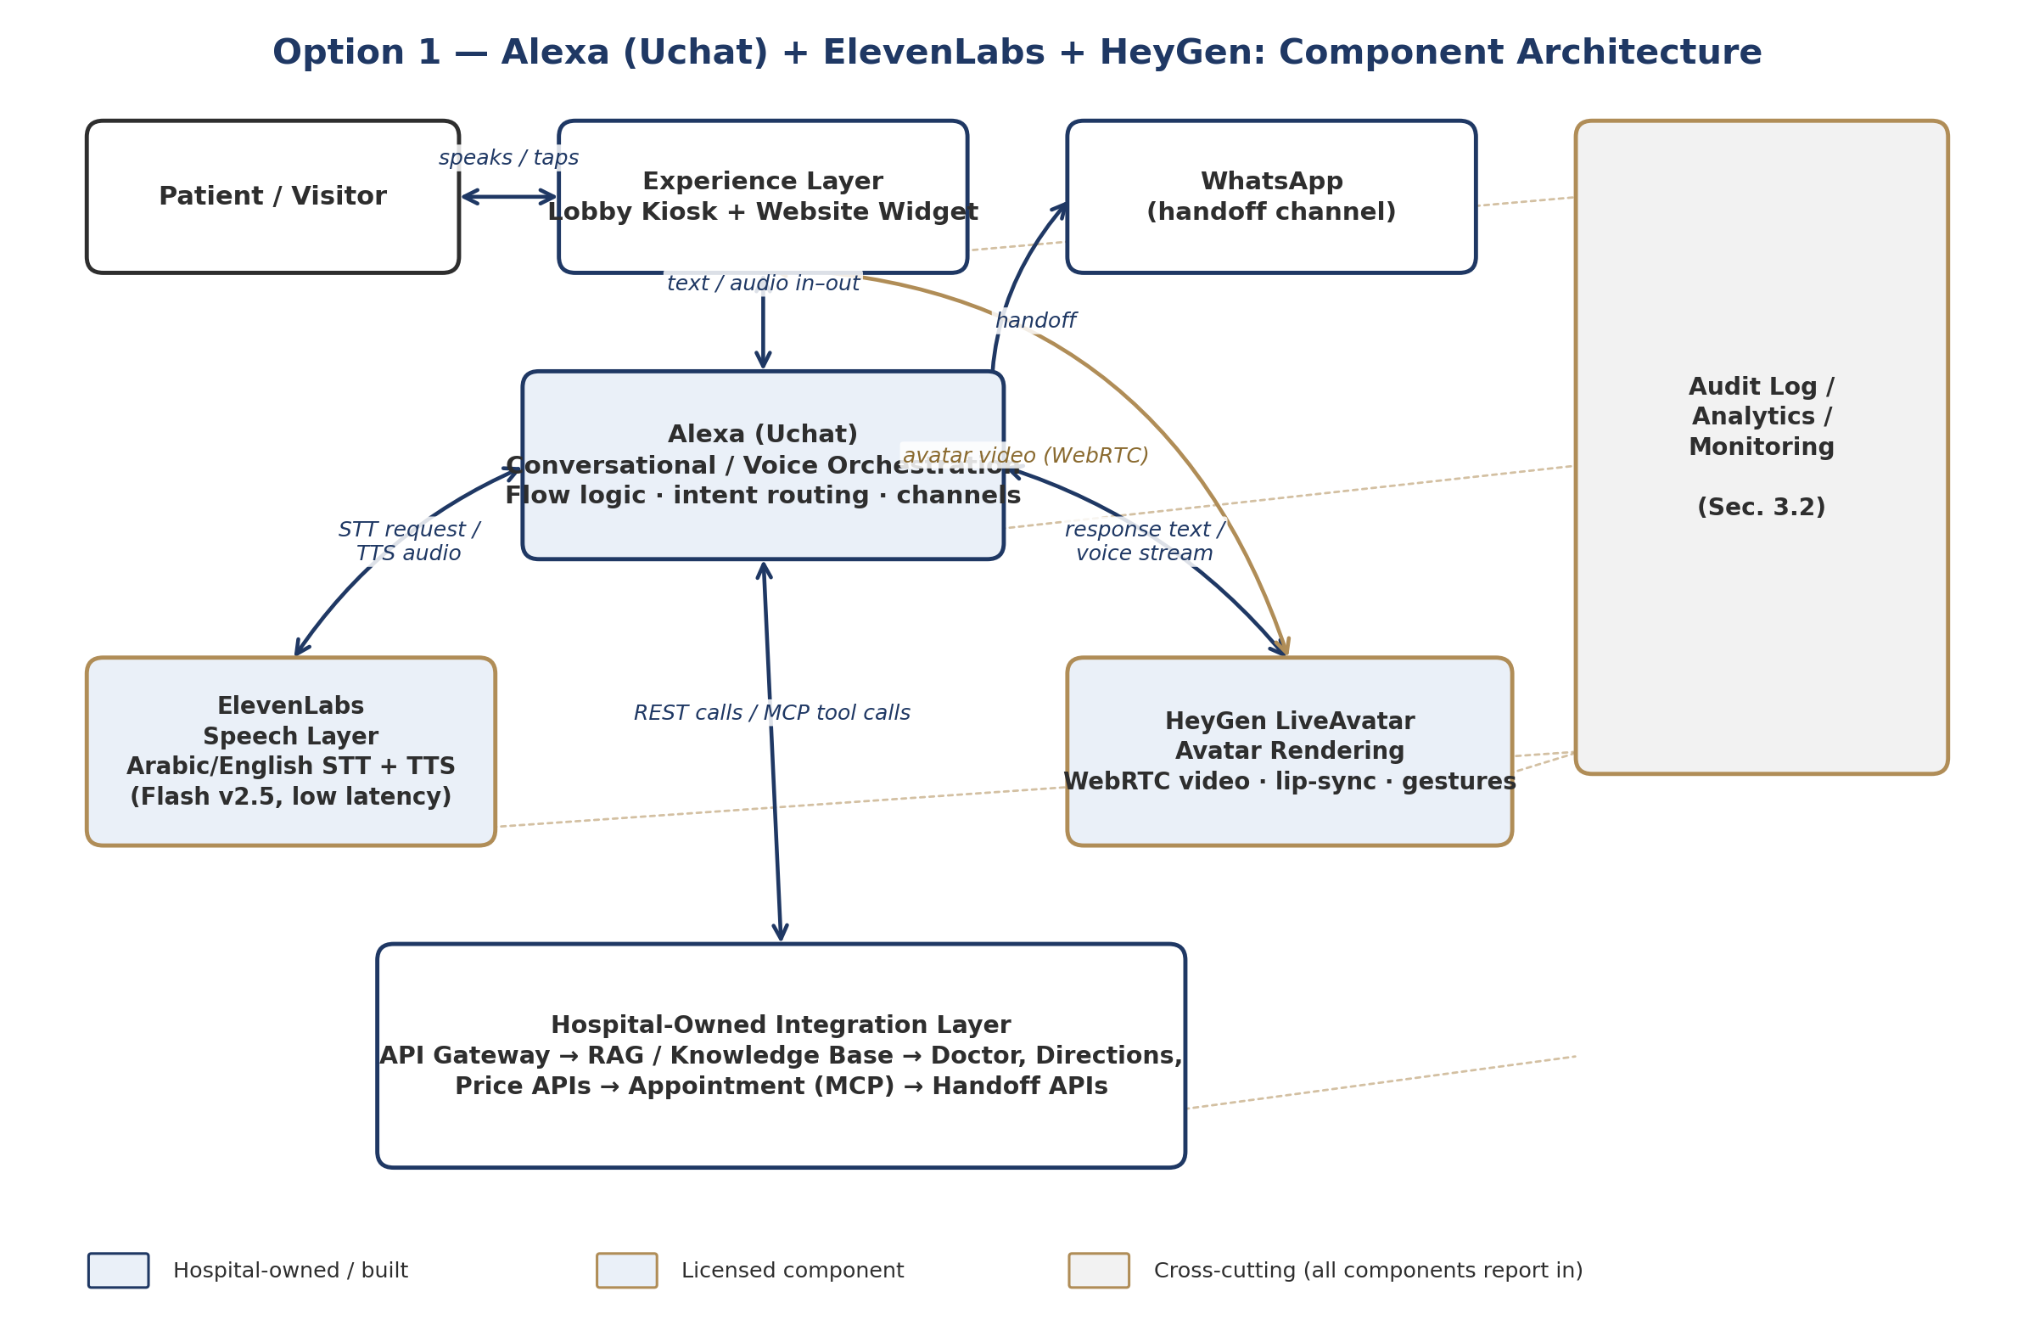
Figure B.1 — Option 1 component architecture: hospital-owned pieces (navy) vs. licensed components (gold).

B.4 What Happens on One Conversation Turn
To make the architecture concrete, here is a single patient turn end-to-end — asking for clinic directions — traced across every component. This is also the walkthrough the demo (Section B.6) needs to reproduce live.
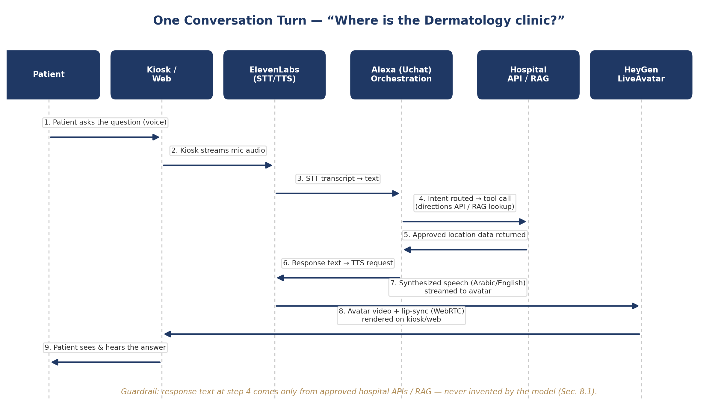
Figure B.2 — Turn-by-turn flow for a single patient question, Kiosk → answer.
Note where the guardrail sits: the orchestration layer (step 4) only ever passes back content retrieved from the hospital's RAG/API layer. Alexa (Uchat), ElevenLabs, and HeyGen never originate facts — they route, voice, and render them.

B.5 Integration Steps

B.5.1 Alexa (Uchat) Setup
- Stand up a Uchat workspace; configure the kiosk/web channel and (later) WhatsApp as a second channel, so the same flow logic serves both.
- Build the core flow visually (no-code flow builder): welcome → language selection → intent menu → sub-flows for doctor search, directions, price inquiry, appointment request, handoff.
- Use Uchat's external-request / webhook nodes to call the hospital's mock APIs first (Section 10.2 of the MVP Pack — /doctors, /departments/{id}/directions, /services/{id}), exactly matching the pack's “mock APIs from Day 1” principle.
- Use a JavaScript node (Uchat supports custom JS) to format API responses into clean, patient-facing sentences before they are sent to ElevenLabs for voicing.
- Log every turn (channel, language, intent, API called, outcome) out to the hospital's audit/analytics endpoint.

B.5.2 ElevenLabs Integration
- Use the Flash v2.5 model for both directions: patient speech → text (STT) and response text → speech (TTS). It is ElevenLabs' lowest-latency model (sub-500ms end-to-end), which matters for a lobby kiosk where silence feels broken quickly.
- Configure Arabic (Saudi Arabia / UAE) and English voices; keep the same two voice IDs consistently mapped to the avatar persona so the character sounds the same every session.
- Call the API over streaming/WebSocket rather than one-shot requests, so speech starts playing before the whole sentence is generated.
- Store the API key only on the hospital-side backend or Uchat's server-side node — never in kiosk-side/browser code (consistent with Section 11.1's secrets-vault requirement).

B.5.3 HeyGen LiveAvatar Integration
- Create/upload the branded Emirati-male persona as a HeyGen avatar; select LiveAvatar's real-time streaming mode (WebRTC, via LiveKit) rather than pre-rendered video.
- LiveAvatar can accept ElevenLabs-generated audio directly (it has native support for eleven_flash_v2_5 and eleven_multilingual_v2 voices) — this can simplify the pipeline by letting HeyGen call ElevenLabs internally for the response leg, instead of the hospital backend stitching audio and video itself.
- Pass approved hospital content in as LiveAvatar's “knowledge base” parameter only for tone/persona grounding — never as a substitute for the hospital's own RAG layer, per Section 9 of the MVP Pack.
- Budget for LiveAvatar's credit-based pricing: roughly 10 US cents per 30 seconds of streaming in Full mode, or per minute in the lighter-weight Lite mode — relevant for sizing a pilot-scale monthly cost estimate.

B.5.4 Hospital Backend Connection
- Stand up the mock Doctor / Directions / Service-Price / Appointment APIs exactly as scoped for Sprint 0 (Section 15.1 of the MVP Pack), so Uchat has something real to call from day one.
- Put an API gateway in front of these mocks now, even though they're mocks — it is the same gateway real HIS/scheduling integrations will sit behind later, so nothing has to be re-wired for the pilot.
- Wire appointment requests through as an MCP tool call rather than a plain REST call, per the addendum's Section A.4, so the appointment sub-task is already shaped the way a future multi-agent layer (Option 2 / LangGraph) would expect it.

B.6 Small Demo (Proof-of-Concept) Scope
A focused, two-to-three-journey demo is enough to validate the stack and surface the orchestration gap — no need to build the full MVP backlog first. Suggested scope:
Journey | What it proves | Data source
Welcome + language selection | Kiosk/web shell, avatar idle/greeting state, Arabic/English switch | Static config
Doctor search → directions (“Where is Dermatology?”) | Full turn shown in Figure B.2: STT → intent → mock API → TTS → avatar answer | Mock /departments API
Appointment request (single specialty, no real booking) | MCP tool call pattern end-to-end; where the demo will most likely expose the multi-agent gap if it also needs to check doctor availability and directions in the same turn | Mock /appointments API

Deliberately out of the demo: WhatsApp handoff, real patient verification, and any live HIS/scheduling data — these stay mocked or stubbed, matching the MVP Pack's own Day 16–30 “build foundation” scope.

B.7 Cost and Latency Notes
Component | Pricing model | Latency profile | Notes
Alexa (Uchat) | Platform subscription (free tier available; paid tiers for volume/channels) | Orchestration overhead only — not the bottleneck | No-code flow builder; JS/webhook nodes for custom logic
ElevenLabs | Billed per character (TTS) / per audio minute (STT); free tier ≈ 10k characters/month | Flash v2.5: well under 500ms end-to-end | Use Flash v2.5 for the live kiosk path; higher-quality models can be reserved for offline content
HeyGen LiveAvatar | Credit-based: ~10 US cents per 30 seconds (Full mode) or per minute (Lite mode) | Real-time WebRTC streaming | Separate credit pool from HeyGen's standard video-generation plans

These figures are enough to size a pilot-month estimate (kiosk operating hours × expected average session length × per-unit cost) once Operations confirms expected daily conversation volume — worth doing before Day 10 (M1) alongside the vendor scoring in Section A.14.

B.8 Known Gap — Reconfirmed, Not Solved
Reminder: This plan operationalizes Option 1 as-is; it does not add multi-agent coordination. The appointment-request demo journey (Section B.6) is specifically chosen because it is the most likely place the gap shows up — e.g., a request that needs doctor availability and directions resolved together in one coherent reply. Watching where the flow-builder logic gets awkward is the actual output of this demo, feeding directly into the Option 1 vs. Option 2 decision in Section A.14.

B.9 Next Steps
Action | Owner | Needed by
Provision Uchat workspace, ElevenLabs API key, HeyGen LiveAvatar credits | Backend/Integration + DevOps | Day 3–5 (Sprint 0)
Build the 3-journey demo flow against mock APIs (Section B.6) | AI/RAG Engineer + Dev Lead | Day 10 (M1)
Record where the appointment-request journey strains the flow builder | AI/RAG Engineer | Day 10 (M1), feeds A.14 decision
Draft pilot-month cost estimate using Section B.7 unit prices + Operations' expected volume | PM/Business Analyst + Operations | Before M1 (Day 10)

