AL SALAM HOSPITALS
Digital Patient Concierge Avatar
Option 3 — Open-Source Graph-Memory Real-Time Avatar
Built on Graphiti — an open-source temporal knowledge graph engine
Companion to: Concept & Technical Approach Addendum, Section A.10. Purpose: evaluate a third candidate — a fully open-source, self-hosted stack that replaces standard vector RAG with a temporal knowledge graph as the assistant's memory — with worked examples.
Naming note: “Alexa” refers to the voice/orchestration platform used elsewhere in this project — a team working name only, not affiliated with Amazon Alexa.

C.1 What This Option Is
This option was surfaced from a public engineering tutorial (Akshay Pachaar / “Daily Dose of Data Science”, ai-engineering-hub repository) demonstrating a real-time AI avatar with what the author calls “human-like memory.” The distinguishing idea is not the avatar rendering itself, but the memory layer underneath it: instead of a standard vector-similarity RAG, it uses Graphiti — an open-source (Apache 2.0), self-hostable temporal knowledge graph engine built by the Zep team.
Unlike Options 1 and 2, which are about how conversations are orchestrated, this option is about what the assistant remembers and how current that memory stays. It is best understood as a candidate upgrade to Section 9 (RAG) of the MVP Pack, not a replacement for Alexa or the avatar/speech layer — it can sit underneath either Option 1 or Option 2.

C.2 Why a Temporal Knowledge Graph Instead of Vector RAG
Standard vector RAG (as scoped in Section 9 of the MVP Pack) retrieves the most similar chunks of approved text to a patient's question. It works well for static content (FAQs, policies) but has a known weakness: when a fact changes — a doctor moves clinics, a price is updated — the old chunk and the new chunk can both look similar enough to the query to be retrieved, and the system has no built-in concept of which one is currently true.
A temporal knowledge graph stores facts as relationships between entities, each with a validity window (when a fact became true, and when it stopped being true). Updating a fact doesn't require deleting old data — it adds a new, currently-valid relationship and marks the old one as superseded. This matches a real hospital problem directly: doctor-to-clinic assignments, price and package changes, and department relocations are exactly the kind of facts that change on a schedule and must never be answered from stale data (Section 8.1's “never invent or use outdated content” rule).
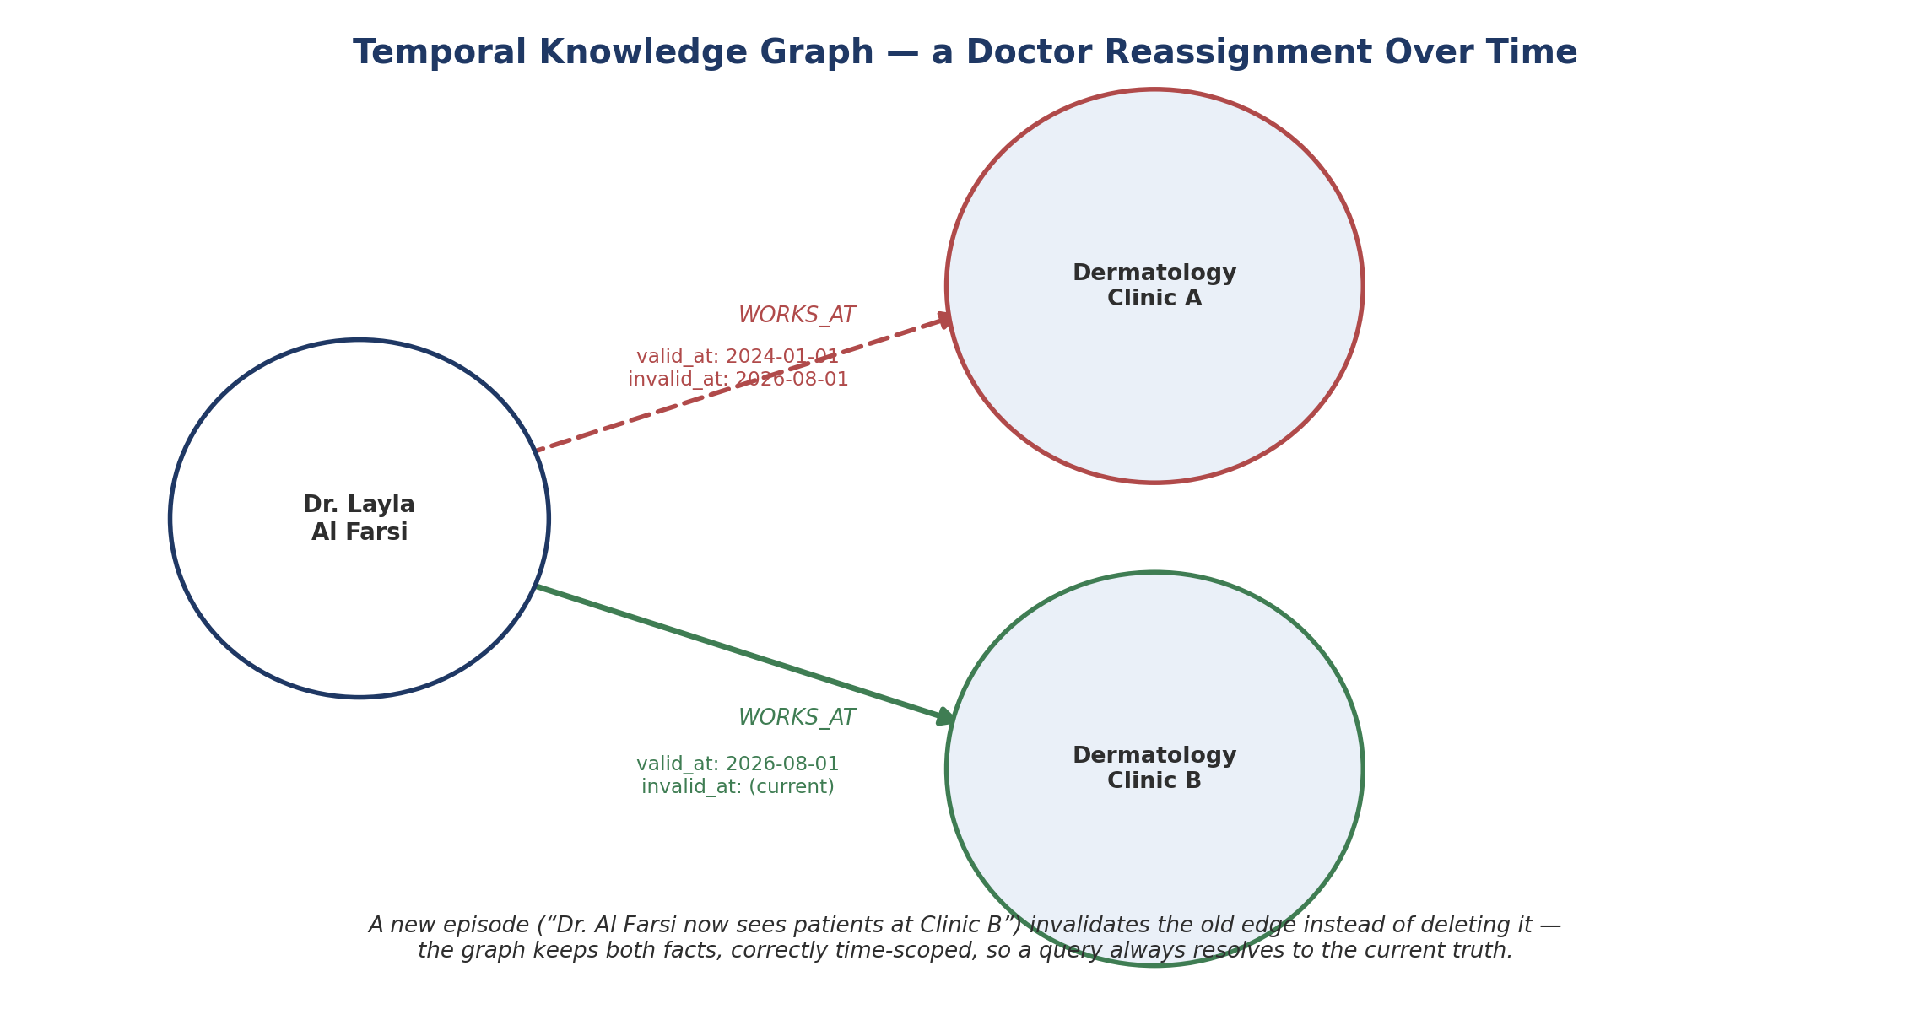
Figure C.1 — A doctor's clinic reassignment as a temporal graph: the old assignment is kept but marked superseded, not deleted.

C.3 Core Components
Layer | Role | This option
Orchestration | Channel handling, flow logic, calling out to memory and hospital APIs | Alexa (unchanged from Option 1/2)
Memory / knowledge layer | Stores and retrieves approved hospital facts | Graphiti — temporal knowledge graph, self-hosted
Graph database | Stores the entities/relationships Graphiti manages | Neo4j, FalkorDB, or Amazon Neptune (Graphiti supports all three)
Extraction LLM | Reads new content and proposes entities/relationships into the graph | Any OpenAI-, Anthropic-, Gemini-, or Groq-compatible model
Speech + avatar | Voice and rendered video, as in Option 1 | Reusable as-is — ElevenLabs / HeyGen, or open alternatives (Whisper, Kokoro, Simli)

C.4 Architecture
The overall shape stays the same as Option 1 — Alexa remains the single orchestration hub talking to speech, avatar, and hospital APIs. The only structural change is what sits behind the knowledge-lookup call: a self-hosted Graphiti/graph-database layer instead of (or in addition to) the vector RAG store.
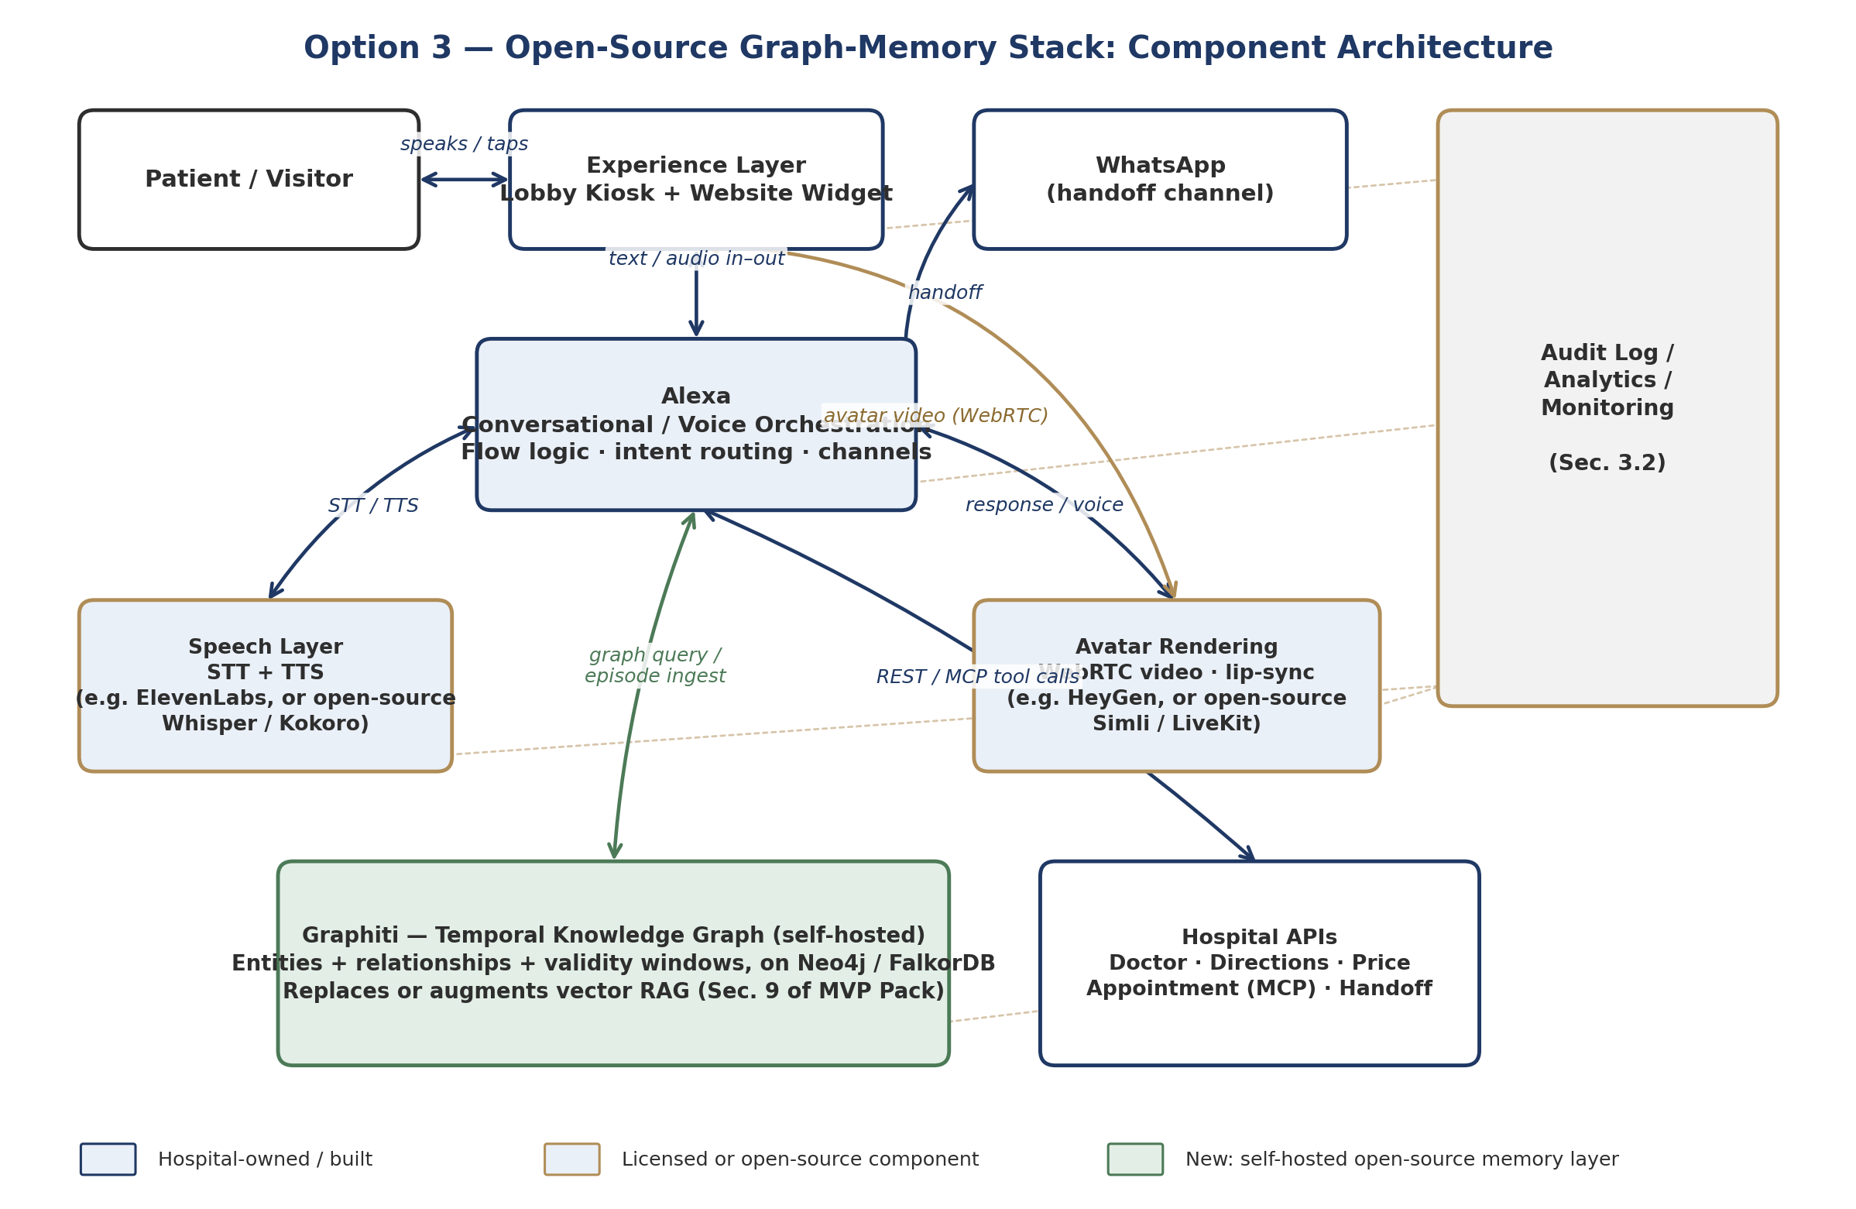
Figure C.2 — Option 3 architecture: the green box is the new self-hosted memory layer; everything else can be reused from Option 1.
Because Graphiti is self-hosted, this is the option that sits most comfortably inside the hard requirement in Section A.6 of the addendum — patient-relevant facts never have to leave hospital-controlled infrastructure to be stored or queried, unlike a third-party vector-RAG or managed knowledge-base service.

C.5 Code Walkthrough — Ingesting a Hospital Fact
Graphiti's core unit of information is an “episode” — a piece of text or structured data that gets automatically parsed into entities and relationships. Below is an illustrative example of how a doctor-directory change (Section 9.1 of the MVP Pack, doctor entity) would be ingested, following Graphiti's published quickstart pattern:
from datetime import datetime, timezone
from graphiti_core import Graphiti
from graphiti_core.nodes import EpisodeType

graphiti = Graphiti(
uri="bolt://localhost:7687", # hospital-hosted Neo4j / FalkorDB
user="neo4j",
password=os.environ["GRAPH_DB_PASSWORD"], # from hospital secrets vault
)
await graphiti.build_indices_and_constraints() # one-time setup

await graphiti.add_episode(
name="doctor_directory_update_2026_08_01",
episode_body=(
"Dr. Layla Al Farsi now sees patients at Dermatology "
"Clinic B, Level 3, Block C. She no longer holds "
"clinic hours at Clinic A."
),
source=EpisodeType.text,
source_description="Approved doctor-directory update, Medical Affairs",
reference_time=datetime(2026, 8, 1, tzinfo=timezone.utc),
)
Graphiti's extraction step reads that sentence, recognizes the doctor and clinic entities already in the graph, adds a new “works at Clinic B” relationship valid from 2026-08-01, and automatically marks the older “works at Clinic A” relationship as no longer current — without anyone writing that logic by hand.

C.6 Code Walkthrough — Answering a Patient Question
On the query side, Alexa would call a single search against the graph rather than a vector similarity lookup:
results = await graphiti.search(
"Where does Dr. Layla Al Farsi see patients?"
)

for r in results:
print(r.fact, r.valid_at, r.invalid_at)

# Example output:
# "Dr. Layla Al Farsi works at Dermatology Clinic B"
# valid_at=2026-08-01 invalid_at=None (current)
Graphiti's search combines semantic similarity with keyword matching and graph-distance reranking, and returns facts tagged with their validity window — so the response passed back through Alexa to ElevenLabs/HeyGen only ever contains the currently valid fact, satisfying the same “never answer from outdated content” guardrail as the existing vector-RAG design (Section 8.1).

C.7 Guardrail Fit
Reminder: Graphiti changes how facts are stored and retrieved — it does not relax any guardrail. The response text returned to Alexa must still come only from a graph query result, never from the extraction LLM's general knowledge; the extraction LLM's only job is building the graph from approved content, not answering patients directly.

C.8 Vector RAG vs. Graph RAG — Comparison
Dimension | Vector RAG (current MVP Pack, Sec. 9) | Graph RAG — Graphiti (Option 3)
How facts are found | Similarity between the question and text chunks | Relationships between named entities (doctors, clinics, services)
Handling changed facts | Old and new chunks can both look relevant; needs manual re-indexing/cleanup | New episode automatically supersedes the old relationship; both are kept, correctly time-scoped
Best suited to | Static content: FAQs, policies, service descriptions | Facts that change on a schedule: doctor assignments, prices, department moves
Hosting | Any vector DB, can be managed/external | Self-hosted graph DB (Neo4j / FalkorDB / Neptune) — stays inside hospital infrastructure
Maturity for this project | Already scoped and understood (Section 9) | New — needs a proof-of-concept before relying on it

These are not mutually exclusive: a pragmatic path is to keep vector RAG for static content (FAQs, policies) and add Graphiti specifically for the entities that change — doctor directory, price catalogue, department assignments — which is exactly the operational content Section 9.1 of the MVP Pack already flags as needing review/effective dates.

C.9 Where This Sits Relative to Options 1 and 2
This is not a competing orchestration path — it is a memory-layer upgrade that can sit underneath either Option 1 (Alexa + ElevenLabs + HeyGen) or Option 2 (LangGraph). It does not solve the multi-agent coordination gap identified in Section A.10; a graph memory still needs to be called by whatever orchestration layer wins that decision. Its main contribution is to the RAG requirement (Section A.5) and the data-control requirement (Section A.6), not to the orchestration debate.

C.10 Maturity and Risk
- Origin is a public tutorial/reference implementation, not a supported product — expect to invest real engineering time to harden it for a hospital pilot (error handling, access control, backup/restore of the graph database).
- Requires running and maintaining a graph database (Neo4j/FalkorDB) in the hospital's private/hybrid environment (Section 3.1) — an additional operational component versus a purely licensed vector-RAG service.
- Ingestion (add_episode) makes an LLM call per fact update to extract entities/relationships — worth costing out for the expected volume of doctor/price/department changes per month.
- The extraction quality (does it correctly recognize “Dr. Layla Al Farsi” as the same entity every time, in Arabic and English) needs its own test set, similar in spirit to the AI Quality Evaluation Set in Section 8.4 of the MVP Pack.

C.11 Next Steps
Action | Owner | Needed by
Stand up Graphiti + Neo4j (or FalkorDB) in a DEV environment; ingest the current doctor directory as a test set | AI/RAG Engineer | Day 10–15 (Sprint 0 / early build)
Run the doctor-reassignment scenario (Section C.5–C.6) end-to-end and confirm old facts are correctly superseded, not just added | AI/RAG Engineer | Before M2 (Day 30)
Compare answer quality and latency against the existing vector-RAG plan for the same 20 test questions (Section 8.4) | AI/RAG Engineer + Quality | Before M2 (Day 30)
Decide scope: full replacement of vector RAG, or hybrid (graph for changing facts, vector for static content) | Product Owner + AI/RAG Engineer | Before M2 (Day 30)

