AL SALAM HOSPITALS
Digital Patient Concierge Avatar
Option 4 — Avatar Rendering Alternatives
A swappable avatar-rendering layer evaluated against HeyGen LiveAvatar
Companion to: Concept & Technical Approach Addendum, Section A.10, and Option 1 Detailed Implementation Plan, Section B.5.3. Purpose: broaden the avatar-rendering choice beyond HeyGen — the orchestration (Alexa) and speech (ElevenLabs) layers stay as already decided; only the rendered face/video component is being re-evaluated.
Naming note: “Alexa” refers to the voice/orchestration platform used elsewhere in this project — a team working name only, not affiliated with Amazon Alexa.

D.1 Why Re-Open the Avatar Choice
Section A.10 named HeyGen LiveAvatar as the avatar-rendering component of Option 1, mainly because it was ready out of the box and integrates natively with ElevenLabs voices. Since then, the avatar-rendering market has broadened noticeably — LiveKit's plugin ecosystem alone now lists more than a dozen real-time avatar providers. This section treats avatar rendering as its own, swappable decision, separate from the orchestration (Alexa) and speech (ElevenLabs) choices, which do not need to change.

D.2 Three Categories of Avatar-Rendering Approach

Category A — Modular “face-only” APIs
You keep your own voice/orchestration stack (Alexa + ElevenLabs) and send audio or text to the provider, which returns a real-time, lip-synced video stream. This is the most natural fit for Al Salam's architecture, since orchestration is already decided. Candidates: Simli, D-ID (Agent API), Anam, Tavus (Conversational Video Interface), and HeyGen LiveAvatar itself, which also operates in this mode.

Category B — Fully-rendered 3D digital humans
Providers build a complete, often photoreal 3D character with full creative control over appearance — closer to the culturally specific Emirati persona in the original concept art. Candidates: Soul Machines, RAVATAR. These typically require more production investment and can carry higher latency than the video-based APIs in Category A.

Category C — Fully custom / self-hosted build
Build the avatar in-house using a 3D engine (Unreal Engine MetaHuman is the most common choice) and a real-time rendering/streaming pipeline (e.g. NVIDIA ACE / Omniverse Avatar Cloud Engine). No per-minute vendor billing once running, and the persona and all rendering stay on hospital-controlled infrastructure — consistent with the same data-control principle behind Option 3's self-hosted memory layer — but it carries real engineering and GPU-hosting cost.

D.3 Where It Plugs Into the Architecture
Whichever provider is chosen, it sits in exactly the same place Figure B.1 already reserved for HeyGen: Alexa sends response audio/text to the avatar layer and receives a WebRTC video stream back for the kiosk/web display. Nothing else in the architecture changes.
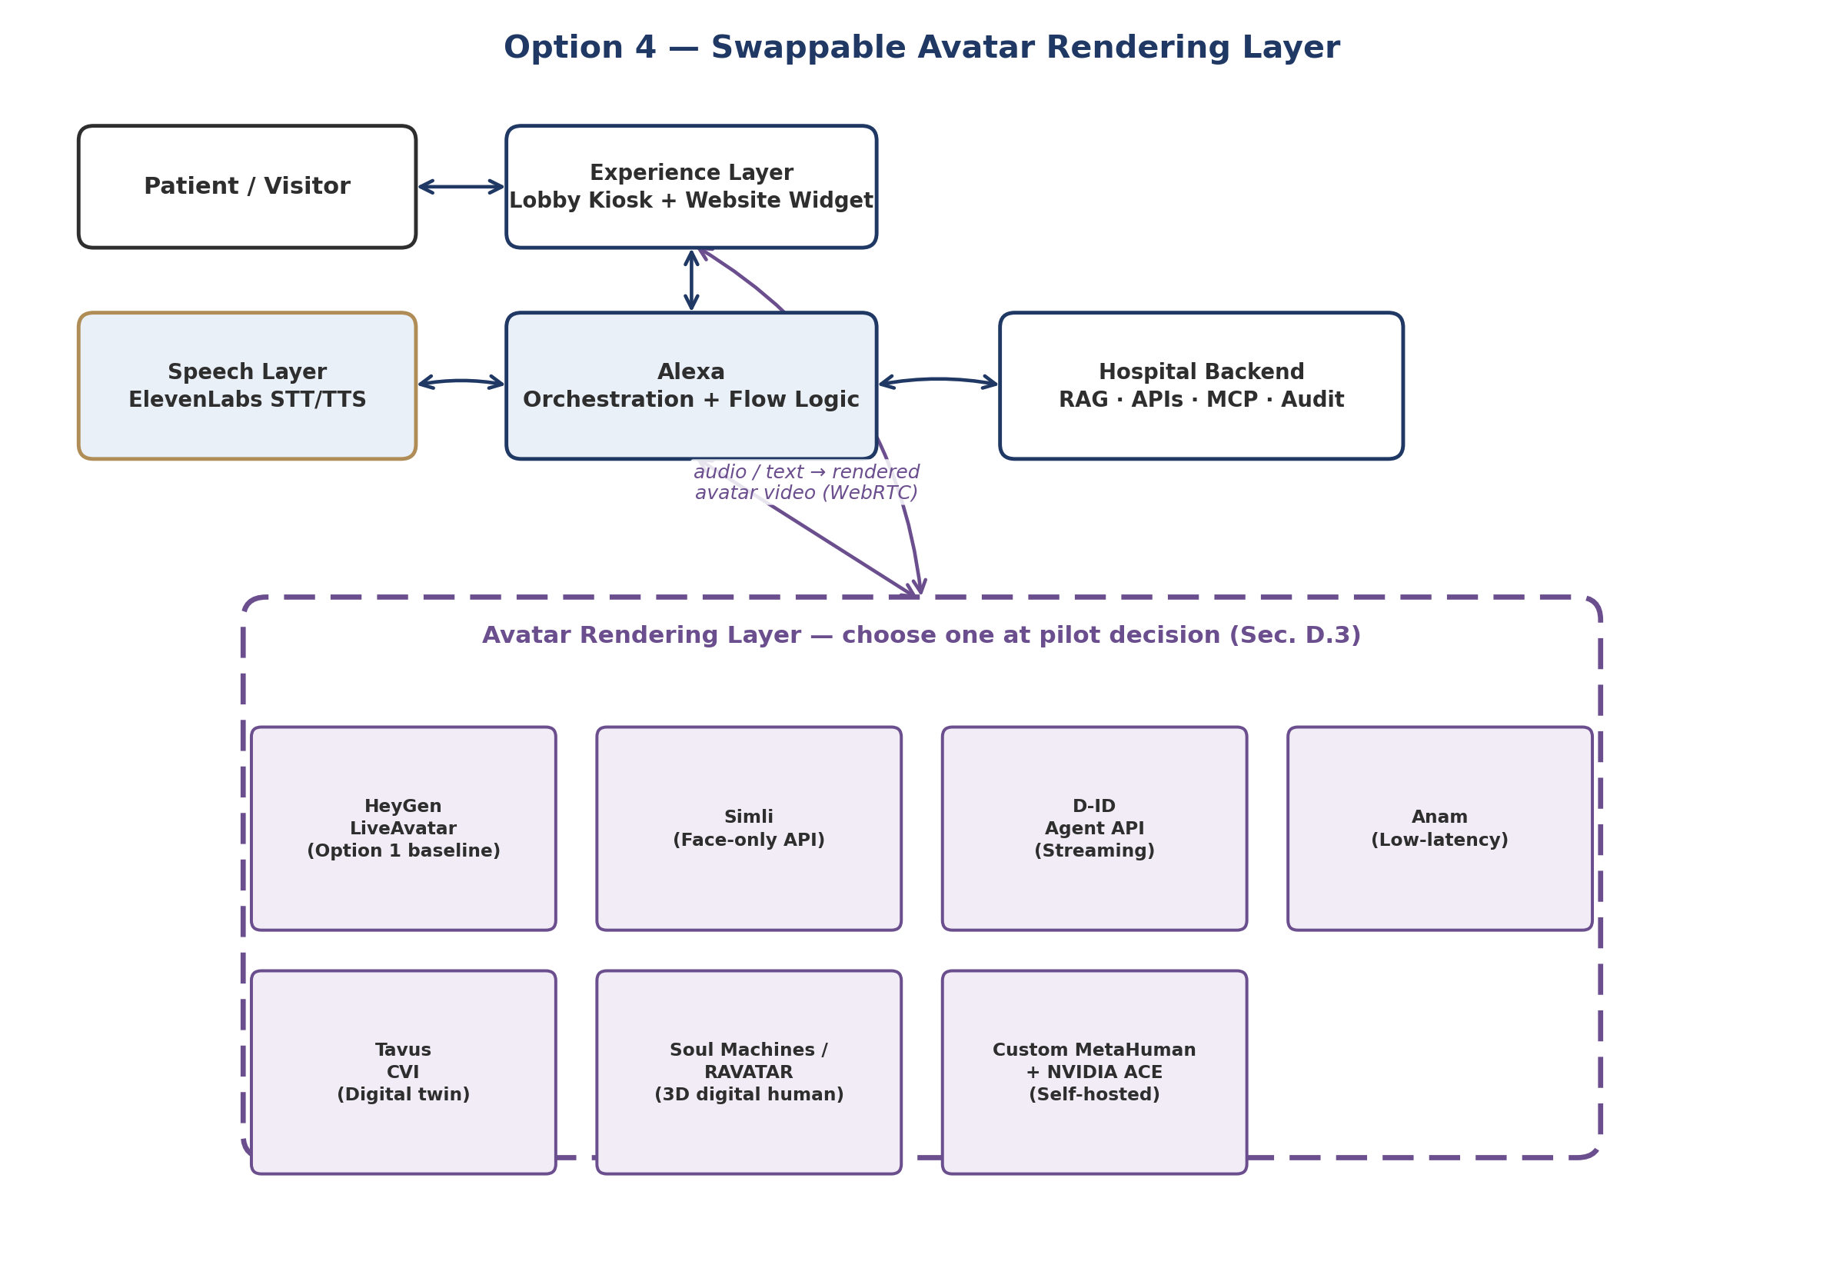
Figure D.1 — The avatar-rendering layer as a swappable component behind Alexa; every candidate plugs into the same interface.

D.4 Candidate Comparison
Provider | Category | Latency / streaming | Indicative cost | Custom persona from your own reference art/footage | Notes
HeyGen LiveAvatar | A — modular API | Real-time WebRTC | ~$0.10 per 30 sec (Full mode) | Yes — avatar creation from photo/video | Option 1 baseline; native ElevenLabs voice support
Simli | A — modular API | Real-time, speech-to-video | Usage-based (in line with managed-API range below) | Yes | Most “unbundled” option — pure face renderer, no bundled voice/LLM
D-ID (Agent API) | A — modular API | WebRTC streaming, sub-2s first frame | Usage-based | Yes — animates a supplied photo or generated persona | One of the more mature developer ecosystems in this space
Anam | A — modular API | ~180ms published benchmark (CARA-3) | Usage-based | Yes | Newer entrant; worth testing purely for responsiveness
Tavus (CVI) | A — modular API | Real-time conversational video | Usage-based | Yes — “digital twin” style personalization | Strong fit if a highly personalized/consistent persona matters
Soul Machines / RAVATAR | B — 3D digital human | Higher than Category A, real-time capable | Higher — production-project pricing, not simple per-minute | Full creative control — built to your art direction | Closest to the original concept art's photoreal/stylized look; real production investment
Custom: MetaHuman + NVIDIA ACE | C — self-hosted build | Depends on hospital GPU hosting | ~$0.06–$0.12/min raw compute once built (no vendor licence fee) | Full control — built entirely to spec | Largest upfront engineering + GPU-hosting effort; best long-run data control

As general market context: managed real-time avatar APIs (Category A) typically run in the $0.10–$0.37 per minute range depending on resolution and concurrency, while a self-hosted custom build (Category C) can bring raw compute cost down to roughly $0.06–$0.12 per minute — the gap being convenience, operations, and concurrency management rather than a difference in underlying rendering quality.

D.5 Evaluation Criteria Specific to Al Salam
Criterion | Why it matters here
Custom persona fidelity | The concept art already specifies a culturally appropriate Emirati-male persona in hospital-branded dress — the provider needs to reproduce that, not offer a generic stock character.
Arabic lip-sync quality | Same bar as the speech layer (Section B.5.2) — needs testing with real Arabic hospital terminology, not just English demo scripts.
Latency in a lobby setting | A kiosk conversation feels broken quickly if there's a visible delay between the voice and the avatar's mouth movement; this is the main practical differentiator between Category A providers.
Data control | Categories A and B send response content to an external rendering service for every turn; Category C keeps it entirely on hospital infrastructure — relevant to the addendum's Section A.6 requirement.
Integration effort vs. Sprint 0 timeline | Category A providers can plug into the existing Alexa/ElevenLabs pipeline within the 90-day window; Category B and C both carry meaningfully more production or engineering time.

D.6 Suggested Approach
Rather than treating this as a single up-front choice, it fits the addendum's existing pattern of validating options against real journeys before committing (Section A.10): trial two or three Category A providers (HeyGen LiveAvatar plus one or two of Simli / D-ID / Anam) against the same doctor-search and directions journey used in the Option 1 demo (Section B.6), scoring them on the criteria in Section D.5. Categories B and C are worth keeping on the roadmap as a post-pilot upgrade path — once patient volume and budget justify the higher production or engineering investment — rather than as MVP candidates.

D.7 Next Steps
Action | Owner | Needed by
Score HeyGen LiveAvatar, Simli, and D-ID against Section D.5 criteria using the same demo journey as Section B.6 | AI/RAG Engineer + Frontend/Kiosk Dev | Before M1 (Day 10), alongside Section A.14's vendor scoring
Request a custom-persona sample (matching the concept art) from each shortlisted Category A provider | IT / Procurement | Day 5–10 (Sprint 0)
Get a rough production quote from one Category B provider (Soul Machines or RAVATAR) for comparison purposes only | IT / Procurement | Day 10 (Sprint 0 close)
Flag Category C (custom MetaHuman build) as a post-pilot roadmap item, not an MVP candidate | Product Owner | M1 decision record

