Qanawat Avatar — Server Specifications
Oct 13, 2026
Prepared by the Qanawat Technical Team.

Summary
Recommended: host the website, admin panel and AI agent on the client's own servers (Docker), and keep LiveKit Cloud for the live audio/video connection. This is option A below.
One small server (4 vCPU, 8 GB RAM) serves about 10–25 simultaneous calls; add one agent server of the same size per extra 10–25 calls. Option A needs no inbound media ports and no separate contracts with the speech, voice and AI-model providers, because LiveKit Cloud includes them. Moving the media server on-premises too (option B) is possible, but it adds a public media server, a wide UDP port range and three provider contracts to manage.

How the parts fit (option A)
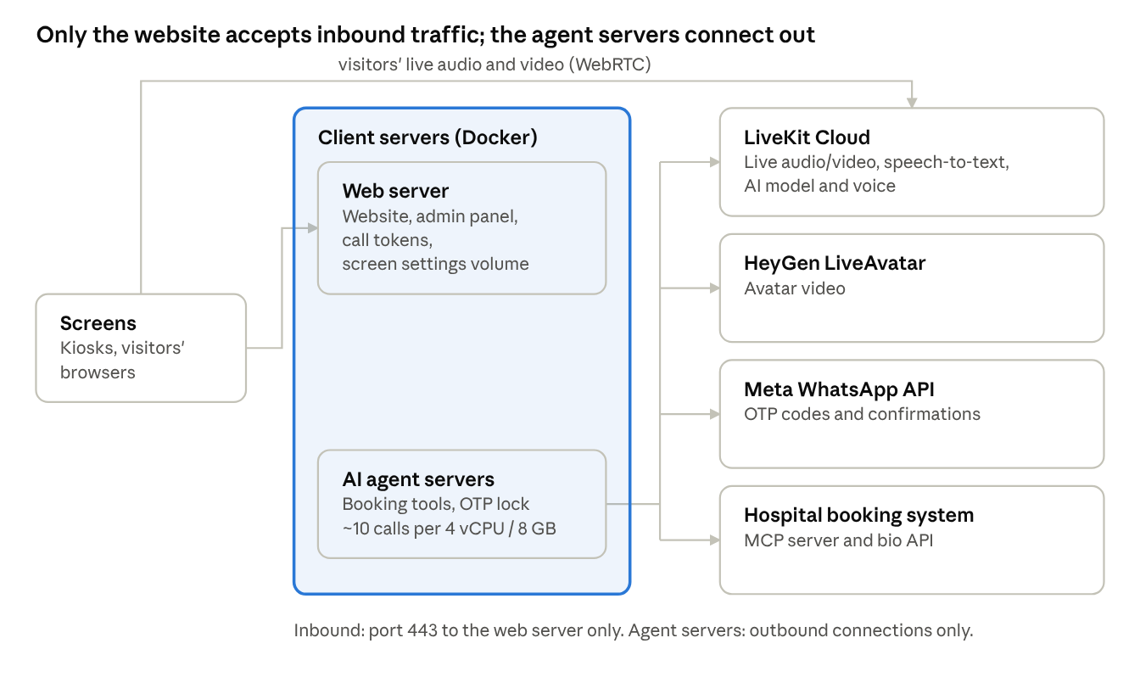
architecture · client servers and the cloud services they use
The screens load the website from the client's web server and stream the call's audio and video through LiveKit Cloud. The agent servers do the work: they call LiveKit for speech and voice, HeyGen for the avatar, WhatsApp for codes, and the hospital system for doctors and bookings. The web server also reads doctor bios from the hospital system for the QR page.

Hosting options
Option A keeps the client's data and logic in-house with the least infrastructure; option B is only worth it if a policy forbids any cloud media relay.
 | A. Client servers + LiveKit Cloud (recommended) | B. Fully on client servers
On client servers | Website, admin panel, AI agent, screen settings | Same, plus the LiveKit media server (and Redis if more than one)
Speech-to-text, AI model, voice | Included through LiveKit Inference; one bill | Separate contracts and API keys with each provider (e.g. Speechmatics, an LLM provider, Cartesia)
Inbound ports to open | 443 only (website) | 443, 80, 7881/TCP, 3478/UDP, 50000–60000/UDP
Public IP needed | Only for the website | Yes, for the media server too
Ongoing operations | Docker updates, backups | Plus media server upgrades, TURN, certificates, scaling
Main dependency | LiveKit Cloud uptime | Client's own network and on-call team
Both options still use two cloud services that cannot run on-premises: HeyGen LiveAvatar (the video face) and Meta's WhatsApp API (OTP and confirmations). LiveKit Inference works only when LiveKit Cloud carries the media (LiveKit Inference), which is why option B needs the separate provider contracts.

Server specifications
The AI agent is the part that needs real CPU; the website is light. LiveKit's guidance is 4 cores and 8 GB RAM per agent server for 10–25 simultaneous calls, with fewer calls per server when noise cancellation and turn detection are on, as they are here (LiveKit: self-hosted deployments). Plan for the low end, about 10 calls per agent server, until a load test says otherwise.
Size | Simultaneous calls | Servers (option A) | Each server
Pilot | up to 10 | 1 server running everything | 4 vCPU, 8 GB RAM, 80 GB SSD
Standard | up to 20 | 1 web server + 2 agent servers | Web: 2 vCPU, 4 GB, 40 GB SSD · Agent: 4 vCPU, 8 GB, 40 GB SSD
Growth | up to 50 | 2 web servers behind a load balancer + 5 agent servers | Same as Standard
- Use dedicated or compute-optimised vCPUs, not burstable ones: speech detection runs in real time, and a test on an underpowered laptop fell 7–11 seconds behind the caller.
- OS: Ubuntu Server 22.04 or 24.04 LTS (64-bit), Docker Engine and Docker Compose.
- Two agent servers rather than one bigger one keeps calls working while one is restarted or updated.
- Option B adds a LiveKit media server: start at 4 vCPU and 8 GB RAM on a public IP, and size its bandwidth from a pilot measurement of real calls (one 720p avatar video plus audio per call).

Network and security
With option A, only the website accepts inbound traffic; the agent servers make outbound connections only and need no open ports (LiveKit: self-hosted deployments).
Direction | From | To | Port | Purpose
Inbound | Screens / visitors | Web server | 443/TCP | Website, admin panel, call tokens
Outbound | Agent servers | LiveKit Cloud (*.livekit.cloud) | 443/TCP | Calls, speech, AI model, voice
Outbound | Agent servers | HeyGen LiveAvatar (api.liveavatar.com) | 443/TCP | Avatar video
Outbound | Agent servers | Hospital booking system (salemmcp.alsalamhosp.com, salemuatapi.alsalamhosp.com:446) | 443, 446/TCP | Doctors, slots, bookings, OTP
Outbound | Agent servers | Meta WhatsApp (graph.facebook.com) | 443/TCP | OTP and confirmations
Outbound | Web server | Hospital bio API (salemuatapi.alsalamhosp.com:446) | 446/TCP | Doctor bio page (QR)
Outbound | Visitors' browsers | LiveKit Cloud | 443/TCP, UDP | Live audio/video of the call
- A domain (e.g. avatar.qanawat.ai or a hospital subdomain) and a TLS certificate; the included nginx config terminates TLS and proxies to the website.
- The admin panel (/admin) is password-protected; restrict it further to the hospital network or VPN if possible.
- Secrets (LiveKit, HeyGen, WhatsApp, alexa360 keys, admin password) live only in the servers' environment files, readable by root only.
- Patient details are fetched only after the caller's WhatsApp code is verified; this is enforced in the agent code.

Software and deployment
The project ships ready to run with Docker Compose: one web container (website, admin panel, token service) and one agent container, configured by two environment files.
- Provision the server(s) above with Ubuntu LTS, Docker Engine and Docker Compose.
- Copy the project to the server and fill in deploy/.env (website: LiveKit keys, agent name, admin password) and deploy/agent.env (agent: LiveKit, HeyGen, WhatsApp, hospital, alexa360 keys).
- Run docker compose up -d --build in deploy/.
- Point the domain at the web server and install the TLS certificate; the nginx config in deploy/ proxies to the website.
- Sign in at /admin and configure each screen (font, theme, background, layout, AI model, voice, avatar, agent ID).
- For more agent capacity, run the agent container alone on additional servers with the same agent.env; LiveKit spreads calls across them automatically.
- Back up the screen-data volume daily: it holds every screen's settings and uploaded backgrounds. Nothing else on the servers needs backing up.
- Monitor CPU on the agent servers (add capacity when it stays above about 70% at peak) and the containers' restart counts. Agent call logs go to the container logs (docker compose logs agent).
- Updates are a git pull (or new copy) and the same docker compose up -d --build; schedule them outside busy hours, since restarting the agent container can cut calls in progress.

External services
Option A needs three accounts (plus alexa360 if its persona is used), each preferably in the client's own name; option B adds three provider contracts.
Service | Used for | Option A | Option B
LiveKit Cloud | Live calls; speech-to-text, AI model and voice through LiveKit Inference | Required (paid by usage) | Replaced by the on-premises media server
HeyGen LiveAvatar | The avatar's video face | Required (credits per minute) | Required
Meta WhatsApp Business API | OTP codes and booking confirmations | Required (approved templates) | Required
alexa360 | Knowledge base for the general persona | If that persona is used | If that persona is used
Speech-to-text provider (e.g. Speechmatics, Arabic + English) | Understanding callers | Included in LiveKit | Own contract and key
AI model provider | The agent's reasoning | Included in LiveKit | Own contract and key
Voice provider (e.g. Cartesia) | The agent's voice | Included in LiveKit | Own contract and key
The hospital booking system (MCP server and bio API) stays as it is today and must be reachable from the agent servers.

Decisions for the client
- ☐ Option A (recommended) or option B, and whether any policy rules out a cloud media relay
- ☐ Expected number of screens and peak simultaneous calls, to pick Pilot, Standard or Growth
- ☐ Physical servers or a private cloud, and the data-centre location
- ☐ The domain for the avatar website and who manages its TLS certificate
- ☐ Whose name the LiveKit, HeyGen and WhatsApp accounts are in, and who pays them
- ☐ Whether /admin may be reached from outside the hospital network
- ☐ The correct SERV_TYPE value for bookings (currently assumed to be 1)

