Qanawat Avatar — Technical Documentation
Oct 13, 2026
Prepared by the Qanawat Technical Team. This document describes the Al Salam Hospital AI avatar: a real-time Arabic/English voice concierge with a video avatar that answers questions, shows doctor information and books appointments.

Overview
The avatar is live at avatar.qanawat.ai: a visitor opens the page, taps Connect, and talks (or types) to a Kuwaiti-Arabic/English assistant shown as a HeyGen video avatar.
What it does:
- Answers general questions about Al Salam Hospital (services, prices, branches, directions).
- Shows a doctor's card — photo, specialty, branch, bio and a QR code to a full bio page — as soon as the caller asks about that doctor.
- Books appointments in the hospital system after verifying the caller with a WhatsApp code, then sends a WhatsApp confirmation; if booking fails, it shows a WhatsApp link pre-filled for the hospital's customer service.
- Lets each screen (kiosk) be configured from an admin panel: theme, fonts, background, layout, AI model, voice, avatar and agent.
Part | Technology | Where it runs today
Web app + admin panel | Next.js 15 (React 19, TypeScript, Tailwind) | Vercel, project qanawat-avatar
Voice agent | Python 3.13, LiveKit Agents 1.8 | LiveKit Cloud, agent CA_KwabQkDMqSWH (alsalam-concierge)
Live media, speech-to-text, AI model, voice | LiveKit Cloud + LiveKit Inference | LiveKit project avatar-fh5ke1ry
Avatar video | HeyGen LiveAvatar (LITE mode) | HeyGen cloud
Hospital data and bookings | Al Salam MCP server + bio API | Hospital servers
The system is in pilot. The admin panel, per-screen configuration and the code-level OTP lock are built and in a Vercel preview, not yet live. Booking uses a SERV_TYPE value of 1 that still needs confirming with the hospital (see Known issues).

Architecture
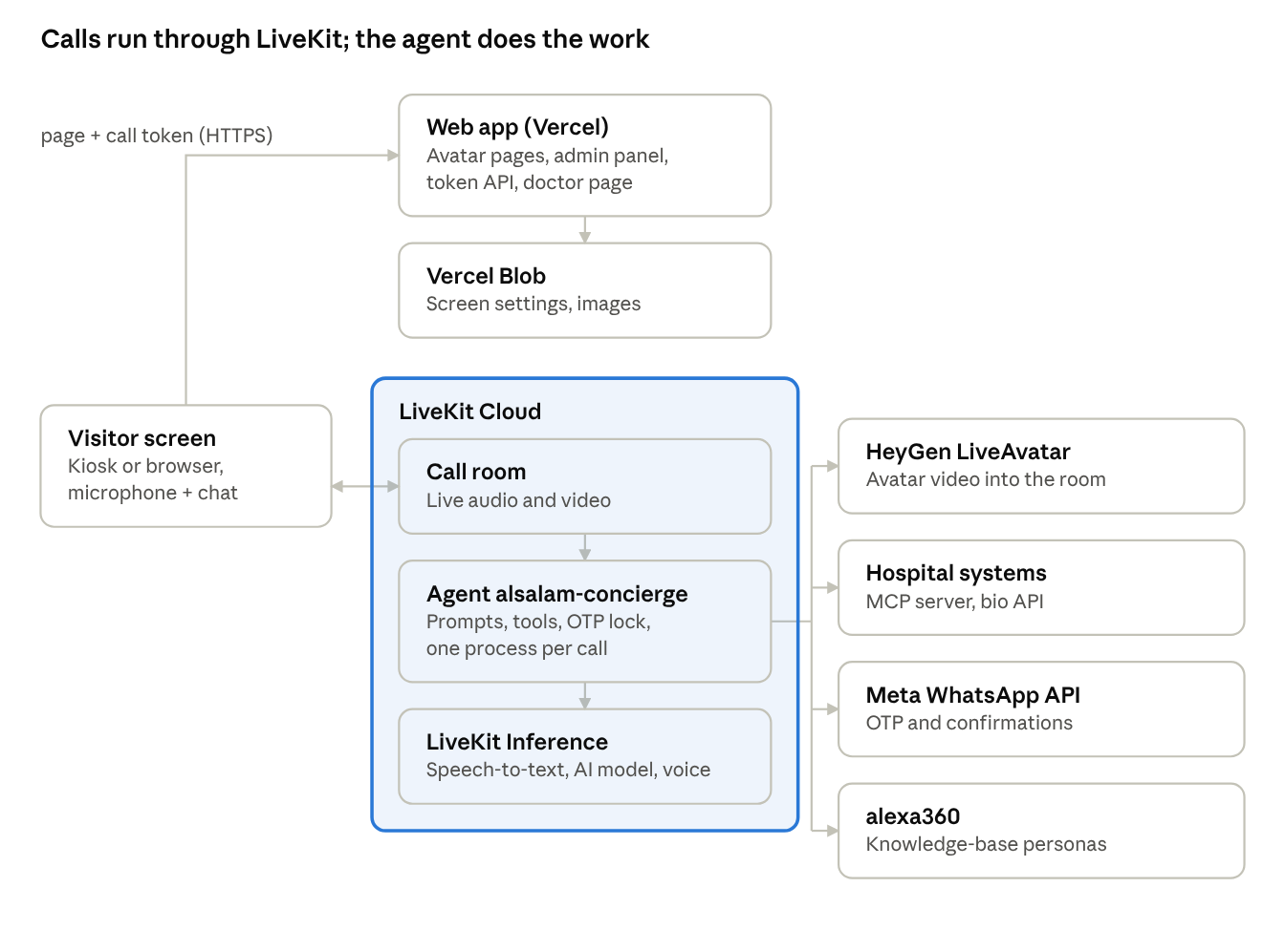
system architecture · current hosting on Vercel and LiveKit Cloud
The visitor's browser loads the page and a call token from the web app, then joins a LiveKit room over WebRTC. LiveKit dispatches the call to the agent, which uses LiveKit Inference for speech and voice and calls the hospital, WhatsApp, alexa360 and HeyGen; HeyGen publishes the avatar's video back into the room. The web app also reads doctor bios from the hospital API for the QR page.

Repository structure
Three top-level folders: web/ (the Next.js site), agent/ (the voice agent) and deploy/ (self-hosting).
Path | What it is
agent/src/agent.py | The whole voice agent: personas and prompts, tools, booking logic, privacy lock, avatar start, call settings (about 2,150 lines)
agent/src/.env.local | Agent secrets for local runs (not committed)
agent/.env.example | Template of every agent setting
agent/livekit.toml | LiveKit Cloud project and agent ID used by lk agent deploy
agent/Dockerfile, agent/pyproject.toml | Container build and Python dependencies (uv)
agent/voice_samples.py | Renders an Arabic sentence with several voices for comparison
agent/SUBMIT_APPOINTMENT_BUG_REPORT.md | Hospital booking-endpoint investigation notes
web/src/pages/index.tsx, web/src/pages/s/[id].tsx | The avatar screen: / (main screen) and /s/<id> (other screens)
web/src/pages/admin.tsx | Admin panel UI
web/src/pages/doctor.tsx | Public doctor bio page opened by the QR code
web/src/pages/api/token.ts | Issues LiveKit call tokens and attaches the screen's AI settings
web/src/pages/api/admin/* | Admin login, screen CRUD, image upload
web/src/pages/api/media/[file].ts | Serves uploaded images when self-hosted
web/src/lib/screen.ts, screenStore.ts, adminAuth.ts | Screen config schema, storage (Vercel Blob or folder), admin auth
web/src/components/playground/ | Call UI: layout, video, doctor card, WhatsApp hand-off cards
web/src/components/chat/ | Chat panel, font controls, Arabic alignment
web/tailwind.config.js, web/src/styles/globals.css | Theme colours; dark/light switched by CSS variables
deploy/docker-compose.yml, deploy/*.example | Self-hosted stack and its settings templates
deploy/avatar.qanawat.ai.nginx, RUNBOOK.md, NO-SERVER.md | TLS proxy config and deployment guides
mcp.js | Copy of the hospital's MCP server source, kept for reference only (it runs on the hospital's side)
gen_token.py | Helper that prints a LiveKit test token

Call lifecycle
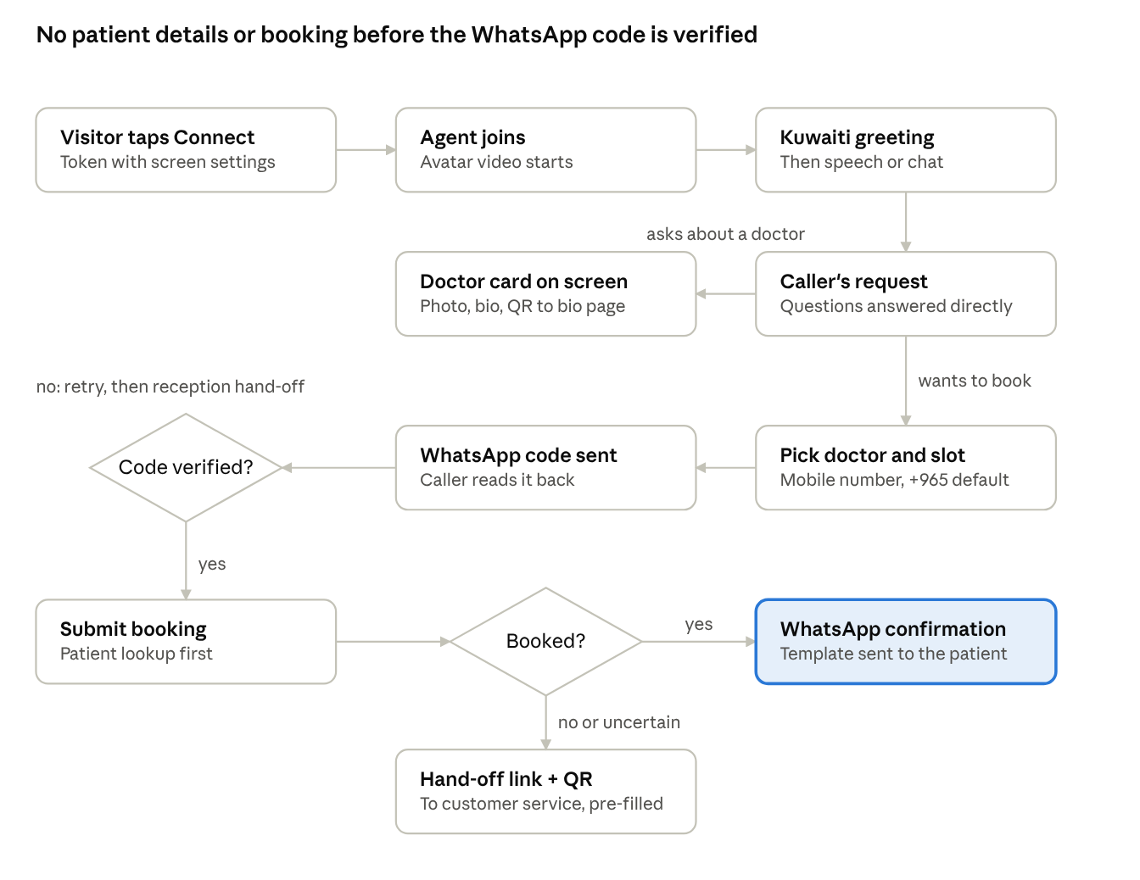
a visitor's call · from Connect to confirmation or hand-off
A doctor question shows the card without starting a booking; a booking always passes the WhatsApp code check before any patient lookup or submission.

Voice agent (agent/)
The agent is one LiveKit Agents worker registered as alsalam-concierge; LiveKit starts one job (a separate process) per call and the website dispatches every call to that name explicitly.
Personas. The agent ID (ai_agent_ns) picks the persona: alsalam loads the hospital booking persona with the hospital's MCP tools; any other ID loads that alexa360 agent's instructions and knowledge base; with neither, a generic fallback persona answers.
Speech pipeline. All three models run through LiveKit Inference, so no separate provider keys are needed.
Stage | Default | Notes
Speech-to-text | speechmatics/linden-1, language ar_en | Handles Arabic/English mixed in one sentence
AI model | google/gemma-4-31b-it | Override with LLM_MODEL or per screen
Voice | cartesia/sonic-3, voice Walid f1cdfb4a-… (Arabic male) | Override per screen
Turn taking | LiveKit turn detector, adaptive interruptions, pre-emptive replies
Noise cancellation | ai-coustics enhancer
Avatar | HeyGen LiveAvatar, LITE mode, it.licenses avatar 3e06afbb-… | LITE = HeyGen only animates the face to our audio
Language rules. The agent greets in Kuwaiti Arabic and replies only in Kuwaiti Arabic or English, never Egyptian or MSA, even when the caller uses another dialect. Doctor names are spoken in Arabic script so the voice pronounces them as Arabic, while tools receive the original spelling.
Local tools (code in agent.py, alongside the hospital's MCP tools):
Tool | Purpose
show_doctor_card | Puts the doctor card on screen; fetches photo and bio from the hospital bio API itself
send_otp_whatsapp | Generates an OTP via the hospital MCP and sends it with Meta's WhatsApp template; adds +965 to 8-digit numbers
verify_otp | Verifies the code and records the verified number for this call
check_patient_whatsapp | Looks up the patient's file; refuses unless that number was verified in this call
select_doctor_from_list | Wraps the MCP tool, converting IDs to the strings it requires
find_real_clinic_id | Recovers a doctor's real clinic ID when the hospital search returns 0
submit_appointment | Books in the hospital system; refuses before OTP verification; returns success / failed / uncertain
show_booking_handoff | On a failed booking: WhatsApp link + QR to customer service, pre-filled with the appointment details
show_reception_handoff | Connects the caller to reception via WhatsApp for any other reason
Per-call settings. At the start of each call the agent reads the room's metadata, set by the website from the screen's admin config: ai_agent_ns, avatar_id, llm_model, tts_model, tts_voice, stt_language. Missing values fall back to the agent's environment. It reads them from the job's room snapshot (ctx.job.room), because the live room object is still empty when the job starts.
Call end. A call ends after 30 seconds in which the caller genuinely doesn't respond; time the agent spends thinking or waiting on a tool doesn't count.

Booking flow and hospital integration
The agent talks to the hospital through its MCP server (https://salemmcp.alsalamhosp.com/mcp, 30-second timeout) and, for bios and clinic lookups, directly to the hospital API (https://salemuatapi.alsalamhosp.com:446).
Booking steps, in the order the agent follows them:
- Find the doctor with search_individual (name or specialty); if several match, the caller picks one and select_doctor_from_list returns the available days.
- Show the doctor card immediately, then fill it with photo, bio and QR via search_bio_all.
- Get real slots with get_doc_next_availble_slot (days first, then one day's slots); offer the soonest open slot.
- Take the mobile number (Kuwait +965 assumed unless the caller says otherwise); read it back; if unclear, ask the caller to type it in the chat.
- send_otp_whatsapp → caller reads the code back → verify_otp. Only now may check_patient_whatsapp look up the patient's file.
- submit_appointment with the doctor, slot and patient details.
- On "success": send_whatsapp_message sends the confirmation template (Arabic or English). On "failed" or "uncertain": show_booking_handoff shows a WhatsApp link and QR to customer service with every detail pre-filled.
Hospital-side behaviour the code works around:
Issue | Workaround in the agent
Search tools return clinic_id 0 | find_real_clinic_id probes the scheduling endpoint for the real ID
search_bio_all matches bio text, not names; & in a term errors | Search by a plain specialty keyword, then match on doctor_id
MCP generate_otp creates a code but never sends it | send_otp_whatsapp generates and sends in one step via Meta's API
submit_appointment / send_whatsapp_message always report success: true | The nested response is classified as success / failed / uncertain
Slot tools reject numeric IDs | IDs are passed as strings
submit_appointment requires SERV_TYPE that no tool returns | Set from ALSALAM_SERV_TYPE (currently 1, unconfirmed)

Web app (web/)
A Next.js 15 (pages router) app, built from LiveKit's open-source Agents Playground (Apache-2.0) and rebranded; every page that shows an avatar loads its screen config on the server first.
Route | What it does
/ | Avatar screen using the default screen config
/s/<id> | Avatar screen using screen <id>; unknown IDs fall back to defaults, invalid IDs return 404
/doctor?id=&term=&lang= | Public doctor bio page (QR target): fetches the bio and photo from the hospital API, right-to-left in Arabic
/admin | Admin panel (password)
POST /api/token | Returns a LiveKit server URL and a 10-minute participant token
/api/admin/*, /api/media/* | Admin APIs and self-hosted image serving (see Admin panel)
Token service. /api/token?screen=<id> creates a random room, dispatches it explicitly to the agent named AGENT_NAME (default alsalam-concierge), and writes the screen's AI settings into the room metadata. Client-supplied room metadata is ignored. Optional ?agent= and ?avatar= URL parameters still override.
Call screen.
- Video and chat side by side on desktop, tabs on mobile; the split, chat side and card corner come from the screen config.
- The avatar video is rendered directly; the green-screen keying component is off unless NEXT_PUBLIC_CHROMA_KEY=true (it delayed the video behind the audio).
- The page asks for the microphone only; camera and screen sharing are disabled.
- The agent drives on-screen cards by setting its participant attributes: doctor_card, booking_handoff, reception_handoff. Cards with QR codes keep a literal white background so they scan in both themes.
- A "Searching…" pill shows while the agent is thinking.
Chat. Callers can type instead of speaking; typed messages reach the agent as input. Arabic messages are laid out right-to-left, sender name included. A− / A+ buttons (12–40 px) and a font menu (Cairo, Tajawal, Noto Kufi Arabic, IBM Plex Sans Arabic, system) start from the screen's settings; a visitor's choice is kept in their browser until an admin changes that screen.
Themes. Tailwind's gray, black and white map to CSS variables. Dark is the default; html[data-theme="light"] flips the palette. The server renders the screen's theme into the HTML, so a light screen never flashes dark.

Admin panel and screen configuration
Each physical screen is a "screen" with an ID (lowercase letters, digits and dashes, up to 48 characters); /admin edits them and a saved change applies on that screen's next page load or call.
Field | Values | Applied by
name, title | Text | Admin list; browser tab and header
theme | dark / light | Page palette
fontSize, fontFamily | 12–40 px; one of five fonts | Chat text default
backgroundImage, backgroundOverlay | http(s) or same-site URL (uploaded or pasted); 0–100% | Page background and its wash
videoPercent | 30–85 (chat gets the rest) | Desktop split
chatPosition | left / right | Desktop layout
cardPosition | bottom-left, bottom-right, top-left, top-right | Doctor and hand-off cards
showSettingsButton | true / false | "Show settings" button
agentId, avatarId | Agent ID (e.g. alsalam); HeyGen avatar ID | Agent, via room metadata
llmModel, ttsModel, ttsVoice, sttLanguage | LiveKit Inference IDs; empty = agent default | Agent, via room metadata
Every input is validated on the server (sanitizeScreen): unknown values fall back to defaults and unsafe image URLs (for example javascript:) are dropped.
Storage. Chosen by SCREEN_STORAGE, or automatically:
- blob (Vercel): JSON at screens/<id>.json and images at uploads/ in the Vercel Blob store qanawat-avatar-screens (public access, Frankfurt), read uncached.
- filesystem (self-hosted): the same files under SCREEN_DATA_DIR (default ./data); images served by /api/media/<file>, which accepts only generated file names.
APIs (all except login require the admin session cookie):
Method and path | Purpose
GET / POST / DELETE /api/admin/login | Status, sign in with {password}, sign out
GET /api/admin/screens | List saved screens and the storage backend
GET / PUT / DELETE /api/admin/screens/<id> | Read, save, delete one screen
POST /api/admin/upload | Upload a JPG, PNG or WebP (up to 4 MB) as the raw request body; returns its URL
Login. One password (ADMIN_PASSWORD). Sign-in sets an HttpOnly, SameSite=Strict cookie holding an expiry signed with ADMIN_SESSION_SECRET (HMAC-SHA256), valid 12 hours; wrong passwords are slowed down by 0.8 seconds.

Configuration reference
Secrets are never committed: locally they live in web/.env.local and agent/src/.env.local; in production in Vercel's environment settings, LiveKit Cloud agent secrets, or deploy/.env and deploy/agent.env when self-hosted.
Web app
Variable | Required | Purpose
NEXT_PUBLIC_LIVEKIT_URL | Yes | LiveKit server URL (wss://avatar-fh5ke1ry.livekit.cloud); built into the page
LIVEKIT_API_KEY, LIVEKIT_API_SECRET | Yes | Sign call tokens
AGENT_NAME | No | Agent to dispatch calls to (default alsalam-concierge)
ADMIN_PASSWORD, ADMIN_SESSION_SECRET | For /admin | Admin login and cookie signing
SCREEN_STORAGE | No | blob or filesystem (default: blob if a Blob token exists)
BLOB_READ_WRITE_TOKEN | Vercel | Vercel Blob access (added by Vercel when the store is linked)
SCREEN_DATA_DIR | Self-hosted | Folder for screen configs and uploads (default ./data)
ALSALAM_RAW_API_BASE | No | Hospital API for the doctor page (default https://salemuatapi.alsalamhosp.com:446)
NEXT_PUBLIC_CHROMA_KEY | No | true re-enables green-screen keying
NEXT_PUBLIC_APP_CONFIG | No | One-line YAML override of playground defaults
Agent
Variable | Required | Purpose
LIVEKIT_URL, LIVEKIT_API_KEY, LIVEKIT_API_SECRET | Yes (supplied by LiveKit Cloud when hosted there) | Register the worker
AGENT_NAME | No | Dispatch name (default alsalam-concierge)
ALEXA360_API_BASE, ALEXA360_API_KEY, ALEXA360_DEFAULT_AGENT_NS | Yes | alexa360 API and the default agent ID (alsalam)
STT_MODEL, STT_LANGUAGE | No | Defaults speechmatics/linden-1, ar_en
LLM_MODEL | No | Default google/gemma-4-31b-it
TTS_MODEL, TTS_VOICE | No | Defaults cartesia/sonic-3, Walid
AVATAR_ENABLED, LIVEAVATAR_API_KEY, LIVEAVATAR_AVATAR_ID, LIVEAVATAR_VIDEO_QUALITY | For video | HeyGen avatar (true, key, avatar ID, high)
ALSALAM_AGENT_KEY, ALSALAM_MCP_URL, ALSALAM_SERV_TYPE | Yes | Hospital persona key (alsalam), MCP URL, booking service type
WHATSAPP_ACCESS_TOKEN, WHATSAPP_PHONE_NUMBER_ID, WHATSAPP_OTP_TEMPLATE, WHATSAPP_OTP_TEMPLATE_LANG, WHATSAPP_API_VERSION | Yes | Meta WhatsApp OTP sending (template otp, en_US, v21.0)
HOSPITAL_WHATSAPP_HOTLINE, HOSPITAL_WHATSAPP_HOTLINE_DISPLAY | Yes | Customer-service number for hand-off links

Local development
You need Node.js 24 LTS, pnpm 9 (or npm), Python 3.13 and uv, plus the LiveKit, HeyGen, WhatsApp and alexa360 keys.
- Web: in web/, copy .env.example to .env.local, fill it in, then run pnpm install and pnpm dev. The site runs at http://localhost:3000.
- Agent: copy agent/.env.example to agent/src/.env.local, fill it in, then run uv sync and uv run src/agent.py dev in agent/.
- Open http://localhost:3000, click Connect, allow the microphone.
To test without touching live calls, start both sides with the same private name, e.g. AGENT_NAME=alsalam-test; calls from that local site then reach only the local agent. To test self-hosted storage, set SCREEN_STORAGE=filesystem and SCREEN_DATA_DIR to a temporary folder.
Checks before deploying:
- npx tsc --noEmit and npx next lint in web/
- uv run python -m py_compile src/agent.py in agent/
- When adding a web dependency, update pnpm-lock.yaml (pnpm install --lockfile-only); Vercel installs with --frozen-lockfile and fails otherwise.
A laptop is often too slow to run the agent realistically: on the test Surface, speech recognition fell 7–11 seconds behind. Use a 4-core machine or test against the cloud agent.

Deployment
Today the web app deploys to Vercel and the agent to LiveKit Cloud; the client's own servers use the Docker stack in deploy/.
Web app on Vercel (team qanawatai-1338, project qanawat-avatar; avatar.qanawat.ai points to Vercel):
- vercel login, then vercel link --project qanawat-avatar in web/. Back up web/.env.local first: linking rewrites it.
- Preview: vercel deploy --target preview. LiveKit keys are saved for Production only, so pass them for a preview with -e and -b (or add them to the Preview environment).
- Production: vercel deploy --prod. Production was rolled back once, so a new production deployment may not take the domain automatically; run vercel promote <deployment-url> if the domain still serves the old one.
Agent on LiveKit Cloud (agent CA_KwabQkDMqSWH, from agent/livekit.toml):
- Export LIVEKIT_URL, LIVEKIT_API_KEY, LIVEKIT_API_SECRET from agent/src/.env.local; lk then needs no browser sign-in.
- Secrets: lk agent update-secrets --secrets-file <file> with every agent variable except LIVEKIT_*; delete the file afterwards.
- Code: lk agent deploy in agent/. LiveKit builds the Dockerfile remotely; lk agent status shows the running version.
Self-hosted (client servers): fill deploy/.env and deploy/agent.env, run docker compose up -d --build in deploy/, and put the nginx config in front for TLS. Screen settings persist in the screen-data volume. Server sizing, ports and options are in the separate Server Specifications document (docs/Qanawat-Avatar-Server-Specifications.docx).
agent/.dockerignore excludes .env files at any depth, so secrets never enter an image.

Operations
Every production change can be undone in a minute: Vercel and LiveKit Cloud both keep previous versions.
Task | Command or place
Web logs | vercel logs <deployment-url>
Agent status and versions | lk agent status, lk agent versions
Agent startup/deploy logs | lk agent logs (per-call logs are not included; use LiveKit Cloud's dashboard sessions view)
Agent settings in the cloud | lk agent secrets (names only)
Roll back the web app | vercel rollback <previous-deployment-url>
Roll back the agent | lk agent rollback
Restart the agent | lk agent restart
Active rooms and their metadata | lk room list --json
HeyGen sessions and credits | LiveAvatar API: GET /v1/sessions?type=active or historic, GET /v1/users/credits (header X-Api-Key)
Self-hosted logs | docker compose logs -f web / agent in deploy/
Health checks after any deploy: the site returns 200; POST /api/token returns a token; a test call shows the avatar and an active HeyGen session appears.
Rotating secrets. Change the key at its provider, then update agent/src/.env.local and re-upload with lk agent update-secrets (web keys: Vercel's environment settings, then redeploy). The keys shared during development in chat (WhatsApp token, alexa360 and LiveAvatar keys, it.licenses password) are due for rotation.

Security and privacy
Patient data is the main risk, so the strongest controls sit around the patient lookup and booking.
Area | Control
Patient lookup | Enforced in code: check_patient_whatsapp and submit_appointment refuse any number not OTP-verified in the same call, registered or not; the agent's prompt also forbids revealing anything about a number before verification
Messaging | OTP codes are generated and sent in one step by code, so the AI never handles the code value; numbers are normalised (+965 default)
Call routing | Explicit dispatch to alsalam-concierge, so a stray or unauthorised worker on the project gets no calls
Call tokens | Short-lived (10 minutes); room metadata is set only by the server
Admin panel | One password, constant-time compare, slowed retries, signed HttpOnly SameSite=Strict cookie (12 h); restrict /admin to the hospital network or VPN if possible
Uploads | JPG/PNG/WebP only, 4 MB max, generated file names; served files limited to those names (no path traversal)
Screen config input | Validated server-side; non-http(s) background URLs dropped
Browser permissions | Microphone only; no camera or screen capture
Secrets | Only in environment files or provider secret stores; excluded from Docker images and git
Screen configs and uploaded backgrounds are stored as public blobs on Vercel: they hold no patient data or secrets, only layout and model choices.

Known issues and open items
The items below are ordered by impact on patients.
- ☐ Confirm SERV_TYPE with the hospital; bookings currently send 1, an assumption.
- ☐ Deploy the admin panel, per-screen settings and OTP code lock to production (built and in preview), then test the lock with a real call.
- ☐ Rotate the keys and password shared in chat during development.
- ☐ Record a custom HeyGen video avatar of a Kuwaiti man (about 2 minutes, with consent) and clone his voice; the current photo avatar can't move its hands and lip-sync is weaker.
- ☐ HeyGen's free tier was seen dropping the stream about 3 minutes into a call, which silences the agent; use a paid plan or add a voice-only fallback.
- ☐ Decide whether the agent should offer booking after answering a doctor question (it currently does).
- ☐ Migrate MCP wiring to MCPToolset; the current way is deprecated in LiveKit Agents.
- ☐ A stray development agent was running on another computer against the LiveKit project; stop it (explicit dispatch already stops it from taking calls).
- ☐ Delete the outdated Desktop\avatar copy so it isn't edited by mistake.

