Cleopatra: A Dual Digital In-Memory Computing Accelerator for Tiled Matrix Multiplication

Introduction
Deep-learning and neural-network workloads repeatedly execute matrix multiplication (matmul) and matrix-vector multiplication (matvec). Convolutional and fully connected layers, attention projections, and related operations can be expressed as large products of weight and activation matrices. A model applies these operations across many layers and input tokens or samples, so the accelerator must process substantial volumes of data as well as perform the arithmetic. The matrices often exceed the capacity of a small local compute array and therefore have to be divided into tiles and transferred from larger memories.
In a conventional processor, storage and arithmetic units are separate. Weights and activations must travel from memory to the compute units, and results must travel back. For large, repeated products, this movement consumes bandwidth and time; compute lanes may wait for operands even when their nominal MAC rate is high. The resulting memory-to-compute bottleneck limits effective throughput and also spends energy on data transfers. Digital in-memory computing (DIMC) addresses this challenge by placing digital arithmetic in or close to the memory structure holding the operands. Reusing locally stored weights for many operations can reduce repeated long-distance transfers. DIMC does not remove the need to move data altogether: large matrices still need to be tiled, loaded, and written back, so the surrounding data path and schedule determine whether the macro can stay busy.
PULP (Parallel Ultra Low Power) is an open-source RISC-V hardware platform built around processor clusters, tightly coupled memories, and hardware accelerators [5]. This repository contributes accelerator IP for integration into a larger PULP-based system; there are four PULP-platform dependencies that provide the integration building blocks: common_cells supplies reusable hardware primitives such as FIFOs [6]; hwpe-stream provides stream interfaces and data-plane components [7]; hci provides cluster interconnect and memory-interface structures for accelerator data movement [8]; and hwpe-ctrl provides the control-register interface used to configure and start an accelerator job [9].
The goal of this work is to take the ST DIMC design used in this project, represented by the spatz_dimc RTL module, and build the accelerator structure needed to use it in that PULP context. The design tiles a matrix product to fit the fixed macro dimensions, and combines the macros with FIFOs, a control unit, streamers, an HCI mux, and an accumulator bank. At the top level, dimc_top contains two independent DIMC modules; each module contains a pair of spatz_dimc macros. This organization provides both a processor-facing accelerator interface and a local schedule for loading operands and returning completed output tiles.
The paired macros use double buffering: while one macro processes the current weight tile, the other receives the next tile. Loading a weight tile takes 128 cycles and fits within the 284-cycle interval for processing eight input vectors, hiding that weight-load latency in steady state.

Background

1. MAC throughput and utilization
A MAC performs one multiplication and adds the result to an accumulated sum. MACs per cycle measures how many such operations an engine performs in one clock cycle. If the clock frequency is $f$, then a sustained rate of $r$ MACs per cycle corresponds to $r×f$ MACs per second.
Utilization compares achieved throughput with a stated peak. For example, if an engine can theoretically issue 100 MACs per cycle but averages 75, its utilization is 75%. The peak and measurement must use the same definition of a MAC and the same scope of hardware.

2. Quantized arithmetic
Quantization represents values with fewer bits than their original format, often using integers instead of floating-point numbers. Lower precision can change numerical accuracy. For example, an 8-bit representation uses less storage per value than a 32-bit floating-point representation. This can reduce data movement and allow more values to fit in a fixed-width datapath.
In this project, precision is a hardware operating mode: the DIMC macro supports 1-, 2-, 4-, and 8-bit operands. Each weight row and input vector occupies a fixed 1024-bit macro word, transferred in four 256-bit sections. Consequently, changing the bit width changes how many scalar values fit in each word: at lower precision, one fixed-size row or vector represents more scalar operands. This is why the supported scalar inner dimension per tile depends on the selected bit width, even though the packed transfer size remains fixed. In 8-bit mode, weights and inputs can each be interpreted as signed or unsigned values. The datapath produces 32-bit partial sums and accumulates contributions across inner-dimension tiles. Thus, precision affects the interpretation and density of the input operands, while accumulation uses a wider result format.

3. Tiling
Tiling is the process of dividing a large computation into smaller subcomputations that fit in a faster, limited-capacity memory or compute array. For matrix multiplication, a tile is a submatrix. The engine loads tiles, computes partial results, and combines those partial results to form the final matrix.
The main benefit is data reuse. A loaded tile of $A$ can be reused with several tiles of $B$, and a tile of $B$ can be reused with several tiles of $A$. Keeping these values local for multiple operations avoids repeatedly fetching them from slower, more distant memory. This can reduce memory traffic and help keep the compute units supplied with operands. The classic matrix multiplication technique is called blocking or loop tiling; it partitions matrices into submatrices to improve reuse in a faster memory level
Tile dimensions must fit the local storage available for the operands and intermediate results. Larger tiles often allow more reuse and amortize the cost of setting up each transfer across more computation. But they also require more local capacity. If the working set exceeds that capacity, tiles may need to be evicted or reloaded, reducing the benefit. Smaller tiles fit more easily, but may cause the same matrix values to be transferred repeatedly and may add more control and transfer overhead. The best tile shape therefore depends on memory capacity, data layout, bandwidth, and the compute hardware.
Tiling does not automatically reduce data movement: a poor tile shape or execution order can reload values unnecessarily. The data must also be arranged so that loaded tiles can actually be reused before eviction. Thus, tile size and loop order are usually chosen together to balance local storage use, transfer volume, and computation per transfer. In this accelerator, the tile size is defined by the hardware.

4. The memory-to-compute bottleneck
Processors can only operate on data that reaches their compute units. If moving operands takes longer than performing arithmetic on them, computation may sit idle waiting for data. This is often described as a memory bottleneck.
One way to reason about the balance is arithmetic intensity: the number of operations performed per byte transferred. The Roofline model uses arithmetic intensity and memory bandwidth to estimate whether a workload is limited mainly by compute capacity or by data movement.
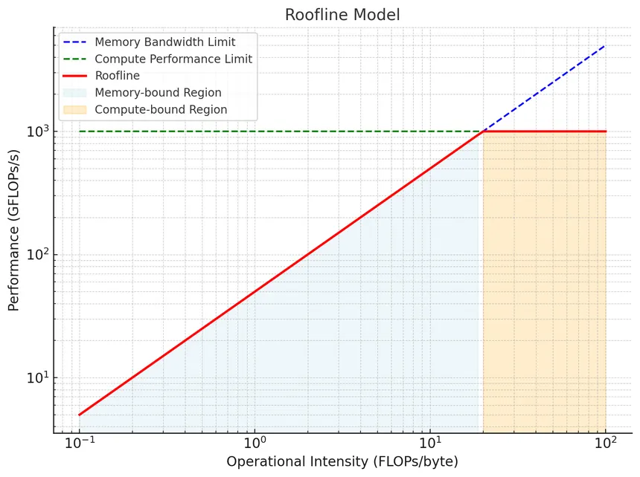

5. Digital in-memory computing (DIMC)
Digital in-memory computing (DIMC) performs some computation within or close to the memory structure holding the data. In DIMC, that computation uses digital logic. The goal is to reduce the distance or frequency of transfers between storage and arithmetic units.
A DIMC macro still needs input data and must return results; its surrounding system still has to move and schedule data.

6. Pipelining, latency, and throughput
A pipeline divides work into stages and overlaps different operations across those stages. Latency is how long one operation takes from start to finish. Throughput is how often completed operations emerge once the pipeline is running.
Pipelining can improve throughput without reducing the latency of an individual operation. The slowest stage constrains the clock period, and stalls or dependencies can reduce the achieved rate.

7. Double buffering
Double buffering uses two storage areas or buffers. While one holds data being processed, the other can receive the next data. Once the current work finishes, their roles switch. This can overlap data loading with computation and hide some transfer latency.
The benefit depends on whether loading the next data takes less time than processing the current data, and whether the memory system can supply data at the required rate. If loading takes longer, part of the transfer remains exposed and the compute engine may wait.

8. FIFOs and ready/valid handshakes
A FIFO (first-in, first-out queue) stores fixed-width words in arrival order and provides them in that same order. The design uses synchronous FIFOs from PULP’s common_cells library. Their push/pop controls and full/empty flags let connected logic enqueue data when space is available and dequeue it when data is present. This buffers the input, weight, and result paths so the DIMC macros, data loader, and accumulators can make progress at different rates. PULP common_cells
These FIFOs use push/pop control; they are distinct from the ready/valid handshakes used on the design’s streaming interfaces. For a ready/valid stream, a transfer occurs on a clock edge when both signals are asserted. The receiver can apply backpressure by deasserting ready, while the sender holds valid data until it is accepted. The Arm AXI4-Stream specification defines that handshake.

9. Hardware accelerators and their control and data interfaces
A hardware accelerator often has two distinct kinds of interface:
- A control interface lets software configure parameters and start work, then learn when the work has completed.
- A data interface moves operands and results between memory and the accelerator datapath. A streamer can generate addresses and turn memory transactions into data streams.
PULP’s Hardware Processing Engine documentation describes this style of memory-coupled accelerator, including control, streamer, and datapath components. HCI and HWPE-Stream are PULP interface concepts; other platforms use different interfaces but solve similar control and data-movement problems.

10. Synthesis area and timing
Synthesis maps a hardware description into cells from a target technology library. The reported cell area is the sum of the areas assigned to those mapped cells. It is a measure of the synthesized logic and storage, not necessarily the full die area.
Static timing analysis (STA) estimates whether signal paths meet clock and interface timing constraints. For a synchronous path, the data must arrive before the receiving register’s setup-time requirement. Slack is the difference between the required arrival time and the estimated arrival time: positive slack meets that constraint; negative slack indicates a violation. A design’s maximum frequency depends on its critical paths and constraints.

Architecture
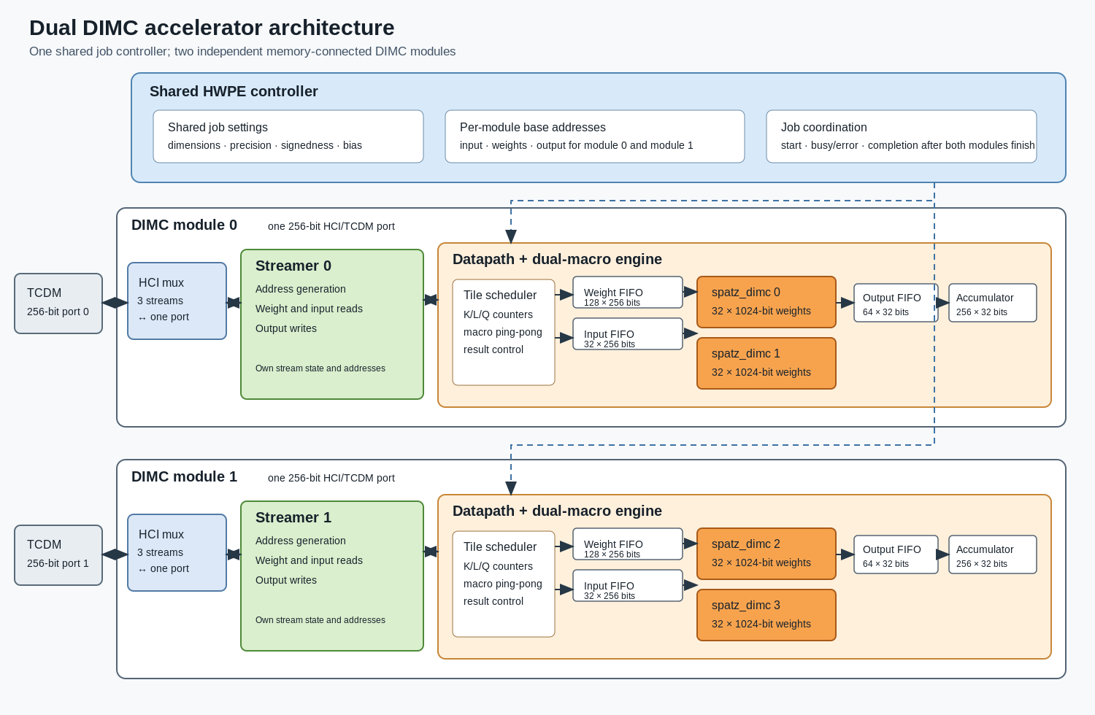

System organization
The top-level dimc_top contains one control/register block and two independent DIMC modules. Each module has its own input, weight, and output addresses and its own 256-bit memory interface. The modules share job dimensions and arithmetic configuration but can process different data regions concurrently.
Each module combines a streamer, a tiled datapath, and a Cleopatra compute core. The compute core contains two DIMC macros, three FIFOs, a result selector, and 256 accumulators. Across both modules, the design instantiates four DIMC macros. The second macro in each pair buffers the next tile; it does not double the number of simultaneously active compute engines in that module.
In this repository, spatz_dimc names the DIMC macro RTL. The RTL hierarchy, from the arithmetic primitive up to the accelerator top, is:
Level | RTL module | Responsibility
Compute primitive | spatz_dimc | One 32-row DIMC macro, with a local feature buffer and pipelined row-dot-product operation.
Paired macro block | spatz_dimc_dual | Two spatz_dimc instances, shared input/weight/output FIFOs, independent macro controls, and selection of the result stream.
Compute and accumulation | cleopatra | Wraps spatz_dimc_dual and routes each 32-bit result to one of 256 accumulators.
Tile sequencer | dimc_datapath | Loads macro tiles, controls row/vector issue, swaps the active and loading macros, and holds completed output tiles.
One memory-connected engine | dimc_module | Connects one dimc_datapath to a dimc_streamer and a dimc_hci_mux.
Accelerator top | dimc_top | Combines one dimc_ctrl with two independent dimc_module instances and their separate TCDM ports.

The data path follows this hierarchy in both directions: TCDM requests pass through the module's HCI mux and streamer; 256-bit weight and input streams feed the datapath and paired macros; the selected macro's results pass through the output FIFO into the accumulator bank; and completed 32 × 8 tiles return through the streamer to memory.
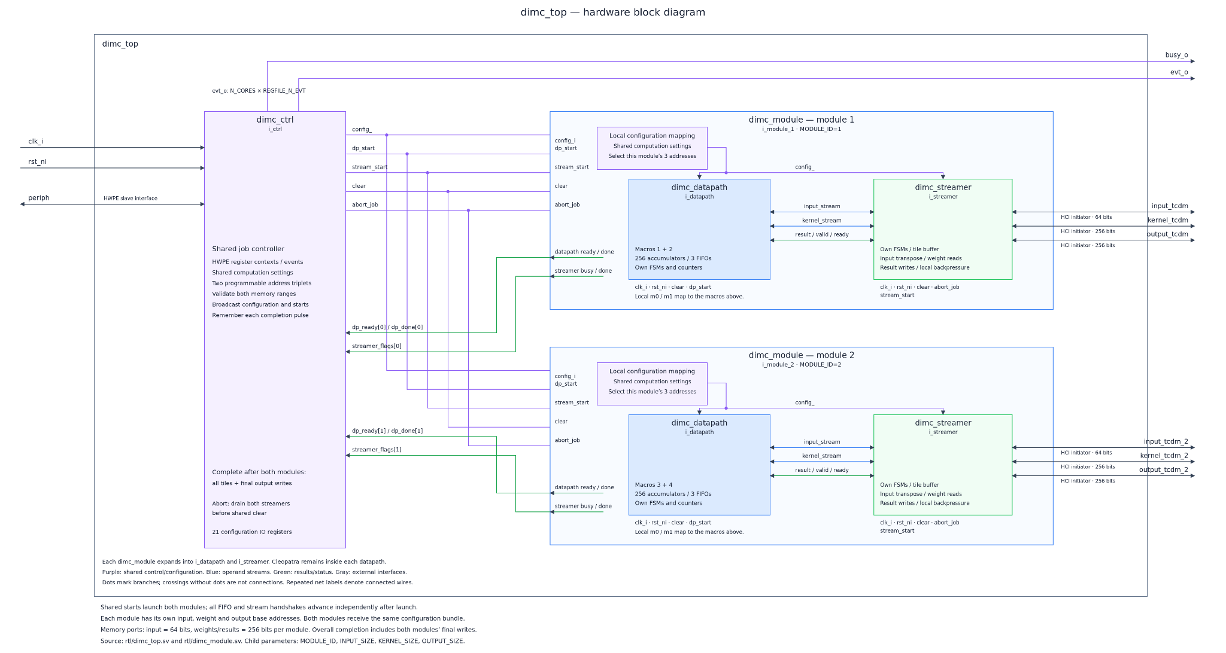

DIMC macro and arithmetic path
Each macro stores 32 weight rows, each 1024 bits wide, and one 1024-bit feature vector. The physical transfer width is 256 bits, divided into four sections for a complete row or vector. A weight-row address selects one of 32 rows and one of four sections. The feature address selects one of the four sections in the local feature buffer.
The macro accepts a row-compute command and pipelines the selected weight row and feature vector through its arithmetic stages. It returns a 32-bit partial sum for that row. The selected macro output is sent through a 32-bit output FIFO to the accumulator bank. The accumulator selector advances on each consumed result so that the 256 values in a 32 × 8 output tile reach their corresponding output accumulators. Contributions from successive inner tiles are accumulated; programmed bias is added only for the first inner tile. The output tile remains stable until the downstream streamer accepts it.
The arithmetic mode selects 1-, 2-, 4-, or 8-bit multiplication. In 8-bit mode, the two sign controls independently select signed or unsigned interpretation for weights and inputs. The macro also exposes masks and a clipped output, while the full matrix path uses the 32-bit partial-sum output for accumulation.

Datapath scheduling
The datapath has an initialization phase followed by repeated tile-product phases. It first receives a weight tile and the first input tile, writes the weights into macro 0, loads the first vector into that macro, and leaves the remaining vectors queued. During computation, it issues one row command per cycle for 32 rows. It then loads the next vector into the active macro and repeats until all eight vectors have been processed.
While one macro is active, the weight and input FIFOs can prepare the other macro. After the active tile has drained from the macro pipeline and all 256 row results have reached the accumulators, the datapath either presents a completed output tile or advances the inner tile. On an inner-tile advance, the macro roles swap and accumulator sums are preserved. When the final inner tile for an output tile completes, the result is held until the streamer accepts it; the accumulators are then cleared for the next output tile.
The steady-state schedule is motivated by an analysis. One weight-tile load takes 128 cycles. Processing eight input vectors requires 256 row-command cycles plus 28 cycles to replace the feature vector between vectors, for a 284-cycle compute interval. That interval fully covers the next 128-cycle weight load. Comparing this ping-pong schedule with a schedule that duplicates current weights in both macros, the ping pong schedule appears more efficient. It reduces steady-state tile cost from 388 to 284 cycles, about 27% fewer cycles or 1.37× the throughput.
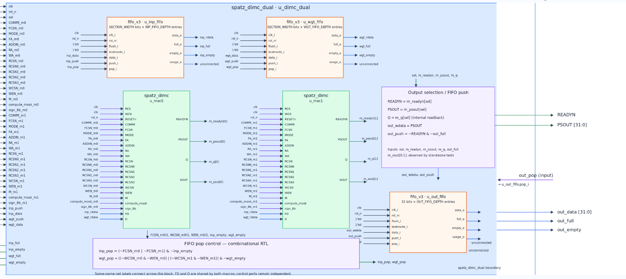

Streamer and memory interface
The streamer generates three transaction streams. It reads 128 256-bit beats for each weight tile, 32 beats for each input tile, and writes one 32-beat output tile. Weight tiles are arranged row-major. Input tiles are addressed in output-column/inner-tile order so input data can be reused for successive output-row groups. Output data is written as eight 32-bit values per row.
The three streams share one HCI port per module through dimc_hci_mux. The mux arbitrates requests and holds the owner of outstanding reads until their responses return. Writes can proceed while read responses are outstanding. The datapath and streamer exchange data with valid/ready handshakes, allowing either side to stall while preserving transaction order.

Configuration and supported dimensions
Software programs input, weight, and output addresses; matrix dimensions; precision and sign mode; bias; and masks. The controller checks non-zero dimensions, matching inner dimensions, tile alignment, address alignment, and address-range overflow before starting a job. The architecture does not pad partial tiles: row counts must be multiples of 32, packed inner dimensions multiples of 128 bytes, and output-column counts multiples of eight. The datapath latches configuration at start and iterates over tile indices in inner-dimension, output-column, then output-row order.

Experimental results

Performance results
MACs-per-cycle performance was measured through RTL simulation of the tb_dimc_top SystemVerilog testbench simulated with QuestaSim, launched using vsim. the testbench recorded elapsed clock cycles for each workload, from which per-module throughput was calculated. These are cycle-level simulation results, not post-layout timing measurements.
Four controlled sweeps were done. Varying K, L, or Q from 1 to 20 while holding the other two dimensions at 1 and five mixed-size experiments. The plots report MACs per cycle per module. Throughput increases with tile count and then approaches a plateau as fixed startup and transfer costs are amortized. The L sweep reaches the highest controlled-sweep rate because it increases the inner work performed before a completed output tile must be written.
Workload point | MACs per cycle per module | Utilization of 128-MAC/cycle peak
K=L=Q=1 | 65.15 | 50.9%
K=20, L=Q=1 | 97.31 | 76.0%
L=20, K=Q=1 | 108.65 | 84.9%
Q=20, K=L=1 | 97.31 | 76.0%
Best mixed-size plotted point | 112.07 | 87.6%

For 8-bit mode, an active macro processes one 128-element row dot product per cycle. The corresponding compute issue peak is therefore 128 scalar MACs per cycle per module. Utilization is the measured MAC/cycle value divided by that peak; it includes loading, output writes, and control overhead.
The two top-level modules operate concurrently, so per-module rates are not total accelerator throughput. System-wide throughput is twice the per-module figure.

Controlled sweeps
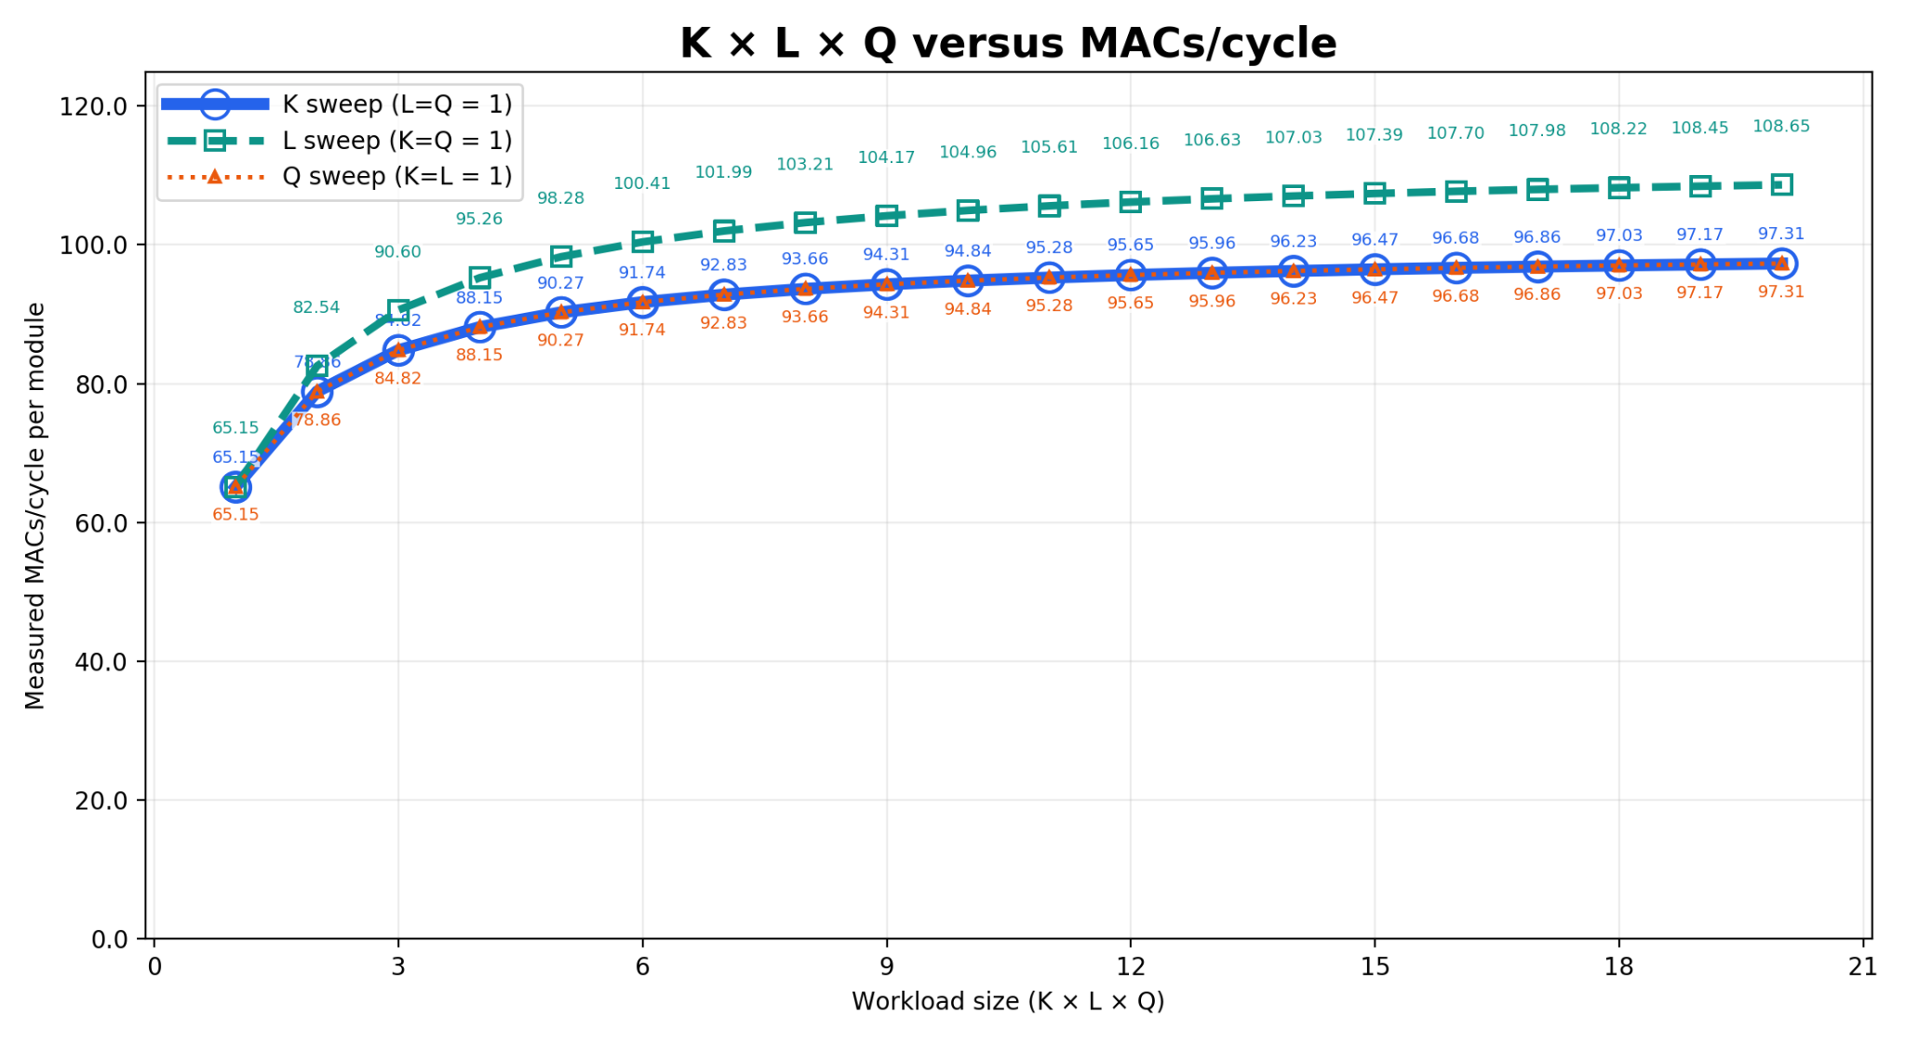
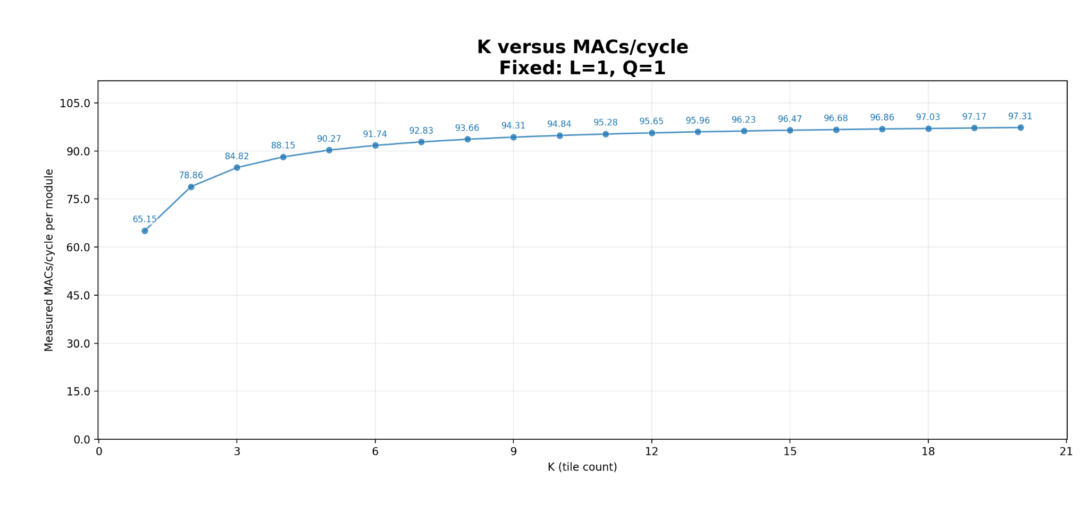
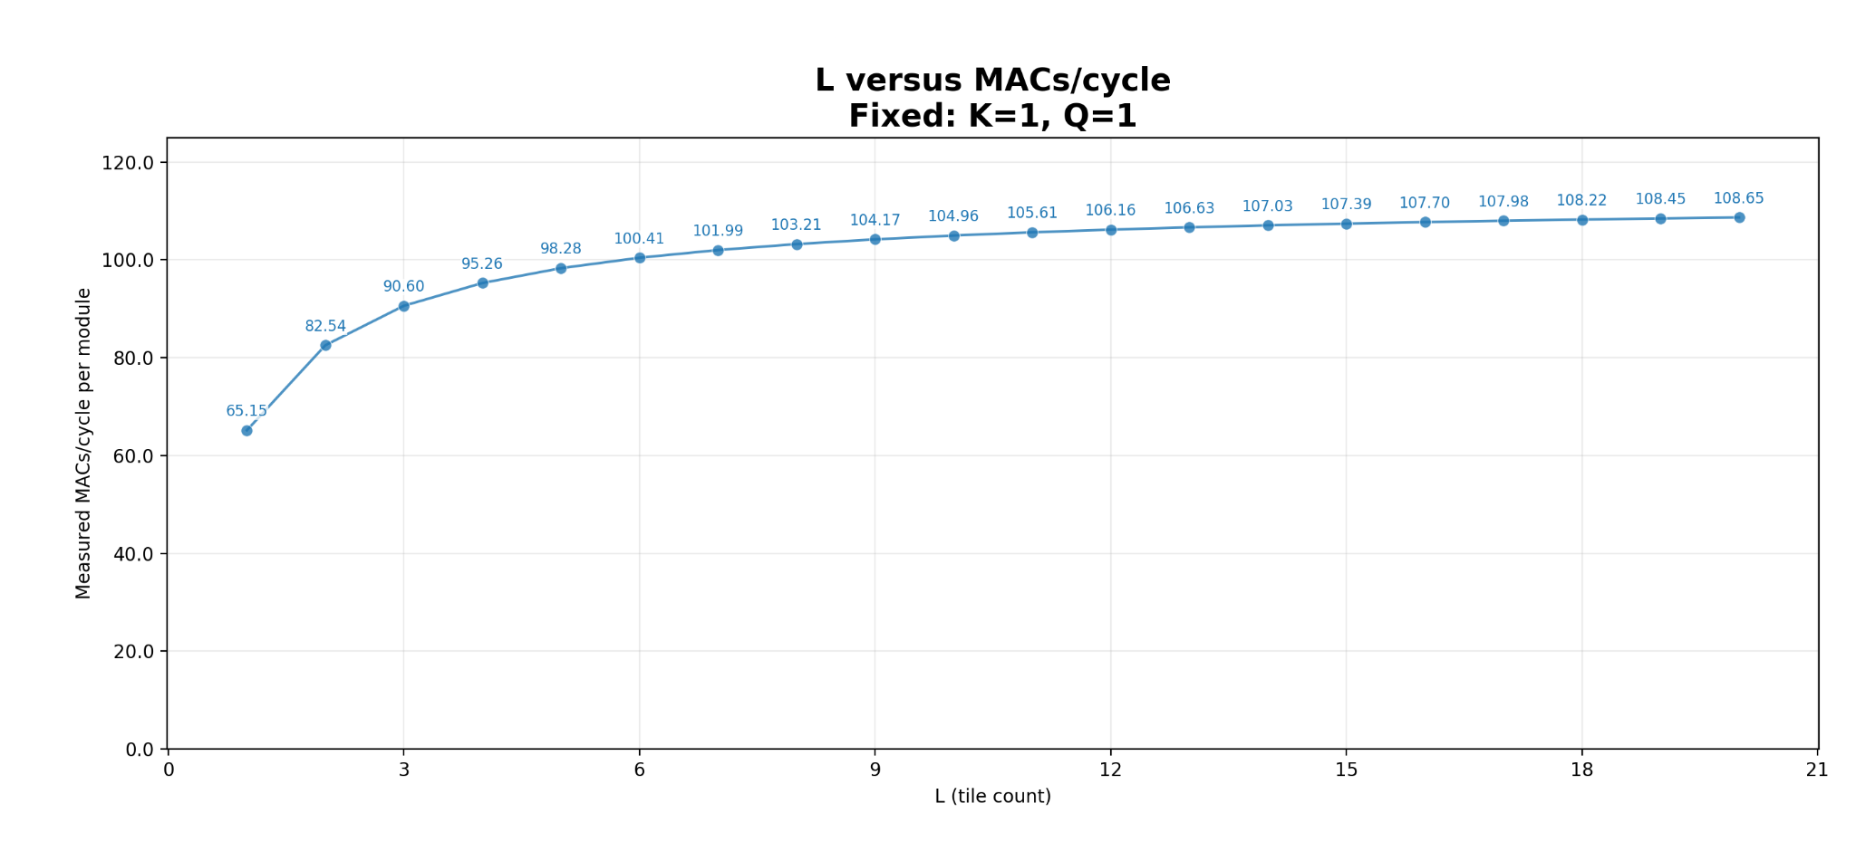
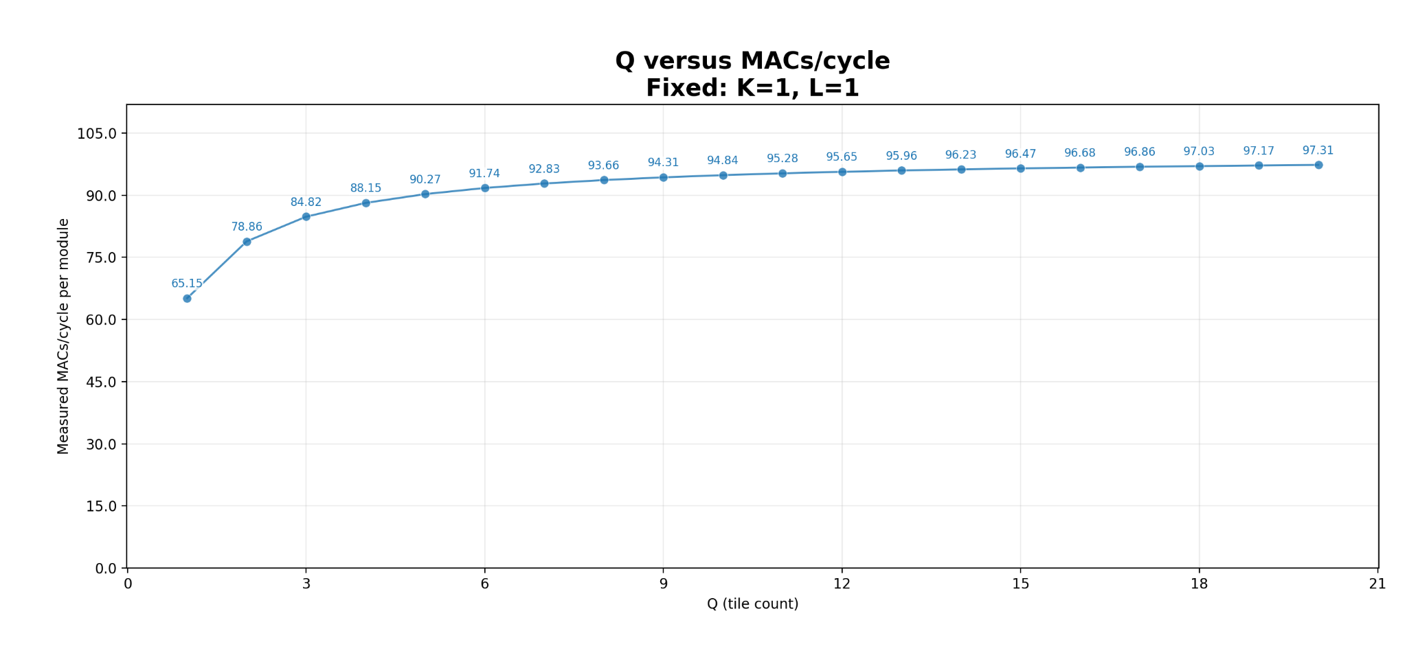

Mixed-size experiments
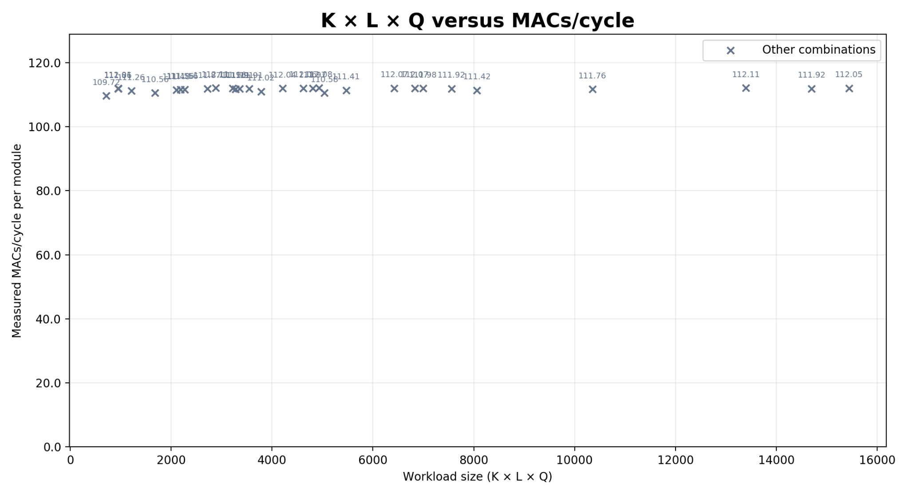
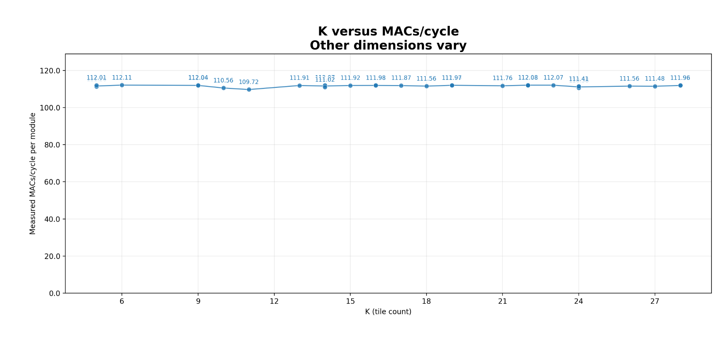
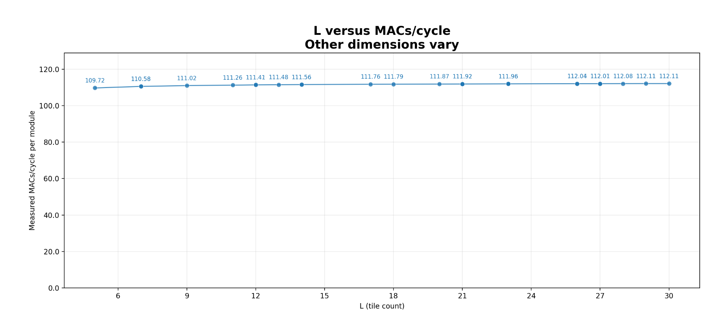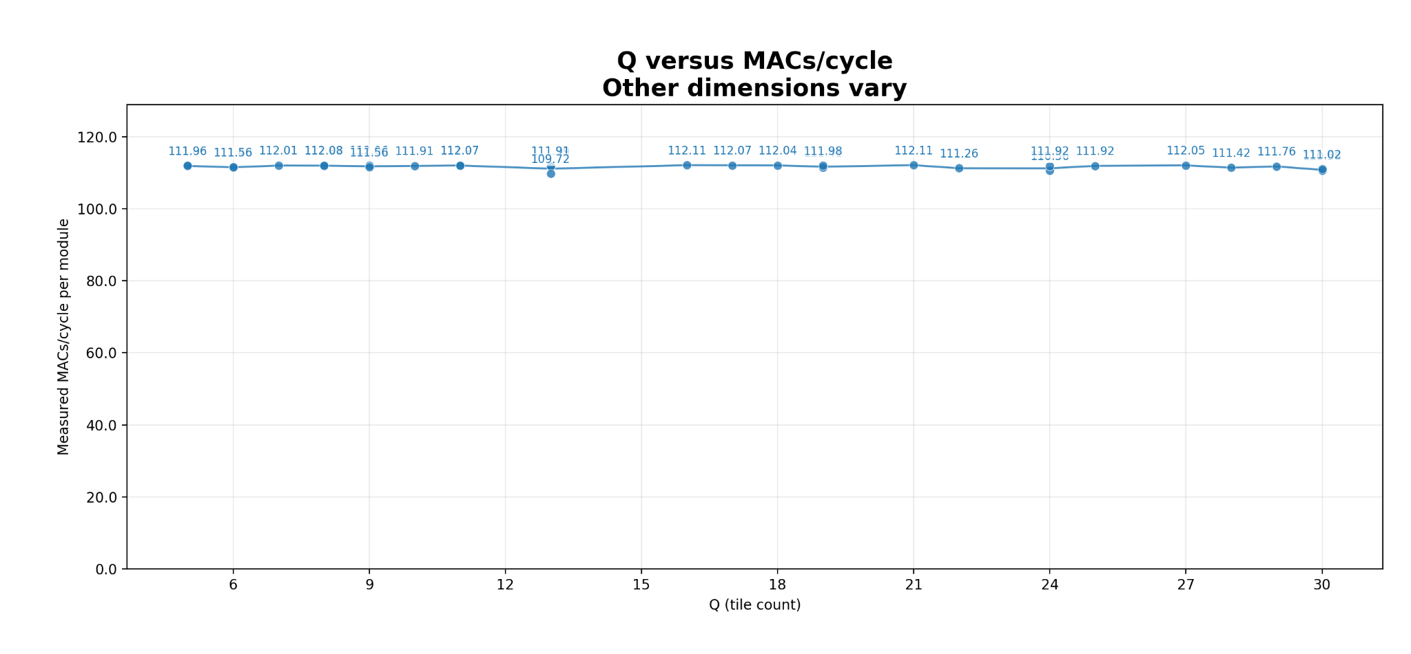

Synthesis results
Synthesis and static-timing results for dimc_top_wrap were generated using Synopsys tools (version W-2024.09-SP2) with the GF22 standard-cell library gf22nspllogl20udl116f at the reported SSG, 0.72 V, −40 °C corner. These are pre-layout tool estimates, not simulator results or measurements from fabricated silicon
At the 1.273 GHz target, the reported total cell area is 594,763.36 µm².
Target clock | Total cell area (µm²) | Worst slack | Result
1.000 GHz | 595,043.08 | 0.0000 ns | Met
1.273 GHz | 594,763.36 | 0.0000 ns | Met
1.400 GHz | 596,588.76 | −0.0711 ns | Violated

At maximum frequency of 1.4 GHz the required time is 0.5156 ns while arrival is 0.5867 ns, a 71.1 ps setup violation.
The highest tested clock target that meets timing is 1.273 GHz. Its critical path has 0.5873 ns data arrival time and 0.5873 ns required time, leaving no positive slack margin. The critical path is in the controller, from the running-context register to the controller state register.

The 1.273 GHz area breakdown is dominated by storage and buffering: DIMC macro black boxes account for 44.21% of total cell area, FIFOs 38.85%, and the accumulator bank 11.45%. Streamers account for 2.83% and the controller for 2.00%. The compute macros are only one part of the implementation cost; queue capacity is also a substantial area choice.

Area results for the maximum frequency possible without violation
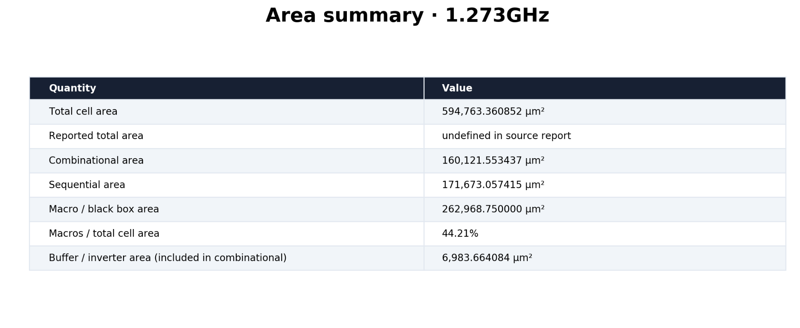
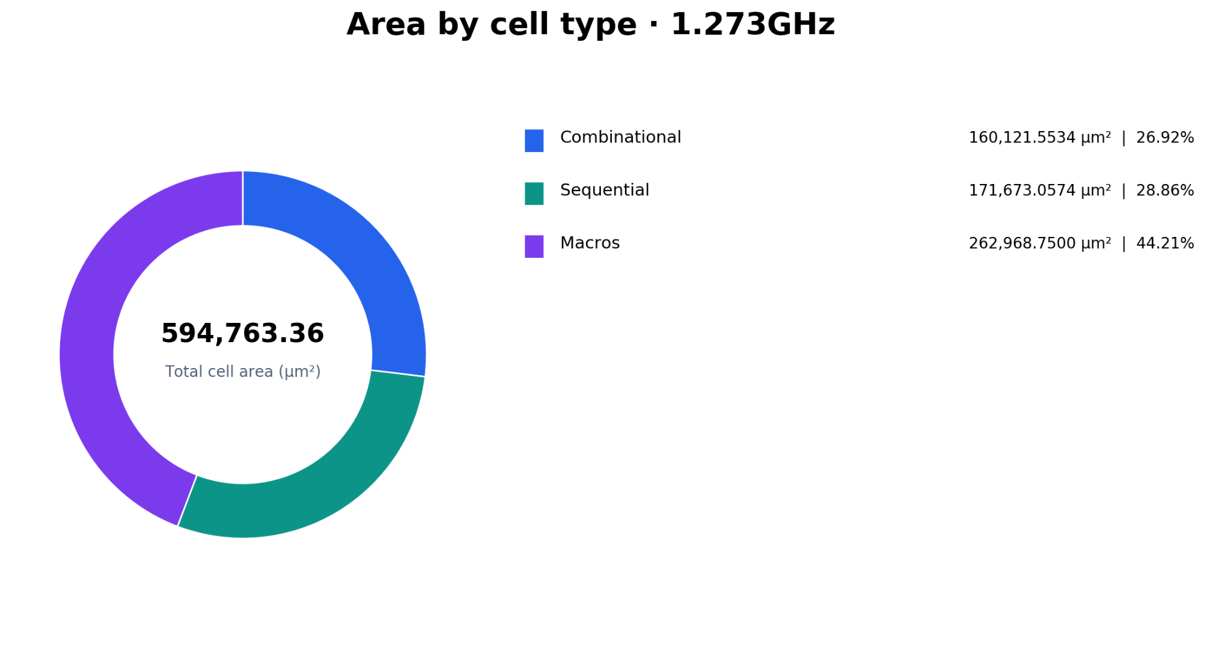
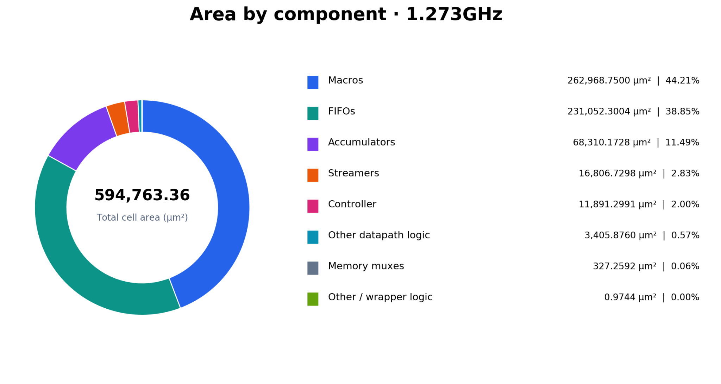

Timing results for the maximum frequency possible without violation

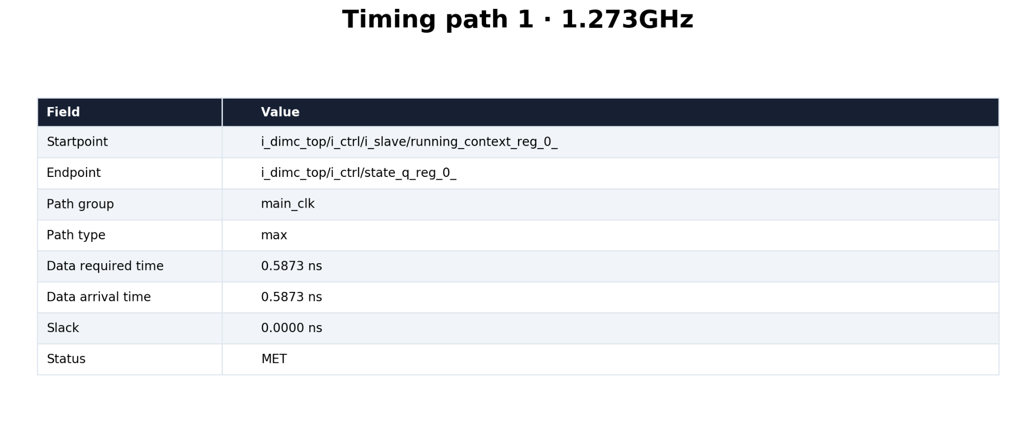

Comparing synthesis area results for 3 different architectures
The comparison is held between the main architecture described earlier of 2 modules with 4 macros, an architecture with only 1 module of 2 macros, and an architecture of only one macro. Synthesis was done at frequency of 1GHz for the purpose of this comparison
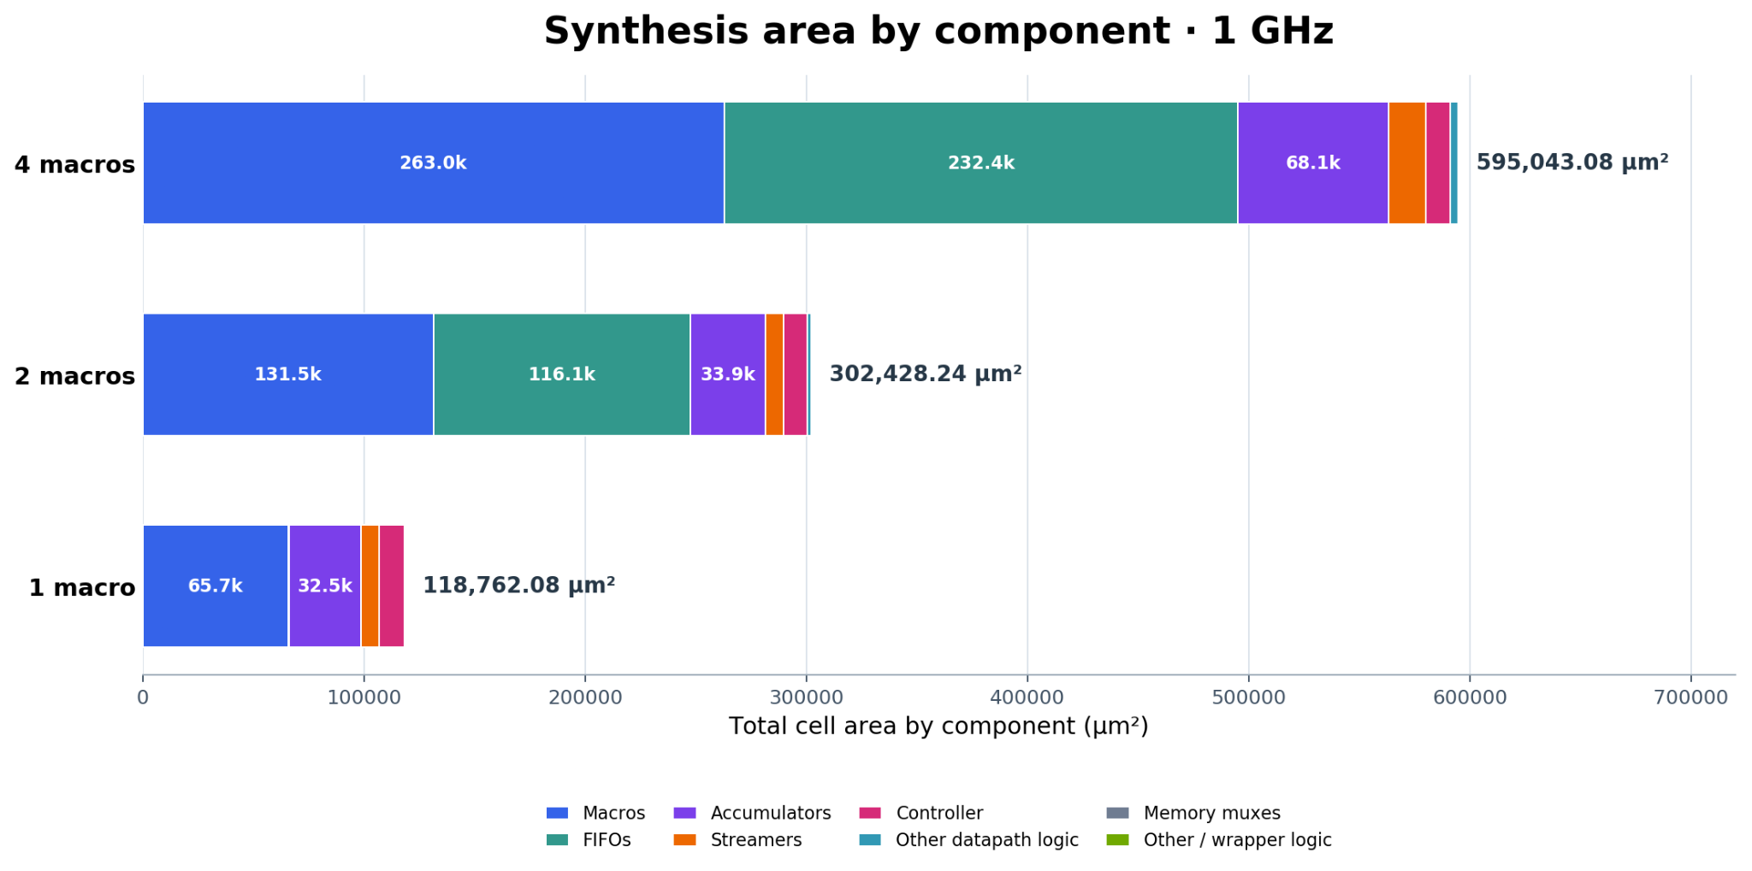

Conclusion
This thesis presented Cleopatra, a two-module digital in-memory computing accelerator for tiled matrix multiplication. The design surrounds pairs of DIMC macros with streaming, control, accumulation, and memory-interface logic. Its ping-pong schedule hides the next weight-tile transfer under current computation, and the datapath controller supports multi-tile matrix products while preserving partial sums across the inner dimension.
The archived RTL timing plots show per-module performance rising from about 65 MAC/cycle for the smallest configuration to about 109 MAC/cycle in the largest controlled L sweep and about 112 MAC/cycle in mixed-size tests. Under the stated 128-MAC/cycle compute-issue peak, the best plotted point corresponds to approximately 87.6% utilization. Synthesis reports a 594,763.36 µm² total cell area at the 1.273 GHz target and show timing met at that target, while the 1.4 GHz target misses by 71.1 ps. These results show that the architecture can combine local computation with multi-tile memory streaming and sustain high issue utilization on larger workloads.

References
PULP project information, including the open-source RISC-V platform and cluster implementation. https://pulp-platform.org/projectinfo.html; https://www.pulp-platform.org/implementation.html.
PULP Platform, “common_cells.” https://github.com/pulp-platform/common_cells.
PULP Platform, “hwpe-stream.” https://github.com/pulp-platform/hwpe-stream.
PULP Platform, “Heterogeneous Cluster Interconnect (HCI).” https://github.com/pulp-platform/hci.
PULP Platform, “hwpe-ctrl.” https://github.com/pulp-platform/hwpe-ctrl.

