Name: Menna Hesham Ali – Group: SE2
Local Serverless Computing and Event-Driven Image Processing Pipeline
5. Create the Project Structure:
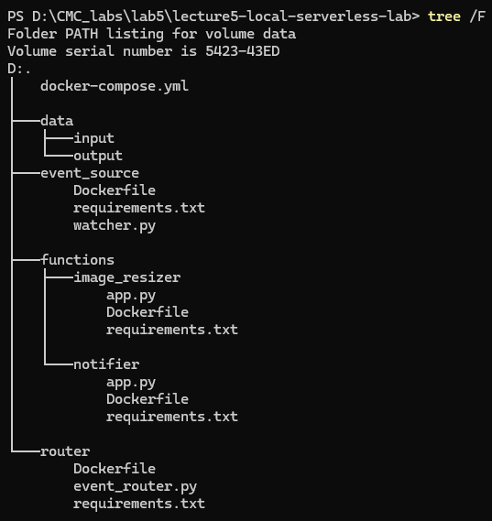
From 6 to 10 - Project Setup Completion:
All required project files and directories were successfully created, including the Event Source, Event Router, and both function services (Image Resizer and Notifier).

11. Step 6 - Run the Full Local Pipeline:
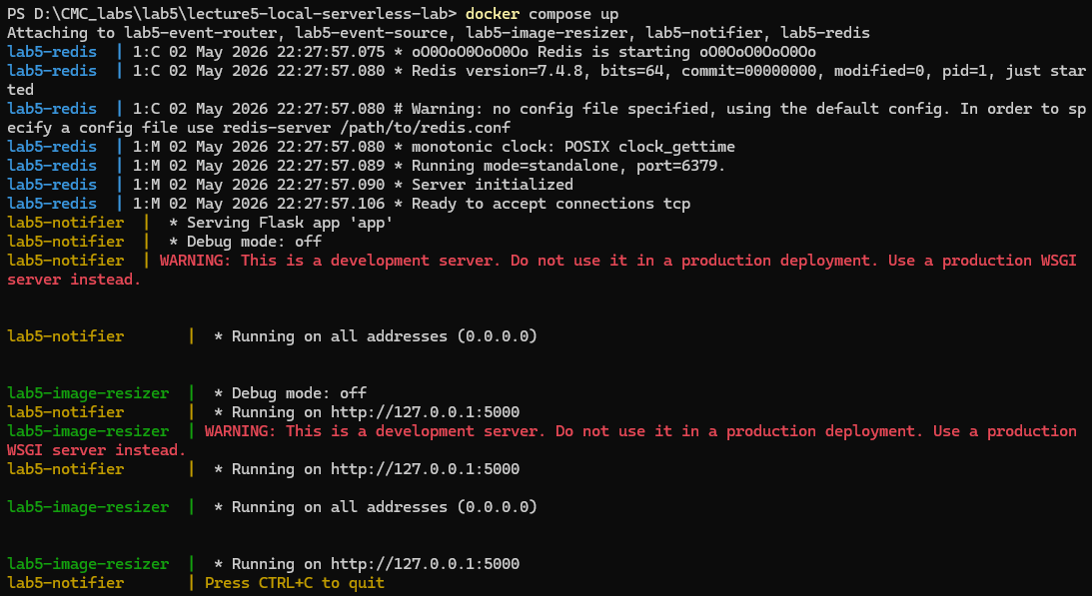
In this step, the entire system was executed using Docker Compose:
- The docker compose up --build command was used to build and start all services, including Redis, Event Source, Event Router, Image Resizer, and Notifier.
- The system successfully initialized, and logs confirmed that each service was running and ready to process events.

12. Step 7 - Create a Test Image Locally:
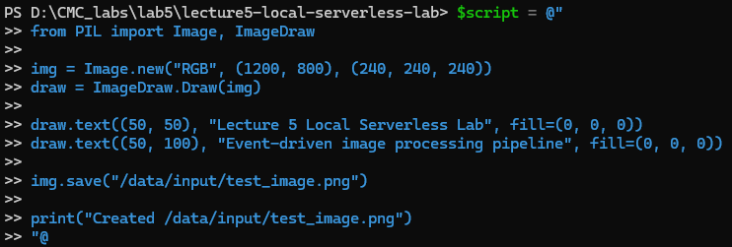
successfully created the test image and it is placed in the input folder
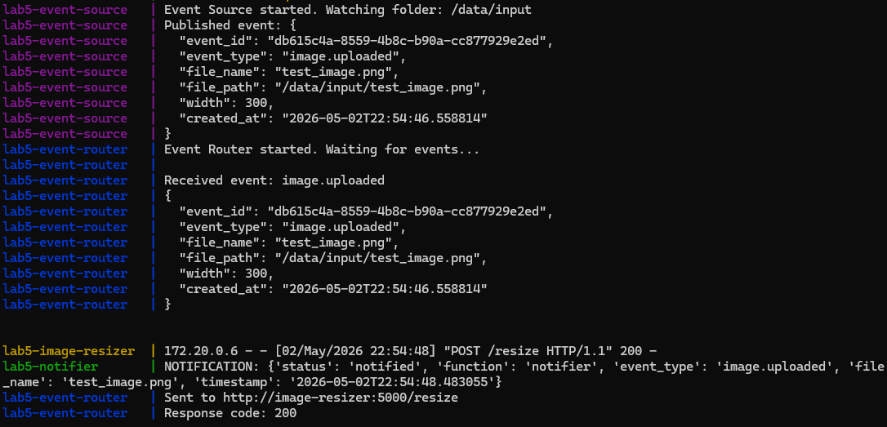
This proves:
- The system detected the image
- Event was sent to Redis

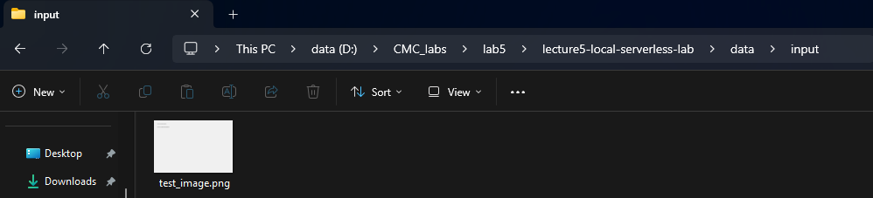
A test image was generated inside the container using a Python script and saved to the /data/input directory.

13. Step 8 - Check the Output:
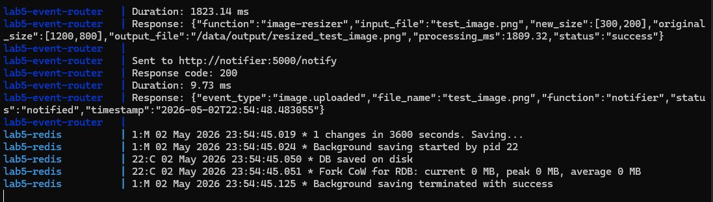

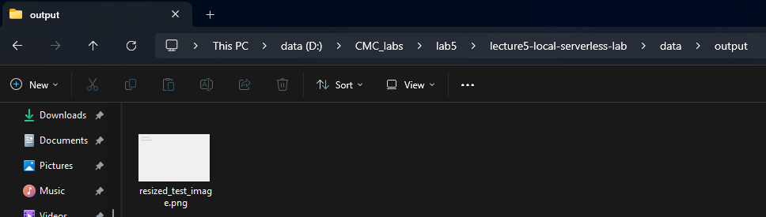
After the event was published, the event-router consumed the event from Redis and routed it to the appropriate services.
The image-resizer function processed the image and generated a resized version in the /data/output directory.
Check logs:
- docker compose logs event-source
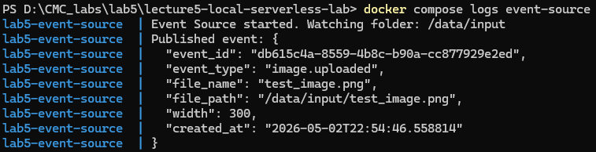

- docker compose logs event-router
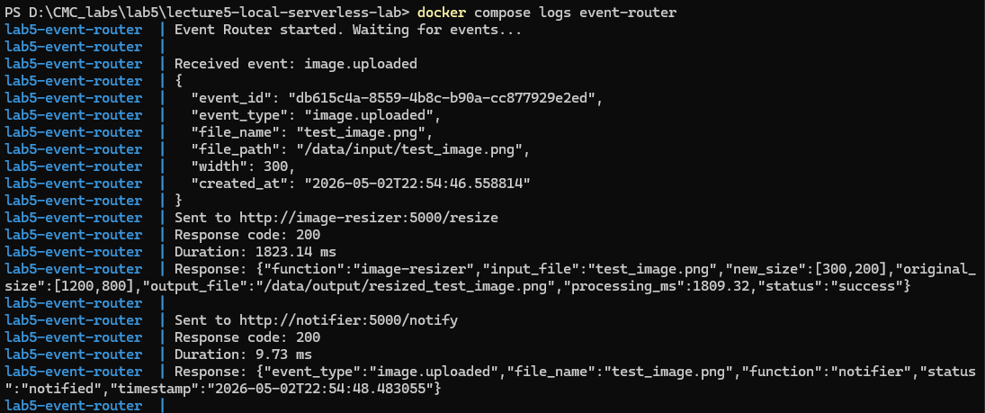
- docker compose logs image-resizer:
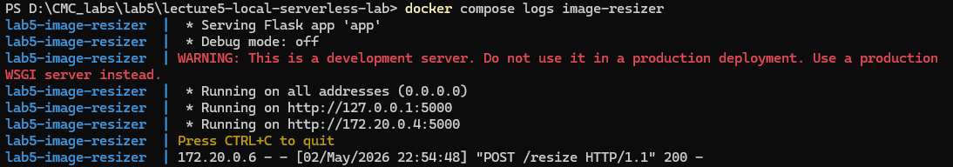
- docker compose logs notifier:
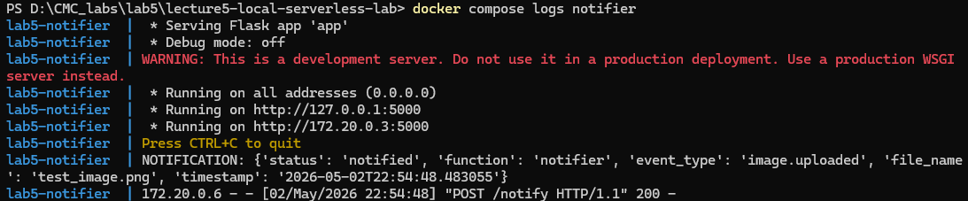

14. Step 9 - Test the Function Directly:
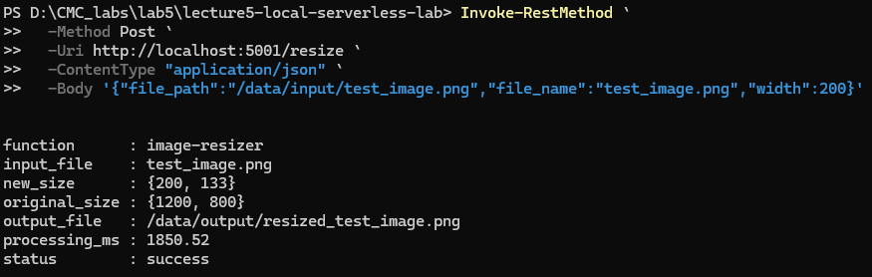
- The image-resizer function was tested directly using an HTTP request, simulating a Function-as-a-Service (FaaS) invocation.
- A POST request was sent to the /resize endpoint with the image path and target width.
- The function successfully processed the image and returned a JSON response containing metadata such as original size, new size, and processing time.
- The resized image was saved in the output directory, confirming correct function execution.

15. Step 10 - Cold Start Mini-Experiment:

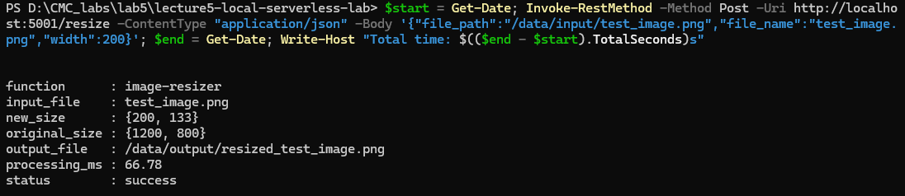

After restarting:
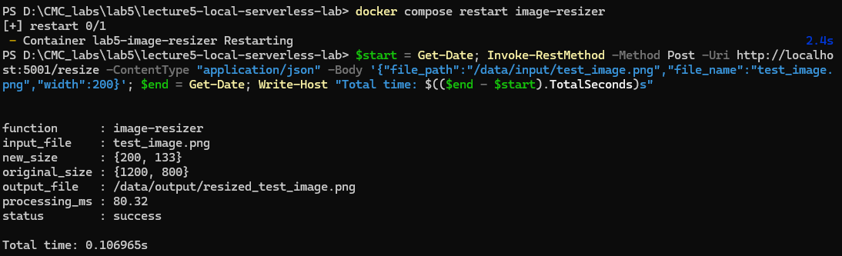
Measurement | Value
Warm request time | 0.089s (88.6ms)
First request after restart | 0.107s (106.9ms)
Difference | ~0.018s (18ms)
Reason / explanation | The container had already finished restarting before the request was sent, so Flask and Pillow were loaded. The small difference reflects Python re-importing libraries on first use. A larger cold start would be seen if the request was sent during restart.

docker compose ps results:
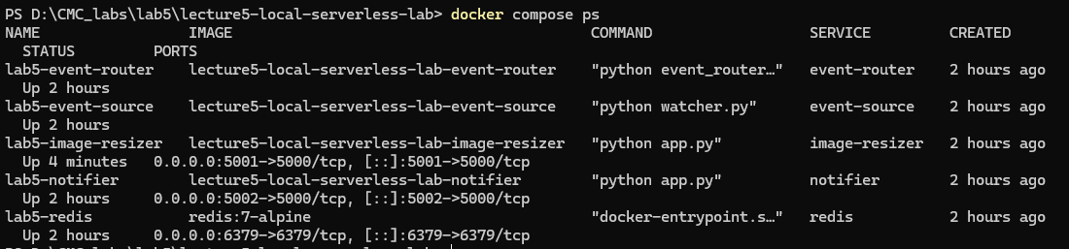

18. Reflection Questions:
1. What is the event source in this lab?
The event source is watcher.py, running inside the event-source container. It watches the /data/input folder and when a new PNG or JPG image is detected, it publishes an image.uploaded event into the Redis Stream.

2. What is the event router?
The event router is event_router.py, running inside the event-router container. It reads events from the Redis Stream and forwards them to the correct function endpoints based on the event type. For image.uploaded events, it routes to both the image-resizer and the notifier.

3. What are the event destinations?
There are two event destinations:
- Image Resizer (/resize endpoint on port 5001) — resizes the image and saves it to /data/output
- Notifier (/notify endpoint on port 5002) — logs a notification message about the event

4. Why is this pipeline loosely coupled?
Because the event source does not directly call the functions. It only publishes an event to Redis. The router and functions have no knowledge of each other — the router just sends HTTP requests to endpoints. This means any component can be replaced, restarted, or extended without breaking the others.

5. What happened after restarting the image-resizer container?
The container took approximately 2.4 seconds to restart. By the time the first request was sent, Flask had already finished initializing, so the response was only slightly slower than the warm request (0.107s vs 0.089s). The small ~18ms difference reflects the overhead of Python re-loading libraries after restart.

6. How is this similar to serverless cold start?
In real serverless platforms like AWS Lambda, the first request after a function has been idle triggers a cold start — the runtime must be initialized before the request is handled, causing extra latency. In this lab, restarting the container simulates that by forcing the Flask app and Pillow library to reload from scratch before serving the first request.

7. What is missing compared with real cloud serverless platforms? Several things are missing:
- True ephemerality — our Flask containers are long-running, not spun up and destroyed per request
- Auto-scaling — real platforms scale function instances automatically based on load
- Sandboxing and isolation — AWS Lambda uses microVMs (Firecracker) to isolate each function execution
- Managed infrastructure — no servers, networking, or container management needed on real platforms
- Billing per invocation — real FaaS charges only for actual execution time

8. How could this pipeline be extended to support image moderation, OCR, or ML enrichment?
New function containers could be added and registered as additional destinations in the router's routing table. For example:
- An image moderation function could call a content-safety model to flag inappropriate images
- An OCR function could use Tesseract to extract text from images and save it alongside the output
- An ML enrichment function could run an object detection model and tag the image with detected labels

