Name: Menna Hesham Ali – Group: SE2
Lab Exercise: Distributed Consistency and Consensus in the Cloud
Redis :-
- Node 1 – Write data:
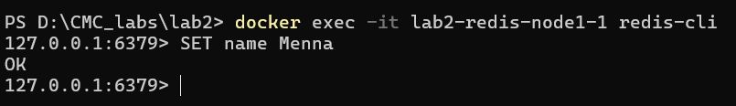
- Node 2 – Read data:

Observation 1:
- Data written to Node 1 is NOT visible in Node 2
- No synchronization exists between nodes

Conclusion 1:
Redis nodes operate independently because replication is not configured. Therefore, data inconsistency exists across nodes, demonstrating lack of distributed coordination.

Simulating Network Partition
- Stop Node 2:
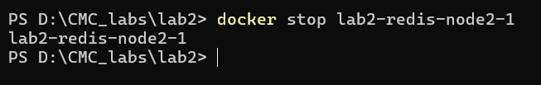
- Write data on Node 1:
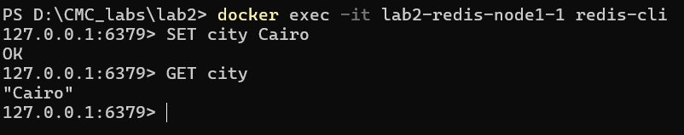
Observation 2:
- Node 1 continues to accept writes
- Node 2 is unavailable (simulated failure)
- System remains partially functional

Conclusion 2:
During node failure, Redis still allows writes on the active node, prioritizing availability over consistency. This demonstrates the CAP theorem trade-off.

Recovery After Failure
- Restart Node 2 & Check data:
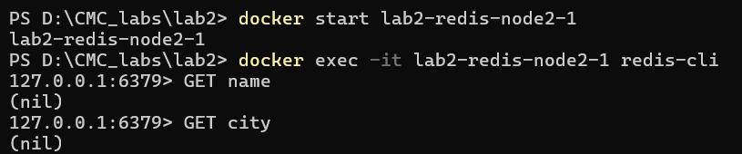

Observation 3:
- Restarted node does NOT receive previous data
- No automatic synchronization occurs

Conclusion 3:
Redis nodes do not recover or synchronize data automatically after reconnection due to missing replication configuration. This confirms lack of eventual consistency in the current setup.

Etcd :-
- Writing and Reading Data:
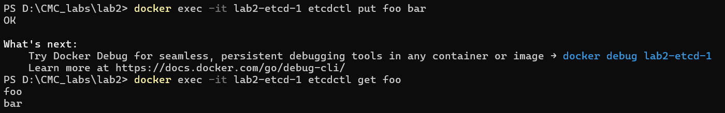
Observation 1:
- Data is successfully written and retrieved
- etcd stores data reliably

Conclusion 1:
etcd provides reliable key-value storage with strong consistency, ensuring that written data can be immediately retrieved.

- Leader Identification:
Observation 2:
- The node identifies itself as the leader
- Only one leader exists in the cluster

Conclusion 2:
etcd uses the Raft consensus algorithm where a single leader manages operations, ensuring strong consistency across the system.

- Simulating Failure:
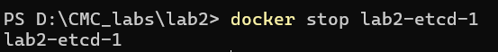

Observation 3
- The etcd node becomes unavailable
- No operations can be performed during downtime

Conclusion 3
When the only etcd node is stopped, the system becomes unavailable since there are no additional nodes to take over leadership.

Recovery and Restart:
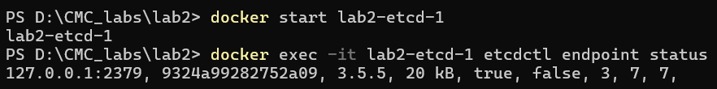
Observation 4:
- Node restarts successfully
- Leader is re-established automatically

Conclusion 4:
etcd automatically restores its state after restart and resumes operation with a leader, demonstrating fault recovery capabilities.

-> Redis showed independent nodes with no consistency due to lack of replication, while etcd demonstrated strong consistency using the Raft consensus algorithm with leader-based coordination. This highlights the trade-off between availability and consistency in distributed systems.

