Name: Menna Hesham Ali – Group: SE2
Microservices and Cloud-Native Design
Part B - Implement product-service:
Started the service:
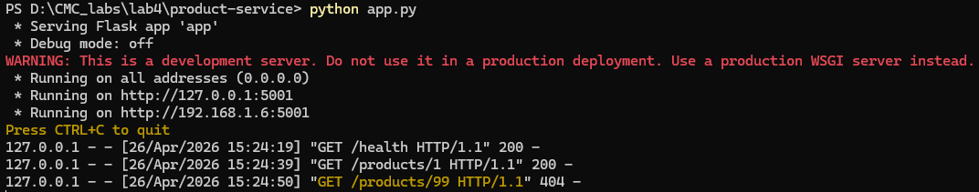
- Valid product:
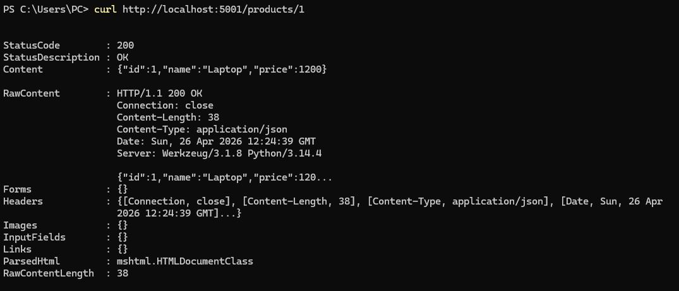
- Invalid product:
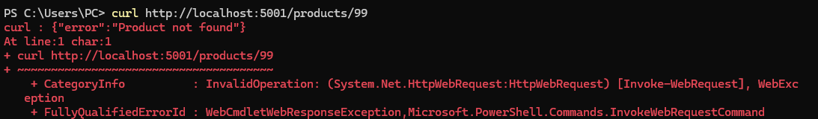

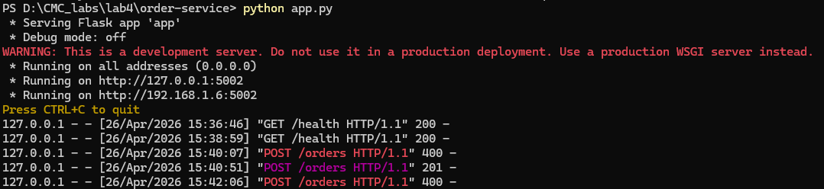
- Valid order:
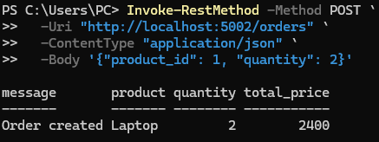
- Invalid order:
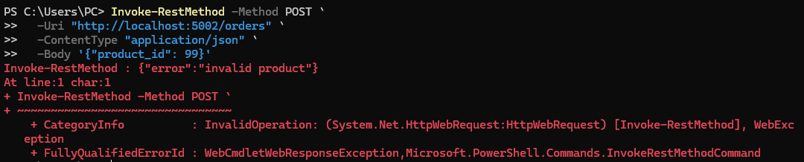
The order-service communicates with product-service using HTTP requests.
- It sends a request to /products/<id>
- Waits for a response
- Uses that data to create an order
This is an example of synchronous communication, where one service depends on another in real time.

Part D - Containerize both services:
Docker images built successfully for both microservices:
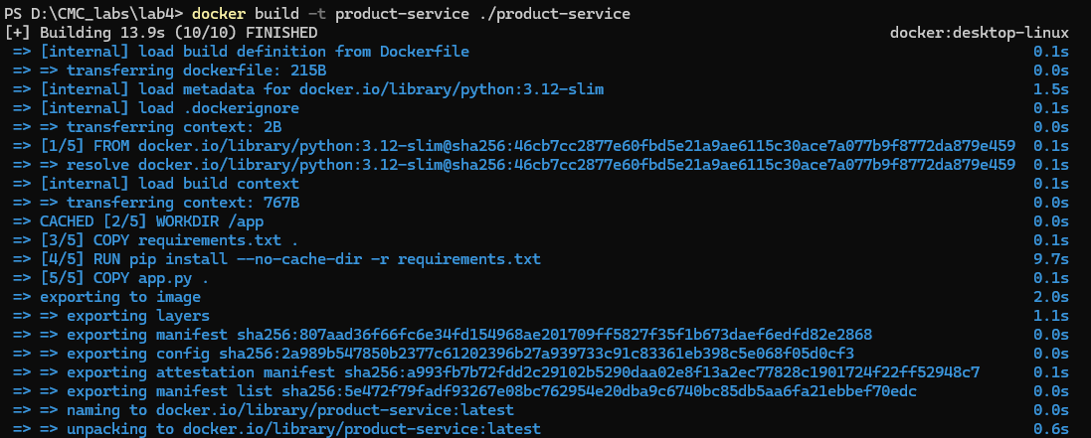
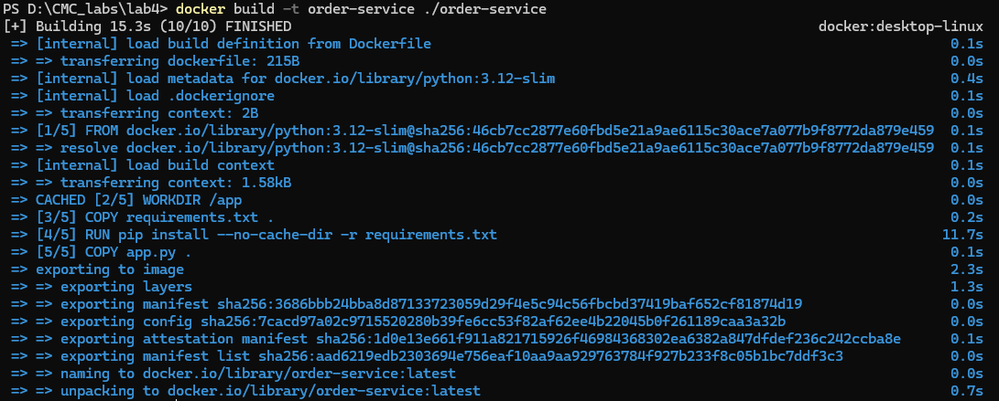
Both microservices running successfully inside Docker containers:
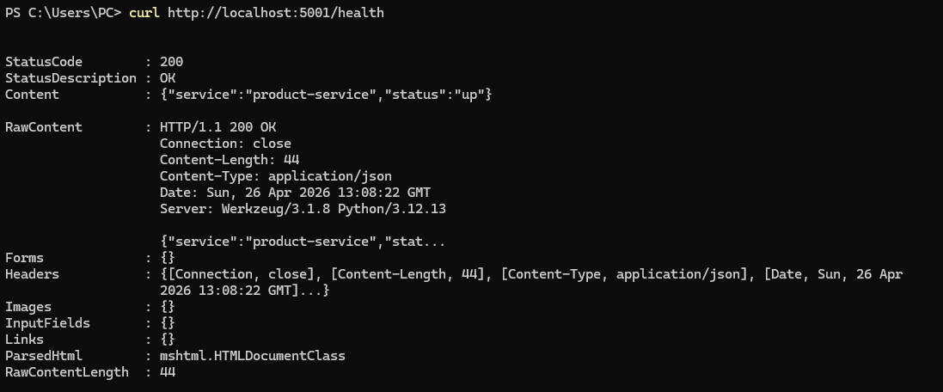
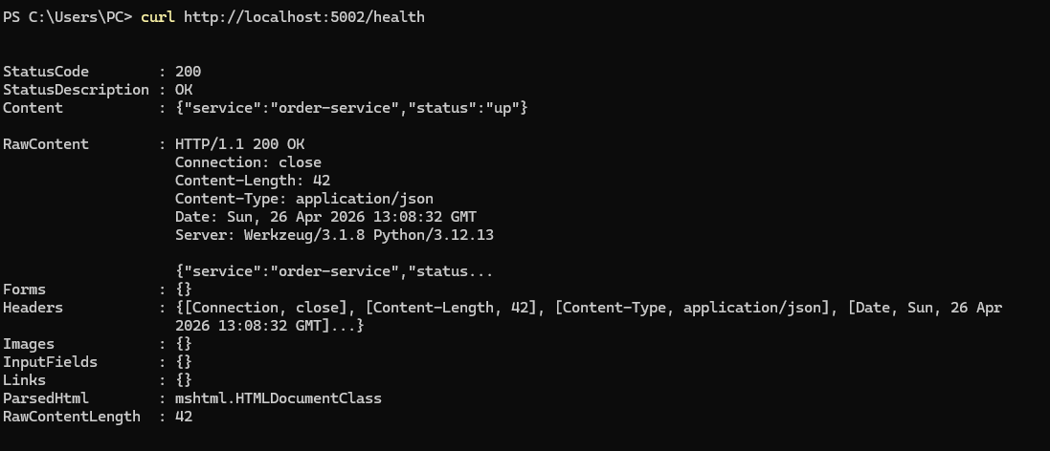
This setup demonstrates:
- Independent deployment units
- Isolation between services
- Reproducible runtime environments

Part E - Define orchestration with Docker Compose & Part F - Build and run the system:
Docker Compose successfully running microservices:
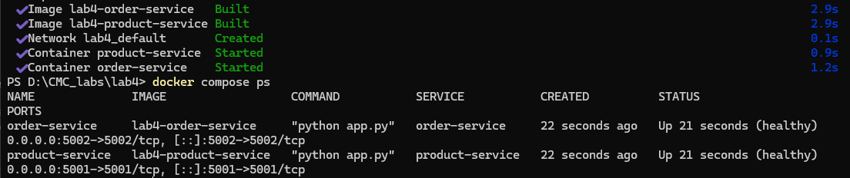
This confirms that:
- containers are running correctly
- services are responding to health checks
- orchestration is functioning properly

Docker Compose acts as a lightweight orchestration tool that simulates cloud-native platforms by managing multi-container applications with networking, health checks, and lifecycle management.

Part G - Functional testing:
1. Test product-service:
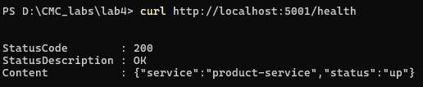
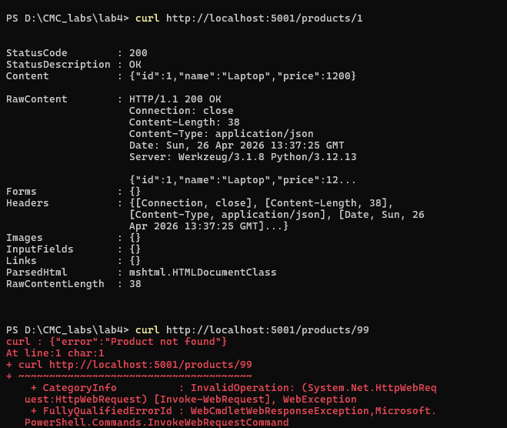

Product-service testing:
- Health endpoint returned service status
- Valid product requests returned correct JSON data
- Invalid product requests returned HTTP 404 error

2. Test order-service:
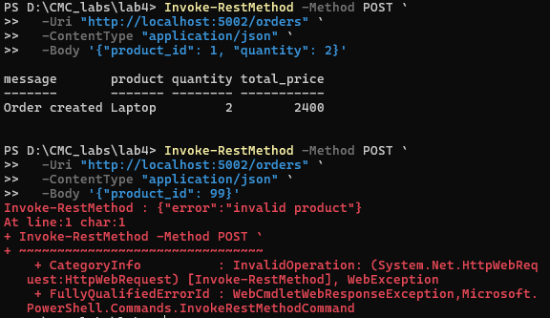
Order-service testing:
- Successfully created orders by communicating with product-service
- Calculated total price correctly
- Handled invalid product cases gracefully

- Conclusion
The system behaves as expected in a fully containerized environment, confirming correct implementation of microservices architecture.
Part H - Failure injection and resilience observation:
Stop product-service simulate failure:
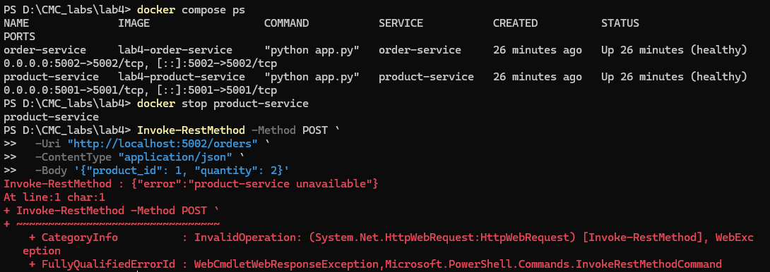
- Restart service:
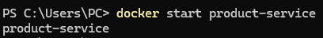
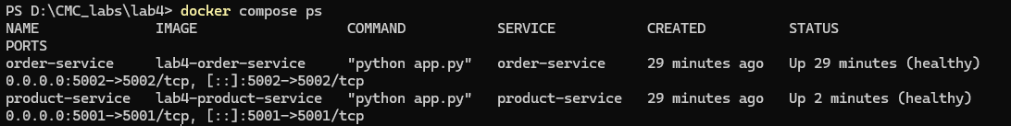
Failure Injection and Resilience Testing
To evaluate system resilience, the product-service was intentionally stopped while the system was running under Docker Compose.

Observations:
- The order-service attempted to communicate with product-service
- Requests failed due to service unavailability
- The system returned an error response

Part I – Architecture Reflection task
- Q: Which parts of this lab show the benefits of microservices over a monolith?
This lab demonstrates several key advantages of microservices compared to a monolithic architecture.
First, the system is divided into two independent services: product-service and order-service. Each service has a clearly defined responsibility. The product-service handles product data retrieval, while the order-service manages order creation and business logic. This separation of concerns improves modularity and makes the system easier to understand and maintain.
Second, each service can be developed, built, and deployed independently. For example, the product-service can be updated without modifying the order-service, as long as the API contract remains unchanged. In a monolithic system, even a small change would require redeploying the entire application.
Third, containerization with Docker ensures that each service runs in an isolated environment. This improves consistency across development and deployment environments and reduces dependency conflicts.
Finally, the microservices approach enables better scalability. If the order-service experiences higher load, it can be scaled independently without scaling the product-service unnecessarily.

- Q: Which new complexities were introduced by splitting the system into two services?
Although microservices provide flexibility, they also introduce additional complexity compared to a monolithic system.
The first major complexity is network communication. In a monolith, function calls are internal and fast, but in this system, services communicate over HTTP. This introduces network dependency, latency, and potential failure points.
The second complexity is service coordination and discovery. The order-service must know the address of the product-service. In this lab, this is managed using environment variables and Docker Compose service names, but in real systems, service discovery tools would be required.
The third complexity is failure handling. If the product-service is unavailable, the order-service must handle timeouts, retries, and error responses. This requires additional logic that does not exist in a monolithic system.
The fourth complexity is debugging and monitoring. Since the system is distributed, logs and errors are spread across multiple services, making troubleshooting more difficult.

- Q: What would break if network latency increased or one service became slow?
If network latency increases or one service becomes slow, the entire system behavior would be significantly affected due to synchronous communication.
For example, the order-service depends on the product-service to validate product information. If the product-service becomes slow, the order-service will experience delayed responses. This leads to increased response time for the user and may cause request timeouts.
If the latency becomes extreme or the product-service becomes completely unavailable, the order-service will fail to complete requests, even though it is functioning correctly. This creates a cascading failure effect.
Although retry logic and timeouts are implemented in this lab, they only provide basic resilience. In real-world systems, additional patterns such as circuit breakers, caching, or asynchronous messaging would be required to prevent system-wide degradation.

- Q: Which 12-factor app principles are visible in this implementation?
This implementation demonstrates several principles from the 12-factor app methodology:
1. Codebase
Each microservice has its own codebase and Docker image, reinforcing the principle of one codebase per service.

2. Dependencies
Dependencies are explicitly declared in requirements.txt, ensuring reproducible builds and avoiding hidden system dependencies.
3. Configuration
The order-service uses environment variables (e.g., PRODUCT_SERVICE_URL) instead of hardcoded values, following the principle of storing configuration in the environment.
4. Backing Services
The product-service acts as a backing service for the order-service. It is treated as an external resource accessed via HTTP.
5. Port Binding
Each service is self-contained and exposes its own port (5001 and 5002), meaning each service binds directly to a network port.
6. Logs
Logs are generated through container stdout/stderr and can be accessed via Docker logs, following the principle that logs should be treated as event streams.
7. Disposability
Containers can be started and stopped quickly using Docker Compose. This supports fast startup and shutdown, which aligns with disposability principles.

