Name: Menna Hesham Ali Mohamed – Group: SE2
Lab 3 Handout Containerization and Cluster Orchestration
Task A1 - Start an interactive container:
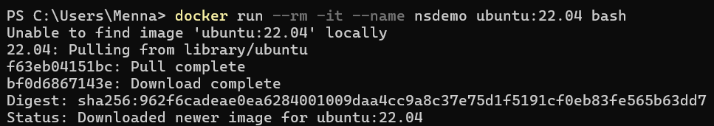
1. Hostname:
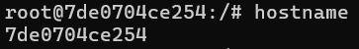
The hostname command returned a container-specific ID (7de0704ce254), which is different from the host machine’s hostname. This shows that the container operates within its own UTS namespace, allowing it to have an independent hostname.
2. ps -ef:
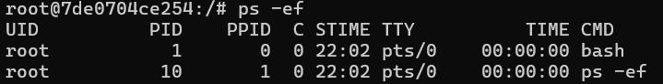
The ps -ef output showed that the bash process inside the container is assigned PID 1. This indicates that the container has its own process namespace, where processes are isolated and managed independently from the host system.
3. ip addr:
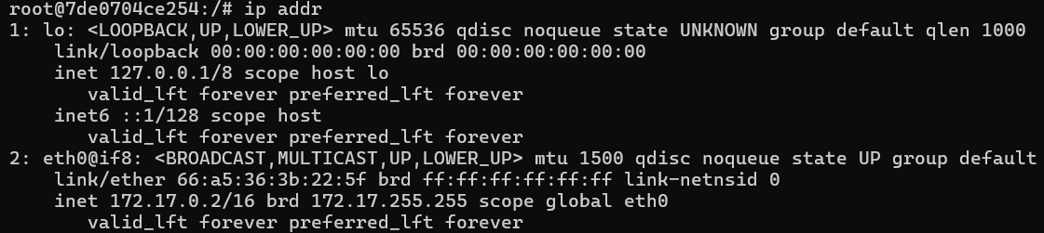
The ip addr command showed a network interface (eth0) with IP address 172.17.0.2, which belongs to Docker’s internal bridge network. This confirms that the container has its own network namespace and does not directly share the host’s network stack.

4. mount | head:
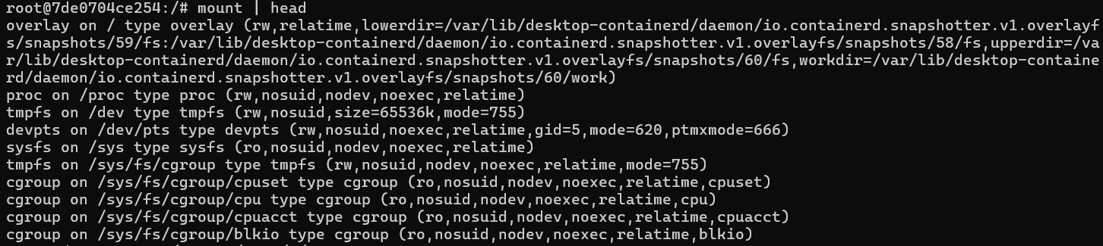
The mount output showed an overlay filesystem mounted on the root (/). This shows that the container uses a layered filesystem and has a separate view of the filesystem from the host.
5. cat /proc/1/cgroup
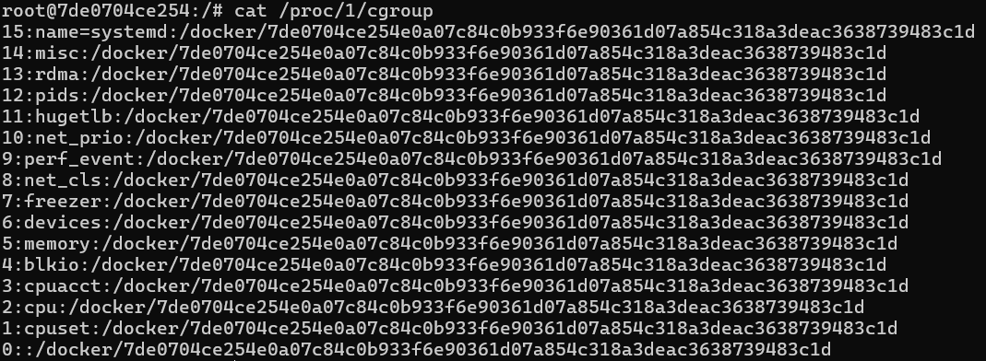
The /proc/1/cgroup output showed multiple control groups associated with the container. This confirms that Docker uses cgroups to manage and limit resource usage such as CPU, memory, and process counts.
- Conclusion:
The experiment demonstrates that containers are isolated using Linux namespaces, which control what a process can see, while cgroups control how much of system resources a process can use.

Task A2 - Compare host and container process views:
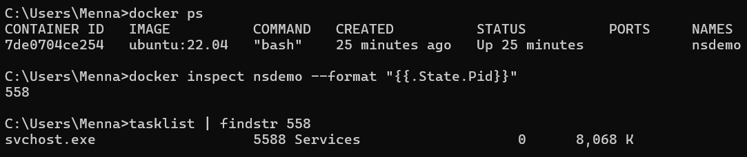
The container reports its main process (bash) as PID 1, while the host system assigns it a different PID (558 in this case). This difference occurs due to the use of the PID namespace.
Question: Why does the container think its main process is PID 1 while the host sees a different PID? Explain the role of the PID namespace.
A PID namespace isolates the process ID numbering inside the container from the host system. As a result:
- The container has its own independent process tree
- The first process inside the container always appears as PID 1
- The host system still tracks the process using its global PID

This allows containers to run processes independently without interfering with or being aware of processes on the host system.

Task A3 - Apply resource limits with cgroups:
Question: How do cgroups complement namespaces?
Namespaces provide isolation by restricting what a container can see, such as processes, network interfaces, and filesystem. However, namespaces alone do not control how much of a resource a container can use. This is where cgroups (control groups) are used.

In this task:
- The container was limited to 0.5 CPU and 256 MB memory
- The stress tool attempted to exceed these limits
- Using docker stats, it was observed that the container stayed within the defined resource boundaries
This demonstrates that:
- Namespaces isolate resources
- cgroups limit and control resource usage

Part B - Docker image layering: (B1 & B2)
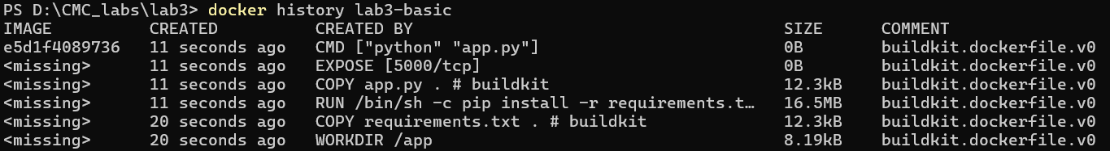
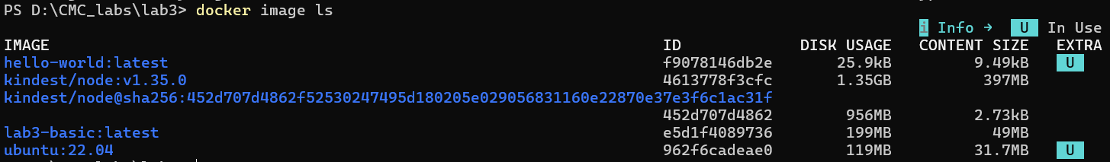
The docker history command shows that the Docker image is built in layers, where each instruction in the Dockerfile creates a new layer.
Task B3 - Build a multi-stage image:
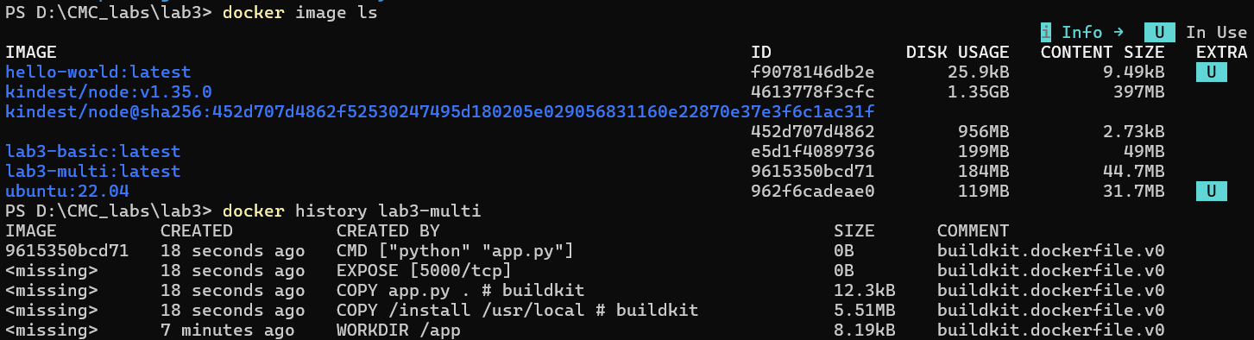
Questions: Which image is smaller? Which steps are cached if only app.py changes? Why does layer order matter?

Two images were built:
- lab3-basic: 199MB
- lab3-multi: 184MB
The multi-stage image is smaller because it excludes unnecessary build dependencies and intermediate files.

Layer Differences:
- In the basic image:
  - Dependencies are installed directly in the final image
  - All build artifacts remain
- In the multi-stage image:
  - Dependencies are installed in a separate builder stage
  - Only the required output (/install) is copied into the final image
  - Unnecessary files are discarded

Layer Order Matters because placing COPY requirements.txt before COPY app.py ensures that:
- Dependencies are only reinstalled if requirements change
- Application changes do not trigger expensive rebuilds

Part C - Local Kubernetes orchestration with kind: C1
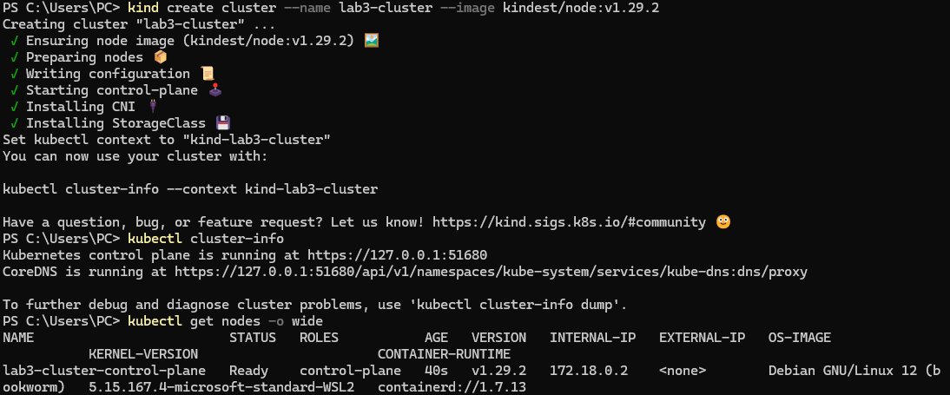
A local Kubernetes cluster was successfully created using kind. The cluster consists of a single node running inside Docker. The node is in Ready state, meaning it can schedule Pods.
Task C2 - Load your image into kind:
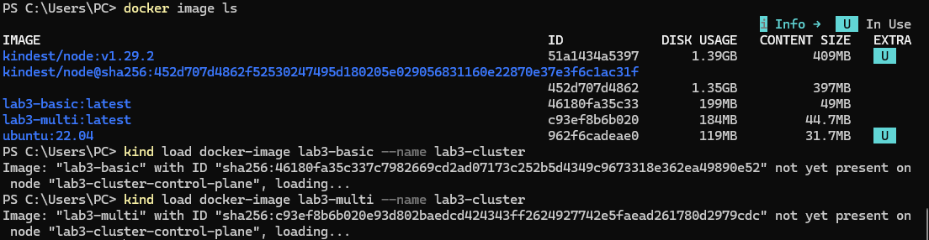
The Docker images were successfully loaded into the kind Kubernetes cluster. Since kind runs Kubernetes inside Docker containers, images must be explicitly loaded into the cluster node to be available for deployments.
Task C3 - Deploy a replicated application:
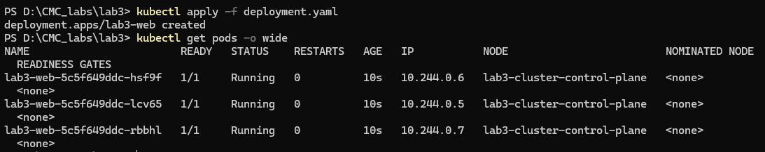
The Kubernetes Deployment created 3 identical Pod replicas. The system automatically scheduled them on the available node without manual intervention. All Pods are running the same container image.
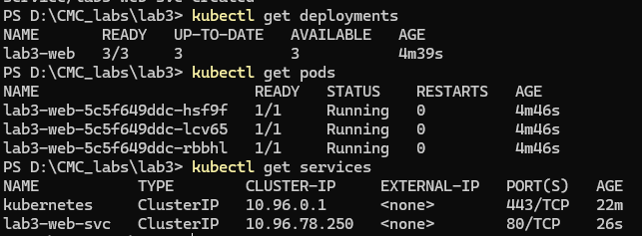
- Deployment: Defines the desired state of the application, such as how many replicas should run, and ensures Kubernetes maintains that state automatically.
- Pod: The smallest Kubernetes unit that runs one or more containers and represents a running instance of the application.
- Service: Provides a stable network endpoint to access Pods and routes traffic to them even if Pods are replaced or moved.
The Deployment defines the desired state (3 replicas of the app). Kubernetes ensures these Pods are running. The Service provides a stable networking endpoint that routes traffic to the Pods using label selectors.
Task C4 - Access the service:
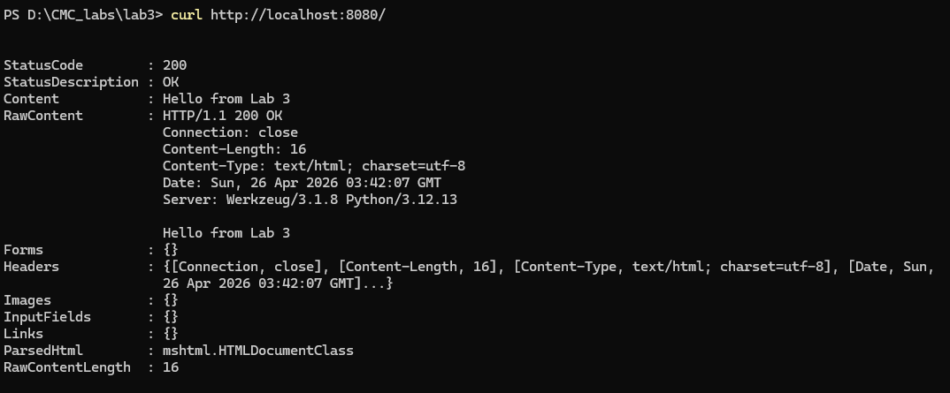
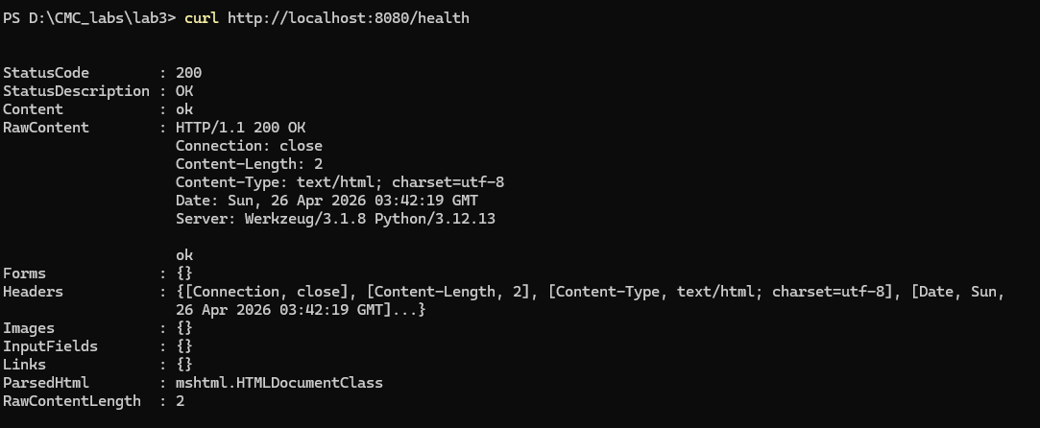
Observation:
The Flask application was successfully accessed using Kubernetes port-forwarding. The Service correctly routed requests to running Pods, and both the root and health endpoints responded with HTTP 200, confirming correct deployment and networking.

8. Part D - Scheduling and placement: D1
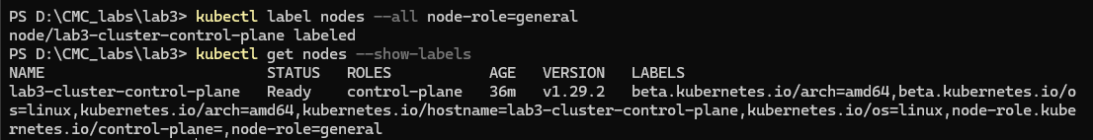
The node lab3-cluster-control-plane was successfully labeled with node-role=general.
Task D2 - Force placement with a node selector
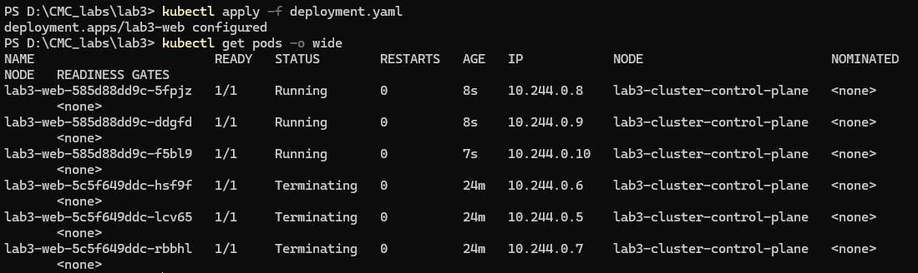
- After adding the nodeSelector, Kubernetes created new Pods that follow the updated scheduling rule.
- Old Pods were gradually terminated and replaced.
- This demonstrates Kubernetes' rolling update mechanism.
Why is this different from hard-coding a machine name in traditional deployment models?
Hard-coding a machine name tightly couples the application to a specific node, reducing flexibility and resilience. If that node fails, the application cannot be scheduled elsewhere.
In contrast, nodeSelector uses labels to describe requirements, not specific machines. Any node that satisfies the label can run the workload, making the system more flexible, scalable, and fault-tolerant.
How does declarative scheduling improve resilience and maintainability?
Declarative scheduling improves resilience and maintainability by allowing developers to specify what the system should achieve rather than how to achieve it.
Instead of manually assigning workloads to specific machines, Kubernetes uses high-level constraints (such as labels and selectors) to automatically determine placement. This means:
- Resilience improves because workloads are not tied to a single node. If a node fails, Kubernetes can reschedule Pods on any other node that satisfies the declared conditions.
- Maintainability improves because configurations are simpler and more flexible. Changes can be made by updating the desired state (e.g., modifying labels or selectors) without rewriting deployment logic.
- The system becomes self-managing, reducing manual intervention and operational errors.
Part E - Self-healing and health probes:
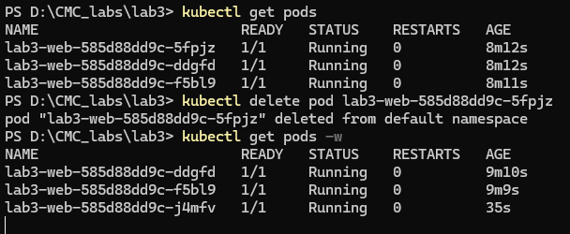
When a Pod is deleted, Kubernetes automatically creates a replacement. This happens because the Deployment maintains the desired number of replicas.
Why is this called reconciliation rather than simple restart logic?
This process is called reconciliation because Kubernetes continuously compares the actual state of the system with the desired state defined in the Deployment.
When a Pod is deleted, Kubernetes does not simply restart that exact Pod. Instead, it detects that the number of running Pods is lower than the desired number and creates a completely new Pod to restore the correct state.
Unlike traditional restart logic, which focuses on restarting a failed process, reconciliation is a continuous control loop that ensures the system always matches the declared configuration.
Task E2 - Add readiness and liveness probes:
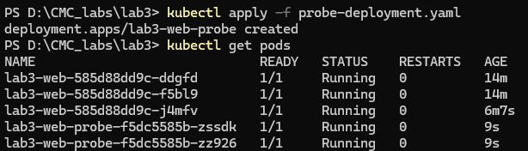
A new Deployment with readiness and liveness probes was successfully created. Two new Pods (lab3-web-probe-*) were launched.
Task E3 - Observe what happens if the container process dies:
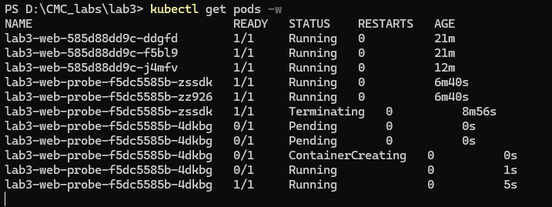
Kubernetes created a new Pod instead of restarting the existing container.
When the original Pod was terminated, the Deployment controller detected that the number of running replicas had fallen below the desired state. It then triggered the creation of a new Pod, which was scheduled and started automatically.

Reflection questions:
1. Why do namespaces alone not guarantee fair resource use?
Namespaces only provide isolation of system views (processes, network, filesystem), but they do not limit resource consumption. A container can still consume all CPU or memory unless restricted by cgroups.

2. How do cgroups improve cluster stability?
Cgroups enforce resource limits such as CPU and memory per container. This prevents resource exhaustion and ensures fair sharing between workloads, improving overall cluster stability.

3. Why is Docker image layering important for large-scale orchestration?
Layering allows reuse of unchanged parts of images, reducing build time, storage usage, and network transfer costs. In large-scale systems, this significantly improves deployment efficiency and scalability.

4. What does Kubernetes mean by desired state?
Desired state is the configuration defined in Kubernetes objects (e.g., Deployments). Kubernetes continuously works to ensure the actual system state matches this desired configuration.

5. How is self-healing different from traditional manual operations?
Self-healing is automatic and continuous. Kubernetes detects failures and restores the system without human intervention, unlike traditional systems where administrators manually restart or fix services.

6. Why are readiness and liveness probes not interchangeable?
Readiness probes control whether a Pod receives traffic, while liveness probes determine whether a container should be restarted. Using them interchangeably can lead to incorrect restarts or traffic routing to unhealthy services.

7. Limitation of single-node kind cluster?
A single-node cluster cannot demonstrate real distributed scheduling, failover, or load balancing across multiple nodes. It only simulates orchestration behavior on one machine.

