Name: Menna Hesham Ali - Group:SE2
Lab1 - Exploring Cloud Virtualization and Data Center Architecture
- VM:
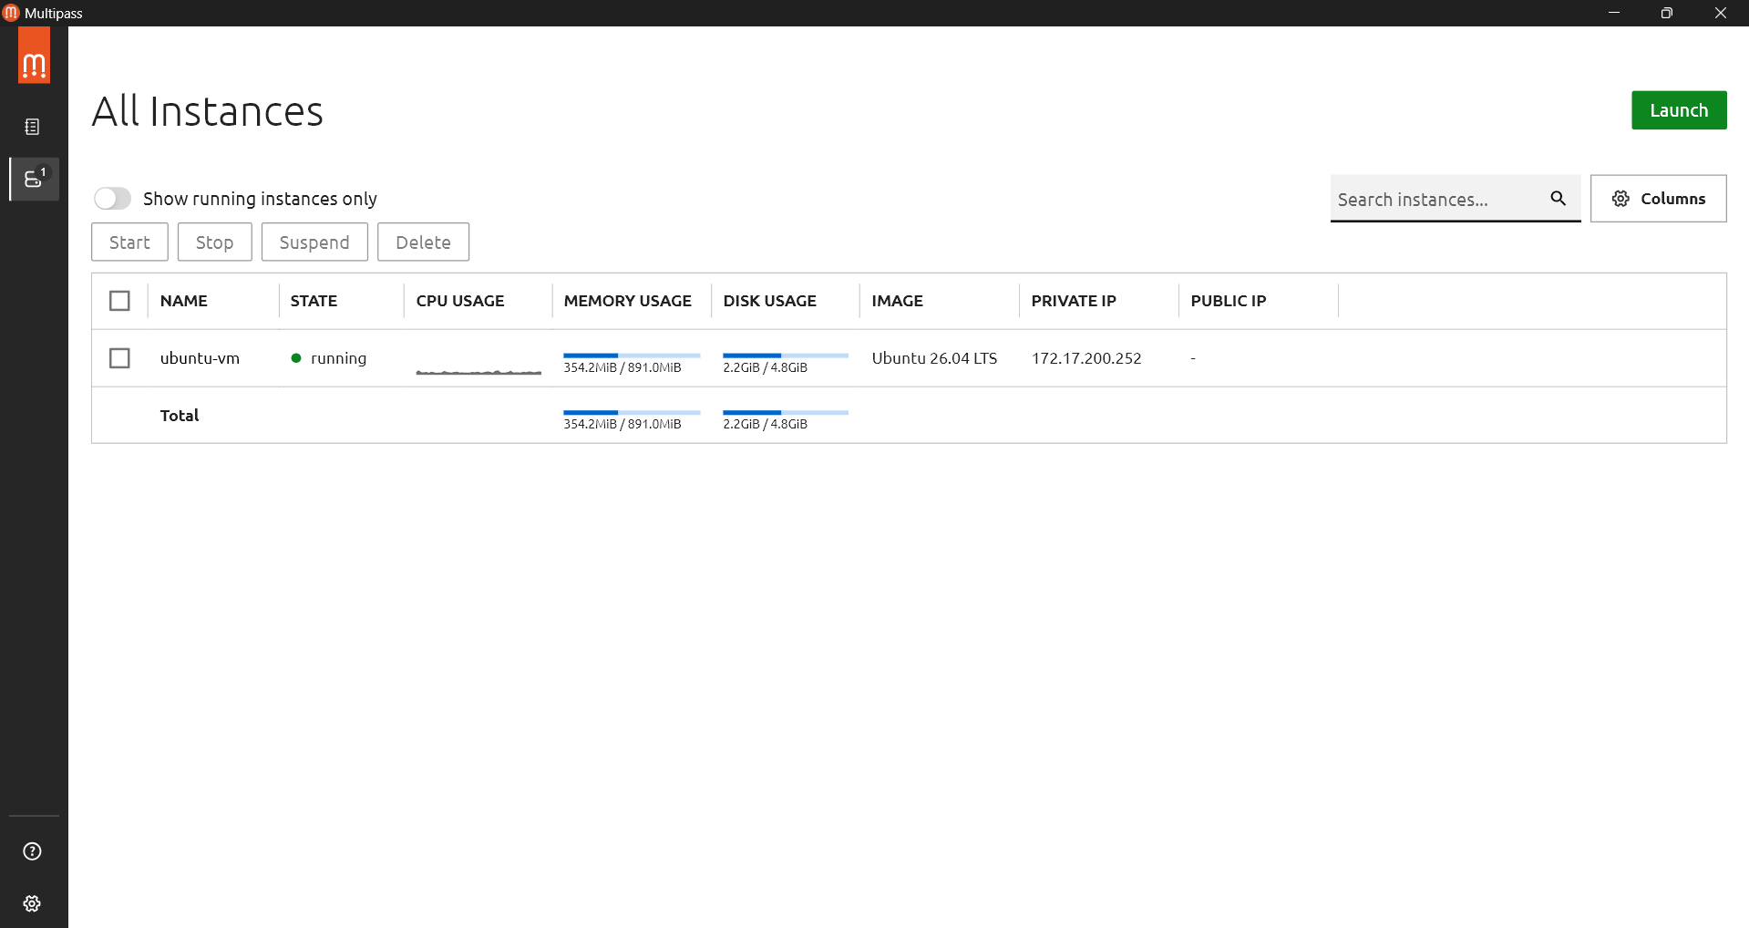
- Docker:
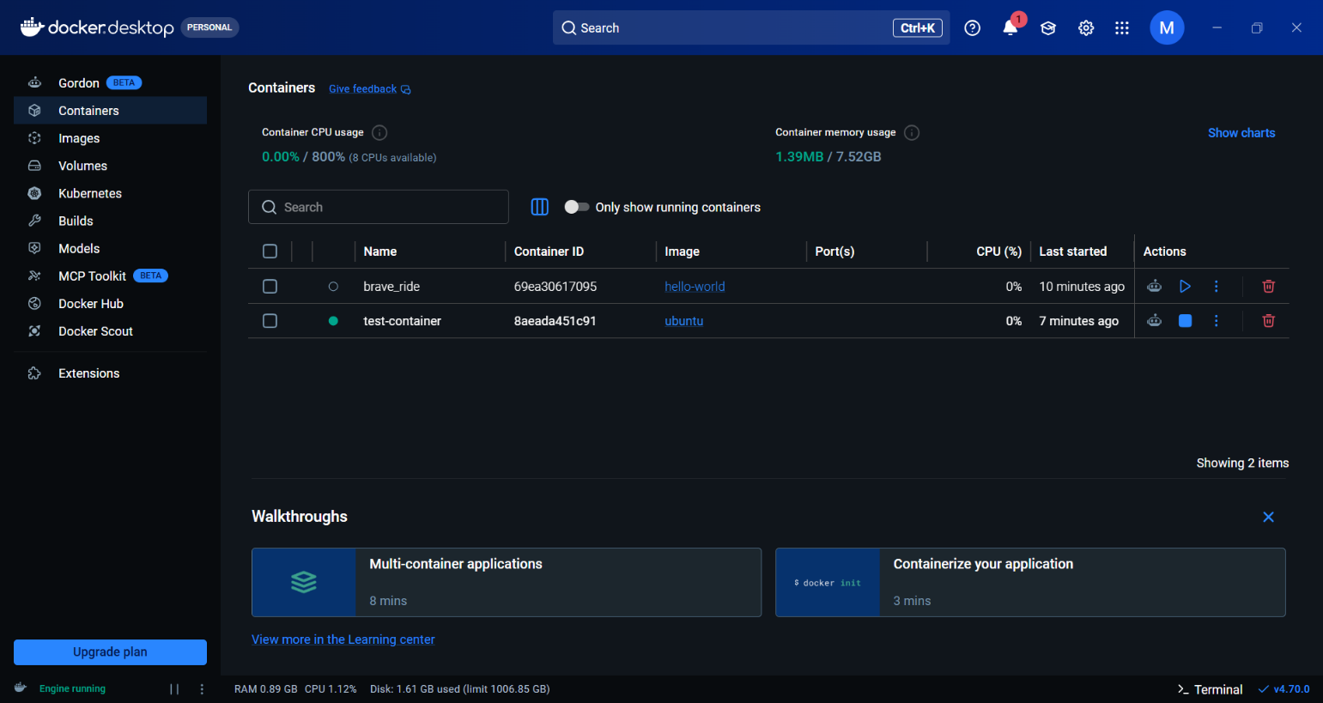
- Observations: 1. Memory Usage
VM:
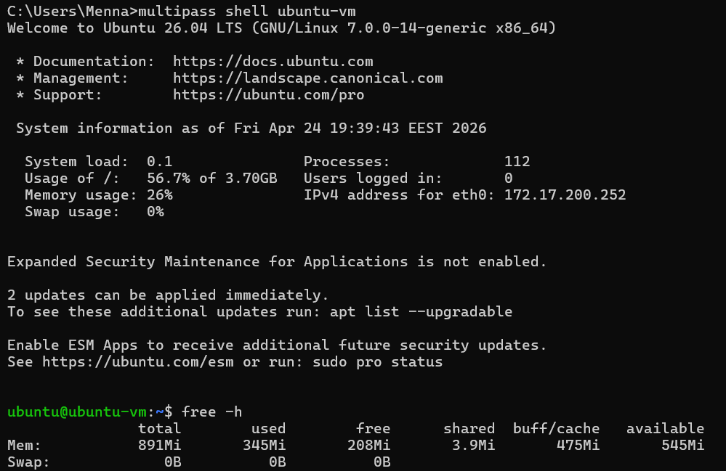
The VM has fixed allocated memory (~891 MB)
Container:
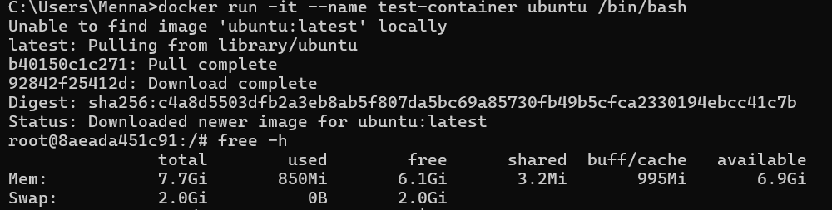
The container sees the host’s full memory (7.7 GB)
- Conclusion:
VM = isolated, fixed resources
Container = shares host resources
2. Number of Processes
VM:
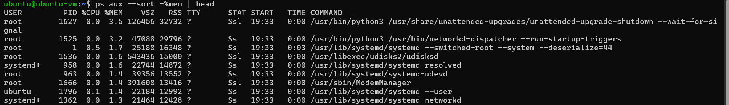
100+ processes, includes:
- systemd
- udisksd
- ModemManager
- networking services

Docker:
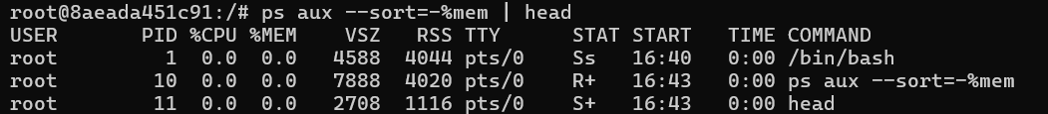
Only 2–3 processes total
- Conclusion:
VM = full operating system running
Container = just one application + minimal processes

3. Disk Usage
VM
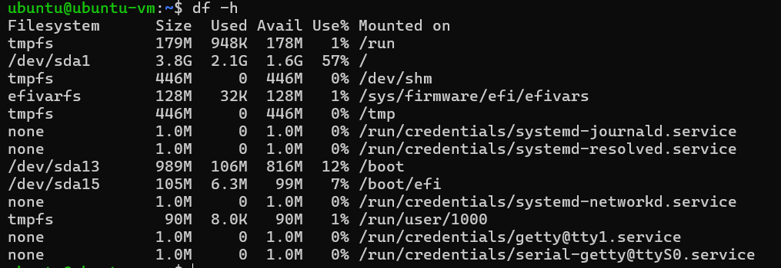
/dev/sda1 → 3.8G total

Docker
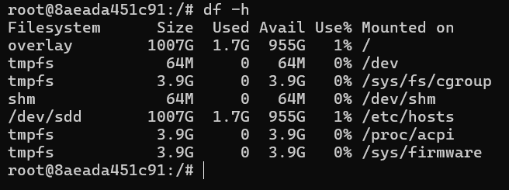
overlay → ~1000G (host disk)

- Conclusion:
VM has its own virtual disk
Container uses host filesystem (overlay)

4. Startup Behavior
- VM → took time (download + boot OS)
- Container → started instantly

Q: Which architecture (VM or container) is better for microservices? Why?

Containers are better for microservices because:
- Lightweight (few processes)
- Fast startup (milliseconds vs seconds)
- Efficient resource usage
- High density (many containers per machine)

While VMs are better when:
- You need strong isolation
- Running different OS types
- Security-critical workloads

Latency Graph of web service:
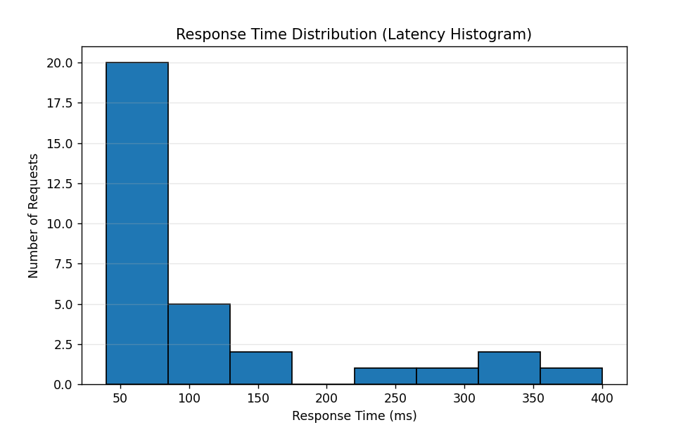

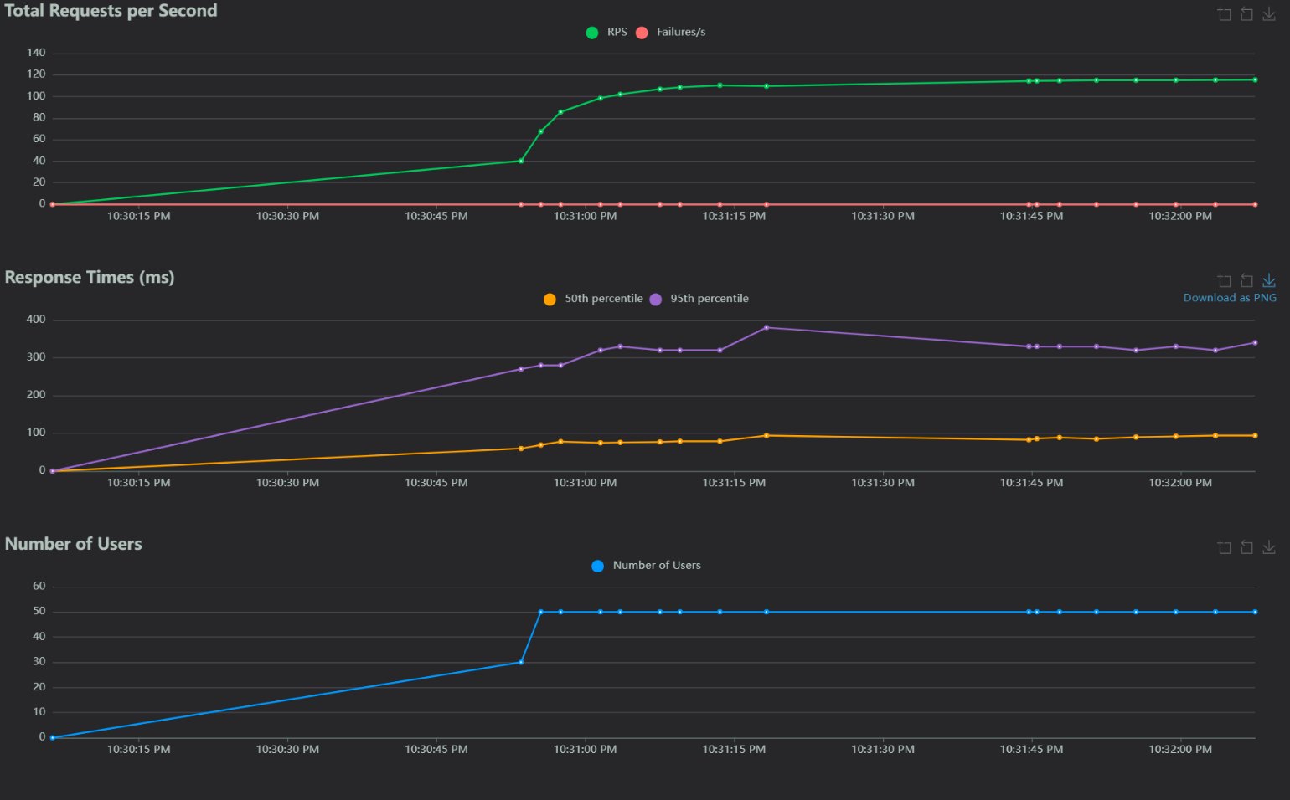

- The graph shows that system performance is not defined by average response time, but by the slowest requests. While most requests complete quickly, a small fraction experience high latency, forming the “tail” of the distribution.

- As concurrency increases, resource contention leads to more frequent and larger latency spikes. This highlights the importance of considering tail latency in the design of scalable cloud systems.

