1. **Top 10 distinct job titles along with their corresponding salaries, ordered by salary in descending order:**

SELECT TOP 10 Job_Title AS nam_job_titles, Salary

FROM (

SELECT DISTINCT Job_Title, Salary

FROM Salary_Data

) AS subquery

ORDER BY Salary DESC;

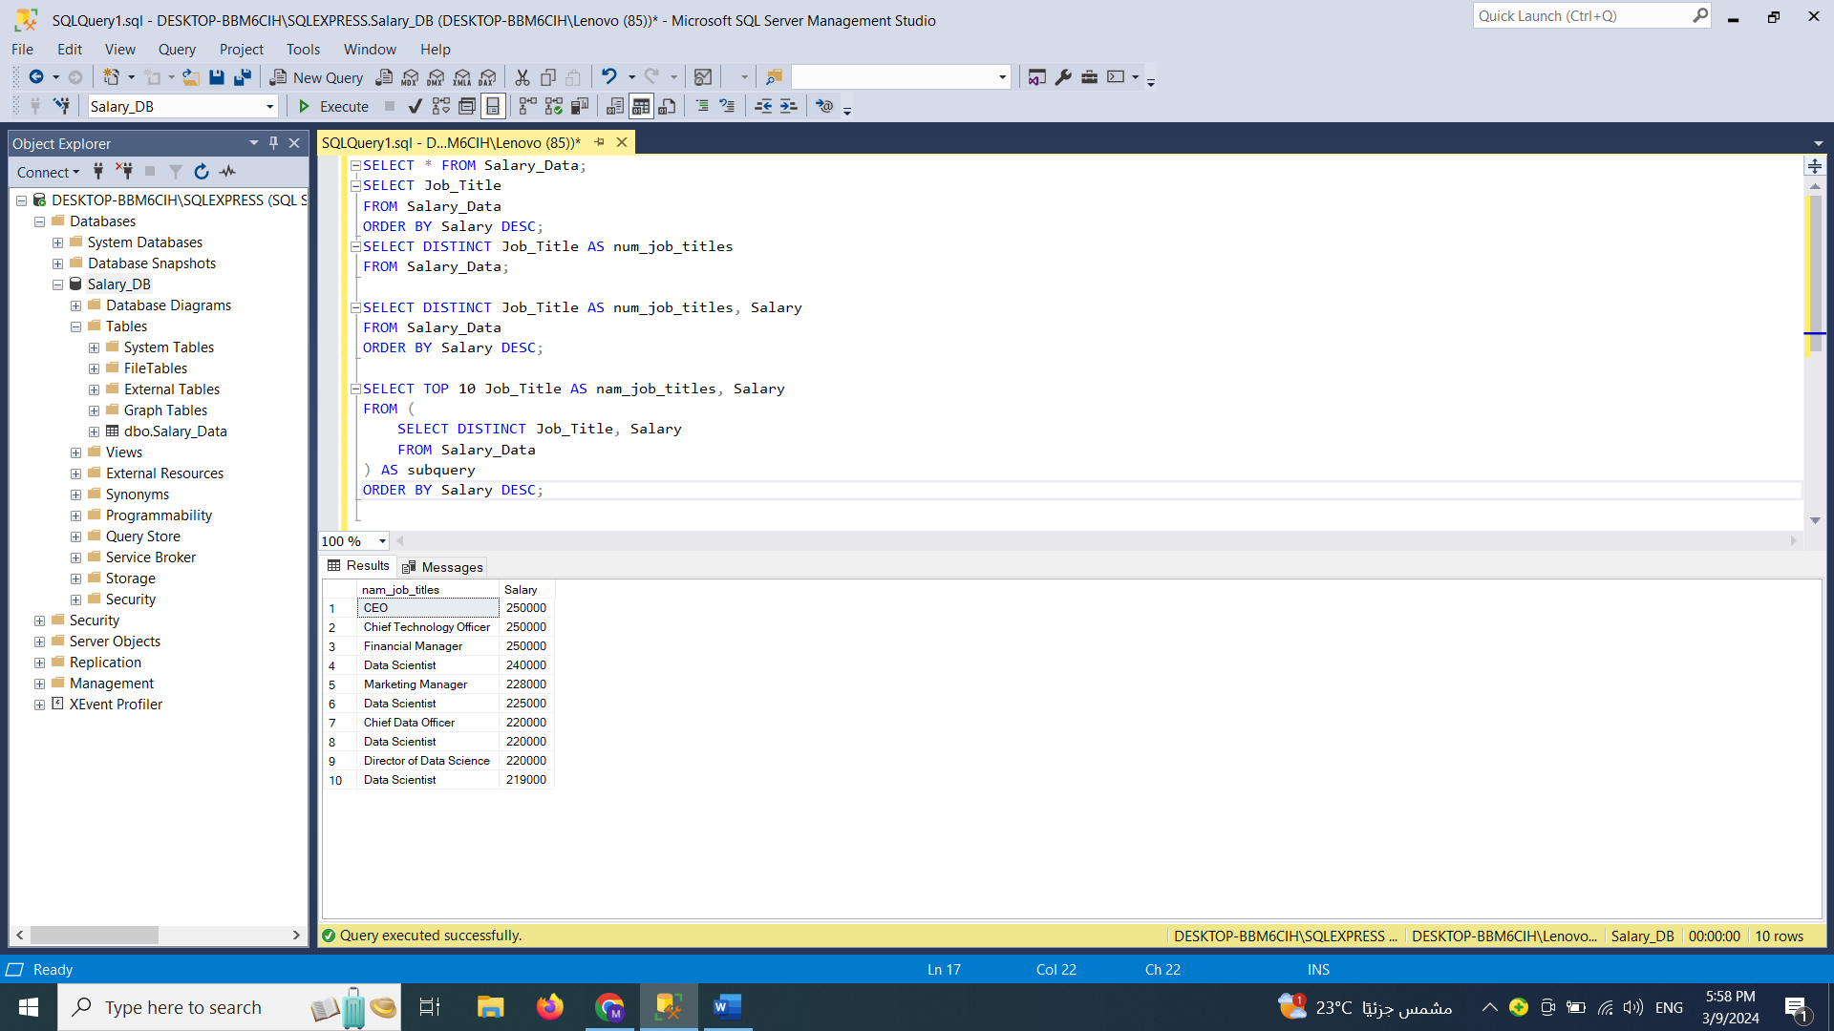

1. **The number of females, males and other in the Gender column:**

SELECT Gender, COUNT(*) AS count_gender

FROM Salary_Data

WHERE Gender IS NOT NULL

GROUP BY Gender

ORDER BY count_gender DESC;

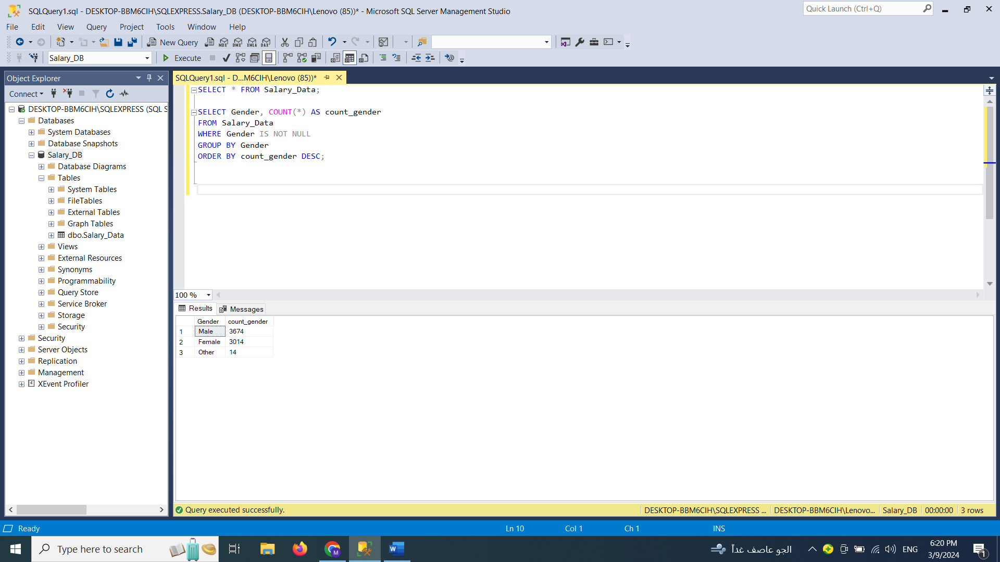

1. **Counting the occurrences of each education level in salary data:**

SELECT Education_Level, COUNT(*) AS count_education_level

FROM Salary_Data

WHERE Education_Level IS NOT NULL

GROUP BY Education_Level

ORDER BY count_education_level DESC;

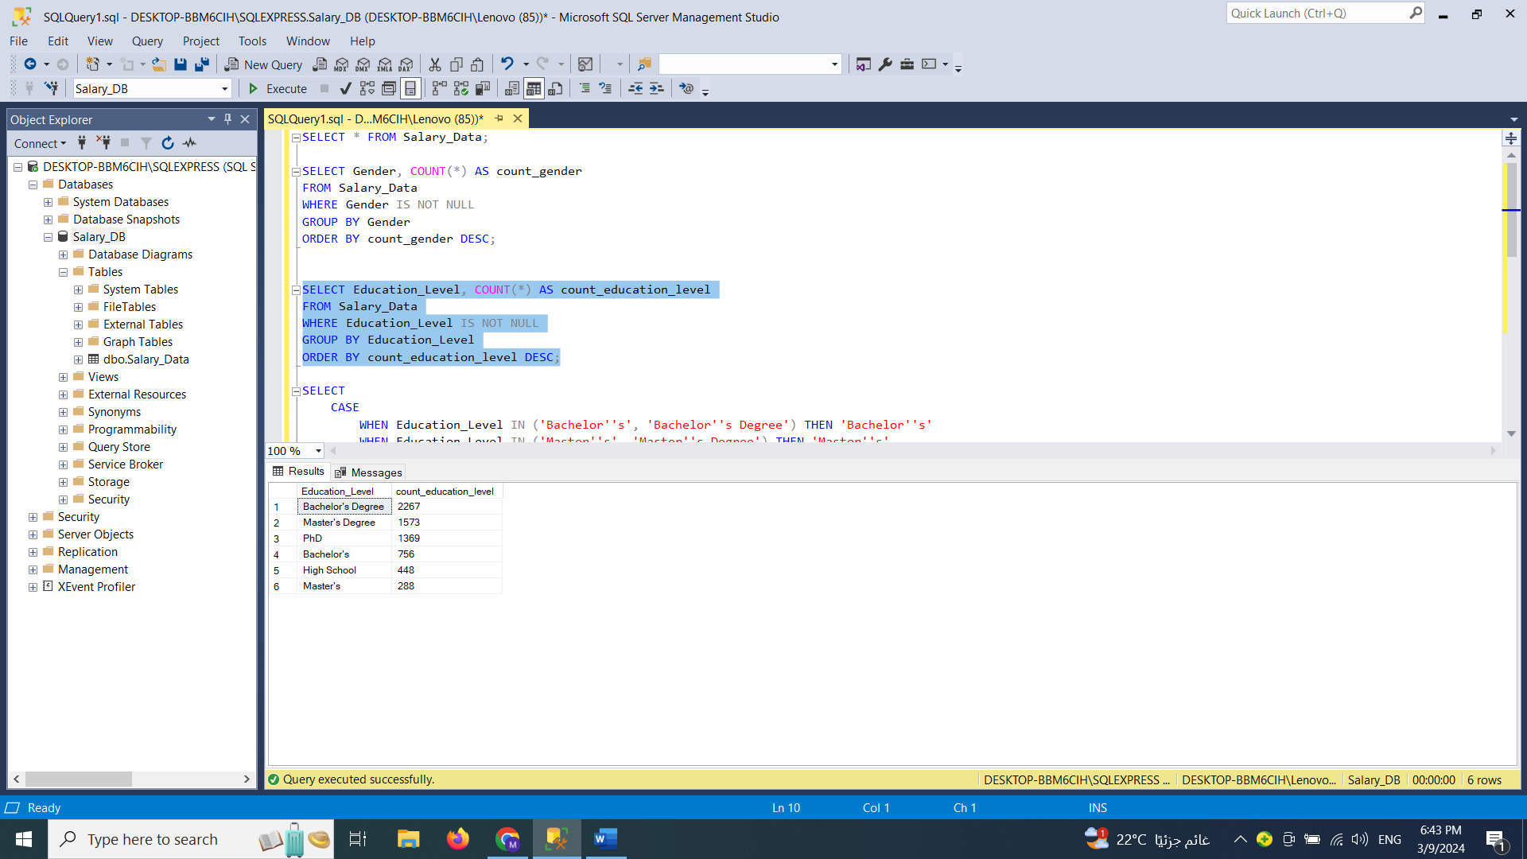

1. **Combine similar values in education level column while counting the occurrences of each education level:**

SELECT

CASE

WHEN Education_Level IN ('Bachelor''s', 'Bachelor''s Degree') THEN 'Bachelor''s'

WHEN Education_Level IN ('Master''s', 'Master''s Degree') THEN 'Master''s'

ELSE Education_Level

END AS Education_Level,

COUNT(*) AS Count_Education_Level

FROM Salary_Data

WHERE Education_Level IS NOT NULL

GROUP BY

CASE

WHEN Education_Level IN ('Bachelor''s', 'Bachelor''s Degree') THEN 'Bachelor''s'

WHEN Education_Level IN ('Master''s', 'Master''s Degree') THEN 'Master''s'

ELSE Education_Level

END

ORDER BY Count_Education_Level DESC;

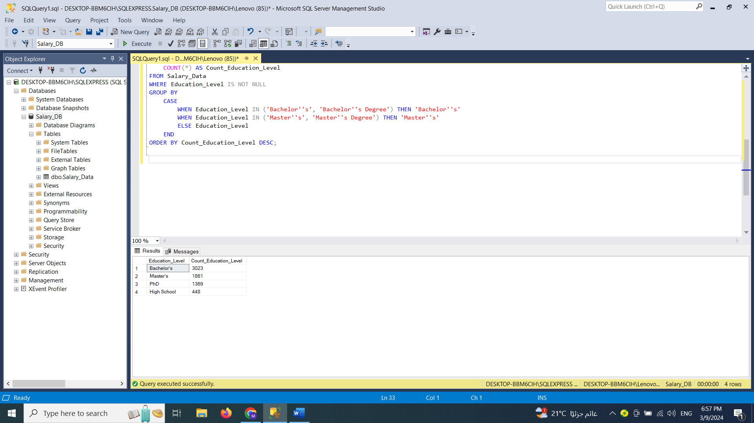

1. **Calculates the top 5 job titles for each education level (Bachelor's, Master's, and PhD) based on the number of occurrences in the Salary_Data table, sorted by education level and rank:**

WITH RankedJobTitles AS (

SELECT

Education_Level,

Job_Title,

COUNT(*) AS Count,

ROW_NUMBER() OVER (PARTITION BY Education_Level ORDER BY COUNT(*) DESC) AS Rank

FROM Salary_Data

WHERE Education_Level IN ('Bachelor''s', 'Master''s', 'PhD') AND Job_Title IS NOT NULL

GROUP BY Education_Level, Job_Title

)

SELECT

Education_Level,

Job_Title,

Count

FROM RankedJobTitles

WHERE Rank <= 5

ORDER BY Education_Level, Rank;

