From

<https://www.flightstats.com/v2/flight-tracker/search>

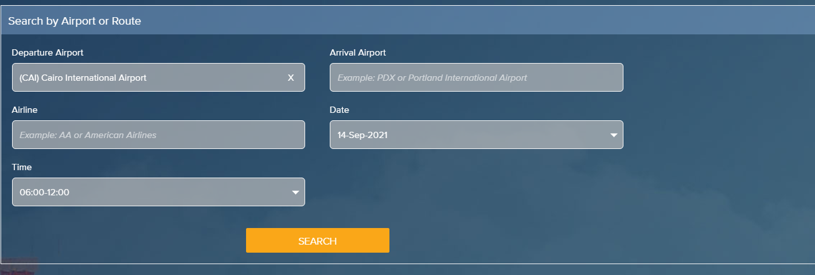

Links for CRAWLING :

* <https://www.flightstats.com/v2/flight-tracker/departures/CAI>

get all flights in each page

<https://www.flightstats.com/v2/flight-tracker/MS/610?year=2021&month=9&date=14&flightId=1070582163>

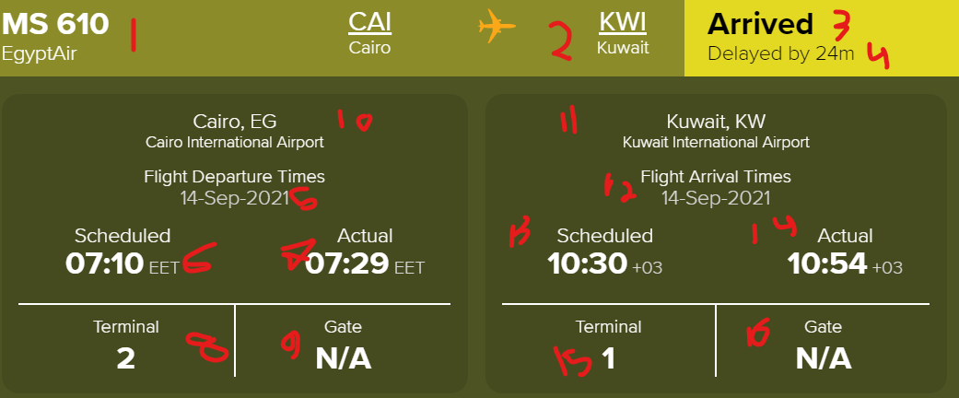

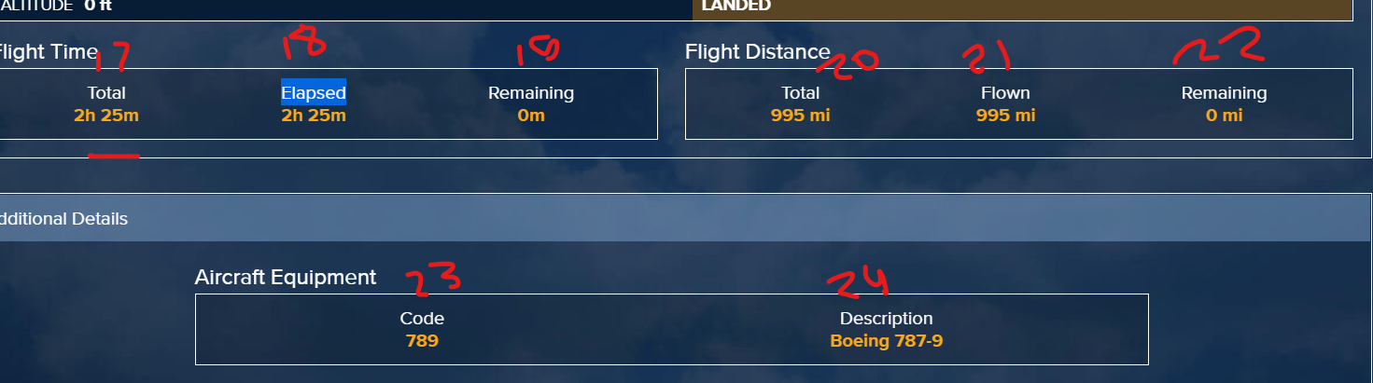

Or select view flight details and get this

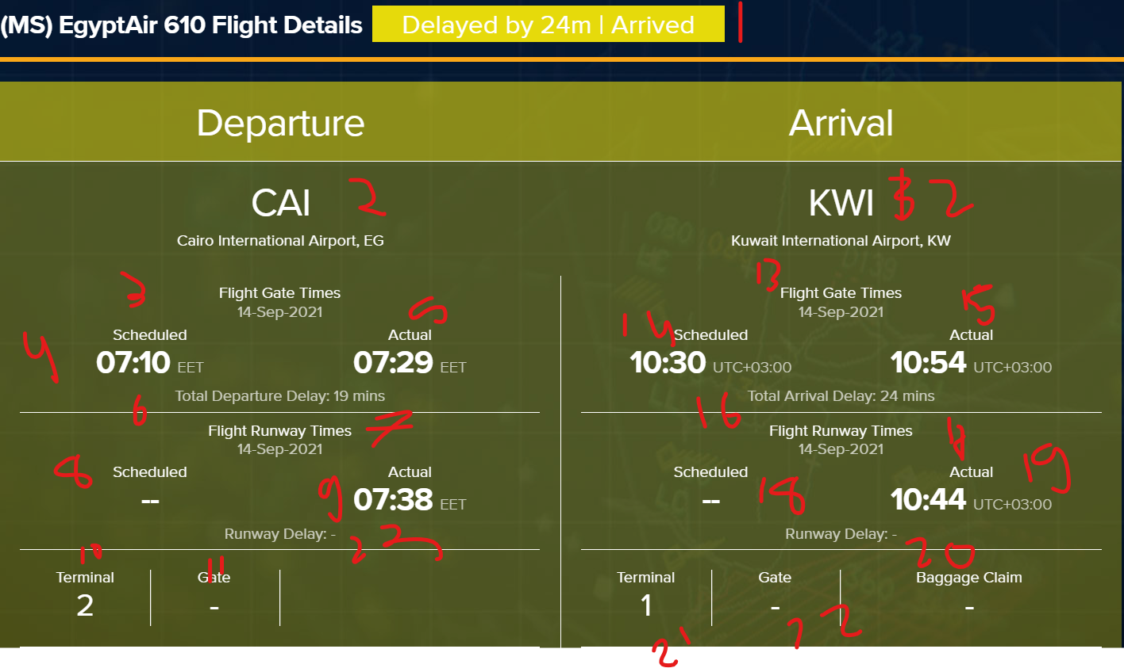

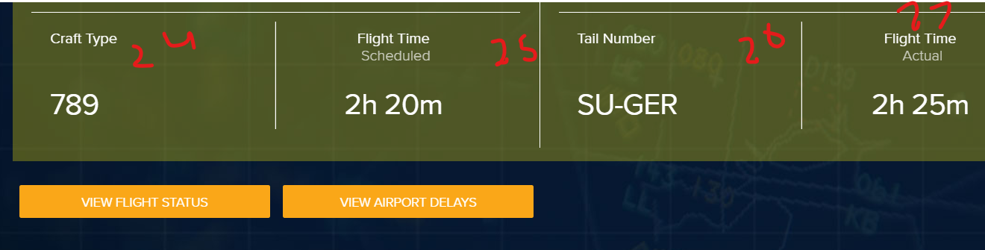

Then select view airport delays

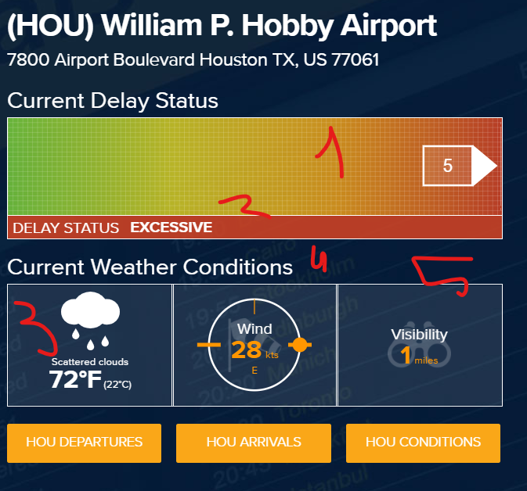

1. Crawling this page

<https://www.flightstats.com/v2/flight-tracker/departures/CAI>

Use 'html.parser' instead of 'html5lib'. This will work.

Get the data from the table

Get the links from herf html

get data from inner link

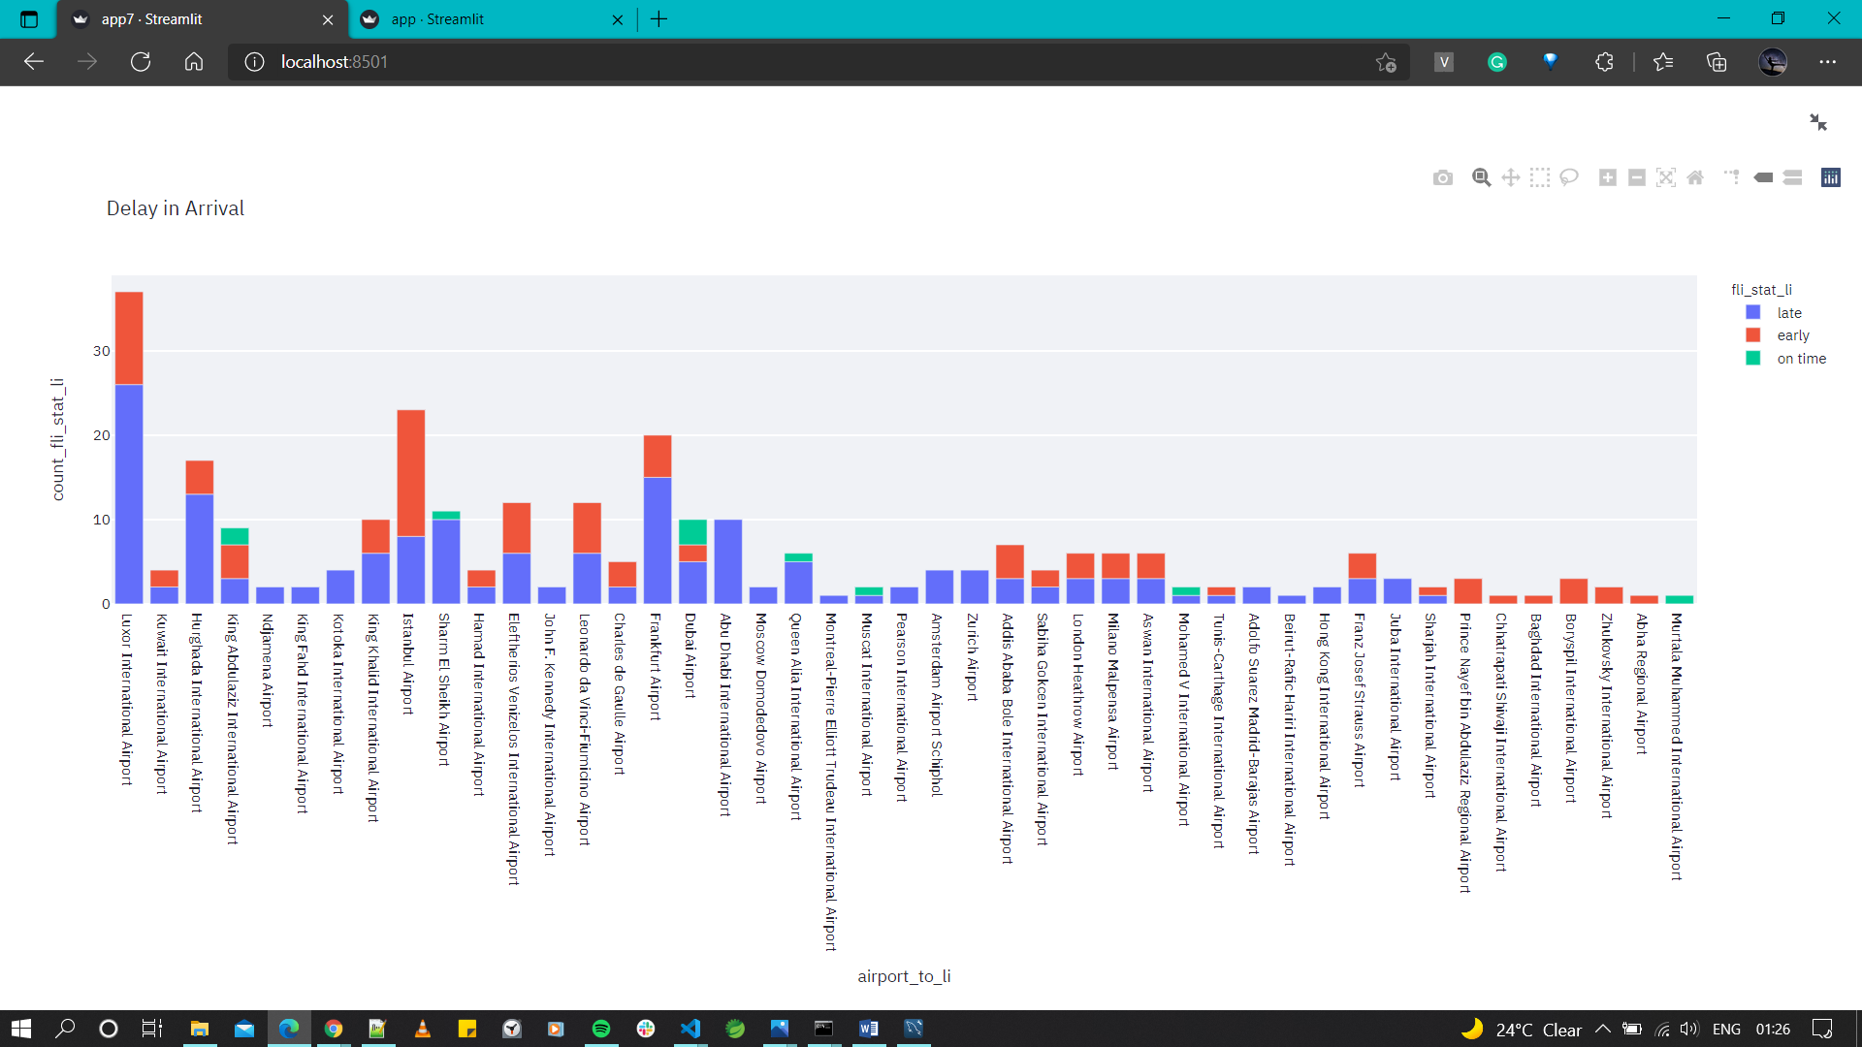

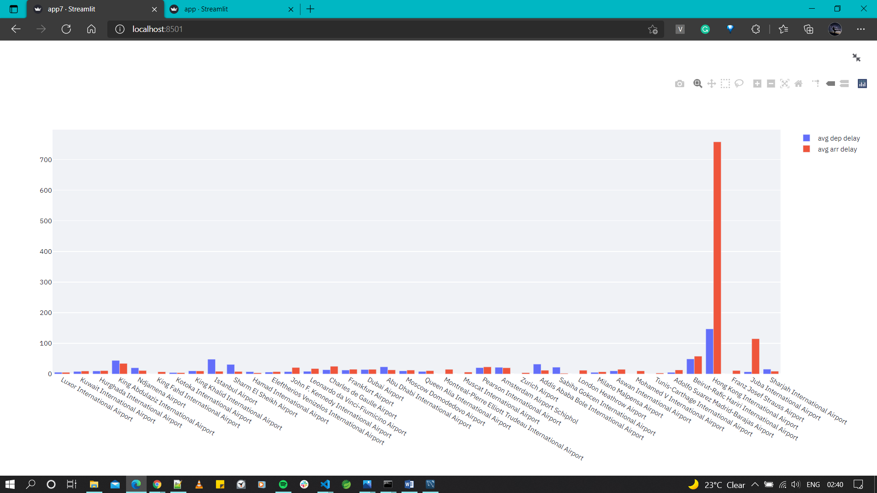

Object >props>initialstate>flightracker>route>flights