Appendix

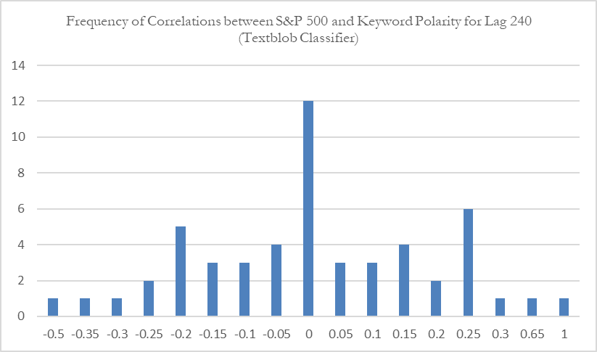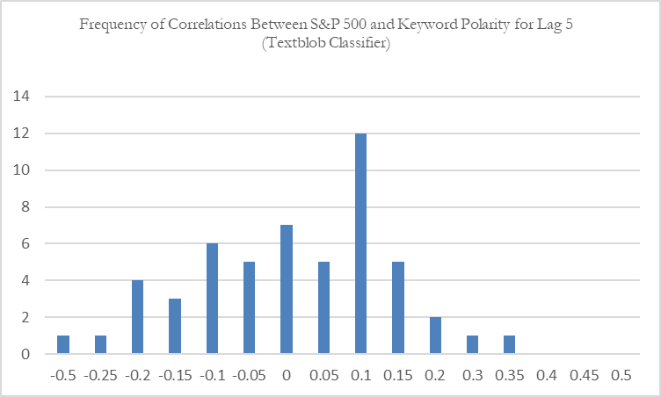In order to check for the expectation that the correlations are non-normally distributed across lags, frequency tables have been made to visually portray this expectation. Correlations have been rounded to the nearest 0.05 digit as this allows for the frequency distribution. While it would be more representative to not round the correlations, creating the graphs would be impossible due to the granularity of the data. The first and the last lag have randomly been selected for visualization. It can be derived from the graphs that the data does not seem to be normally distributed.