***Instructions for use and testing***

When you start running it will ask you to enter your username and your identity (librarian or administrator).

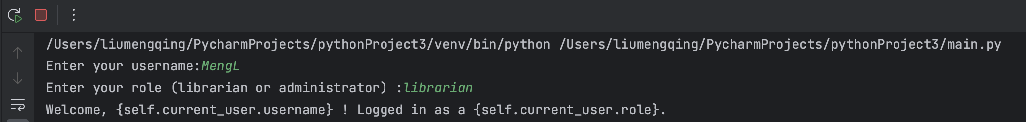

Then it will have multiple options:

1. Add Book

2. Add Patron

3. Display Book

4. Display Patron

5. Exit the Library

All you need to do is enter its number. If you accidentally enter another number, it will return this multiple choice. You just need to enter it again.

1. Add Book

It will bring up the ISBN, title, author, and quantity in turn, and when you're done it will prompt you with "Book added successfully!!!!!!!". If it can't (you don't have permission to do so), it will prompt you "You don't have permission to add books :)".

2. Add Patron

It will bring up the ISBN, title, author and quantity in turn, and when you're done, it will prompt you "Patron added successfully!!!!!!!!!!!!!!!!!!!!!!!!!!!!!!!!!!!!!!!!!". If it can't (you don't have permission to do so), it will prompt you "You don't have permission to add Patrons:)".

3. Display Book

It will show you all the information of the book.

4. Display Patron

It will show you all the information of Patron.

5. Exit the Library

This is an opt-out and it will prompt you with "Thanks for choosing Library!".

Other

If you enter an option that does not exist, you will be prompted with "Invalid Choice". It will return this multiple choice.

***Discuss***

This was the first relatively large project for me in the program. During the process I often encountered some, missed some details or code. Or double entry of some code.

* Duplicated in some naming, resulting in confusing code.
* Implementing complex operations in the command line interface may become cumbersome.
* It needs to be constantly iterated and improved, optimized based on feedback and requirements.

There are a few details I could add to improve the overall code to make it clearer and neater. When dealing with a large amount of data, a more advanced database solution can be considered.