Q1 Done

Q2

The cat command displays the complete file, so if it is more than one screen full some of it scrolls out of view.

more command displays one screenfull at a time and you just tap the space bar to scroll up the next page.

Q3

Rm : remove the dir or file   
rmdir : remove empty dir



Q4

Q4 a)

Rm only will not work we have to use rm -r to remove the files then the directory.

Q4 b)

The command removes the directory and its parent (full path)

Q4 c) absolute: /home/menshawy/docs/mycv

Relative : /docs/mycv

Q5

Q6

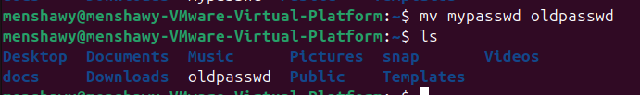

Q7

Q8

Q9

Q10

Q11



Q12



Q13



Q14

Q15 a) press esc then (j)

b) press esc then (k)

c) press esc (/age) then enter

d) press esc then (:5) or (5G)

e) press esc the (dd)

f) press esc then (A)

Q16

