The reasoning behind the design of the last two stages (M1M2) (M3M4) comes from the fact that these two layers form the gain of the system.
Let’s assume that both stages contribute to the gain of the system. In this case the output stage (M1M2) should have a non trivial gain. This can be achieved either via high or low $r_{o}$. We will show that both cases are not viable, and therefore prove that the output stage should give low or even negative gain.
- If $r_{o}$ is high, this means that $r_{0}C_{L}$ is low, and we will get poor BW. This will be corrected by setting a low $R_{F}$ which will reflect (miller) to the output and load the resistance plummeting the gain. Therefore the gain is low in contradiction to the gain being high.
- If $r_{o}$ is low, this means that $r_{o}C_{L}$ can be made to be 1GHz. However, this will induce high currents, which will in turn make big transistors. Such a big transistors will have high $C_{GS}$ which will reflect (miller) to the input to the output stage, the output of the common source (M3M4) stage. This will generate a close zero that will produce stability problems. Therefore this case is also discarded.
The resulting pursued way is to have a small output stage whose only role is to set the BW of the system. To do so, we will aim for high $r_{o}$ at the output stage (low L and low current) and use the reflection of the feedback resistor to set the pole.
This means that:
$$f_{3dB}≈\frac{1}{2πC_{L}R_{F}}=1GHz→R_{F}=15.9 kΩ$$
This is valid only for high resistances which will be developed next.
We call the length and width of the output stage and the common source stage as $LN1 WN1 LP1 WP1 LN2 WN2 LP2 WP2$.
We start from the output stage, connect a DC voltage at the input and set it to 0.5V. We set $LN1=WN1=LN2=200nm$ and iterate over $WP1$ to get 0.5VDC at the output. The debug circuit looks as follows:
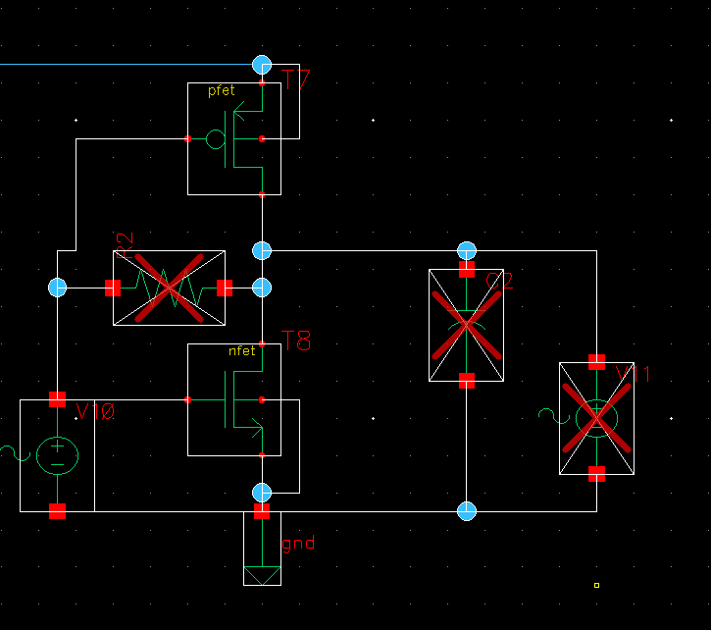
The result of the simulation on the output node reads:
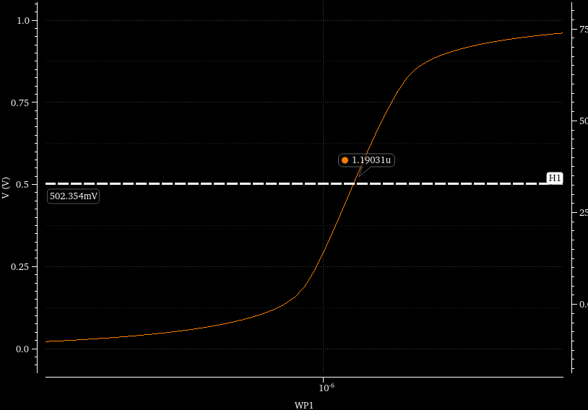
We set $WP1=1.2μm$. The AC simulation, with $R_{F}=15.9kΩ$ reads:
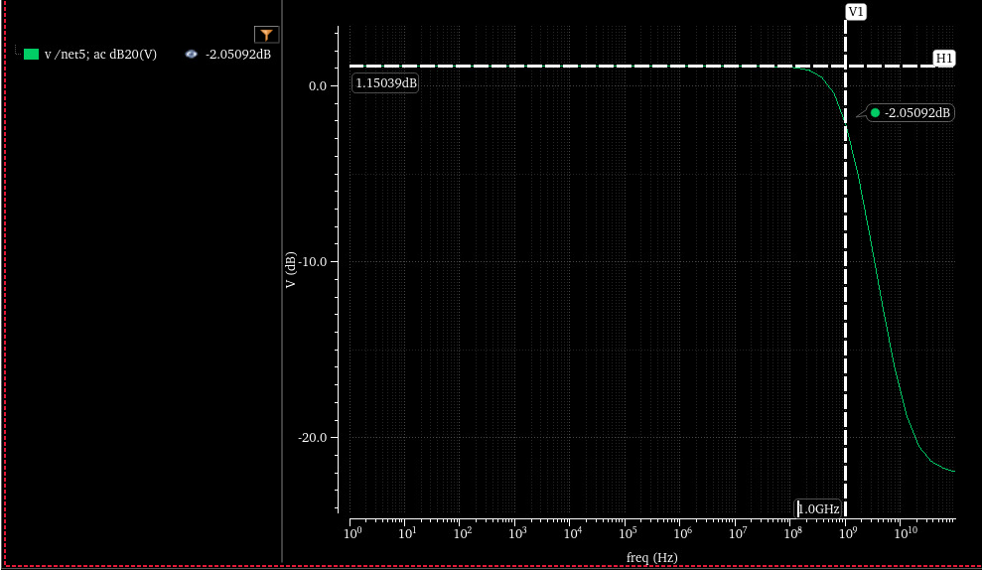
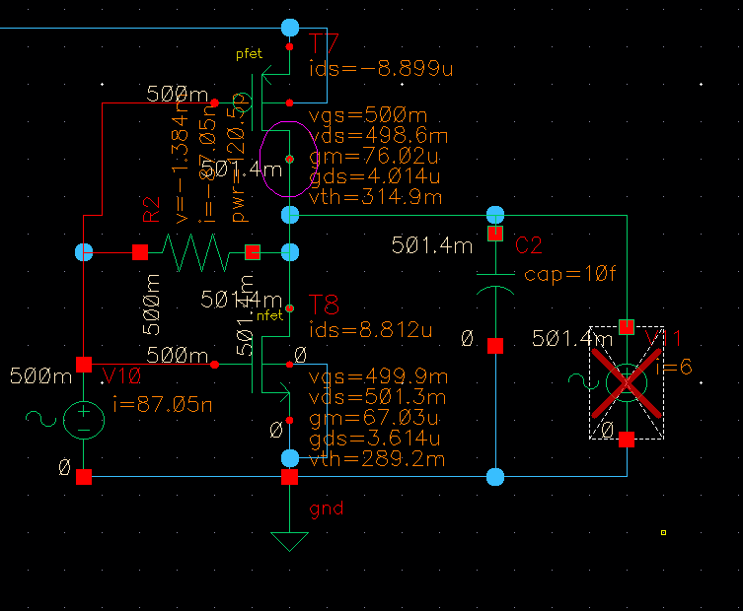
The fine tunning will be done at the end. The current expenditure is $\sim 9μA$.
Next we will solve the common source stage.
For this stage we want high gain and low resistance (to not be loaded by the output reflection).
To match this, we will use low $V_{GS}-V_{th}$ on each transistors and high L.
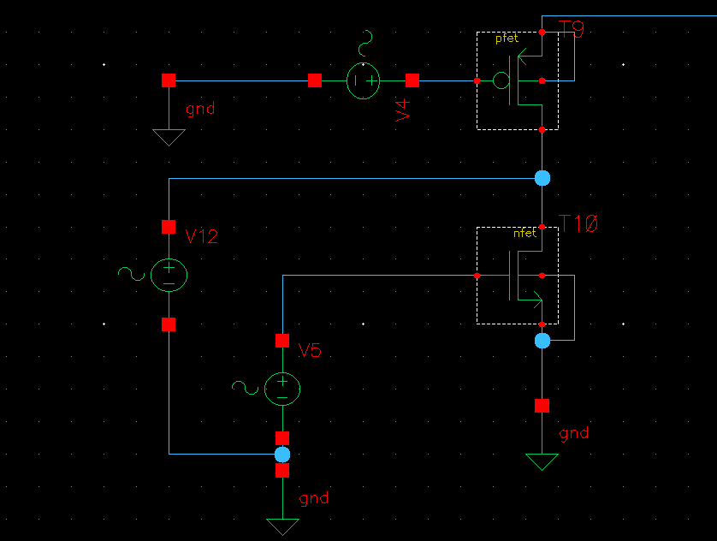
We use V5 = 0.4V start from $LN2=LP2=1μm, WN2=5μm$ and iterate on PMOS widths, WP2, to get 0.5VDC:
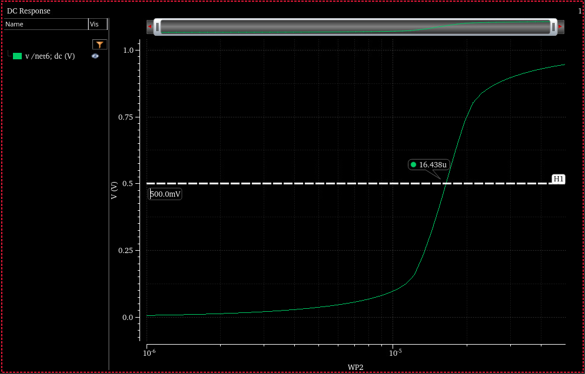
So we select $WP2=16.4μm$.
Overall we get the following DC point:
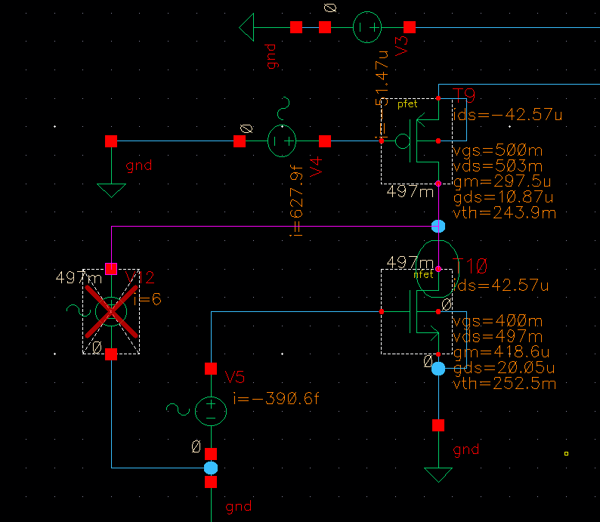
We connect the stages and plot the AC response:
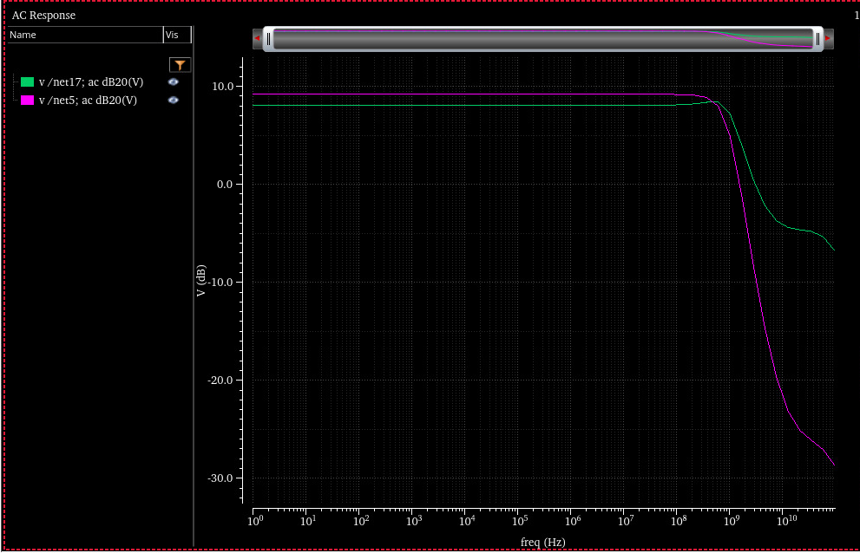
We see that low gain is achieved. The main reason for this is the loading of the rout. After inspection we found that the rout of the transistors is about $50kΩ$.
We will repeat the previous simulation with V12 but with $L=200nm$. We will then iterate through WN to get various values of $r_{out}$:
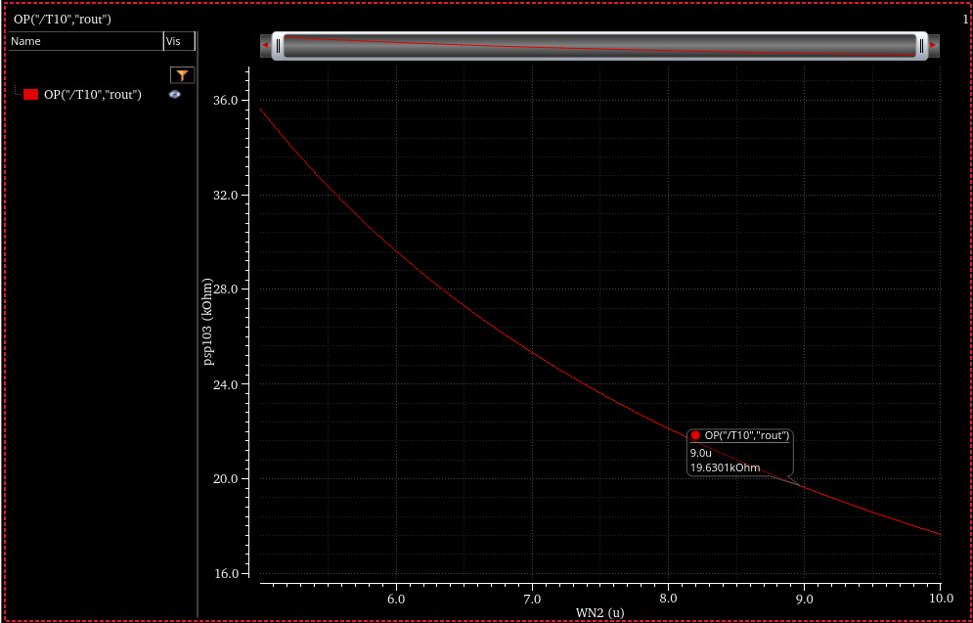
We will use $LN2=9μm$. To set the PMOS we will iterate over $WP2$ to get the value for which VDC = 0.5V. 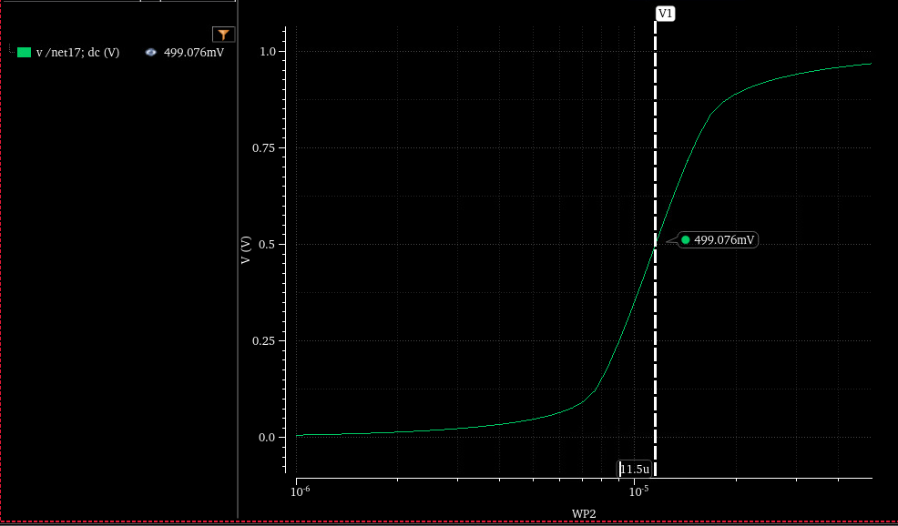
So we set $WP2=11.5μm$.
After looking at AC we saw that this wasn’t enough so we increased WN2 = 10mu and replot:
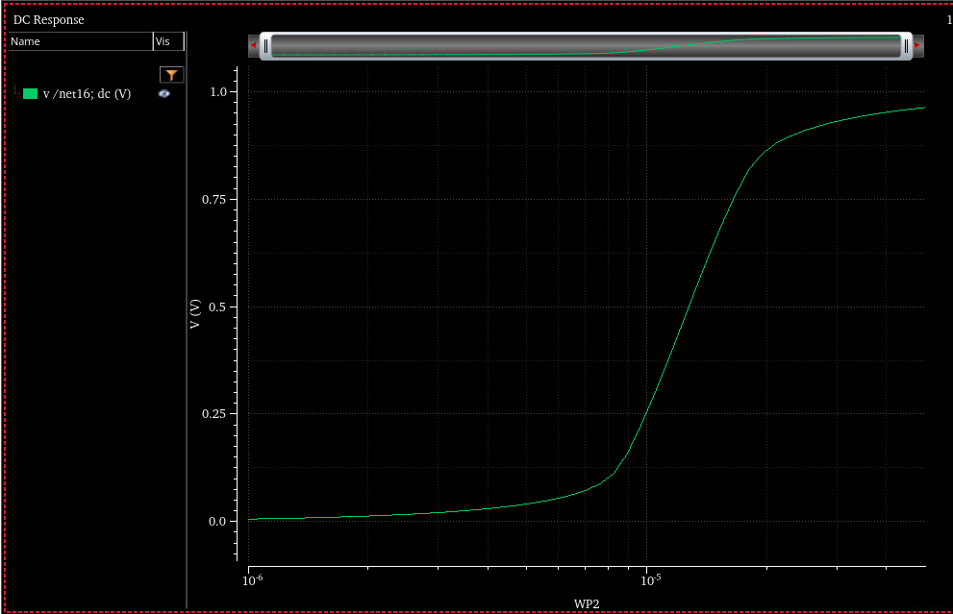
WP2 = 12.7 mum.

