EX2 – Wideband Linear Driver
We want to design the following driver:
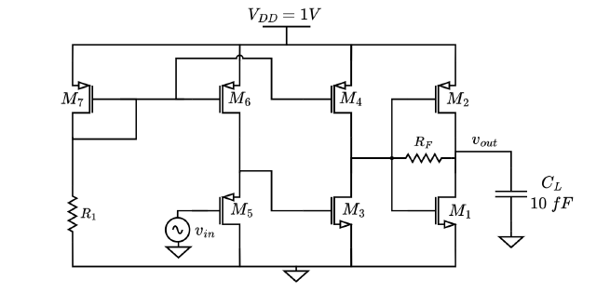
We will concentrate on each stage, design for it and then integrate together.
Stages Overivew:
The leftmost stage (M7 R1) is a biasing stage responsible for setting the voltage of all the PMOS current sources of the next stages.
The input stage (M5 M6) is a simple buffering stage, because of the common drain M5. The DC level of vin is 0V and therefore we must increase it in order to be far enough from the rail voltages (0 and 1V). As such, we expect a gain close to 1.
The third stage (M4 M3) is a classical common source (M3) gains stage with a PMOS current source (M4). This gain will be responsible for the gain $A_{3}=g_{m_{3}}(r_{03}|\left|r_{o4}\right)$.
The last stage is a class AB is the output stage. In order to buffer this stage from the previous stage we will ensure that no current flows through $R_{F}$ at DC. This can be done for example if we enforce that at both sides of $R_{F}$ $V=\frac{V_{DD}}{2}=0.5V$.
Output Stage Design:
To design the output stage we use the following subcircuit:

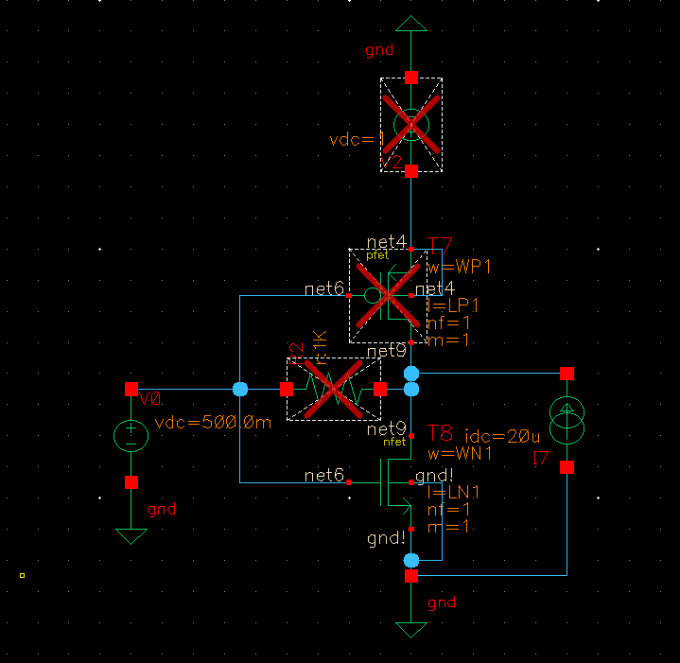
Notice that in this subcircuit the input gate was taken to be 0.5V. The PMOS and the resistor are disabled and a current source of $20μA$ was randomly chosen (if $20 μA$ is found to be OK for this stage then the stage will consume 10% of the overall allowed consumption of $200 μW$).
We will use $W_{N1}=2μm$ and iterate through various values of L to find the L that gets us to $V_{out}=0.5V$ @DC.
From the following figure, we see that the closest “valid” value that we can use is $L_{N1}=2.3μm$. The precise voltage now is of less importance as we are going to fine tune it with the PMOS, but we write it for reference as $V=467mV$.

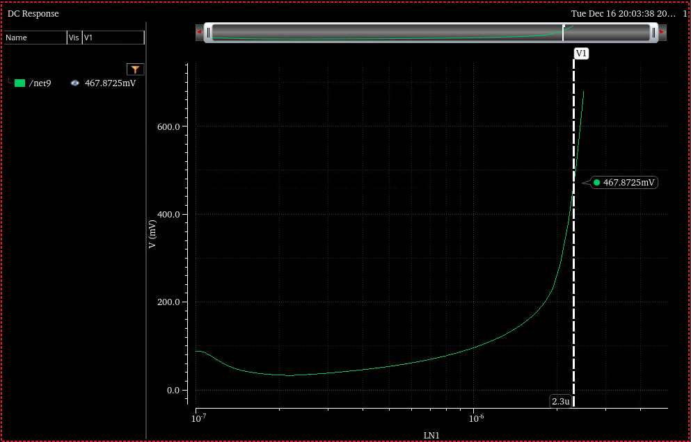
Next, the PMOS is simulated with the following subcircuit:
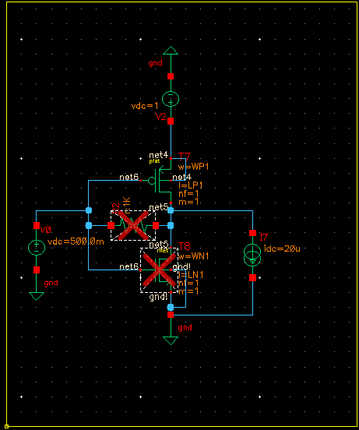
Notice that in this case the current has been inverted. Because PMOS are usually half as strong as NMOS we will start with $W_{P1}=4μm$ and iterate over $L_{P1}$. We try to find the $L_{P1}$ such that the drain voltage is $\frac{V_{DD}}{2}$.
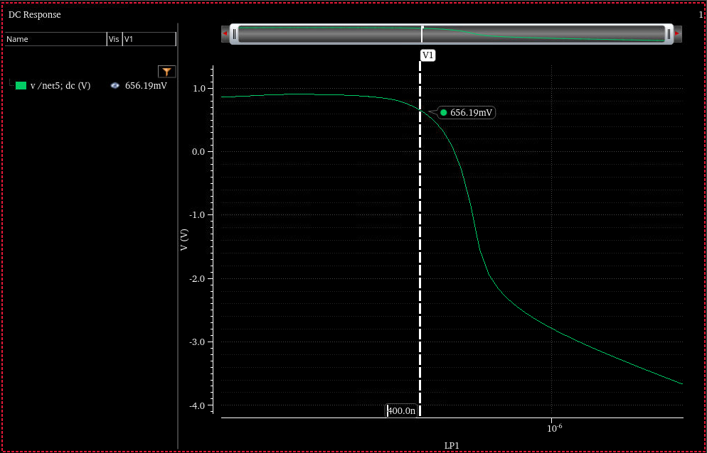
The closest voltage we found was 656mV for 400nm.
Now we connect the PMOS and the NMOS together without the current source and without the resistor to find the drain voltage. The drain voltage was found to be 582mV. This means that the PMOS pulls stronger than the NMOS.
We increase the NMOS width by steps of 100nm in order to find the width for which the drain voltage is 0.5V.
We found that for $W_{N1}=2.1μm$ the drain voltage settles at $0.515V$.
Now we set the resistor. The resistor needs to accommodate for the bandwidth needed. Looking from the output, we see $R_{B}\left|\left|r_{o1}\right|\right|r_{02}$, if $R_{B}$ is much smaller than $r_{01}||r_{02}$ then we will effectively see only $R_{B}$.
In the case that $R_{L}$ is much lower than $r_{01}||r_{02}$, the bandwidth reads:
$$f_{3dB}=\frac{1}{2πC_{L}R_{B}}$$
Solving for $f_{3dB}=1GHz$ and $C_{L}=10fF$ we get $R_{B}=15.9kΩ$. Both transistors have $r_{on}\sim 100kΩ$ so the assumption that $R_{B}$ is much smaller than $r_{01}||r_{02}≅50 kΩ$ is not much justified. We will therefore try to use $R_{B}=23kΩ$ as in such case the resulting resistance is approximately $15.7kΩ.$
To simulate this we use the following circuit:
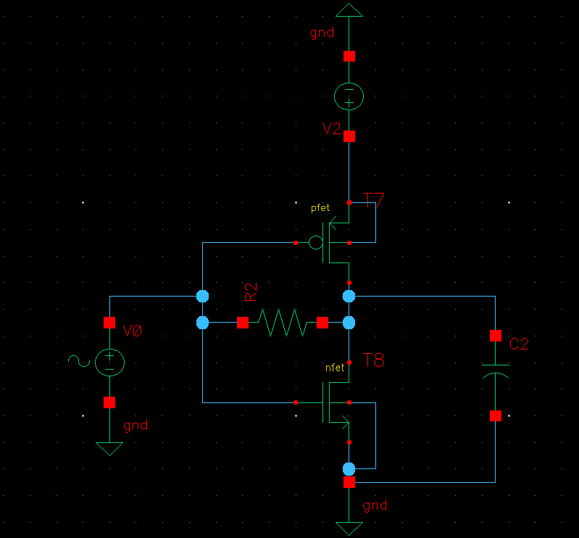
The response is given next:

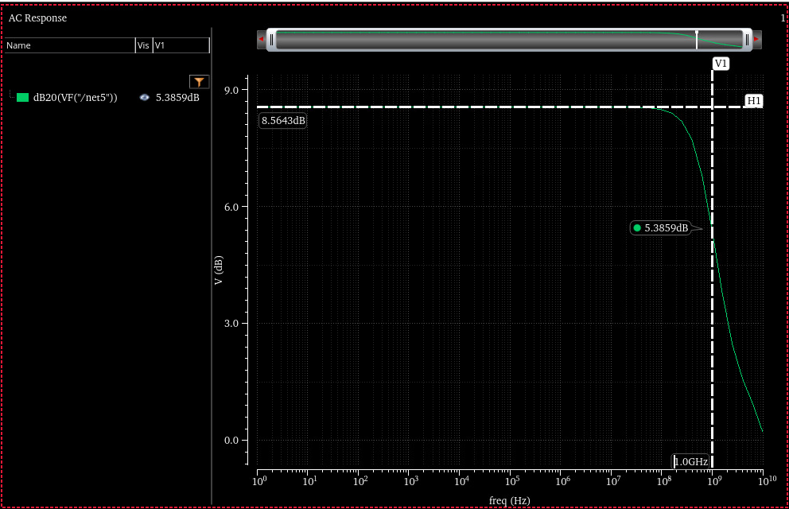
We see that approximately the BW is 1GHz and that the gain of the output stage is 8.5dB.
Common Source Stage (M3 M4).
The requirements for this common source stage are to have around 16.5dB gain and at least 1 GHz BW.
The main difficulty to solve here is that the output seen at this stage is resistive (RB) generating a loading effect that will hurt the gain of the amplifier.
We will try to analyze this circuit by assuming that the resistor $R_{B}$ simply ads in parallel to the overall circuit.
The plan will be to get to $0.5V$ at the drain of the transistors and replicate the current (increasing W) so that the gain increases.
To find 0.5V at the drain of the transistors we need not to include the resistor, because in the same way that was assumed for the output stage, the resistor will only affect the ac point.
We need to assume something about the input DC voltage to transistor M3. Because this transistor will be responsible for most gain, we should use a low voltage. However, as this voltage is the drain voltage from the input stage (M5 M6), using a low gate votlage will result in taking M5 out of conduction!
We will start with the trivial but convenient assumption that the gate of M3 is biased with $0.5V$. Using this assumption, we wish to use the transistor at $V_{GD}=0$ (which is clearly saturated).
The circuit used to simulate this stage is shown next:
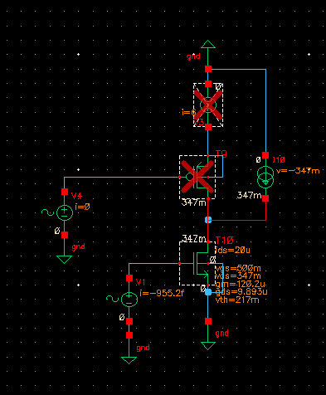
Notice the disconnected PMOS and votlage source, and the added current source. The starting current source is taken to $20μA$ and it will be changed later on. The first step is to find some L such that for a predefine W the drain voltage is 0.5V (this is the same as done before). We choose randomly $W_{N2}=2.1 μm$ and iterate over L’s.
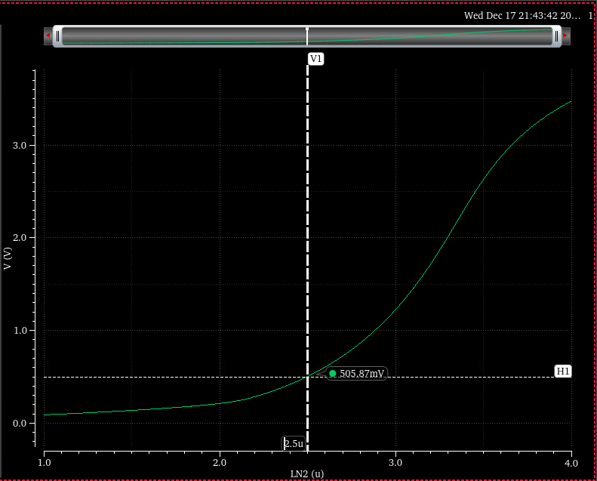
We proceed with $L_{N2 }=2.5 μm$.
Now we repeat for the PMOS. For the PMOS we invert the direction of the current source, disable the NMOS sources and enable only PMOS sources.
The gate of the PMOS is trivially biased to 0.5V. After a multidimensional (W and L) simulation we found a nice solution over $W_{P2}=3.8 μm$ and $L_{P2}=400nm$:
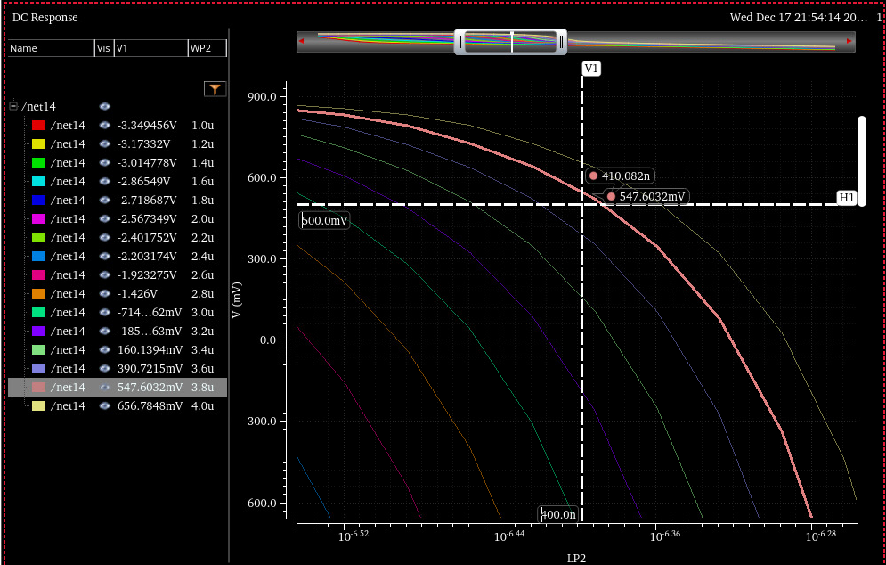
This is the closest solution we found.
The next step is to connect the transistors and try to manually tune them to reach the desired 0.5V.
The closest solution we found was for $L_{N2}=1.8μm$ and $W_{P2}=3.9μm$ $L_{P2}=300n.$
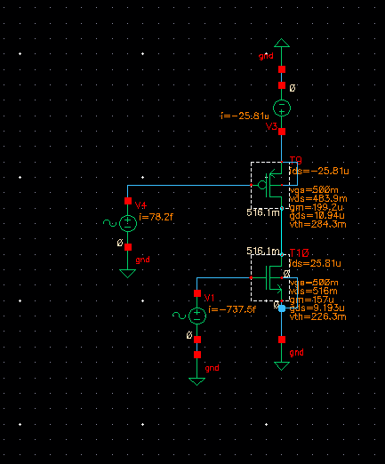
Now we will connect both stages together and find the overall gain. If more gain is needed we will increase the current of the common source stage.
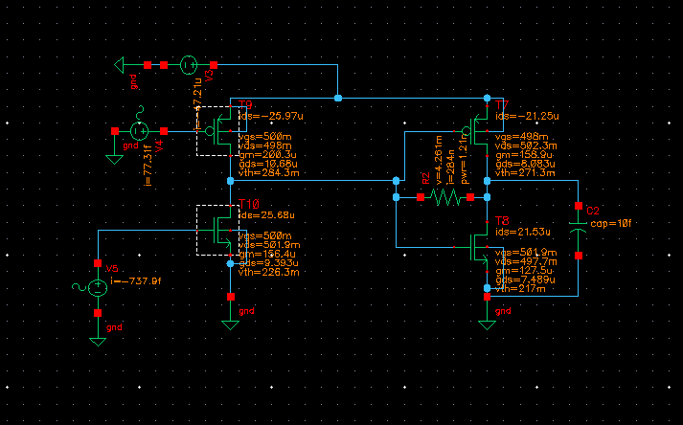
The previous figure shows the DC point of the last two stages. We can se that the reisistor current is negligible with respect to the stages currents, indicating minimal effect on the DC point (as desired).
The AC response is shown next:
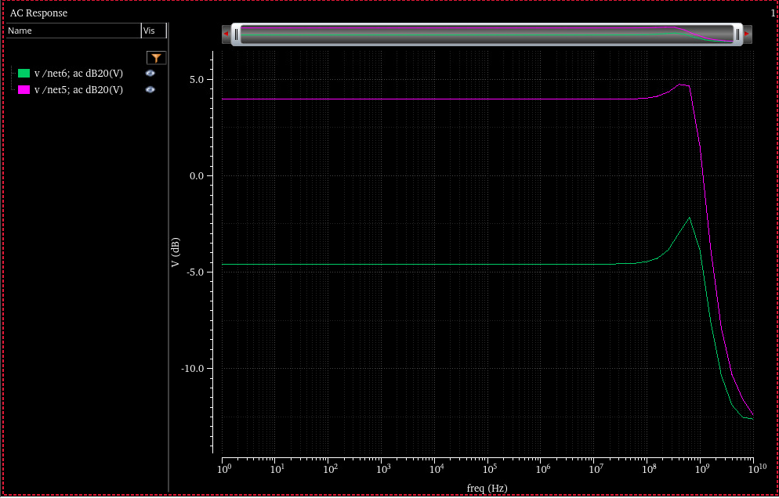
Net5 and net6 are the left and right nodes of the resistor Rb respectively. We can see that the common source stage suffers from low gain, probably from the loading of Rb that kills the output resistance of the stage.
We do see that the gains of the stages are multiplicative, meaning that we can take the common source stage and use it (there will be some gain reduction because of the output resistance loading from transistors M2 and M1).
In order to increase gain without paying high current, we can increase L and reduce $V_{ov}$ of the common source transistor M3.
We will use the following circuit:
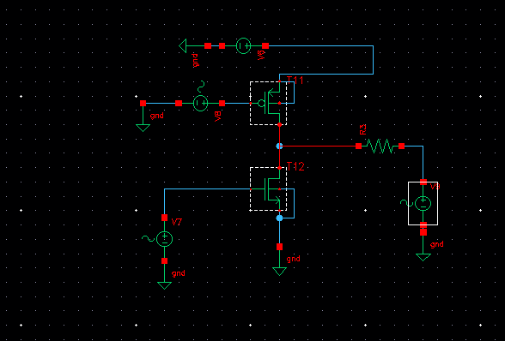
The voltage source on the right node of R3 is set to 0.5V to resemble the output node DC point (approximately).
We decrease $V_{GSN}$ to 0.4V and find the W needed so that the left node of R3 sits at 0.5V DC. A close solution is found for $WN2=4.3μm$
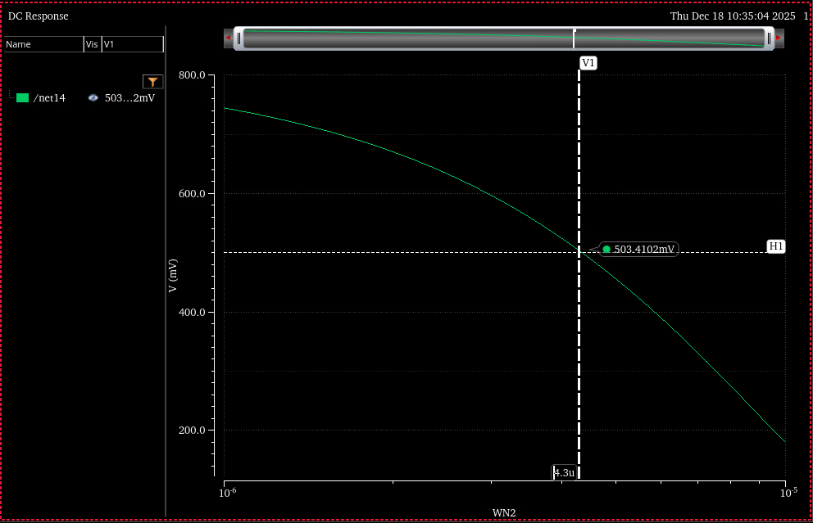
This is interesting because it lets us use a smaller $V_{GS}$ while keeping the same DC point, leading to higher gain for the same current expenditure.
Now, we will iterate for various finger count values (which are simulated simply by multiplying both $W_{N2}$ and $W_{P2}$ by the same factor N.
The results of such plots are seen next:
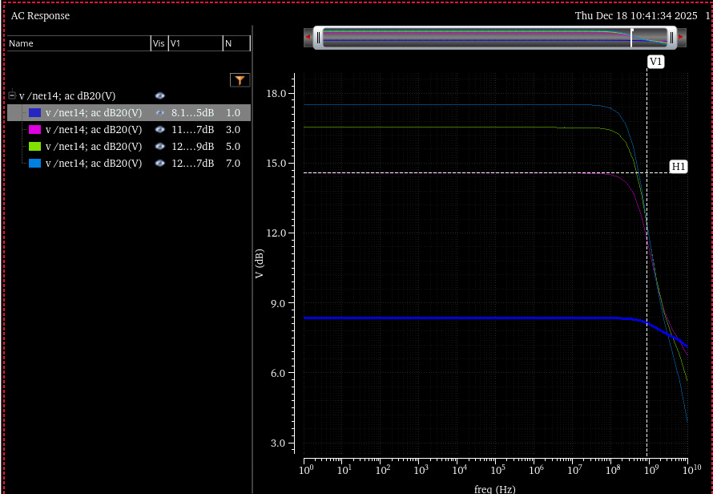
It can be seen from the figure that increasing L increases the gain at the cost of GBW (because the parasitic capacitacnes increases). Smaller parasitic capacitances are achieved by making the absolute W and L values of the transistor smaller (while keeping the relationships). This trades with gain as it will decrease the output resistance (decreasing L). However as the BW increases quadratically, and the gain decreases linearly on transistor sizes, we should get a linear increase in GBW per line.
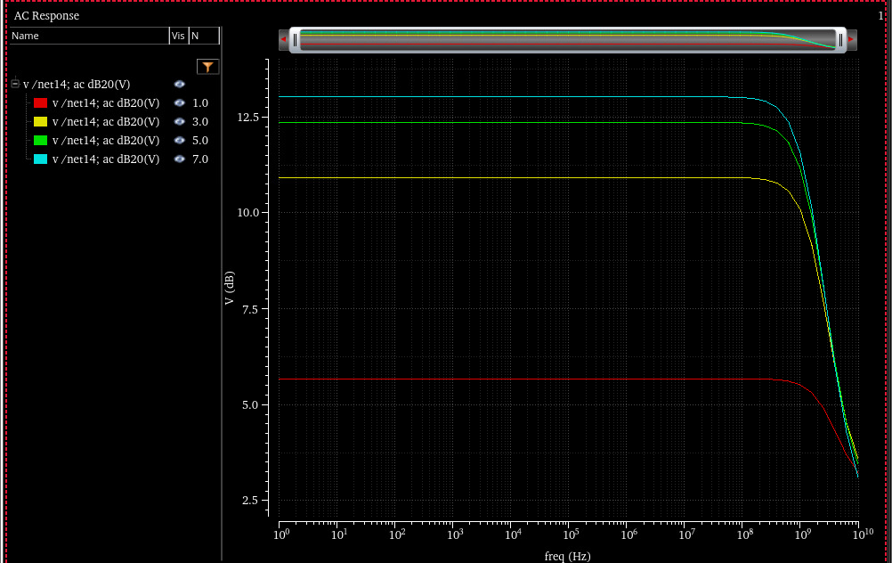
The last figure shows a much broader response as expected. The finishing of the response will be done later.
We will chose the highest gain (N=7). After some manual tunning we got:
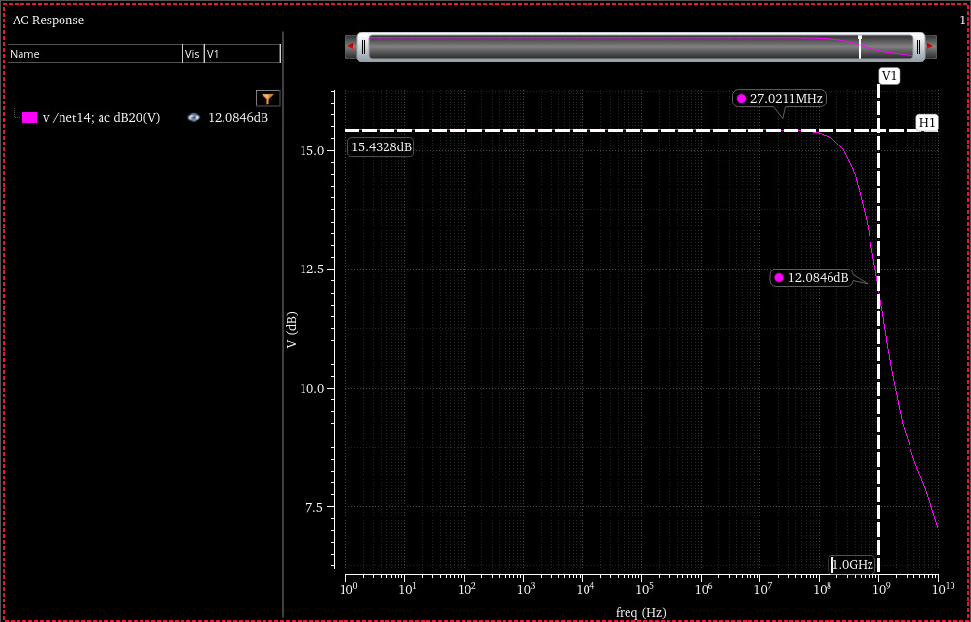
With the parameters:
N = 7
$$L_{N2}=1.8μm*N$$
$$W_{N2}=2.4μm*N$$
$$L_{P2}=200nm$$
$$W_{P2}=1.8 μm*N$$
Then we connect the two stages together and get the following DC OP;
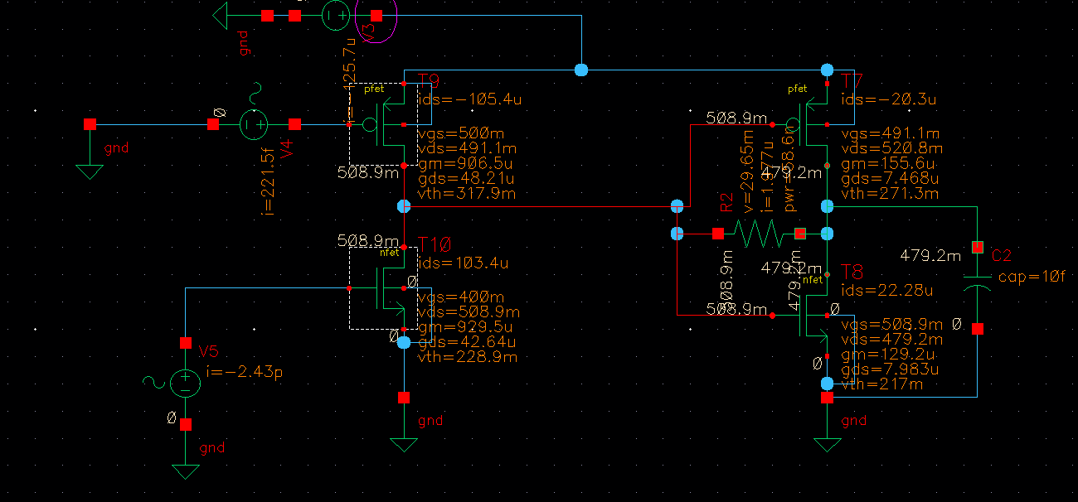
We can clearly see that the current flowing through the resistor isn’t negligible wrt to the output stage current. To fix this we will manually tweak the output PMOS to meet the 500mV mark.
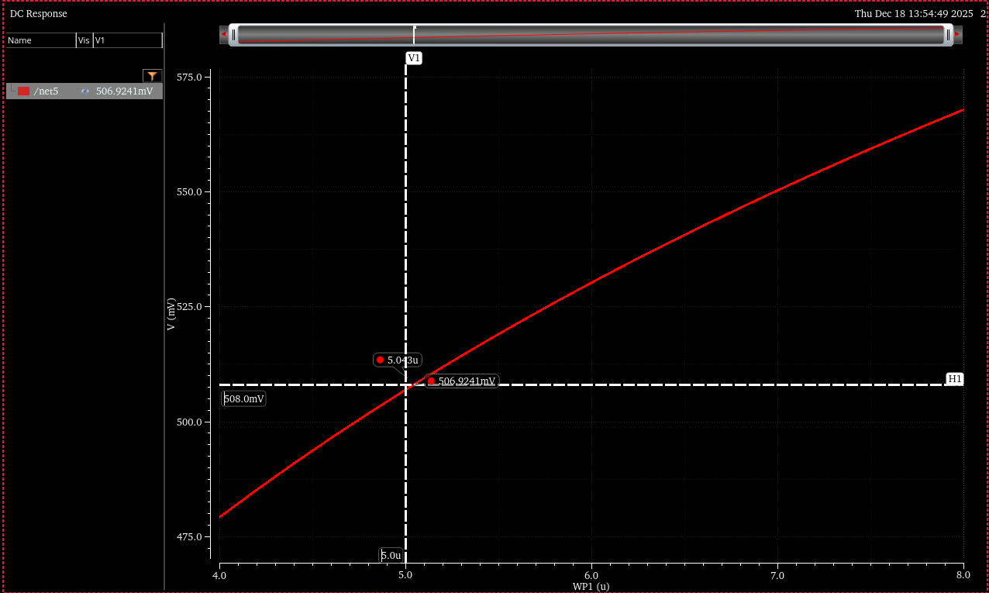
And the corresponding ac line reads:

Second Venure:
We start by noticing that the output stage and the common source stage are two amplifiers. If we can make the miller capacitance seen at the input of the output stage, be much bigger than the output capacitance, then such capacitor will form the principal pole and will be responsible for the $f_{3dB}$. Denoting such capacitance as $C_{M}=C_{gd}A_{2}$ and the resistance seen at the input of the second stage as $R_{in2}$ we get the expression:
$$f_{3dB}=\frac{1}{2πR_{in2}C_{gd}A_{2}}$$
The gain of the common source stage is given by:
$$A_{1}=g_{m1}⋅R_{in2}$$
The gain of the second stage is given by:
$$A_{2}=g_{m2}⋅R_{out}$$
The GBW product is given by:
$$f_{3dB}⋅A_{1}⋅A_{2}=\frac{g_{m1}}{2πC_{gd}}$$
We remember that this assumes that $C_{gd}A_{2}≫C_{L}$.
The strategy will be as follows:
- Start with initial guesses for the transistor values.
- Set the output stage so that the output DC is on 0.5V (max swing).
- Set the common source stage so that its output is also at 0.5V (this ensures minimal resistor influence).
- Measure the gate to drain capacitance.
- Change the current on the common source stage to match the gm needed for GBW.
We start by minimal lengths and widths of $200 nm$ and with the following circuit:
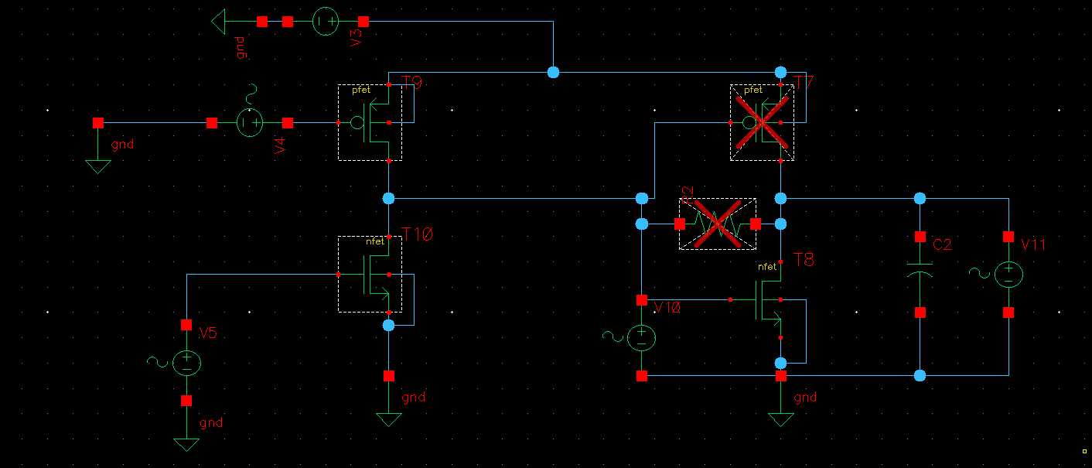
We set the input and output voltage of the output stage to 0.5V and will sweep the W values to find a (trivially set) value of $I=20 μA$.
Because we aim for a high $C_{gd}$ we choose the initial value $L=1μm$.
For the NMOS:
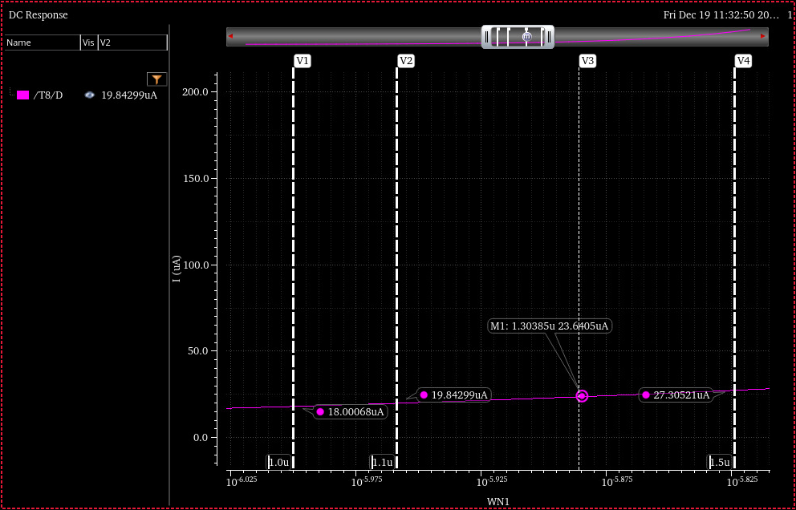
And for the PMOS
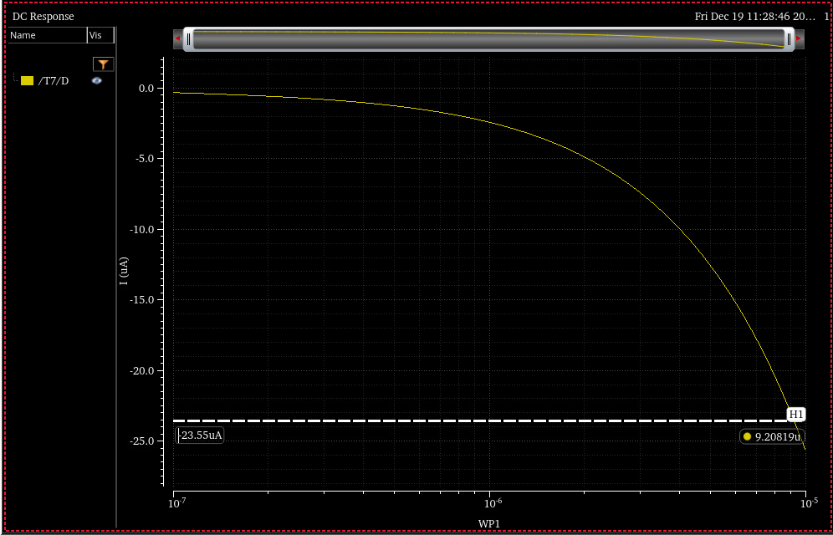
From the figures we set: $W_{P1}=9.2 μm$ and $W_{N1}=1.3 μm$. This gives a current of 23.55 muA at the output stage.
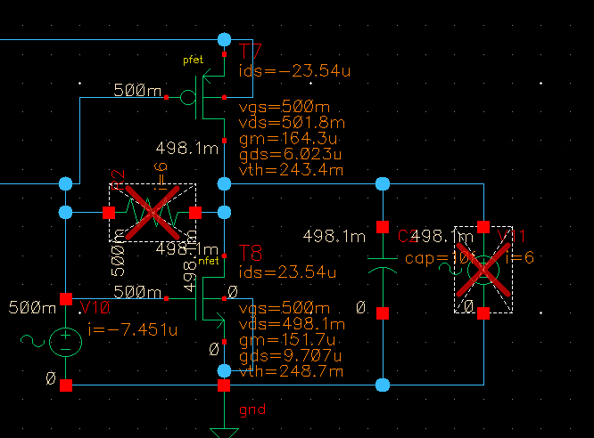
The total
Third Venure:
We think of the output stage and the common source stage as two amplifiers connected one after the other. Without the resistance $R_{B}$ the gain of the second stage would be ${\tilde{g}}_{2}{\tilde{r}}_{02}$ were the tilde symbolizes the overall effect of the NMOS and PMOS connected together.
The feedbacked output stage can be replaced with a input resistor to the ground with resistance $\frac{R_{B}}{{\tilde{g}}_{2}{\tilde{r}}_{02}}$ and an output resistance $R_{B}$ to ground.
If we assume that the total output resistance from the commons source stage is similar to the output resistance of the output stage, and we assume that the input capacitance to the output stage is several dozens of femto farads (which can be designed for), then, the dominant pole will be at:
$$f_{3dB}=\frac{1}{2πC_{in2}{\tilde{r}}_{o1}}$$
The total gain will be at:
$$A_{v}={\tilde{g}}_{m1}{\tilde{r}}_{o1}{\tilde{g}}_{m2}{\tilde{r}}_{o2}$$
The GBW of the system is given by:
$$GBW= \frac{g_{m1}{\tilde{r}}_{o1}{\tilde{g}}_{m2}{\tilde{r}}_{o2}}{2πC_{in2}{\tilde{r}}_{o1}}=\frac{g_{m1}{\tilde{g}}_{m2}{\tilde{r}}_{o2}}{2πC_{in}}$$
Notice that this development doesn’t assume anything about the relationship between $R_{B}$ and ${\tilde{r}}_{oi}$ for $i=1/2$.
Note:
If the achieved input capacitance to the output stage is of the same order or smaller than the output capacitance, then the dominant pole will sit at:
$$f_{3dB}=\frac{1}{2πC_{L}{\tilde{r}}_{o2}}$$
And the GBW will read:
$$GBW= \frac{g_{m1}{\tilde{r}}_{o1}{\tilde{g}}_{m2}{\tilde{r}}_{o2}}{2πC_{L}{\tilde{r}}_{o2}}=\frac{g_{m1}{\tilde{g}}_{m2}{\tilde{r}}_{o1}}{2πC_{L}}$$
This result is less desired as ${\tilde{r}}_{o1}$ depends on $R_{B}$ and ${\tilde{g}}_{m2}r_{o2}$ and will give a complex dependency to design for.
The nice thing about our design, is that the $R_{B}$ resistance can be included at the output simply by noticing that:
$${\tilde{r}}_{o2}=r_{oP}||r_{oN}||R_{B}$$
Another simplification that we can make is to notice that once we use the miller resistance, we have the concatenation of two amplifiers.
We will start by using a high $R_{B}$. In this case, $R_{F}$ will affect little our gain and GBW.
We will choose it $R_{F}=500kΩ$, we will also use $L_{init}=2μm$ for all transistors.
We’ll start from the output stage and aim for a $0.5 VDC$ for maximal swing.
The main consideration for gain split between the output stage and common source stage should be the reduction of resistance $R_{B}$ at the miller equivalent $\frac{R_{B}}{{\tilde{g}}_{s2}}$. This means that we should achieve much of the gain on the common source so the miller resistance isn’t to low.
We can aim for 25 dB on the common source and 0 dB on the output stage. This is a good idea because if achieved, it will result in the miller resistance on the input side to be $R_{G}!$
We will begin by the output stage with the following circuit:
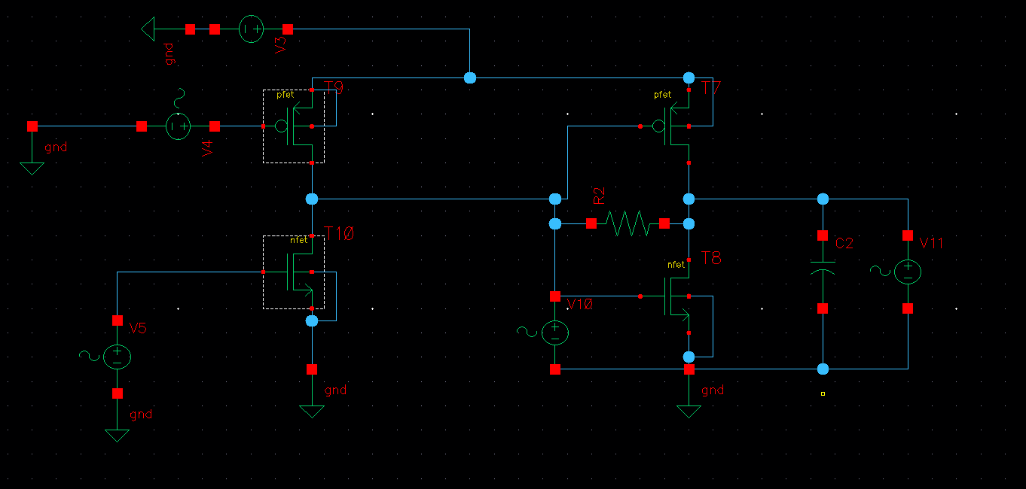
V10 secures a gate voltage of 0.5V, which was set from symmetry considerations (both PMOS and NMOS provide gain on the output stage so there is no reason to favor one over the other). V11 set’s the output voltage on 0.5V and we will aim to set a WN1 and a WP1 that get’s the PMOS and the NMOS to the same current.
The NMOS currents are presented next:
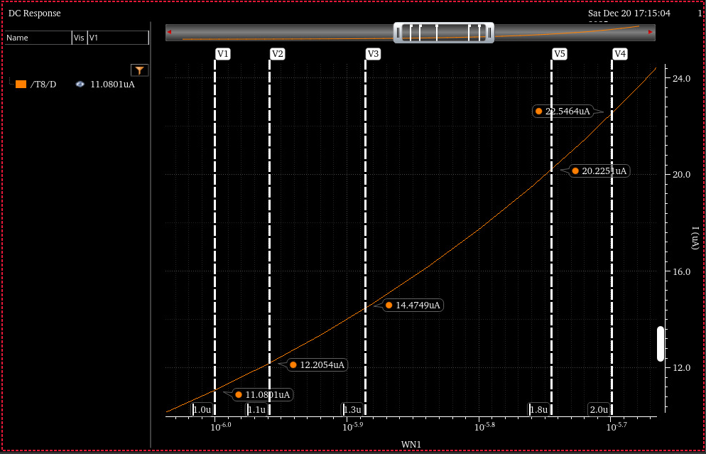
The PMOS currents are presented next:
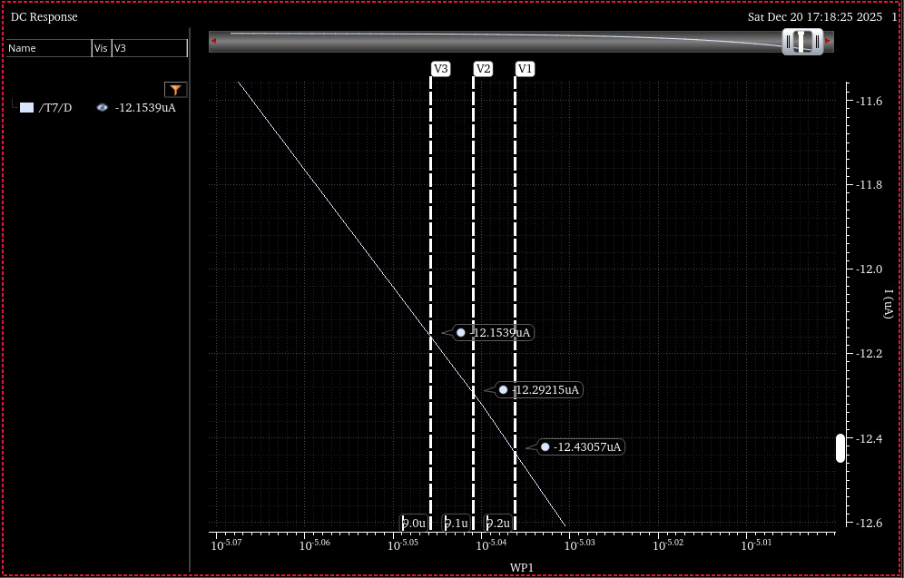
So we choose $WN1=1.1μm$ and $WP1=9.0μm$.
Disabling votlage source V11 we confirm the dc biasing point of the output stage. The output DC point is 493mVDC on this case, which means a current of ~12nA on the resistor, which is negligible w.r.t the 12$μA$ current present on the transistors.

Fourth Venture:
We will assume that the $r_{out}$ of the output stage (M1-M2) combined with the output capacitors form the pole that we are seeking to get.
We get:
$$r_{out}=\frac{1}{f_{3dB}2πC_{L}}=15.9 kΩ$$
The $R_{F}$ capacitance reflects both output and input of the output stage, to the output stage it reflects approximately as $R_{F}$ and to the input it reflects approximately as $\frac{R_{F}}{(g_{m1}+g_{m2})(r_{01}|\left|r_{02}\right)}$.
Using this notation we get:
$$r_{out}=r_{o1}\left|\left|r_{02}\right|\right|R_{F}$$
If $R_{F}$ is big enough, we will get $r_{out}=r_{o1}||r_{o2}$.
The strategy will be as follows:
- Find W and L values so that both transistors are at $V_{out}=0.5V$ with the same current.
- Increase this current (by increasing the transistor widths, therefore more current) up to the point the output resistance is OK.

We will begin by the output stage with the following circuit:
We will start with minimal transistor lengths to support high current with low input capacitance (to be explained later on).
V10 secures a gate voltage of 0.5V, which was set from symmetry considerations (both PMOS and NMOS provide gain on the output stage so there is no reason to favor one over the other). V11 set’s the output voltage on 0.5V and we will aim to set a WN1 and a WP1 that get’s the PMOS and the NMOS to the same current.
The NMOS currents are presented next:
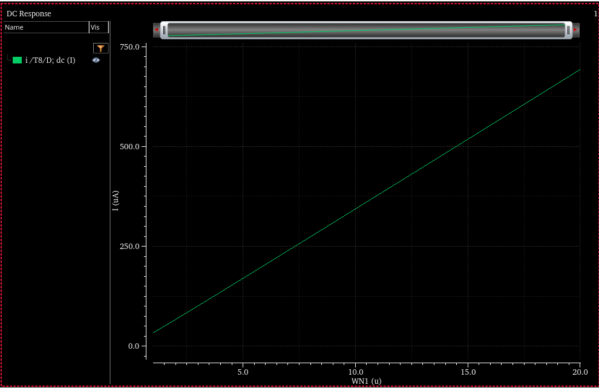
The PMOS currents are presented next:
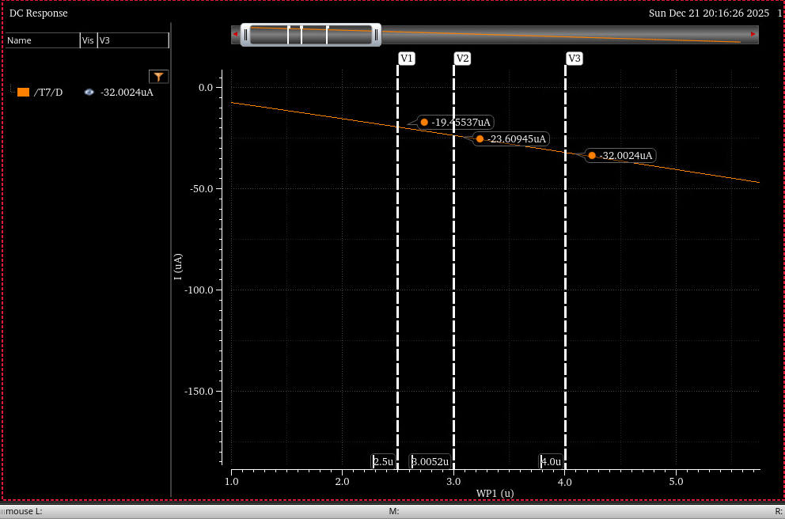
On the same graph:
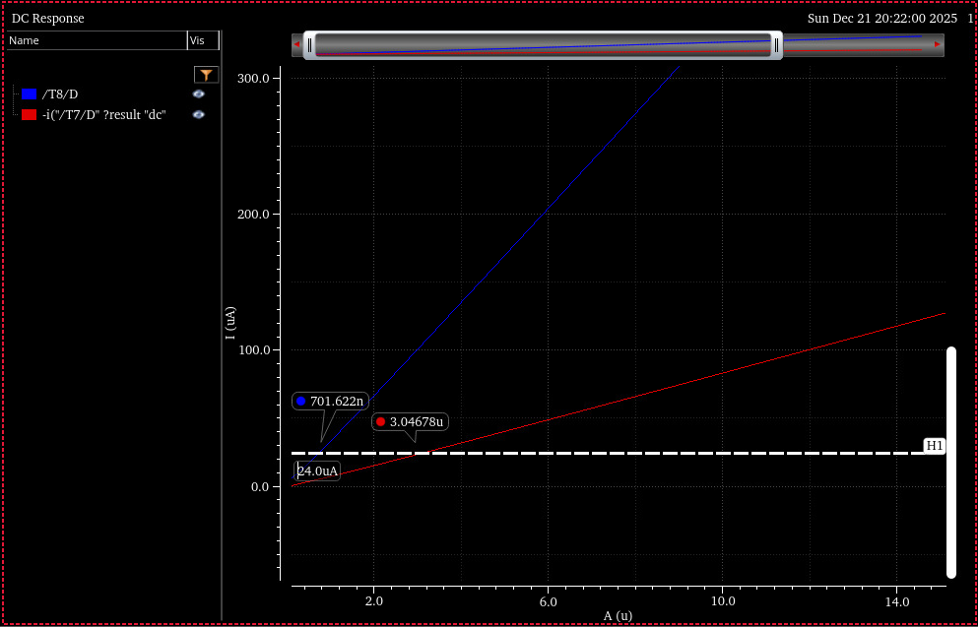
So we choose $WN1=700nm$ and $WP1=3μm$.
After removing the V11 voltage source we found that the voltage achieved was 485mVDV on the output.
We will increase the width of both transistors by a multiplicative factor N1 and find the overall output resistance (without considering $R_{G}$).
The results are shown next:
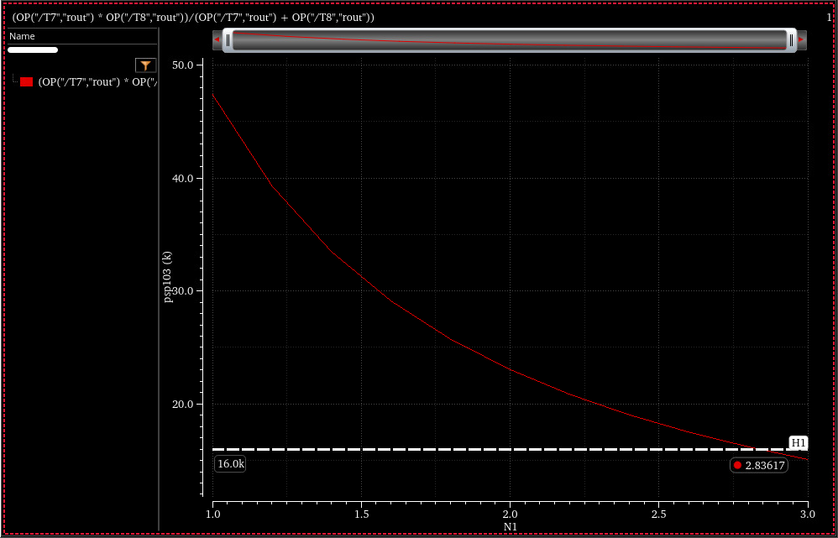
Choosing $N≅2.836$ will give $WN1=2μm$ and $WP1=8.5μm$.
Next we check the AC response of the circuit, and verify that the design works.

