Data Analytics Report

Community Mental Health Signposting Portal (Escale)

Prepared by: Vivian Enenta
Role: Data Analytics Lead
Team: Apex Innovators

Dashboard Link: Community Mental Health Signposting Portal Dashboard https://public.tableau.com/views/CommunityMentalHealthSignpostingPortalDashboard/Dashboard1

Figure 1. Mental Health and Burnout Risk Among Early-Career Professionals
The dashboard provides an overview of burnout risk, stress levels, mental health conditions, workplace stigma, and Employee Assistance Program (EAP) access among early-career professionals. It highlights key patterns that informed the recommendations and proposed portal design.
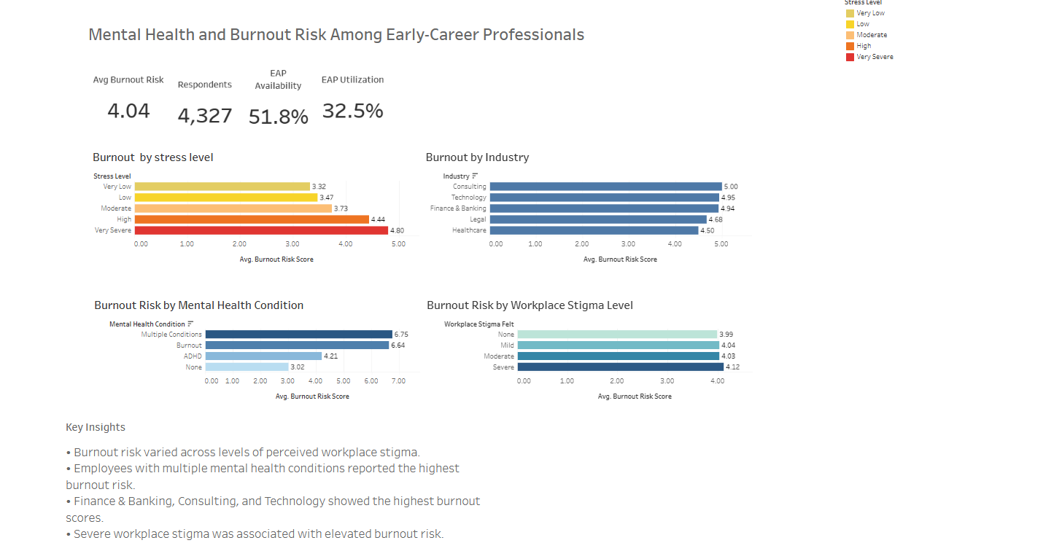
Source: Author's analysis of the Workplace Mental Health Dataset (Kaggle), 2026.

Executive Summary
This analysis examined mental health challenges among 4,327 early-career professionals (0–10 years of experience). Findings revealed high burnout risk associated with increasing stress levels, significant industry differences, a substantial burden of mental health conditions, and low utilization of available support services. These findings informed the design of the Escale Community Mental Health Signposting Portal, a platform intended to improve awareness of, navigation to, and access to mental health resources and peer-support services.

Objectives
The primary goal of this research was to investigate burnout trends, mental health obstacles, and support availability deficits within the early-career workforce to guide the development of the Escale Community Mental Health Signposting Portal.

Dataset Description

Item | Description
Source | Workplace Mental Health Dataset (Kaggle)
Total dataset | 10,000
Target Group | Early-Career professionals
Early-Career Subgroup | 4,327
Definition | 0-10 years of experience
Variables Used | Stress level, Industry, Mental Health condition, EAP Availability, EAP Usage, Burnout Risk.

Methodology
The dataset was cleaned and filtered to isolate early-career professionals (0–10 years of experience). Pivot table analysis was used to examine burnout risk across stress levels, industries, mental health conditions, and access to workplace support services. Visualisations were created to identify key patterns and trends.

Summary Table

Metric | Value
Average Burnout Risk | 4.04
EAP Availability Rate | 51.8%
EAP Utilisation Rate | 32.1%
Total Records Analysed | 4,327

Early-Career Professional Segment (n = 4,327)

Key Findings

Finding 1: Stress and Burnout
Burnout risk increased as stress levels increased. Respondents reporting very severe stress had the highest average burnout risk score (4.80), while those reporting very low stress had the lowest score (3.32). This suggests that stress management should be a key component of mental health interventions for early-career professionals.

Stress level | Average of burnout_risk_score
Very Low | 3.32
Low | 3.47
Moderate | 3.73
High | 4.44
Very Severe | 4.80

Finding 2: Industry sector differences
Burnout risk varied across industries, with Consulting, Technology, and Finance & Banking recording the highest scores. These sectors may benefit from targeted mental health support and resource navigation services.

Industry | Average of burnout_risk_score
Consulting | 5.00
Technology | 4.95
Finance & Banking | 4.94
Legal | 4.68
Healthcare | 4.50

Finding 3: Mental Health Conditions
Respondents experiencing burnout or multiple mental health conditions reported substantially higher burnout risk scores than those reporting no mental health conditions. This highlights the need for timely identification and support. Approximately 72.1% of early-career professionals reported mild, moderate, or severe mental health concerns, indicating a substantial mental health burden within the target population.

Mental Health Conditions | Average of burnout_risk_score
Burnout | 6.71
Multiple Conditions | 6.69
ADHD | 4.12
None | 3.02

Finding 4: Support Access Gap
Only 51.8% of respondents had access to an Employee Assistance Program (EAP), while 48.2% had no access to workplace mental health support services. Although EAPs were available to many respondents, utilization remained low. With only 728 individuals engaging with EAP offerings, the utilization rate stands at 32.5%. This indicates that obstacles such as restricted knowledge, social stigma, lack of confidence, or complexities in finding help may hinder professionals from accessing these supportive resources.

Variables | Values
eap_available | 2,241
eap_not_available | 2,086
eap_users | 728
eap_non-users | 1,513
Utilization rate | 32.5%

Tools Used
- Excel
- Tableau Public
- Kaggle Workplace Mental Health Dataset

Conclusion
The data highlights a significant mental health burden among early-career professionals, characterized by elevated burnout risk, high stress levels, and under-utilization of available support services. These findings provide evidence for the development of the Escale Community Mental Health Signposting Portal, which aims to improve awareness, navigation, and access to mental health resources and peer-support services.

Recommendations
- Encourage early help-seeking behaviors.
- Improve awareness of available support services.
- Develop a Mental Health Signposting Portal.
- Reduce workplace stigma through education and training.
- Target high-risk industries with tailored interventions.

Proposed Solution
The portal was designed to address the gaps identified in this analysis, particularly low utilisation of support services, limited awareness of available resources, and challenges in navigating mental health support options. The proposed Community Mental Health Signposting Portal will:
- Match users to relevant mental health and peer-support services.
- Provide plain-language guidance on available resources.
- Improve awareness and navigation of support options.
- Centralize verified mental health resources in one location.
- Help users identify appropriate support based on their needs.

Limitations
- Secondary data was used for this project
- The dataset may not represent all industry sectors equally.
- Findings indicate associations and do not establish causation.

