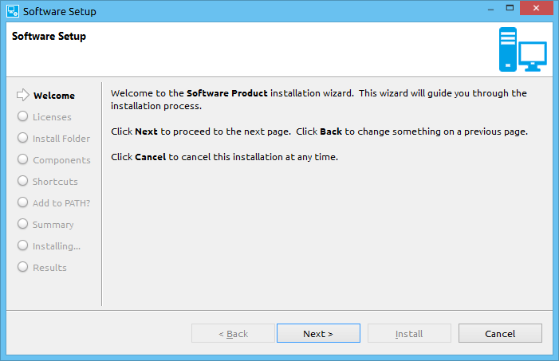

P2 Installer
The P2 Installer is an Eclipse Rich Client Platform (RCP) application that can install products packaged in P2 repositories.

For additional information on P2, see:
- http://www.eclipse.org/equinox/p2/
- https://wiki.eclipse.org/Equinox/p2

The base installer supports:
- GUI, console, and silent operation
- Showing welcome, information, and license pages
- Choosing the install location
- Showing required and optional components for install along with disk usage
- Install P2 units
- Creating product short-cuts (and Windows add/remove)
- Extending the system PATH environment variable
- Installing Windows drivers
- Launching programs/files at the end of installation
- Uninstalling
- Packaging in a self-extracting binary

The installer can be extended with additional wizard pages and install actions.

Requirements
The P2 Installer requires:
- Eclipse SDK 3.8 or greater
- Oracle Java runtime environment (JRE) SE 7 or greater (Other JRE’s are not supported)

Source
The latest source for the P2 installer can be obtained from the GitHub repository, https://github.com/MentorEmbedded/p2-installer. The P2 Installer is composed of one plug-in project, one feature project, and multiple platform specific fragment projects.

com.codesourcery.installer
- P2 Installer plug-in project

feature.com.codesourcery.installer
- P2 Installer feature project

The installer platform specific fragments contain a native utility (INSTMON) that is used by the installer to perform certain operations (like writing to the Windows registry). The instmon C/C++ Development Toolkit (CDT) project can be used to build these binaries. It contains project build configurations for different platforms. Make files in the instmon/src folder can also be used.

Getting Started
In order to start using the P2 Installer, import the source projects into a new Eclipse PDE workspace. Since we need P2 repositories for a product to install, we will create a simple RCP application for this purpose. You will want to use your product’s P2 repositories when creating your own installer.

Select File>New>Project. Choose Plug-in Project. This will open the New Plug-in Project wizard.

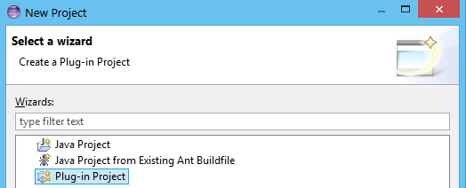

Enter the name, “Example”, for the project name and click Next.

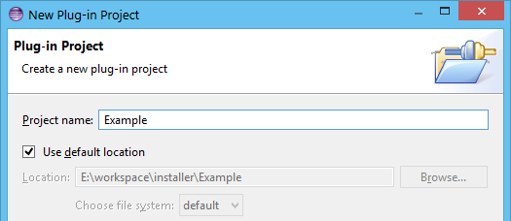

Make sure to select Rich Client Application on the Content page.

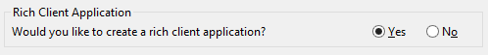

Choose the RCP Mail Template for our application and click Finish.

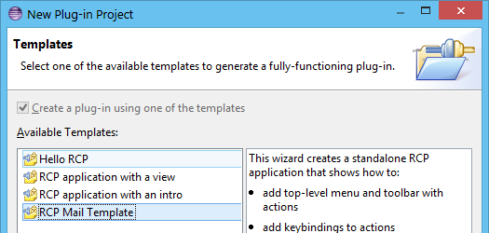

Next, we will want to create a Product Configuration for our application. Right-click on the Example project we just created and select File>New>Other. Choose Plug-in Development>Product Configuration.

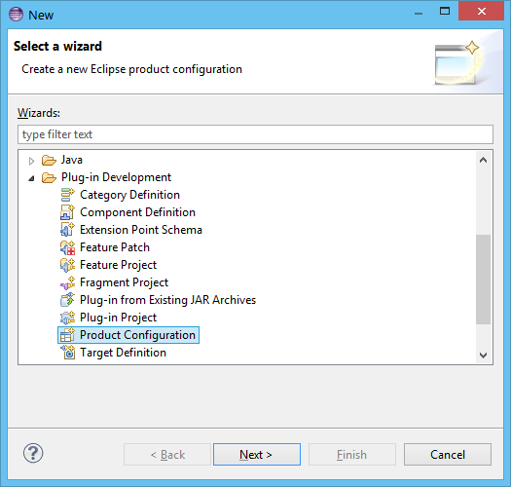

Enter “example.product” for the product filename.

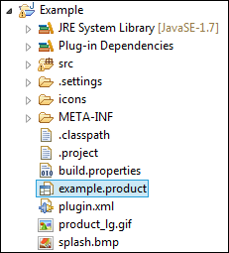

Open the product configuration file, enter “org.eclipse.example” for the ID, and save the file.
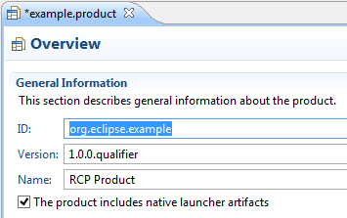

Now that we have created an application project, we will build, export it, and use the P2 repositories to install it. Select File>Export and choose Plug-in Development>Eclipse product.

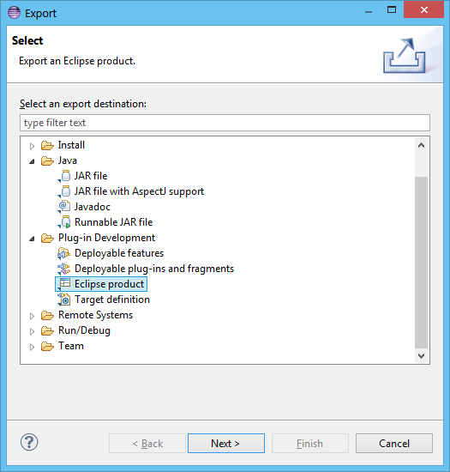
For Configuration, browse to the “example.product” product configuration file we created. Choose to export to a Directory and enter a path. Make sure the Generate metadata repository option is checked.

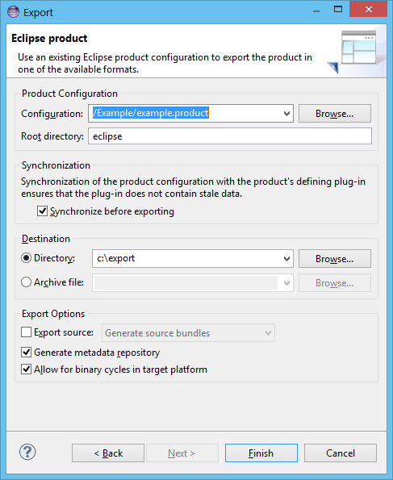

Now we have the P2 repositories for a simple application that we can use to install. Browse to the directory you exported the example product and copy the contents of the “repository” directory into the “repos” folder of the feature.com.codesourcery.installer project.

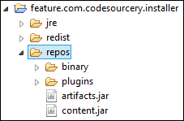

Edit the installer.properties file in the feature.com.codesourcery.installer project. Set the eclipse.p2.requiredRoots property to the identifier we used for our example RCP application.

eclipse.p2.requiredRoots=org.eclipse.example

Optionally, set the eclipse.p2.launch property to run our application after it has been installed.

eclipse.p2.launch=Run Example;eclipse/eclipse{exe};exe;true

Now run the installer using the Installer – GUI launch configuration.

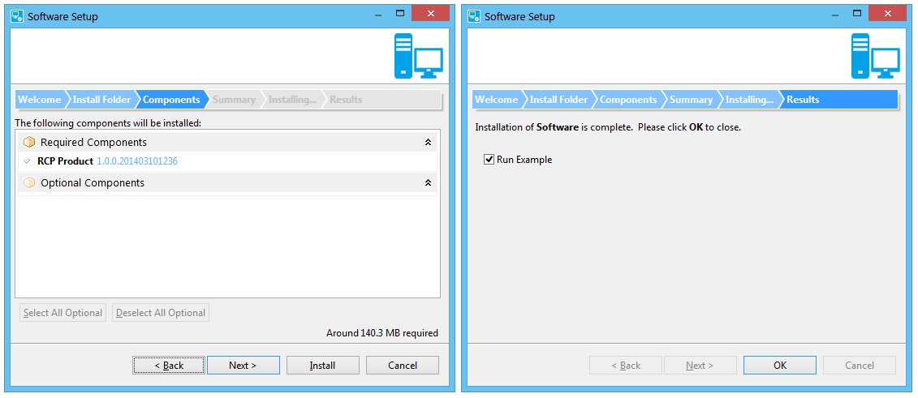

Installer Properties
The P2 Installer is configured using a properties file. This file contains properties that specify what will be installed and the behavior of the installer. Normally, the installer looks for the installer.properties in the same directory as the installer launcher binary. If there is a localized directory (for example, “en_US”), the installer properties will be loaded from that directory. You can also specify a different properties file to load by using the “-install.desc” command line switch.

The values of installer properties can be expressed in terms of other installer property values using the syntax, ${<property name}, where <property name> is the name of the property to substitute. For a complete list of installer properties along with their documentation, refer to the template installer.properties file located in the feature.com.codesourcery.installer project or refer to Appendix 1.

Exporting the P2 Installer
A stand-alone installer can be created by exporting the P2 Installer product. Before exporting, you should set up the feature.com.codesourcery.installer for your product.

- Copy your products’ P2 repositories into the repos folder.
- Edit the installer.properties file for your product installation.
- It is advisable to copy the required JRE into the jre folder. This will ensure that the installer has a JRE to run and will not be dependent on the system JRE.

Select File>Export and choose the Eclipse product wizard. Choose the feature.com.codesourcery.installer/installer.product for the configuration to export.

The normal PDE export will produce a launcher executable to run the installer. This will be setup on Linux. It will be setup.exe and setupc.exe on Windows. On Linux, the setup binary is used to run the GUI, console, and silent installer. On Windows, setup.exe is used to run the GUI installer while setupc.exe is used to run the console and silent installers.

On Windows, the UAC will display a warning for any executable run that has *setup* or *install* in the name if it doesn’t include the proper embedded manifest. It will also attempt to run the executable using administrator privileges. For these reason, special binaries are exported from the feature.com.codesourcery.installer/win32.win32.x86 folder and replace the ones normally generated by the PDE export. These binaries have been embedded with a manifest. The manifest can be found in: feature.com.codesourcery.installer/win32/installer.manifest.

You can use the Windows SDK manifest tool (mt.exe) to embed the manifest into a new executable.

mt.exe -nologo -manifest "installer.manifest" -outputresource:"setup.exe;#1

Refer to the MSDN documentation on mt.exe for more information.

Running the P2 Installer
When running from the Eclipse workbench you can use the included launch configurations to run the P2 Installer.

Installer – GUI
- Runs the installer GUI wizard
Installer – Console
- Runs the installer in console mode
Installer – Silent
- Runs the installer in silent mode
Installer – Uninstall
- Runs the uninstaller. This assumes you have run the installer and have product(s) for uninstallation. The launch will prompt for an install.manifest file for the product to uninstall. This will be in the product installation uninstall directory.

Please note that when running from the Eclipse workbench, not uninstaller will be copied to the product installation uninstall directory.

An exported P2 Installer can be run using the setup executable. By default the GUI installer is run.

Windows
setup.exe

Linux
./setup

To run the console installer, specify the “-nosplash –install.console” command line options.

Windows
setupc.exe –nosplash –install.console

Linux
./setup –nosplash –install.console

To run the silent installer, specify the “-nosplash –install.silent” command line options. Note, the silent installer will use defaults for all options.

Windows
setupc.exe –nosplash –install.silent

Linux
./setup –nosplash –install.silent

The command line options supported by the P2 Installer are:

-help
Prints usage and exits

-install.desc=”URL of installer.properties”
Specifies the path to an install properties file to use.
Example:
-install.desc=”file:/temp/installer.properties”

-install.manifest=”Path to the install manifest file”
This option specifies the path of a product install manifest file to use for uninstallation.
Example:
-install.manifest=”C:\users\user\product\uninstall\install.manifest”

-nosplash –install.console
This option runs the installer in console mode. If large amounts of text are output, like a license agreement, the console will pause after every 25th line. This limit can be changed by passing =<limit> where <limit> is the maximum number of lines to display before pausing.
Example:
-nosplash –install.console=120

-nosplash –install.silent
This option runs the installer in silent mode.

-install.D<property name>=”<property value>”
Sets an installer property value where <property name> is the property to set and <property value> is the value to set. This will replace any property values loaded from the installer properties file.

-install.status=<file path>
This option creates a status file text file. The <file path> will be created after the installer completed and will contain either “OK”, “CANCELED”, OR “FAIL:” followed with an error message.

-install.data=”<directory>”
This option specifies the installer data directory. If <directory> does not exist, it will be created. If this option is not specified, the .p2_installer directory in the users’ home directory will be used.

Product Information
There are several installer properties that set information for the product to be installed.
The unique identifier for the product is specified in the eclipse.p2.productId property. The unique P2 profile to use is specified in the eclipse.p2.profileName property. The version of the product is specified using the eclipse.p2.productVersion property. The installer will not allow a version of a product to be installed into a directory already containing the same version of that product. A name to display for the product can be specified in the eclipse.p2.productName property.

Install Location
The eclipse.p2.rootLocation property can be used to set the default install directory for a product. If this property uses “~”, the location will be based on the user’s operating specific home directory.

eclipse.p2.rootLocation=~/${eclipse.p2.productName}

P2 Repositories
The P2 repositories containing the P2 units to be installed are listed in the eclipse.p2.repos property.

eclipse.p2.repos=file:./repos

By default, this property is set to the /repos folder. This folder is located in the feature.com.codesourcery.installer project and is exported with the installer.

Alternatively, the eclipse.p2.metadata property can be used to specify P2 meta-data repositories and the eclipse.p2.artifacts property can be used to specify the P2 artifact repositories.

The P2 root installable units that will be installed for the product are specified in the eclipse.p2.requiredRoots and eclipse.p2.optionalRoots. Any units specified in the eclipse.p2.optionalRoots property can be selected by the user on the install wizard Components page. Optional roots that should be checked for install by default can be specified in the eclipse.p2.optionalRootsDefault property.

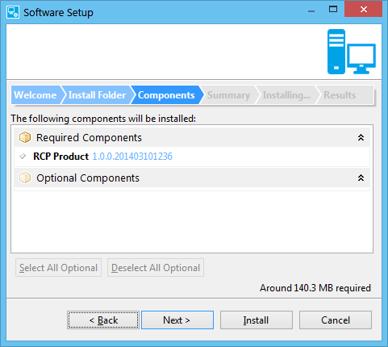

License Information
The P2 Installer wizard can display a page for the user to accept any required license agreements. License information can be included in files by using the eclipse.p2.license property.

eclipse.p2.license=license1.txt:License 1,license2.txt:License 2

The files must be included in the build.properties as root files in order to be available in the exported installer.
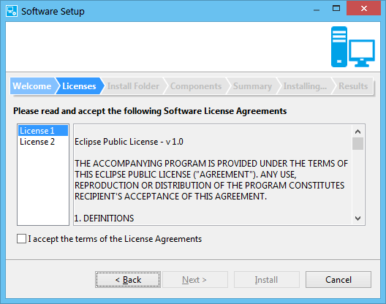

Licenses can also be displayed from the P2 root installable units by setting the eclipse.p2.licenseIU to true.

eclipse.p2.licenseIU=true

Product Shortcuts
The P2 Installer can create shortcuts to launch the product using the eclipse.p2.links property. Shortcuts can be created in the programs area, desktop, or launcher (Ubuntu Unity only) and can include arguments. On Linux, short-cuts are created using symbolic links. All program shortcuts are created relative to the folder specified in the eclipse.p2.linksLocation property. It is usually set to a directory based on the product name. On Windows, this folder will be created in the start menu. On Linux, this folder will be created in the user’s home directory.

eclipse.p2.linksLocation=${eclipse.p2.productName}
eclipse.p2.links=programs;;${eclipse.p2.productName};eclipse/eclipse{exe};;;,
desktop;;${eclipse.p2.productName};eclipse/eclipse{exe};;;

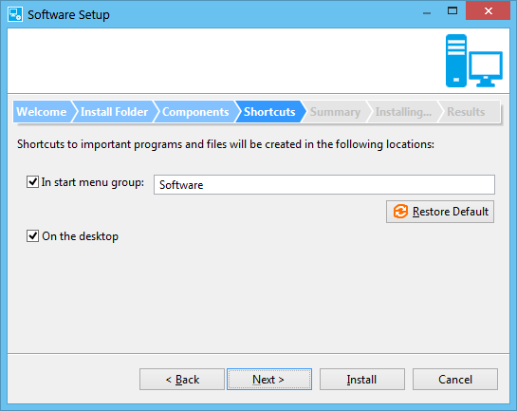

A shortcut can also be created to uninstall the product by pointing to the uninstall/uninstall{exe} target,

eclipse.p2.links=programs;;Uninstall ${eclipse.p2.productName};uninstall/uninstall{exe};;;

Product Launching
The P2 Installer can be set to launch the product at the end of a successful installation by using the eclipse.p2.launch property.

eclipse.p2.launch=Run Example;eclipse/eclipse{exe};exe;true,\
View documentation;docs/doc.pdf;file;false,\
Visit www.eclipse.org;http://www.eclipse.org;html;false

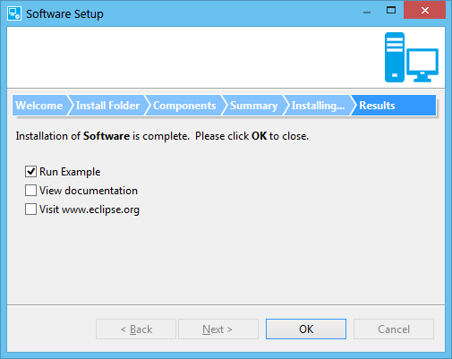

PATH Environment
Some products may require that their binaries be available on the system path. The eclipse.p2.env.paths property can be used to add product directories to the system PATH environment variable.

eclipse.p2.env.paths=bin

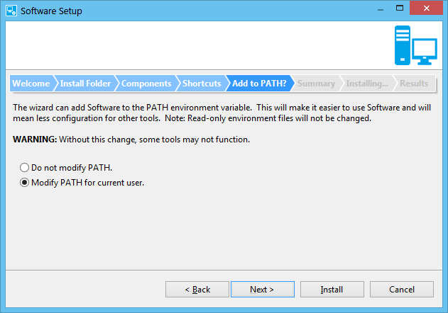

Uninstaller
The P2 Installer creates an uninstall directory after installation and writes a manifest (install.manifest) file in the directory that records information about what was installed. It will also copy the installer binaries to run as the uninstaller. The files copied are specified in the eclipse.p2.uninstallFiles property. Note, these files will only be available in an exported installer so running the uninstall launch configuration from a workbench will not be able to copy the files.

On Windows, the installer will also create information in the Add/Remove Programs.

Add-ons
The eclipse.p2.addons property can be used to specify additional remote P2 repositories containing add-on components for a product. The P2 Installer will query these repositories and include all root installable units found on the Components wizard page as optional.

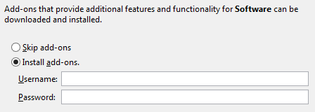

If the add-on sites require a log-in, set the eclipse.p2.requiresLogin property to true. Additional site credential handling can be done using the com.codesourcery.installer.verifiers extension point and IInstallVerifier.verifyCredentials() method. The description for a product’s add-ons can be set using the eclipse.p2.addons.description property.

Creating a Custom Installer
Although the installer can be used by itself, you will probably want to create your own feature and plug-ins in order to add additional install wizard pages and custom install actions.

Create an additional feature and plug-in project for your installer. In the feature project, edit the feature.xml and add the installer com.codesourcery.installer feature.

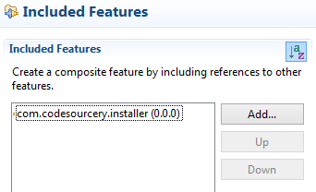

If you will be including any files with the installer like information or license, add these as root files in the build.properties.

root=file:license.txt
root=file:information.txt

Add a project configuration to your feature project (File>New>Other and choose Plug-in Development>Product configuration). This will be used to export your installer application. Edit the product file. Select the Dependencies tab and add your feature along with the com.codesourcery.installer feature. On the Splash tab, select your plug-in for the splash screen or you can use splash screen included with the com.codesourcery.installer plug-in.

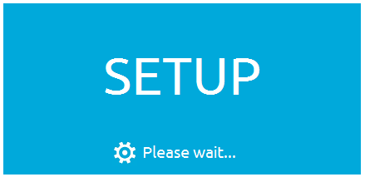

In order to avoid “Bundle … has already been installed” warnings in the Eclipse log file when running, the “org.eclipse.update.reconcile=false” property should be added in the Configuration tab.

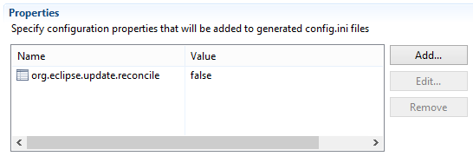

See: http://www.eclipse.org/forums/index.php/t/158631/ for more information.

Branding
Branding for the P2 installer is done using a combination of installer properties and extension points. The title for the installer window can be set using the eclipse.p2.windowTitle property. A message can be displayed in the title area using the eclipse.p2.title property.

eclipse.p2.windowTitle=${eclipse.p2.productName} Setup
eclipse.p2.title=Setup will install software for ${eclipse.p2.productName}.

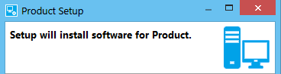

The page navigation bar in the install wizard can be changed using the org.eclipse.p2.wizardNavigation property. The bar can be set to not show (“none”), show at the top (“top”), or show at the left side (“left”).

org.eclipse.p2.wizardNavigation=top

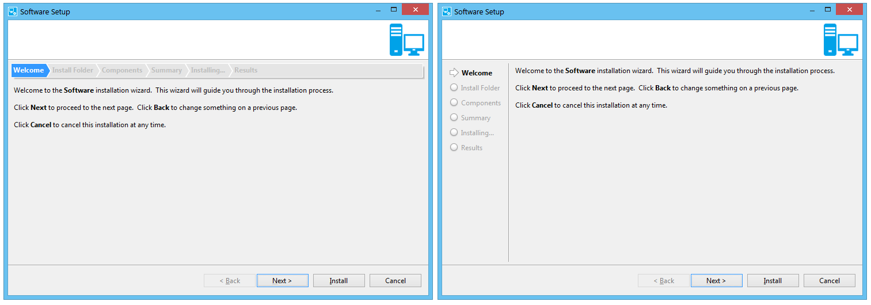

To change the splash screen, you can replace splash.bmp in the com.codesourcery.installer project, but it is recommended that you create your own feature and plug-in projects (see Creating a Custom Installer).

The com.codesourcery.installer.icon extension point can be used to replace the image used in the installer wizard title area. For example, you could replace it with a logo.png image located in your installer plug-in’s icons folder with the following declaration in the plug-in’s plugin.xml,

<extension point="com.codesourcery.installer.icon">
<icon image="icons/logo.png" />
</extension>

Debugging an Exported P2 Installer
If you run the installer from the Eclipse workbench, debugging can be directly. In order to debug an installer that has been exported, do the following:

1. Add the following additional options after the –vmargs option in the setup.ini file located in the installer directory:
-Xdebug
-agentlib:jdwp=transport=dt_socket,server=y,suspend=n,address=8000

2. Create a new Remote Java Application launch configuration. Specify the com.codesourcery.installer project.

3. Run the exported installer and then run the launch configuration to attach and debug.

Extending the P2 Installer
The P2 Installer is composed of modules. These modules provide pages that are displayed in the install wizard along with actions that get performed during installation. The installer includes one module that provides the standard wizard pages and install actions.

A new install module is contributed using the com.codesourcery.installer.modules extension point. The Java class for a module must implement the IInstallModule interface or can extend AbstractInstallModule.

<extension
point="com.codesourcery.installer.modules">
<module
class="org.eclipse.example.InstallModule"
id="org.eclipse.example.InstallModule">
</module>
</extension>

By default, the installer will load all registered modules. You can configure the installer to only use certain modules by listing them in the eclipse.p2.modules installer property.

Install Wizard Pages
An install module contributes wizard pages through the method,

IInstallWizardPage[] getInstallPages()

The wizard pages must extend the InstallWizardPage class. A wizard page is passed an IInstallData to save its data and read data from other pages.

If a wizard page will be included when the installer is run in console mode, it should implement IInstallConsoleProvider. There are two classes that can aid in console presentation. The ConsoleListPrompter class can be used to display a list of items to select. The ConsoleYesNoPrompter can be used to display a standard yes/no prompt.

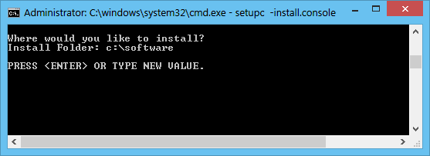

Install Actions
An install module can contribute actions to perform during installation through the method,

IInstallModule.getInstallActions(IProvisioningAgent, IInstallData)

This method is passed an IInstallData that can be used to read data from wizard pages. An action must implement the IInstallAction interface.

An action performs its operation when the IInstallAction.run() method is called. The method is passed an IInstallMode that specifies the installation mode. This can be installing, uninstalling, or upgrading.

The installer calls the IInstallAction.save() method to store the action data in the install manifest. When a product is uninstalled, the installer calls the IInstallAction.load() method to load the action data.

An action can call Installer.getInstallPlatform() to get an IInstallPlatform interface that has methods to perform certain platform specific operations (like writing/reading the Window registry, installing Windows drivers, etc.).

Packaging the P2 Installer (SFX)

After the installer has been exported, it can be packaged into small self-extracting binary, or a single executable file, which the user executes to launch the installer. The self-extracting binary is supported on Linux and Windows hosts. Support for SFX on Mac is not included at this time.

User Host Requirements
Linux
The Linux self-extraction script is based on a concept described in the Linux Journal by Jeff Parent (http://www.linuxjournal.com/node/1005818). The p2 installer SFX script itself can be found in the source:
sfx/scripts/src/linux/p2_sfx.h
This script will extract and launch the installer on any modern Linux distribution which includes standard core utilities such as tar with gzip compression (-z argument), df, readlink (-e argument), awk, tail, and others.

The extraction script has been tested using bash and dash shells.
Windows
The Windows self-extracting program will extract and launch the installer on any recent Windows version such as Windows 7 or 8. The SFX for Windows uses unzip.exe from http://www.info-zip.org/. By default, this is automatically bundled with SFX for Windows with no additional software needed to be installed by the user.
The algorithm used by SFX for Windows is a rather simplistic usage of the incbin assembly directive to link binary blobs to an executable and then extract them on the user's machine. It uses zip and unzip to create and extract the binary blobs. The source code for Windows SFX can be found here:
sfx/src/windows/p2_sfx.*

SFX Command Line Arguments
The following command line arguments are supported by sfx for the user on both Windows and Linux hosts:
- -silent
  - Performs a silent installation
- -console
  - Performs a text console based installation
- -location=[path]
  - Specifies the path for the installation
- -noplash
  - Suppresses the splash screen
- -x [path]
  - Extracts the installer to the path specified but does not start the installer.
All other arguments are passed directly to the installer.
By default, the extractor will extract the installer to the system temporary directory. A different directory can be used by setting its path in the P2_INSTALLER_TEMP_PATH environment variable.
The SFX will put any logs in the user’s home location in a directory named .p2_installer. On Linux SFX typically won't add a log unless the JRE crashes on start up. On Windows however, SFX is a Microsoft GUI application and not a console application. Therefore it is not capable of printing any output (including help) to the command line. This means on Windows, all status and errors are printed directly to the log file which by default is named p2_installer_extraction.log. If the SFX fails on ar Windows machine, check the log file.

Creating the SFX
The creation of the SFX binary for both Linux and Windows must be performed on a Linux host and requires a bash shell. In addition, the creation of the Windows SFX requires the Minimalist GNU tools for Windows to be installed.
The scripts that can be used to build the SFX executable binary can be found here:
sfx/scripts/build

Building SFX
The script that can be used to build the Linux SFX executable is
sfx/scripts/build/build_linux_p2_sfx.sh.
The script that can be used to build the Windows SFX executable is
sfx/scripts/build/build_windows_p2_sfx.sh.
To brand SFX for your product, you can modify these scripts directly or use them as a template. The arguments for the SFX build scripts are as follows:
--installer-dir <directory where the exported installer to be packaged by SFX can be found. This argument is required>
--scratch-dir <directory where temporary objects and files can be written during SFX generation. This argument is optional. The script will use the current directory if not specified>
--output-file <path and file name of generated SFX binary. This argument is required>
--silent <Turn off messages from this script. This argument is optional>
The Linux extraction script (p2_sfx.h) contains the following tags:
#@PREPROCESS@
and
#@POSTPROCESS@.
These tags can be replaced with any script code you deem necessary by writing your own SED scripts.
The windows extraction program behavior and splash screen may be changed by modifying the code in the functions found in build_windows_p2_sfx.sh.

Windows SFX build
The script that can be used to build the Windows SFX executable is sfx/scripts/build/build_windows_p2_sfx.sh. You can modify this file directly or use it as a template. It takes similar input arguments as the build script for Linux SFX, but it also adds the following:
--compiler <path to mingw compiler. Required>
--resource-compiler <path to mingw resource compiler. Required>

SFX JRE Requirement
The SFX for Linux and Windows requires a JRE to be present in the following directory before the installer will successfully launch on the user's computer:
$installer_dir/jre/bin
The easiest way to accomplish this is to add a JRE to the installer exported by eclipse prior to building SFX.

Repositories
SFX requires that all P2 repositories for the product be in zip files. Directory repositories are not supported.

Windows Firewall
On Windows, P2 can sometimes trigger a firewall warning during installation. This is due to the BackupStore class in the org.eclipse.equinox.p2.touchpoint.natives bundle. The genUnique() method uses InetAddress methods to generate a unique string. This can be avoided by patching the org.eclipse.equinox.p2.touchpoint.natives plug-in and changing the genUnique() method to use Java 1.6 UUID. The genUnique() method implementation can be replaced with the following:

private String genUnique() {
long timePart = (System.currentTimeMillis() << 5) | (msCounter++ & 31);
return Long.toHexString( timePart) + "_" + UUID.randomUUID().toString();
}

Signing
You may want to digitally sign all of your installer executables. This can possibly avoid Antivirus software reporting the binaries as suspicious. You can check various Antivirus reports against files using a tool like: https://www.virustotal.com/

Appendix 1: Installer Properties Template
###############################################################################
# Copyright (c) 2014 Mentor Graphics and others.
# All rights reserved. This program and the accompanying materials
# are made available under the terms of the Eclipse Public License v1.0
# which accompanies this distribution, and is available at
# http://www.eclipse.org/legal/epl-v10.html
#
# Contributors:
# Mentor Graphics - initial API and implementation
###############################################################################

###############################################################################
# This file specifies properties used by the installer. The file is first
# searched for in a locale directory in the installer directory. If a locale
# directory is not found, it will be looked for in the installer directory.
# Property values can be expressed in terms of other property values using the
# following syntax:
# ${<property name>}
# where
# <property name> is the name of the other property
###############################################################################

###############################################################################
# P2 Repositories (Required)
# Specify the URL for P2 repositories. Separate multiple repositories with
# a comma.
# By default, the installer expects repositories to be located in the /repos
# folder of the feature.com.codesourcery.installer feature.
#
# To specify an archived repository use the following syntax,
# "jar:file:<full or relative path to archive file>!/"
# For Example:
# jar:file:./repos/repo-file.zip!/
###############################################################################
eclipse.p2.repos=file:./repos

###############################################################################
# P2 Meta-data Repositories (Required)
# Specify the URL for the P2 meta-data repositories. Separate multiple
# repositories with a comma.
###############################################################################
eclipse.p2.metadata=${eclipse.p2.repos}

###############################################################################
# P2 Artifact Repositories (Required)
# Specify the URL for the P2 artifact repositories. Separate multiple
# repositories with a comma.
###############################################################################
eclipse.p2.artifacts=${eclipse.p2.repos}

###############################################################################
# Add-ons (Optional)
# Optional add-ons sites. This property can specify the URL of repositories
# containing add-ons that can be selected to install. Separate multiple
# repositories with comma.
# If this property is specified, the install wizard will display a page that
# gives the user the option to install additional components. If add-ons are
# selected, the installer will query all root installable units from the
# available repositories.
# If this property is specified then the "eclipse.p2.addons.description"
# property must also be specified.
###############################################################################
#eclipse.p2.addons=

###############################################################################
# Add-ons Login (Optional)
# Specify if the add-on sites require a login. This property is only applicable
# if the "eclipse.p2.addons" property is specified. If this property is set to
# "true", the installer will prompt for a log-in user name and password.
###############################################################################
eclipse.p2.addons.requiresLogin=false

###############################################################################
# Add-ons Description (Optional)
# Optional description to display for add-ons.
# This property is only applicable if the "eclipse.p2.addons" property is
# specified.
# Text can be made bold using the <b> tag. For example,
# "This is <b>bold</b> text."
# Text can be made italic using the <i> tag. For example,
# "This is <b>italic</b> text."
###############################################################################
eclipse.p2.addons.description=Add-ons that provide additional features and functionality for <b>${eclipse.p2.productName}</b> can be downloaded and installed.

###############################################################################
# Update Site (Optional)
# Optional update sites for the product.
# Each update site specified will be added and available in the 'Install New
# Software' dialog.
# Separate multiple update sites with a comma. An optional name for the update
# site can be specified using a semicolon.
# <update site 1 URL>;<update site 1 name>,<update site 2 URL>;<update site 2
# name>,...
# Example:
# http://www.mysite1.com;Update Site 1,http://www.mysite2.com;Update Site 2
###############################################################################
#eclipse.p2.update=

###############################################################################
# Installer Title (Optional)
# Optional property to specify the title area text that is displayed for all
# wizard pages in the installer. If this property is not specified, no title
# will be displayed.
###############################################################################
#eclipse.p2.title=Software Setup

###############################################################################
# Window Title (Optional)
# Specify the window title of the installer. If this property is not
# specified, the product name will be used.
###############################################################################
eclipse.p2.windowTitle=${eclipse.p2.productName} Setup

###############################################################################
# Product Information (Optional)
# Optional file containing additional information to display for the product.
# If this property is specified, the installer will display an information page
# with the contents of the file. The path to the file is relative to the
# installer properties file.
# Text in the file can be made bold using the <b> tag. For example,
# "This is <b>bold</b> text."
# Text in the file can be made italic using the <i> tag. For example,
# "This is <b>italic</b> text."
###############################################################################
#eclipse.p2.information=./information.txt

###############################################################################
# Product Install Location (Required)
# Specifies the default root install location. Use '~' to specify a location
# based on the operating system specific home directory.
#
# Note: Do not use this property in the values for other properties as it can
# be changed by the user during installation.
###############################################################################
eclipse.p2.rootLocation=~/${eclipse.p2.productName}

###############################################################################
# P2 Install Location (Required)
# Specifies the location for the P2 (i.e. Eclipse) installation directory
# relative to the product location (eclipse.p2.rootLocation).
###############################################################################
eclipse.p2.installLocation=eclipse

###############################################################################
# Uninstaller (Optional)
# This property specifies the installer files/directories to copy into the
# /uninstall directory. If this property is not specified, the uninstaller
# will not be copied to the product installation directory. Also, no
# add/remove entry will be created on Windows host.
#
# If the file is an executable binary, append {exe} that will be replaced with
# ".exe" on Windows and nothing on Linux.
###############################################################################
eclipse.p2.uninstallFiles=setup{exe}:uninstall{exe},setup.ini:uninstall.ini,configuration,features,jre,mon,plugins,.eclipseproduct

###############################################################################
# P2 Flavor (Required)
# As part of a product build, PDE/Build automatically generates default
# configuration meta-data to set start levels and config.ini property. This
# meta-data is commonly referred to as Configuration Units (CUs). In
# particular, start levels are set using CU fragments on the IU for the bundle
# being started. The flavor is used as a qualifier when generating the CU's
# name based on the IU. For example, with "p2.flavor = tooling",
# 'toolingwin32.win32.x86org.eclipse.core.runtime' will be the name of the CU
# that configures the org.eclipse.core.runtime bundle on windows. It may be a
# good idea to use a flavor based on your product id to avoid conflicts with
# other meta-data, particularly if your product has particular needs with
# respect to start levels.
###############################################################################
eclipse.p2.flavor=tooling

###############################################################################
# Product Identifier (Required)
# Specifies a unique identifier for the product
###############################################################################
eclipse.p2.productId=${eclipse.p2.productName}

###############################################################################
# Product Name (Required)
# Specifies a name for the product.
###############################################################################
eclipse.p2.productName=Software

###############################################################################
# Product Vendor Name (Optional)
# Specifies the vendor name for the product. This will appear in the
# add/remove entry on Windows host.
###############################################################################
#eclipse.p2.productVendor=Eclipse.org

###############################################################################
# Product Version (Required)
# Specifies the version of the product
###############################################################################
eclipse.p2.productVersion=1.0.0

###############################################################################
# Product Help URL (Optional)
# Specifies the URL for product help. This will appear in the add/remove
# entry on Window host.
###############################################################################
#eclipse.p2.productHelp=http://eclipse.org/

###############################################################################
# P2 Profile (Required)
# Specifies the P2 Profile to use for installation.
###############################################################################
eclipse.p2.profileName=SGXXProfile

###############################################################################
# Remove Profile IUs (Optional)
# This property specifies if all installable units included in the profile
# should be removed when the product is uninstalled or upgraded. This will
# include any installable units that are installed into the profile after the
# initial installation (add-ons).
# If this property is set to "true" all IUs in the profile will be removed.
# If this property is set to "false" only the root IUs recorded during
# installation will be removed.
###############################################################################
eclipse.p2.removeProfile=true

###############################################################################
# Launch (Optional)
# Specifies items to launch after installation is complete. If this property
# is specified, the installer will display a page to choose items to launch
# after installation.
# Separate multiple items with a comma.
# The format for an item is:
# <name>;<path>;<type>;<default>
# where
# <name> is the name to display
# <path> is the path to the file that should be launched. This path can be
# a file relative to the product installation director
# (eclipse.p2.rootLocation), or an HTML address.
# If the item is an executable binary, append {exe} that will be replaced
# with ".exe" on Windows and nothing on Linux.
# <type> is
# exe - Executable to run
# file - File to open
# html - Web page to open in the browser
# <default> is "true" to perform or "false" to not perform by default.
#
# Example:
# Visit Eclipse.org?;http://www.eclipse.org/;html;true
#
###############################################################################
#eclipse.p2.launch=

###############################################################################
# Short-cuts (Optional)
# Specifies short-cuts/links to create.
# If this property is specified, the installer will display a page to choose
# short-cuts.
#
# Separate multiple short-cuts with a comma.
# The format for links is:
# <folder>;<link path>;<link name>;<link target>;<icon path>;<arguments>
# where,
# <folder> is
# programs - Programs folder. This folder is relative to the
# eclipse.p2.linksLocation folder.
# desktop - The desktop folder
# launcher - The Unity launcher panel (Ubuntu Linux only)
# <link path> - The folder/directory to create the short-cut in. This path
# is relative to the <folder> location and can be omitted.
# <link name> - The name for the short-cut.
# <link target> - The path to the target file for the short-cut relative
# to the root install location. If the link target is an executable
# binary,
# append {exe} that will be replaced with ".exe" on Windows and nothing on
# Linux.
# <icon path> - The path to the icon that will be used to display the link.
# <arguments> - A comma-separated list of command-line arguments that will
# be passed to the executable when the link is activated.
#
# Example:
# programs;Mentor Graphics/CodeBench#CodeBench;bin/eclipse{exe};;;
# desktop;;CodeBench;bin/eclipse{exe};bin/icon.png;;
#
# Created Short-cut directories will be removed on uninstallation if they are
# empty.
###############################################################################
#eclipse.p2.links=

###############################################################################
# Short-cuts Location (Optional)
# Specifies the folder program short-cuts/links. The folder is relative to
# the user's home directory on Linux and Start Menu on Windows.
# This property is required if the "eclipse.p2.links" property is set.
###############################################################################
#eclipse.p2.linksLocation=${eclipse.p2.productName}

###############################################################################
# Short-cut Defaults (Optional)
# Specifies the short-cuts that will be selected by default. Separate
# short-cut folders to be selected by a comma.
# If this property is not specified, all short-cuts will be created by
# default.
# This property is only applicable if the "eclipse.p2.links" property is set.
#
# Example:
# eclipse.p2.links=desktop,programs
###############################################################################
#eclipse.p2.linksDefault=desktop,programs,launcher

###############################################################################
# PATH (Optional)
# Specifies paths to append to the system PATH environment variable. The
# paths are relative to the product installation directory
# (eclipse.p2.rootLocation). Separate multiple paths with a comma.
# If this property is specified, the install wizard will display a page to
# choose if the path should be modified.
#
# Example:
# eclipse.p2.env.paths=bin
###############################################################################
#eclipse.p2.env.paths=

###############################################################################
# Required Root Installable Units (Required)
# Specifies the identifiers of the root installable units (IU) that will be
# installed. IU's that are specified will be listed on the Components page of
# the install wizard under the "Required" section.
# Any IU's listed must be present in the P2 repositories specified in the
# "eclipse.p2.repos" property.
# Separate multiple IU's with a comma.
#
# Example:
# eclipse.p2.requiredRoot=org.eclipse.example,org.eclipse.extras
###############################################################################
eclipse.p2.requiredRoots=

###############################################################################
# Optional Root Installable Units (Optional)
# Specifies the identifiers of the root installable units (IU) that can be
# optionally installed. IU's that are specified will be listed on the
# Components page of the install wizard under the "Optional" section and can
# be selected for install.
# Any IU's listed must be present in the P2 repositories specified in the
# "eclipse.p2.repos" property.
# Separate multiple IU's with a comma.
###############################################################################
#eclipse.p2.optionalRoots=

###############################################################################
# Default Optional Root Installable Units (Optional)
# Specifies the optional root installable units that should be selected by
# default. Any IU's listed will initially be checked on the install wizard
# Components page.
# Separate multiple IU's with a comma.
# Note: Any IU's found in an existing installation that is being upgraded,
# will be selected for install automatically regardless if they are not listed
# in this property.
###############################################################################
#eclipse.p2.optionalRootsDefault=

###############################################################################
# Component Sorting (Optional)
# The following optional properties can be specified to sort components by
# name on the install wizard components page. By default components will
# appear in the order that they are listed in the "eclipse.p2.roots" property.
###############################################################################
eclipse.p2.sortRoots=false
eclipse.p2.sortOptionalRoots=true

###############################################################################
# License Agreement (Optional)
# Specifies files containing license agreements for the product. If this
# property is specified, the installer will display a page for the user to
# accept the license agreements.
# Multiple files should be separated with a comma. An optional name to
# display for the license agreement can be entered separated with a ':'.
# The format is:
# <path to license file 1>:<optional name>,
# <path to license file 2>:<optional name>,
# ...
# <path to license file 3>:<optional name>
#
# Example:
# eclipse.p2.license=./license.txt
# eclipse.p2.license=./license1.txt, ./license2.txt
# eclipse.p2.license=./license1.txt:License Agreement A,\
# ./license2.txt:License Agreement B
#
# The file paths are relative to the installer.properties file.
# If no name is provided for the license agreements, the licenses will be
# named "License Agreement 1", "License Agreement 2", etc.
#
# To include a license file, place it in the
# feature.com.codesourcery.installer project and modify the build.properties
# to include it as an exported root file.
# For example, if the license file is license.txt, the following would need
# to be added in the build.properties,
# root=file:installer.properties
# The property would be set to:
# eclipse.p2.license=./license.txt
###############################################################################
#eclipse.p2.license=

###############################################################################
# License IUs (Optional)
# Specifies if license information from selected component IU's should be
# displayed on the license page. If this property is set to "true", license
# information found in the IU's will be displayed.
###############################################################################
#eclipse.p2.licenseIU=true

###############################################################################
# Wizard Navigation (Optional)
# Specifies the type of wizard page navigation bar. This property can be one
# of the following values:
# none - Don't show a page navigation bar
# top - Show a page navigation bar at the top of the wizard
# left - Show a page navigation bar on the left of the wizard
###############################################################################
org.eclipse.p2.wizardNavigation=top

###############################################################################
# Page Order (Optional)
# Specifies the order that install wizard pages should be displayed. Separate
# page names with a comma. The pages will be displayed in the order that they
# are listed in this property. Any page not listed will be displayed after the
# pages specified. Any page listed that does not exist will be skipped.
# The names of common pages are:
# welcomePage, licensePage, informationPage, installFolderPage,
# componentsPage, shortcutsPage, and pathsPage.
# Note: Some wizards pages are designed to be shown after certain other pages.
###############################################################################
#eclipse.p2.wizardPages=

###############################################################################
# P2 Progress Filter (Optional)
# Specifies a set of regular expressions to filter the progress messages
# reported from P2 during installation. Multiple properties can be specified
# and the first match will be applied.
#
# The format of the property names is:
# eclipse.p2.progressFind0
# eclipse.p2.progressFind1
# ...
# eclipse.p2.progressFindn
#
# For each eclipse.p2.progressFind property, there should be a corresponding
# eclipse.p2.progressReplace property that specifies the expression used to
# replace the progress message. The eclipse.p2.progressFind expressions can
# contain groups that are referenced by the eclipse.p2.progressReplace
# expressions.
#
# Example:
# eclipse.p2.progressFind0=\
# (.*) (([_A-Za-z0-9-]+)\\.([_A-Za-z0-9-]+)\\.([._A-Za-z0-9-]+))(.*)
###############################################################################
eclipse.p2.progressFind0=(.*) (([_A-Za-z0-9-]+)\\.([_A-Za-z0-9-]+)\\.([._A-Za-z0-9-]+).jar)(.*)
eclipse.p2.progressFind1=(.*) (([_A-Za-z0-9-]+)\\.([_A-Za-z0-9-]+)\\.([._A-Za-z0-9-]+))(.*)

###############################################################################
# P2 Progress Filter Replacement (Optional)
# Specifies a set of regular expressions to replace the progress messages
# from P2.
#
# The format of the property names is:
# eclipse.p2.progressReplace0
# eclipse.p2.progressReplace1
# ...
# eclipse.p2.progressReplacen
#
# For each "eclipse.p2.progressFind" property, there should be a corresponding
# "eclipse.p2.progressReplace" property that specifies the expression used to
# replace the progress message. The "eclipse.p2.progressFind" expressions can
# contain groups that are referenced by the eclipse.p2.progressReplace
# expressions.
#
# Example:
# eclipse.p2.progressReplace0=Installing $2
###############################################################################
eclipse.p2.progressReplace0=Reading $2
eclipse.p2.progressReplace1=Installing $2

###############################################################################
# P2 Properties (Optional)
# Specifies additional properties used by P2.
# The property, "org.eclipse.update.install.features", set to "true" will
# cause the P2 update manager features to be installed.
###############################################################################
org.eclipse.update.install.features=true

###############################################################################
# Installer Modules (Optional)
# The installer can be extended with modules that implement the
# com.codesourcery.installer.IInstallModule interface or extend the
# com.codesourcery.installer.AbstractInstallModule class. Modules can
# contribute additional install wizard pages and install actions.
# Installer modules are registered using the
# "com.codesourcery.installer.modules" extension point. The installer
# includes one module, "com.codesourcery.installer", that contributes the
# common wizard pages and install actions.
# By default, all registered modules are loaded. This property can be used
# to only include certain modules. The identifiers for modules that should
# be loaded should be separated with a comma.
###############################################################################
#eclipse.p2.modules=com.codesourcery.installer.generalModule

