**CS002.2 Introduction to Computer Applications**

**Group Project**



|  |  |
| --- | --- |
| **Name** | **Index number** |
| R.B.W. Karunarathne | 18894 |
| S.M.D. Nawarathna | 18950 |
| C.G.K. haputhanthri | 18525 |
| N.N.D.G. Liyanage | 18419 |
| B.P.P. Silva | 18409 |

**Specification Report**

# Introduction ,

Software development is the process of conceiving , specifying, documenting , designing , programming , testing , and bug fixing involved in creating and maintaining applications , frameworks , or other softwares components.

The spata is a software development company with a mission that includes using technology for improve Video games , sports and many industries in Sri Lanka.

This year we plan to recruit new 50 employees for our developing team.

Software development may include research, new development, prototyping, modification, reuse, re-engineering, maintenance, or any other activities that result in software products.

There for we want purchase 50 laptops firstly.

It will help to build infrastructure Of the IT department.

The purpose of this report is find and select best laptop brand for purchase.

# Summery ,

And as we discussed there are broadly three types of software i.e. system software, application software, and programming language software. Each type of software has its function and runs on the computer system, Spata main aims to increase our Software development process by purchasing best performances laptops

Behavioral of performance properties that the laptop must have, Usability, Reliability, Accuracy, Maintainability, Portability, Cost.

Computers with low performance is reason to big time waste in a programming.

This report can be provides about the reliable laptop brand with good performance and determining whether to proceed with the project.

**Compare and recommendation**

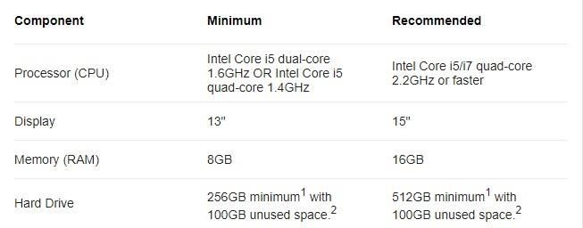

# Laptop buying guide

* Reason for purchasing new laptops.
* Specifications of the laptops.
* Price range and comparison.
* Conclusion.

# Reason for purchasing new laptops

• Company decided to buy new laptops for software development team.

# Specifications of the laptops

* Processor: intel i7 10th generation.
* Memory: 16GB DDR4.
* Graphics Card: Nvidia GeForce GTX 1650 4GB GDDR6.
* Hard drive: 512GB M.2 NVMe SSD.
* Display: 1920x 1080p FHD (minimum requirement).
* Operating System: Windows 10 Home 64bit version.
* Warranty: 1year minimum.

Above details are main things that we are considering before our purchase. There are few more things to consider. Let’s discuss these things in comparison part.

# Price range and comparison

* Our targeted price range is $1600 to $2000(295,504 LKR to 369,380 LKR).
* We are decided to looking into different brands of laptop manufactures web sites.
  + Dell
  + HP
  + ASUS
* Main reason for choosing these brands.

Build quality.



Easy access in our country retail shops

Good service center facilities

* **Comparison:**

○ Dell XPS 15 2020 edition **:-**

|  |  |
| --- | --- |
| Processor | Intel Core i7-10750H 2.6 GHz Six-core Processer (turbo up to  5.0 GHz) |
| RAM | 16GB DDR4 RAM |
| Storage | 512GB SSD |
| Graphics | Nvidia GeForce GTX 1650 Ti 4GB DDR6 Graphics |
| Display | 15.6-inch Full HD+ (InfinityEdge) Anti-Glare Display (1920 x  1200) with 500-nits brightness |
| Operating System | Windows 10 Home |
| Battery Life | Up to 10 hours |
| Weight | 4.0 lbs |
| Price | $1,763.99 ( 325,608.47 LKR) |

# Conclusion

Our Lastyly analysis its clear company need best performences laptop with productivity with higher efficiency more durability because company going to do long term investment, Finally, we decide to buy DELL brand.

Our selection series has best software development performence and with productivity with higher efficiency. then we also talk with local dealers of DELL laptop brand It will help us to know about after sale services and repairs.

THANK YOU.

*********