**Welcome to SCPM!**

SCPM is an Automated Cryptonight Profit Manager for the average Joe. Easy to setup, extremely powerful with granular configurations for each coin, algo, and worker. An automated front-end for XMR-Stak, compatible with CPU, AMD, and Nvidia mining -- all in 1 package!

* Build-in automatic upgrading
* Works in 2 modes; profit manager, and static coin mining.
* Automatically imports your settings in to the newest verison. Upgrade while you sleep, and never miss a hash!
* Backs up your previous version for you, when you allow automatic upgrades
* Logging system
* Works with CPU, AMD, and Nvidia
* Run it from a shared local network location and manage all config's from 1 spot.

**** We support all coins listed on: <https://minecryptonight.net/> ****

Free to use, donations kindly accepted.

ETH Address: 0xA58B04A5Dc2F3934cB54E087b927268836Ac0159 BTC Address: 3Pz3JPxGsQxsyJT7km58NTohC9C16ndpAN

*** See Release section for the latest release. ***

[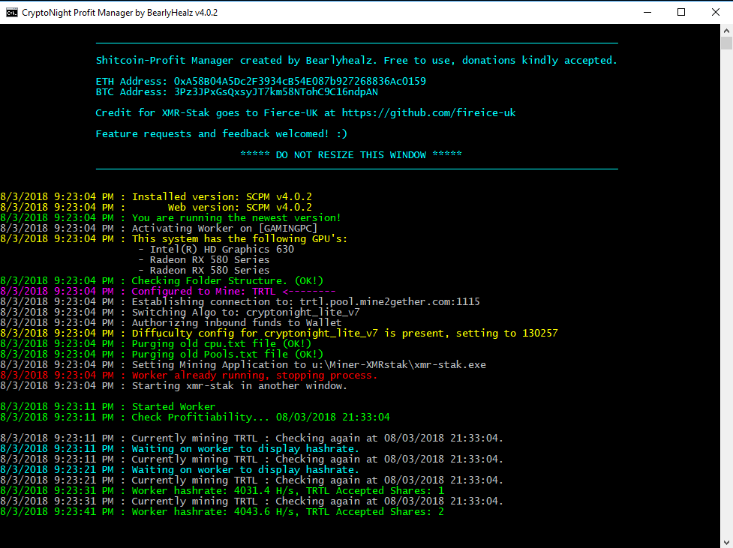](https://postimg.cc/image/fite8ii8n/)

**How do I get this installed?**

1. Download the zip file and extract it somewhere.
2. Create a location (local or via network share for multiple machines)
3. In **settings.conf** change the path to match the location of the folder. I prefer a mapped drive, since all my workers can share the same folder structure. Only 1 place to make changes, or updates.

"path":"u:", <---- You can change this to whatever "c:\blah". Make sure you use 2x "" in your path. Leave off the training slash. ***A full example would be "C:\SCPM\my_directory"***

1. Configure profit more or static mode by changing the following:

"static_mode" : "no", <----- yes = mines whatever your default coin is, forever. No = profit miner mode.

1. List out the coins you want to mine in coin_settings.conf:

"my_coins":[  
"ETNX", "ETNC", "XTL", "XMR", "TRTL", "GRFT", "ITNS", "TUBE", "LOKI", "ETN", "XMV", "MSR", "XHV", "AEON", "XRN" ],

****take note that the last entry does not end with a comma ",".

1. Set your default coin. This is in the event the best coin to mine is not in your list.

"default_coin":"ETNC", <----- this is also the coin which is used for static mode.

1. Change the wallet addresses from MINE to YOURS. Otherwise, you'll be mining for me.

{"symbol":"ETNC", "software":"xmr-stak", "static_param":"2", "algo":"cryptonight_v7", "pool":"classic.etnminers.com:7779", "wallet":"etncwyLYagfDCeLqT4v1bV8vGCUttpsarXrcaujsh87hffNzvNhcn9eEDG2BJNHe6w4YqVvk7b8biUc8H9fHUE6BYZRcazra7DX", "amd_config_file":"amd_MSR.txt" },

1. You may add or remove coins from coin_settings.conf. These are intended to be examples -- and also the coins I like to mine.
2. Download XMR-Stak from: <https://github.com/fireice-uk/xmr-stak/releases>

**IMPORTANT!**

You need to download XMR-STAK, and copy the files to Miner-XMRstak Folder (See Below), otherwise the software will not work!

[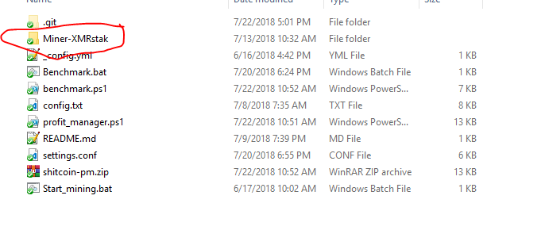](https://user-images.githubusercontent.com/8581255/43092401-b5a02706-8e72-11e8-84fe-7bb1a120ef82.png)

The files should look like this:

[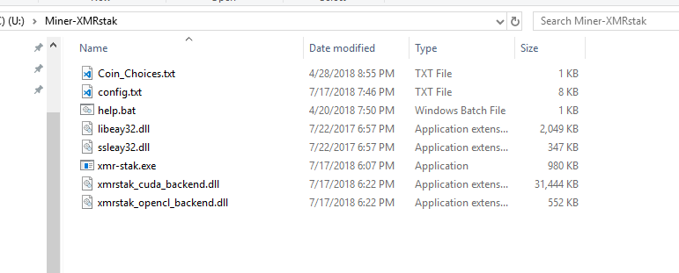](https://user-images.githubusercontent.com/8581255/43092406-b88b38b6-8e72-11e8-9f34-7aa98d4fb387.png)

1. When setting the diff config params in settings.conf, it's important to pay attention to the static param value.

"static_param":"1",

If the fixed diff join character isn't the same as the pool expects, you can get an error, or the pool will ignore your value.

Here is a legend:

1 = "wallet+$set_diff_value" 2 = "wallet.$set_diff_value" 3 = "wallet.$pc+$set_diff_value" 4 = ".$pc" 5 = No fixed diff config setting used.

$set_diff_value is obtained by either manually creating the file, or running benchmark.bat $pc is the name of your computer - this is pulled in through my software.

1. Run the benchmarking tool on all workers by double clicking on benchmark.bat

[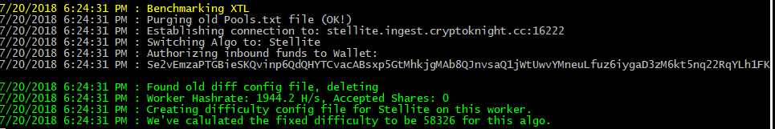](https://user-images.githubusercontent.com/8581255/43092463-eaffdc70-8e72-11e8-888c-356cfeefd8d6.png)

1. Once complete, you'll see a bunch of conf files. You can make further adjustments, if you so choose.

[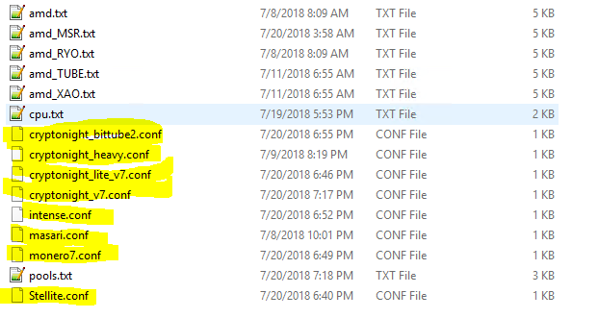](https://user-images.githubusercontent.com/8581255/43092503-063eb664-8e73-11e8-8244-d6d3c20926ee.png)

1. After you have benchmarked your worker, you may now click on start_mining.bat

**How does the update process work?**

1. Each time the worker reloads (or when you 1st start the worker), the software will check for an update. If you've enabled automatic updates, the new files will be downloaded.
2. The 1st file to download is profit_manager.ps1 - which is the main file. After this file is downloaded, the worker will restart and then download the rest. I do this because there may be instructions that the old file does not have, which allows your worker to update without you having to deal with errors, or copying configs.

[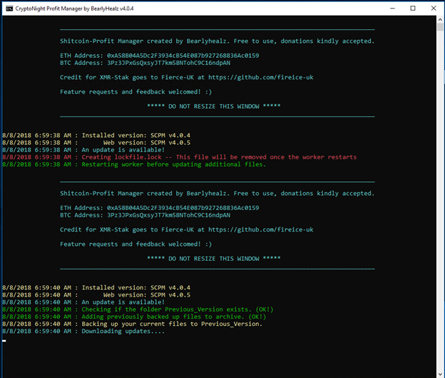](https://postimg.cc/image/lculnpslz/)

1. When the worker restarts, the rest of the files are downloaded and your settings are imported. Afterwhich, the worker does 1 final restart.

[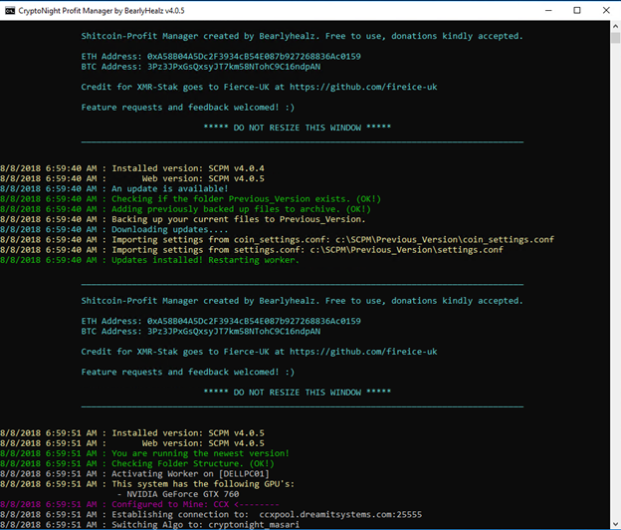](https://postimg.cc/image/g1fp32yuf/)

1. Provided everything went smoothly, your worker should automatically start mining again.

Enjoy!