CampusConnect: Campus Ride Coordination and Student Safety
NPRT630 / Diploma in ICT / Group Assignment 2026
Final report consolidating problem definition, system analysis, interface and database design, implementation and evaluation. Prepared against the eight-page assignment brief dated 13 February 2026; its due date is TBA. Report preparation date: 5 October 2026.
Submission status: evidence-based draft. The project owner must supply the group number, team leader, all 4–6 full names and student numbers, contribution records, confirmed forked repository URL, human-testing results and final presenter recording. No invented participants or performance measurements appear in this report.
Academic authorship: the group must review and understand the code, diagrams and analysis, cite external material, and follow the institution’s rules on assisted writing. This document is not an attestation of independent authorship.
Member | Full name | Student number / contribution
Team leader | PENDING | PENDING
Member 2 | PENDING | PENDING
Member 3 | PENDING | PENDING
Member 4 | PENDING | PENDING
Member 5, if applicable | PENDING | PENDING
Member 6, if applicable | PENDING | PENDING

Executive overview and report guide
CampusConnect coordinates campus rides for riders, drivers, administrators and security staff. A React Native/Expo client communicates with a Spring Boot REST backend and MySQL. The project brings booking, scheduling, driver decisions, trip status, messages, history, ratings and safety alerts into a single role-based workflow.
The implementation demonstrates a broad student-project feature set. Recent owner feedback led to responsive page frames, one persistent rider navigation bar, clearer back controls and scrollable dialogs. Mocked browser checks validate navigation and selected actions without charging a card or dispatching a real security unit. Nine isolated backend unit tests and a fresh TypeScript check passed on 5 October 2026.
This is not a production assurance report. Biometric matching is not implemented by the inspected face endpoints; payment records do not settle funds; live integration and multi-user usability measurements remain outstanding. Schema drift and privileged account provisioning also need attention.
Coverage | Pages
Phase 1: context, problem, existing approaches, proposed features | 3
Phase 2: processes, requirements, planning, UML | 4–8
Phase 3: screen catalogue, iterations, ERD and dictionary | 9–15
Phase 4: implementation, testing, usability, demonstration | 16–19
Limitations, reflection and references | 20
Source convention: [B] is the assignment brief; [C] is the current local codebase; [T] is recorded automated evidence; [F] is direct project-owner feedback; [R1–R4] are primary documentation references on page 20. Planning targets and proposed evaluation procedures are not measured outcomes.

Phase 1 — Context, problem and solution
The campus context is Sol Plaatje University, reflected in interface text and configuration. A rider needs a pickup, destination, driver response and a way to report a safety concern. A driver needs a manageable request queue and clear trip controls; administrators need approval and account workflows; security staff need active rides and incident evidence. Campus-wide research has not been supplied, so broader transport behaviour is a design hypothesis rather than a survey finding.
Observed workflow breakdowns [F]: the owner reported that navigation could move with page content, tablet views needed to adjust, and duplicate back buttons were confusing. On 5 October the owner also requested removal of a dollar icon beside a rand-denominated fare. These are direct project feedback, not interviews with multiple students.
Existing approach comparison: phone calls can coordinate a pickup but leave trip status across separate conversations; a group chat can share requests but does not intrinsically provide structured acceptance, scoped ratings and an incident queue; an unrelated transport platform may offer booking but requires investigation of campus membership and security integration. This is a workflow comparison, not a verified market survey. Validate these assumptions with students and campus security.
The proposed improvement is a single journey with explicit statuses and role-appropriate tasks. Success should be measured using booking time, navigation mistakes, task completion and satisfaction before and after the changes; no reduction percentage is claimed.
Concrete functionality | User need
1. Register and sign in; 2. recover password | Access and account recovery
3. Capture a selfie; 4. review driver applications | Onboarding and administration; biometric verification is a gap
5. Request a ride; 6. schedule a ride | Immediate and planned travel
7. Accept/decline requests; 8. update trip status | Driver decisions and rider feedback
9. Exchange ride messages; 10. retain history | Coordination and records
11. Rate a completed ride; 12. manage payment display records | Feedback and payment selection; settlement is out of scope
13. Raise SOS and inspect audio evidence | Safety escalation; actual response is not guaranteed

Phase 2 — Processes and functional requirements
Requirements connect user tasks with inputs, processing and outputs. The IDs below support traceability to code, interface designs and tests. Implementation presence means a route or handler exists; it does not prove that every path works against a live database.
ID / actor | Input → process → output | Code evidence
FR01 / all | Account data → validate and hash password → stored account | AuthController, AuthService
FR02 / all | Email/password → verify and issue JWT → role dashboard | AuthService, SecurityConfig
FR03 / all | Email/code/new password → verify expiry and attempts → password replaced | PasswordResetService
FR04 / applicant | Selfie/direction → accept nonempty upload → success flag | AuthController; no biometric inference
FR05 / admin | Application/decision → update driver approval → queue changes | AdminController
FR06 / rider | Pickup/destination → persist request and fare data → pending ride | RideController, RideService
FR07 / rider | Locations/date/time → store scheduled trip → schedule listing | RideController; dispatch path
FR08 / driver | Request ID/accept or decline → check assignment → ride decision | DriverController
FR09 / driver | Ride ID/status/location → update trip record → rider status | DriverController
FR10 / participants | Ride ID/message → check membership and persist → chat thread | MessageController
FR11 / participants | Completed ride/rating 1–5 → validate ownership → stored rating | RideController
FR12 / rider | Display metadata/method → save owned records → payment preference | UserController, PaymentController
FR13 / rider/security | Ride/GPS/audio → create alert; officer dispatch → incident record | RideController, SecurityController
FR14 / admin | User/status/settings → validate and persist → updated dashboard | AdminController
Booking: rider enters locations → reviews fare → submits → driver reviews → accepts → arrives → starts → completes → participants rate. Safety: rider triggers an alert → security inspects context → records dispatch → reviews evidence. A record of dispatch is not proof of a real-world unit response.

Quality requirements and project planning
The targets below are acceptance criteria for future evaluation, not achieved service-level claims. Layout checks already exercise seven viewport sizes; latency, availability and human satisfaction have not been measured. Responsibilities are proposed work packages and must be assigned to named group members.
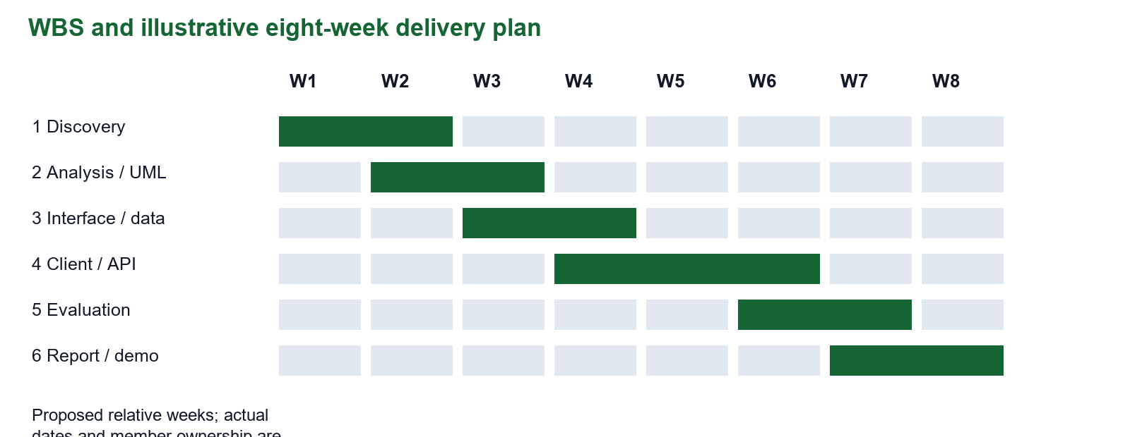
Quality | Measurable target / verification
Reliability | No lost or duplicate booking in 100 controlled attempts; test transaction failures
Availability | Proposed 99% during a 30-day pilot; monitor outages and dependency failures
Performance | Proposed p95 API response <2 s with 20 simultaneous users; controlled load test
Usability / portability | Complete core tasks at 320–1280 px; no hidden footer actions; Android/iOS device checks
Security | 401/403 for unauthorised actions; hashed passwords; ownership and role tests
Maintainability | Documented endpoints, repeatable build and migration path; no new critical lint/type errors
Accessibility | Normal text contrast ≥4.5:1; large text ≥3:1; labels and keyboard checks [R1]
WBS: 1 discovery (context and research); 2 analysis (requirements/UML); 3 prototype (screens/data); 4 implementation (client/API/database); 5 evaluation (unit/integration/usability); 6 delivery (report/video/fork). Gantt weeks are an illustrative eight-week plan, not reconstructed actual dates. Confirm baseline, dependencies, owners and actual completion dates before submission.

UML — Use cases and booking activity
The use-case diagram presents the actors and their tasks inside the CampusConnect boundary. Authentication supports protected tasks. Administrative approval and security dispatch belong to different roles. The activity diagram describes a rider’s immediate-booking journey, including invalid input and unavailable-driver outcomes.
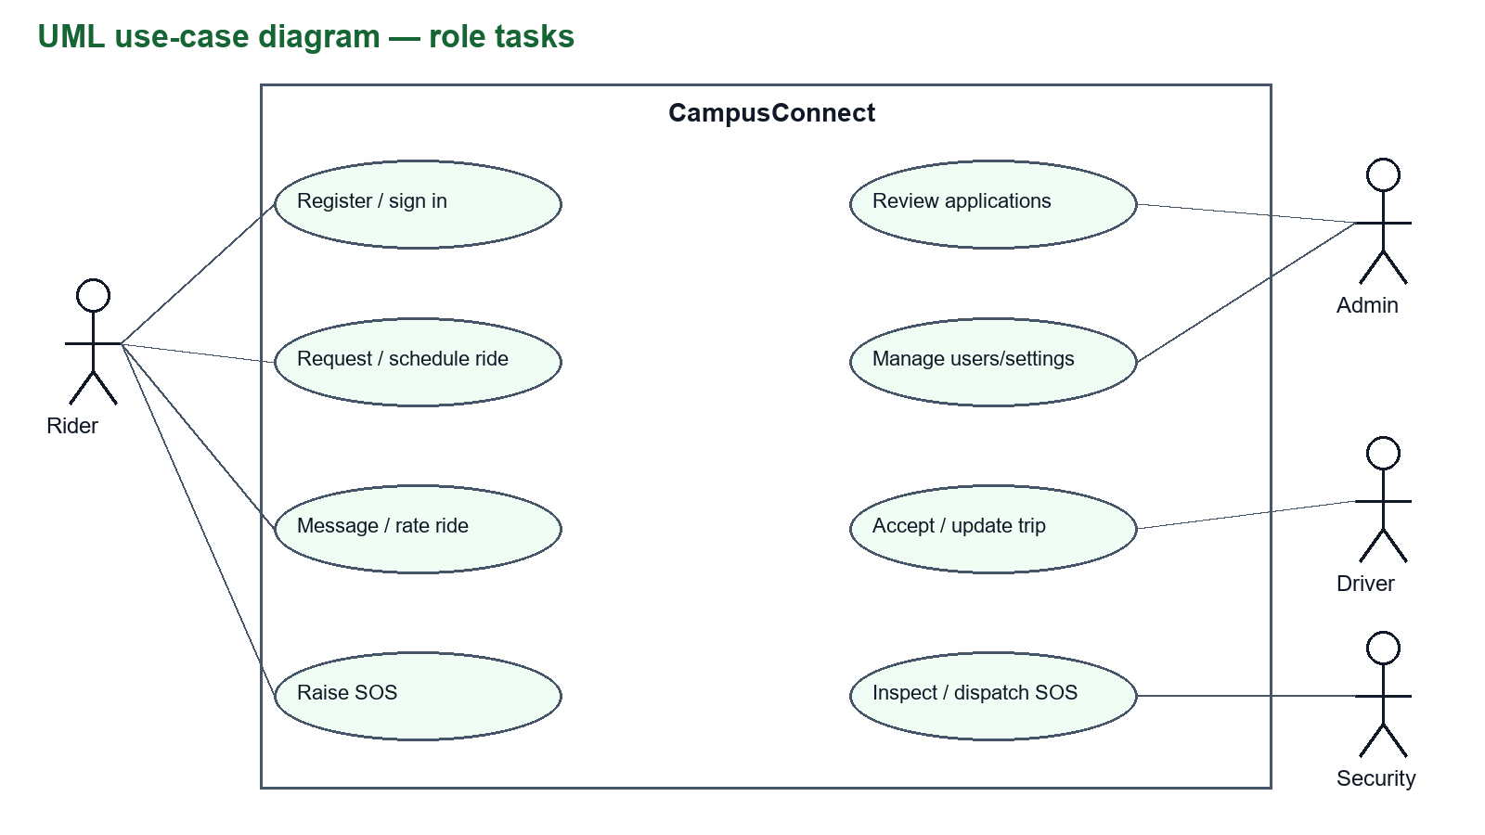
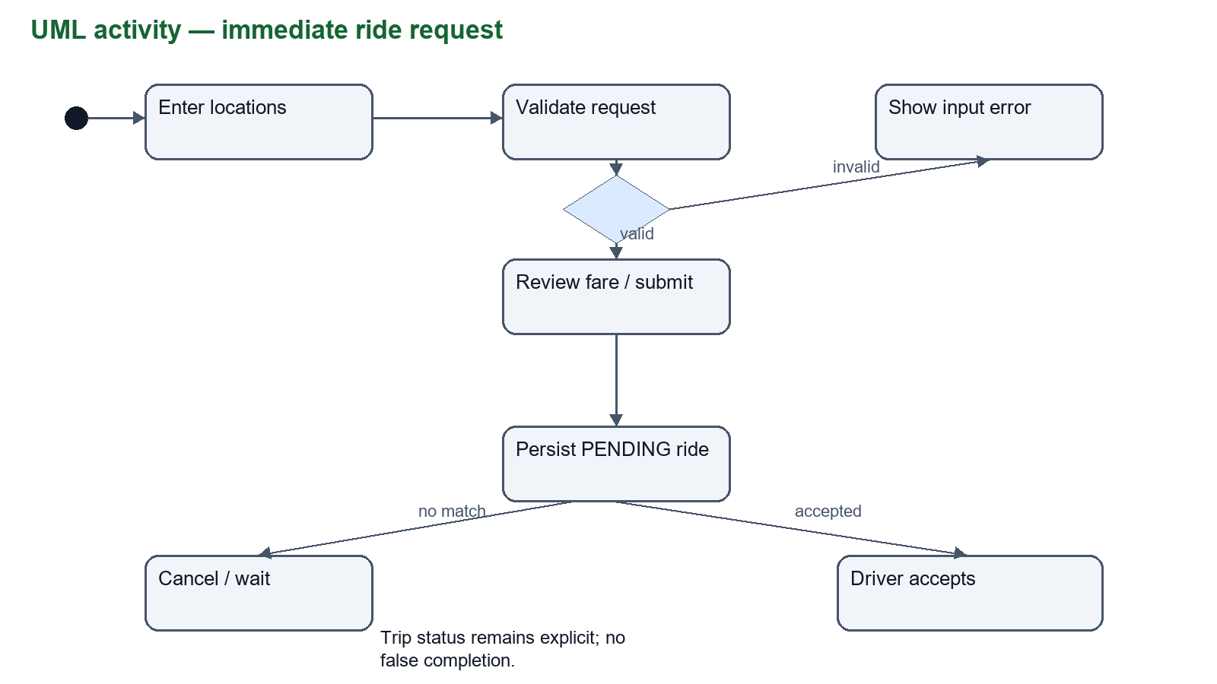
These diagrams document intended interactions supported by the inspected routes [C]. Use-case participation does not establish production authorisation completeness. If no driver accepts, the rider must see the pending state and retain a cancellation path rather than a false completion message.

UML — Trip states and class structure
Ride.RideStatus declares SCHEDULED, PENDING, ACCEPTED, ENROUTE, ARRIVED, STARTED, COMPLETED and CANCELLED. The diagram summarises the intended lifecycle, not an assertion that every controller enforces every arrow. A scheduled ride requires dispatch into the request workflow. Cancelled and completed trips remain available for history.
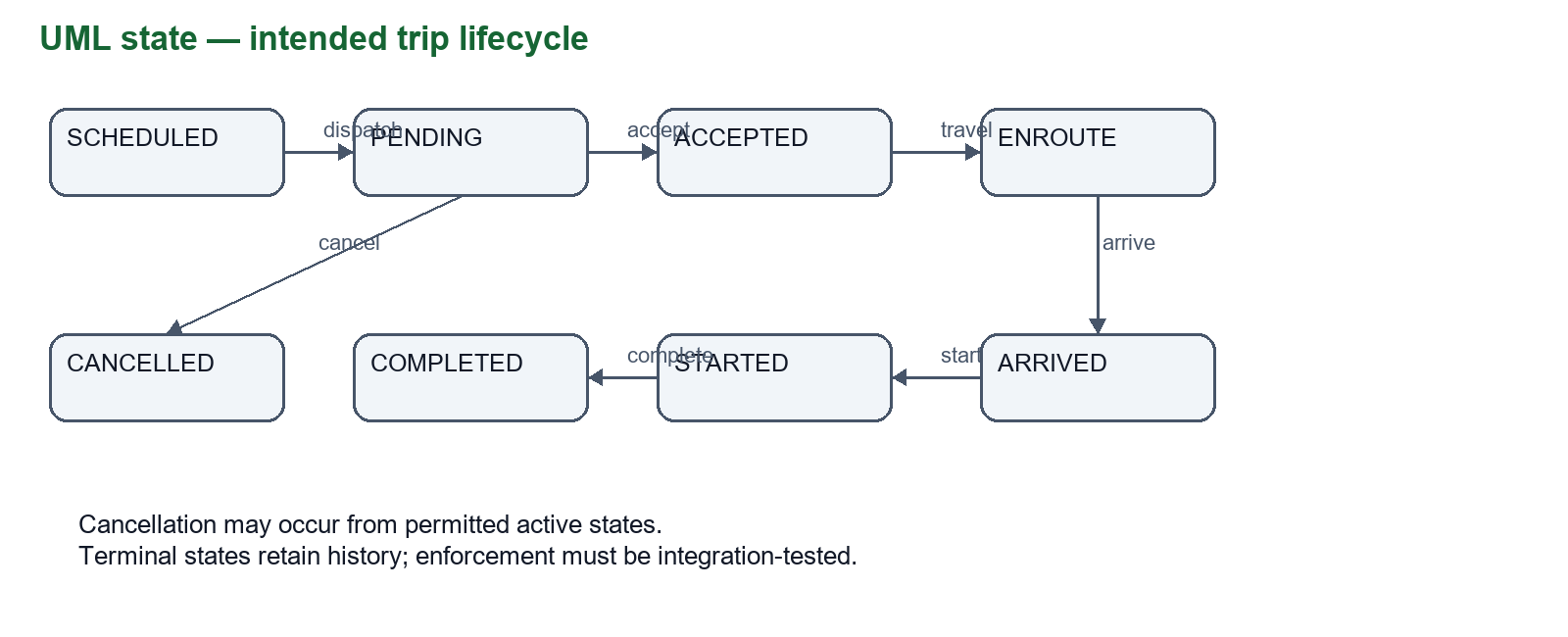
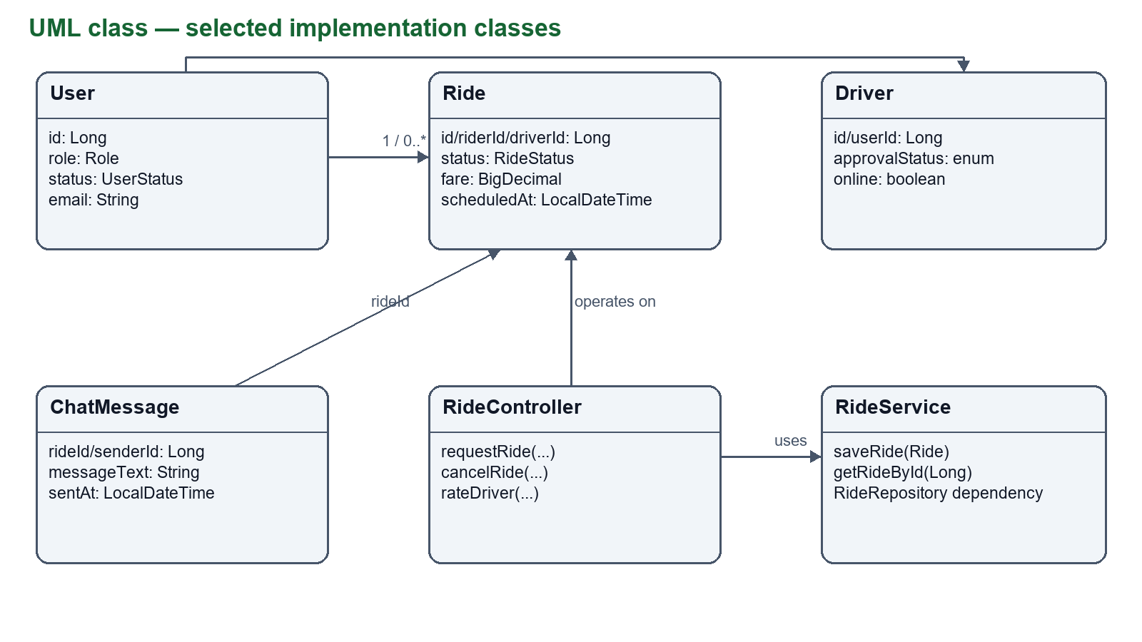
The class diagram represents selected actual Java entities, controller/service boundaries and repositories. Many relationships are stored as scalar IDs rather than JPA object associations. Empty scaffold files, including PaymentService and several proposed entities, are not implemented classes in this model.

UML sequence, architecture and technology
A rider request crosses the client/API/database boundary. A driver’s later acceptance changes the stored ride; the client retrieves status through polling. The diagram intentionally depicts polling rather than claiming an active WebSocket delivery path. Failure responses must remain visible to the caller.
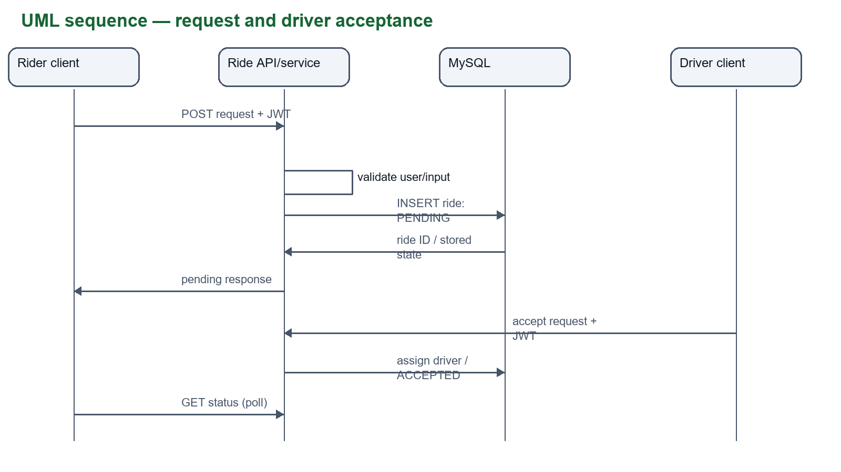
Layer / selected technology | Reason and trade-off
React Native 0.86 / React 19.2 / Expo 57 | One TypeScript UI with web preview and mobile tooling; native APIs still need device tests [R2]
React Navigation / shared AppLayout | Role routes, safe areas and bounded scrolling; one rider bar persists across four tabs
Spring Boot 3.5 / Java 25 | HTTP controllers, dependency injection and security support; versions come from pom.xml [R3]
MySQL / JPA / JdbcTemplate | Relational trip/account data and explicit SQL; InnoDB offers transactions and foreign keys [R4]
JWT / BCrypt / SMTP | Stateless sessions, password hashes and reset email; provisioning and secrets require hardening
Leaflet / OSRM / location / audio | Maps and trip context; availability, permissions and privacy depend on external/device services
Logical architecture: browser/phone → HTTP API → controllers → services/repositories or JdbcTemplate → MySQL. Maps and SMTP are external dependencies. Local API uses port 8080; a physical phone needs a reachable LAN address. HTTPS deployment is a future requirement.

Phase 3 — Authentication and rider entry screens
The catalogue covers every screen registered in mobile/App.tsx. A panel labelled ‘SCHEMATIC’ is an explanatory mock-up based on route purpose and controls, not a captured runtime screen. ‘FIXTURE CAPTURE’ identifies an actual local web screen with synthetic data. Captures and mock-ups demonstrate interface design, not real-user evaluation.
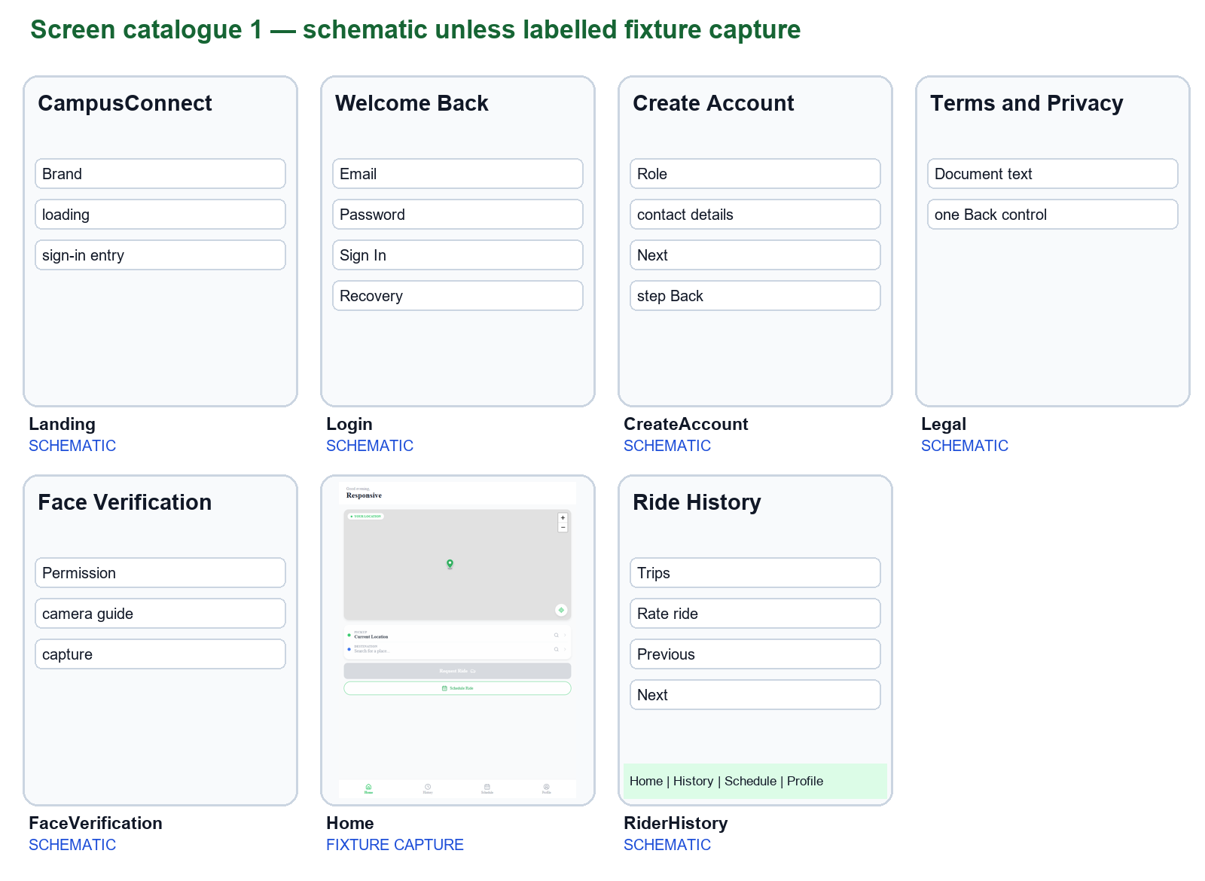
Landing shows branding and entry; Login handles credentials and recovery; CreateAccount collects role/contact details and onboarding steps; Legal presents terms/privacy; FaceVerification represents camera permission and selfie capture; Home supports locations and requests; History lists trips with pagination and rating access. Registration step-back is retained; redundant stack headers are suppressed.

Phase 3 — Rider controls and driver entry screens
The four rider tabs share a persistent sibling navigation bar. Their page area shrinks and scrolls above the bar. Secondary screens retain one back control. Shared scrollable dialogs keep actions reachable in short landscape windows.
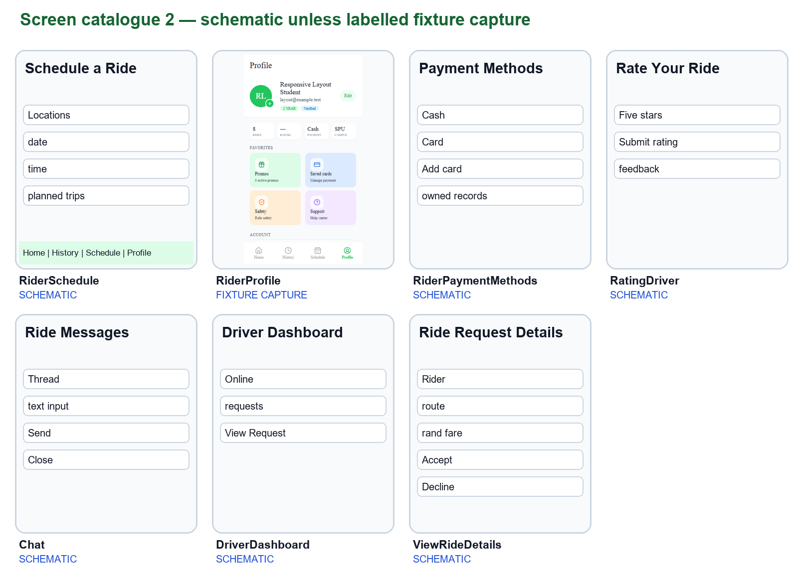
ScheduleRide collects route/date/time and lists planned rides; Profile exposes editable personal details and help panels; PaymentMethods saves limited display metadata and default selection; RatingDriver submits 1–5 stars; Chat is a ride-scoped message thread; DriverDashboard shows availability and requests; ViewRideDetails offers request context, rand fare, Decline and Accept Ride. Saved-card storage is not a payment gateway.

Phase 3 — Driver and administrative workflows
Driver screens organise the request-to-completion journey and separate earnings/history from the active trip. Administrative screens organise applications, users and current rides. Controls that mutate state display busy feedback; map containers resize when the page dimensions change. Reporting views are dashboard summaries and earnings; no in-app downloadable report-generation screen is evidenced.
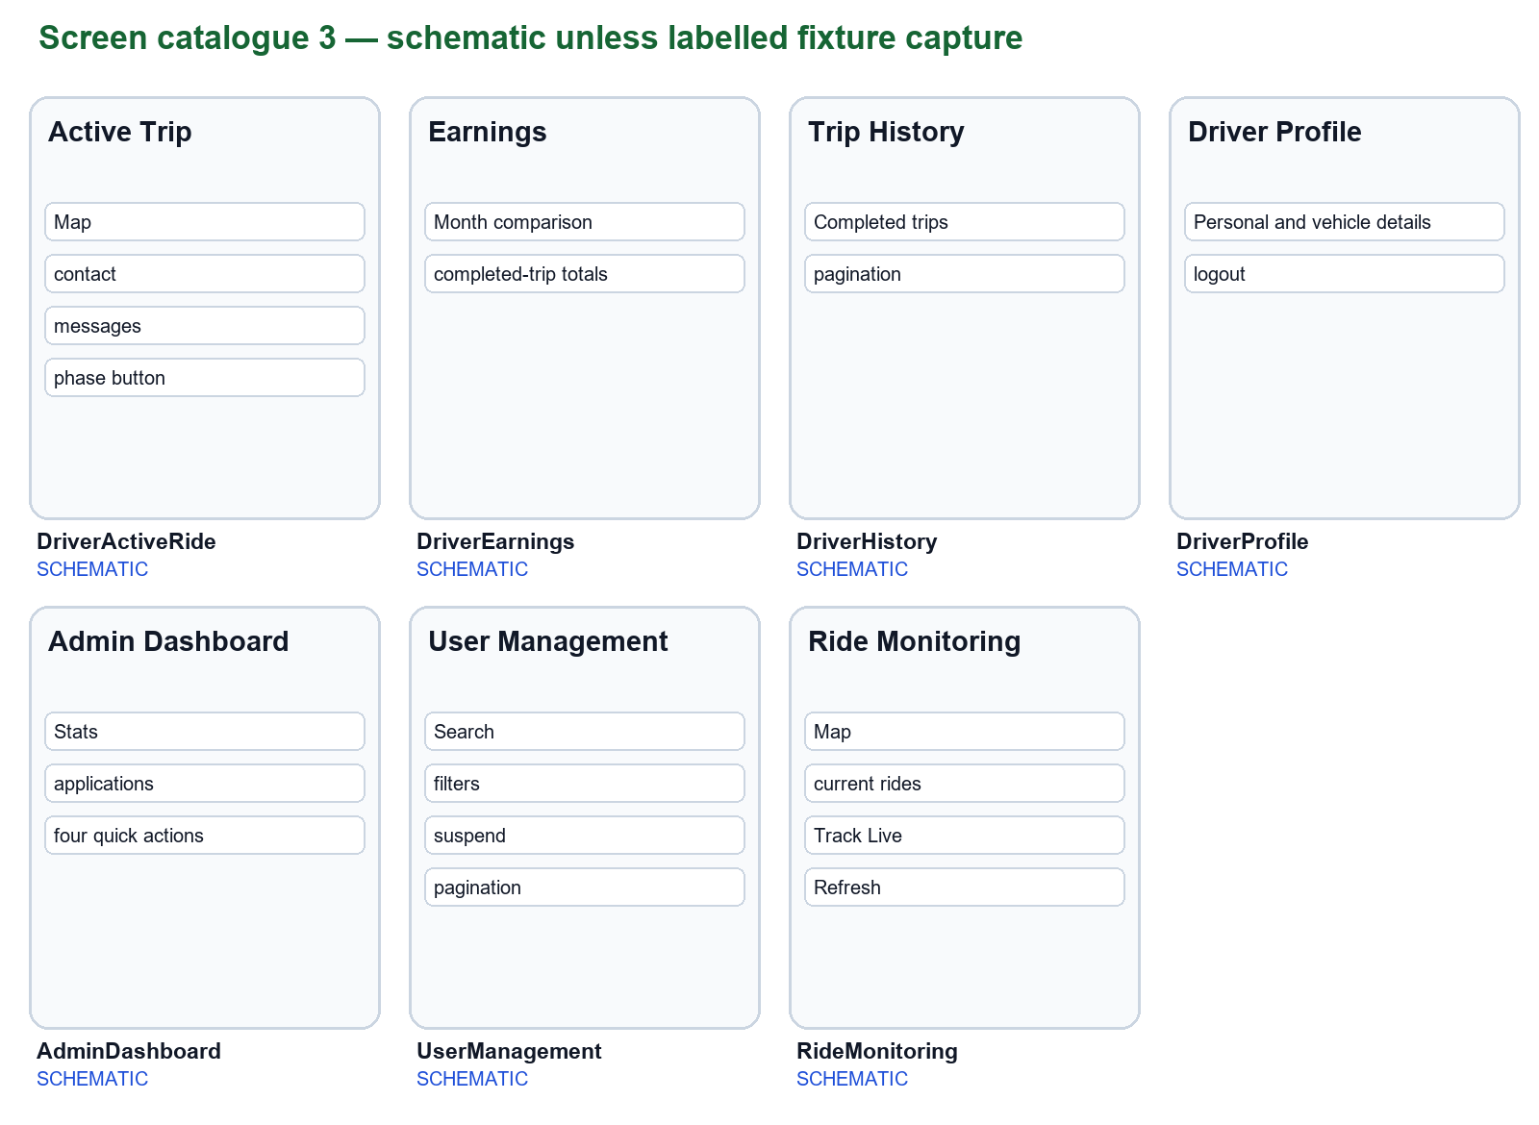
DriverActiveRide exposes trip phases, contact, messages and cancellation; DriverEarnings aggregates completed trips; DriverHistory lists prior rides; DriverProfile presents account/vehicle details; AdminDashboard offers applications and quick actions; UserManagement filters and changes account status; RideMonitoring selects current rides for the map. Aggregated earnings are not confirmation of settlement.

Phase 3 — Safety screens and design iterations
Security views prioritise ride context and incident evidence. Incident and resolved-SOS pagination reserve room instead of covering the list. A populated active-SOS list scrolls above its navigation bar. Audio playback and download errors appear as visible feedback.
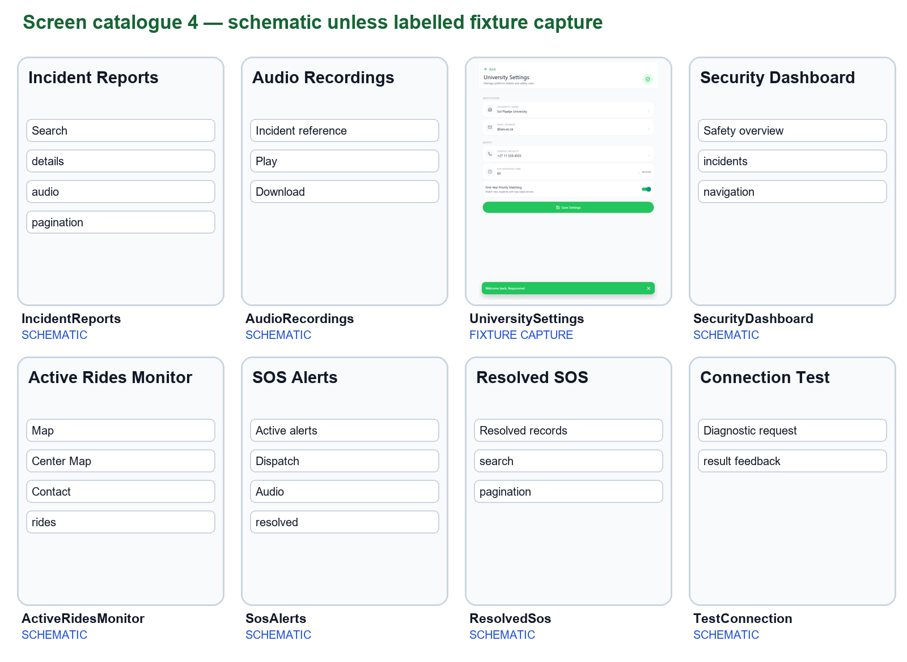
Owner feedback [F] / previous design | Applied revision and evidence
Content displaced bottom navigation | One persistent rider bar; bounded page frame; 28 rider geometry checks [T]
Duplicate or ineffective back controls | Shared header policy; registration step-back retained; Earnings decorative back removed
Dollar icon beside rand fare | DollarSign icon removed from ViewRideDetails on 5 October
Buttons and narrow pages needed care | Scrollable confirmations, mutation guards, toast dismissal and authenticated downloads
Panels include IncidentReports, AudioRecordings, UniversitySettings, SecurityDashboard, ActiveRidesMonitor, SosAlerts, ResolvedSos and the TestConnection diagnostic route. The before/after comparison is reconstructed from recorded code changes and owner requests; no historical screenshot or multi-participant study is invented.

Database design and relationship justification
The ERD distinguishes code-supported logical associations from enforced SQL constraints. The current source is split between JPA entities, JDBC-created tables and historical migrations. It is not a verified export of a live database. Nine tables are represented; empty future entities such as University and SafeZone are excluded.
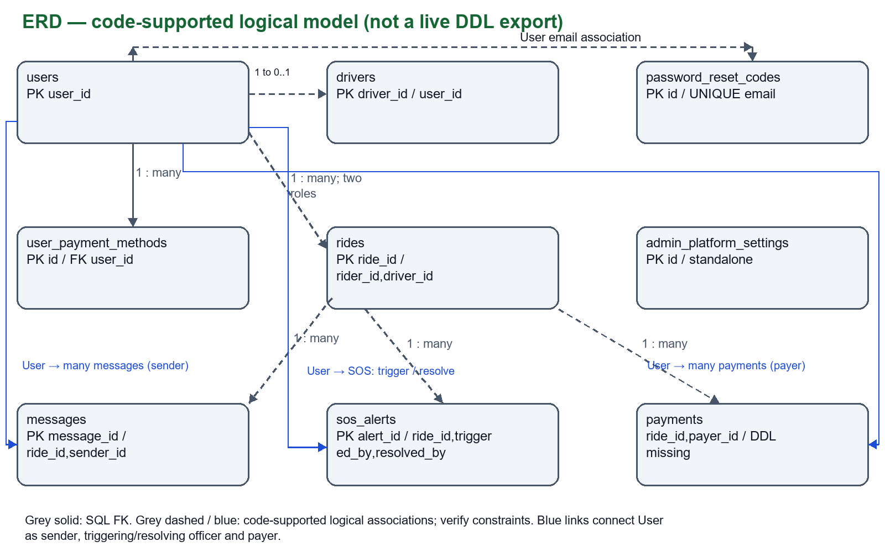
Relationship | Reason / enforcement caveat
User → many rides (rider and driver roles) | A person can participate in multiple trips; driver_id refers to users.user_id, not drivers.driver_id
User → optional driver profile | Intended 1:0..1; Driver.userId alone does not prove UNIQUE enforcement
Ride → many messages / SOS alerts | A trip has a conversation and can have several alerts; sender/trigger IDs reference users
User → many saved-card display records | Owned records, maximum three enforced in application; SQL FK is present
Ride/user → payment records | PaymentController uses ride_id/payer_id; full creation DDL is missing in inspected scripts
Reset code email → user email | Logical association; reset-code table has no declared FK
Platform settings | Standalone intended configuration row; SQL does not enforce singleton count
No standalone many-to-many join table is evidenced. Users can share trips over time through ride participation, but each ride stores one rider and at most one assigned driver. Source details and uncertain field types are recorded in data-dictionary.csv.

Entity dictionary — Accounts, drivers and rides
Field names and sizes below describe the code contract. A grouped row applies the listed type to each field. VARCHAR(255) is the default JPA string length where @Column does not specify a size. The complete one-field-per-row dictionary with source and certainty is supplied as a supporting CSV/Markdown document.
Table / fields | Type / size | Purpose
users: user_id | BIGINT | Primary key
full_name, email, password_hash | VARCHAR(255) | Identity; unique email; password hash
role / status | ENUM | RIDER/DRIVER/ADMIN/SECURITY; ACTIVE/PENDING/SUSPENDED
year_of_study / vehicle_year | INT | Academic and vehicle years
emergency_contact, student_number, phone | VARCHAR(255) | Contact and membership details
licence_plate, vehicle_make | VARCHAR(255) | Registration vehicle details
face_verified / created_at | BOOLEAN / DATETIME | Upload state; account creation
face_embedding / profile_photo | TEXT or LONGTEXT / LONGTEXT | Image data; schema and entity size differ
default_payment_method | VARCHAR(20) | JDBC-added preference
drivers: driver_id / user_id | BIGINT | Driver key and linked user
licence_plate, vehicle_make / vehicle_year | VARCHAR(255) / INT | Vehicle identification
vehicle_photo / rating | LONGTEXT / DECIMAL unspecified | Vehicle image; summary rating
total_trips / online / approval_status | INT / BOOLEAN / ENUM | Activity and PENDING/APPROVED/REJECTED
rides: ride_id, rider_id, driver_id, cancelled_by | BIGINT | Trip key; participant/cancelling IDs
pickup_location, destination | VARCHAR(255) JPA default | Route labels; SQL baseline uses 200
pickup_lat/lng, dest_lat/lng, current_lat/lng | DOUBLE | Coordinates; precision differs in baseline SQL
fare / distance_km / duration_min | DECIMAL unspecified / DOUBLE / DOUBLE | Fare, distance and duration
status | ENUM (8 states) | Lifecycle from Ride.RideStatus
scheduled_at, started_at, completed_at, created_at | DATETIME | Trip timing
rider_rating / driver_rating | INT | Two directions of feedback
rider_rating_comment, driver_rating_comment, cancellation_reason | VARCHAR(500) | Feedback and cancellation explanation
Critical drift: schema.sql calls the ride key id and duration duration_minutes; Ride.java maps ride_id and duration_min. Other scripts use ride_id. Confirm SHOW CREATE TABLE output and consolidate migrations before claiming a clean-install database.

Entity dictionary — Messages, safety and supporting tables
Schema control method: inventory entity mappings and SQL migrations; compare against a disposable database; select one migration history; apply it to an empty database; inspect keys/types; execute registration, trip, chat, SOS and payment tests. Do not run fix_rides_table.sql against valuable data: it contains destructive table rebuilding.
MySQL fits relational account/trip records and reporting, while InnoDB supports transactions and referential constraints [R4]. This does not remove the need for correctly declared constraints, tested migrations, backups and least-privilege credentials. No Oracle or NoSQL benchmark was performed.
Table / fields | Type / size | Purpose / source confidence
messages: message_id, ride_id, sender_id | BIGINT | Message and participant keys; entity + migration
message_text / sent_at | VARCHAR(1000) / DATETIME | Body and send time
sos_alerts: alert_id, ride_id, triggered_by | BIGINT | Alert key, trip and triggering user
gps_lat / gps_lng | DOUBLE entity; DECIMAL(10,7) SQL | Coordinates; physical type requires verification
audio_file_path / recording_duration | VARCHAR(500) / INT | Evidence file location and seconds
status / created_at | VARCHAR(30) / DATETIME | Alert state and creation
resolved_at / resolved_by | DATETIME / BIGINT | SQL/controller resolution fields, absent from SosAlert entity
user_payment_methods: id, user_id | BIGINT | Saved display-record ownership
label / last_four / brand / expiry | VARCHAR(80) / CHAR(4) / VARCHAR(32) / CHAR(5) | Card display metadata; no full PAN/CVV
cardholder / is_default / created_at | VARCHAR(120) / BOOLEAN / DATETIME | Display name, default and creation
password_reset_codes: id / email / code_hash | BIGINT / VARCHAR(255) / VARCHAR(255) | Key, unique email and hash
expires_at / created_at / attempts | DATETIME / DATETIME / INT | Expiry, cooldown and invalid attempts
admin_platform_settings: id | BIGINT | Configuration row key; startup DDL
university_name / email_domain | VARCHAR(160) / VARCHAR(120) | Institution display and configured domain
campus_security_phone | VARCHAR(40) | Configured contact
sos_response_time_seconds / first_year_priority_matching | INT / BOOLEAN | Configuration values; not evidence of enforced response/matching
updated_at | DATETIME | Latest configuration save
payments: ride_id, payer_id, amount, method, status, transaction_ref | IDs, decimal amount and strings; sizes UNVERIFIED | Observed JDBC insert contract; creation DDL unavailable

Phase 4 — Implementation and error handling
The client uses registered role routes, Axios API access and shared UI components. AppLayout bounds the navigator, supplies safe-area padding and renders the rider navigation as a sibling. ScrollableCard and ConfirmationDialog keep actions reachable. screenChrome suppresses duplicate native headers where the screen already owns its controls.
The backend exposes authentication, user, driver, ride, message, payment, administrator and security controllers. JPA handles core entities; JdbcTemplate handles saved payment display records, settings and some reporting. This mixed approach makes schema consistency important. Several empty scaffold services/controllers remain and should not be counted as delivered features.
Authentication uses BCrypt and JWT; admin/security paths have role restrictions in SecurityConfig. Password reset stores a hash, expires after ten minutes, uses a five-attempt limit and a sixty-second resend cooldown. Unknown-account requests return without revealing an account. These isolated behaviours are unit-tested; SMTP delivery still needs configuration and live verification.
Failure / action | User-facing behaviour and boundary
Saved-card load/mutation failure | Retry or visible error; busy guard; ownership scoped on server
Dirty settings / leaving | Stay retains edits; Leave replays navigation; save confirms
Missing phone or audio | Visible explanation; no silent disabled control
Audio playback/download | Authenticated request; catch failure; release player on leaving
Trip status / unavailable ride | Visible failure; retry and return path
Network and list loading | Bounded scrolling, loading indicators and selected retry controls
Production blockers found in inspected code: public registration accepts privileged ADMIN/SECURITY role values; startup resets seeded privileged credentials; responses return a User object without evidenced password-field redaction; broad public auth/verification/test paths need review. The report documents these risks without changing application behaviour or printing credentials.

Testing methods, results and colour contrast
Fresh verification on 5 October 2026: npm.cmd run typecheck exited successfully. mvn.cmd -o -Dtest=AuthServiceTest,PasswordResetServiceTest test compiled the project and passed nine tests with zero failures/errors/skips. Repositories and email are mocked in these tests; they do not establish database or SMTP correctness.
Session evidence from 4 October: check-responsive.cjs passed 28 rider tab/size checks, driver/security/admin layout checks, auth forms and dialogs. check-pages.cjs passed seven-size checks for detail pages and mocked card, settings, audio, security, chat and driver-trip actions. Production web export also passed. These are historical recorded checks; they are not newly measured performance or human studies.
Existing historical Surefire reports include one failure in AdminControllerPendingDriversTest (3 tests, 1 failure). Other stored controller reports are not a substitute for a fresh complete run. Some integration tests create accounts, so only the isolated services were rerun for this documentation review.
Colour pair [C] | Calculated contrast | Interpretation [R1]
#111827 on #FFFFFF | 17.74:1 | Passes normal-text minimum
#6B7280 on #FFFFFF | 4.83:1 | Passes normal-text minimum
#FFFFFF on #22C55E | 2.28:1 | Fails normal and large text minima
#FFFFFF on #16A34A | 3.30:1 | Fails normal; can meet large-text minimum
#FFFFFF on #2563EB | 5.17:1 | Passes normal-text minimum
Ratios are calculated from theme tokens using relative luminance; they do not constitute a complete accessibility audit. In particular, white text on green buttons needs a darker background or different foreground. The report therefore does not claim WCAG conformance. Test keyboard access, screen-reader labels, zoom, native touch and image text separately.

Human evaluation: protocol and evidence gaps
The brief requires multiple real users, completion times, error rates and satisfaction. No completed participant dataset was supplied. Direct owner requests provide useful formative feedback, but they do not establish a multi-user study or justify numerical usability improvements. This page specifies a reproducible evaluation the group can conduct.
Recruit at least six consenting participants, including rider and driver tasks and an administrator/security reviewer where available. Use anonymous IDs rather than student numbers in results. Explain the test purpose, obtain consent, avoid live emergency dispatch and real card data, and allow participants to withdraw. Report who participated by role without identifying them.
For each task, define the start cue and successful end state before testing. Record seconds, completion without assistance, wrong taps, validation errors, help requests, device/viewport and a 1–5 ease rating. Use equivalent synthetic scenarios for a baseline and revised build, alternate test order when possible, and acknowledge learning effects. Do not invent a baseline if the earlier version is unavailable.
Task | Success state / target to test
Register and sign in | Role dashboard reached; target 90% unaided completion
Request and schedule a trip | Correct route/date saved; target no wrong destination
Find History and return to Home | Correct tab; target no accidental back/scroll obstruction
Driver review/message/start trip | Correct request/status; target no duplicate submission
Edit profile / saved-card record | Validation understood; target save/cancel difference clear
Security inspect a fixture alert | Correct incident/audio; never dispatch a real unit during test
Use supporting usability-results.csv and usability-study.md. Compute completion rate = unaided successes / attempts; error rate = defined error events / attempts; report median task time with sample size and spread. Satisfaction averages are optional and must show raw counts. RESULTS: PENDING. Attach anonymised logs, feedback themes and actual before/after evidence.

Execution, demonstration and delivery
Execution documentation accompanies the report. Install the project’s declared Java 25 and Node dependencies; provide a compatible MySQL database; configure environment secrets locally. The repository uses development ddl-auto update and schema repair, so a clean deployment must verify the schema rather than assume all historical scripts can be run in sequence. Never include real credentials, .env files or local dependency caches in submission.
Run the backend with Maven from backend and the Expo client from mobile. API port is 8080; select a free Expo port such as 8083. ApiClient uses emulator/browser defaults; a physical phone must use a reachable LAN host. Password-reset mail has a separate documented local launcher. A browser build does not prove native camera, microphone or file sharing.
The demonstration script follows a complete user journey: explain the problem → register/login → request/schedule → driver decision → message and trip status → history/rating → admin settings/users → security incident/audio → responsive navigation → limitations and technical decisions. Record the actual integrated system with test accounts for the final presentation. Include presenters’ names and be ready to explain code and answer supervisor questions.
Submission follows the discovered template: Code, Demo, Dox and a names text file, in a module/year/group/leader folder. A code archive is excluded from this working package until it can be exported without secrets/generated caches and tied to the confirmed fork. Code/README gives explicit export instructions. The repository requirement is not fulfilled merely by an existing local git folder.
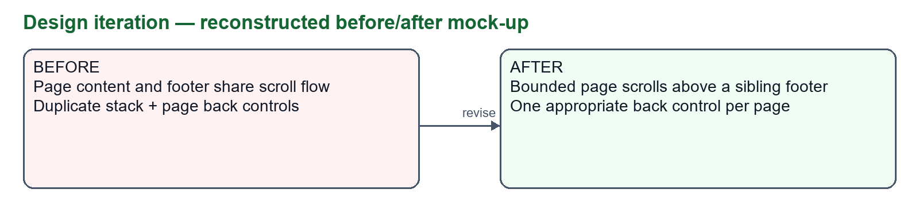
Deliverable | Current status
15–20 page report DOCX/PDF | Generated 20-page PDF and editable Word draft
Design and engineering support | UML/ERD images, dictionaries, runbook, API and screen catalogue
Group names and confirmed fork URL | PENDING owner input
Real-user usability results | PENDING data collection
Narrated integrated demo / supervisor Q&A | Script prepared; presenters and final recording pending
Reflection for group review: navigation stability matters because people form spatial expectations; duplicate controls create uncertainty; error messages need an action users can take. Confirm these observations in testing. Add each member’s own account of what surprised them, decisions they made and what they would change.

Limitations, conclusion and references
CampusConnect demonstrates the planned campus workflow through role-specific interfaces and backend routes. Its strongest verified evidence is repeatable layout/action fixtures and isolated account/reset tests. The next priority is an integrated, disposable-database demonstration and an honest human evaluation, followed by native-device checks.
Prioritise: (1) restrict privileged registration and remove credential resets; redact sensitive account fields; (2) consolidate and test schema migrations, including payments; (3) replace selfie acceptance with real verification only if ethically approved and technically validated; (4) enforce lifecycle/assignment concurrency and evaluate external dependencies; (5) improve text contrast, keyboard access and native permissions; (6) measure real-user outcomes and record a narrated demonstration. No payment settlement, biometric assurance, campus-wide adoption, uptime or guaranteed emergency response is claimed.
This report is ready for group review but must not be described as submission-complete while names, fork identity, contribution evidence, participant results and the final demo are missing. The verified template structure is used; update folder/file names once the group number and leader are confirmed.
Reference | Source / use
[B] Assignment brief | 2026-Group-Assignment_NPRT630-Project.pdf, 13 Feb 2026, pp.1–8; requirements and rubric
[C] Local project | backend/src, mobile/src, database/mysql, pom.xml, package.json; inspected 5 Oct 2026
[T] Test evidence | Surefire service reports (5 Oct); session browser/build checks (4 Oct); test scripts and docs/responsive-layout.md
[F] Owner feedback | Conversation requests on responsiveness/back controls; fare icon request on 5 Oct 2026
[R1] W3C | https://www.w3.org/WAI/WCAG22/Understanding/contrast-minimum.html
[R2] Expo | https://docs.expo.dev/
[R3] Spring Boot | https://docs.spring.io/spring-boot/index.html
[R4] MySQL InnoDB | https://dev.mysql.com/doc/refman/8.4/en/innodb-introduction.html
External references accessed 5 October 2026. Version numbers are taken from the project manifests rather than inferred from current vendor documentation. Supporting files contain source paths, reproducible commands and explicit evidence gaps. Replace draft metadata and add members’ own final reflection before submitting.

