Smart Pantry Manager
Written Report

MOBILE APP DEVELOPMENT 700
App name: Smart Pantry Manager
Student name: Sithembile Biyela
Student number: 402111624
Module name: MOBILE APP DEVELOPMENT 700
Date: 30 / 09 / 2026

Signature 

Prepared from the Smart Pantry Manager Android Studio project archive

Table of Contents
This report follows the required order in the Mobile App Development 700 practical assignment. The screenshot spaces are intentionally empty because the supplied project archive did not contain runtime screenshots. Replace each space with a real screenshot from the running application before submission.
If the table of contents does not populate automatically, right-click it in Word and select “Update Field”.
1. Introduction
2. System design
3. Screenshots of every output
4. Key code snippets
5. Challenges and solutions
6. Conclusion and reflection
7. Reference list

1. Introduction
Smart Pantry Manager is a native Android application written in Java. It addresses a common household problem: people often have food in their pantry but do not know what meals can be prepared from it, which can lead to food waste and unnecessary shopping. The application records the ingredients already available and suggests recipes only when the complete set of required ingredients and quantities is present.
The intended users are students, households, and individuals who want a simple offline tool for managing pantry items and deciding what to cook. The application does not depend on maps, GPS, a shopping service, or an external recipe API. Pantry data is stored locally on the Android device using SQLite, which allows the data to remain available after the application is closed.
The main functionality includes pantry create, read, update, and delete operations; validation of ingredient names, quantities, units, and optional expiry dates; a dynamic RecyclerView list; recipe suggestions; recipe detail pages; navigation using Intents; and a Settings screen for expiry-alert preferences. The project includes 18 pre-loaded recipes so that the recipe feature has useful content on first launch.

2. System design

2.1 Application structure
The app uses an Activity-based Android structure. MainActivity presents the pantry list and starts the add/edit, suggested recipes, and settings screens. SuggestedRecipesActivity evaluates the current pantry against the seeded recipes and starts RecipeDetailActivity when a recipe is selected. DatabaseHelper is responsible for SQLite table creation, seed data, and pantry/recipe queries. IngredientMatcher contains the strict recipe business rule, while ValidationUtils contains date validation.

2.2 Screen flow / wireframe diagram
[ Pantry List / MainActivity ]
|
| Add ingredient
v
[ Add/Edit Ingredient ] -- Save / Cancel --> [ Pantry List ]
^ |
| Edit / Delete | Recipes
| v
+---------------- [ Suggested Recipes ]
|
| Tap recipe
v
[ Recipe Detail ]
[ Pantry List ] ---- Settings ----> [ Settings ]
Figure 1 is a logical screen-flow diagram. Each arrow represents either an Android Intent, an Activity result/return, or an in-screen action such as saving, editing, or deleting an ingredient.

2.3 Screen summary
Screen | Main purpose | Important controls / output
Pantry List | Shows persisted pantry items. | RecyclerView, add button, edit/delete actions, bottom navigation.
Add/Edit Ingredient | Creates or updates a pantry row. | Name, quantity, unit, expiry date, save/cancel actions.
Suggested Recipes | Shows recipes that pass strict matching. | RecyclerView, empty-state message, recipe selection.
Recipe Detail | Explains one selected recipe. | Required ingredients, quantities, preparation steps, back button.
Settings | Stores the expiry-alert preference. | Switch, save button, navigation.

2.4 Data model / ER diagram
The application uses three SQLite tables. A recipe has many recipe_ingredients rows. Pantry items are the user-owned inventory rows and are compared with recipe_ingredients by normalised ingredient name and compatible quantity units.
┌──────────────────────┐ ┌──────────────────────┐
│ pantry_items │ │ recipes │
├──────────────────────┤ ├──────────────────────┤
│ id PK │ │ id PK │
│ name │ │ name │
│ quantity │ │ steps │
│ unit │ └──────────┬───────────┘
│ expiry_date │ │ 1
└──────────────────────┘ │
│
┌────────▼───────────┐
│ recipe_ingredients │
├────────────────────┤
│ id PK │
│ recipe_id FK │
│ name │
│ required_quantity │
│ unit │
└────────────────────┘
Pantry rows are matched to recipe requirements in application logic;
they do not need a direct foreign-key relationship.
Figure 2. Simplified entity-relationship diagram for the SQLite database.

2.5 Persistence and matching design
SQLiteOpenHelper creates the database the first time the app runs. DatabaseHelper creates pantry_items, recipes, and recipe_ingredients, then inserts the initial pantry rows and recipe collection. Subsequent launches read the same local database, so pantry changes persist across restarts.
IngredientMatcher applies the strict rule. It normalises names such as tomato/tomatoes, checks unit compatibility, converts metric quantities to common base quantities, adds duplicate pantry rows for the same ingredient, and rejects a recipe as soon as any ingredient is absent or insufficient. Count units such as pieces and slices are deliberately not mixed.

3. Screenshots of every output
The supplied project archive did not include screenshots from an Android emulator or physical device. The spaces below are prepared for the required evidence. Before submitting the final report, replace each labelled space with an actual screenshot of the running Smart Pantry Manager application and keep the caption below it.
SCREENSHOT 1
Pantry List screen
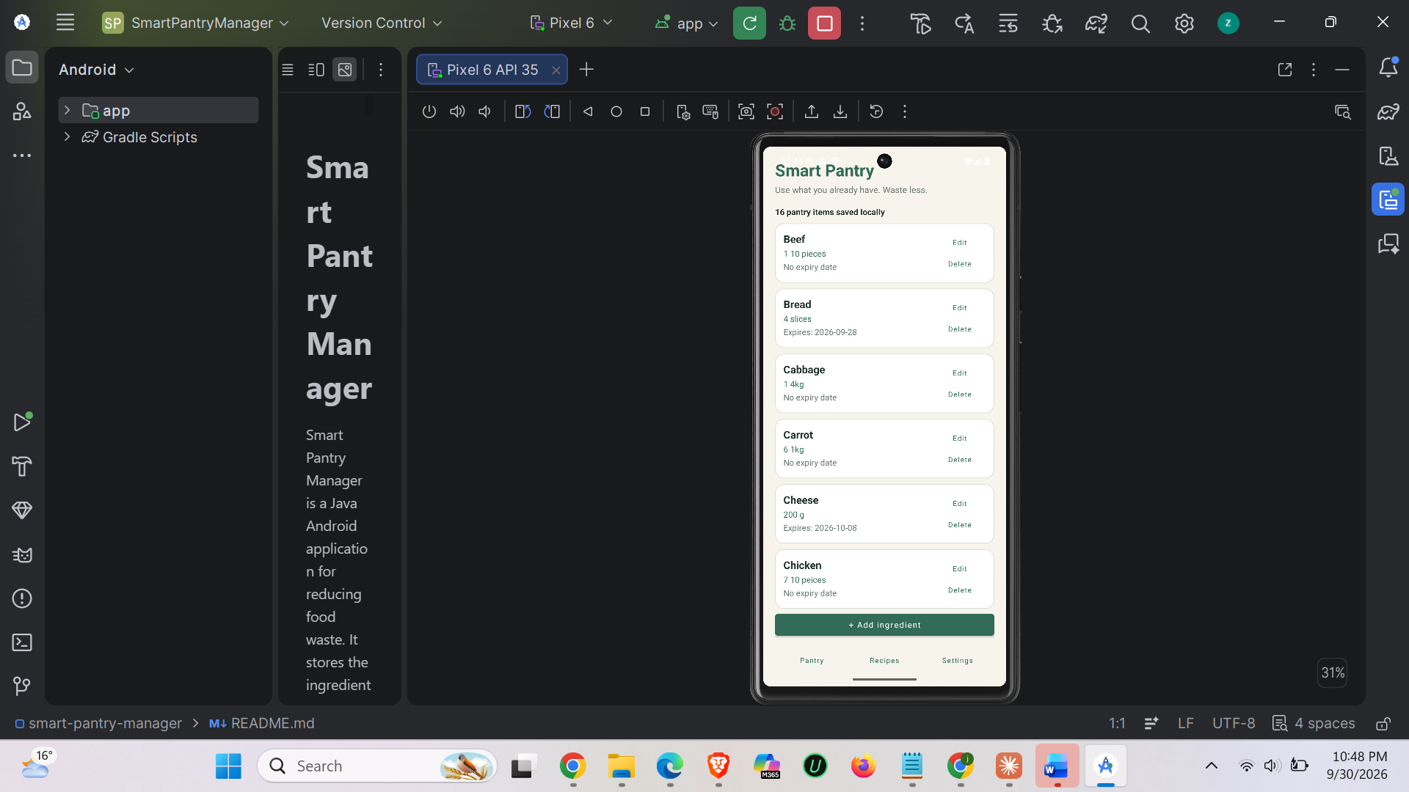

Figure 1. The initial Pantry List screen showing the seeded pantry items and the RecyclerView.
SCREENSHOT 2
Add Ingredient screen
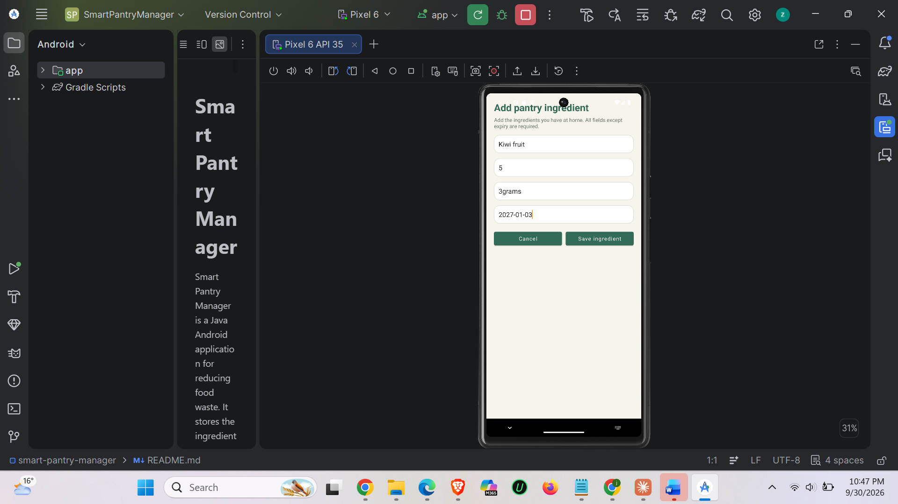
Figure 2. The form used to enter a new ingredient, quantity, unit, and optional expiry date.

SCREENSHOT 3
Validation error
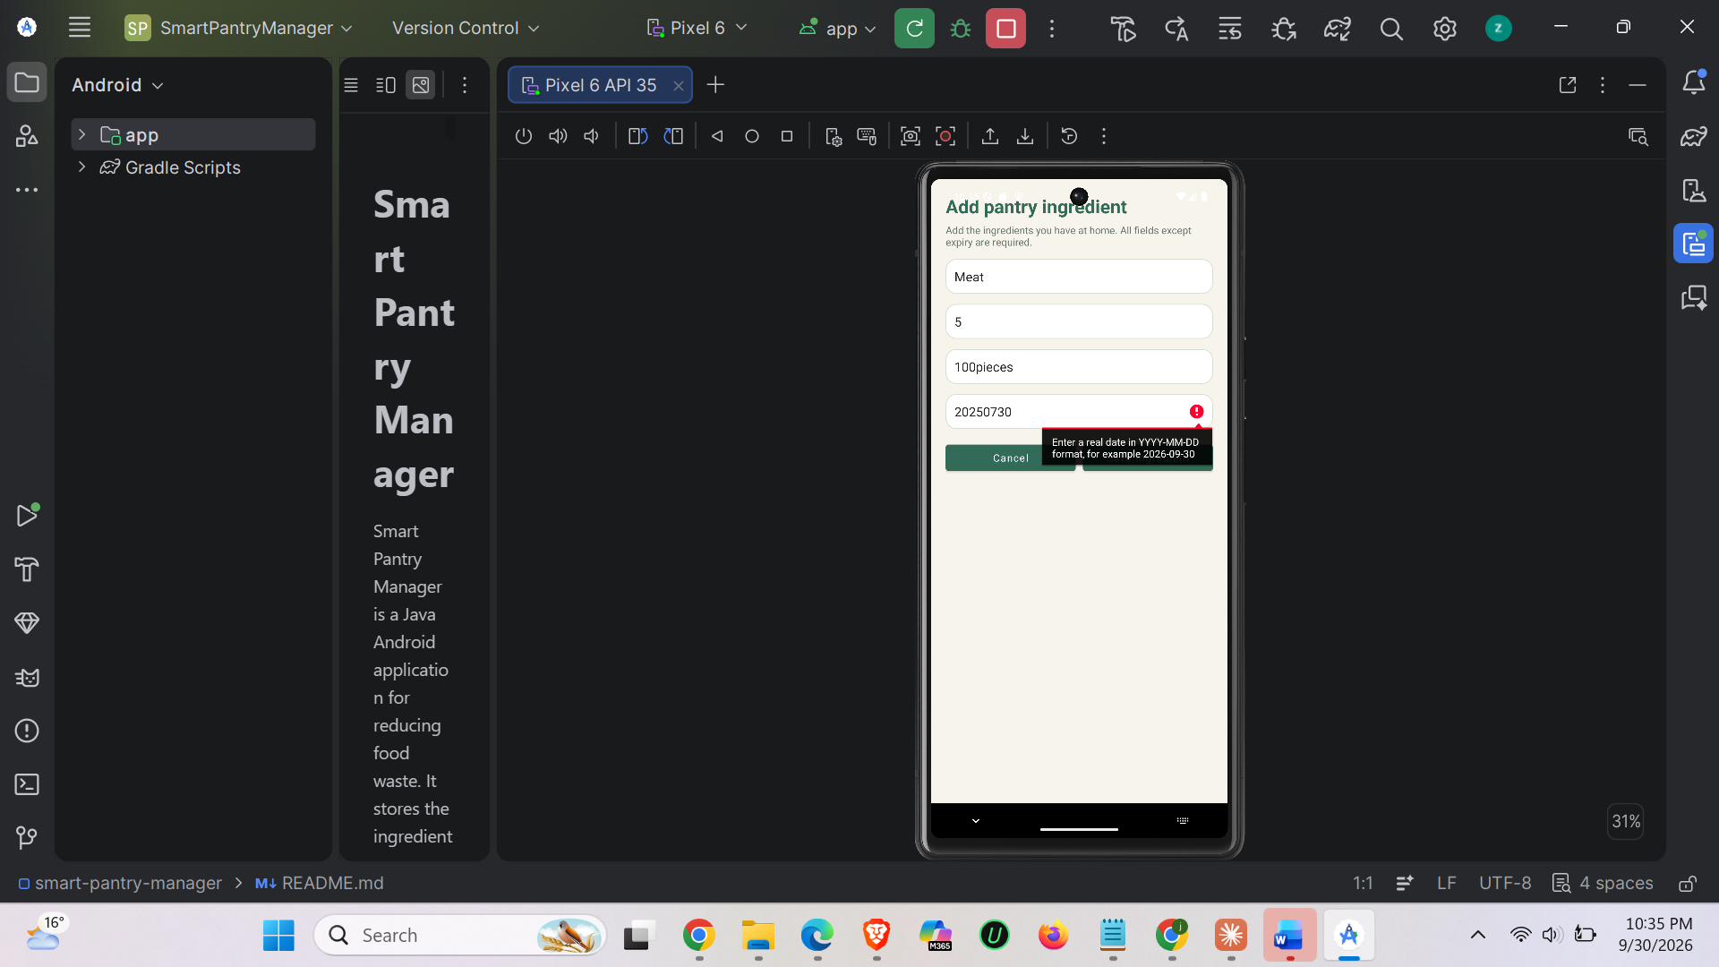
Figure 3. The add/edit form showing an inline validation message for an empty, invalid, or non-positive value.
SCREENSHOT 4
Pantry list after adding
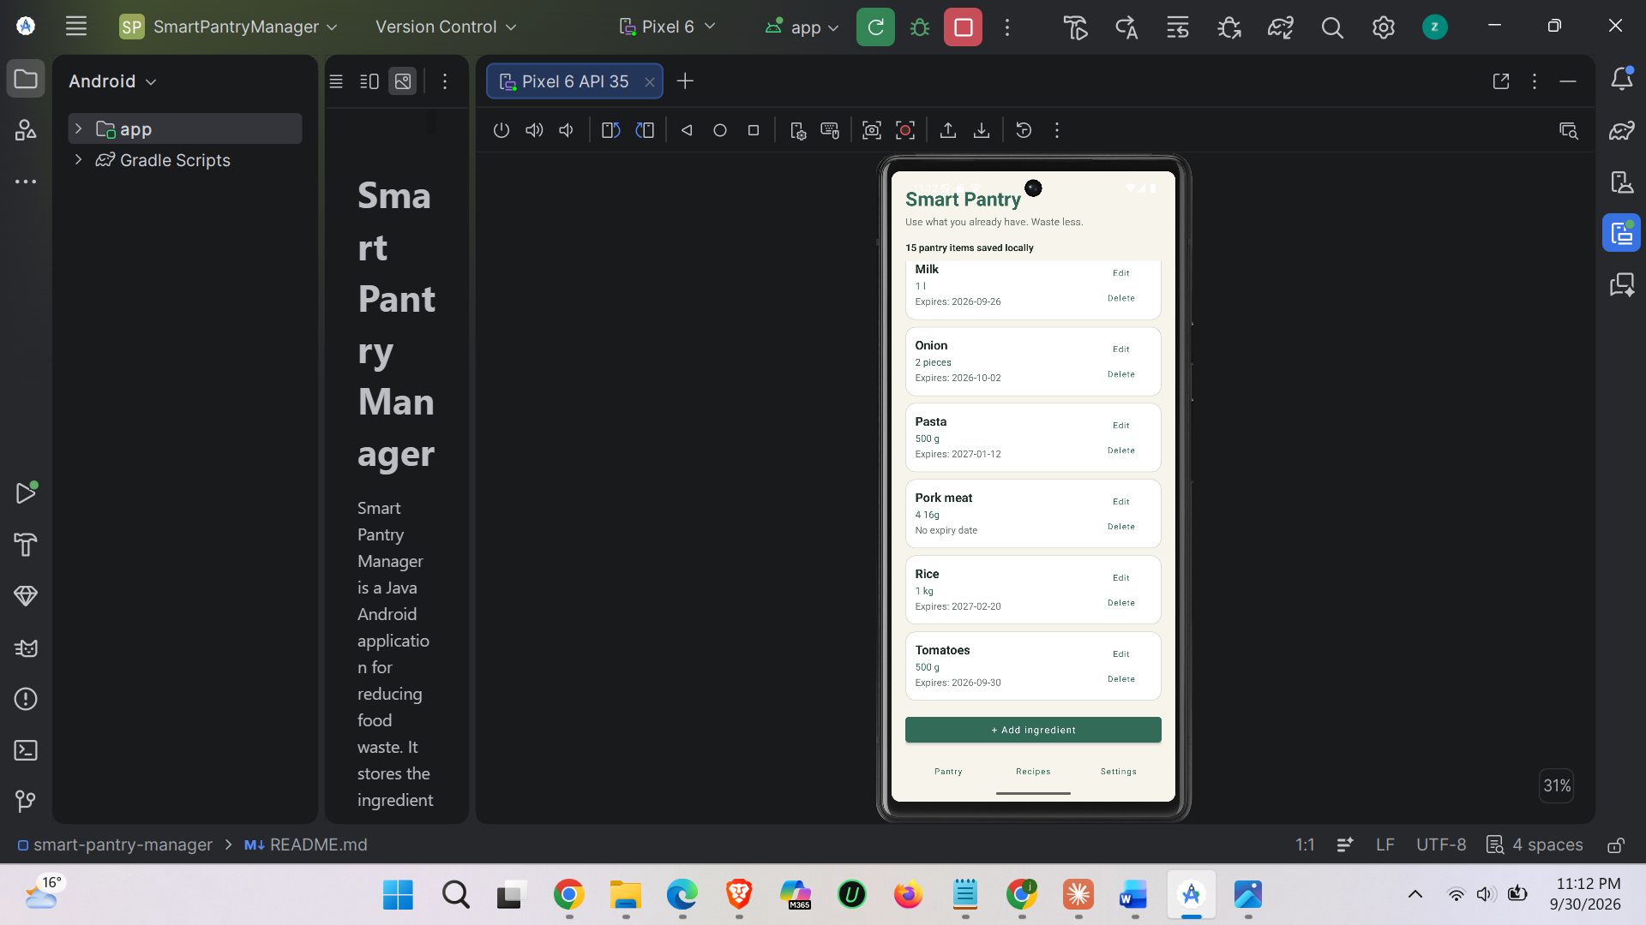
Figure 4. The newly added ingredient displayed in the dynamic RecyclerView list.

SCREENSHOT 5
Edit Ingredient screen
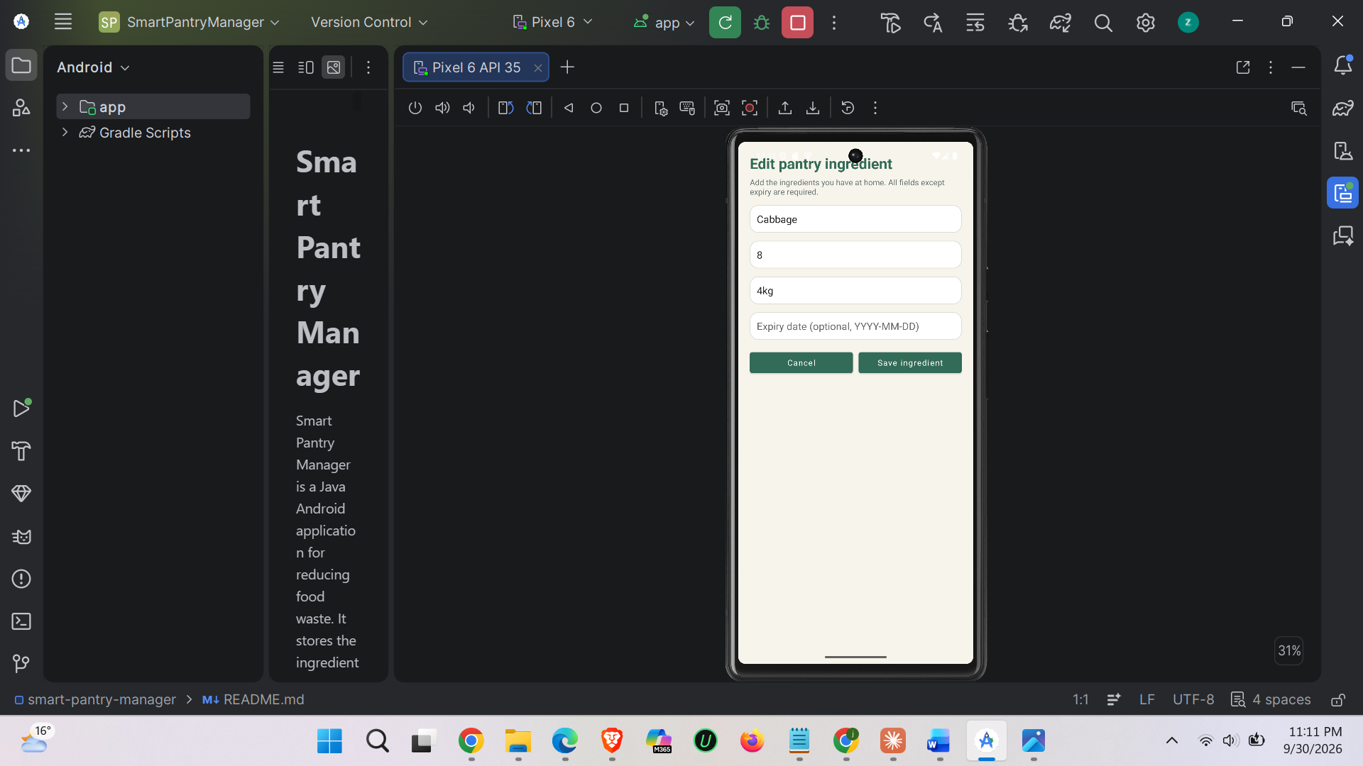
Figure 5. An existing pantry item loaded into the form before its quantity or other value is changed.
SCREENSHOT 6
Pantry list after editing
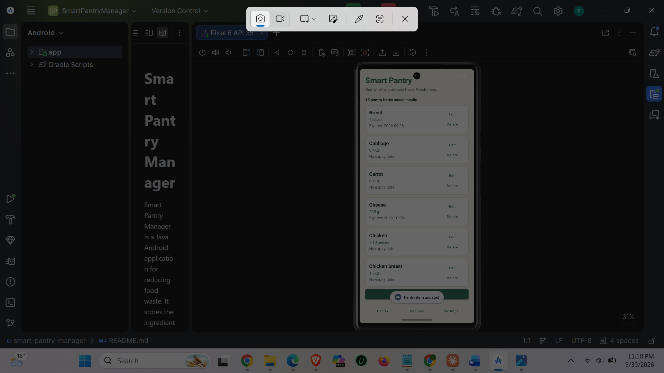
Figure 6. The updated pantry item after saving an edit.

SCREENSHOT 7
Delete confirmation
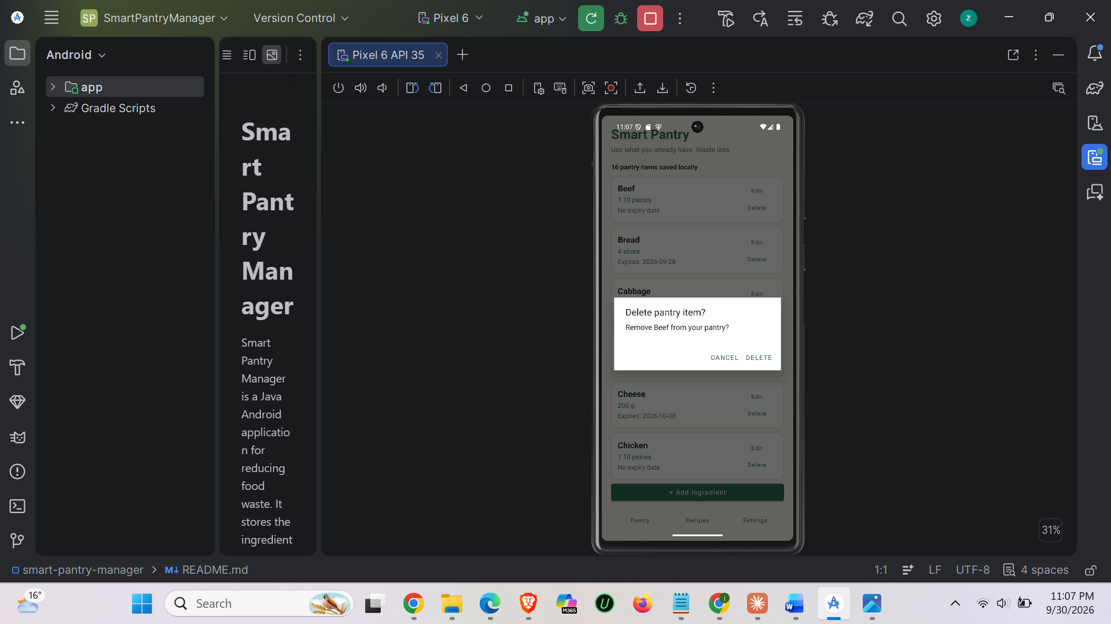
Figure 7. The confirmation dialog displayed before a pantry item is removed.
SCREENSHOT 8
Pantry list after deleting
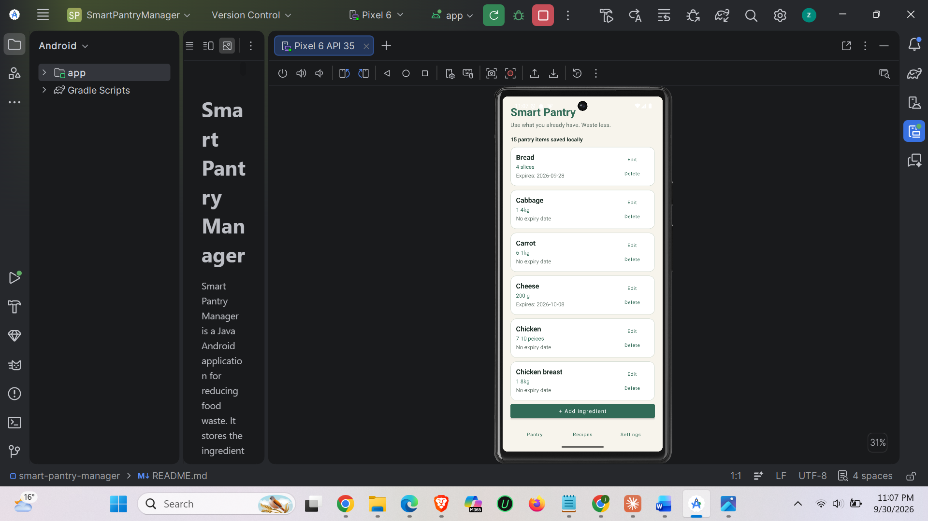
Figure 8. The list after the selected pantry item has been deleted.

SCREENSHOT 9
Suggested Recipes screen
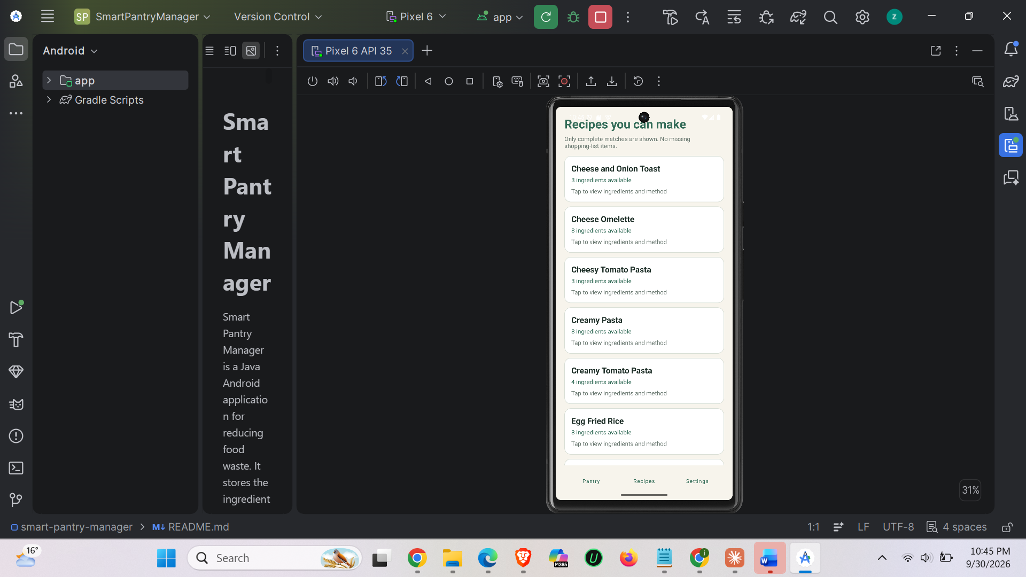
Figure 9. Recipes that pass the all-ingredients-and-quantity matching rule.
SCREENSHOT 10
Empty Suggested Recipes state
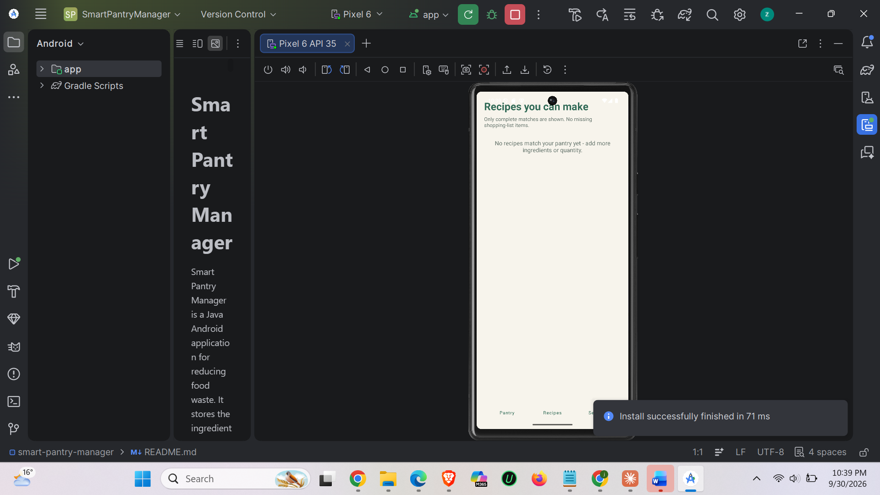
Figure 10. The feedback shown when no recipe can currently be made.

SCREENSHOT 11
Recipe Detail screen
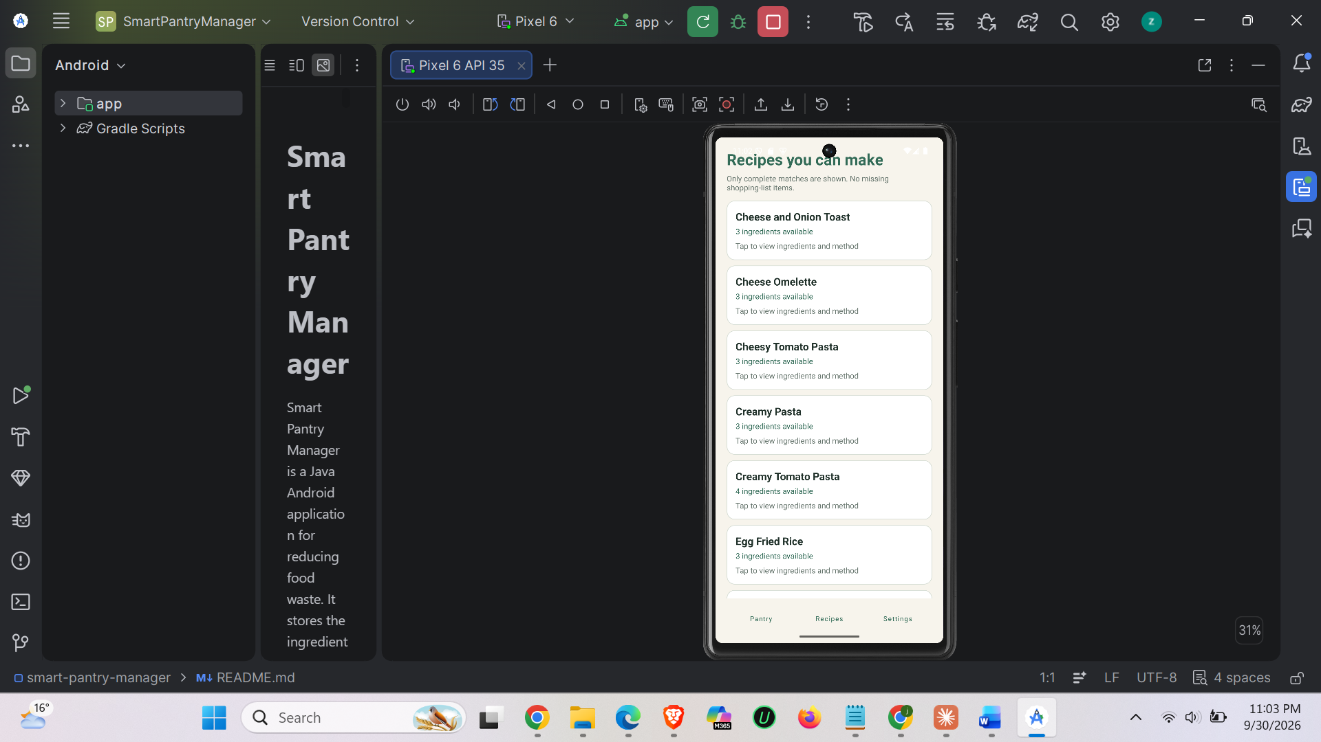

Figure 11. The selected recipe showing its required ingredients, quantities, and preparation steps.
SCREENSHOT 12
Settings screen
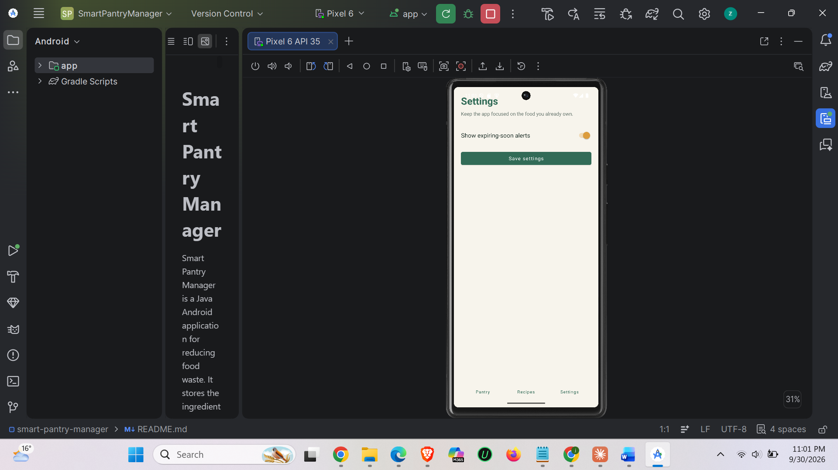

Figure 12. The expiry-alert preference and navigation controls.

SCREENSHOT 13
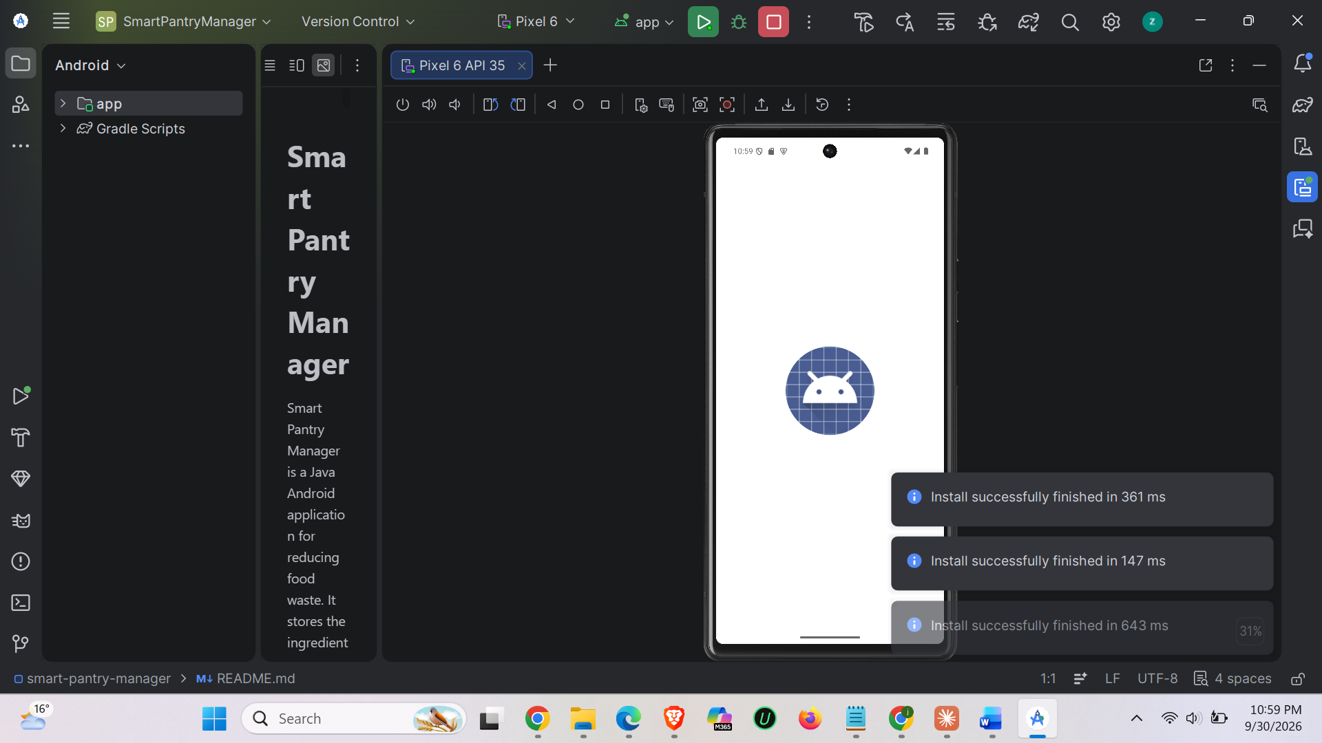Persistence after restart

Figure 13. The same pantry data visible after closing and reopening the application.
SCREENSHOT 14
Strict matching comparison
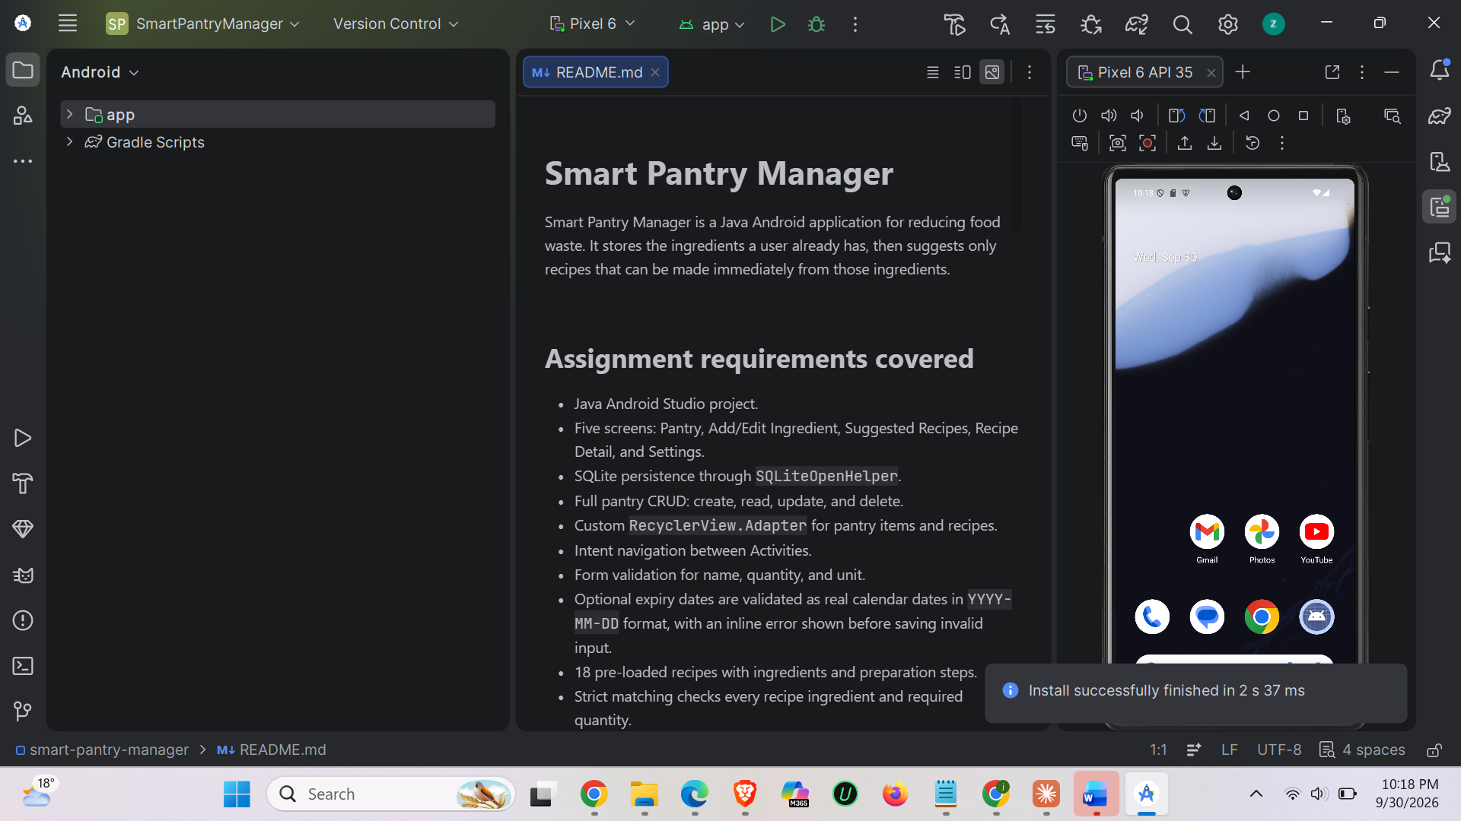
Figure 14. Evidence that a recipe disappears when one required ingredient is reduced below its required quantity, and returns when restored.

4. Key code snippets
The following snippets are short extracts from the attached project archive. They demonstrate the database structure, strict business logic, validation, and dynamic list/navigation implementation without reproducing the entire codebase.

4.1 SQLite database schema
Source: app/src/main/java/com/example/smartpantry/data/DatabaseHelper.java
db.execSQL("CREATE TABLE pantry_items (" +
"id INTEGER PRIMARY KEY AUTOINCREMENT, " +
"name TEXT NOT NULL, quantity REAL NOT NULL, unit TEXT NOT NULL, " +
"expiry_date TEXT)");
db.execSQL("CREATE TABLE recipes (" +
"id INTEGER PRIMARY KEY AUTOINCREMENT, name TEXT NOT NULL, steps TEXT NOT NULL)");
db.execSQL("CREATE TABLE recipe_ingredients (" +
"id INTEGER PRIMARY KEY AUTOINCREMENT, recipe_id INTEGER NOT NULL, " +
"name TEXT NOT NULL, required_quantity REAL NOT NULL, unit TEXT NOT NULL, " +
"FOREIGN KEY(recipe_id) REFERENCES recipes(id) ON DELETE CASCADE)");
Explanation: The schema separates user pantry data from the recipe catalogue and its ingredient requirements. The foreign key allows each recipe to have multiple ingredient rows while keeping the data model simple and local.

4.2 Strict recipe matching
Source: app/src/main/java/com/example/smartpantry/util/IngredientMatcher.java
for (RecipeIngredient required : recipe.getIngredients()) {
double available = 0;
boolean compatibleIngredientFound = false;
for (PantryItem pantryItem : pantryItems) {
if (normalizeName(pantryItem.getName()).equals(normalizeName(required.getName()))
&& compatibleUnits(pantryItem.getUnit(), required.getUnit())) {
compatibleIngredientFound = true;
available += toBaseQuantity(pantryItem.getQuantity(), pantryItem.getUnit());
}
}
double needed = toBaseQuantity(required.getRequiredQuantity(), required.getUnit());
if (!compatibleIngredientFound || available + 0.0001 < needed) return false;
}
return true;
Explanation: The loop checks every required ingredient rather than counting partial matches. It also supports duplicate pantry rows and compatible metric conversions, while returning false for missing or insufficient requirements.

4.3 Form validation before saving
Source: app/src/main/java/com/example/smartpantry/AddEditIngredientActivity.java
if (quantity <= 0) {
quantityInput.setError("Quantity must be greater than zero");
quantityInput.requestFocus();
return;
}
if (!expiryDate.isEmpty() && !ValidationUtils.isValidExpiryDate(expiryDate)) {
expiryInput.setError("Enter a real date in YYYY-MM-DD format");
expiryInput.requestFocus();
return;
}
Explanation: Validation is performed before SQLite writes occur. This prevents zero or negative stock from affecting recipe suggestions and gives the user an inline message next to the problematic field.

4.4 Custom RecyclerView adapter
Source: app/src/main/java/com/example/smartpantry/ui/PantryAdapter.java
@Override
public void onBindViewHolder(@NonNull PantryViewHolder holder, int position) {
PantryItem item = items.get(position);
holder.name.setText(item.getName());
holder.quantity.setText(String.format(Locale.getDefault(), "%.2f %s",
item.getQuantity(), item.getUnit()));
holder.edit.setOnClickListener(v -> listener.onEdit(item));
holder.delete.setOnClickListener(v -> listener.onDelete(item));
}
Explanation: The adapter binds each database item to a reusable row and forwards edit/delete actions to MainActivity through a listener. This provides the required dynamic list with a custom adapter.

4.5 Intent navigation and refresh
Source: app/src/main/java/com/example/smartpantry/MainActivity.java
findViewById(R.id.buttonAddIngredient).setOnClickListener(v ->
startActivity(new Intent(this, AddEditIngredientActivity.class)));
@Override
protected void onResume() {
super.onResume();
loadPantry();
}
Explanation: The Intent opens the add/edit Activity, while onResume reloads the SQLite results whenever the user returns. This makes saved, edited, and deleted items visible without restarting the application.

5. Challenges and solutions

5.1 Enforcing complete recipe matches
A partial match would create misleading suggestions. For example, having bread without cheese should not show a cheese toast recipe. The solution was to make IngredientMatcher iterate over every RecipeIngredient and reject the recipe immediately when one required ingredient is missing or the converted quantity is too small. Tests were added for missing ingredients, plural names, metric conversion, and incompatible pieces/slices.

5.2 Comparing quantities and units safely
Users may enter quantities using different but compatible units, such as 0.5 kg and 500 g. The solution was to normalise unit names and convert compatible metric units to a common base before comparing them. Count units are kept separate so that two slices are not incorrectly treated as two pieces.

5.3 Preventing invalid data from entering the pantry
An empty ingredient name, non-positive quantity, missing unit, or impossible expiry date would reduce the reliability of the pantry and recipe results. ValidationUtils checks real calendar dates in YYYY-MM-DD format, while the ingredient form validates required text and positive numeric quantities before calling the database insert or update method. Inline errors keep the user on the form until the value is corrected.

6. Conclusion and reflection
Smart Pantry Manager demonstrates how a native Java Android application can combine Activities, Intents, RecyclerView adapters, SQLite persistence, validation, and a clear domain rule. The application solves a practical household problem by turning a pantry inventory into recipe suggestions without requiring an internet connection or external service.
The project reinforced the importance of separating responsibilities. DatabaseHelper manages storage, the model classes represent data, the adapters manage list presentation, Activities manage screen interaction, and IngredientMatcher contains the recipe decision logic. This separation makes the project easier to explain, test, and extend.
Given more time, I would add a date-picker control, search and filtering for recipes, a way to save favourite recipes, richer expiry reminders, and UI instrumentation tests on several Android screen sizes. I would also add a more detailed accessibility pass for content descriptions, contrast, and larger text settings.

7. Reference list
References are presented in a consistent author-date style and were consulted for Android platform and Java implementation decisions.
- Android Developers (n.d.) Activities. Available at: https://developer.android.com/guide/components/activities/activities-intro (Accessed: 30 September 2026).
- Android Developers (n.d.) Intent and intent filters. Available at: https://developer.android.com/guide/components/intents-filters (Accessed: 30 September 2026).
- Android Developers (n.d.) Save data in a local database using SQLite. Available at: https://developer.android.com/training/data-storage/sqlite (Accessed: 30 September 2026).
- Android Developers (n.d.) RecyclerView. Available at: https://developer.android.com/develop/ui/views/layout/recyclerview (Accessed: 30 September 2026).
- Oracle (n.d.) SimpleDateFormat (Java Platform SE documentation). Available at: https://docs.oracle.com/javase/8/docs/api/java/text/SimpleDateFormat.html (Accessed: 30 September 2026).
- JUnit (n.d.) JUnit 4 documentation. Available at: https://junit.org/junit4/ (Accessed: 30 September 2026).
- Mobile App Development 700 (2026) Practical Assignment brief: Smart Pantry Manager requirements. Course-provided document.

