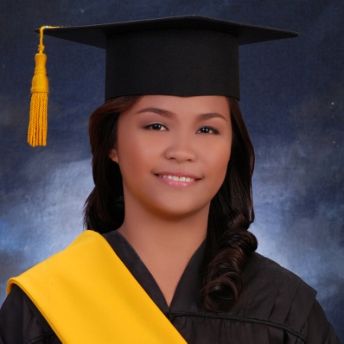**SHAIRA MAE ROMEO**

**Associate in Computer Technology**

On-the Job training at TESDA-PO CEBU, with experience in PC building, Repair, and Issues Troubleshooting, Computer Hardware Servicing (NCII holder), 2D Animation (NC III holder ) Basic Computer language programming C# with MySql database, Involve in Multimedia design using HTML, Photoshop, CSS, and Bootstrap, Attended various computer workshops seminars

**Objective**

To obtain part time employment, I would welcome a challenging job. That involves my currently skills and hopefully learn new experience.

**Contact Information**

Address : Labangon Tisa , Cebu City

Mobile : 09339681041

Email : romeoshairamae@gmail.com

**Personal Information**

Age : 22

Gender : Female

Height : 5’1

Weight : 66 kg

Civil Status : Single

Birthdate : December 17,1996

Birth Place : 83 St. Katipunan, Labangon Cebu City

Religion : Roman Catholic

Nationality : Filipino

Father’s Name : Jose Rexon C. Guradillo

Mother’s Name : Rufina R. Guradillo

Language Spoken : English, Tagalog, Bisaya

**Educational Attainment**

**College:** **University of Cebu- Main Campus**

**Bachelor of Science in Information Technology**

Sanciangko St., Cebu City

2016 – Present

Interface Computer College

**Associate in Computer Technology**

Jones Ave., Cebu City

2014 – 2016

**Secondary:** Dalaguete National High School

2011 – 2014

**Primary:** Dalaguete Central Elementary School

2003 – 2010

**Skills**

* Oriented in Microsoft Office Application such as:
  + - Microsoft Office Word
    - Microsoft Office Excel
    - Microsoft Office Power Point
* PC building and Basic Computer Troubleshooting
* Basic Computer Networking (Cabling and Crimping)
* Computer Hardware Servicing NC II Holder (CHS NCII)
* 2D Animation NC III Holder
* Oriented in Language programming using C# and Java including database MySql
* Capable in creating wed design using HTML and CSS, Bootstrap
* Oriented in graphics design using Adobe Photoshop and Adobe Illustrator
* Ability to work
* Ability to cooperate with others

**Seminar Attended / Training**

* **On-The Job Training**

TESDA-PO Cebu

October 19, 2015 – April 15, 2016

* **7 Habits of Highly Effective People**

Interface Computer College

* **C Language Seminar**

Interface Computer College

October 25, 2014

* **Cyber Security Awareness Seminar**

Cebu Business Hotel, Junquera St., Cebu City

March 13, 2015

**References**

**Name** : Ms. Tiffany Joyce Aloba

**Position**  : Scholarship Support Staff -TESDA PO Cebu

**Address** :Salinas Drive corner Archbishop Reyes Avenue, Lahug,

Cebu City

**Contact no.** : 09435313885