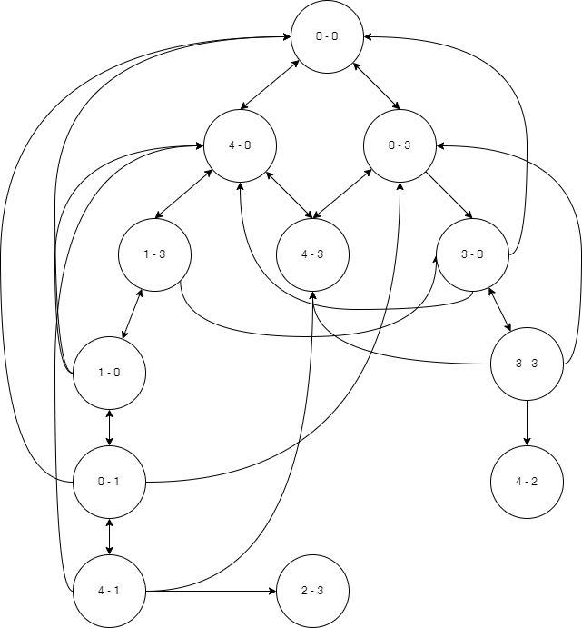

Đồ Thị

|  |  |  |
| --- | --- | --- |
| **Lần** | **open** | **closed** |
| Lần 1 | 0 – 0 | 0 – 0 |
| Lần 2 | 4 – 0, 0 – 3 | 0 – 0, 4 – 0, 0 – 3 |
| Lần 3 | 0 – 3, 1 – 3,  4 – 3 | 0 – 0, 4 – 0, 0 – 3, 1 – 3, 4 – 3 |
| Lần 4 | 1 – 3, 4 – 3,  3 – 0 | 0 – 0, 4 – 0, 0 – 3, 1 – 3, 4 – 3, 3 – 0 |
| Lần 5 | 4 – 3, 3 – 0,  1 – 3 | 0 – 0, 4 – 0, 0 – 3, 1 – 3, 4 – 3, 3 – 0, 1 – 3 |
| Lần 6 | 3 – 0, 1 – 3 | 0 – 0, 4 – 0, 0 – 3, 1 – 3, 4 – 3, 3 – 0, 1 – 3 |
| Lần 7 | 1 – 3, 3 – 3 | 0 – 0, 4 – 0, 0 – 3, 1 – 3, 4 – 3, 3 – 0, 1 – 3, 3 – 3 |
| Lần 8 | 3 – 3, 1 – 0 | 0 – 0, 4 – 0, 0 – 3, 1 – 3, 4 – 3, 3 – 0, 1 – 3, 3 – 3, 1 – 0 |
| Lần 9  (Tìm thấy) | 1 – 0, 4 – 2 | 0 – 0, 4 – 0, 0 – 3, 1 – 3, 4 – 3, 3 – 0, 1 – 3, 3 – 3, 1 – 0,  4 – 2 |
| Lần 10 | 4 – 2, 0 – 1 | 0 – 0, 4 – 0, 0 – 3, 1 – 3, 4 – 3, 3 – 0, 1 – 3, 3 – 3, 1 – 0,  4 – 2, 0 – 1 |
| Lần 11 | 0 – 1, 4 – 1 | 0 – 0, 4 – 0, 0 – 3, 1 – 3, 4 – 3, 3 – 0, 1 – 3, 3 – 3, 1 – 0,  4 – 2, 0 – 1, 4 – 1 |
| Lần 12  (Tìm thấy) | 4 – 1, 2 – 3 | 0 – 0, 4 – 0, 0 – 3, 1 – 3, 4 – 3, 3 – 0, 1 – 3, 3 – 3, 1 – 0,  4 – 2, 0 – 1, 4 – 1, 2 – 3 |
| Lần 13 | 2 – 3 | 0 – 0, 4 – 0, 0 – 3, 1 – 3, 4 – 3, 3 – 0, 1 – 3, 3 – 3, 1 – 0,  4 – 2, 0 – 1, 4 – 1, 2 – 3 |
| Lần 14 |  | 0 – 0, 4 – 0, 0 – 3, 1 – 3, 4 – 3, 3 – 0, 1 – 3, 3 – 3, 1 – 0,  4 – 2, 0 – 1, 4 – 1, 2 – 3 |