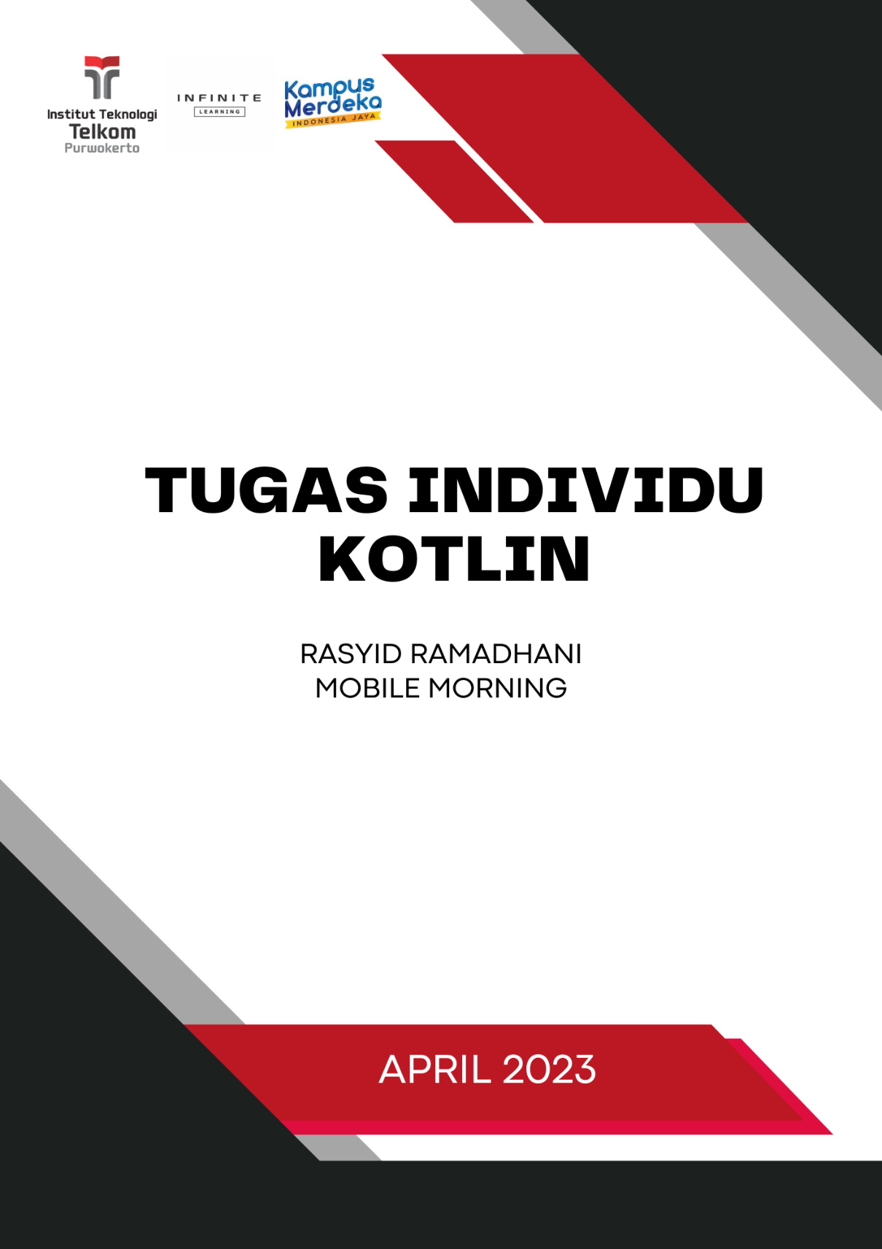COVER

# KOTLIN FUNDAMENTAL

|  |  |
| --- | --- |
| **1.** | Data Types |
| Code | |
| **Output** | |
|  | |

|  |  |
| --- | --- |
| **2.** | Functions |
| **Code** | |
| **Output** | |

|  |  |
| --- | --- |
| **3.** | If Expressions |
| **Code** | |
| **Output** | |

|  |  |
| --- | --- |
| **4.** | Nullable Types |
| **Code** | |
| **Output** | |

|  |  |
| --- | --- |
| **5.** | Safe Calls and Elvis Operator |
| **Code** | |
| **Output** | |

|  |  |
| --- | --- |
| **6.** | String Template |
| **Code** | |
| **Output** | |

|  |  |
| --- | --- |
| **7.** | Variable |
| **Code** | |
| **Output** | |

# KOTLIN CONTROL FLOW

|  |  |
| --- | --- |
| **1.** | If Else Expressions |
| **Code** | |
| **Output** | |

|  |  |
| --- | --- |
| **2.** | When Expressions |
| **Code** | |
| **Output** | |

|  |  |
| --- | --- |
| **3.** | Range |
| **Code** | |
| **Output** | |

|  |  |
| --- | --- |
| **4.** | Looping For |
| **Code** | |
| **Output** | |

|  |  |
| --- | --- |
| **5.** | Looping While |
| **Code** | |
| **Output** | |

|  |  |
| --- | --- |
| **6.** | Break |
| **Code** | |
| **Output** | |

|  |  |
| --- | --- |
| **7.** | Continue |
| **Code** | |
| **Output** | |

# KOTLIN COLLECTION

|  |  |
| --- | --- |
| **1.** | List |
| **Code** | |
| **Output** | |

|  |  |
| --- | --- |
| **2.** | Set |
| **Code** | |
| **Output** | |

|  |  |
| --- | --- |
| **3.** | Map |
| **Code** | |
| **Output** | |

|  |  |
| --- | --- |
| **4.** | Filter() |
| **Code** | |
| **Output** | |

|  |  |
| --- | --- |
| **5.** | Find(), firstOrNull(), dan lastOrNull() |
| **Code** | |
| **Output** | |

|  |  |
| --- | --- |
| **6.** | First() & Last() |
| **Code** | |
| **Output** | |

|  |  |
| --- | --- |
| **7.** | Sum() |
| **Code** | |
| **Output** | |

|  |  |
| --- | --- |
| **8.** | Sorted() |
| **Code** | |
| **Output** | |