Arduino Watchdog Protoshield – Production

Parts list:
1x 555 timer chip.
1x 1M ohm resistor.
1x 220 ohm resistor.
1x 560 ohm resistor.
1x diode.
1x 100 uF/mF capacitor (C1 below, large cap)
1x 10 nF capacitor (C2 below, small cap)
1x Arduino protoshield
Colored wires (red, black, and two other colors of your choice – I used yellow and blue).

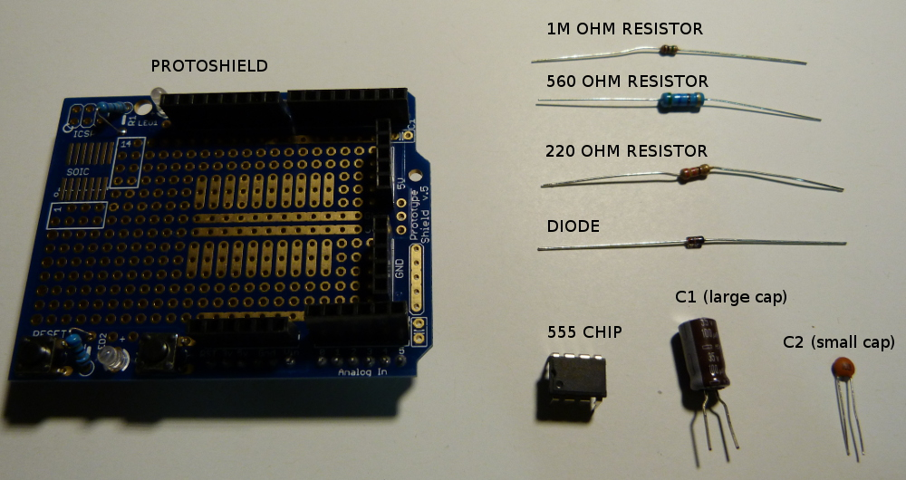

Master List Of Steps (see below for details on each step):

-Place 555 chip in bottom right hand corner of the protoshield, with the small notch/dot to the bottom left (see photo below in Step 1)
-Pin 1 is at top left (on notch/dot), pin 8 is top right (across from notch/dot).
-Pin 1 goes to ground.
-Pin 2 goes between pin 6 (the “wire nexus”) and C1 (the big cap, the striped end of which goes to ground).
-Pin 3 goes through a diode and wire to Reset.
-Pin 4 goes to 5V.
-Pin 5 goes through C2 (the small cap) to ground.
-Pin 6 goes to other connections (it's the “wire nexus”) as described above/below, as well as into a 560 ohm resistor connected to a wire to Digital I/O pin 4.
-Pin 7 has two connections: it goes through a 1M ohm resistor to 5V, and also through a 220 ohm resistor to pin 6 (the “wire nexus”).
-Pin 8 goes to 5V.

STEP 1: Place 555 chip in bottom right hand corner of the protoshield, with the small notch/dot to the bottom left.

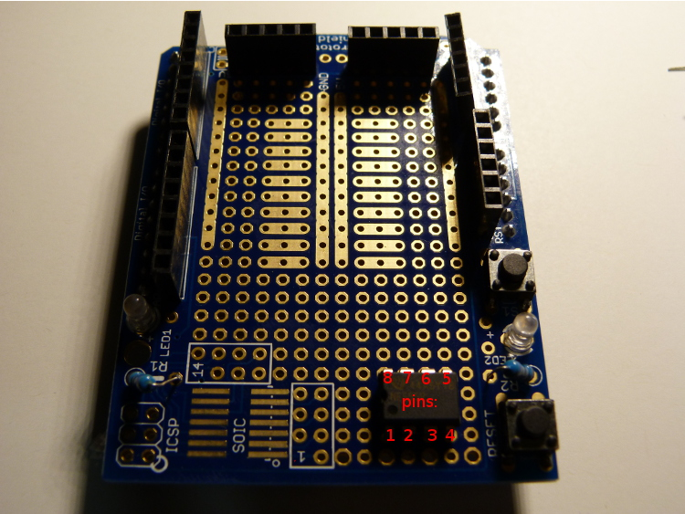
STEP 2: Solder pin 1 to GND on the bottom side of the protoshield (note numbered bottom view of pins), using black wire as shown:

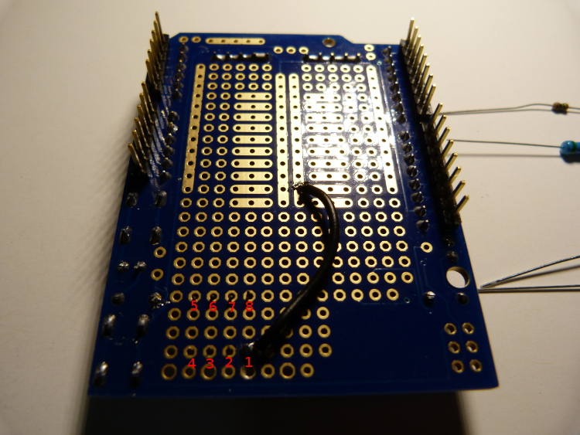

STEP 3: Put C1 (the big brown cap) into the protoshield from the top, as shown. Note that the white stripe on the cap MUST face LEFT (the side with the dot/notch on the chip) as shown.

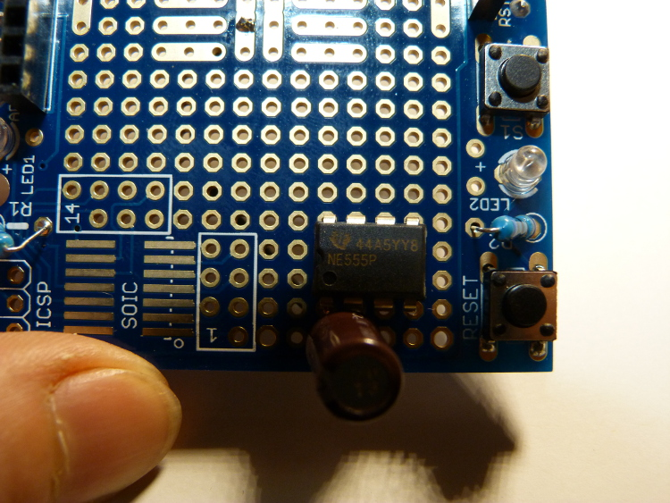

STEP 3, CONTINUED: Turn the protoshield over (slightly bend the legs of C1 to hold it into the shield if need be). Then solder the right-hand leg (connected to the stripe side of C1) to ground / Pin 1 as shown (only more neatly, please :P)

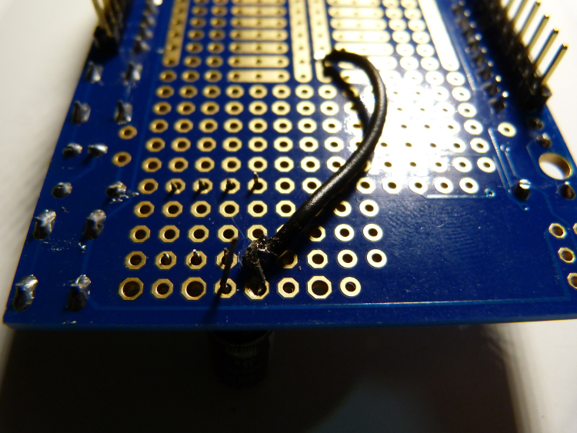
STEP 3, CONTINUED, CONTINUED: Solder the second leg of C1 to Pin 2, as shown (from reverse angle):

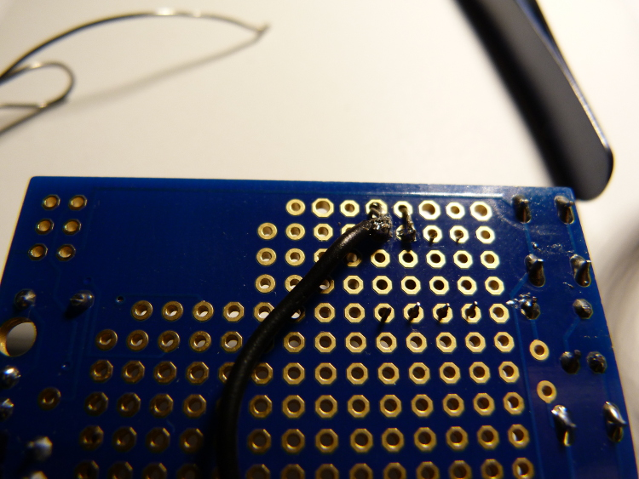

STEP 4: Bend the diode and push it through the top of the protoshield next to C1, as shown. Note that the black end of the diode MUST face LEFT (i.e. toward C1 / Pin 3) as shown.

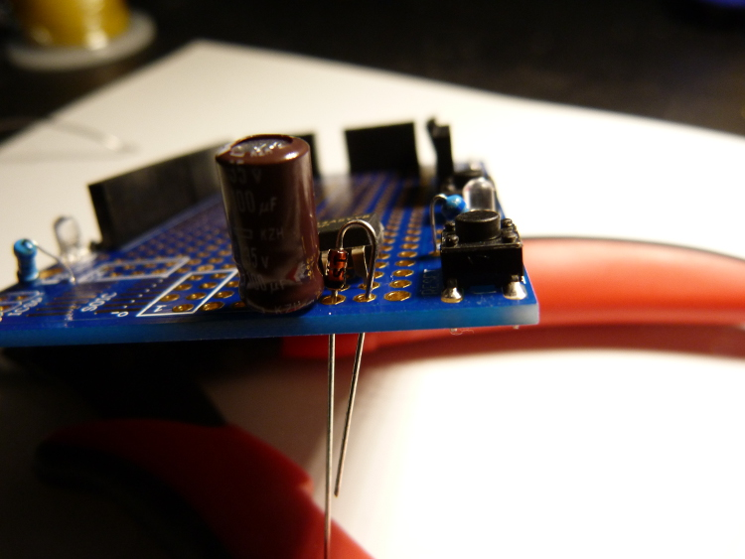
STEP 4, CONTINUED: Solder the striped end of the diode to Pin 3. Then push a long-ish wire (preferably yellow) through the protoboard from the top (either into the same hole as the other leg of the diode, or one hole over) and solder it to the other leg of the diode, as shown. The other end of this wire will go to the Reset header on the protoboard (worry about that part later, for now just strip the wire so that there's a bit of bare wire at the end).
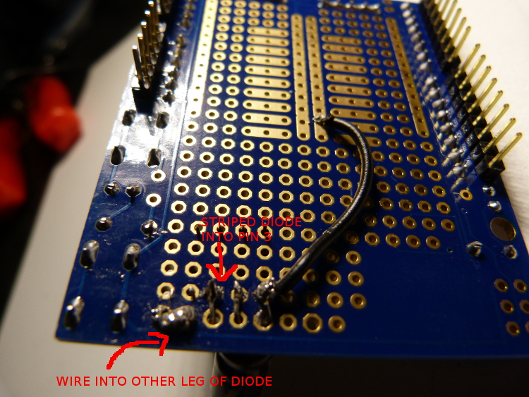

STEP 4, top view with diode and yellow wire:

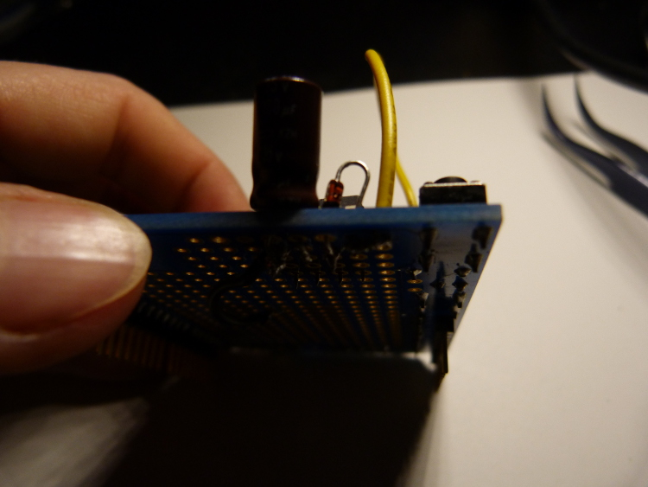

STEP 5: Solder pin 4 (using red wire as shown) to 5V. Ignore the extra black wire on the right, that's from the next step.

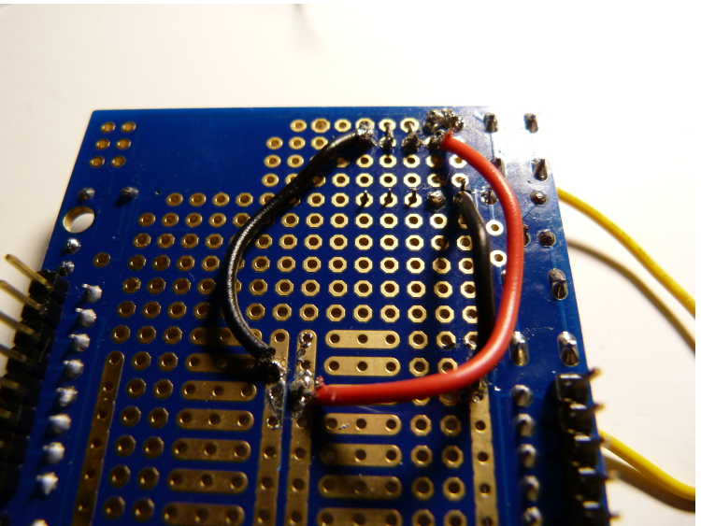

STEP 5.5: You are now halfway done with the pins. Take a break!

STEP 6: Place C2 (the small orange cap) through the top of the protoboard next to Pin 5 and the edge of the board, as shown. Solder one leg to Pin 5, and one to ground (using black wire), as shown.

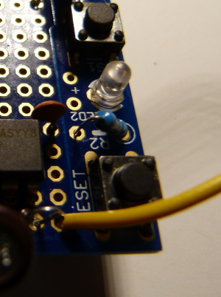

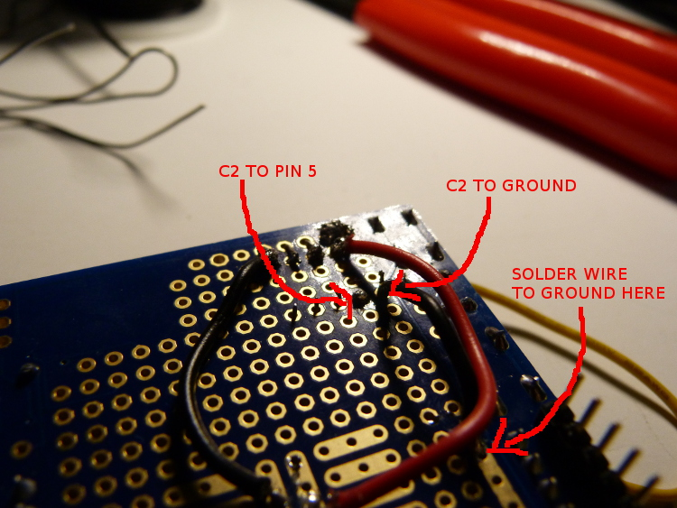

STEP 7: Bend a 1M ohm resistor (brown, black, green stripes) into a bow shape and push it through the top of the protoboard next to Pin 7, as shown. We will skip pin 6 for now.

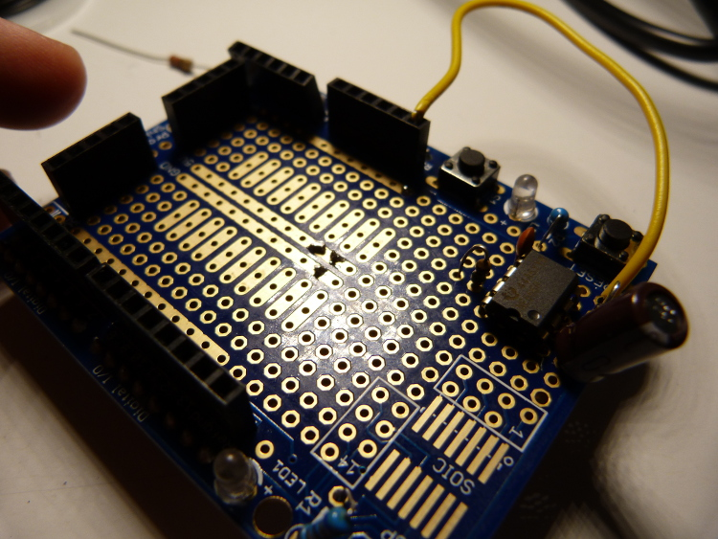

(step 7 continued, next page)

STEP 7, CONTINUED: Flip the protoboard over and solder one side of the 1M ohm resistor to Pin 7 (NOT pin 6, I recommend skipping this for now – it's easier to wire at the end), and the other to a (red) wire to 5V, as shown.

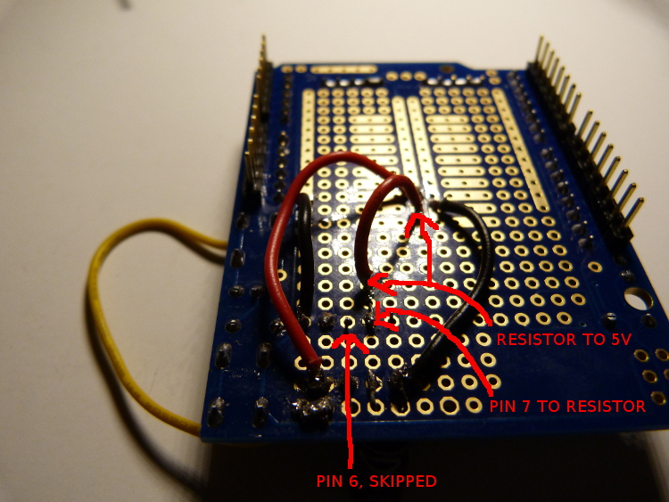
STEP 8: Bend a 220 ohm resistor (one brown and two red stripes) into a bow shape and push it through the top of the protoboard next to Pin 6, as shown. (Ignore the extra blue resistor & wire in the photo, we haven't placed them yet).

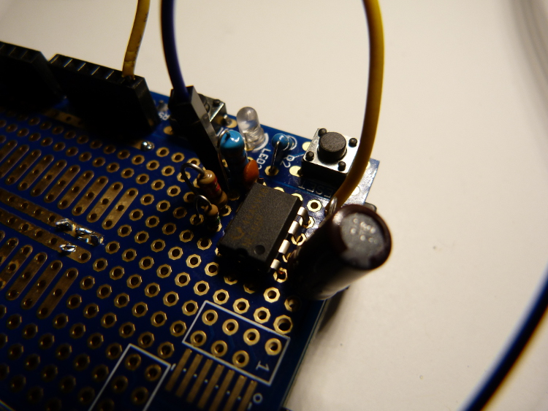

STEP 8, CONTINUED: Solder one end of the 220 ohm resistor to Pin 7, and the other end to Pin 6, as shown.

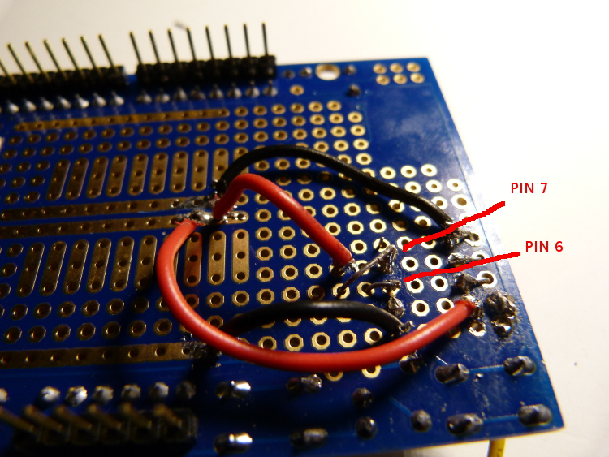

STEP 9: Solder pin 8 to 5V, using a red wire (orange you glad I didn't say resistor!)

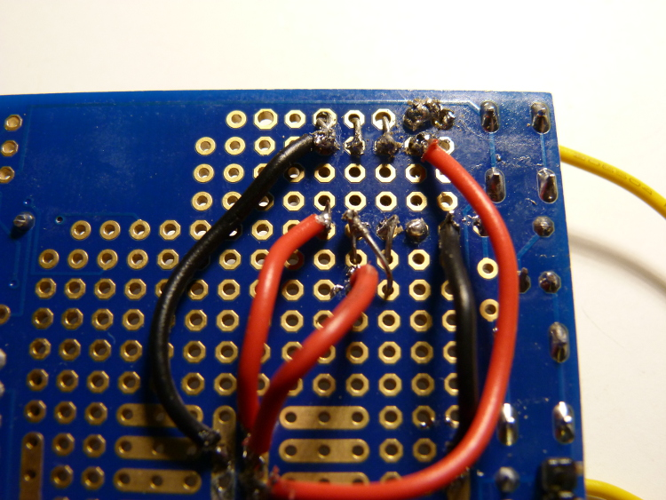

STEP 10: j/k, step 10 is totally another resistor! Bend a 560 ohm resistor (gold, red, blue, green stripes) into a bow shape and push it through the top of the protoboard next to Pin 5 and the edge of the board, as shown.

(Step 10, continued next page)

STEP 10, CONTINUED: Flip the protoboard over and solder one side of the 560 ohm resistor to Pin 6. Then poke a long-ish wire (preferably blue) through the top of the protoboard (as shown in the photo above, use the same hole as the other leg of the resistor or one next to it), and solder it to the other end of the resistor. Last, take a small piece of wire (the clipped end of one of the resistors you used earlier works well) and solder it between Pin 2 and Pin 6, as shown:

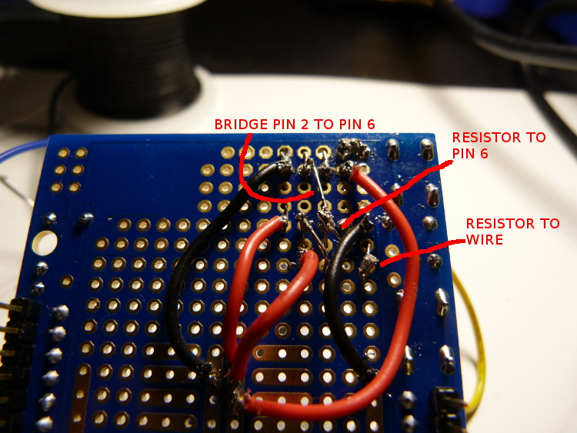

(step 11, next page)

STEP 11: Sorry for step 10! But if your protoboard looks something like the photos below, then you are DONE (ﾉoヮo)ﾉ*:・ﾟ.*✧

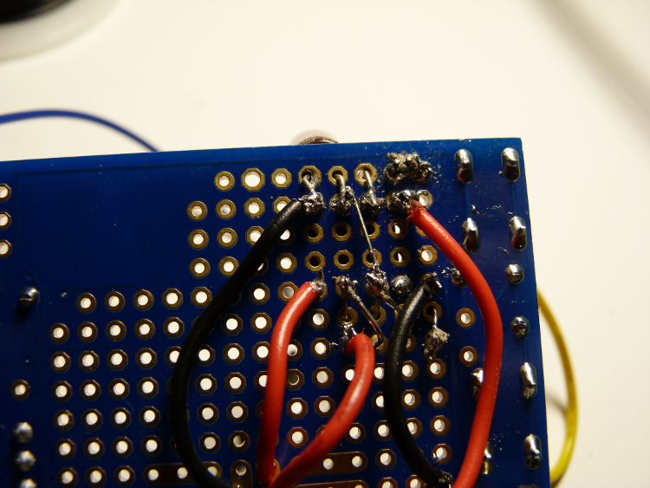
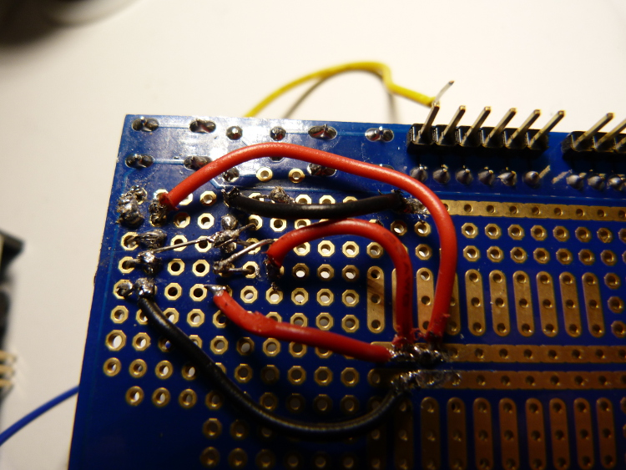

Completed watchdog protoshield:

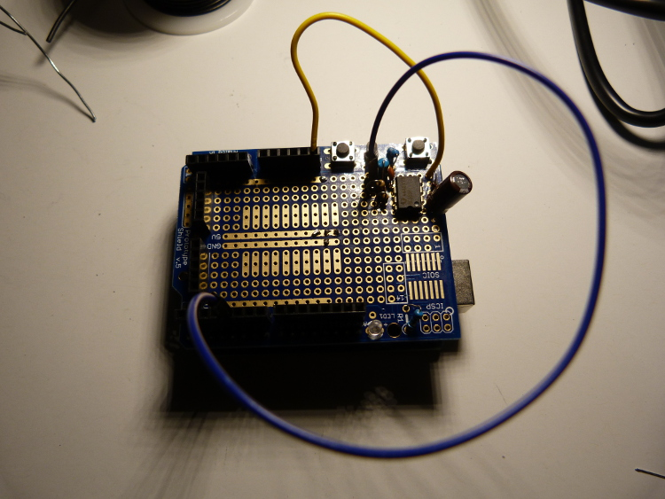

The last step is TESTING. Go to the github (https://github.com/MeowWolf/Arduino-Watchdog-Circuit) and download the “watchdog-sketch”. Upload it to an Arduino with the shield attached (ask someone on the tech team for help with this step if you're not sure how), and open the Serial Monitor. Assuming that the yellow wire is plugged into RST and the blue wire is plugged into Digital I/O 4 (as shown above), you'll see messages that say:

Arduino Reset
Heartbeat Sent
Uptime: 5 seconds (0 seconds since last heartbeat)
Heartbeat Sent
Uptime: 10 seconds (2 seconds since last heartbeat) [...]

For the first phase of the test, allow this to continue until Uptime reads at least 300 seconds. If you DO NOT see a further “Arduino Reset” message during this time, the first test passes! If you DO see “Arduino Reset”, see “IF THINGS GO WRONG“ below.

For the second test, remove the blue wire from Digital I/O 4. This will cause the watchdog to stop receiving heartbeats, which should cause a reset. Wait at least 300 more seconds, and up to 500. If you see a further “Arduino Reset” message during this time, the second test passes, and you have made a functioning Arduino watchdog circuit! (if not, see IF THINGS GO WRONG below).

Once you see “Arduino Reset” during the second test, allow the circuit to reset a few more times (it will do so automatically), and record the last Uptime message before the “Arduino Reset” (it's OK if it's not exactly the same each time, but it should be roughly similar...) Write “Watchdog, Uptime <x> seconds” on a piece of white tape, along with the your name and the date, and tape it to the back of the watchdog protoshield. You are finished, congratulations!

IF THINGS GO WRONG: If you are unable to upload a program to the Arduino with the shield attached (especially if you get messages about “avrdude”), check the back of the circuit and make sure no two connections have been bridged (connected accidentally). This can happen if you connect the wires/components, OR if you connect the metal circles around each hole in the board. You can usually fix this with the soldering iron, just wipe the extra solder away.

If your watchdog fails test 1 (i.e. it reboots with I/O 4 attached) and/or 2 (i.e. it fails to reboot within 500 seconds after removing I/O 4), then something went wrong – most likely with the soldering, or the order of the components. Compare your protoshield to the photos, and see if you can fix it; if not, that's OK, just start another!

