Task 01 : AI-POWERED YOUTUBE SCRIPT AND THUMBNAIL GENERATOR

Topic Name - 5 AI Tools That Can Replace a Full-Time Job (in 2025)

Prompt Chain Document
PROMPT 1 — Generate Titles
“Generate 10 catchy, curiosity-driven YouTube video titles for the topic: ‘5 AI Tools That Can Replace a Full-Time Job in 2025.’ Make them optimized for high CTR and focused on AI, careers, and future-of-work trends.”
Selected title - 5 AI Tools That Could Replace Your Job in 2025
PROMPT 2 — Pick Title → Generate Full Script
“Write a complete YouTube script (800–1500 words) based on the following title: 5 AI Tools That Could Replace Your Job in 2025. Use an engaging hook, clear explanations, real examples, optimistic tone, and YouTube-friendly pacing.”
Script -
INTRO
If you think AI is just about writing emails or generating cute cat pictures, buckle up. Because 2025 is shaping up to be the year AI officially stops being a “tool”… and starts acting more like a full-time employee. Today, I’m revealing five AI tools that can actually replace major parts of a human job — sometimes entire job functions — and what that means for you. Whether you want to stay ahead, switch careers, or build something new, this list is your cheat code.
Let’s get into it.
SECTION 1 — Tool #1: AutoGPT-Type Autonomous Agents
Imagine hiring an assistant who works 24/7, doesn’t complain, and can manage full workflows from start to finish. That’s what modern AI agents do. Tools like GPT-powered Agents, Devin-style coding assistants, and workflow AIs can plan tasks, research, generate assets, troubleshoot, and even complete multi-step projects without supervision.
Example: Give the agent a goal like “Build me a simple ecommerce site,” and it will plan the steps, write the code, find product descriptions, optimize SEO, test the site, and deliver a finished project.
Jobs it replaces:
• Junior developers
• Virtual assistants
• Research analysts
• Project coordinators
• QA testers
Why it matters: Anyone who knows how to “manage” these agents becomes instantly more valuable — and faster than entire teams.
SECTION 2 — Tool #2: Video Creation AI (InVideo, Pictory, Runway)
Video production used to require scriptwriters, editors, voiceover artists, designers, and animators. Now, AI tools turn a script into a finished video in minutes.
You paste text → AI generates scenes → AI adds visuals → AI voiceover → AI editing → Export.
Creators, agencies, and businesses are using this to produce ads, explainer videos, product demos, and even long-form content.
Jobs it replaces:
• Editors
• Motion designers
• Scriptwriters
• Thumbnail designers
• Stock footage researchers
Why it matters: Anyone who can supervise these tools can run an entire content studio solo.
SECTION 3 — Tool #3: Code Generators (Cursor, Replit AI, GitHub Copilot X)
Writing code is no longer reserved for specialists. AI coding copilots turn natural language instructions into full software features. They debug, refactor, generate tests, and even architect systems.
Think of it as having a senior engineer looking over your shoulder at all times.
Jobs it replaces:
• Junior developers
• Bug-fix teams
• Test writers
• Basic backend/frontend work
Why it matters: It doesn’t kill developer jobs — it kills boring developer jobs and multiplies productivity.
SECTION 4 — Tool #4: Business Automation AI (Zapier AI, Make AI, Airtable AI)
These tools act like digital employees who manage repetitive tasks:
• Sending emails
• Generating reports
• Updating spreadsheets
• Filing documents
• Moving data between apps
With AI decision-making included, they can now decide when tasks should happen, not just automate them.
Jobs it replaces:
• Admins
• Operations assistants
• Data entry workers
Why it matters: Large companies are replacing entire back-office workflows with these systems. Smart entrepreneurs use them to build “one-person businesses” that run automatically.
SECTION 5 — Tool #5: AI Customer Support (Forethought, Intercom AI, Cohere Chat)
Customer support used to require armies of people. Now AI handles:
• FAQs
• Troubleshooting
• Returns
• Billing questions
• Live chat
• Knowledge lookup
Modern AI support bots understand context, escalate issues, access company knowledge, and mimic human tone.
Jobs it replaces:
• Support representatives
• Onboarding agents
• Tier-1 customer service
Why it matters: Companies are switching entire call centers to AI because it gives instant responses at a fraction of the cost.
CONCLUSION
So does this mean AI is coming for everyone’s job? Not exactly. It’s coming for boring, repetitive tasks. It’s coming for bottlenecks. It’s coming for inefficiency.
But for those who learn to use it? It's not a threat — it’s leverage.
If you understand these tools, you’re not competing against AI…
you’re competing with the people who refuse to use it.

PROMPT 3 — Thumbnail Text
“Generate 10 short, punchy thumbnail texts (2–5 words) for the video title above. Style them for shock, curiosity, and contrast.”
Thumbnail text title - AI Replaces Jobs?
PROMPT 4 — Thumbnail Image Description
“Create a detailed thumbnail concept for a YouTube video titled: ‘AI Replaces Jobs?’.
Include: main subject, emotions, colors, style, background, object placement, lighting, and overall vibe.”
Concept -
A shocked person looking at a glowing laptop screen, surrounded by holographic AI icons floating in the air. Background is a dark gradient with neon blue and purple lighting. Text on top left says “AI Replaces Jobs?” in bold yellow. The person’s expression is exaggerated and high contrast, classic YouTube style. Add a robot hand pointing at a checklist. Use glossy reflections and cinematic lighting.
PROMPT 5 — AI Image Prompt
“Generate a thumbnail image in cinematic, glossy YouTube style. Visual elements: [ADD THUMBNAIL DESCRIPTION HERE]. Use bright contrast, dramatic lighting, bold focus, and professional thumbnail composition.”
Prompt -
“Create a cinematic YouTube thumbnail. A shocked person looking at a glowing laptop, surrounded by floating holographic AI icons and charts. Dark gradient background with neon blue and purple rim lighting. Add a robotic hand pointing toward a digital checklist. High contrast, glossy style, dramatic shadows, bold focus, 4K YouTube thumbnail composition.”

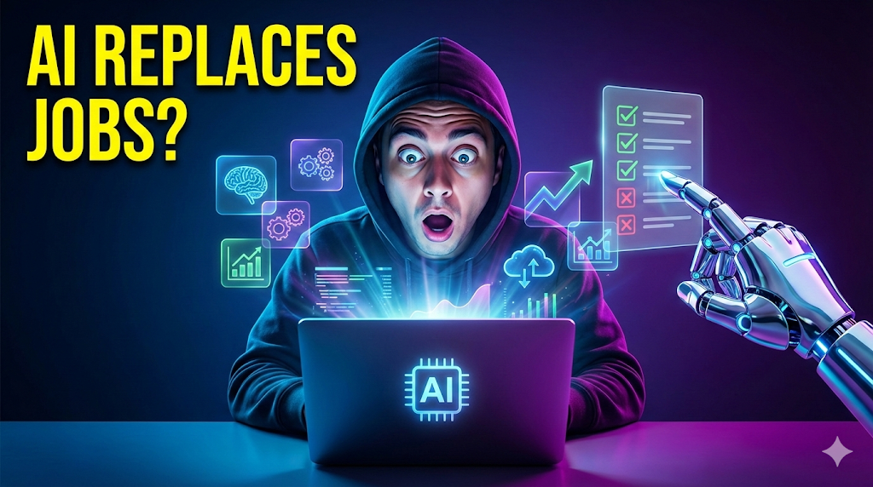

PROMPT 6 — Scene Breakdowns / Storyboard
“Break this script into a scene-by-scene storyboard. For each scene include:
• 1–2 sentences of narration
• Recommended visuals
• Text overlays
• Sound style (optional)”
Scenes -
Scene 1
Narration: Hook about AI replacing jobs in 2025.
Visuals: Fast montage of robots, computers, code, futuristic city.
Text: “5 AI Tools Replacing Jobs”
Scene 2
Narration: Intro to autonomous AI agents.
Visuals: Screens showing tasks auto-completed.
Text: “AI Agents”
Scene 3
Narration: Examples of how agents automate workflow.
Visuals: Flowcharts, computers auto-testing code.
Scene 4
Narration: AI video tools.
Visuals: InVideo/Pictory dashboards.
Text: “AI Video Creation”
Scene 5
Narration: AI code generators.
Visuals: Cursor, Copilot coding automatically.
Text: “AI Coding”
Scene 6
Narration: Business automation tools.
Visuals: Zapier workflows.
Scene 7
Narration: Customer support AI.
Visuals: Chatbots, support dashboards.
Scene 8
Narration: Final message about AI as leverage.
Visuals: Person using AI tools confidently.
Text: “Use AI, Don’t Fear It”

PROMPT 7 — Video Creation
“Convert the script into short segments (7–15 seconds each) with clear visual suggestions, b-roll ideas, and pacing for an AI-generated YouTube video.”
Drive Link for Video - Link

