Name: CESAR IAN AGUJAR Section:BSIT III-A Day  
Instructor: ANGELBERT MAGHANOY Score:   
In this Exercise you will use Visual Studio and the Forms Designer to build a simple Application Notepad. Follow the steps in Designing the Notepad:   
  
1. Open Visual Studio then Select Windows Form Application: Then Change the Name to your Lastname_Pad.

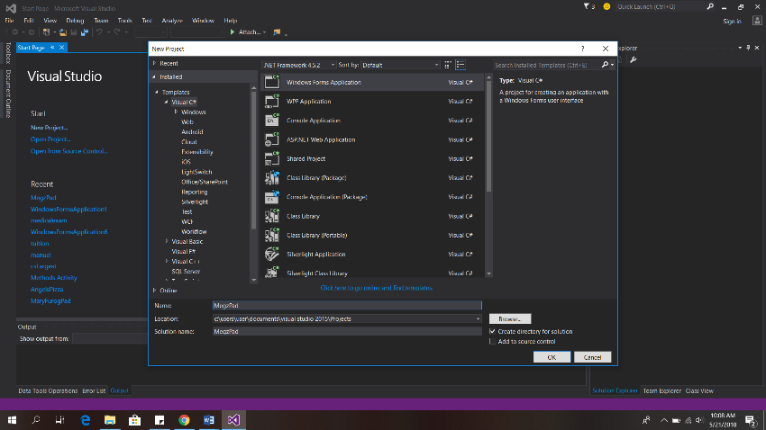  
  
  
  
  
  
  
  
  
  
  
  
2. In your Form Designer. Click the toolbox in the left side portion of your screen, then search Menustrip and drag it into the Form.   
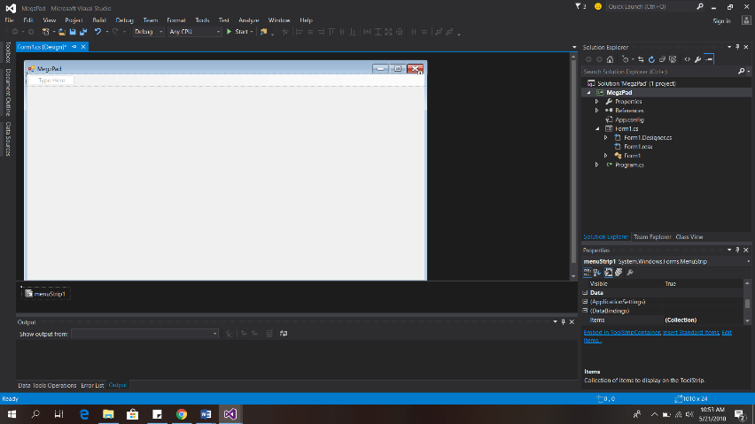

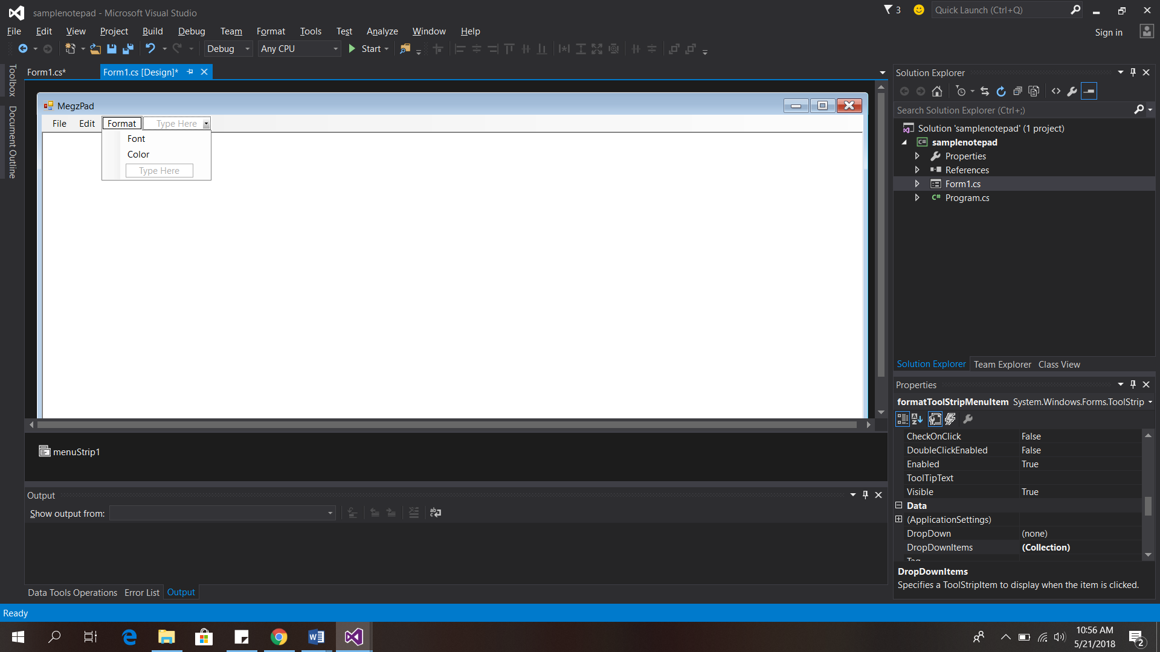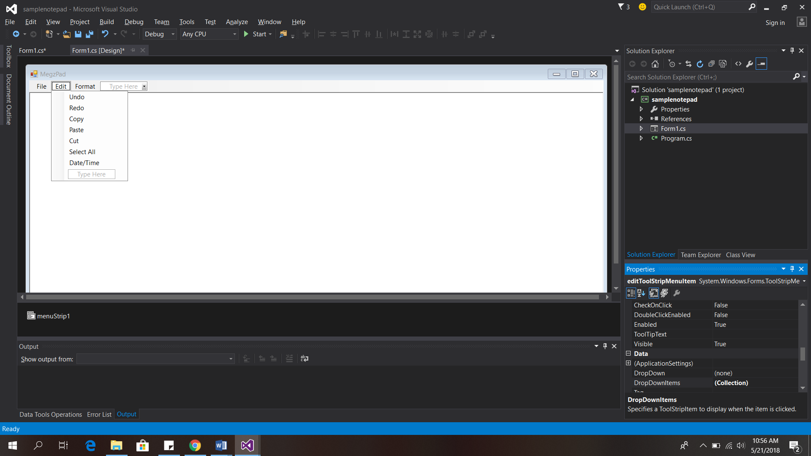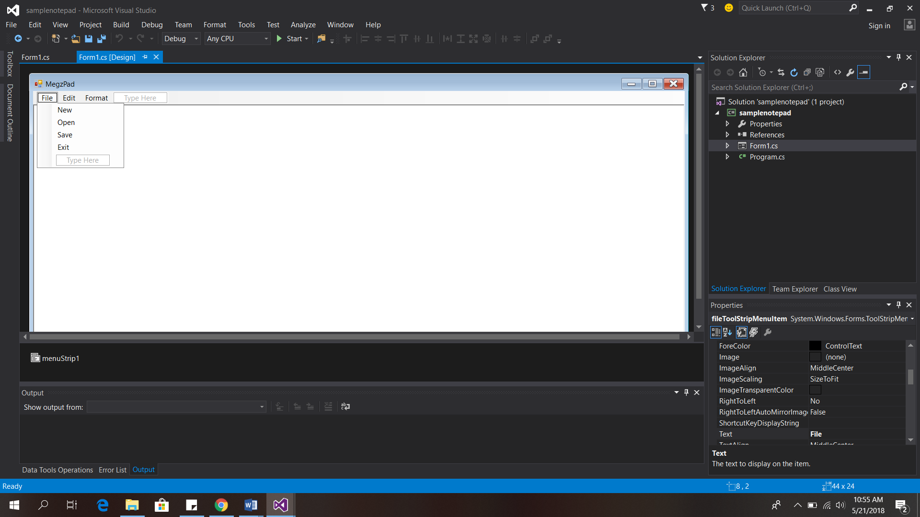3. Follow the Name of the given for the Main Menu Below   
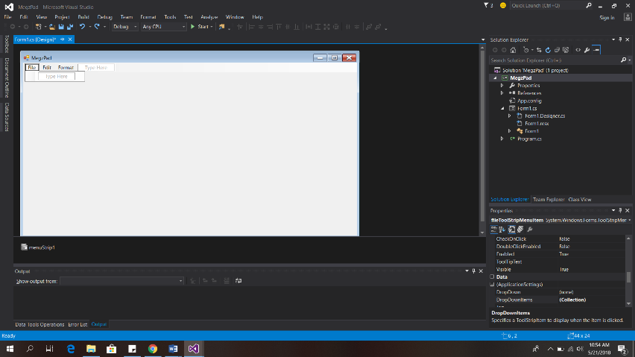  
4. Click the Toolbox then search richtextbox.   
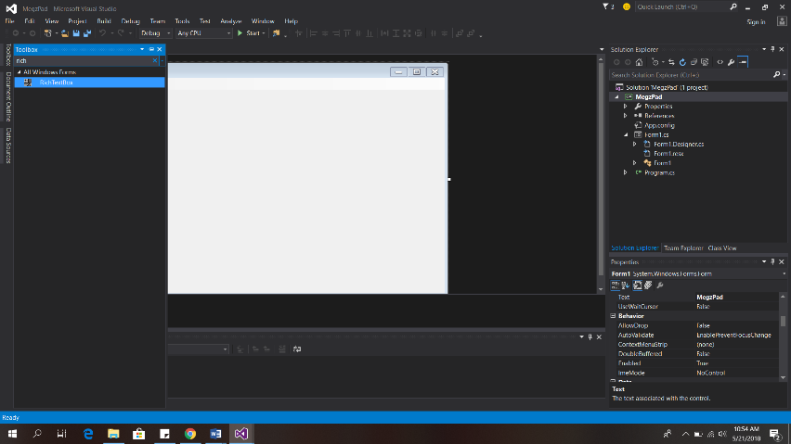  
5. Then drag it in the Form Designer. Select the richtextbox then click the arrow right then select dock in parent container.   
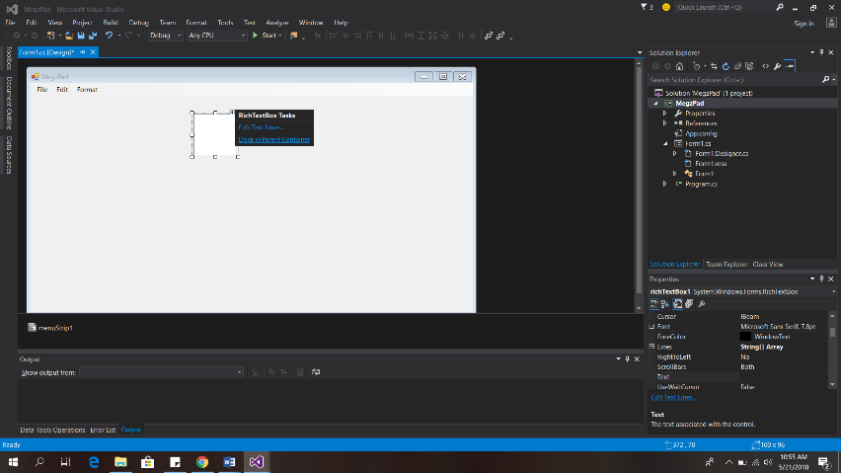  
6. Add this Sub Menus and Create Shortcuts in Every Sub Menus. Example(Ctrl + A) Select All.

7. Copy the Code Below:

//Open

OpenFileDialog op = new OpenFileDialog(); op.Title = "open"; op.Filter = "Text Document(*.txt)|*.txt| All Files(*.*)|*.*"; if (op.ShowDialog() == DialogResult.OK) richTextBox1.LoadFile(op.FileName,RichTextBoxStreamType.PlainText); this.Text = op.FileName;

//Save SaveFileDialog op = new SaveFileDialog(); op.Title = "Save"; op.Filter = "Text Document(*.txt)|*.txt| All Files(*.*)|*.*"; if(op.ShowDialog() == DialogResult.OK) richTextBox1.SaveFile(op.FileName, RichTextBoxStreamType.PlainText); this.Text = op.FileName;

//Exit

string message = "Do you want to close this window?"; string title = "Close Window"; MessageBoxButtons buttons = MessageBoxButtons.YesNo; DialogResult result = MessageBox.Show(message, title, buttons); if (result == DialogResult.Yes) { this.Close(); } else { //Modify this code.. MessageBox.Show("Ok","Ok",MessageBoxButtons.OK); } //Undo richTextBox1.Undo();

//Redo richTextBox1.Redo();

//Copy richTextBox1.Copy();

//Paste richTextBox1.Paste();

//Cut richTextBox1.Cut();

//SelectAll richTextBox1.SelectAll();

//Date Time richTextBox1.Text = System.DateTime.Now.ToString();

//Font FontDialog op = new FontDialog(); if (op.ShowDialog() == DialogResult.OK) richTextBox1.Font = op.Font;

//Color ColorDialog op = new ColorDialog(); if (op.ShowDialog() == DialogResult.OK) richTextBox1.ForeColor = op.Color;

Bonus Points (30pts) Add Status Bar Functionality – 20pts.

Add Shortcuts for Edit sub menus – 10pts.

1. Apply Error Trapping: that if you accidentally close the application the user will choose two options either save or exit. 2. Ask your instructor to check your work.