**Transmuda Project User Stories & Test cases**

**Story 1**: As a user, I should be **accessing** all the **main** **modules** of the app.

**AC #1:** Store and sales managers should view 8 module names.

Expected module names: Dashboards, Fleet, Customers, Sales, Activities, Marketing, Reports & Segments, System

**AC #2:** drivers should view 4 module names

Expected module names: Fleet, Customers, Activities, System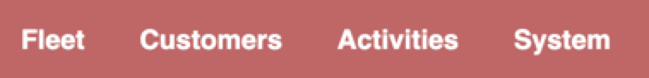

**Test cases #1**

Description: Manager access to main modules

Environment: https://qa.transmuda.com/

Steps: 1. login as a salesmanager or storemanagers

2. Verify the users see 8 modules: Dashboards, Fleet, Customers, Sales, Activities, Marketing, Reports & Segments, System

**Test cases #2**

Description: Driver access to main modules

Environment: https://qa.transmuda.com/

Steps:: 1. login as a driver

2. Verify the users see 4 modules: Fleet, Customers, Activities, System

**Story 2**: As a user, I should be access to the Oroinc Documentation page. (Window handle)

**AC #1:** users access the Oronic Documentation page by clicking the question icon. The page URL: is https://doc.oroinc.com/

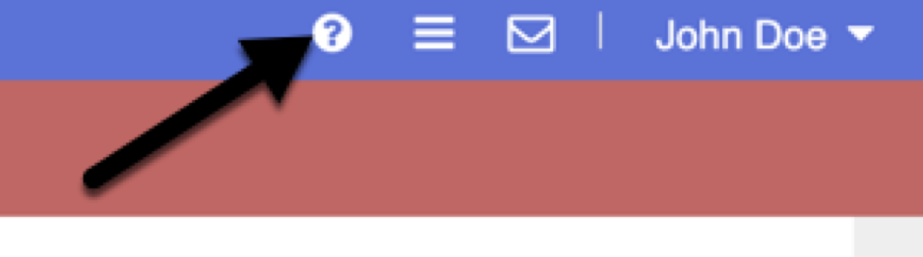

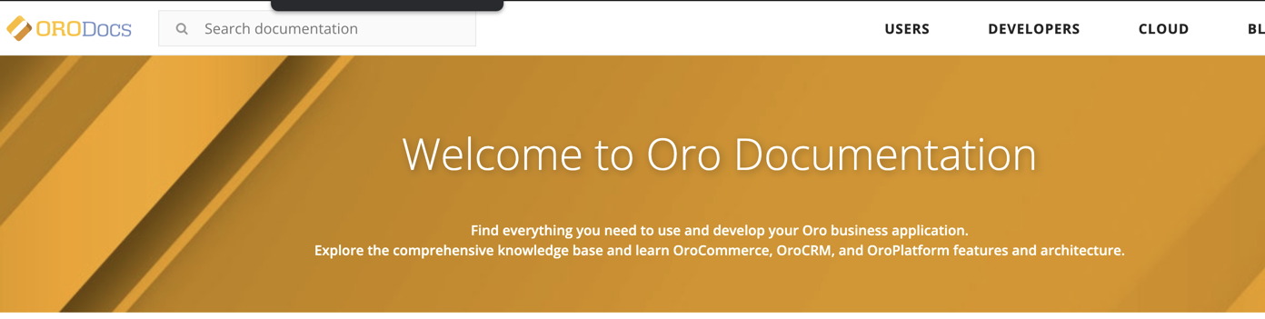

**Test cases #1**

Description: users access the Oronic Documentation page

Environment: https://qa.transmuda.com/user/login

Steps:

1. Users are on the homepage
2. Click the question icon on the right top of the homepage
3. Verify the user's access to the Oronic Documentation page

**Story 3**: As a user, I want to learn how to use the pinbar.

**AC1:** when users click the “Learn how to use this space” link on the homepage, users should see:

“How To Use Pinbar” and

“Use the pin icon on the right top corner of the page to create fast access link in the pinbar.”

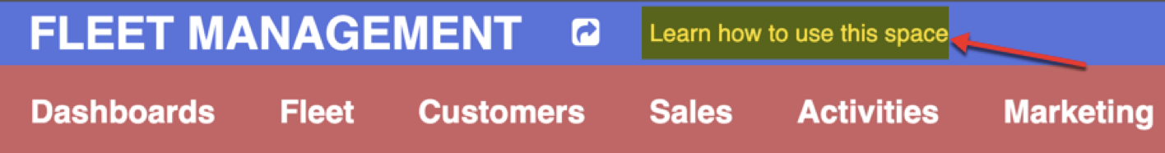

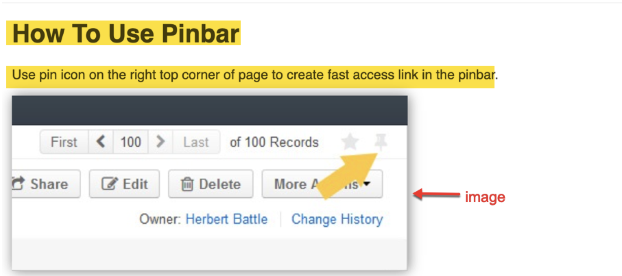

**AC2:** users should see an image on the page.

[**in automation testing**, just verify the image source.]

Expected source:

/bundles/oronavigation/images/pinbar-location.jpg

**Test cases #1**

Description: users learn how to use the pinbar

Environment: https://qa.transmuda.com/user/login

Steps:

1. Users are on the homepage
2. Click the Learn how to use this space message
3. Verify the users see 2 messages:

“How To Use Pinbar” and

“Use the pin icon on the right top corner of the page to create fast access link in the pinbar.”

**Test cases #2**

Description: users see an image on the pinbar page

Environment: https://qa.transmuda.com/user/login

Steps:

1. Users are on the homepage
2. Click the Learn how to use this space message
3. Verify users see an image

(manual testing - screenshot proof

Automation testing - verify image source)

**Story 4**: As a user, I want to access to Vehicle contracts page

**AC1:** Store managers and Sales managers access the Vehicle contracts page.

**Expected URL:** https://qa.transmuda.com/entity/Extend_Entity_VehicleContract

**Expected title:** All - Vehicle Contract - Entities - System - Car - Entities - System

**AC2:** Drivers should **NOT** able to access the Vehicle contracts page, the app should display “You do not have permission to perform this action.”

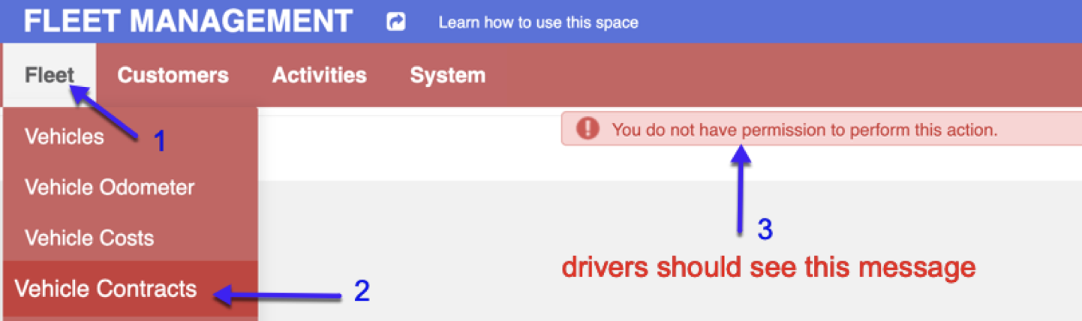

**Test cases #1**

Description: Managers access the Vehicle contracts page

Environment: https://qa.transmuda.com/user/login

Steps:

1. Login as store or salesmanager
2. Click the Vehicle contracts under the Fleet
3. Verify managers can access the Vehicle contracts page

**Test cases #2**

Description: Drivers can NOT access the Vehicle contracts page

Environment: https://qa.transmuda.com/user/login

Steps:

1. Login as drivers
2. Click the Vehicle contracts under the Fleet
3. Verify users see an error message: “You do not have permission to perform this action.”

**Story 5**: As a user, I want to view columns on the Vehicle models page. (web-table)

**AC #1:** The store manager and sales **manager** should **see** 10 columns on the Vehicle Model page.

***Expected Column names:***

MODEL NAME, MAKE, CAN BE REQUESTED, CVVI, CO2 FEE (/MONTH), COST (DEPRECIATED), TOTAL COST (DEPRECIATED), CO2 EMISSIONS, FUEL TYPE, VENDORS

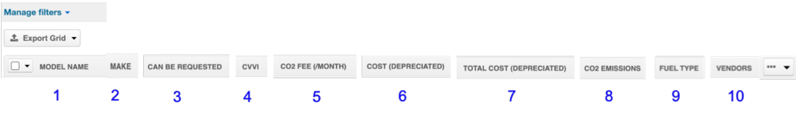

**AC #2:** Drivers should not able to access the Vehicle Model page, users should see “You do not have permission to perform this action.”

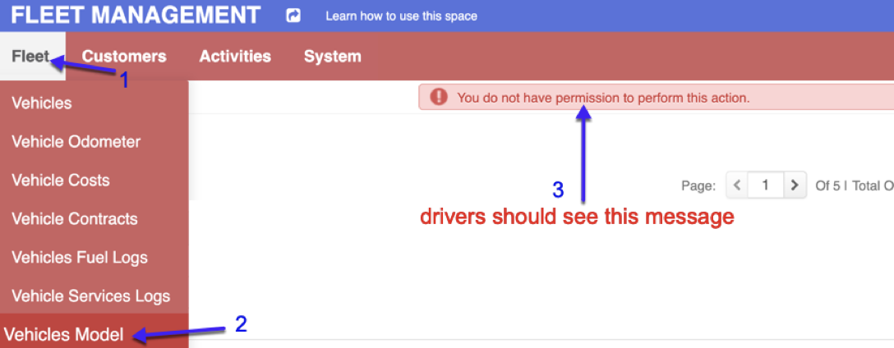

**Test cases #1**

Description: managers has access to the Vehicle models

Environment: https://qa.transmuda.com/user/login

Steps:

1. Login as store and sales managers
2. Click the Vehicle Model under the Fleet
3. Verify managers see 10 columns in the web-table

**Test cases #2**

Description: Drivers can **NOT** access the Vehicle models page

Environment: https://qa.transmuda.com/user/login

Steps:

1. Login as store and sales managers
2. Click the Vehicle Model under the Fleet
3. Verify the drivers see the error message “You do not have permission to perform this action.”

**Story 6**: As a user, I want to see edit car info icons from the Vehicle page.

**AC #1:** users should see “**view, edit, delete**” when they hover the mouse over the 3 dots “…” 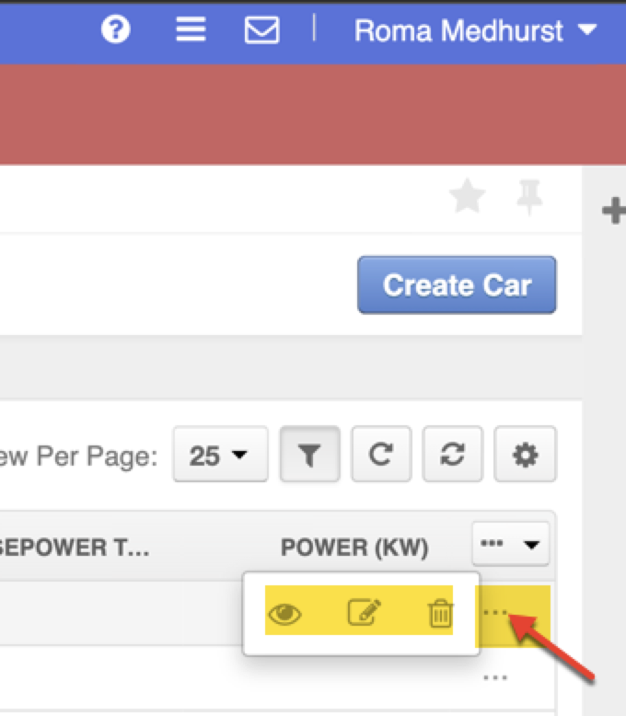

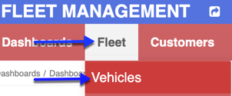

**Test cases #1**

Description: users see the car edited options on the Vehicle page

Environment: https://qa.transmuda.com/user/login

Steps:

1. Users are on the homepage
2. Click the Vehicles under the Fleet
3. Verify any car info has 3 dots “...”, and there are “**view, edit, delete” icons.**

**Story7**: As a user, I should be able to select any **vehicle** from the Vehicle page(web table)

**AC #1:** once the users launch on the Vehicle page, all the checkboxes should be unchecked**.** 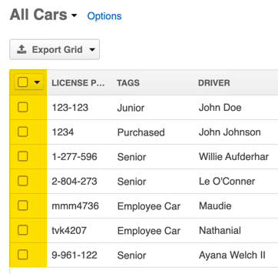



**AC #2:** user checks the first checkbox to check all the cars

**AC #3:** users can select any car 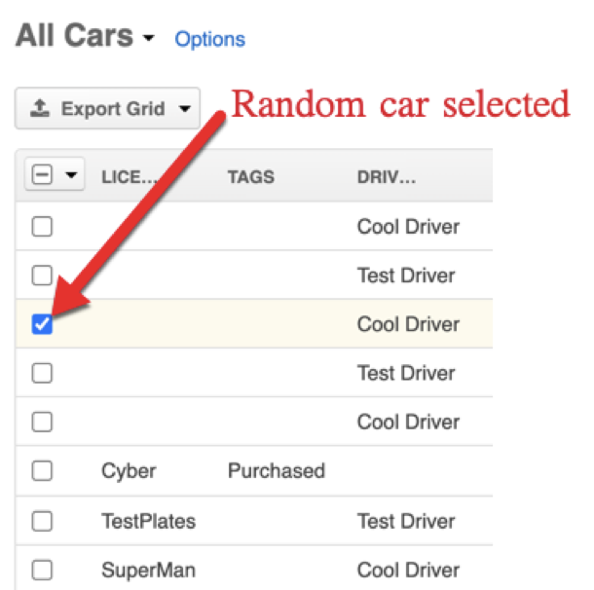

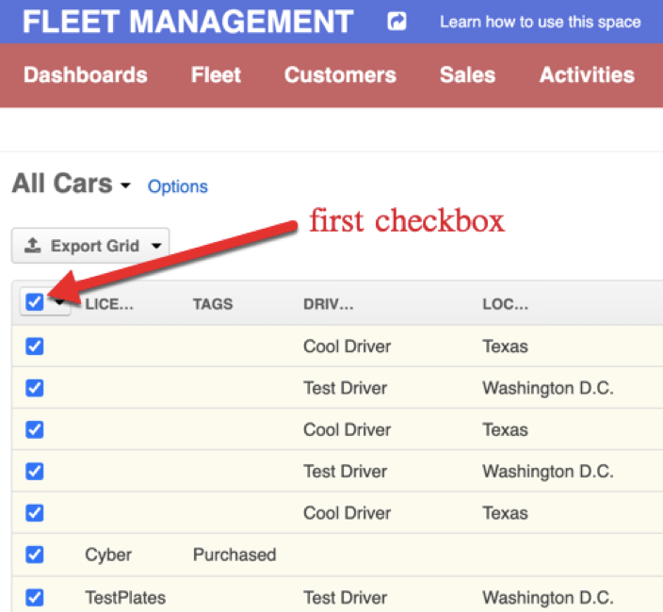

**Test cases #1**

Description: users view unchecked checkboxes on the Vehicle page

Environment: https://qa.transmuda.com/user/login

Steps:

1. Users are on the homepage
2. Click the Vehicle under the Fleet
3. Verify all the checkboxes are unchecked

**Test cases #2**

Description: users check the first checkbox to check all the cars

Environment: https://qa.transmuda.com/user/login

Steps:

1. Users are on the homepage
2. Click the Vehicle under the Fleet
3. Click the 1st checkbox in the web-table
4. Verify all the checkboxes also checked

**Test cases #3**

Description: users check any car’s checkbox

Environment: https://qa.transmuda.com/user/login

Steps:

1. Users are on the homepage
2. Click the Vehicle under the Fleet
3. Check any car’s checkbox
4. Verify the box is checked

**Story 8**: As a user, I want to create a recurring(repetitive) calendar event.

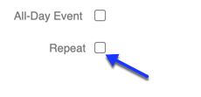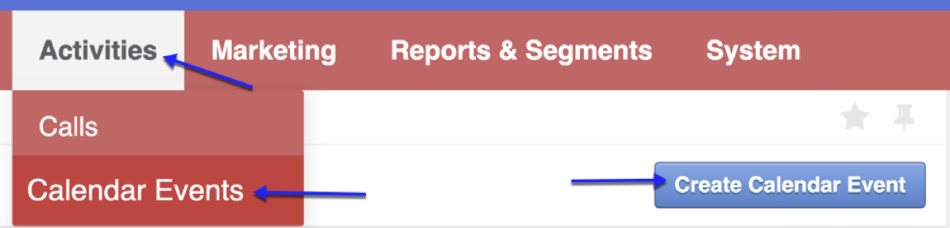

**AC #1:** user should see the number “1” by default in the Repeat Every input. 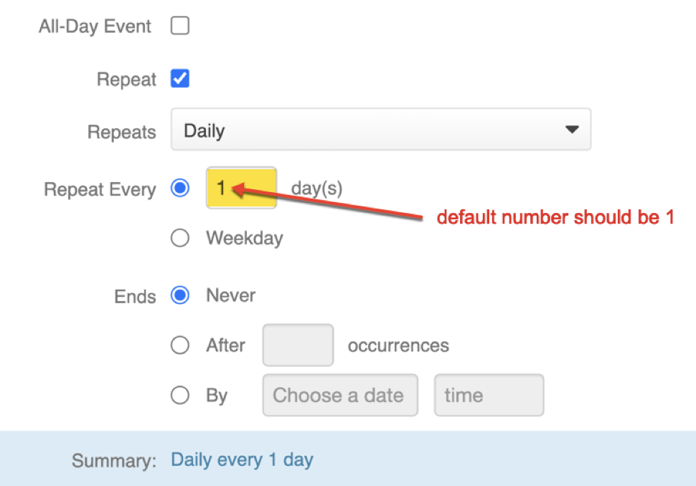

**AC #2:** user should see an error message “This value should not be blank.” when the Calendar event repeat field is cleared(delete the number 1). 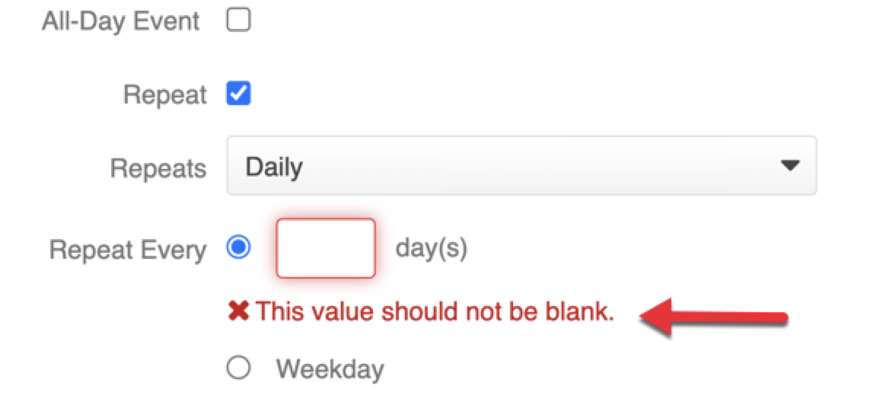

**Test cases #1**

Description: users see the default repeat day as 1

Environment: https://qa.transmuda.com/user/login

Steps:

1. Users are on the homepage
2. Click the “Calendar Events” under the Activities
3. Click the “Create Calendar Event” button
4. Check the Repeat checkbox
5. Verify the repeat number is 1

**Test cases #2**

Description: users clear the repeat day and see an error message

Environment: https://qa.transmuda.com/user/login

Steps:

1. Users are on the homepage
2. Click the “Calendar Events” under the Activities
3. Click the “Create Calendar Event” button
4. Check the Repeat checkbox
5. Clear(delete) the number 1
6. Verify the app displays “This value should not be blank.”

**Story 9**: As a user, I should see error messages when I enter an invalid integer into the calendar repeat day input box. 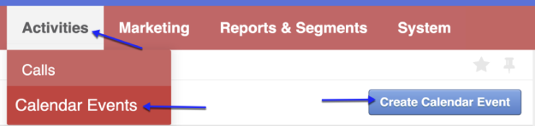

**AC #1:** users see error messages for entering invalid integers.

If enters less than 1 —> user should see “The value have not to be less than 1.”

If enters more than99 —> user should see “The value have not to be more than 99.”

[Note: no need to test valid number, data type, etc in this story.]

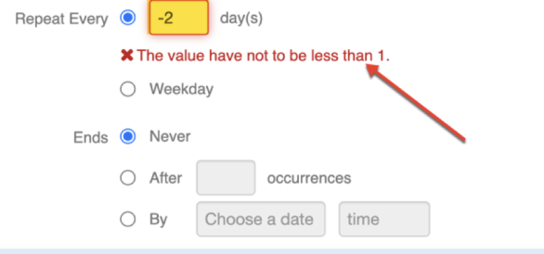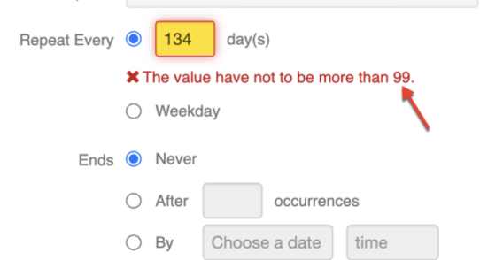

**Test cases #1**

Description: users enter an INVALID integer in the repeat day input box

Environment: https://qa.transmuda.com/user/login

Steps:

1. Users are on the homepage
2. Click the “Calendar Events” under the Activities
3. Click the “Create Calendar Event” button
4. Check the Repeat checkbox
5. Users enter an INVALID integer (x<1 || x>99)
6. Verify users get 2 error messages

**Story10**: As a user, I want to write the “Description” when I create a calendar event. (Iframe)

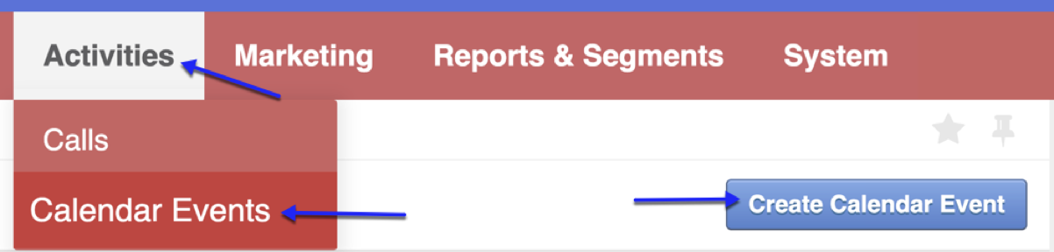

**AC1:** users should be able to write messages in the Descriptionfield on the calendar event page**.**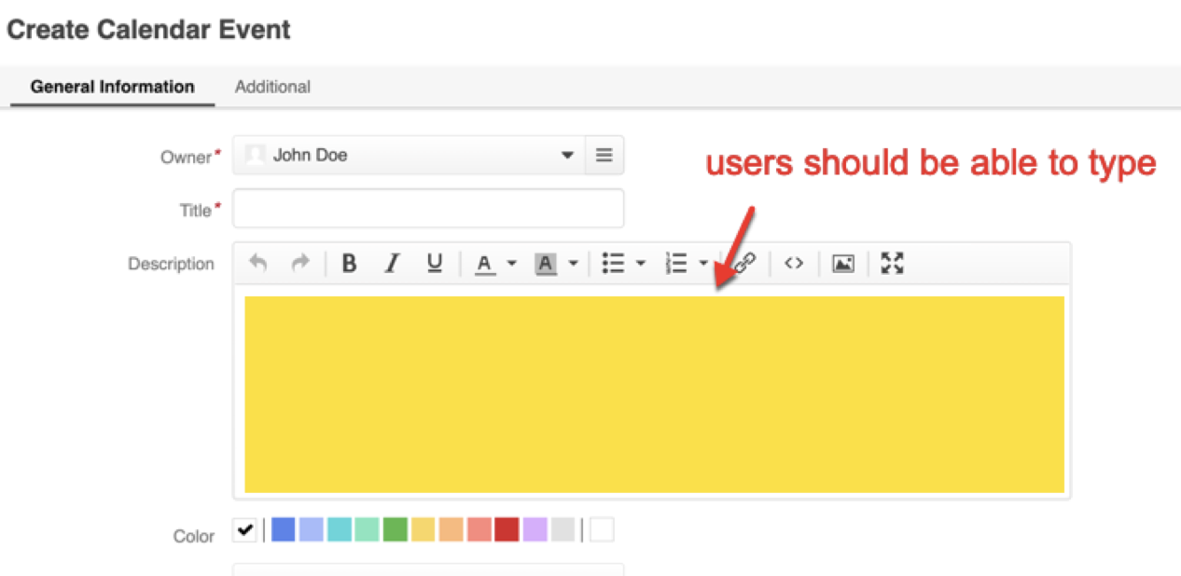

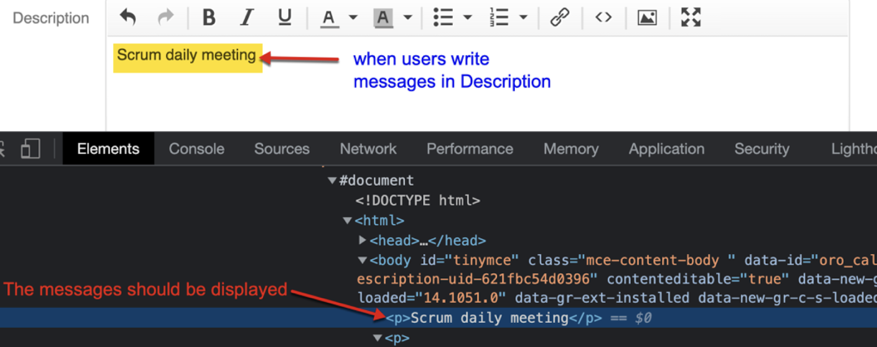

**Test cases #1**

Description: users write a description to create a calendar event

Environment: https://qa.transmuda.com/user/login

Steps:

1. Users are on the homepage
2. Click the “Calendar Events” under the Activities
3. Click the “Create Calendar Event” button
4. Write a message in the Description field
5. Verify the message is written in the input box

**Story11**: As a user, I want to view car odometer info on the Vehicles Odometers page.

AC1: Store and Sales managers should see an error message “You do not have permission to perform this action.”

when they click the “Vehicle Odometer” module.

AC2: Drivers should see the default page as 1.

AC3: Divers should see the View Per Page is 25 by default.

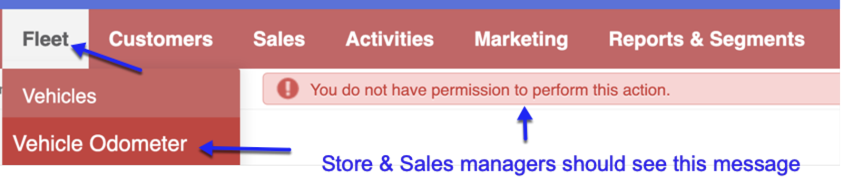

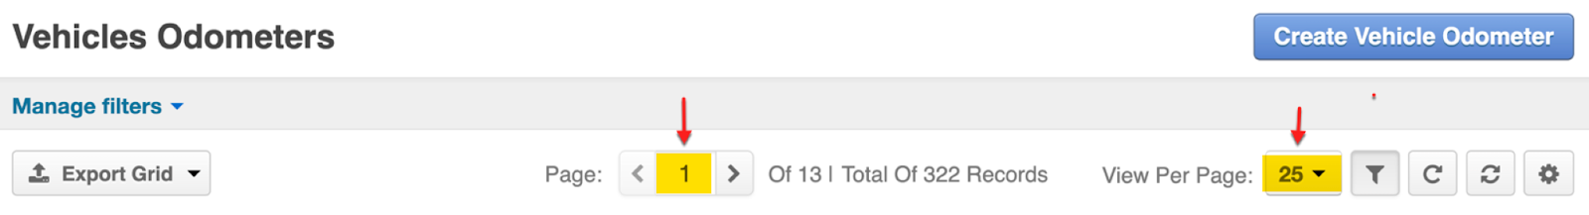

**Test cases #1**

Description: manager can NOT access the Vehicle Odometer

Environment: https://qa.transmuda.com/user/login

Steps:

1. Log in as store or sales managers
2. Click the “Vehicle Odometers” under the Fleet
3. Verify the managers see “You do not have permission to perform this action.”

**Test cases #2**

Description: Drivers should see the default page number as 1

Environment: https://qa.transmuda.com/user/login

Steps:

1. Log in as drivers
2. Click the “Vehicle Odometers” under the Fleet
3. Verify the default page number is 1

**Test cases #3**

Description: Divers should see the View Per Page is 25 by default.

Environment: https://qa.transmuda.com/user/login

Steps:

1. Log in as drivers
2. Click the “Vehicle Odometers” under the Fleet
3. Verify the default view per page is 25

**Story12**: As a user, I want to filter customers’ info on the Account page.

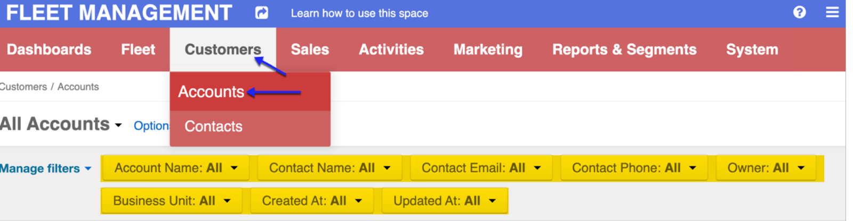

**AC1:** users should see 8 filter items on the Accounts page

**Expected filter names:** Account Name, Contact Name, Contact Email, Contact Phone, Owner, Business Unit, Created At, Updated At

**Test cases #1**

Description: users see 8 account name filter options

Environment: https://qa.transmuda.com/user/login

Steps:

1. Log in as store or sales managers
2. Click the “Accounts” under the Customers
3. Verify there are 8 filter options

Account Name, Contact Name, Contact Email, Contact Phone, Owner, Business Unit, Created At, Updated At

**Story 13**: As a user, I want to manage filters on the Vehicle Costs page. (Web table and checkbox)

**AC #1:** Users should see 3 columns on the Vehicle Model page.

Expected Column names:TYPE, TOTAL PRICE, DATE

**AC #2:** users check the first checkbox to check all the Vehicle Costs 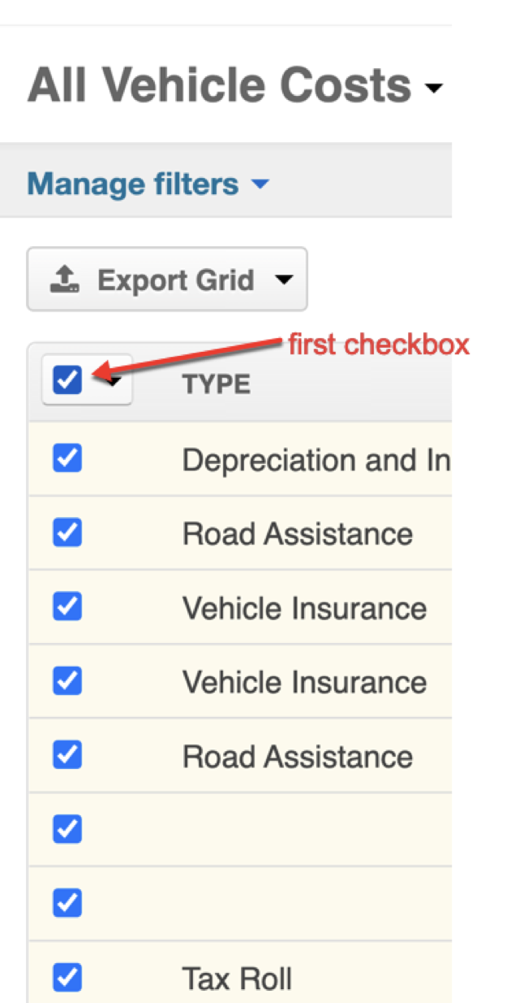

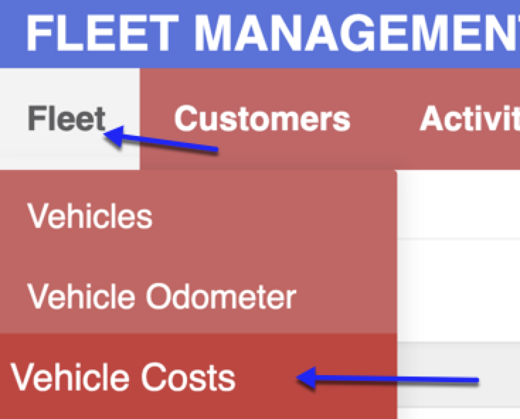

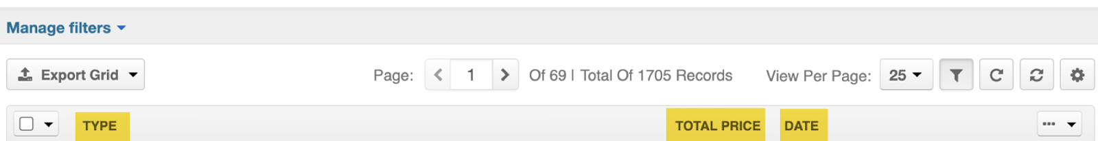

**Test cases #1**

Description: users see 3 columns on the Vehicle Model page

Environment: https://qa.transmuda.com/user/login

Steps:

1. Users are on the homepage
2. Click the Vehicle Costs under the Fleet
3. Verify there are 3 columns in the table:

Expected Column names:TYPE, TOTAL PRICE, DATE

**Test cases #2**

Description: users select all the vehicle costs

Environment: https://qa.transmuda.com/user/login

Steps:

1. Users are on the homepage
2. Click the Vehicle Costs under the Fleet
3. Click the first checkbox
4. Verify all the vehicle costs are checked

**Story 14**: As a user, I want to manage filters on the Marketing page.

AC #1: Store and sales managers should see all 5 filter options are checked by default.

AC #2: any amount of boxes should be unchecked. (can check only 1, or multiple)

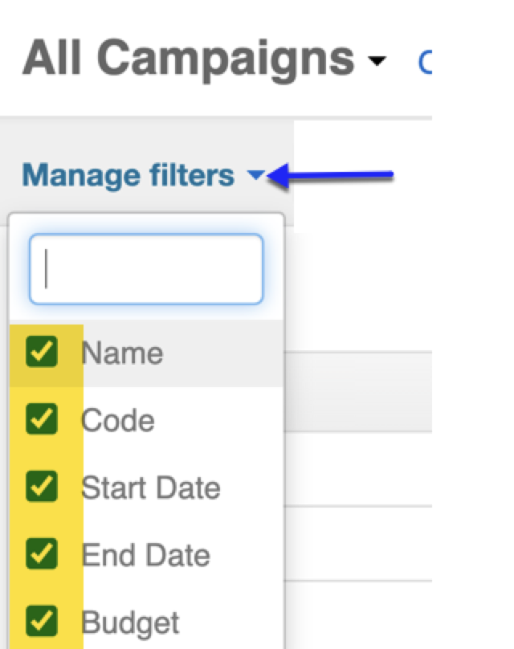

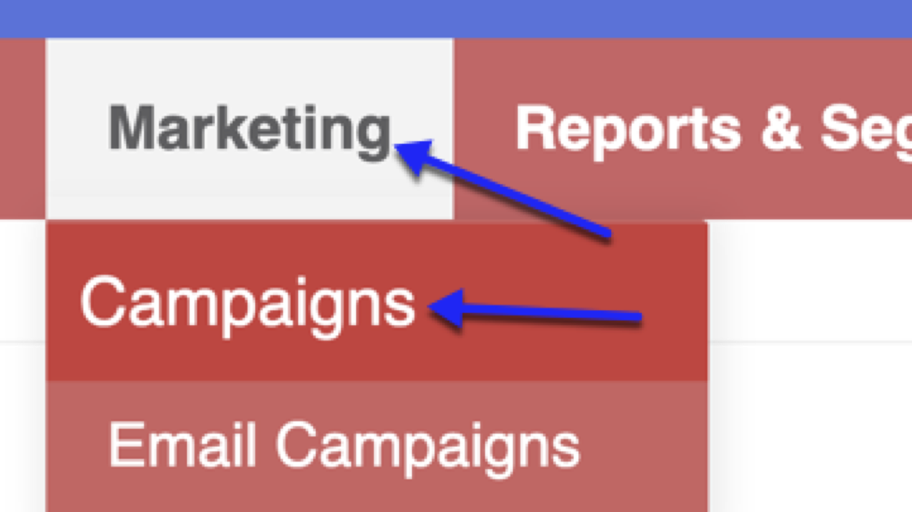

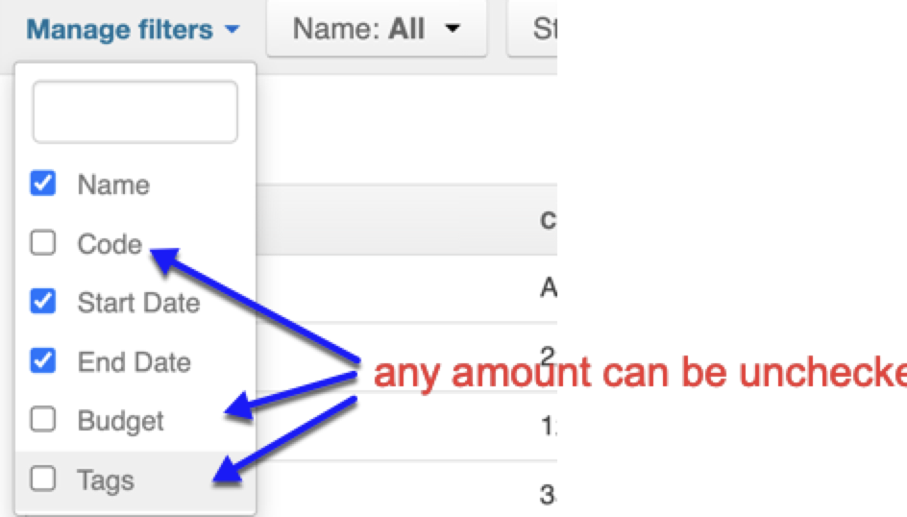

**Test cases #1**

Description: managers see default checked filters on the Campaigns page

Environment: https://qa.transmuda.com/user/login

Steps:

1. Users are on the homepage
2. Click the Campaigns under the Marketing
3. Click the Manage filters button
4. Verify 5 options are checked by default

**Test cases #2**

Description: managers can uncheck any filter options

Environment: https://qa.transmuda.com/user/login

Steps:

1. Users are on the homepage
2. Click the Campaigns under the Marketing
3. Click the Manager filters button
4. Uncheck one or more filter options
5. Verify one or more options are unchecked