**Delaunay Triangulation Practice Problems**

1.What property do Delaunay Triangulations possess that is not found in a normal scan triangulation? Explain this property in your own words

2.Is this a valid Delaunay Triangulation of our former presidents face?

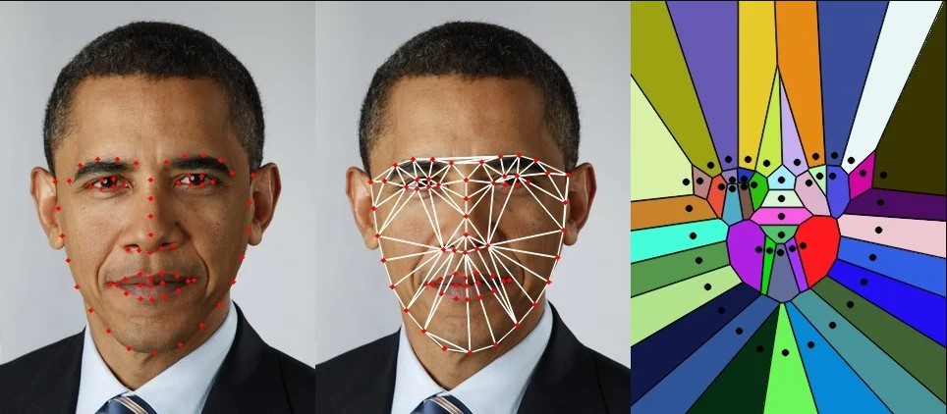

3. How would you produce a Delaunay triangulation of the 4 points? (Remember the properties)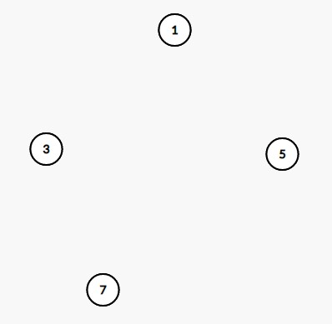

4. Q: Find the Delaunay triangulation for this set of 6 points: 