**Delaunay Triangulation Practice Problems Answer Key**

1. Empty Circle Property. The circumcircle of a triangle in the triangulation cannot contain a vertex of another triangle

2. Yes it is! For proof visit this link: <https://www.youtube.com/watch?v=GGx8gxp9LyY&t=1s> Also remember that a voronoi diagram has a dual relationship with Delaunay triangulation

3. There are only two options The first is incorrect the second is a Delaunay triangulation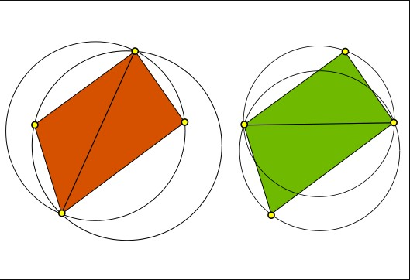

4. 